**Debugging your code**

with Chrome Developer Tool (F12) and Komodo Edit

**These notes, NOT REQUIRED FOR Test 3**

Browsers as well as Komodo Edit have error checking in them. The browser’s debugging tool is found in the developer tool of the browser. I will go over the developer tool in Chrome here. Load the HTML page with the JavaScript in Chrome. Press **F12** (or the **fn** key and the **F12** key together), this will open the Chrome developer tool. To close the developer tool window, press **F12** again, or click on the “X” close button. The developer tool will display your rendered page in one window and the code in another window.

Click on the *Elements* tab to open the elements window. It will open a small *Console* window beneath it as well. In the bottom *Console* window appears a short description(s) of the error(s) in your code. It also lists the location of the error by line number.

The *Source* tab is also good to use. It shows the same information along with a snapshot of your code including line numbers.

Using a tool such as this makes your work in coding more efficient. You will waste less time figuring out why your program will not run properly, so that you can go about remedying it and moving on.

Take a look at my code in Figure #1a below. In the body of the page is an h1, h2 , some script and finally a p element. The script, JavaScript, consists of two document.write statements is enclosed between <script> and </script>. The second document.write statement contains a syntax error. Figure #1a and #1b is my code and a small image of how the code renders.

Figure #1a

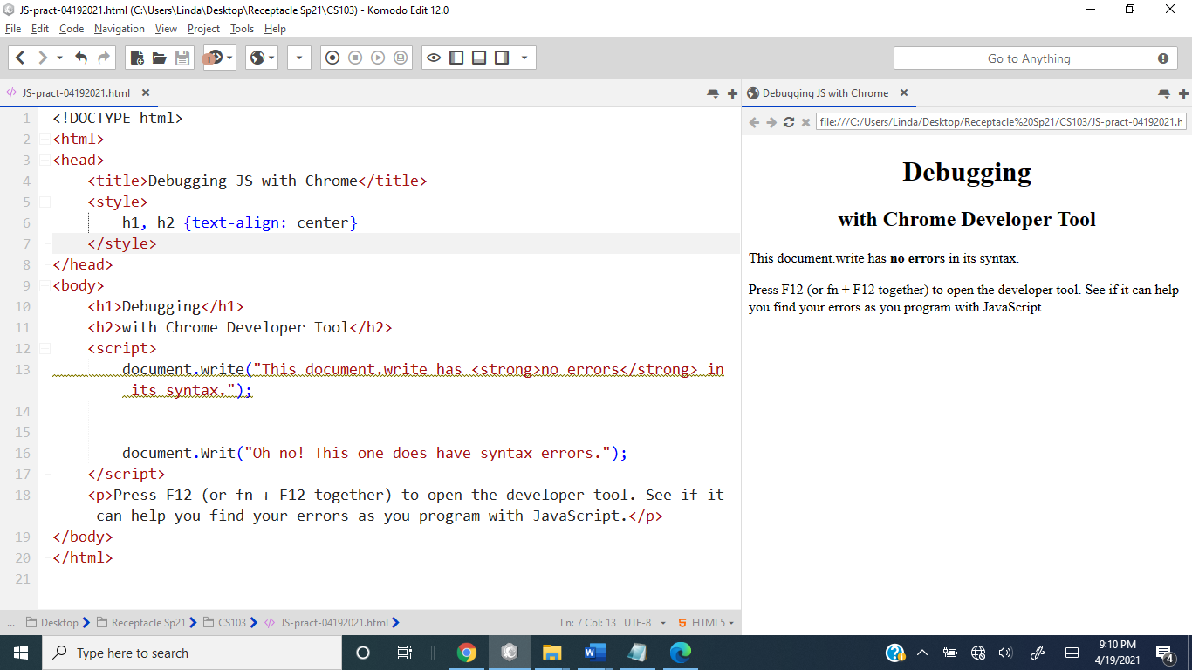



Figure #1b



Then I rendered my HTML page in Chrome and press F12 (fn + F12) to open the developer tool. I clicked on the *Elements* tab if necessary. Figure #2 is what I see.

Figure #2a – Developer tool with *Elements* tab active. Go to Figure #2b for a zoomed‑in look at this image.

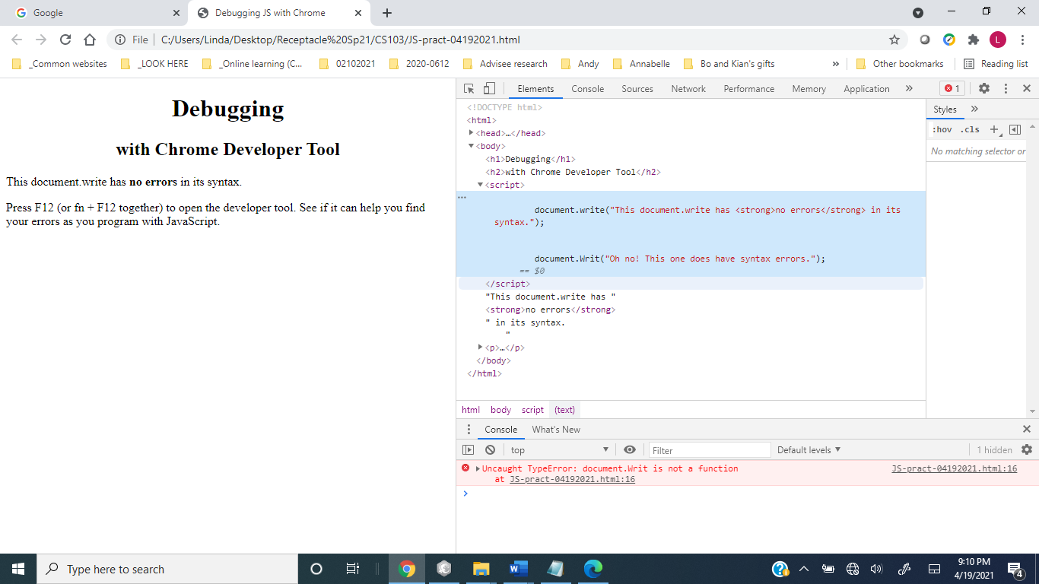

go to next page -->

Notice the code in the *Elements* pane and the error identified in it in the small *Console* window below it.

Figure #2b – This is Figure #2a, but zoomed into just the right *Elements* panel showing.





go to next page -->

Figure #3 below shows what you see with the *Sources* Tab active. The line numbers show as well. This same view appears if you click on the error description link in the *Console* pane.

Figure #3

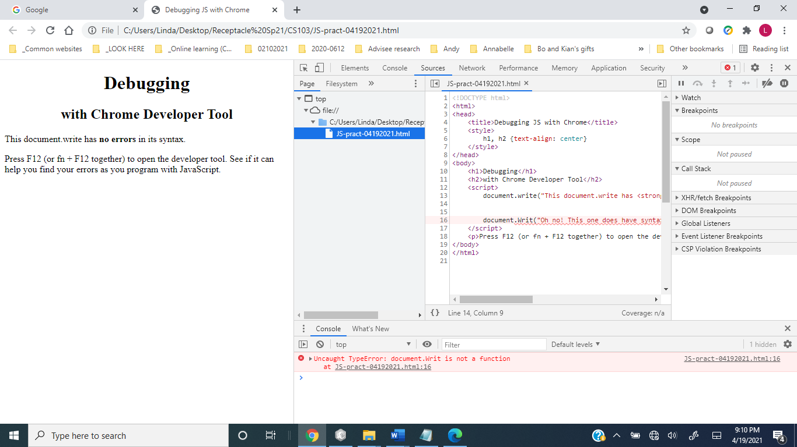

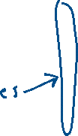

Finally, you can also use Komodo Edit in a similar way. To do so, click on the *View* menu, *Tabs & Sidebars* and select *Notifications*. A small window opens and shows the error description and its line number. Study the next 2 figures below.

Figure #4a

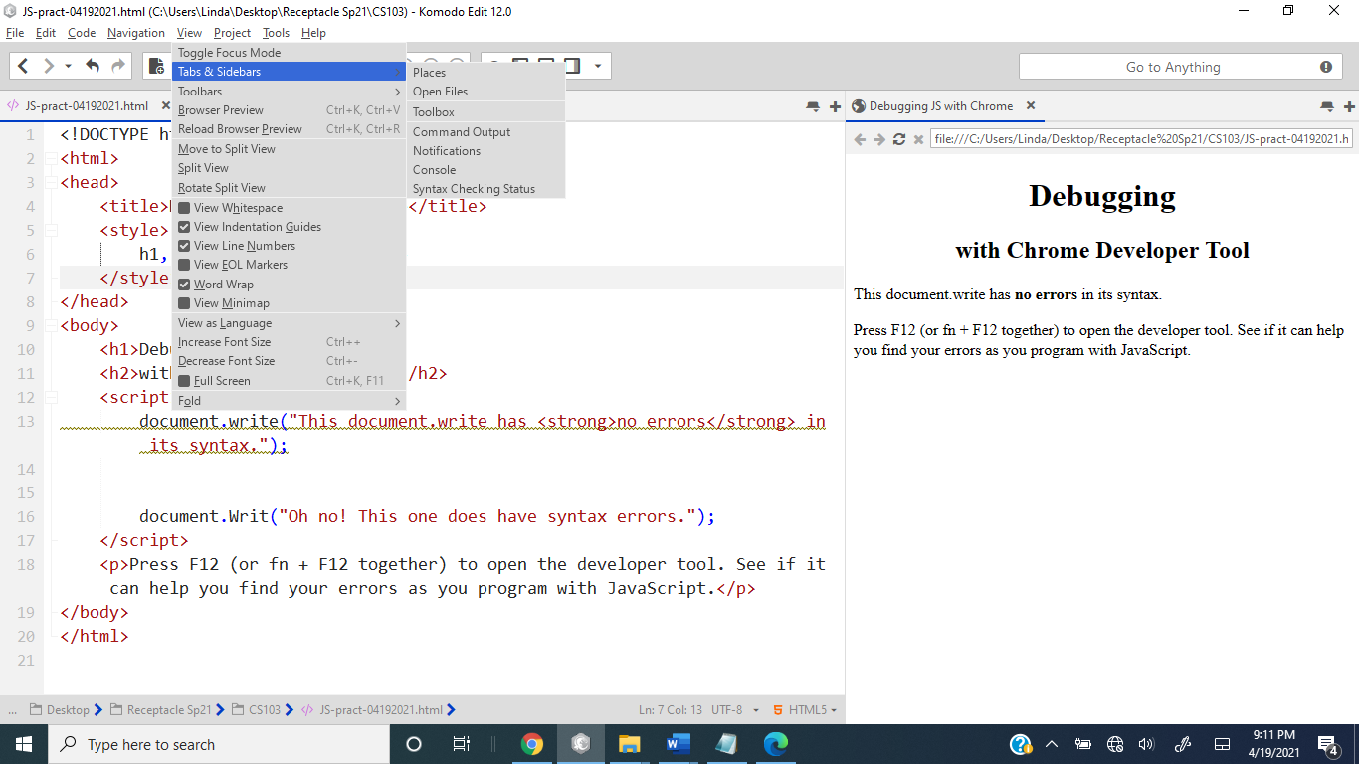

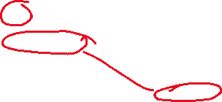

go to next page -->

Figure #4b

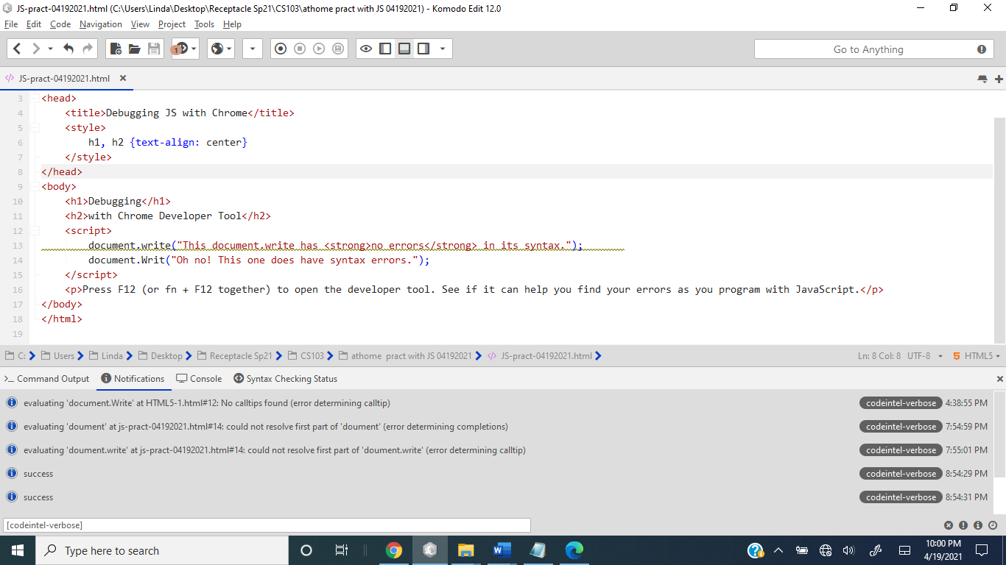



The End.