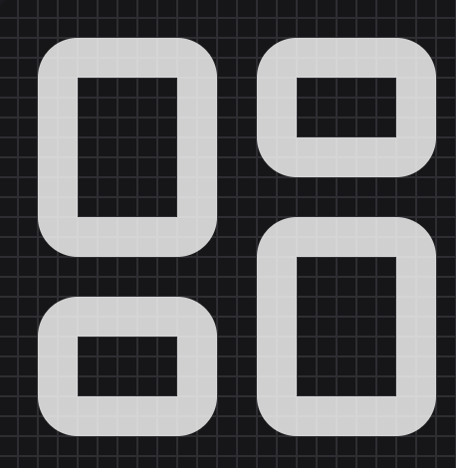
<script>
import { createIcons, layoutDashboard } from 'lucide';

createIcons({
icons: {
layoutDashboard
}
});
</script>

<i data-lucide="layout-dashboard"></i>


<script>
import { createIcons, folder } from 'lucide';

createIcons({
icons: {
folder
}
});
</script>

<i data-lucide="folder"></i>


<script>
import { createIcons, folderOpenDot } from 'lucide';

createIcons({
icons: {
folderOpenDot
}
});
</script>

<i data-lucide="folder-open-dot"></i>


<script>
import { createIcons, folderClosed } from 'lucide';

createIcons({
icons: {
folderClosed
}
});
</script>

<i data-lucide="folder-closed"></i>


<script>
import { createIcons, folderClock } from 'lucide';

createIcons({
icons: {
folderClock
}
});
</script>

<i data-lucide="folder-clock"></i>


<script>
import { createIcons, bookUser } from 'lucide';

createIcons({
icons: {
bookUser
}
});
</script>

<i data-lucide="book-user"></i>


<script>
import { createIcons, cog } from 'lucide';

createIcons({
icons: {
cog
}
});
</script>

<i data-lucide="cog"></i>


<script>
import { createIcons, botMessageSquare } from 'lucide';

createIcons({
icons: {
botMessageSquare
}
});
</script>

<i data-lucide="bot-message-square"></i>
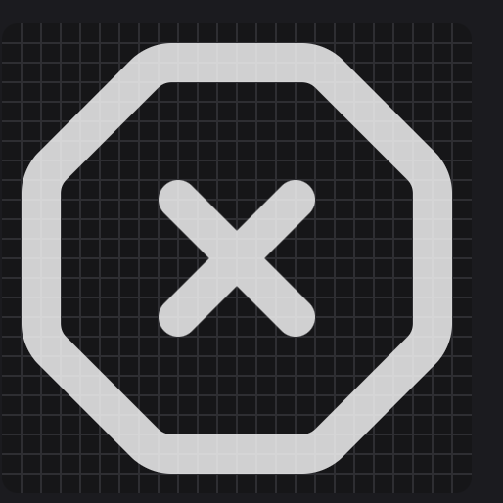
<script>
import { createIcons, octagonX } from 'lucide';

createIcons({
icons: {
octagonX
}
});
</script>

<i data-lucide="octagon-x"></i>

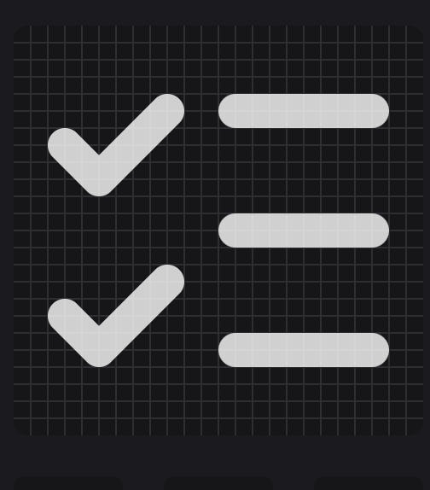
<script>
import { createIcons, listChecks } from 'lucide';

createIcons({
icons: {
listChecks
}
});
</script>

<i data-lucide="list-checks"></i>

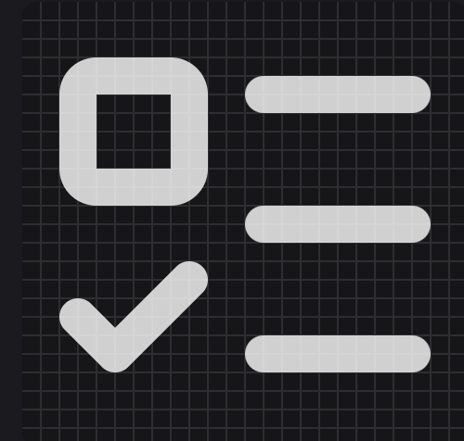
<script>
import { createIcons, listTodo } from 'lucide';

createIcons({
icons: {
listTodo
}
});
</script>

<i data-lucide="list-todo"></i>

