WapHub — Social Media Connection Guide
Facebook Pages, Instagram, Meta Ads, Lead forms, Posts & Reels — from Meta app setup to a client posting their first reel.
Who should read what:
Part | Who does it | How often
Part 1 — Why the connection failed (your screenshots) | Platform owner | Read once
Part 2 — Meta app setup (developers.facebook.com) | Platform owner (Super Admin) | Once
Part 3 — WapHub Social Gateway Settings | Super Admin | Once (and when the app secret changes)
Part 4 — A client admin connects Facebook / Instagram / Ad Account | Each client admin | Once per client
Part 5 — An agent connects for a sub-client | Agent | Once per client
Part 6 — Using posts, reels, ads, leads, inbox | Client team | Daily
Part 7 — Troubleshooting | Anyone | When something fails

Part 1 — Why you saw “App not active” and then “Feature unavailable”
Short answer: nothing is broken in WapHub. Both messages come from Facebook itself, before WapHub is even contacted. They mean Meta is not yet allowing people outside your app to log in to it with the permissions WapHub asks for.

1.1 “App not active” (before you published the app)
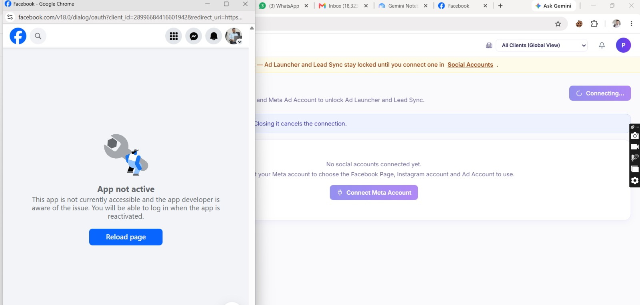
Screenshot: App not active — the app was in Development mode.
While a Meta app is in Development mode, ONLY people who have a role on the app (Administrator, Developer or Tester) can log in to it. You created the app with the “Saleem” Facebook ID, but you were connecting with your second Facebook ID, which has no role on the app — so Meta blocked it.

1.2 “Feature unavailable” (after you published the app)
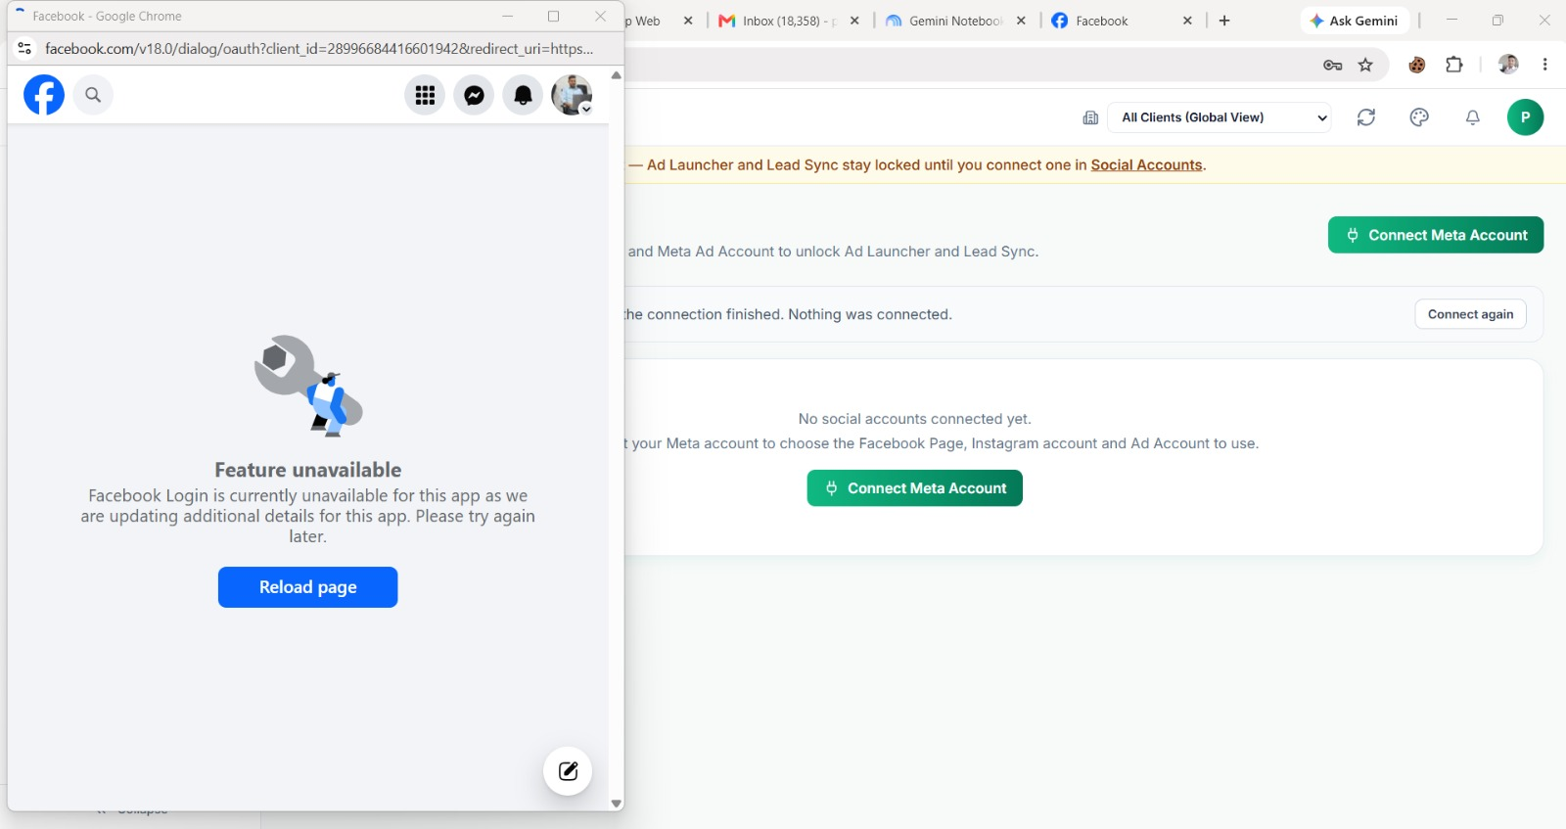
Screenshot: Feature unavailable — the app is Live, but its permissions are not approved for the public yet.
Publishing (Live mode) does not by itself open the app to everybody. WapHub asks Meta for these permissions: pages_show_list, pages_read_engagement, ads_read, ads_management, business_management (plus the optional groups you tick in Social Gateway Settings). For a person who has no role on the app, each of these needs “Advanced Access”, which Meta gives only after Business Verification and App Review. Until then Meta shows “Feature unavailable”. Pending items under “Required actions” (you have 2 alerts in the Alert Inbox) and an empty Category also block the login.

1.3 Two more things in your settings that will fail next
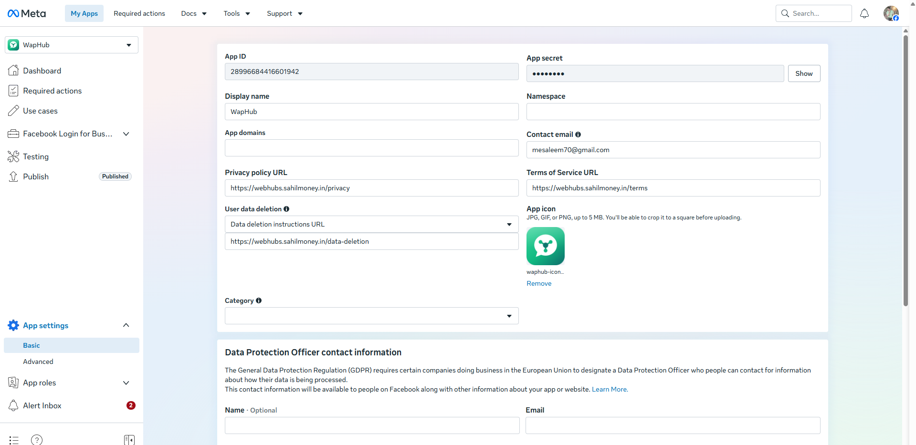
Screenshot: Meta app → App settings → Basic. App domains and Category are empty.
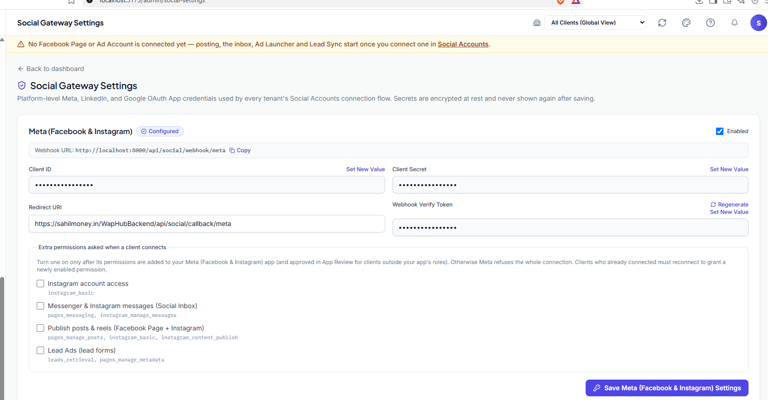
Screenshot: WapHub Social Gateway Settings. The Redirect URI points to the live server, but you were testing on localhost.
- App domains and Category are empty. Fill in App domains (e.g. sahilmoney.in) and choose a Category (e.g. Business and pages).
- Redirect URI vs. where you test. Your Redirect URI is https://sahilmoney.in/WapHubBackend/api/social/callback/meta, but you were clicking Connect on http://localhost:5173. Facebook sends the user back to the LIVE server, which cannot read the login started on your laptop (each server signs the request with its own APP_KEY) — you would get “Invalid or tampered authorization state”. Always test the connection on the same server the Redirect URI points to.
- Webhook URL is localhost. The Webhook URL shown (http://localhost:8000/api/social/webhook/meta) comes from APP_URL. Meta cannot reach localhost, so lead forms, comments and messages will only arrive on the live server (APP_URL = your public https address).

1.4 What to do right now (quick fix for testing)
- Add your second Facebook ID as a Tester: developers.facebook.com → your WapHub app → App roles → Roles → Add People → Testers → enter that person’s Facebook name or ID.
- Accept the invite: log in to Facebook with the second ID and open developers.facebook.com/requests → Accept (it may ask that ID to register as a Meta developer first — free, 1 minute).
- Finish Required actions: open “Required actions” in the left menu and complete every item (data-use checkup, contact email, etc.).
- Fill App domains + Category in App settings → Basic, then Save changes.
- Test on the live site (the domain your Redirect URI uses), not on localhost: Social Accounts → Connect Meta Account.
Good to know: people with a role on the app (Admin / Developer / Tester) can connect with all permissions straight away, even without App Review. That is the right way to test with your own IDs and with your first 1–2 friendly clients. Real clients at scale need Part 2.7 (App Review).

Part 2 — Meta app setup (done once by the platform owner)
Where: developers.facebook.com → My Apps → WapHub. Meta renames menu items from time to time; if a name below does not match exactly, look for the closest one.

2.1 Business portfolio and verification
- Create (or use) a Meta Business portfolio at business.facebook.com for your company (Sahil Money / WapHub).
- In the app: App settings → Basic → connect the app to that Business portfolio.
- Business settings → Security Center → Start Business Verification (company documents, phone, domain). This takes a few days and is required before Meta gives Advanced Access.
- Verify your domain (Business settings → Brand safety → Domains) — the same domain as your website.

2.2 App settings → Basic
Field | What to put
App ID | Already created — copy it into WapHub as Client ID (Part 3).
App secret | Click Show, copy it into WapHub as Client Secret. Never share it.
App domains | sahilmoney.in (and the domain of your live WapHub panel, if different).
Privacy policy / Terms / Data deletion URLs | Already filled — the pages must open publicly without login.
Category | Choose a business category (e.g. Business and pages).
App icon | Already uploaded.

2.3 Add the use cases / products
Left menu → Use cases (or Add products). Add:
- Facebook Login for Business — the login popup clients see.
- Manage everything on your Page — Page posts, Page list, Page insights.
- Create & manage ads with Marketing API — Meta Ads Launcher, Ads Dashboard.
- Capture & manage ad leads with Marketing API — Lead forms (Instant Lead CRM).
- Manage messaging & content on Instagram — Instagram posts, reels, comments, DMs.
- Engage with customers on Messenger from Meta — Social Inbox (Messenger).

2.3.1 Add the permissions inside each use case
Adding a use case is not enough. Open each use case → Customize → Permissions and features, and click “+ Add” on every permission below until its status shows “Ready for testing”. A permission that is not added makes Meta reject the login with “Invalid Scopes”, or refuse that one feature later.
Use case → Customize | Click “+ Add” on each | Used by WapHub for
Manage everything on your Page | pages_show_list, pages_read_engagement, business_management, pages_manage_posts, pages_manage_metadata | Connect Page, Page posts, Lead Ads webhook
Manage messaging & content on Instagram (API setup with Facebook login) | instagram_basic, instagram_content_publish, instagram_manage_messages | Instagram account, posts & reels, Instagram DMs
Create & manage ads with Marketing API | ads_read, ads_management, business_management | Meta Ads Launcher, Ads Dashboard
Capture & manage ad leads with Marketing API | leads_retrieval, pages_manage_metadata | Lead Ads → Instant Lead CRM
Engage with customers on Messenger from Meta | pages_messaging | Social Inbox (Messenger)
- Instagram: open the “API setup with Facebook login” permissions (instagram_basic …). Do not add instagram_business_* permissions — those belong to Instagram login, which WapHub does not use.
- The Add use cases dialog opens on “Featured (2)”. Switch the filter to “Business messaging” to find the Messenger use case and to “Ads and monetization” to find “Capture & manage ad leads with Marketing API”.
- leads_retrieval exists only in the ad leads use case, and pages_messaging only in the Messenger use case.
- Optional extras (pages_manage_engagement, pages_read_user_content, read_insights, pages_manage_ads, instagram_manage_comments, instagram_manage_insights) are harmless to add, but WapHub does not request them today.
- After adding permissions: tick the matching groups in Social Gateway Settings (Part 3), then every client reconnects once so the new permissions are granted.

2.4 Facebook Login for Business → Settings
- Valid OAuth Redirect URIs: paste EXACTLY the Redirect URI shown in WapHub Social Gateway Settings, e.g. https://sahilmoney.in/WapHubBackend/api/social/callback/meta. Same spelling, same https, no extra slash.
- Client OAuth login: Yes. Web OAuth login: Yes. Enforce HTTPS: Yes. Use Strict Mode for redirect URIs: Yes.
- Login from Devices: No (not needed).
- Save changes.
Note: Meta accepts only https redirect addresses (localhost is the exception, and only while testing). For local testing you would add a second URI http://localhost:8000/api/social/callback/meta AND set that same value in a LOCAL Social Gateway Settings — the two servers must never share one Redirect URI.

2.5 Webhooks (leads, comments, messages arrive by themselves)
- Left menu → Webhooks (or inside each use case → Configure webhooks).
- Callback URL: https://<your live backend>/api/social/webhook/meta (the “Webhook URL” shown in Social Gateway Settings once APP_URL is your public https address).
- Verify token: the Webhook Verify Token from Social Gateway Settings (copy it there with Set New Value / Regenerate, then paste the same value here).
- Page object — subscribe to: leadgen, feed, messages (and messaging_postbacks).
- Instagram object — subscribe to: comments, messages.
- Click Verify and save. A green tick means Meta reached your server.
Automatic: each client’s Page is subscribed to your app automatically when the client binds the Page in WapHub — you do not do that by hand.

2.6 Which permission powers which WapHub feature
WapHub feature | Meta permissions | Switch in WapHub
Connect Facebook Page, list Pages | pages_show_list, pages_read_engagement, business_management | Always asked
Meta Ads Launcher, Ads Dashboard | ads_read, ads_management | Always asked
Instagram account | instagram_basic | Instagram account access
Posts & Reels (Facebook + Instagram) | pages_manage_posts, instagram_basic, instagram_content_publish | Publish posts & reels
Social Inbox (Messenger + Instagram DMs) | pages_messaging, instagram_manage_messages | Messenger & Instagram messages
Lead Ads → Instant Lead CRM | leads_retrieval, pages_manage_metadata | Lead Ads (lead forms)

Important: tick a group in Social Gateway Settings ONLY after its use case is added in Meta (2.3). If WapHub asks for a permission the app does not have, Meta rejects the whole login with “Invalid Scopes”.

2.7 Going live for every client: App Review + Access Verification
- App Review → Permissions and features → for every permission in table 2.6 that you use, click Request advanced access.
- For each one, Meta asks how you use it and a short screen recording: record WapHub — Connect Meta Account → choose Page → create a post / launch an ad / see a lead. Use a Tester account in the recording.
- Complete Business Verification (2.1) and, if Meta asks, Access Verification (you act on other businesses’ Pages — you are a “Tech Provider”).
- Submit. Review usually takes a few days; Meta may ask for changes.
- When every permission shows Advanced Access, any client can connect — “Feature unavailable” disappears.

2.8 App mode
- Development: only app-role people (2.9) can connect. Good for building and testing.
- Live (Published): anyone can connect — but only for permissions with Advanced Access (2.7).

2.9 App roles (testing before App Review)
- App roles → Roles → Add People → choose Testers (or Developers).
- Enter the person’s Facebook ID / name. Max a few dozen testers.
- That person accepts at developers.facebook.com/requests.
- Now that person can connect in WapHub with every permission, even before App Review.

Part 3 — WapHub Super Admin: Social Gateway Settings
Login as Super Admin → sidebar Social Gateway Settings (Platform section).
Social Gateway Settings — Meta (Facebook & Instagram) card.
Field | Value
Enabled | Ticked.
Client ID | Meta App ID (App settings → Basic). Click Set New Value to change it.
Client Secret | Meta App secret. Saved encrypted; never shown again.
Redirect URI | https://<your live backend>/api/social/callback/meta — must be identical to Valid OAuth Redirect URIs in Meta (2.4).
Webhook Verify Token | Regenerate (or set your own), then paste the same value into Meta Webhooks (2.5).
Webhook URL (read-only) | Copy it into Meta Webhooks. If it shows localhost, set APP_URL in backend .env to your public https address.
Extra permissions | Tick only the groups whose Meta use case you added (table 2.6). After ticking a new one, already-connected clients must reconnect once.

Click Save Meta (Facebook & Instagram) Settings.
Plans: the client’s plan decides what they see. Social media (posts, inbox, leads) needs a plan with Social — Meta Growth or Meta Pro; the Ads Launcher needs Ads in the plan. Starter / CRM plans do not show the social menu. Super Admin can also switch modules for one client from Manage Clients.

Part 4 — Client admin connects Facebook, Instagram and Ad Account

4.1 Before you start (check these on Facebook)
- You are an Admin (Full control) of the Facebook Page you want to use.
- Your Instagram account is a Professional account (Business or Creator) and is linked to that Facebook Page (Instagram app → Settings → Account type and tools; Page → Settings → Linked accounts).
- For ads: you have access to the Ad Account (Business Settings → Accounts → Ad accounts) with a payment method added in Meta.
- Your WapHub plan includes Social media (and Ads for the Ads Launcher). Your user has the “Manage social accounts” permission (admins have it by default; give it to team members from Team & Permissions).

4.2 Connect
- WapHub → sidebar Social Accounts → Connect Meta Account.
- A Facebook popup opens (allow pop-ups for the site). Log in with YOUR Facebook ID — the one that owns the Page.
- Facebook asks which businesses, Pages, Instagram accounts and ad accounts to share → select them (or “Opt in to all current and future”) → Continue → Save.
- Keep the popup open until it closes by itself. Closing it early cancels the connection (“Nothing was connected”).
- Back in WapHub a window lists what Facebook shared: tick the Facebook Page, the Instagram account and the Ad Account to use → Connect.
- The accounts now show as Connected on Social Accounts. The yellow “No Facebook Page or Ad Account is connected yet” banner disappears.
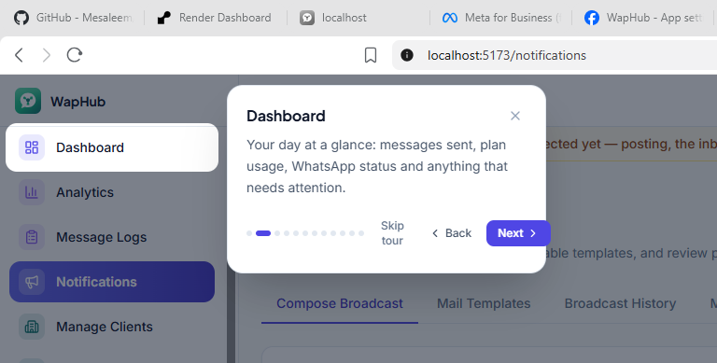
The yellow banner at the top disappears once a Page / Ad Account is bound.

4.3 Reconnect when
- the status shows Expired or Revoked (Facebook password changed, access removed, ~60-day token ended),
- the Super Admin enabled a new permission group (e.g. Posts & reels),
- you want to add another Page or Ad Account.
Just click Connect Meta Account again — the existing data stays.

Part 5 — Agent connects for a sub-client
- Login as the agent. In the top bar, open the client selector (“All Clients (Global View)”) and choose the client.
- Open Social Accounts → Connect Meta Account — everything you connect now belongs to that client, not to you.
- Log in with a Facebook ID that has access to the client’s Page / Ad Account. Two ways:
- a) Best: the client clicks Connect themself (Part 4) — use their own login.
- b) Agency way: the client adds your business as a Partner in their Business Settings (Pages + Ad Account), then you connect with your own Facebook ID.
- Tick the client’s Page / Instagram / Ad Account → Connect.
Super Admin: the Super Admin does the same through the client selector for any client.

Part 6 — Using it
Want to… | Go to | How
Post a photo / video / carousel / Story / Reel on Facebook and Instagram | Meta Ads Launcher → Organic Post | Pick Page/Instagram, format (post, reel, story, carousel), media, text → Publish now or Schedule. Reels/Stories look best in vertical 9:16.
Run a paid ad | Meta Ads Launcher → Paid Meta Ad Campaign | Objective, budget, audience, image, text, button. For Lead generation pick an Instant form. Ads start paused/active as you choose; spend is billed by Meta to the client’s ad account.
See ad results | Ads Dashboard | Spend, results, cost per lead; automatic rules (e.g. pause when CPL too high).
Get leads from Facebook lead forms | Instant Lead CRM | Leads arrive by webhook within seconds; can auto-send a WhatsApp welcome and create a CRM lead.
Reply to Messenger / Instagram DMs | Social Inbox | Needs the Messenger & Instagram messages permission group.
Auto-reply to comments | Comment Rules | Keyword → public reply and/or private DM.
Post and page insights | Social Analytics / Social Reports | Reach, engagement, best posts.

Part 7 — Troubleshooting
Message you see | Why | Fix
App not active | App in Development mode and this Facebook ID has no app role. | Add the ID as Tester (2.9) or finish App Review and go Live (2.7).
Feature unavailable — Facebook Login is currently unavailable for this app | App is Live but permissions lack Advanced Access, or Required actions / Business verification pending. | Tester role for testing (2.9); App Review + verification for everyone (2.7); clear Required actions.
Invalid Scopes: … | WapHub asked for a permission whose use case is not on the Meta app. | Add the use case (2.3) and “+ Add” each permission inside it (2.3.1), or untick that group in Social Gateway Settings.
Page connects, but Social Inbox / Organic Post / Meta Ads then show “Access revoked” | Meta refused that feature because its permission is not added on the app or not granted (Graph error 10 / 200). WapHub versions before 2026-10-15 then marked the whole Page revoked. | Add the permission (2.3.1), tick its group (Part 3), reconnect and press Check. From 2026-10-15 WapHub shows “Permission missing” and keeps the Page connected.
URL blocked / redirect_uri is not whitelisted | Redirect URI in WapHub ≠ Valid OAuth Redirect URIs in Meta. | Make both identical (2.4 and Part 3).
Invalid or tampered authorization state | Login started on one server (e.g. localhost) but Facebook returned to another (live). | Test on the server the Redirect URI points to.
The connection finished. Nothing was connected. | Popup closed early, or no Page / account was selected in Facebook’s dialog. | Connect again and select the Page / Instagram / Ad Account.
Instagram account not listed | Instagram is personal, or not linked to the Page, or Instagram group not enabled. | Switch to Professional, link to the Page, enable Instagram account access, reconnect.
Leads not arriving | Webhook not verified / APP_URL is localhost / leads_retrieval not granted. | Fix Webhooks (2.5), enable Lead Ads group, reconnect, then use Meta’s Lead Ads Testing Tool.
Ad launch fails: permission error | Token connected before ads_management was granted, or no access to the ad account. | Reconnect; check ad account access and payment method in Meta.
Status: Expired / Revoked | Token ended or the user removed access in Facebook. | Connect Meta Account again.

Checklist
☐ Business portfolio created and verified
☐ App domains + Category filled; Required actions all done
☐ Use cases added (2.3)
☐ Every permission inside each use case shows “Ready for testing” (2.3.1)
☐ Valid OAuth Redirect URI = WapHub Redirect URI
☐ Webhooks verified (Page + Instagram fields)
☐ Testers added for your own IDs
☐ App Review: Advanced Access for every permission used
☐ Social Gateway Settings saved, groups ticked to match Meta
☐ Backend APP_URL = public https address
☐ Client plan includes Social (and Ads)
☐ Client connected and Page / Instagram / Ad Account bound

