PROJECT DOCUMENTATION & CASE STUDY
Crestway
Car Rental Website — WordPress

Business model, client requirements, system workflows and a full case study of the design and development of a direct-booking car rental website.
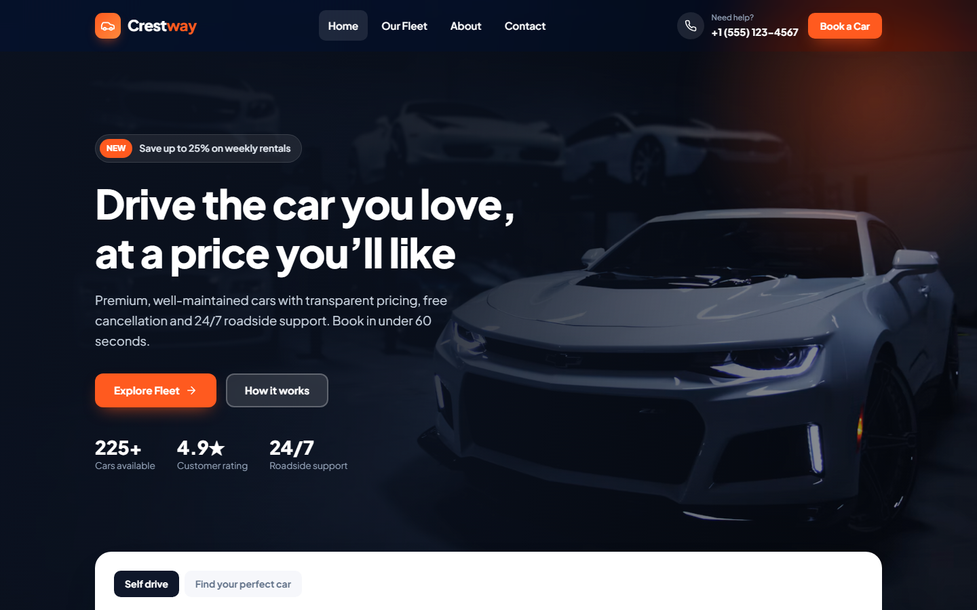
Crestway homepage — hero section with direct booking call-to-action

Prepared by | Mesam Abbas — WordPress Developer
Date | November 2026
Source code | github.com/Mesamabbas22/Crestway

SECTION 1

Project Overview
Crestway is a car rental business that needed a modern website where customers can browse the fleet, compare cars and send a booking request online, and where staff can manage cars and bookings without technical help. The project delivered a custom WordPress theme built from scratch: no page builder and no paid plugins.

Client | Crestway Car Rental
Industry | Car rental / mobility
Engagement | Portfolio project based on a realistic client brief
Deliverable | Custom WordPress theme with booking management
My role | UI/UX design, front-end and WordPress (PHP) development, testing, deployment
Timeline | 4 weeks (Discovery → Launch)
Tech stack | WordPress, PHP 7.4+, vanilla JavaScript, CSS Grid/Flexbox, Customizer API

At a glance
Pages | Core features | Admin tools
Home, Fleet, Car type archives, Car details, About, Contact, 404 | Search, filters and sorting, live price calculator, booking requests, contact form | Fleet manager, Bookings with statuses, Customizer settings, one-click demo content

SECTION 2

Business Model
Crestway rents vehicles by the day to individuals and businesses from several city pickup points. Before the project, most bookings came by phone or through third-party booking aggregators, which take a commission on every rental. The website’s job is to move customers to direct online booking, which earns a higher margin.

Business Model Canvas
Building block | Crestway
Customer segments | Tourists and business travellers arriving by air or rail; local residents needing a temporary car; families on holiday; corporate clients with recurring needs; enthusiasts renting sports and luxury cars for special occasions.
Value proposition | Well-maintained cars across six categories, transparent all-in pricing, free cancellation up to 24 hours, flexible pickup points, 24/7 roadside assistance and booking in under a minute.
Channels | Direct website (primary goal), phone and WhatsApp, Google Search and Maps, social media, aggregator listings (secondary).
Customer relationships | Self-service online booking, email confirmation, human support line, repeat-customer and corporate accounts.
Revenue streams | Daily rental fees; add-ons charged per day (full insurance, GPS, child seat, additional driver); long-term and corporate rentals; premium pricing on luxury and sports cars.
Key resources | Vehicle fleet, pickup locations, booking website, support staff, maintenance partners.
Key activities | Fleet acquisition and maintenance, booking handling and confirmation, vehicle handover and inspection, marketing.
Key partners | Insurance provider, vehicle dealers and leasing companies, maintenance workshops, airports and railway parking operators.
Cost structure | Fleet financing and depreciation, insurance, maintenance and cleaning, staff, location rent, marketing, aggregator commissions (to be reduced).

How the website makes money
- Commission savings — every booking made on the website instead of through an aggregator keeps the full rental fee.
- Add-on upsell — extras are offered at the moment of booking with live price updates, which raises average booking value.
- Lead capture — every booking request and contact message collects name, email and phone, building a customer list for repeat business.
- Brand trust — a professional site with clear policies and pricing converts visitors who would otherwise compare on aggregators.

Pricing logic
Total = (daily rate + selected extras per day) × number of rental days. The total is shown live to the customer and recalculated on the server when the booking is submitted, so prices cannot be manipulated in the browser.

SECTION 3

Client Requirements

Background & problem
- Phone-only booking — staff spent hours on calls answering availability and price questions.
- Aggregator dependency — a large share of bookings came through third-party platforms that charge commission.
- Outdated web presence — no fleet catalogue, no pricing, and a poor experience on mobile, where most visitors browse.
- No booking records — requests were tracked in notebooks and chat apps, so bookings were sometimes missed.

Project goals
- Let customers find a suitable car and request a booking online in under a minute.
- Show transparent, all-in pricing with optional extras before the customer commits.
- Give staff one place to manage the fleet and track every booking from request to completion.
- Look premium and trustworthy, and work perfectly on mobile phones.
- Allow the owner to update content (cars, prices, contact details) without a developer.

Functional requirements
ID | Requirement | Priority | Status
FR-01 | Fleet catalogue with photo, price per day and key specs for each car | Must | Delivered
FR-02 | Car categories (SUV, Sedan, Luxury, Electric, Sports, Hatchback) with their own pages | Must | Delivered
FR-03 | Homepage search by pickup location, dates and car type | Must | Delivered
FR-04 | Fleet filters (type, max price, transmission, fuel, seats) and sorting | Must | Delivered
FR-05 | Car details page with specs, features list and rental policies | Must | Delivered
FR-06 | Booking request form with dates, location, extras and customer details | Must | Delivered
FR-07 | Live price summary that updates when dates or extras change | Must | Delivered
FR-08 | Bookings saved in the admin with statuses: Pending, Confirmed, Completed, Cancelled | Must | Delivered
FR-09 | Email notification to the business and confirmation email to the customer | Should | Delivered
FR-10 | Contact page with a message form and business details | Must | Delivered
FR-11 | Editable settings: phone, email, address, hours, currency, locations, hero text | Should | Delivered
FR-12 | Testimonials, FAQ and "How it works" sections to build trust | Should | Delivered

Non-functional requirements
Area | Requirement
Responsive | Mobile-first layout that works from 360px phones to large desktops, with no horizontal scrolling.
Performance | Lightweight theme: no page builder, no jQuery, lazy-loaded images, a single stylesheet and a single script.
Security | Nonce-protected forms, sanitised input, escaped output, a honeypot against spam bots, and server-side price calculation.
Usability | Clear calls to action, at most three steps to book, and readable typography with strong contrast.
Accessibility | Skip link, form labels, keyboard focus styles, and reduced-motion support.
Maintainability | Standard WordPress APIs, organised code, and no paid plugin dependencies.

Out of scope (Phase 2)
- Online card payments and deposits
- Real-time availability calendar that blocks double bookings
- Customer accounts and booking history
- Multi-language support and WhatsApp/SMS notifications

SECTION 4

Workflows

4.1 Customer booking workflow
Step | Customer action | What the system does
1 | Lands on the homepage and enters location, dates and car type | Sends the search to the Fleet page with filters applied
2 | Browses results, refines with filters or sorts by price or rating | Updates the list; dates and location are carried into every car link
3 | Opens a car to view photos, specs, features and policies | Pre-fills the booking form with the chosen dates and location
4 | Adjusts dates and selects extras | Recalculates days, extras and total instantly in the price summary
5 | Enters name, email and phone, then submits the request | Validates input and dates, recalculates the price, saves the booking as Pending
6 | Sees a success message with a booking reference (e.g. CW-00021) | Emails the business and sends a confirmation email to the customer

4.2 Staff booking management workflow
- New request — the booking appears under Fleet → Bookings with status Pending and an email alert is sent.
- Verify — staff check car availability and call or email the customer if needed.
- Confirm — status changes to Confirmed and the customer is informed.
- Handover — at pickup, staff check the licence and ID and hand over the keys.
- Close — after return and inspection, the status changes to Completed. If plans change, it is set to Cancelled.

Status | Meaning | Next possible status
Pending | Request received, not yet confirmed | Confirmed, Cancelled
Confirmed | Car reserved for the customer | Completed, Cancelled
Completed | Car returned and rental closed | —
Cancelled | Customer or business cancelled | —

4.3 Project delivery workflow
Phase | Duration | Activities | Deliverables
Discovery | 3 days | Client interview, competitor review, goals and requirements | Requirements list, sitemap
UX & wireframes | 4 days | User flows for booking, page layouts, content plan | Wireframes, booking flow
UI design | 5 days | Brand colours, typography, components, responsive layouts | Design system, page designs
Development | 8 days | Custom theme, post types, filters, booking system, admin tools | Working WordPress theme
Testing | 3 days | Functional, form-validation, mobile and cross-browser testing | Bug fixes, test report
Launch & handover | 2 days | Deployment, demo content, admin training | Live site, documentation

SECTION 5

Case Study
From phone calls to one-minute online bookings

The challenge
Crestway’s customers were ready to book, but the business made it hard for them. There was no way to see prices or compare cars online, so visitors either called during office hours or booked through an aggregator, which cost Crestway a commission. Staff had no central record of bookings, so requests were sometimes missed. The brief was to build a website that turns visitors into direct bookings and gives staff a simple way to manage them.

My approach
- Map the customer journey — I reduced booking to three steps (choose car → pick dates → send request) and removed anything that did not help a visitor decide.
- Design for trust — I put transparent pricing, policies, insurance and support messages exactly where hesitation happens: next to the price and the booking button.
- Mobile first — most rental searches happen on phones, so every layout was designed for small screens first and then expanded.
- Keep it owner-friendly — I used native WordPress screens so staff can add cars, change prices and manage bookings without training on a page builder.

The solution

1. Search-first homepage
A bold hero section with a clear value proposition and a search card overlapping it, so the main action is visible straight away. Below it are car categories, popular cars, a three-step explainer, reasons to choose Crestway, stats, testimonials, FAQ and a final call to action.
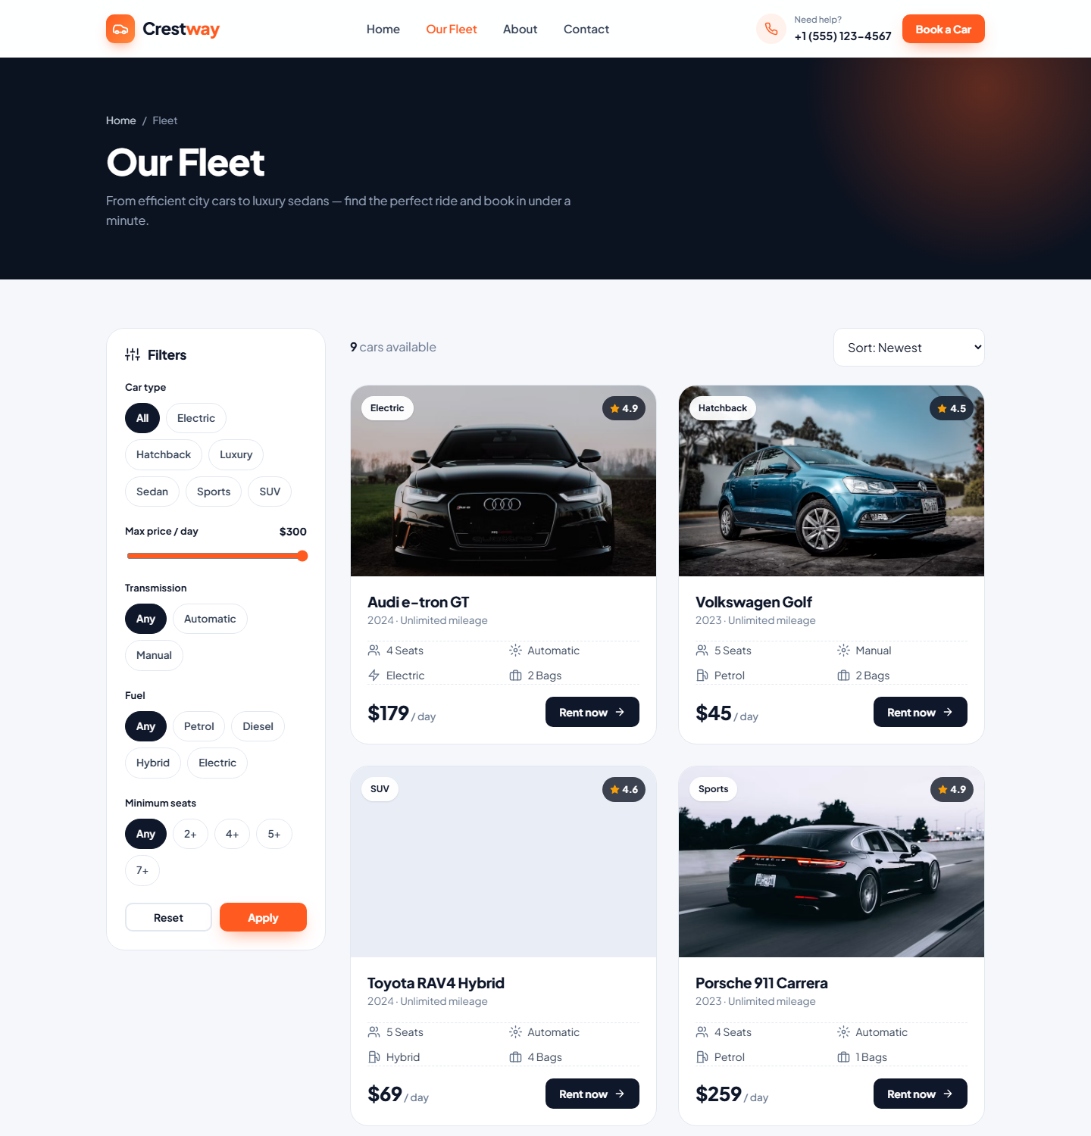
Fleet page — filters sidebar, sorting and car cards with key specs and price

2. Filterable fleet
Customers can narrow the fleet by type, maximum daily price, transmission, fuel and seats, and sort by price or rating. Each card shows the information people compare first: seats, gearbox, fuel, luggage and price per day.

3. Car details with live pricing
The booking card stays visible while the customer scrolls. Changing dates or ticking extras updates the price summary instantly, so there are no surprises. On submit, the server checks the details again, recalculates the total, saves the booking and sends confirmation emails.
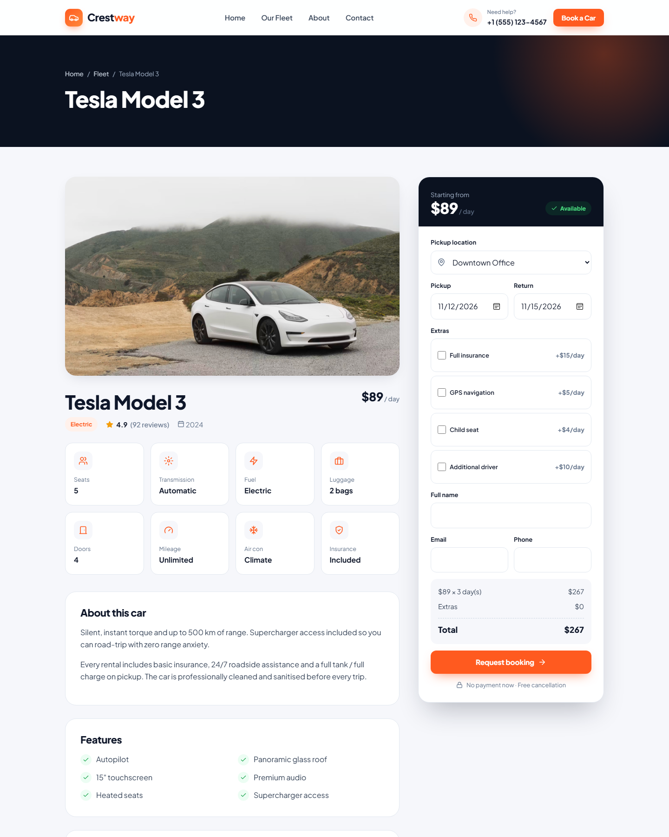
Car details page — specs, features and booking card with live price summary

4. Admin booking management
Bookings appear in the WordPress dashboard with car, dates, total and a colour-coded status. Staff open a booking to see the full details and change its status. Cars are managed through a simple form with fields for price, specs, features and a "show on homepage" option.

Design system
Element | Decision | Why
Primary colour | Orange #FF5A1F | Energetic and action-oriented; used only for calls to action so they stand out
Base colours | Deep navy #0B1220, slate greys, off-white background | Premium, calm contrast that makes car photos the hero
Typography | Plus Jakarta Sans (400–800) | Modern geometric sans; strong bold weights for prices and headings
Components | Rounded cards (16–24px), pill badges, chips, icon set | Friendly and consistent; one component library used on every page
Motion | Subtle hover lift, scroll reveal, animated counters | Feels polished without slowing the site; switched off for reduced-motion users

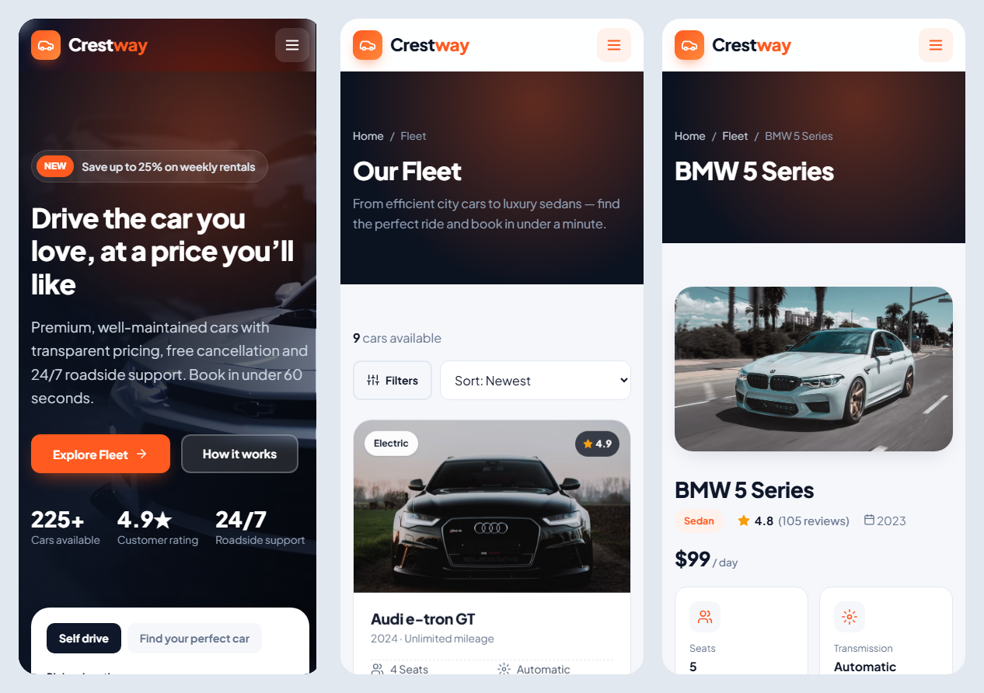
Mobile views — homepage, fleet and car details at 390px width

Technical highlights
- Custom post types — Car and Booking, plus a Car Type taxonomy with its own URLs (/cars/type/suv/).
- Query filtering — filters and sorting run through WordPress’s own query system (pre_get_posts), so pagination keeps working with any filter combination.
- Secure forms — nonces, sanitisation, escaping, a honeypot field, date validation and server-side price recalculation.
- Zero-dependency front end — vanilla JavaScript for the menu, filters, date rules, price calculator and animations.
- One-click setup — activating the theme creates demo cars, categories, pages and the menu, so the site is ready to present.

Testing
Test | Result
All pages load without PHP errors (Home, Fleet, Car types, Car details, About, Contact, 404) | Passed
Filters and sorting return the correct cars | Passed
Booking saved with correct total: $89 + $5 + $15 per day × 3 days = $327 | Passed
Return date before pickup date is rejected with a clear message | Passed
Responsive layout at 390px mobile and 1440px desktop, no horizontal scroll | Passed

Outcome
Crestway now has a complete direct-booking channel: customers can find a car, see the full price and request a booking at any hour, and staff manage every request from a single dashboard instead of calls and notebooks.

Success metrics to track after launch
Metric | Why it matters
Share of bookings made directly on the website | Measures the reduction in aggregator commissions
Visitor-to-booking conversion rate | Shows how well the booking flow turns interest into requests
Average booking value | Shows the impact of offering extras during booking
Phone enquiries about price and availability | Should fall as information moves online
Booking requests from mobile devices | Confirms the value of the mobile-first design

Next steps (Phase 2)
- Online payments and deposits (Stripe or a local payment gateway)
- Availability calendar to prevent double bookings
- Customer accounts with booking history and faster repeat bookings
- WhatsApp and SMS booking notifications
- Multi-language support and local currency

Links
Source code: github.com/Mesamabbas22/Crestway — Designed & developed by Mesam Abbas.

