**APPJ Startup/Shutdown Procedure**

Mesbah Lab 2021

Last Updated: February 14, 2021

WARNING: The APPJ setup involves **high voltage** equipment! Use caution during operation, and DO NOT touch/reach into any part of the setup within the PVC cage!!

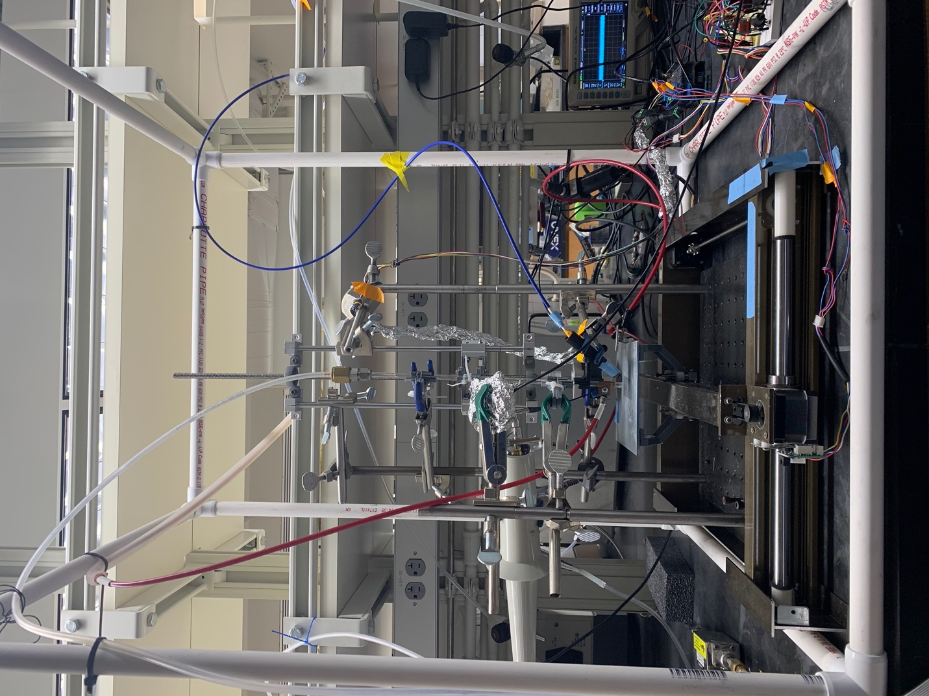

**STARTUP:**

1. Open Gas Flow (see Figure 1 for Helium tank setup):
   1. Ensure **regulator** (large red knob in center) is decreased fully.
   2. Open **tank valve** on the top of the He gas tank. The **gauge on the right** should indicate some pressure.
   3. Increase the **regulator** (turn clockwise) until the **left gauge** shows an appropriate amount of pressure (enough to get up to 3-5 slm).
   4. Open the **line valve** on the left (turn parallel to gas line)

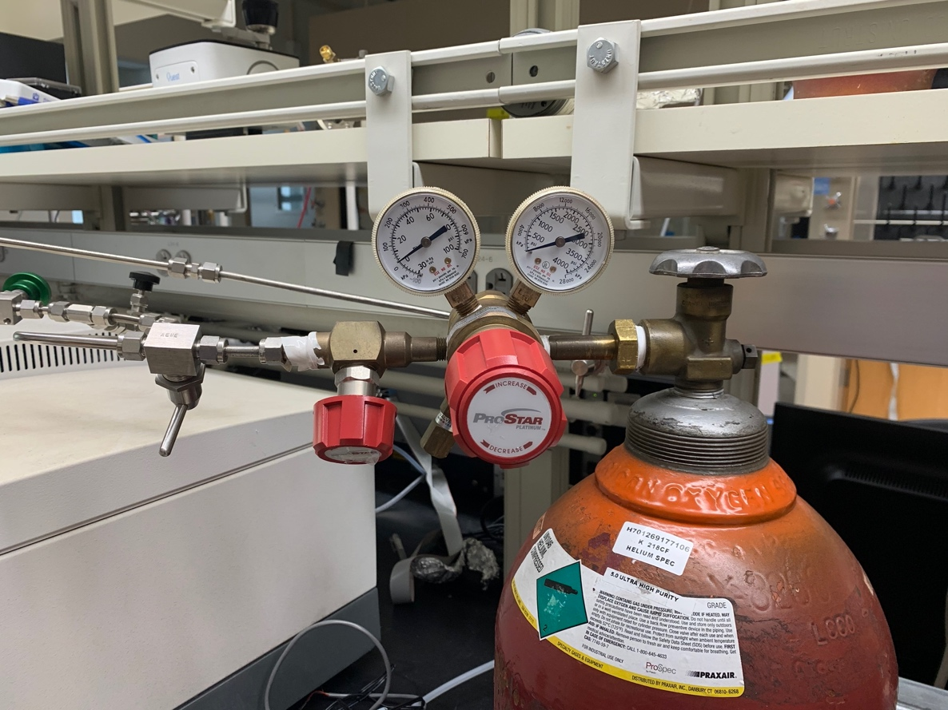

**Line Valve**

**Regulator**

**Tank Valve**

Figure 1: Helium Tank Setup

1. Turn on Amplifier for Frequency Generator (See Figure 2 for Amplifier startup):
   1. Flip the **power switch** to turn on power.
   2. Pull **gray knob** to unlock high voltage lock.
   3. Push **white button** to turn on high voltage. HV ON indicator light should light up green.

**CAUTION: Once this is powered on, do NOT touch anything in the setup!!! Risk of high voltage delivered to body!**

Figure 2: Amplifier Power Switches

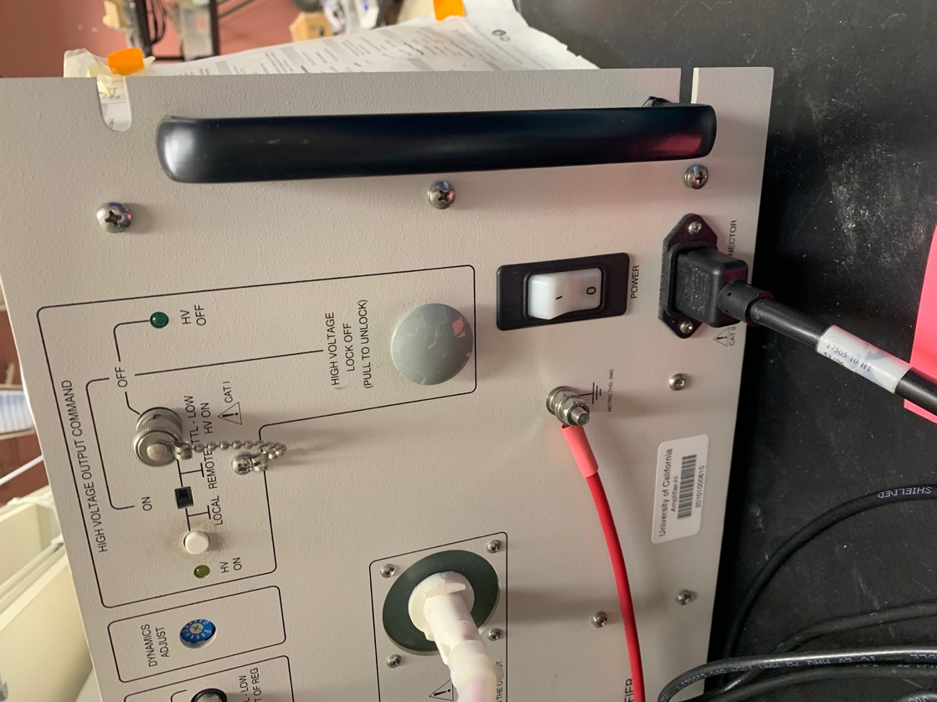

**Power Switch**

**High Voltage Lock**

**HV Local ON Button**

1. Connect Computer to setup:
   1. Locate the USB Hub.
   2. Connect to computer.
2. Startup APPJ by EITHER:
   1. Running Python script: APPJstartup.py provided in APPJ-MacOS-Communication (ensure required dependencies/libraries for Python are installed with pip)
   2. Connecting to the Arduino directly using the following commands in the Terminal:
      1. This line starts/connects the Arduino to the computer and reads the status of the connection:  
         $ stty -f /dev/cu.usbmodem1434401 raw 38400 -hupcl & cat /dev/cu.usbmodem1434401  
         Ensure the `usbmodem1434401` device number is consistent with what is read by your computer. If you have the Arduino app installed on your computer, this can be checked by going to Tools > Port, and looking at the Arduino device number.
      2. Then, the following commands can be used to ignite the plasma:
         1. This command sets the **duty to 100**:  
            $echo "p,100" > /dev/cu.usbmodem1434401
         2. This command sets the **power to 2**:  
            $echo "w,2" > /dev/cu.usbmodem1434401
         3. This command sets the **flow rate to 1.5**:  
            $echo "q,1.5" > /dev/cu.usbmodem1434401
      3. Once started, the same commands can be used to adjust those parameters (duty, power, flow rate). Just change the numerical value in the quotes.

**SHUTDOWN:**

1. Push the reset button on the Arduino to reset all parameters.
2. Turn off Amplifier (see Figure 2):
   1. Flip the **power switch** to the off position.
   2. Push the **gray knob** to lock.
3. Turn off Gas (see Figure 1):
   1. Close **tank valve** on the top of the tank.
   2. Go to setup. On the manual flow controller (see Figure 3), flip the **switch** to ‘Purge’ to purge the remaining gas in setup.
   3. Decrease the **regulator** fully (turn counterclockwise).
   4. Close **line valve** (turn perpendicular to gas line).

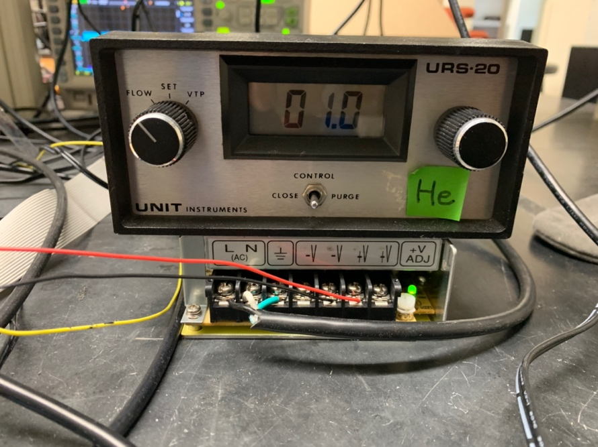

Figure : Manual Flow Controller