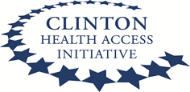

BASIC OXYGEN THERAPY TRAINING FOR HEALTH PROFESSIONALS

ORGANIZED BY: -CLINTON HEALTH ACCESS INITIATIVE (CHAI)