**Homework 2**

|  |  |  |
| --- | --- | --- |
| **Yash Bansod** | **116776547** | **ENSE 622** |

1. **Problem 1 (50 points):**

A natural gas processing plant can produce two grades of gas: Regular and Premium. The production of these grades of gas involve availability and time constraints shown in the table below - note that only one type of gas can be produced at a time.

|  |  |  |  |
| --- | --- | --- | --- |
| **Resource** | **Regular** | **Premium** | **Total Available** |
| Feed gas required | 7 m3/kg | 11 m3/kg | 77 m3/s |
| Production time | 10 h/kg | 8 h/kg | 80 h/kg |
| Max feed rates | 9 kg/s | 6 kg/s |  |
| Profit | 150 cents/kg | 175 cents/kg |  |

1. (10) Write the optimization problem in standard form.
2. (30) Develop a graphical (essentially a hand-calculated) solution that optimizes this problem, where X1 and X2 are the flow rates of Regular and Premium gas, respectively, in kg/s.
3. (10) State the solution.

**Solution 1.**

I defined the optimization problem in the standard form based on my interpretation of the data. Please consider the solution to problem 2 as my formal submission for part A of the assignment.

**a.**

Let X1 and X2 be the flow rates of Regular and Premium gas, respectively, in kg/s.

Let Z be the overall profit made by the processing plant.

Therefore, the task is to maximize the following objective function:

Such that:

(Feed gas constraint)

(Production time constraint)

(Feed rate constraint 1)

(Feed rate constraint 2)

(Optional positive integer value constraint)

**b.**

or

or

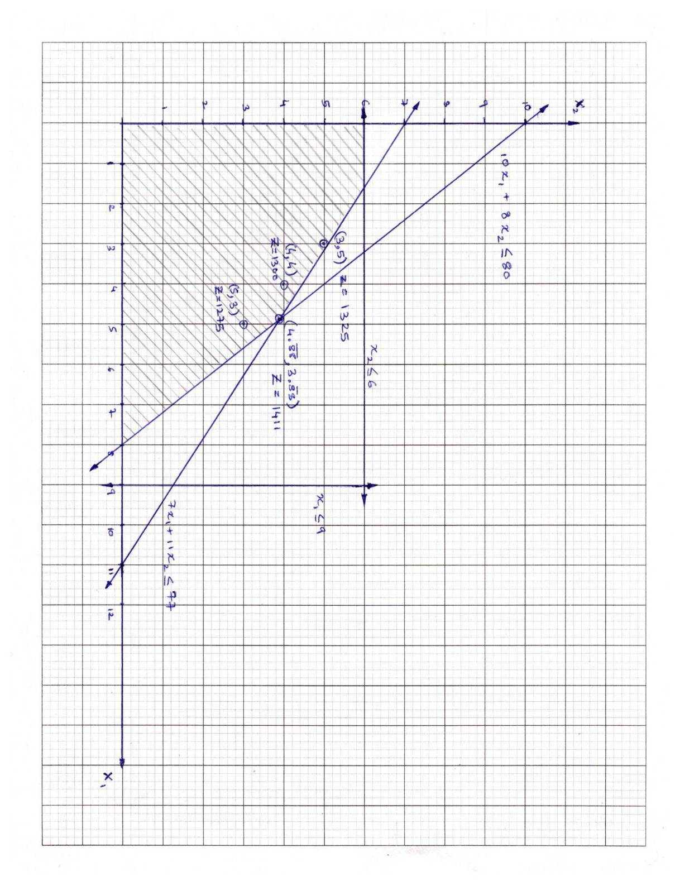

**c.**

**Linear Solution:**

**Integer Solution:**

Please find the attached file named: **ENSE622_HW2_Q1_Yash_Bansod.m**

1. **Problem 2 (50 points):**

Consider the following linear optimization model.

1. (10) Write the optimization problem in standard form with the consideration of slack variables.
2. (30) Solve the problem using simplex tableau method.
3. (10) State the optimal solution for all variables.

**Solution 2:**

Such that:



Re-writing the objective function for the simplex tableau method:

|  |  |  |  |  |  |  |
| --- | --- | --- | --- | --- | --- | --- |
| X1 | **X2** | X3 | S1 | S2 | Z | C |
| 3 | **4** | 1 | 1 | 0 | 0 | 2 |
| 1 | **3** | 2 | 0 | 1 | 0 | 1 |
| -3 | **-6** | -2 | 0 | 0 | 1 | 0 |

, ,

|  |  |  |  |  |  |  |
| --- | --- | --- | --- | --- | --- | --- |
| **X1** | X2 | X3 | S1 | S2 | Z | C |
| **1 2/3** | 0 | -1 2/3 | 1 | -1 1/3 | 0 | 2/3 |
| **1/3** | 1 | 2/3 | 0 | 1/3 | 0 | 1/3 |
| **-1** | 0 | 2 | 0 | 2 | 1 | 2 |

, ,

|  |  |  |  |  |  |  |
| --- | --- | --- | --- | --- | --- | --- |
| **X1** | **X2** | X3 | S1 | S2 | **Z** | **C** |
| **1** | **0** | -1 | 3/5 | - 4/5 | **0** | **2/5** |
| **0** | **1** | 1 | - 1/5 | 3/5 | **0** | **1/5** |
| **0** | **0** | 1 | 3/5 | 1 1/5 | **1** | **2 2/5** |

**c.**

, , , , ,

1. **Problem 3 (50 points):**

You own of a shop producing automobile trailers and wish to determine the best mix for your three products: flat-bed trailers, economy trailers and luxury trailers. The shop is limited to working 24 days/month on metalworking and 60 days/month on woodworking for these products. This table indicates production data for trailers.



1. (10) Write the optimization problem in standard form.
2. (20) Develop and submit your program/procedure to determine the optimal production and profit for the shop.
3. (20) Derive the **dual** and submit your program/procedure for the optimal production and profit for the shop.

**Solution 3.**

**a.**

Let X1, X2, and X3 be the number of units to be produced of flat-bed trailers, economy trailers and luxury trailers respectively.

Let Z be the overall profit made by the production shop (as multiple of $100).

Therefore, the task is to maximize the following objective function:

Such that:

(Metalworking constraint)

(Woodworking constraint)

(Positive real value constraint)

(Optional positive integer value constraint)

**b.**

Please find the attached file named: **ENSE622_HW2_Q3b_Yash_Bansod.m**

**c.**

Dual:

Let Y1 and Y2 be the value (shadow price) of metalworking and woodworking resources.

Let W be the minimum acceptable price for the resources (as multiple of $100).

Such that:

or (Resource value for flat-bed trailers)

or (Resource value for economy trailers)

or (Resource value for luxury trailers)

(Positive real value constraint)

Please find the attached file named: **ENSE622_HW2_Q3c_Yash_Bansod.m**