PASADA
Software Manual Guide
The complete guide to the franchise registry system for municipal tricycle operators


BEN JAMES J. DUAG
2026 Edition

About This Manual

This manual is the complete guide to PASADA. It explains what the system is, where its name comes from, how every page works, what every button does, and what to do when something goes wrong. It is written for the people who actually use the system: the clerks who keep the records and the admin who looks after the office.
You do not need computer training to follow this manual. Every chapter gives the steps in order, shows the real screen, and explains the choices in plain words. When a term first appears, it is explained right there and again in the glossary at the back.
Why the system is called PASADA
In Filipino street language, pasada is the word tricycle and jeepney drivers use for going out to work: driving their route, picking up passengers, and earning the day's living. One pasada is one working trip. When drivers cannot work, they say tigil pasada, the runs have stopped. The government's own fuel program for drivers is even called Pantawid Pasada, fuel support for the pasada.
That word carries the whole point of this system. Every record inside it is a real person's livelihood: the driver who leaves home each morning to carry passengers and bring income home to a family. PASADA keeps each of those livelihoods on file, so the office knows who holds each franchise, who renewed, who has not, and who deserves help getting back on the road. The system is named after their daily work out of respect for it.
Who this manual is for
- Clerks who add, edit, renew, and print operator records every day.
- The office admin who manages accounts, approves big changes, and keeps the system healthy.
- New staff learning the job, who need the whole picture in one place.
How to read the steps
Numbered steps mean do them in order. Pictures show the real screen so you can compare what you see with what this manual shows. Highlighted boxes hold advice and warnings:
TIP: Tips are optional. They make the work faster or safer, but you can skip them.
WARNING: Warnings matter. Read them before you click anything they describe.
Words used in this manual
Table 1. Vocabulary used throughout this manual.
Word | What it means in this manual
Record | One operator's franchise information: name, SBN, motor, plate, route, dates.
SBN | Franchise serial number, like BA-002-26. Identifies one slot.
TODA line / route | One group of operators, like BATODA or HCTODA.
Renewal | The yearly re-registration that keeps a franchise active.
Inactive / vacant | A slot with no operator, or not renewed for 2+ years.
Sync | Automatic sharing of records between office computers.
Approval ticket | A clerk's request for a big change. The admin approves it before anything happens.
Admin | The one account allowed to manage accounts, approve tickets, and change big settings.

Table of Contents

Table 2. Chapters in this manual.
Chapter | Title | What it covers
1 | Getting Started | Opening the program, signing in, the main screen, dark mode
2 | Accounts, Passwords, and Security | First account, security questions, recovery, roles
3 | The Dashboard | Totals, volume charts, compliance, route fullness
4 | Working with Records | Add, edit, renew, delete, restore, print, export
5 | Search and Activity History | Finding anything, and the record of every change
6 | Inactive Operators and Importing | The archive, and bringing records in from files
7 | Settings | Office details, preferences, PIN, backups, updates
8 | The Admin Console | Every admin tool explained: approvals, accounts, templates, health
9 | The Two-Key Rule | How approval tickets protect the registry
10 | Connecting Computers (Sync) | How office computers share one registry
11 | If You Are the Admin | What changes when you become admin, and what stays the same
12 | Troubleshooting | 14 common problems, each with exact fix steps
13 | Quick Reference Card | One page to print and keep beside the computer

Chapter 1 — Getting Started

What PASADA does
PASADA is the office's franchise registry. It replaces paper folders and scattered spreadsheets with one program that every computer in the office can use at the same time. It remembers all operators, warns about franchises that were not renewed, prints the certificates and summaries the office issues, and keeps a history of who changed what. Nothing leaves the office: the program works fully without internet.
Opening the program
1. Open PASADA from the desktop shortcut or the Start menu.
2. The PASADA logo appears while the program starts. This takes a few seconds.
3. The log-in screen appears with boxes for your full name and password.
4. The status at the bottom left of the sidebar says Online when the system is ready.
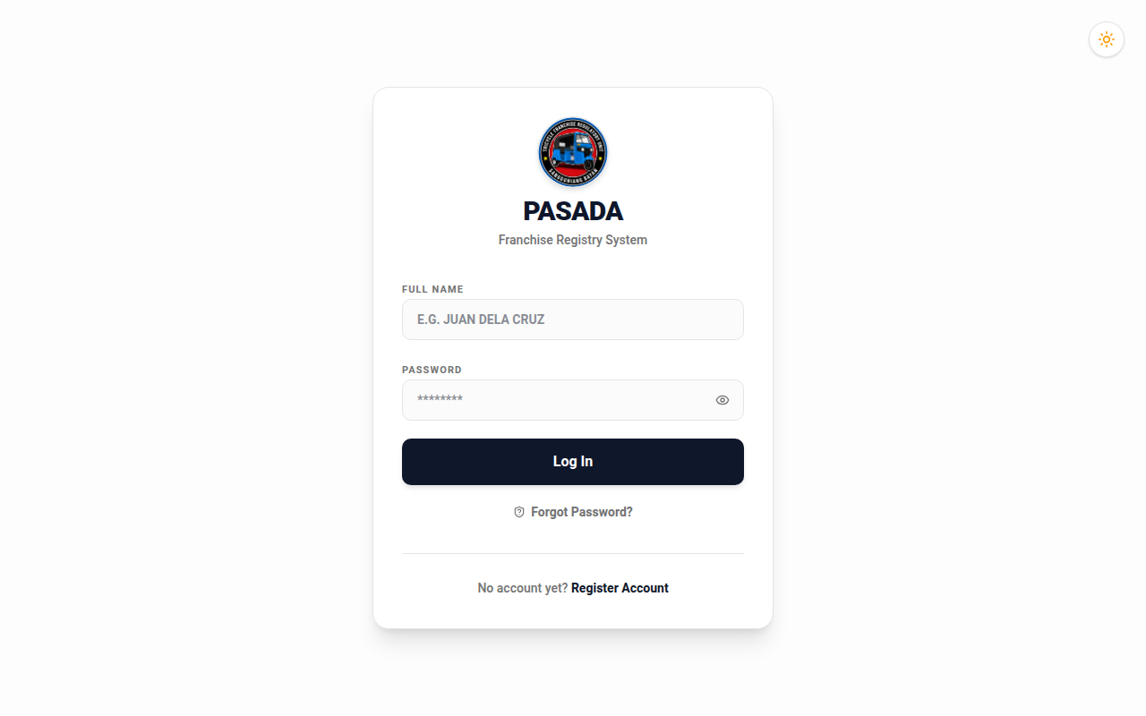
Figure 1. The log-in screen. Everything starts here.
Signing in
1. Type your full name exactly as it was registered, for example JUAN DELA CRUZ.
2. Type your password. Press the eye button to check what you typed.
3. Click Log In.
4. The dashboard opens and your name shows at the top of the sidebar.
WARNING: Five wrong password attempts lock the account for 15 minutes. This protects the records. Wait it out, or ask the admin to reset your password.
The main screen
Everything lives in one window. The left side is the sidebar. From top to bottom: the PASADA name and theme button, your name and role, five page links (Dashboard, Activity History, Import Records, Inactive Operators, Settings), the search box, the list of TODA lines, the connection status, and the Log out button. The right side shows the page you opened.
Light and dark mode
Click the sun or moon button at the top of the sidebar. The whole program switches between light and dark. PASADA remembers your choice on this computer, so the next person to sign in here sees your choice.
Logging out, and the quick PIN
Click Log out when you leave your desk. You can also set a 4-digit PIN in Settings. With a PIN set, stepping away locks the screen, and coming back asks for the PIN instead of your full password. Same protection, less typing.

Chapter 2 — Accounts, Passwords, and Security

The first account, and why registration closes
The very first time PASADA runs, the Register Account button appears on the log-in screen. One person creates the first account. Registration then closes for good. From then on, new accounts are created by the admin, inside the program. This is deliberate: an open registration would let anyone who touches the computer create an account on the office registry.
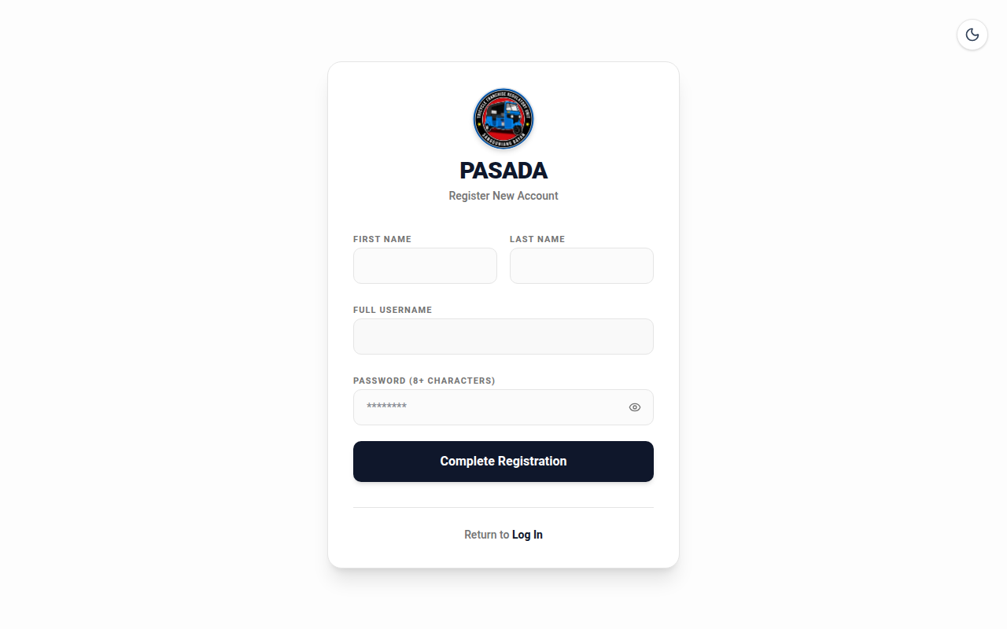
Figure 2. First-run registration. This door closes once an account exists.
Creating your account (first time only)
1. On the log-in screen, click Register Account.
2. Type your first name and last name. PASADA builds your username from them.
3. Type a password with at least 8 characters. Pick something you will remember but others cannot guess.
4. Click Complete Registration.
5. Sign in with your name and password.
Security questions: your spare key
PASADA asks three personal questions, for example your mother's maiden name or the street you grew up on. Answer them truthfully and remember the answers. They are your way back in if you ever forget your password. The answers are stored in secret form. Nobody, not even the admin, can read them. You can set or change your questions in Settings.
If you forget your password
1. On the log-in screen, click Forgot Password?
2. Type your full name. Your three questions appear.
3. Answer all three correctly.
4. Type a new password (8+ characters) and confirm it.
5. Sign in with the new password.
NOTE: The admin can also set a new password for you from the Admin Console. Your records are never lost because of a forgotten password.
The two roles: Clerk and Admin
Every account is a Clerk or an Admin. The difference is a short, clear list of extra powers, explained fully in Chapter 8:
Table 3. What each role can do. The full list of admin tools is in Chapter 8.
Work | Clerk | Admin
Add, edit, renew, delete records | Yes | Yes
Search, print, export | Yes | Yes
Import Excel files | Yes | Yes
File a request to delete/rename a route | Yes | Directly
Restore deleted records | File request | Approve or do directly
Create accounts, reset passwords | No | Yes
Upload document templates | No | Yes
Import or restore a database file | No | Yes
See system health and error notes | No | Yes

Chapter 3 — The Dashboard

The dashboard is the office at a glance. Open it any time from the sidebar. Everything updates on its own every few seconds.
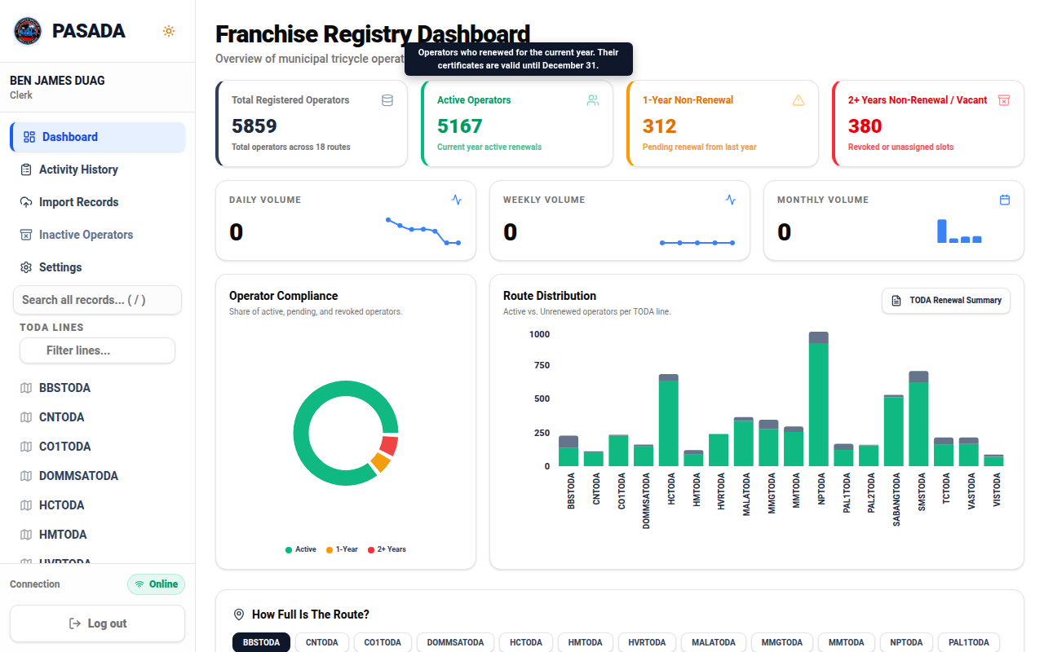
Figure 3. The dashboard: totals, volume charts, compliance ring, and route distribution.
The four totals
Table 4. The four numbers across the top of the dashboard.
Total | Meaning
Total Registered Operators | Every franchise slot in the registry, filled or vacant.
Active Operators | Operators who renewed for the current year. Certificates valid until December 31.
1-Year Non-Renewal | Did not renew last year. Keep the slot, must renew this year.
2+ Years Non-Renewal / Vacant | Empty slots, or franchises revoked after 2+ years. Can be reassigned.
Volume charts
Daily, weekly, and monthly volume count issuances and renewals recorded today, this week, and this month. The small line or bars beside each number show how the totals spread over recent days, weeks, or months. A quiet week shows immediately.
Operator Compliance ring
The ring shows the share of active, pending, and revoked operators. Green is healthy. A growing red slice means many slots need attention. Hover a slice to see its exact share.
Route Distribution bars
The bar chart compares active and unrenewed operators on every TODA line. Click TODA Renewal Summary to print the yearly summary document the office submits.
How Full Is The Route?
Below the charts, pick a TODA line. PASADA shows whether the route is full, the count of active operators, and a fullness score. The score compares active operators with the route's population and road length. Above 1.0 means the route carries more tricycles than its roads comfortably support. Three clustering scores below (Silhouette, Davies-Bouldin, Calinski-Harabasz) tell you how much to trust the estimate: at the values shipped, trust it. If better population or road data becomes available, correct the two boxes and click Save Route Info.

Chapter 4 — Working with Records

Opening a TODA line
1. Find the line in the sidebar under TODA LINES. Many lines? Use Filter lines to narrow the list.
2. Click the line name. The operator list opens.
3. Click the pin button beside a line to keep it at the top of your list.
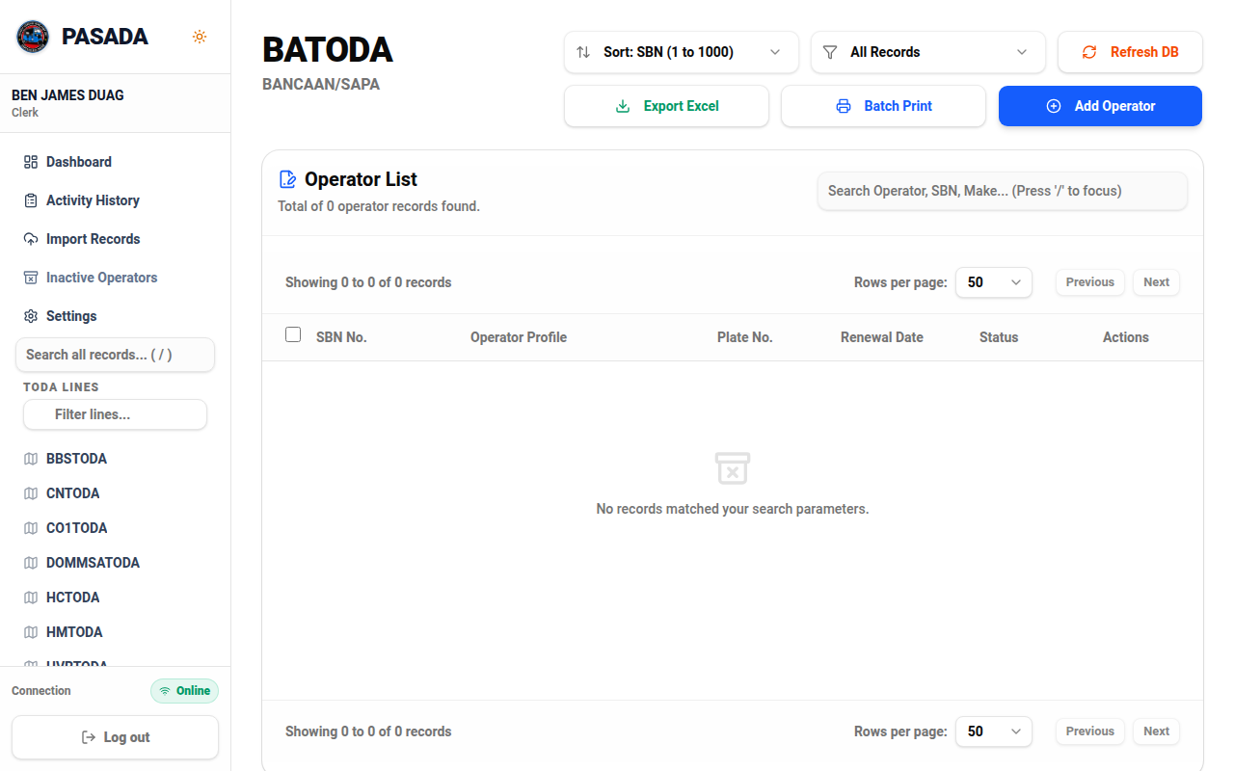
Figure 4. A TODA line: search, sort, export, batch print, and Add Operator.
Reading the list
Each row shows the SBN, the operator profile (name, address, make), the plate number, the renewal date, and a status chip. Green chip: Active, renewed this year. Amber chip: 1-Year, renewal pending. Red chip: 2+ Years, vacant or revoked. The search box on the page filters by operator, SBN, or make as you type. Sort controls order the list by SBN, name, or renewal date.
Every button on the list, top to bottom
Table 5. Controls on a TODA line page.
Control | What it does
Rename | Admin only. Changes the line's code name and can standardize every SBN prefix on it.
Sort: SBN | Orders rows by SBN ascending or descending.
All Records | Filter to Active only, 1-Year only, 2+ Years only, or everything.
Refresh DB | Re-reads the latest data immediately. Use if numbers look stale.
Export Excel | Downloads this line's records as an Excel file.
Batch Print | Merges certificates for all ticked rows into one printable PDF.
Add Operator | Opens the form to create a new record on this line.
Search Operator | Filters the visible rows as you type. Press / to jump here.
Rows per page | Shows 25, 50, or more rows per page.
Previous / Next | Moves between pages of the list.
Every icon on a row
Table 6. Row icons on every operator.
Icon | What it does
Eye | Opens the record view with print and download options.
Pencil | Opens the edit form. Saving changes here is a renewal when the issue date moves to this year.
Circular arrows | Change Motor: records a new motor number and updates the motor date.
Trash | Deletes the record. It is not destroyed: it moves to the deleted list and can be restored. Undo appears right after.
Adding an operator
1. Click Add Operator on the line's page.
2. Leave the SBN empty to get the next free number automatically, or type one to control it.
3. Fill in the operator's name, address, motor number, chassis number, make, and plate number.
4. Choose the issue date. Validity is computed automatically: December 31 of that year.
5. Click Save. The new row appears with a green Active chip.
Editing and renewing
Click the pencil icon. Change what needs changing. The rules the system applies are worth knowing: moving the issue date to the current year is a renewal and turns the chip green. Changing only the name is an edit, not a renewal. Changing the motor number also updates the motor date when the auto-date preference is on. Every save is written to the Activity History with your name, the old values, and the new values.
Deleting and restoring
The trash icon deletes one operator; tick checkboxes and use the delete-selected control for many at once. Deleted records are not destroyed. They move to the deleted list, and the Undo button that appears right after a delete brings records back immediately. Older deletions are restored by the admin (Chapter 9).
Printing certificates
- Eye icon: open the record, then download the MTOP certificate as Word or PDF.
- Printer icon on a row: download that record's certificate directly.
- Batch Print: tick several rows first, then merge many certificates into one PDF for the office printer.
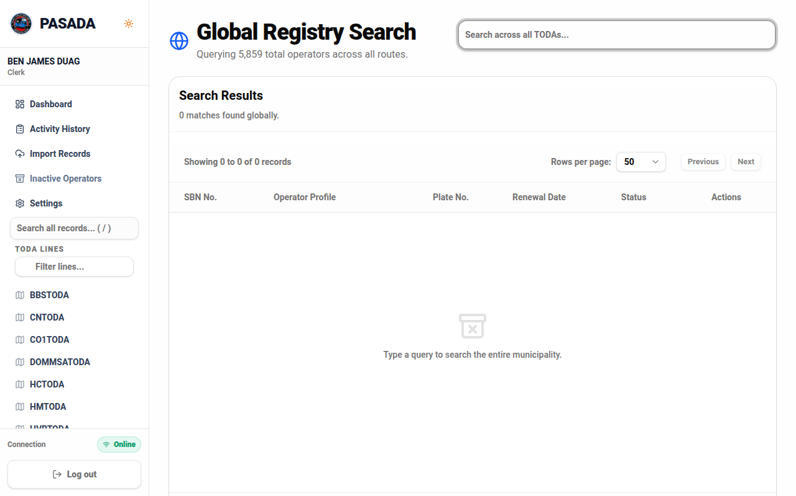
Figure 5. Search across every line at once. Press / on any page to jump here.
Exporting Excel
Export Excel on a line's page downloads that line. The Activity History page exports its own filtered logs as Excel. The dashboard prints the TODA Renewal Summary. Every export lands in the Activity History.

Chapter 5 — Search and Activity History

Searching everything
1. Press the / key on any page, or click the search box in the sidebar.
2. Type a name, an SBN, a plate number, or any word from an address.
3. Results appear grouped by TODA line. Click a result to open the record with full actions.
Activity History
The Activity History page lists every change made in PASADA: log-ins, edits, renewals, deletions, restorations, exports, prints, account changes, ticket approvals. Each line shows when it happened, who did it, the action, the record it touched, and the details including old and new values.
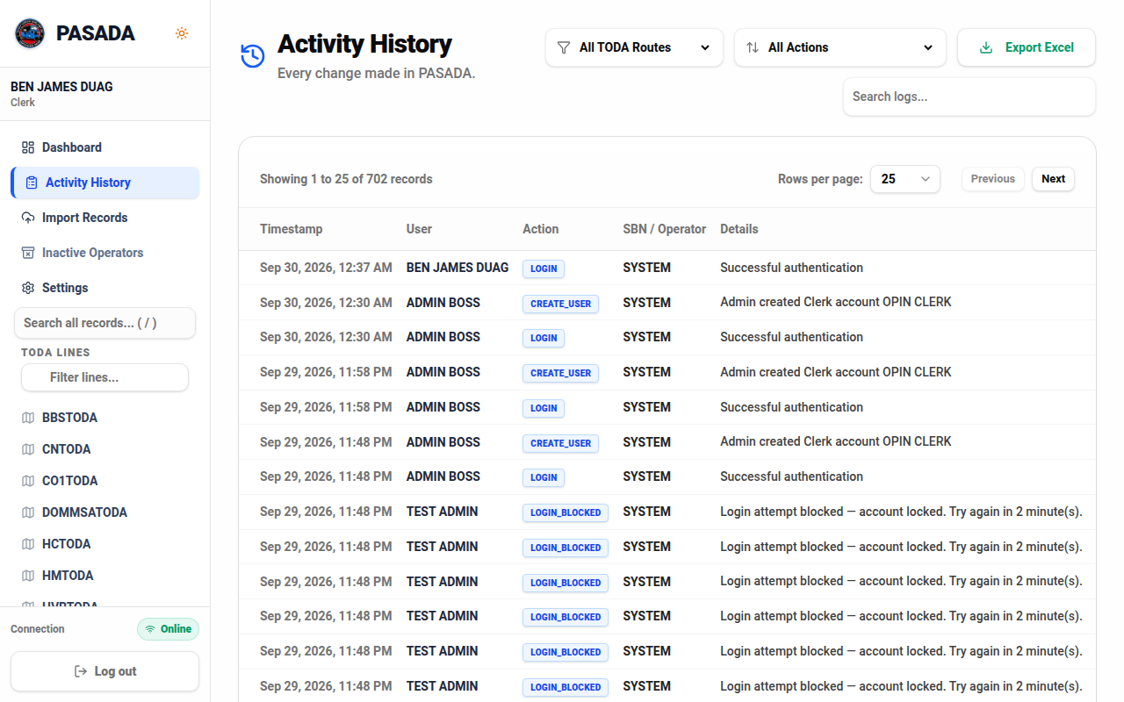
Figure 6. Activity History: the office's complete record of changes.
Filters
Table 7. Activity History filters. Offices export these for monthly reports.
Filter | Use it to
Route | Show one TODA line only. SYSTEM shows log-ins and technical events.
Action | Show one kind of event, for example RENEWAL, DELETE RECORD, or TICKET approval.
Search box | Find the events about one operator or SBN.
Rows per page | Show 25, 50, 100, or 250 entries per page.
Export Excel | Download every entry matching the filters, not just this page.

Chapter 6 — Inactive Operators and Importing

The Inactive Operators page
This page lists operators who have not renewed for two or more years, plus vacant slots. These franchises may be reassigned to new applicants under the office's rules. Each row shows the last known operator, the SBN, how long the slot has been idle, and the usual record actions, still printable for reference.
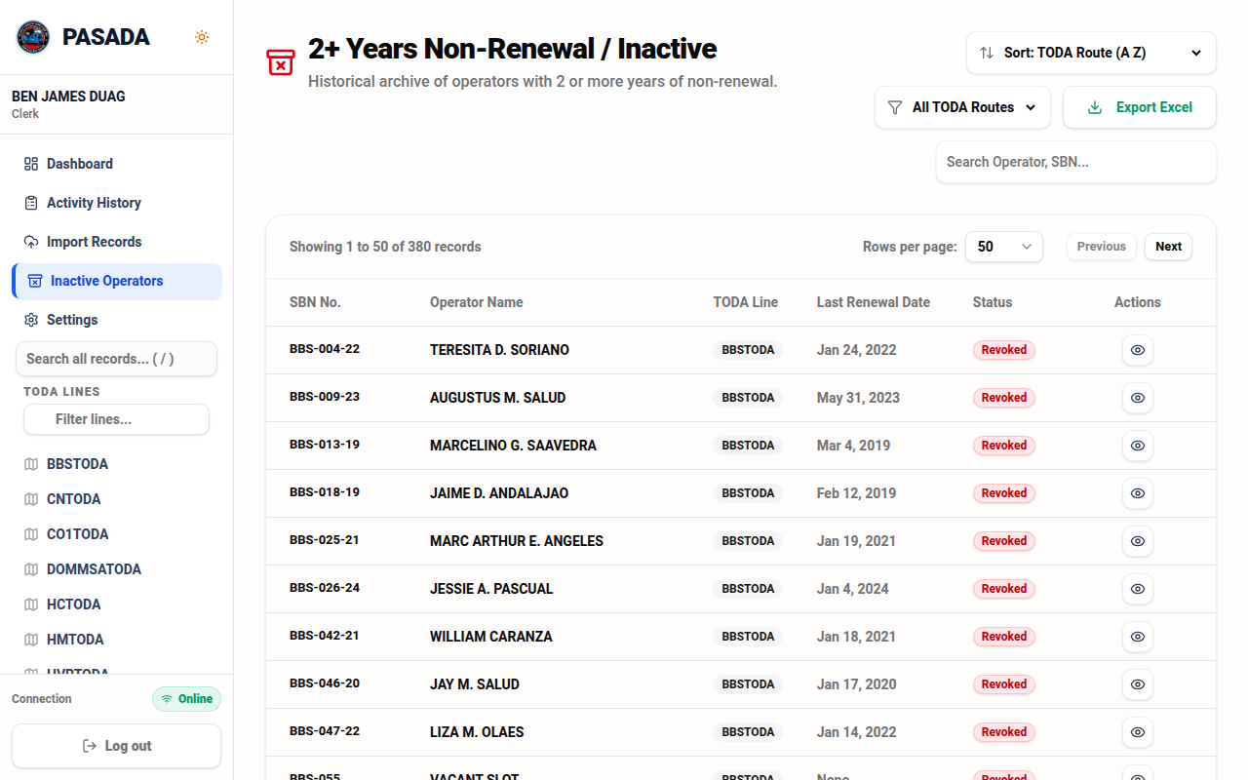
Figure 7. Inactive operators: candidates for reassignment.
Bringing records in from a file
1. Click Import Records in the sidebar.
2. Drop or choose the Excel or CSV file. A .db database backup is also accepted.
3. PASADA previews the file. Check that columns line up: name, SBN, route, dates.
4. For spreadsheets, choose whether to skip existing records or overwrite them.
5. Click Import. A summary reports rows added, updated, or skipped, and any row-level errors.
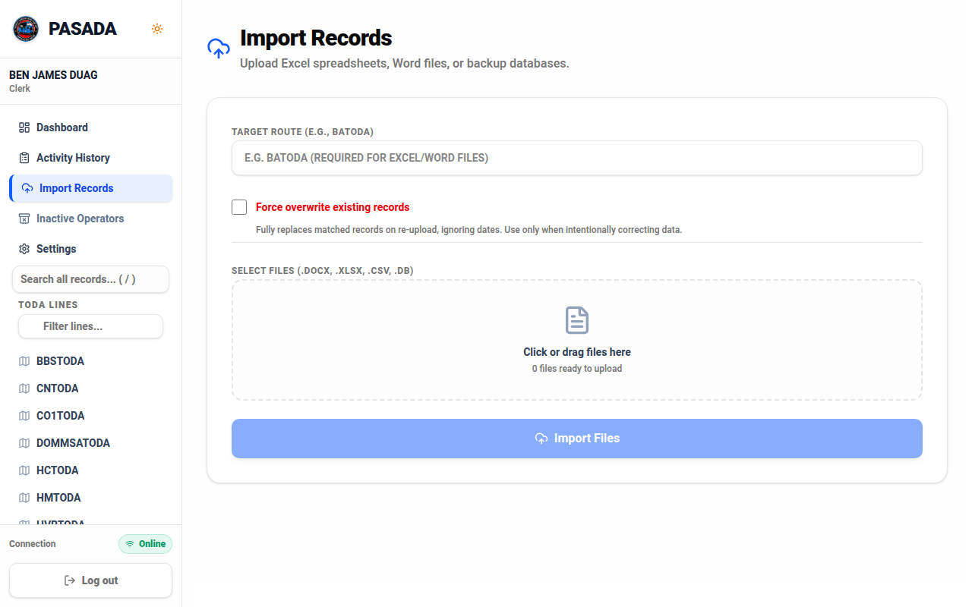
Figure 8. Import Records: pick the file, check the preview, confirm.
Importing a database backup file
When the chosen file is a .db backup, PASADA offers two choices. Merge new records only adds records that do not exist yet and leaves everything else alone. Full Restore replaces the current records with the backup's contents. Full Restore is admin-only: a clerk who selects it will be refused at the moment of upload, and the request must go through the admin.
WARNING: Full Restore overwrites matching records with the backup's values. Download a fresh backup first (Settings > Full Database Backup) so today's state can always be recovered.
After an import
Dashboard counts change, affected lines appear in the sidebar, and the import lands in the Activity History. Computers connected for sync receive the new records automatically.

Chapter 7 — Settings

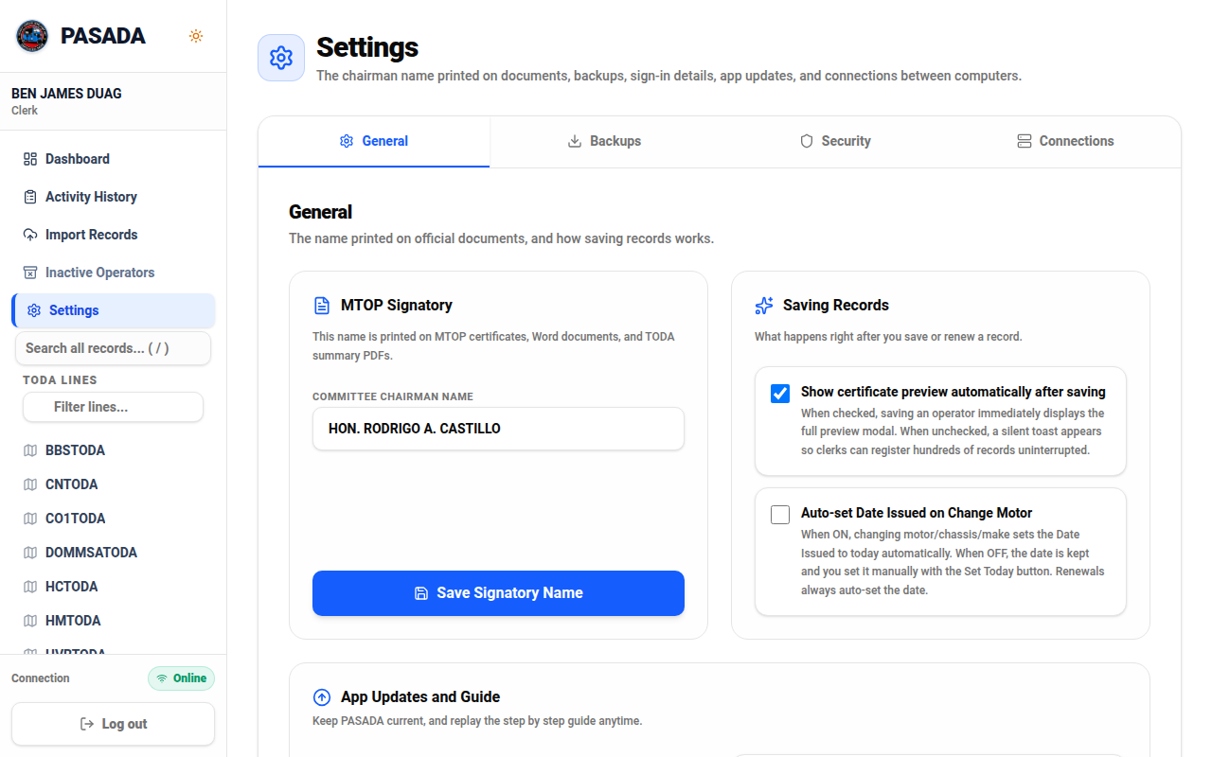
Figure 9. Settings: office details, preferences, security, backups, updates.
Office details
Set the committee chair and signatory names printed on certificates. These values fill the matching placeholders in the templates, so one change here corrects every future document.
Preferences
Table 8. Everyday preferences.
Preference | What it changes
Save preview | Shows a confirmation window before every save. Turn off for faster data entry.
Auto-date for Change Motor | Changing a motor number also updates the motor date automatically.
Security PIN
Set a 4-digit PIN. PASADA then locks the screen when you step away, and the PIN unlocks it without typing your full password. The PIN is stored only on this computer, in secret form, and the change is written to the Activity History.
Security: Manage Office Accounts (admin)
The admin creates accounts for new clerks here and resets forgotten passwords. Choose the account, type the new password, save. The new password works on every computer in the office. Creating an account and resetting a password both land in the Activity History.
Recovery questions
Set or change your three security questions here. Answer honestly; these are your spare key. Answers are stored in secret form and never leave this computer.
Full Database Backup
Download an exact copy of the whole registry as one .db file. Save one before big cleanups, before imports, and regularly anyway. PASADA also takes its own nightly backup; see Chapter 8.
Updates
PASADA checks for new versions automatically and shows a prompt when one is ready. Click Install. The updater verifies the release signature before installing anything. If the office has no internet, updates wait; the program keeps working fully offline.

Chapter 8 — The Admin Console

The Admin Console gathers everything that should be touched by one trusted person only. Admin sees a new link in the sidebar. Everyone else who opens the page sees a polite refusal screen, and the system itself refuses non-admin requests no matter what the screen shows.
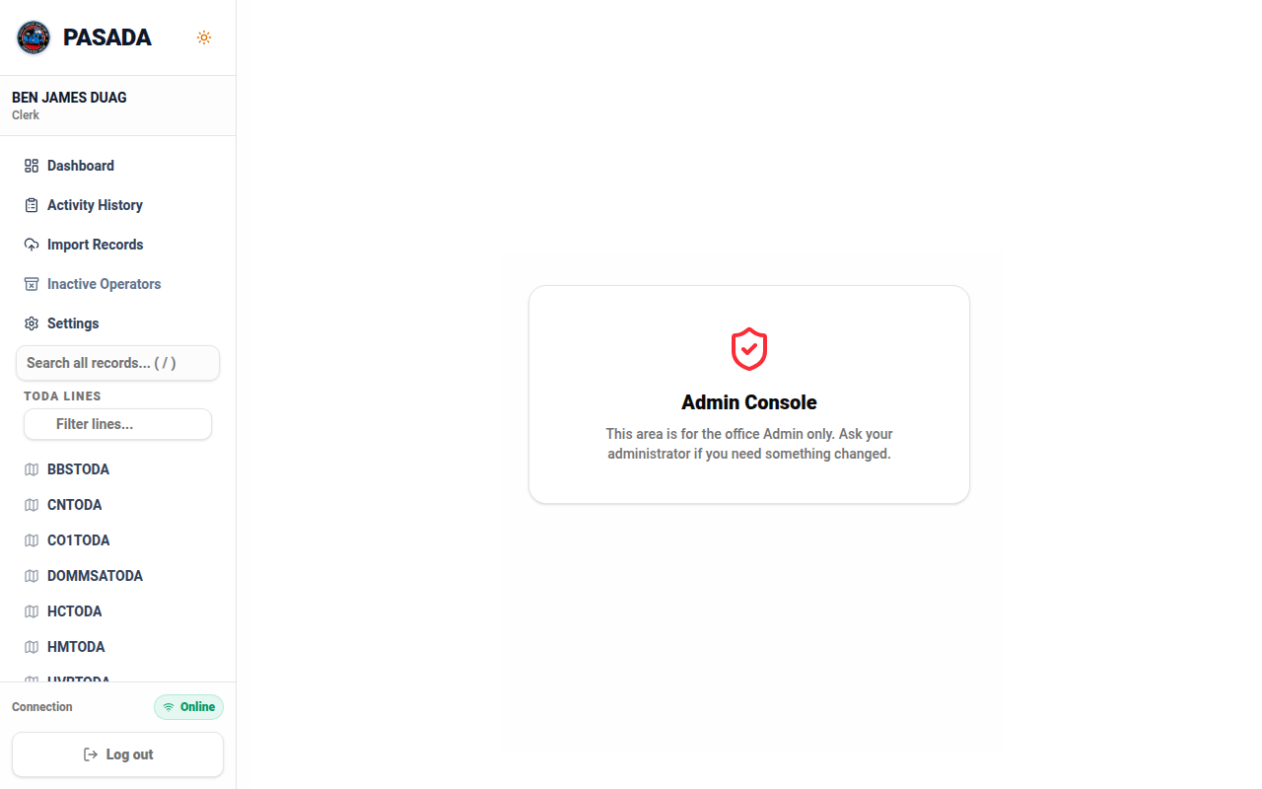
Figure 10. Non-admins see this refusal screen instead of the console.
Becoming the first admin (one-time setup)
If the office started with only a clerk and no admin exists yet, the console offers a one-time door: confirm your own password, and this account becomes the admin. The door closes forever once an admin exists. From then on, the admin manages any further accounts inside the console. Chapter 11 explains what changes and what does not after promotion.
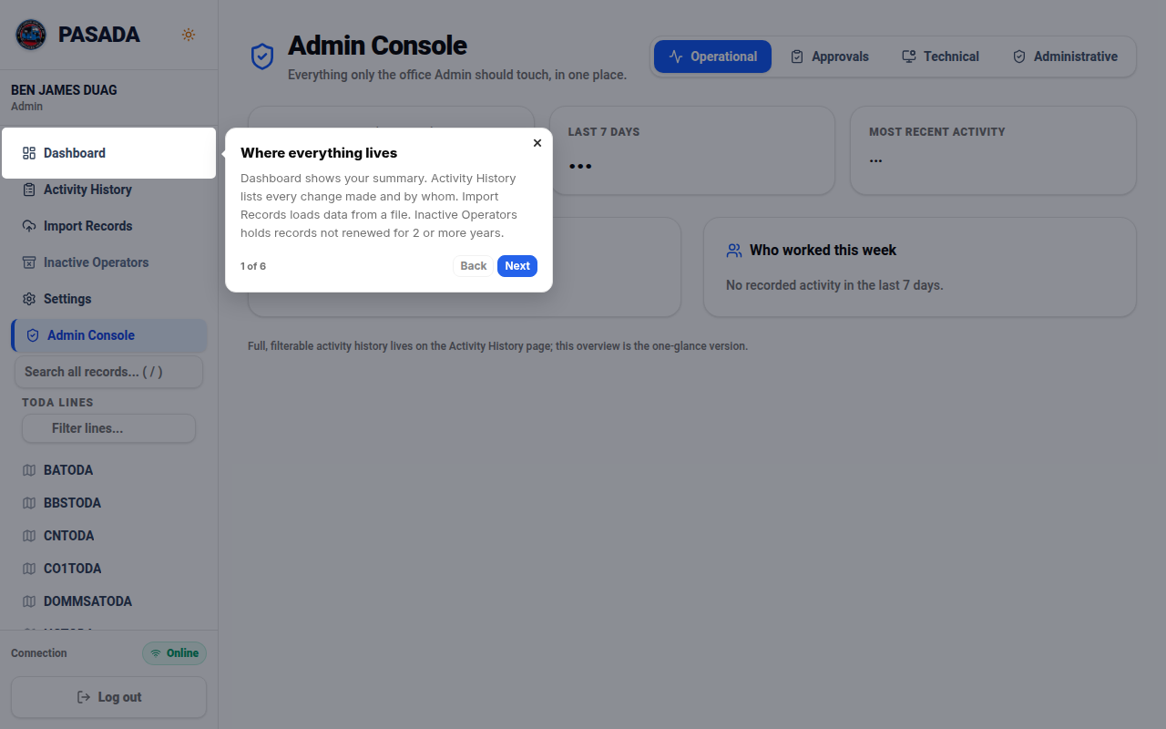
Figure 11. The Admin Console: four tabs, one place for everything admin.
Operational tab: what the office has been doing
Three cards at the top count all-time entries, entries in the last 7 days, and the most recent activity. Two lists below show the most common actions this week and the busiest people. Use this to notice unusual activity: a delete spree or a burst of logins at midnight looks exactly like what it is.
Approvals tab: the two-key queue
Requests from clerks land here. Each ticket shows who asked, when, exactly what will happen, and any reason they gave. Waiting tickets sit at the top with Approve and Reject buttons.
Figure 12. The Approvals tab: nothing big happens without a yes here.
Approving or rejecting a ticket
1. Open Admin Console > Approvals.
2. Read the ticket. It states the action in plain words: which route is deleted, what a rename changes, how many records come back.
3. Unsure? Click Reject, type a short reason, and talk to the requester. A rejected ticket changes nothing.
4. Sure? Click Approve. The action runs immediately and the result note appears on the ticket.
WARNING: Approve carefully: approval really deletes, renames, or restores. When a delete ticket is approved, the records move to the deleted list (still recoverable). When in doubt, reject first and ask.
Technical tab: system health in plain words
Figure 13. The Technical tab: computer, records, sharing, backup, error notes.
Table 9. The Technical tab cards.
Card | What it tells you
This computer | Machine name and when PASADA was last started on it.
Records | Database check result (want: all good), records saved, accounts, and who the admins are.
Sharing between computers | This computer's name and address, and which other computers are connected.
Latest backup | The newest automatic nightly backup: file, date, size.
Error notes | The last 60 lines of the error log. Normal logging, not a breakdown; support reads this first.
Administrative tab: accounts and templates
Office accounts: create an account by typing a first name, last name, password, and role. Reset a password by choosing the account and typing the new one. Both sync to every computer in the office.
Document templates: the certificate (MTOP) and the TODA summary are Word files with placeholders like [SBN_NO] and [NAME]. When the LGU amends a form, upload the new .docx here. PASADA checks the file is readable, counts the placeholders, warns if any are missing, keeps the previous file as a .bak beside it, and writes the upload to the audit log. One bad upload can always be undone by restoring the .bak.
Every admin power, in one list
Table 10. The complete admin power list.
Power | Where | Notes
Approve or reject tickets | Approvals tab | Runs the action immediately on approve.
Create accounts | Administrative tab | Clerk or Admin role; syncs everywhere.
Reset any password | Administrative tab / Settings | Also clears a lockout on that account.
Delete a route directly | Sidebar / route page | Admin click executes; clerk click files a ticket.
Rename a route directly | Route page | Same rule: admin direct, clerk ticket.
Restore deleted records | Deleted list / tickets | One or many, on approval.
Import database (merge) | Import page | Admin only.
Full Restore a database | Import page | Admin only; replaces matching records.
Upload templates | Administrative tab | .docx with placeholders; .bak kept.
Refresh DB | Technical tools | Rebuilds the fast lists after big imports.
See system health | Technical tab | Database check, sharing, backups, error notes.
See the full audit overview | Operational tab | Who did what, this week and all time.

Chapter 9 — The Two-Key Rule

Some actions are too big for one click. Deleting a whole TODA line can move hundreds of records at once. Renaming a line rewrites its code and every SBN prefix on it. Restoring many deleted records changes the registry in bulk. For these, PASADA uses two keys: one person requests, another person approves.
How a request flows
1. The clerk clicks the normal button, for example Delete Entire Route.
2. PASADA answers immediately: your request was sent to the admin. Nothing has changed yet.
3. The request becomes a ticket in the admin's Approvals tab, showing who asked, what will happen, and when.
4. The admin approves (the action runs at once) or rejects with a reason.
5. Both outcomes land in the Activity History, with names and timestamps.
What is two-key and what is not
Table 11. The two-key rule at a glance.
Action | Clerk | Admin
Delete one record | Direct (undoable) | Direct (undoable)
Delete a whole route | Files ticket | Direct
Rename a route + SBN prefix | Files ticket | Direct
Restore deleted records (batch) | Files ticket | Approves or direct
Import Excel | Direct | Direct
Import / restore database file | No | Direct
Everything else in the manual | Direct | Direct
Why the office should like this
- No dead ends: a clerk who clicks a big button gets a clear message, not an error.
- No surprises: the person who can say yes sees exactly what will happen before saying it.
- No lost history: filings, approvals, and rejections are all in the Activity History forever.
- No rush: tickets wait in the queue until the admin has time to read them properly.

Chapter 10 — Connecting Computers (Sync)

What sync does
Computers running PASADA on the same office network find each other automatically and share records. Create an account on computer A and a person can sign in with it on computer B a moment later. Every computer keeps a full copy, so if one breaks, the others keep working and no data is lost.
What you see
Table 12. Sidebar connection states.
Status | Meaning
Online (green) | Sync is working normally.
Offline Mode (amber) | This computer cannot reach the others. Keep working; changes are kept and shared when the connection returns.
Rules that keep sync safe
- Computers must be on the same office network.
- Every message between computers is signed with a shared secret held only by office computers. Strangers on the network are refused.
- Passwords travel only in secret form so accounts work on every computer. Security answers never leave the computer where they were typed.
- The same record changed on two computers is merged by newest change. Nothing is silently lost.
Good habits
- Keep every computer on during office hours so they stay current.
- After moving a computer to a new network, check the Technical tab's connected computers list.
- One office, one registry: let sync fill each computer; avoid running a second empty database by hand.

Chapter 11 — If You Are the Admin

The short answer: you lose nothing
When a clerk becomes the admin (through the one-time setup in Chapter 8), every clerk power stays exactly the same. The same log-in, the same password, the same name. Create records, edit, renew, delete, print, export, import Excel, search: all unchanged. Nothing about everyday work gets harder or moves somewhere else.
This was tested directly: after promotion, the same account created records, listed them, edited them, and exported them, all exactly as before. The only difference is the extra doors that open.
What opens up
- The Admin Console link appears in the sidebar.
- Approve and Reject buttons appear on the Approvals tab.
- The big buttons (Delete Entire Route, Rename) now execute directly instead of filing tickets.
- Database import and Full Restore accept your sign-in.
- Manage Office Accounts, template uploads, system health, and the audit overview become available.
What stays gated
Other clerks keep exactly their own set of powers. Their big clicks still file tickets to you. Their access to accounts, templates, and database files stays closed. Promotion is per-account, not office-wide.
Being a good admin
- Read tickets fully before approving; the ticket text is the whole plan.
- Create accounts for new staff promptly, and reset passwords without fuss; it happens to everyone.
- Download a database backup before any big import or cleanup, and keep one off this computer (a USB stick is fine).
- Check the Technical tab after installs, moves, or strange behavior; it usually names the problem.
- Promote a second admin only if the office truly needs one: two keys are safer than five.

Chapter 12 — Troubleshooting

Find the problem you are seeing, then follow the steps exactly. Nothing here needs technical training.
1. I forgot my password
1. On the log-in screen, click Forgot Password?
2. Type your full name.
3. Answer your three security questions.
4. Type a new password (8+ characters) and sign in.
If you never set the questions, or the answers will not match: ask the admin to reset your password. It takes under a minute and your records are unaffected.
2. The account is locked (five wrong attempts)
The lock lasts 15 minutes and clears by itself. Wait, then sign in with the correct password. If it must open sooner, the admin can reset your password, which also clears the lock.
3. I cannot register; the Register button is missing
- Registration closes after the first account exists, on purpose. Ask the admin to create your account.
- If the register page jumps or flickers, update PASADA; early versions had a display glitch, fixed in the current release.
- If the page says it cannot reach the server, see problem 4.
4. Cannot connect to server / Offline Mode
1. Check that PASADA is running on the computer that hosts the records. The status at the sidebar bottom tells you.
2. If other computers cannot reach this one, check all are on the same office network (same Wi-Fi or switch).
3. Restart the PASADA app on the computer with the problem. Wait one minute and check the status again.
4. Still stuck? Open the Technical tab (admin) and read the Error notes card.
Offline Mode is not an error. PASADA keeps every change safely on this computer and shares them when the connection returns.
5. Records from another computer are not appearing
1. Confirm both computers show Online.
2. Admin: open the Technical tab and check the connected computers list names the other machine.
3. Give it a minute; sync runs in the background and catches up by itself.
4. A computer that was off for days catches up automatically the next time both are on.
6. A record is missing or was deleted by mistake
1. Check the Activity History for the SBN to see what happened and who did it.
2. If it was just now, click Undo immediately.
3. Otherwise ask the admin to restore it from the deleted list, or file a restore request for many records.
7. Printing gives a blank or wrong-looking certificate
- Admin: check the Administrative tab; both templates should show installed with a sensible date.
- If a template was replaced recently and documents look wrong, restore the .bak copy, or upload the correct .docx again.
- The template must keep placeholder tokens like [SBN_NO] and [NAME]; PASADA warns during upload if any are missing.
8. The list is slow or numbers look stale
1. Click Refresh DB on the line's page to re-read the latest data.
2. Lists are kept in fast memory for one minute for speed; wait a moment and switch pages.
3. After a very large import, close and reopen the app once; the first open re-organizes the fast lists.
9. Two computers show different numbers
Short differences are normal; each computer catches up within a minute. If they stay different, restart PASADA on both, then check the connected computers list in the Technical tab. If one computer never appears there, treat it as problem 4.
10. The screen is frozen or the app will not close
1. Wait 30 seconds first: big exports and batch prints can look like a freeze while working.
2. If truly stuck, close the window. Every completed change was already saved; finished work is safe.
3. Reopen. If the same page hangs every time, note what you clicked and tell the person who maintains the program.
11. I see error notes or a crash message
The Technical tab keeps the last lines of the error log. This is normal logging, not a breakdown: PASADA writes a note whenever something unusual happens so problems can be traced later. If the app works, ignore old entries. If it misbehaves, the newest lines usually name the exact cause; show them to support.
12. Updates will not install
- Updates need internet once. Connect, open Settings, and click Install when the prompt appears.
- If an install is interrupted, run the app again; it finishes the update before opening.
- Compare the version number in Settings with the office's newest computer to know if you are behind.
13. An operator is under the wrong TODA line
1. Open the record with the pencil icon and check the route field.
2. One operator in the wrong line: edit the record's route directly.
3. A whole line needs re-arranging: that is a rename or route move, which follows the two-key rule.
14. A database was restored and something looks wrong
1. Do not panic: the previous database copy is always kept before a restore.
2. Compare dashboard totals with the Activity History exports you expect.
3. Admin: restore an earlier backup file if numbers are wrong; each restore keeps a rollback copy.
Still stuck?
Collect four things before asking for help: what you clicked, what appeared on screen, the time it happened, and the newest lines from the Technical tab's Error notes. With those four, almost any PASADA problem can be found and fixed quickly.

Chapter 13 — Quick Reference Card

Print this page and keep it beside the computer.
Table 13. The one-page cheat sheet.
To do this | Do this
Sign in | Full name + password, click Log In
Jump to search | Press / on any page
Switch pages fast | Alt+1 Dashboard, Alt+2 Activity, Alt+3 Import, Alt+4 Inactive, Alt+5 Settings
Add an operator | Open the TODA line, click Add Operator
Renew | Edit the record, set issue date to this year
Print certificates | Eye icon, or tick rows + Batch Print
Export Excel | Export Excel on the line's page
Request a big change | Click the normal button; the admin approves it
Approve requests | Admin Console > Approvals
New account / reset password | Admin Console > Administrative (admin)
Lock the screen | Set a PIN in Settings; it locks when you leave
Backup everything | Settings > Full Database Backup
Check system health | Admin Console > Technical
Dark mode | Sun/moon button, top of the sidebar
Log out | Log out button, bottom of the sidebar

Glossary

Table 14. Terms used in this manual and in PASADA.
Term | Meaning
Pasada | Filipino term for a driver's working trip: going out to transport passengers and earn the day's living. The system is named for this work.
Tigil pasada | When the runs stop: drivers cannot work. Shows why keeping franchises active matters.
MTOP | Motorized Tricycle Operator's Permit: the franchise document per operator.
SBN | Serial bound number: the franchise serial like BA-002-26.
TODA | Tricycle Operators and Drivers Association: one line or route.
Renewal | Yearly re-registration keeping a franchise active for the calendar year.
Deduplication | The system collapsing duplicate rows of the same SBN into one clean record.
Fullness score | Active operators compared with the route's population and road length.
Approval ticket | A logged request for a big action, waiting for admin approval.
Audit log / Activity History | The permanent record of every change: who, what, when, old and new values.
Backup | An exact copy of the whole registry, downloadable as one .db file.
Sync | Automatic record sharing between office computers on the same network.
Cluster secret | The shared key office computers use to recognize each other during sync.
Template | The Word document (.docx) with placeholders that certificates are printed from.
Soft delete | A delete that keeps the record recoverable in the deleted list.

