* *Name :* **Meshach Opoku Boadi**
* *Index number:****5200104020***
* *Programme:* ***Information Technology Education (weekend)***
* *Course Title : Principle of accounting*

Applicant Number:1040084

**

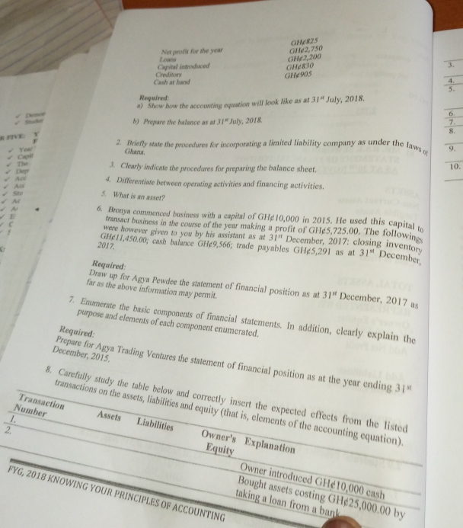

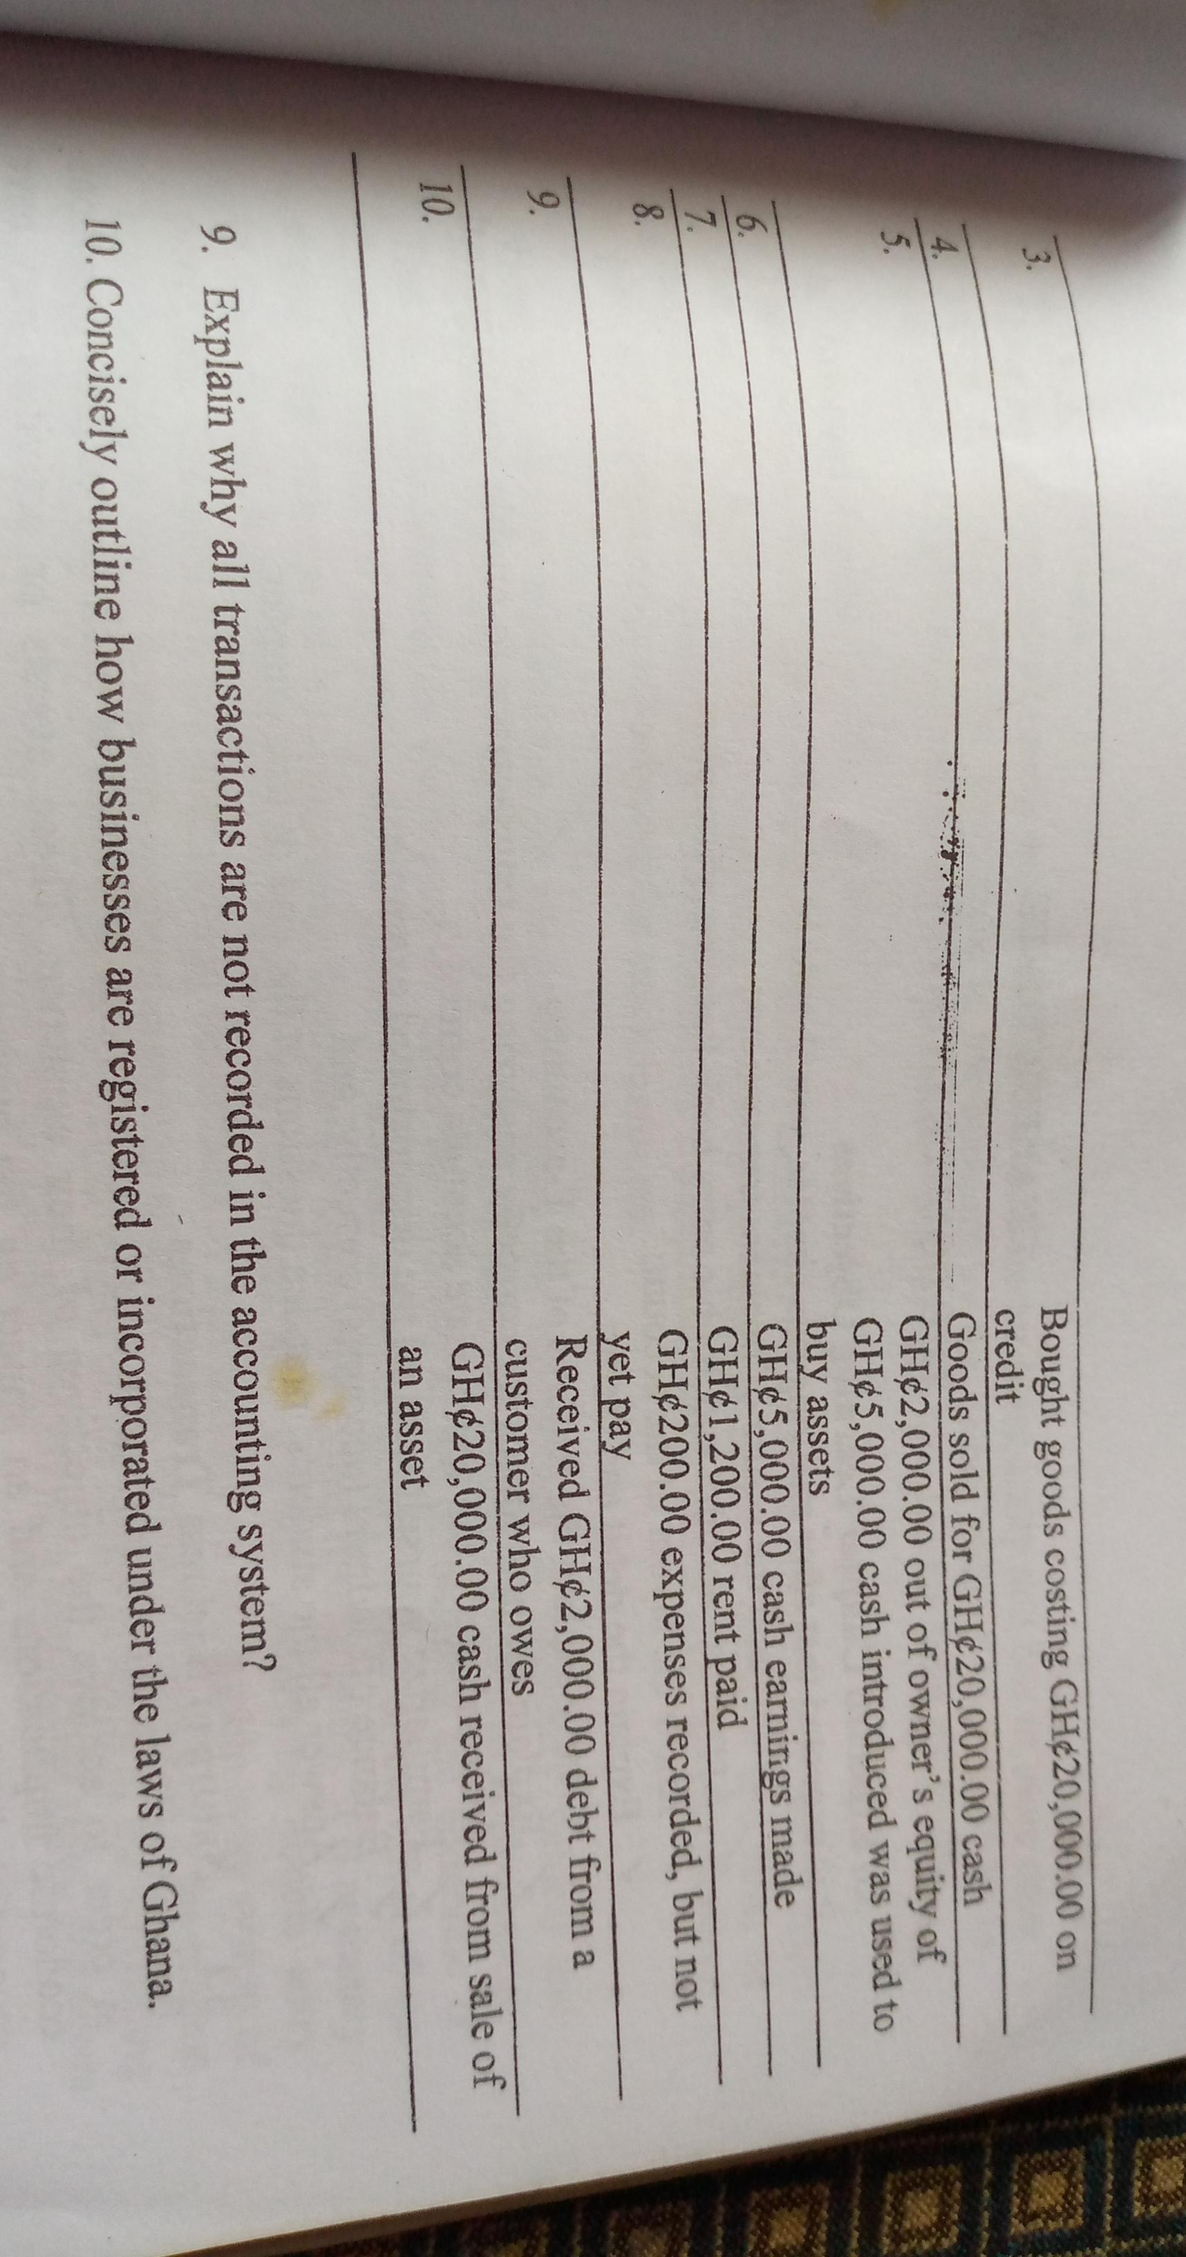

***Answers***

1a..Asset=Liabilities+capital

Asset=motor vehicle +Debtors+loan+cash at hand

=11450+1500+905+2750=6605

Capital=Net profit +Capital introduced

=2200+825

Liabilities=loans +Creditors

=2750+830

A=C +L

1450+1500+905+2720=2200+825+2750+830

6605=6605

***b. SEDOFIA FINANCIAL STATEMENT AS 31St JULY 2018***

***Assets Gh¢***

Non-Current Assets

Motor vehicle. 1450

1450

Current Asset

Debtors. 1500

Cash at hand. 905

Cash(loan). 2750

5155

**TOTAL** **ASSETS** **6605**

**REPRESENTED** **2.**

Owners’ Equity

Capital Introduced. 2200

Net Profit. 825

3025

Add Liabilities. 2750

Creditors. 830

3580

**Owners’ Equity & Liabilities. 6605**

Question2 **Answer**

**Step1**:**Company name search at Registrar General Department(RGD) to obtain incorporated forms:** conduct your company name search at the RGD in Ghana to ensure the availability of the proposed business for the company. Fill in relevant application form such TIN registration for manager, shareholders

Add company regulations

**Step2: Apply to the Registrar General Department to obtain incorporated certificate**

Submit all required documents to RGD

After forms are duly completed, directors,mangers and etc must append their signature

Incorporated and filing fees are also required to be paid upon submission of completed business registration form

**Step3:Collect Business Registration Certificate**

Upon submission of forms one should expect to have the process completed in 2 weeks , after which of the following documents will be issued .

**Certificate of incorporation**

* **Form(3 &4)**
* **Certificate of commencement**

**Company regulations**

**Step4:Registrar with the Ghana investment promotion Center (IPC):**All investors are required to complete investor Registration form and pay applicable fees.

**Step5 : Registration with Ghana Revenue Authority (GRA):** All enterprises must register for purpose statutory tax . example taxes rebate and exemption ..

**Step6: Apply for business license at the metropolitan Authority** :The registration fee depends on the type of business and the category in which they fall in base on their turn over

**Step7: Apply for social security:**To register attach the list of employee salaries ,social security Number and the company’s certificate of incorporated and certificate of commence business

**Step 8: Environmental impact assessment certificate:** apply and obtain environmental permit with the Environmental Protection Agency(EPA)

**Question3 Answers**

* Determine the reporting date and period
* Identify your assets
* Identify your liabilities
* Calculate shareholders’ equity
* Add total liabilities to the total shareholders’ equity and compare to asset.

**Questions 4 Answer**

Operating activities is a classification of cash flow with the statement of items classified within this area are an entity’s primary revenue – producing activity ,so cash flow are generally associated with revenue and expenses but financial activities are activities that companies undertake to help achieve their economic goals and maintaining account for example arranging loans selling bonds or stock are also financial activities .

**Questions 5 Answer**

Assets are any economic resources owned or controlled by a business and can be utilized to produce value .It signifies all kinds all kind of resources that help generate revenue as well as receivables

Asset= capital + liabilities

**Question 6 Answer**

A= C+L

Asset= closing inventories + cash balance

A= 11450 + 9566=21016

Capital = capital Introduced + profit

C=10000+5725

Liabilities =Trade payable

L =5291

A=C+L

Closing inventories +cash balance =capital Introduced +profit+ trade payables

11450+9566=10000+5725+5291

21016 =21016

**AGYA PEWDEE FINANCIAL STATEMENT AS AT 31st December,2017**

Assets. Gh ¢

Current Asset

Closing inventories. 11450

Bank. Balance. 9566

**TOTAL ASSETS. 21016**

**REPRESENTED BY:**

Owners’ Equity

Capital Introduced. 10000

Net profit 5725

**15725**

Add Liabilities. 5291 **OWNERS’ EQUITY & LIABILITIES 21016**

**Question7 Answer**

**Asset** are economic resources owned or controlled by a company which can incur future benefit

Purpose Assets: Asset. Is used to store wealth

Element of assets are

Non current Asset : example building

Current Asset : stock

**Liabilities** is something a person or company owes , usually sum of money and are settled over time through the transfer of economic benefits .

Purpose of Liabilities : liabilities is used to finance operations and pay for large expansion

Equity represent the value that would be returned to a company ‘s shareholders if all

all of the assets are liquidated and all of the company debt were paid off.

Purpose of equity : Equity is used to finance expansion .That is funding business operations by selling share of stock to to investor is “ equity financing” . When a company sells a stock for cash ,it sells equity to investor for cash that can be used to find growth.

**Question8: Answers**

|  |  |  |  |
| --- | --- | --- | --- |
| **Asset** | **Liabilities** | **Capital** | **Explanations** |
| **+10000** |  | **+10000** | Owners’ introduced Gh¢10000cash |
| **See-25000** | **-25000** |  | Bought asset costing Gh¢25000 by taking a loan from a bank |
| **-20000** | **-20000** |  | Bought goods costing Gh¢ 20000 on credit |
| **+20000** |  | **+20000** | Goods sold for Gh¢ 20000 cash |
| **+2000**  **+3000** |  | **+2000**  **+3000** | Gh¢ 2000 out of owners’ equity of Gh¢ of Gh¢5000 cash introduced was used to buy an asset |
| **+5000** |  | **+5000** | Gh¢ 5000 cash earnings made |
| **-1200** | **-1200** |  | Gh¢ 1200 rent paid |
| **-200** | **-200** |  | Gh¢ 200 expenses recorded ,but not pay |
| **+2000** |  | **+2000** | Received Gh¢ 2000 debt from a customer who owes |
| **+20000** |  | **+20000** | Gh¢20000 cash received from sale of an asset |

**Question9** **Answers**

By passing the general journal could result in inccuracies of the transactions is overlooked .

General journal entries usually takes place at the time of the transactions or soon hereafter . Entering transaction in the general ledger later may require guesswork or may be wrong because of faulty memory

**Question10 answer**

**Sole proprietor** is an incorporated business usually run by one incorporated individual .The Liability of a sole proprietor is unlimited . A sole proprietor shall not carry out business in business in finance , banking or communication sectors.An individual may carry out business in his / her legal name or under a trade name.

A sole proprietor who adopts trade name must register the name with Registrar General’s Department and renew the registration annually.

**Partnership** are an association of two or more ( up to a maximum of 20). Members of partnership are called “ partners” and the terms and conditions of their relationship must be documented in a partnership agreement .It must be registered with RGD

**Incorporating company**  mean establishing a legal entity for the company that is separated from the legal entity of director.

Three types of companies that may be incorporated in Ghana

* **Company Limited by shares:** means an incorporated business company that cannot offer it’s shares to the public

To incorporate a private company Limited by share you must

1 Decide who will act as the company’s first director.A company incorporated and and registered in Ghana must have minimum of two directors ,both natural person over 21 years ,one of whom must be a permanent.

2.Register with the GRA

3.Choose business name

4.Prepare the regulations of a company

5. If the Registrar is satisfied that the information contained in the application and the supporting document is accurate , a certificate of incorporation will be issued.

6. Within 28 days of the date of the certificate of incorporation ,the company must submit to the Registrar of companies a statement of company particulars and shareholding ( forms ) and declaration of payment for ( form4).

7.The completed form , capital duty charged at 0.5% of the company’s stated share capital and the registration must fee be submitted to the Registrar of companies.If the Registrar is satisfied with the documents submitted , a certificate to comment business will be issued.

8.

Register for social security contribution