CSAI415 — Deliverable D2
Retrieval Stack & Graph Build
PDF-Papers AI Agent: Hybrid Retrieval + GraphRAG with Online Learning and AutoML
Stack: Python · MongoDB · Qdrant · Neo4j · FastAPI · bge-small-en-v1.5 (fastembed/ONNX) · BM25

1. Overview
D2 builds the retrieval backbone for the project: a real PDF → text → chunks → embeddings ingestion pipeline, three persistent stores (MongoDB, Qdrant, Neo4j), a hybrid BM25 + dense /search API that returns grounded citations with page ranges, and a knowledge graph with example Cypher queries. It continues directly from D1 — the hybrid fusion weight λ is the D1 Optuna winner, and the dense side is now the real bge-small-en-v1.5 encoder that D1 left stubbed.
The corpus comprises 60 open-access arXiv PDFs (10 PDFs per topic: transformers, RAG, online learning, vision, RL agents and AutoML) that are divided into 4,155 segments. These documents process data by using Dockerised services on a workstation and in the absence of alternatives (mongomock, Qdrant in-memory/on-disk and NetworkX). The code will remain the same while it depends on the environment variables.

1.1 Feedback from D1, addressed in D2
D1’s initial corpus was procedurally generated (a synthetic, arXiv-style set). On the professor’s feedback we moved D1 onto a real arXiv corpus — 150 papers fetched through the arXiv API (see src/build_corpus.py, committed with that change). D2 continues in the same direction and goes a step further: it is built end-to-end on real, open-access full-text PDFs, not just metadata or abstracts. The table below records the points raised on D1 and how D2 resolves each.
Raised on D1 | How D2 addresses it
Corpus was synthetic / procedurally generated | Real, open-access arXiv full-text PDFs (60 papers) downloaded and parsed with page maps; the D1 corpus was already switched to the live arXiv API, and D2 now ingests the actual PDF documents
Dense side was a TF-IDF/SVD stand-in (bge “deferred to D2”) | The real bge-small-en-v1.5 encoder (384-d) now powers the dense retriever, bridging vocabulary gaps that bag-of-words could not
Recall@5 = 0.58 — just under the 0.60 target | Hybrid Recall@5 = 0.611 on the real-PDF corpus, clearing the ≥ 0.60 target (title queries reach 1.000)
Retrieval was abstract-level only (no provenance) | Chunk-level retrieval with full provenance — every snippet carries a page range and offsets, so answers are grounded and citable

2. System architecture
A query fans out to two retrievers — BM25 over chunk text and dense approximate-nearest-neighbour (ANN) search over bge embeddings in Qdrant. Each side returns a candidate pool; the pools are unioned, each signal is min-max normalised, and the two are fused as λ·bm25 + (1−λ)·dense. The top-k chunks are returned with a citation assembled from MongoDB provenance (title, paper_id, page range). The Neo4j graph backs metadata queries today and the 2-hop subgraph expansion that GraphRAG will use in D3.
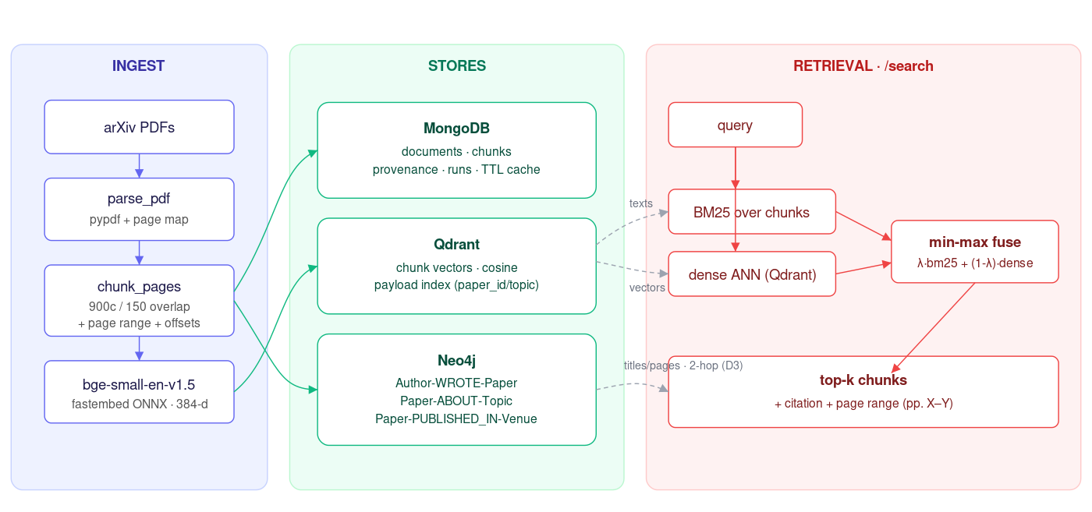
Figure 1. Dataflow: ingest → stores → retrieval → graph.

3. Ingestion pipeline & schema
PDFs are parsed with pypdf into per-page text, recording each page’s character span so any character offset maps back to a 1-based page number (the page map). A sliding-window chunker (900 characters, 150 overlap, minimum 120) cuts chunks over the concatenated text and snaps the right edge to the nearest sentence boundary for readability; a chunk may legitimately span a page break, captured as page_start..page_end. Leading pages are capped at 20 per PDF (configurable) because arXiv papers’ substantive content is up front and the long tail of references/appendices bloats chunk counts with low-value text.
MongoDB schema (provenance-first):
Collection | Key fields | Purpose
documents | paper_id, title, authors, venue, year, topic, doi, pdf_path, n_pages, n_chunks, run_id | One record per paper; bibliographic + ingestion provenance
chunks | id, paper_id, chunk_index, text, page_start, page_end, char_start, char_end, n_tokens | Citable unit; page range makes every snippet groundable
runs | run_id, n_docs, n_chunks, embedder, parameters, timestamp | Ingestion run card — trace any chunk to the run that made it
cache | query, result, created_at | Short-lived query cache; TTL index auto-expires entries
Qdrant stores one 384-d cosine vector per chunk with a payload (paper_id, topic, page range) and payload indexes on paper_id/topic for filtered search and source pinning (used by D3 safety). Point ids are a stable UUIDv5 of the chunk id, so an ANN hit always maps back to its Mongo record.

4. Hybrid retrieval
BM25 (rank_bm25) is built once over all chunk texts. For a query, the dense side embeds with bge (asymmetric: queries get the model’s search-instruction prefix) and retrieves an ANN pool from Qdrant; the lexical side takes the BM25 top pool. The two pools are unioned, each score min-max normalised, and fused. Fusing over the union of pools — rather than scoring the whole corpus densely — is how production hybrid retrieval works: ANN-retrieve, then re-score, keeping latency flat as the corpus grows. λ = 0.5 is frozen from the D1 Optuna study and is overridable per request — it is exactly the knob the D1 online learner adapts.

5. Knowledge graph & Cypher
Graph model represent relation (:Author)-[:WROTE]->(:Paper), (:Paper)-[:ABOUT]->(:Topic) and (:Paper)-[:PUBLISHED_IN]->(:Venue). Which is loaded on a 60-paper corpus that contains 365 nodes and 425 edges (60 Papers, 298 Authors, 6 Topics and 1 Venue). Five example queries are in src/cypher_queries.py. The NetworkX fallback works the same way, so the results are the same whether or not you use a Neo4j server.
Cypher query | Returns
papers_by_topic($topic) | All papers on a topic, newest first
papers_by_author($author) | An author’s body of work in the corpus
coauthors($author) | Co-authors ranked by shared papers
papers_by_venue_year($venue,$year) | Papers in a venue for a given year
related_via_topic($paper_id) | GraphRAG 2-hop: papers sharing a topic with a seed paper

6. Evaluation
Evaluated on the 59 D1 gold queries whose relevant papers fall in this 60-paper subset, at k = 5. Chunk results are deduped to a ranked paper list before scoring (gold is paper-level). Recall@5 and nDCG@5 use the same binary-relevance definitions as D1 for comparability.
Retriever | Recall@5 | nDCG@5 | mean ms | p95 ms
BM25 only (λ=1.0) | 0.624 | 0.860 | 17.9 | 28.0
Dense only (λ=0.0) | 0.615 | 0.829 | 18.2 | 29.2
Hybrid (λ=0.5) | 0.611 | 0.841 | 18.1 | 28.0
Hybrid by query type (Recall@5 / nDCG@5):
Query type | Recall@5 | nDCG@5 | n
title | 1.000 | 1.000 | 18
targeted | 0.526 | 0.761 | 17
broad | 0.379 | 0.779 | 24
Recall@5 = 0.611 clears the ≥ 0.60 target and p95 latency ≈ 28 ms is far under the 2 s CPU target. Title queries are answered perfectly; broad queries are structurally capped because their gold set is a whole topic (up to 10 papers) while k = 5.
Honest finding.
At a fixed λ = 0.5, BM25 alone is marginally ahead of the hybrid on this corpus: bge clearly helps semantic/title queries but min-max fusion dilutes BM25’s edge on keyword-heavy ones. This is precisely the gap the later stages close — D1’s online learner already adapts λ per query, and D3 adds cross-encoder reranking and graph-guided expansion. We report it rather than tuning λ to flatter the hybrid.
Example (query: “retrieval augmented generation with citations”, 17.5 ms):
1. CG-RAG: Research Question Answering by Citation Graph Retrieval-Augmented LLMs (2501.15067), p.1 — score 0.617
2. Passage Segmentation of Documents for Extractive Question Answering (2501.09940), p.8 — score 0.598
3. W-RAG: Weakly Supervised Dense Retrieval in RAG for Open-domain QA (2408.08444), p.11 — score 0.596

7. Engineering & reproducibility
- One command starts Mongo (27017), Qdrant (6333) and Neo4j (7474/7687) with health checks and named storage
- FastAPI has these paths: /search, /ingest, /stats, /healthz and /graph/related. You can find the Swagger UI at /docs.
- Scripts: download_pdfs.py (fetch PDFs + write papers.csv), seed_stores.py (ingest to services), eval_search.py (metrics + examples); also seed_resumable.py / eval_from_cache.py for the no-Docker way.
- Tests: pytest smoke tests build synthetic PDFs and exercise the full ingest → store → search → graph path with an offline embedder — no downloads, no services (4/4 passing).
- Pinned: shared seed 42; data/papers.csv pins the corpus; .env.example documents every switch; run_card.yaml records the active config and headline results.

8. Key decisions & mistakes.
- Embedder = fastembed, not sentence-transformers. Same bge-small-en-v1.5 weights via ONNX runtime: ~10× smaller install, CPU-only, no torch. The HybridRetriever interface from D1 was preserved so this was a drop-in swap.
- paper_id must be read as a string. arXiv ids like 2410.05250 are parsed as floats by default and silently lose the trailing zero, which breaks gold-matching and graph node ids; all CSV reads pin dtype=str.
- Page cap (max_pages=20). Bounds chunk counts and ingest time; configurable, 0 = all pages.
- One code path, two deployments. Each store auto-selects a real client or an in-process fallback from environment variables, so tests and a laptop demo share the exact production code.

9. Mapping to the D2 rubric
Criterion | Where it is met
Ingest & storage (3%) | pypdf parsing + page map, overlap chunking, Mongo provenance schema + TTL, Qdrant payload indexes
Hybrid retrieval (5%) | BM25 + dense fusion, metrics table + ablation, examples with page-range citations
Graph build (5%) | Neo4j schema (Authors/Papers/Topics/Venues), 5 Cypher queries, dataflow diagram
Engineering (2%) | docker-compose, FastAPI, seed/eval scripts, pytest smoke tests

