

*[Geophysical Research Letters]*

Supporting Information for

**Against the Agulhas Current flow**

M. Krug1,2*, S. Swart3, and J. Gula4

Figure S1 provides an overview of the oceanographic conditions experienced during the Shelf Agulhas Glider Experiment (SAGE), based on the AVISO global merged altimetry dataset.

Figure S2 is provided to support the discussion in Section 3.3 on the potential role of bathymetric curvature in leading to an increase in the meandering of the Agulhas Current south of 34oS.

The Agulhas Current is referred to as AC in the figure captions.

Text S1.

AVISO maps of absolute geostrophic velocities (delayed time and all sat merged product) were used to determine the position of the AC dynamical core along the Topex/Jason altimeter Track #020, following the method described in Krug et al. [2014]. This method is based on the identification of the along-shore current velocity maximum. Offshore excursion in the Agulhas Current position exceeding 300km have been flagged. Fluctuations in the path of the AC derived from altimetry over the period 1992 to 2016 show that the AC meandered very little between April and June 2016, with both offshore and inshore deviations in its path only reaching about half a standard deviation from the mean.

Figure S1. Location of the Agulhas Current core derived from altimetry between 1992 and 2016. The solid black line shows the distance (in km) between the Agulhas Current's dynamical core and the coast derived along Jason-Topex Track #020. The dotted line shows the value associated with 1 standard deviation from the mean. The period of glider acquisition presented in this manuscript is plotted in red.

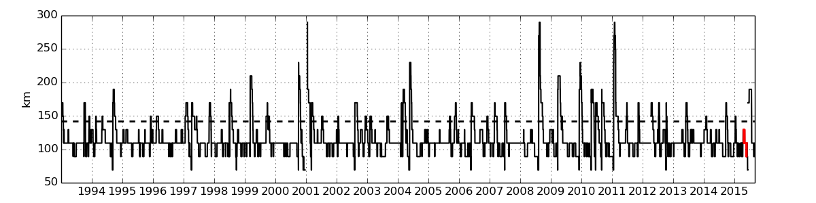

Text S2.

Odyssea gridded maps of merged Sea Surface Temperature (SST) produced by the CERSAT (http://cersat.ifremer.fr) were used to follow perturbations at the AC front. The Odyssea product is provided at daily intervals and a spatial resolution of 2 km. While it has been shown that large Agulhas meanders can successfully be identified along the Topex/Jason Track #020 using merged altimetry products, variability occurring over time-scales of a week or less is not adequately represented in the mapped AVISO products due to the temporal and spatial smoothing required to map geostrophic currents from multiple altimeters, as shown by [Rouault et al., 2010]. A simple algorithm was thus applied to the daily Odyssea product in an attempt to better capture short-term variability in the AC position. The algorithm is based on the detection of the warm waters associated with the AC. For each daily SST map and within the limits of the study region (35oS to 33.5oS, 24.25oE to 26.75oE), data points falling within 2oC of the latitudinal maximum were selected and masked. The contour associated with the northern limits of the masked region was tracked in time to map fluctuations in the path of the AC. The threshold of 2oC was selected because, on average, regions of strongest SST gradient at the AC inshore edge were approximately 2oC colder than the waters encountered in the AC core. Although the selected contour did not always match the region of strongest SST gradient associated with the AC front, it did successfully captured day to day variations in the position of the AC path.

We used the Odyssea SST imagery to evaluate changes in the meandering of the Agulhas Current within a larger region (36.5oS to 33oS, 22oE to 29oE) using the method described above. From the analysis, we derive the northward extent of the Agulhas Current inshore front for each day and over a 3-year period spanning years 2013, 2014, and 2015. Again here, the location of the Agulhas inshore edge is defined as northern extension of warm waters within 2oC of the latitudinal maximum). To limit our analysis to small meanders, we remove all deviations from the mean location of the Agulhas Current's inshore edge which exceed 0.5 degrees in latitude. The result of the aalysis are plotted in Figure S3. The results show that the standard deviation in the location of the Agulhas Current's inshore front increases southwards. The results we obtained on the whole dataset and including both large and small meanders also show an increase in the Agulhas Current meandering southward.

Figure S2. Mean Odyssea SST over a 3-year period spanning the years 2013-2015. The thick black line shows the location of the 1000 m isobath. The thick red indicates the mean position of the AC inshore edge while white lines show the northward deviation from the mean. All deviations greater than 0.5 degrees in latitude have been removed.

