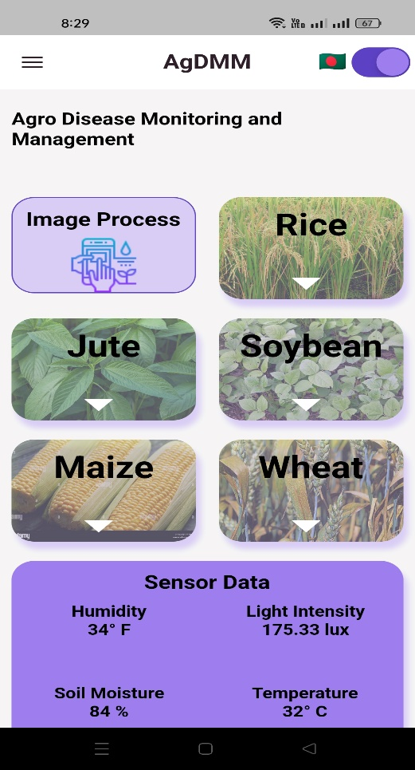

Click Here. You get Translate Option.( Bangla & English)

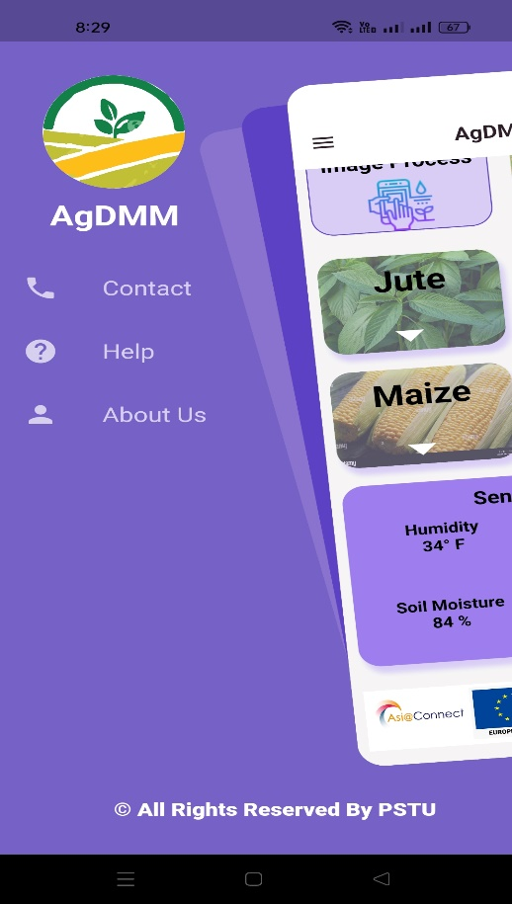

This is Menu page



If you need any information about the app, please contact us

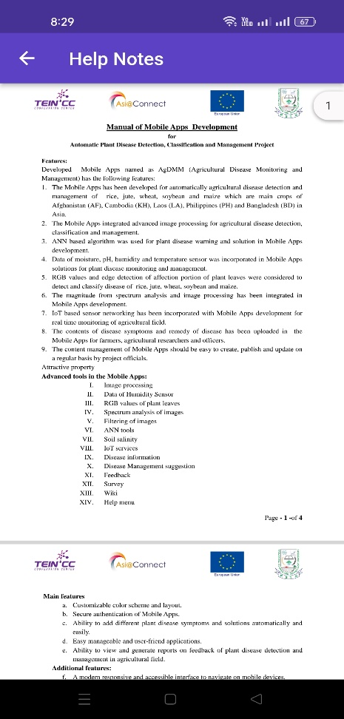

Help note page. Here you can get Help notes



About Us Page for developer.

you can Contact With Them

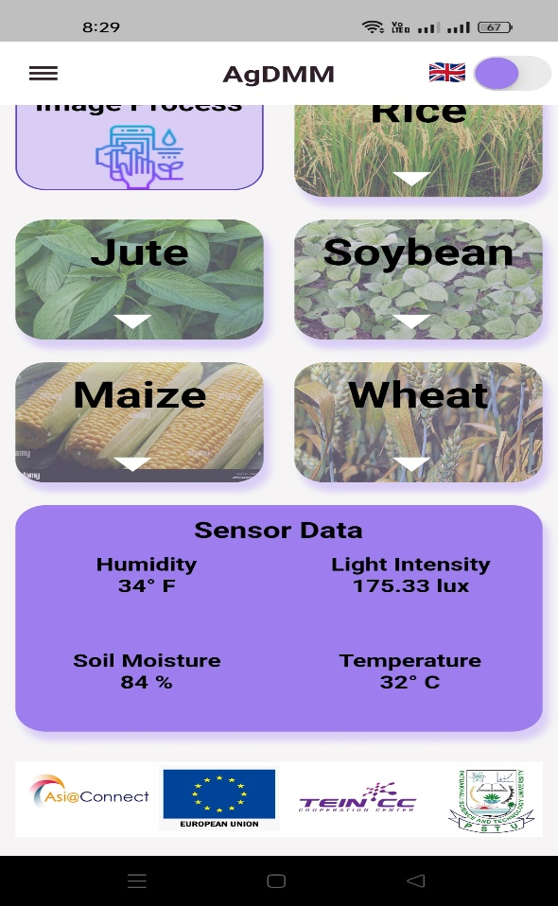

Sensor Data Update Form FireBase



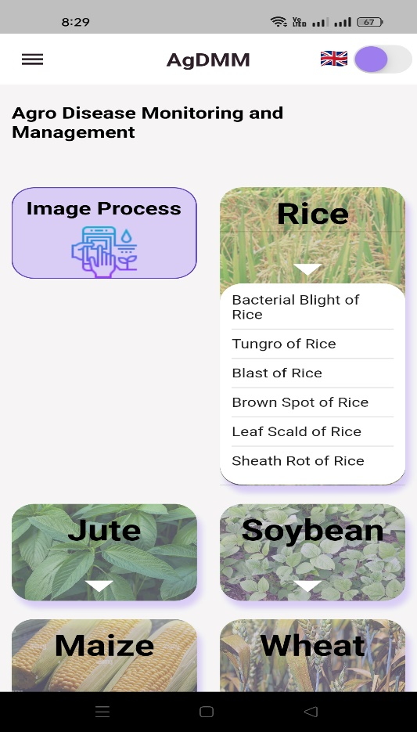

Click This **arrow** we get more Disease name

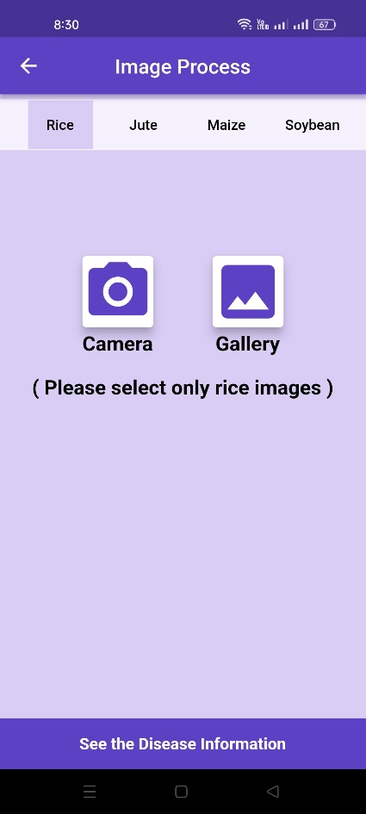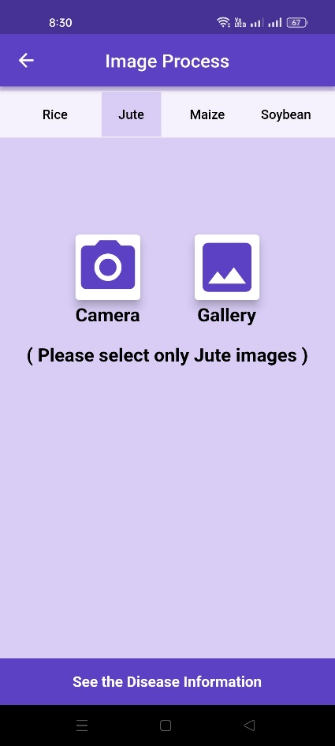



Click Camera option for live image. OR Click Gallery Option for Image form your Phone.



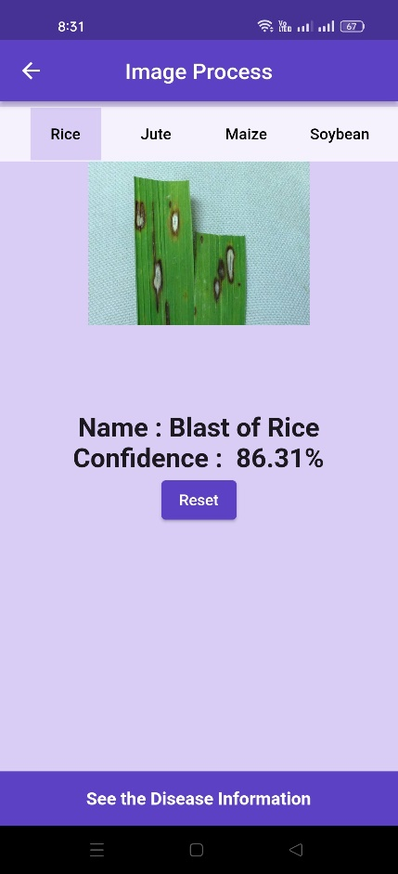

Click **Reset** Button

We get Image Process page



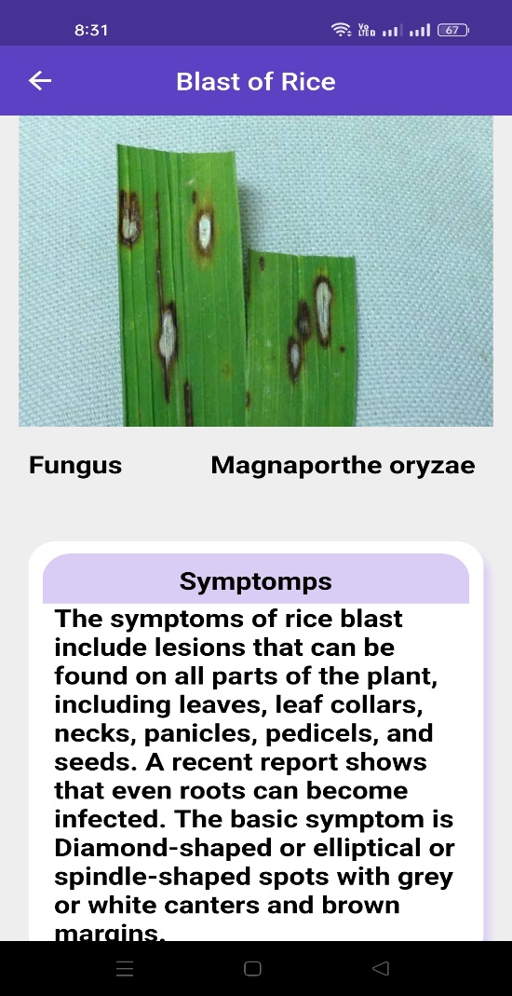

When we click (**see the Disease Information**)

We get Disease Information.