DC ELECTRONIC LOAD TESTER
R150

User Manual



Table of Contents
1 Product Overview
1.1 Features
1.2 Panel Introduction
2 Technical Specifications
3 Operations
3.1 Button Key Introduction
3.2 Main Menu
3.3 CC Mode (Constant Current)
3.4 CV Mode (Constant Voltage)
3.5 CR Mode (Constant Resistance)
3.6 CP Mode (Constant Power)
3.7 CC/CV/CR/CP Mode Operation
3.8 CDC/CDCDC Mode
3.9 CDxN Mode (Charge/Discharge Cycling)
3.10 BRT Mode (Battery Resistance Test)
3.11 PT Mode (Power Supply Test)
3.12 CT Mode (Conductor Resistance Test)
4 System Settings
4.1 Settings Menu
4.2 Communication Settings
4.3 Firmware Upgrade
5 Host Computer Analysis Software

1. Product Overview
This product is a multi-function, high-precision, single-channel DC electronic load tester used for testing batteries, power adapters, chargers, and power banks. It features a dual MOSFET design with hardware reverse-polarity protection to ensure stable electrical performance, safety, and reliability.
1.1 Features
- Dual MOSFET with hardware reverse-polarity protection
- Maximum loading power up to 150W
- Voltage range: 0V-150V
- Current range: 0A-25A
- 2.4-inch color display
- Integrated intelligent cooling fan
- Supports 10 testing modes
1.2 Panel Introduction
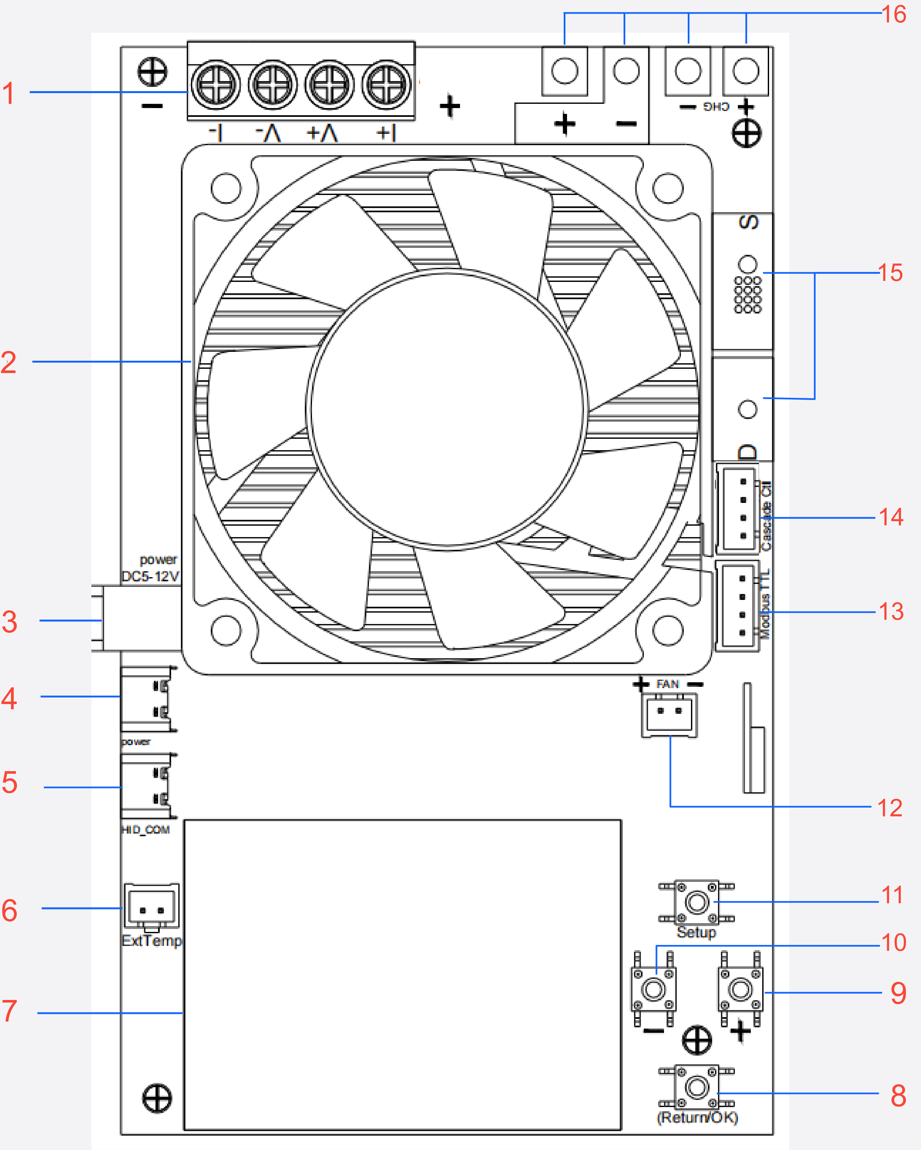
Figure 1. Panel Overview
1. 4-wire input ports: Connection terminals for 4-wire measurement (see connection diagram below).
2. Cooling fan: Integrated intelligent cooling fan for thermal management.
3. DC power input port 1: DC 5-12V power supply input.
4. USB power input port 2: Type-C, 5V/2A power input.
5. COM port (HID): Communication interface to PC software.
6. External temperature probe: Interface for external temperature sensor.
7. Built-in display: 2.4-inch color display.
Button Functions
8. [Return/OK] Button: Short press: Start/Stop load. Long press: Return to the previous menu.
9. [+] Button: Short press: Menu add or value increase. Navigates cursor down or right.
10. [-] Button: Short press: Menu reduce or value decrease. Navigates cursor up or left.
11. [Setup] Button: Long press: Set parameters. Short press: Adjust the digit value.
Reserved Interface Ports
12. Cooling fun port: Interface for cooling fun.
13. Modbus TTL port: Reserved for Modbus communication.
14. Reserved control port: Extended cascade to a slave device.
15. Reserved output port: Extended cascade to a slave device.
16. External power input port: Connect to an external power supply to charge the battery during CDC, CDCDC, and CDxN modes.

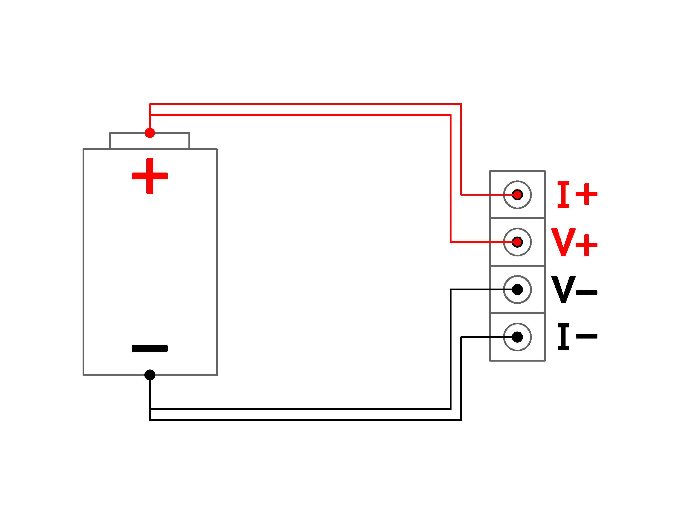
Figure 2. 4-Wire Input Connection Diagram

2. Technical Specifications
The following table lists the technical specifications for the R150 model:
Category | Parameter | Specification
Input Channel | Channels | Single Channel
Rated Value | Voltage | 0-150V
 | Current | 0-25A
 | Power | 0-150W
CV Mode | Voltage | Range 0-150V, resolution 0.001V
 | Accuracy | ±(0.1%+0.025%FS)
CC Mode | Current | Range 0-25A, resolution 0.001A
 | Accuracy | ±(0.1%+0.05%FS)
CR Mode | Resistance | Range 0.001Ω-9999.999Ω, 16-bit
 | Accuracy | ±(0.1%+0.5%FS)
CP Mode | Power | Range 0-150W, resolution 0.01W
 | Accuracy | ±(0.1%+0.5%FS)
BRT Mode | Resistance | 0-100Ω
PT Mode | Range | Power: 0-150W, Current: 0-25A
CT Mode | Resistance | 0-100Ω
Work Temperature | Range | 0-40℃

3. Operations
3.1 Button Key Introduction
This device has 4 multi-function button keys:
[Return/OK]: Short press: When the device is discharging, Start/Stop load tester. When the device is not discharging, short press to confirm; Long press: long press to return to the previous menu.
[+]: Short press: Menu add or value increase. When navigating the menu, short press to move the cursor down or right. Firmware upgrade mode: While powering on, long press [+] to enter firmware upgrade mode automatically.
[-]: Short press: Menu reduce or value decrease. When navigating the menu, short press to move the cursor up or left.
[Setup]: Long press: Set parameters. Short press: Adjust the digit value.
3.2 Main Menu
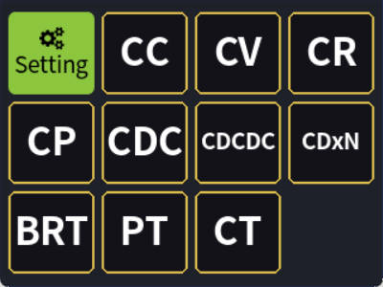
Figure 3. Main Menu Screen
The main menu provides access to the following 10 testing modes:
- Settings - System settings menu
- CC - Constant Current mode
- CV - Constant Voltage mode
- CR - Constant Resistance mode
- CP - Constant Power mode
- CDC - Charge-Discharge mode
- CDCDC - Charge-Discharge-Charge-Discharge mode
- CDxN - Charge/Discharge Cycling mode
- BRT - Battery Resistance Test mode
- PT - Power Supply Test mode
- CT - Conductor Resistance Test mode
⚠ NOTE: CDC, CDxN, and CDCDC modes require an external constant current power supply / charger / dedicated charger to enable automatic charge and discharge.
3.3 CC Mode (Constant Current)
In CC mode, the load tester draws a constant current regardless of the input voltage.
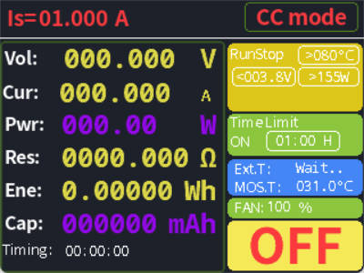
Figure 4. CC Mode Screen
3.4 CV Mode (Constant Voltage)
In CV mode, the load tester adjusts the current output to maintain a constant voltage.
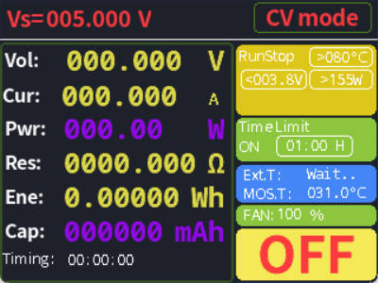
Figure 5. CV Mode Screen
⚠ NOTE: CV mode must not be used for battery testing! Forced use will burn out the MOSFETs!
3.5 CR Mode (Constant Resistance)
In CR mode, the load tester adjusts the input current and voltage to maintain a constant resistance.
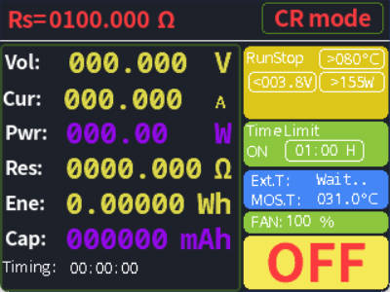
Figure 6. CR Mode Screen
3.6 CP Mode (Constant Power)
In CP mode, the load tester adjusts the current and voltage to maintain the set power value.

Figure 7. CP Mode Screen
3.7 CC/CV/CR/CP Mode Operation
The operation procedure for CC, CV, CR, and CP modes is as follows:
 | 
Figure 8. CC Mode (left) and CV Mode (right) parameter setting
 | 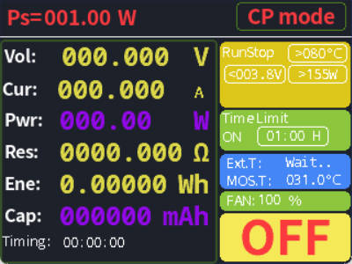
Figure 9. CR Mode (left) and CP Mode (right) parameter setting
1. Set the discharge parameter according to the operation mode: CC - set target constant current value; CV - set target constant voltage value; CR - set target resistance value; CP - set target constant discharge power.
2. Set protection parameters: Configure discharge stop voltage (to prevent battery over-discharge), as well as over-power and over-temperature protection. Set the stop voltage according to actual battery parameters.
3. Set the discharge countdown time, ranging from 0-99 hours.
4. Short press [Return/OK] to start the load. The system displays real-time status.
Real-Time Status Display
During operation, the system displays the following parameters:
Parameter | Description
Vol | Actual voltage value under testing.
Cur | Actual current value.
Pwr | Actual discharge power.
Res | Equivalent load resistance (calculated).
Ene | Energy value of the current discharge.
Cap | Capacity value of the current discharge.
Timing | Elapsed time of discharge.
Mode | Active operating mode.
Temp | Temperature of external probe and internal MOSFET.
Fan | Cooling fan speed rate.
Status | Operating status: "ON" or "OFF".
3.8 CDC/CDCDC Mode
CDC (Charge-Discharge) and CDCDC (Charge-Discharge-Charge-Discharge) modes combine charging and discharging cycles for comprehensive battery testing.
⚠ NOTE: Before entering CDC/CDCDC mode, connect the external charging module accessory to your device first. Due to voltage drop in the charging module, set the constant current charger output voltage at least 3V above the nominal battery voltage to ensure normal charging. The charging current in CDC and CDCDC modes is regulated by the external constant current charger.
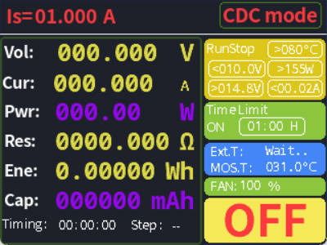 | 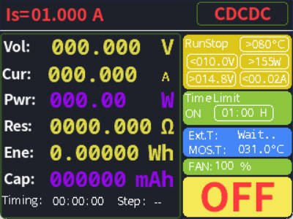
Figure 10. CDC Mode (left) and CDCDC Mode (right) parameter setting
Setup Steps
1. Set discharge current: Set appropriately according to your test requirements.
2. Set protection parameters: Configure discharge stop voltage (to prevent battery over-discharge), full charge voltage (prevents over-charge), charge stop current, as well as over-power and over-temperature protection. Please set according to actual battery parameters.
3. Set the discharge countdown time, ranging from 0-99 hours.
3.9 CDxN Mode (Charge/Discharge Cycling)
In CDxN mode, the device works with an external constant current charger to automatically repeat charge/discharge battery cycles. This mode is suitable for battery cycle life testing or durability evaluation. Users can set the number of charge/discharge cycles (up to 99 cycles).
⚠ NOTE: Due to voltage drop in the charging module, set the constant current charger output voltage at least 3V above the nominal battery voltage to ensure normal charging. The charging current in CDxN mode is regulated by the external constant current charger.
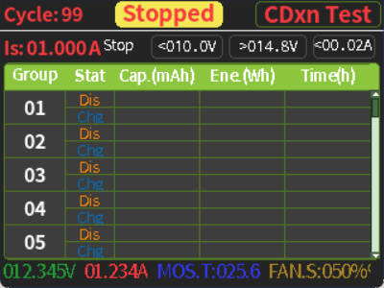
Figure 11. CDxN Mode Screen
Parameters
1.Cycle: Set total number of cycle repeats (up to 99).
2.Is: Set discharge current according to your test requirements.
3.Cycle Progress: Short press [+] / [-] to switch between screens.
4.Protection Parameters: Configure discharge stop voltage (prevents over-discharge), full charge voltage (prevents over-charge), and charge stop current. Set according to actual battery parameters.
Real-Time Display
- Real-time battery voltage.
- Real-time charge/discharge current.
- MOSFET temperature.
- Fan speed.
- Operating status: "Running" or "Stopped".
3.10 BRT Mode (Battery Resistance Test)
In BRT mode, the load tester measures the internal resistance of the battery, suitable for quickly detecting the health status of the battery.
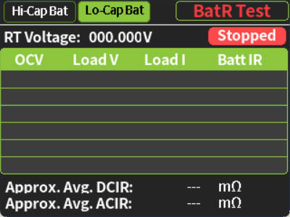
Figure 12. BRT Mode Screen
Setup Steps
1. Connect the battery to the device accordingly.
2. Select battery type: Long-press the [Setup] key to enter parameter settings. Then, briefly press [Setup] to select the battery type (Hi-Cap Bat/Lo-Cap Bat). Finally, long-press [Setup] to confirm the battery type To optimize the test parameters.
- Hi-Cap Bat Test Current: 1 A, 2 A, 3 A, 4 A, 8 A, 12 A, 18 A.​
- Lo-Cap Bat Test Current: 0.1 A, 0.2 A, 0.3 A, 0.4 A, 0.8 A, 1.2 A, 1.8 A.
Measurement Parameters
Parameter | Description
RT Voltage | Output voltage of the battery under test.
OCV | Open circuit voltage.
Load V | Loaded voltage.
Load I | Loaded current.
Batt IR | Battery internal resistance (calculated).
DCIR | DC voltage drop method comprehensive average internal resistance.
ACIR | AC comprehensive average internal resistance.
Mode | Currently active operating mode.
Status | Operating status: "Running" or "Stopped".
3.11 PT Mode (Power Supply Test)
In PT mode, the load tester automatically tests the maximum output current capability of power supplies or chargers, suitable for evaluating the load capacity of power adapters and chargers.
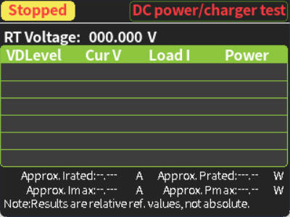
Figure 13. PT Mode Screen
Measurement Parameters
Parameter | Description
Status | Operating status: "Running" or "Stopped".
RT Voltage | Output voltage of the power supply under test.
VD Level | Voltage drop threshold.
Cur V | Current voltage.
Load I | Load current.
Power | Output power (automatically calculated).
Irated | Rated output current.
Imax | Maximum output current.
Pmax | Maximum output power.
Prated | Rated output power.
⚠ NOTE: Test results are relative values for reference only and should not be treated as absolute measurements.
3.12 CT Mode (Conductor Resistance Test)
In CT mode, the load tester automatically tests conductor resistance and current performance data.
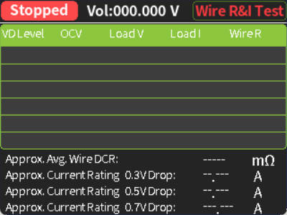
Figure 14. CT Mode Screen
Measurement Parameters
Parameter | Description
Status | Operating status: "Running" or "Stopped".
VD Level | Voltage drop threshold.
OCV | Open-circuit voltage.
LoadV | Loaded voltage.
LoadI | Loaded current.
WireR | Conductor resistance (calculated).
WireDCR | DC conductor resistance.
0.3V Drop | Rated current value at a 0.3V voltage drop.
0.5V Drop | Rated current value at a 0.5V voltage drop.
0.7V Drop | Rated current value at a 0.7V voltage drop.
Mode | Current operating mode.
Voltage | Output voltage of the power supply under test.

4. System Settings
4.1 Settings Menu
The following table lists the settings menu items:
No. | Setting Item | Description
1 | Screen Brightness | Set screen brightness level.
2 | Standby Brightness | Set standby screen brightness.
3 | Standby Time | Screen automatically enters standby after the inactivity time.
4 | Discharge Time Limit | Set global discharge time limit (0-99 hours).
5 | Ext. Temp Calibration | Calibrate the external temperature probe.
6 | Charge Stop Voltage | Set the maximum allowable battery voltage during charging to prevent over-charge damage.
7 | Discharge Stop Voltage | Set the minimum safe voltage during discharge to prevent battery over-discharge damage.
8 | Charge Stop Current | Set the charge termination current. Charging is considered complete when current falls below this value.
9 | Over Current Threshold | Set the over current protection threshold. Operation automatically stops and an alarm triggers when the threshold is reached.
10 | C/D OverPower Threshold | Set the overpower protection threshold. Operation automatically stops and an alarm triggers when the threshold is reached.
11 | Probe Over Temp Threshold | Set the over temperature protection threshold for the external temperature probe.
12 | MOSFET Over Temp Threshold | Set the over temperature protection threshold for internal MOSFETs.
13 | C/D Transition Delay | Set the wait time interval between each charge/discharge phase.
14 | Zero Offset Current | Perform zero-calibration when the no-load current display is non-zero.
16 | Clear All Data | Clear all cumulative charge/discharge data stored in the device memory.
17 | Factory Reset | Restore system parameters to factory defaults.
18 | Startup Info | Switch the startup information display (OFF/ON).
19 | Minimum Discharge Current | The minimum discharge current value required for a load constant-current loop.
20 | Key Sound | Switch the button key sound (OFF/ON).
21 | Alarm Sound | Switch the alarm sound (OFF/ON).

4.2 Communication Settings
This device supports two communication methods: USB HID and Modbus-TTL.
4.2.1 HID Communication
HID (Human Interface Device) communication connects to a computer via the HID interface on the board. Combined with host computer software, it enables data monitoring and remote control.
Connecting the Device to a PC
1. Connect the device HID port to your PC via a Type-C data cable.
2. Start the software "ELoad Electronic Load Control System.exe" on your PC.
3. Click the "CONNECT" button.
Driver Installation (Windows 7 Only)
Windows 10/11 systems are plug-and-play with no additional driver installation required.
Windows 7 systems require manual installation of the CDC driver (USB serial device recognition driver):
1. Open the "drivers" folder in the software directory.
2. Install "driver.bat".
3. After installation is complete, reconnect the device to the computer.
4.2.2 Modbus Communication
Modbus TTL communication is used to integrate the electronic load tester into automated testing systems or industrial control environments. It supports the standard Modbus RTU protocol, allowing real-time data such as voltage, current, and power to be read via Modbus commands.
Communication Parameters: Default settings are 9600 baud rate, 8 data bits, 1 stop bit, no parity.
Pin Definitions
Pin | Signal | Description
G | GND | Power Ground
T | TX | Data Transmit
R | RX | Data Receive
3.3V | VCC | Power Positive (3.3V)
4.3 Firmware Upgrade
1. While the device is powering on, long press the [+] button to enter firmware upgrade mode.
2. Follow the steps below in the host computer software to complete the upgrade:
- Click "Firmware" in the main software interface.
- Click "Enter Upgrade Mode" to enter upgrade mode.
- Open the firmware file to be upgraded.
- Click "Start Upgrade".
- Wait for the "Upgrade Progress" bar to reach 100% to complete the firmware update.

5. Host Computer Analysis Software
The host computer analysis software can be accessed via the following link:
https://wiki.meshnology.com/Ransanx/Ransanx_R150_DC_electronic_load_tester
5.1 Host Computer Interface
The interface layout and operation logic are similar across all modes. The system also supports test data export and data analysis functions. The figure below uses Constant Current (CC) mode as an example.
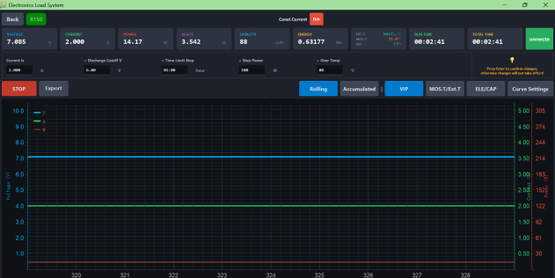
Figure 15. CC Test Mode Interface
5.2 CDCDC Test Mode
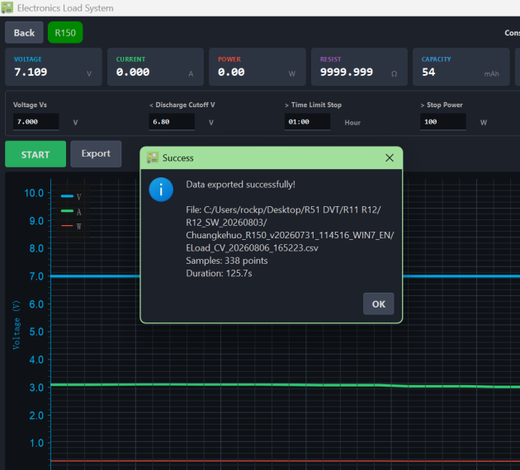
Figure 16. CDCDC Test Mode Interface
5.3 Cable Test
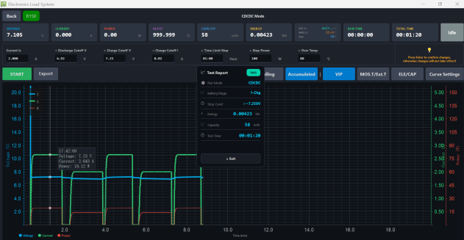
Figure 17. Cable Test Interface
5.4 Connecting to the Device
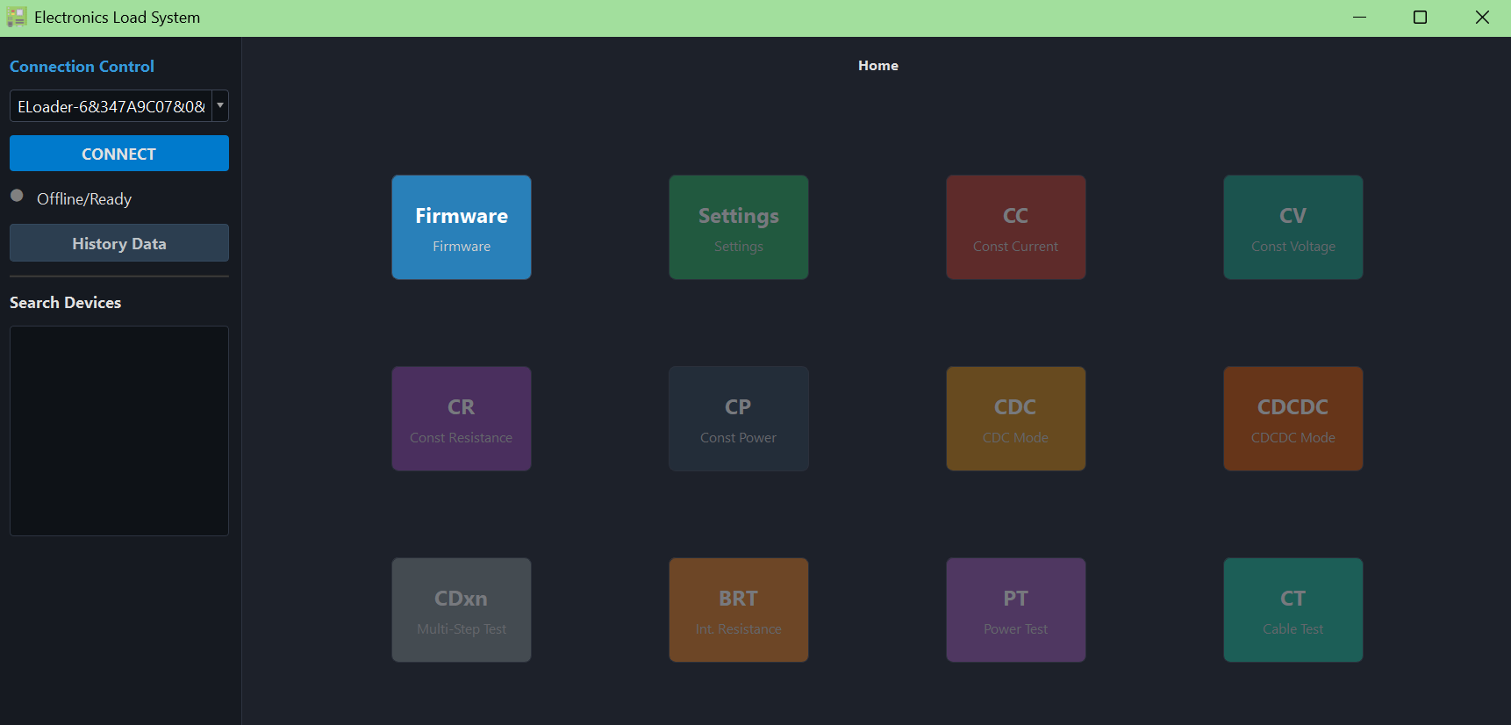
Figure 18. Device Connection Interface or Host Interface
5.5 Test Data Export
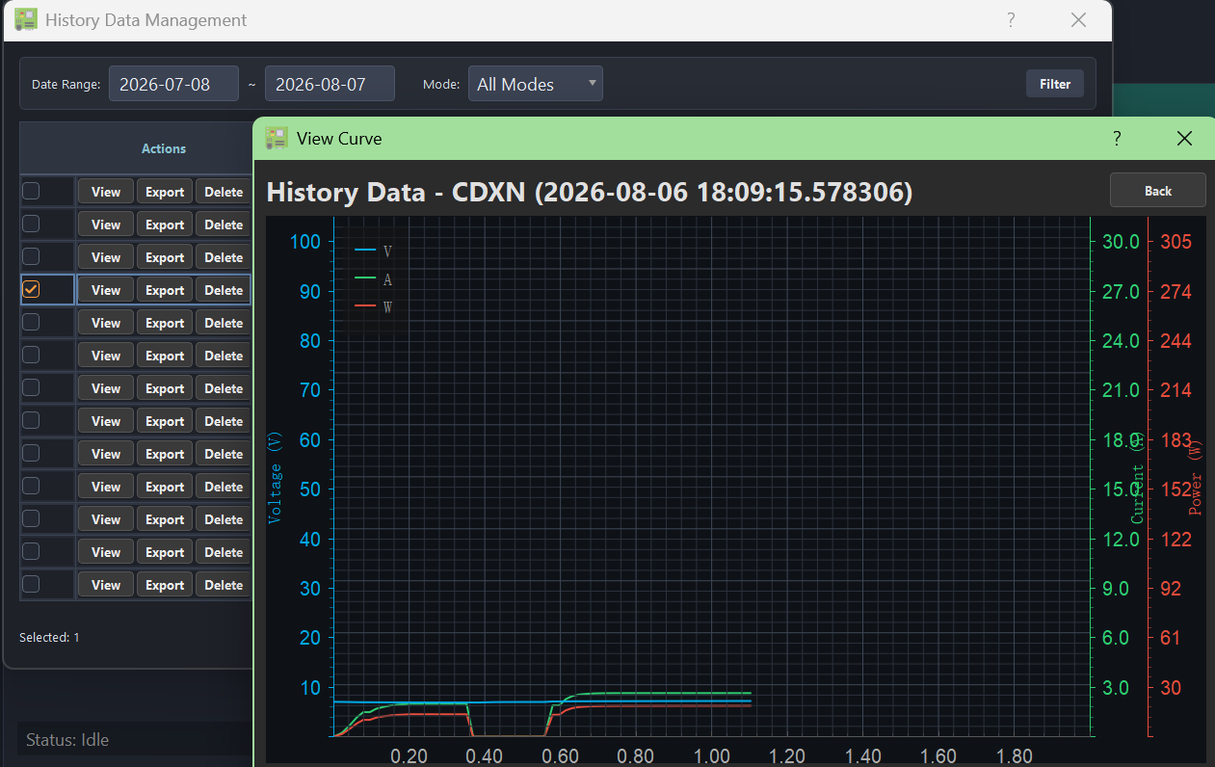
Figure 19. Test Data Export Interface
5.6 Test Data Analysis
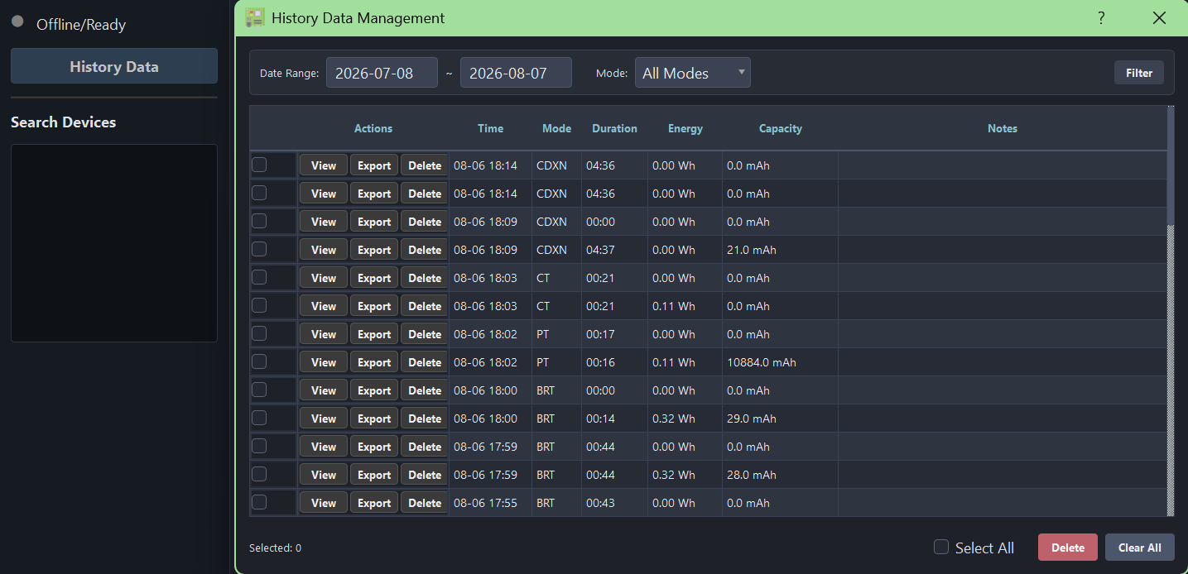
Figure 20. Test Data Analysis Interface (History Data)

[Caution]
1. Be sure to check the instruction manual before use , and familiarize yourself with the device’s usage methods and performance parameters.
2. Caution to avoid collision, falling, or other damage.
3. Avoid use it in hot, humid or easily disturbed environment.
4. Damage caused by force majeure events (such as floods, fires, earthquakes, war, etc.) or human factors (such as construction, cleaning, and other unintentional human factors) shall be resolved through mutual negotiation. Our company assumes no liability for any losses arising from product abnormal use.

