ST. VINCENT PALLOTTI COLLEGE OF ENGINEERING
& TECHNOLOGY, NAGPUR
(An Autonomous Institution under RTM Nagpur University)
DEPARTMENT OF ARTIFICIAL INTELLIGENCE
MINI PROJECT REPORT
Practical No. 9
SOFTWARE ENGINEERING AND PROJECT MANAGEMENT
ONLINE VOTING SYSTEM FOR STUDENTS
Submitted by
Student Name Yug Meshram
UID 24001027

Submitted to: Dr Vikas Bhowate
Course: Software Engineering and Project Management
Semester: V (5th Semester)
Academic Year: 2026–2027
Institution: St. Vincent Pallotti College of Engineering & Technology, Nagpur

ABSTRACT
The Online Voting System for Students is a proposed web-based software solution designed to organise the complete process of conducting student elections: voter registration and eligibility verification, candidate nomination, election scheduling, secure ballot casting, vote counting, result publication, and administrative reporting. In colleges, student council, class representative, club, and committee elections are often conducted through paper ballots, show of hands, or informal messaging polls. Such methods may cause duplicate or proxy voting, slow counting, disputes over results, loss of ballot secrecy, heavy manual effort for staff, and limited records for later audit. The proposed system addresses these problems by providing a centralised platform through which elections can be configured, voters verified, ballots cast once, and results produced consistently.
From the perspective of Software Engineering, the project follows an organised approach beginning with problem identification, stakeholder analysis, and requirement gathering. It identifies students (voters), candidates, election officers or administrators, and faculty auditors as the primary stakeholders. The proposed functional modules include user registration and authentication, voter-roll management, candidate nomination and approval, election scheduling, ballot casting, vote counting, result publication, and audit reports. Non-functional requirements such as security, ballot secrecy, reliability, usability, performance, and maintainability are also considered. The design is supported by a modular architecture, database entity definitions, workflow descriptions, and sample UI/UX website screens that illustrate how the application could operate.
From the perspective of Project Management, the report describes project scope, feasibility, work breakdown structure, resource requirements, a tentative development schedule, risk identification, quality assurance, and change management. An iterative development methodology is proposed so that essential features can be implemented and reviewed before more advanced functions are introduced. Planned testing includes eligibility checks, prevention of duplicate voting, role-based access verification, election-state transitions, ballot secrecy, and result accuracy. These activities provide a structured basis for tracking progress and assessing whether the software meets its stated requirements.
The expected outcome is an accessible, transparent, and trustworthy system that can reduce repetitive administrative work, prevent duplicate voting, speed up counting, and maintain consistent, auditable records. The interface designs included in this report are illustrative mockups rather than screenshots of a deployed application, and the testing scenarios represent planned verification rather than measured results. Potential future enhancements include OTP or biometric verification, a mobile application, multi-language ballots, end-to-end verifiable voting, and turnout analytics. Overall, the project demonstrates the practical application of software engineering and project management principles to a real-world campus election process.
Keywords: Online voting, student elections, e-voting, software engineering, project management, ballot secrecy, authentication, UI/UX design, testing.

TABLE OF CONTENTS
NO. | CONTENTS
01 | Abstract
02 | Introduction
03 | Problem Statement and Objectives
04 | Requirements Analysis and Feasibility
05 | System Architecture and Design
06 | UI/UX Design and Website Screenshots
07 | Software Engineering Methodology
08 | Project Planning and Management
09 | Proposed Implementation and Data Design
10 | Testing and Quality Assurance
11 | Security, Challenges, and Limitations
12 | Conclusion and Future Scope
13 | References
14 | Appendix A: Data Dictionary
15 | Appendix B: User Stories and Acceptance Criteria

CHAPTER 1: INTRODUCTION

1.1 Background
Student elections give learners practical experience of democratic participation and choose representatives for class, department, club, and college-level bodies. Colleges usually conduct these elections through paper ballots or informal digital polls. The conducting team must prepare voter lists, verify identities, supervise polling, count ballots, and announce results. As the number of students and posts increases, manual processes become slow, error-prone, and open to disputes.

1.2 Need for the Proposed System
A digital voting platform is needed to reduce dependence on paper lists, manual verification, and manual counting. A well-designed system can standardise voter eligibility, ensure that each student votes only once for each post, keep the ballot secret, produce results quickly, and give clear visibility into election status. It also creates an auditable history of the election, which is useful for resolving disputes and for future elections.

1.3 Scope of the Project
- Student-side facilities for registration, login, viewing active elections, candidate information, casting a vote, and viewing published results.
- Administrative facilities for creating elections and posts, uploading voter rolls, approving candidates, opening and closing polls, and publishing results.
- Candidate-side view for nomination submission, manifesto upload, and nomination status.
- Vote counting, result generation, turnout summaries, and audit reporting.
- Responsive web interface suitable for desktop and mobile access.
- A future-ready structure to support OTP verification, notifications, and advanced analytics.

1.4 Stakeholders
Stakeholder | Primary Interest / Responsibility
Student Voter | Log in, view candidates, cast one vote per post, and confirm that the vote was recorded.
Candidate | Submit nomination, share manifesto, and view nomination status and final result.
Election Officer / Administrator | Configure elections, manage voter rolls, approve nominations, and open or close polling.
Faculty Auditor / Principal | Oversee fairness, review audit reports, and approve result publication.
Faculty / Evaluator | Review the project report, design quality, and implementation approach.

1.5 Benefits of the System
The expected benefits include faster voting, prevention of duplicate and proxy voting, higher accessibility for students, instant and accurate counting, reduced paper use, and transparent records for audit. By converting a largely manual process into a structured information system, the project also becomes a good case study for software engineering and project-management principles.

CHAPTER 2: PROBLEM STATEMENT AND OBJECTIVES

2.1 Problem Statement
Develop an Online Voting System for Students that automates voter verification, candidate management, election scheduling, ballot casting, vote counting, and result publication. The system should reduce manual errors, enforce one vote per student per post, protect ballot secrecy, support role-based access, improve transparency, and provide a structured basis for fair and efficient conduct of student elections.

2.2 Objectives
- Design a centralised system for managing student elections from nomination to result declaration.
- Allow only eligible, authenticated students to vote and prevent more than one vote per post.
- Keep each ballot secret by separating voter identity from the choice made.
- Provide an end-to-end election lifecycle: Draft, Scheduled, Open, Closed, and Published.
- Maintain consistent records of students, candidates, elections, ballots, and results.
- Provide an easy-to-use and visually clear website interface for students and administrators.
- Define a practical test plan, project schedule, and quality criteria for implementation.

2.3 Expected Outcomes
The expected outputs of this academic project are a full project report, requirement analysis, system architecture, proposed UI/UX design, database schema, implementation plan, test cases, risk and security considerations, and optionally a website prototype. The final report should be suitable for printing and presentation. If the system is implemented, a demonstrable website would allow a student to log in and vote, and an administrator to create an election, close polling, and publish results.

2.4 Constraints and Assumptions
The project assumes internet connectivity for users, availability of an accurate student database from the college, and a defined set of eligible voters per election. It further assumes that the prototype will focus on core workflow functionality rather than full-scale integration with the college ERP, biometric devices, or formal election standards. Time, infrastructure, and data limitations may restrict development to a manageable academic prototype.

2.5 Feasibility Summary
Feasibility Type | Observation
Technical | A web-based prototype can be developed using standard frontend, backend, and database technologies.
Operational | Election officers and students can benefit directly from structured digital workflows.
Economic | A student prototype can be developed with low-cost or open-source tools.
Schedule | A basic version is feasible within an academic mini-project timeline if features are prioritised.

CHAPTER 3: REQUIREMENTS ANALYSIS AND FEASIBILITY

3.1 Functional Requirements
ID | Requirement
FR-01 | Allow students to register, log in, and manage their profile using college credentials.
FR-02 | Allow administrators to create elections, posts, and voting windows.
FR-03 | Allow administrators to upload and manage the eligible voter roll.
FR-04 | Allow candidates to submit nominations; administrators approve or reject them.
FR-05 | Allow an eligible student to cast one vote per post while the election is Open.
FR-06 | Track election status through Draft, Scheduled, Open, Closed, or Published states.
FR-07 | Count votes automatically and generate result and turnout reports.
FR-08 | Restrict actions using role-based access control.

3.2 Non-functional Requirements
- Usability: the interface should be simple, readable, and responsive on common screen sizes.
- Reliability: the system should avoid duplicate votes and inconsistent election states.
- Performance: voting and login should respond promptly even when many students vote in a short period.
- Security: passwords must be protected and users must not access data outside their role.
- Ballot secrecy: no user, including administrators, should be able to link a voter to the chosen candidate.
- Maintainability: modules should be separated clearly to simplify future changes.
- Scalability: the design should support additional students, posts, and departments in future versions.

3.3 Hardware and Software Requirements
Category | Proposed Requirement
Client System | Laptop/desktop/mobile with a modern web browser and internet access.
Development Environment | Python with Flask or Django / Node.js with Express; VS Code or equivalent IDE.
Database | MySQL, PostgreSQL, or SQLite for a prototype.
Version Control | Git and GitHub for change tracking and collaboration.
Deployment Option | Local server or low-cost cloud hosting for demonstration.

3.4 User Roles and Access Rights
Role | Key Permissions
Student Voter | Log in, view active elections and candidates, cast a vote, view published results.
Candidate | Submit nomination and manifesto, view nomination status and results.
Administrator | Manage elections, posts, voter rolls, nominations, polling status, and reports.
Auditor | View audit logs, turnout, and results; cannot modify votes.

3.5 Requirement Traceability Note
Each key functional requirement must later be linked to a corresponding module and one or more test cases. This traceability reduces the chance of missing features and helps demonstrate that the system design and validation activities are directly derived from the requirement set.

CHAPTER 4: SYSTEM ARCHITECTURE AND DESIGN

4.1 Proposed Architecture
The proposed system uses a modular web-application structure. Student, candidate, administrator, and auditor interactions are routed through role-appropriate interfaces. The application server handles authentication, eligibility validation, voting rules, vote counting, and report generation. A database stores users, elections, posts, candidates, voter-participation records, ballots, and audit-related timestamps. Optional notification services can be added later for reminders and result alerts.
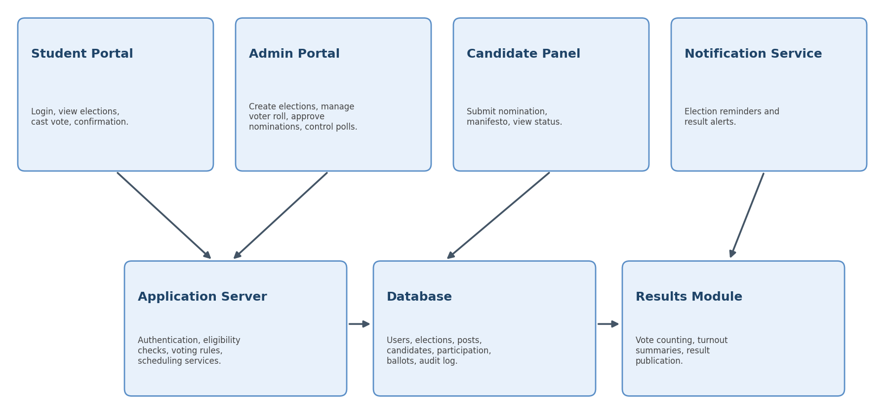
Figure 4.1: Proposed architecture of the Online Voting System for Students

4.2 Architectural Components
Component | Purpose in the System
Student Portal | Handles login, viewing elections and candidates, vote casting, and vote confirmation.
Admin Portal | Provides election setup, voter-roll management, nomination review, polling control, and reporting.
Candidate Panel | Allows nomination submission, manifesto upload, and status viewing.
Application Server | Applies validation rules, eligibility checks, voting logic, and business operations.
Database | Stores structured election data and supports retrieval and updates.
Results Module | Counts votes and produces results, turnout summaries, and audit reports.
Notification Layer | Can send election reminders and result alerts in future versions.

4.3 Process Flow
- The administrator creates an election, defines posts, and uploads the eligible voter roll.
- Candidates submit nominations; the administrator approves valid candidates.
- The election is scheduled and moves to the Open state at the configured start time.
- A student logs in; the system verifies identity and eligibility for each post.
- The student selects a candidate and confirms the ballot; the system records the vote and marks the student as having voted for that post.
- At the end time the election moves to the Closed state and votes are counted.
- After approval by the auditor, results are published and the full record is retained for audit.

4.4 Data Design Overview
The core entities are User/Student, Election, Post, Candidate, Voter Participation, Ballot, and Audit Log. Relationships must ensure that one student can vote at most once per post, and that each ballot belongs to one election and post. To protect secrecy, the Voter Participation record (who has voted for a post) is stored separately from the Ballot record (what was chosen) with no key linking the two. Primary keys, foreign keys, timestamps, and status fields are essential for integrity and traceability.

CHAPTER 5: UI/UX DESIGN AND WEBSITE SCREENSHOTS

5.1 Design Principles
The website concept has been designed with a focus on clarity, trust, and ease of use. The interface uses a clean layout, card-based information blocks, readable typography, and simple navigation. Important actions such as viewing candidates, casting a vote, and confirming a ballot are kept visually prominent. The colors and layout are selected to make the system appear modern yet formal and practical for an election workflow.

5.2 Student Dashboard
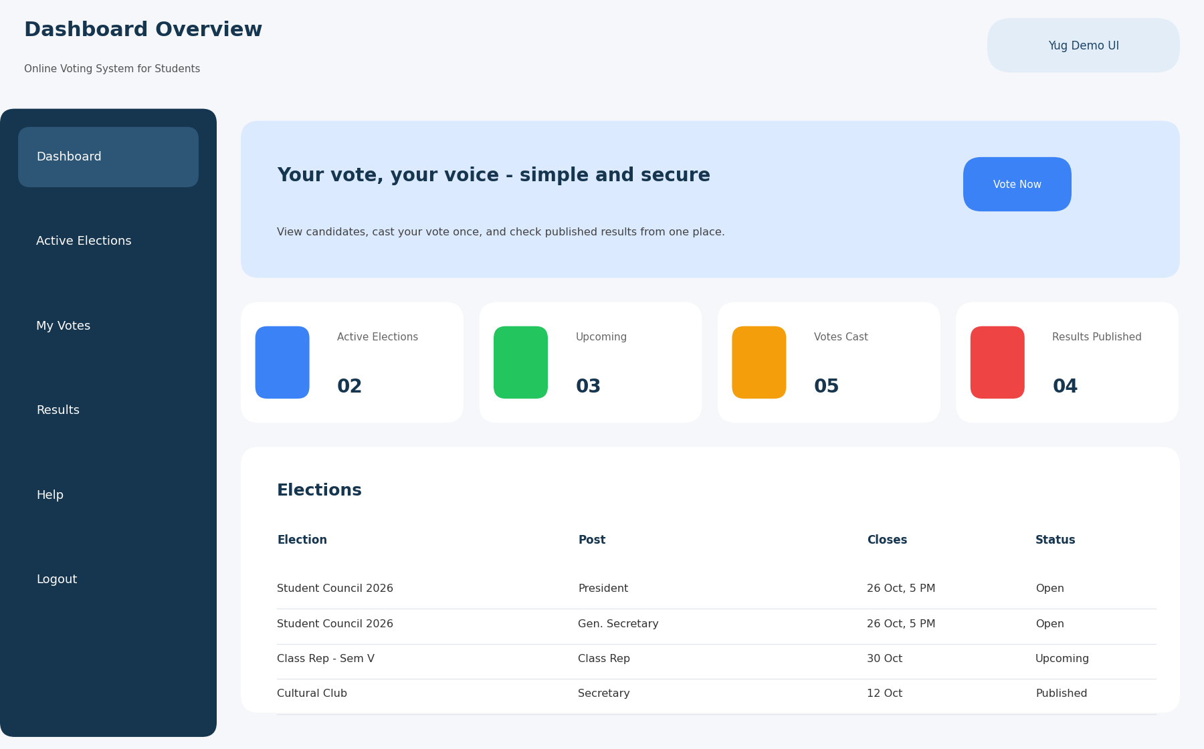
Figure 5.1: Student dashboard showing active elections, vote status, and quick actions
The student dashboard provides a quick summary of the election experience. It includes counts of active and upcoming elections, votes already cast, published results, and a table of elections with their closing time and status. This layout helps a student understand current activity without searching through multiple pages. The design also supports quick actions such as voting or viewing results.

5.3 Ballot Screen
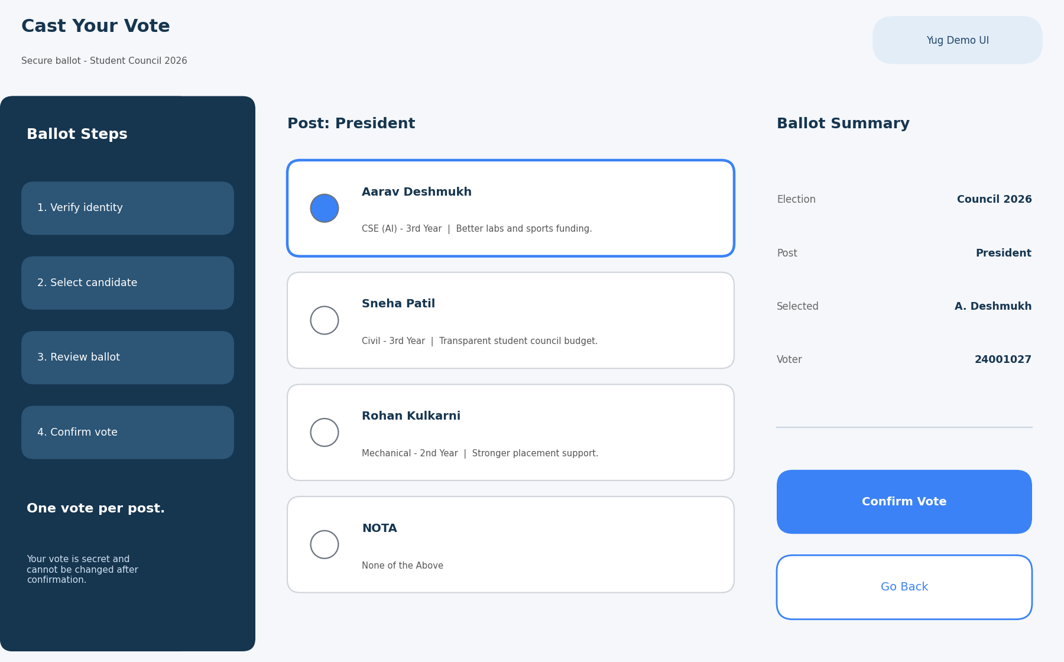
Figure 5.2: Proposed ballot screen with candidate selection and ballot summary
The ballot screen is designed to reduce input errors and make the voting process easy to understand. It divides the process into logical steps, shows each candidate with department, year, and a short manifesto, and displays a ballot summary before confirmation. The screen is intended to minimise confusion by showing both the choices and the summary on the same page, with a clear note that a confirmed vote cannot be changed.

5.4 UI/UX Notes for the Ballot Page
- Step-by-step flow reduces the chance of accidental or incomplete voting.
- Visible ballot summary improves confidence before final submission.
- Clear call-to-action buttons support confident user decisions.
- The layout can be adapted for mobile devices by stacking candidate cards vertically.

5.5 Administrative Election Console
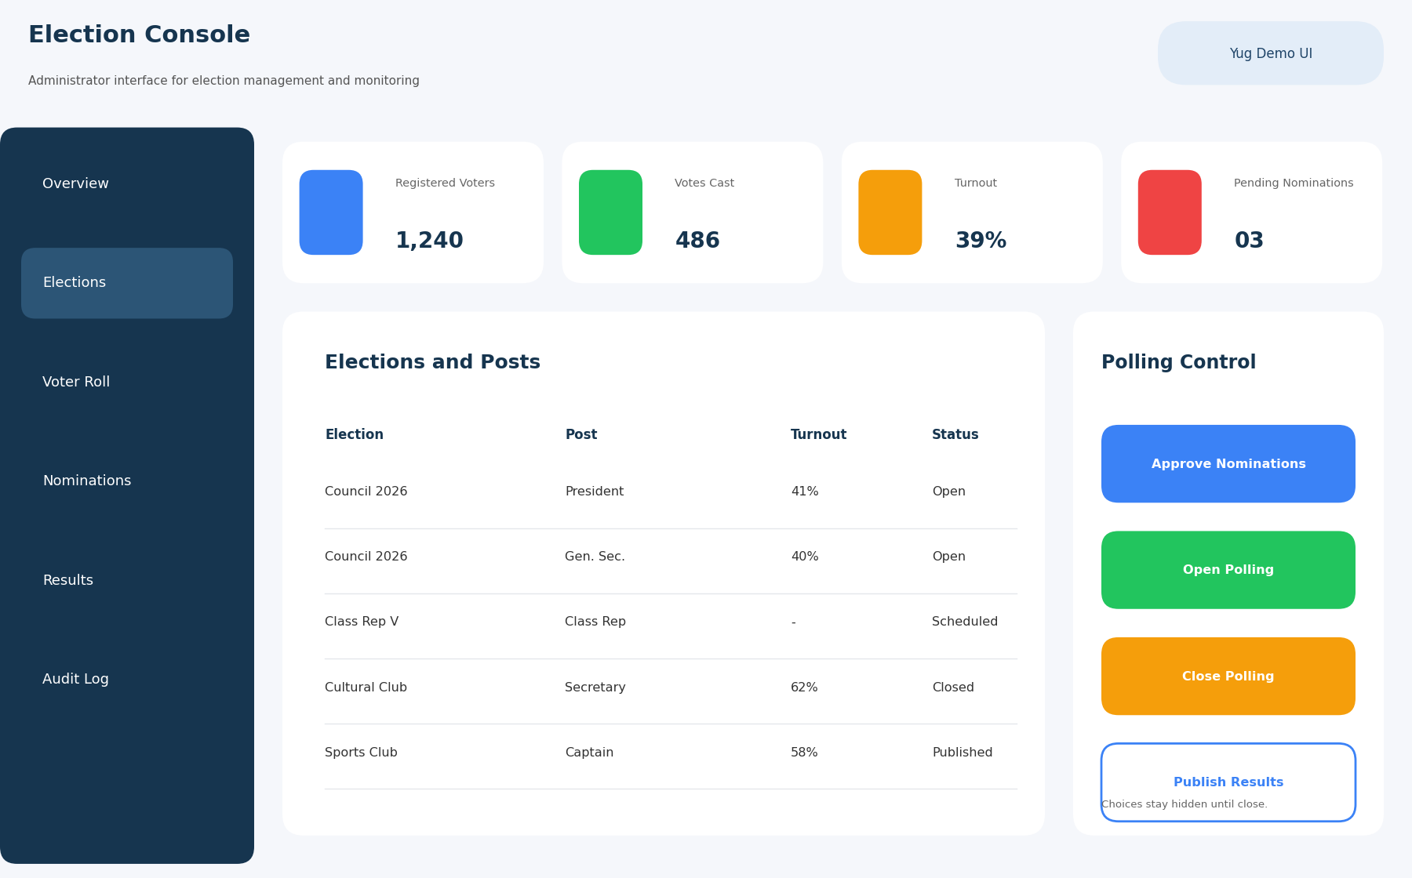
Figure 5.3: Admin election console for polling control and monitoring
The administrative console focuses on election management. It combines metric cards, a table of elections and posts, and a polling control panel for approving nominations, opening polling, closing polling, and publishing results. The interface is designed to support quick decisions while keeping important information visible in one place, without revealing how any student voted.

5.6 UI/UX Notes for the Admin Page
- High-priority metrics are shown at the top for quick situational awareness.
- The election table makes upcoming, open, and closed elections easy to scan.
- The control panel reduces manual context switching during election management.
- Vote counts remain hidden until polling is closed, supporting fairness.

CHAPTER 6: SOFTWARE ENGINEERING METHODOLOGY

6.1 Development Approach
An iterative or incremental software-development approach is suitable for this project. In the early iteration, the project can focus on core features such as student authentication, election creation, and ballot casting. Later iterations can introduce the nomination workflow, vote counting, result publication, and audit reporting. This approach supports continuous review, manageable scope, and early feedback.

6.2 Requirement Gathering Techniques
Requirements may be gathered through interviews with election officers, faculty coordinators, and students, observation of the current paper-based election process, use-case discussion, and analysis of pain points such as duplicate voting, delayed counting, and disputes. The requirement set should then be validated with a simple review document or prototype walkthrough to ensure that stakeholders agree with the proposed workflow.

6.3 UML / Analysis Artefacts
Artefact | Purpose
Use-case diagram | Shows interactions of student, candidate, admin, and auditor roles with the system.
Activity diagram | Describes operational flow such as nomination approval or vote casting.
Sequence diagram | Shows message flow between user, system, and database for key tasks such as casting a vote.
Class / ER diagram | Defines entities, attributes, and relationships.

6.4 Module Decomposition
Module | Responsibility
Authentication Module | User registration, login, logout, and session handling.
Election Module | Create elections and posts, set schedules, and manage election state.
Voter Roll Module | Import and verify the list of eligible voters.
Nomination Module | Submit, review, approve, or reject candidate nominations.
Voting Module | Present ballots, validate eligibility, and record votes securely.
Reporting Module | Count votes, publish results, and generate turnout and audit reports.

6.5 Change Management Note
If additional requirements emerge during development, they should be analysed for impact on scope, data model, schedule, and testing. Maintaining this discipline is important in project management because uncontrolled feature additions can delay completion and weaken quality.

CHAPTER 7: PROJECT PLANNING AND MANAGEMENT

7.1 Work Breakdown Structure
Work Package | Planned Deliverable
Project Initiation | Topic approval, scope statement, stakeholder identification.
Requirement Analysis | SRS notes, user roles, functional and non-functional requirements.
Design | Architecture, database design, UI wireframes, and UML artefacts.
Core Development | Authentication, election setup, voter roll, and voting modules.
Supporting Features | Nomination workflow, results, reporting, and interface polishing.
Testing and Review | Test cases, defect log, corrections, and validation notes.
Documentation & Demo | Final report, screenshots, and presentation preparation.

7.2 Tentative Project Schedule
Week | Main Activity | Milestone
1 | Problem study and scope confirmation | Approved topic and goal
2 | Requirement gathering and analysis | Requirement baseline
3 | Architecture, UI planning, and data design | Design review
4–5 | Implementation of core authentication, election, and voting modules | Usable prototype
6 | Nomination, results, and reporting features | Integrated build
7 | Testing and corrections | Quality-check stage
8 | Final report and demonstration preparation | Submission-ready package

7.3 Resource Planning
The primary human resource for the academic mini project is the student developer, supported by faculty guidance and feedback from representative users. The project also needs software tools such as a code editor, version control, a database engine, browser testing tools, and a document-preparation environment. Hardware requirements remain modest and can be met using a standard student laptop or desktop with internet access.

7.4 Risk Management
Risk | Possible Effect | Mitigation Strategy
Requirement ambiguity | Rework and inconsistent design | Confirm scope in writing after each review.
Time shortage | Incomplete feature set | Prioritise core modules and defer non-essential features.
Voting logic defects | Duplicate votes or disputed results | Test duplicate-vote and eligibility cases thoroughly.
Security mistakes | Unauthorised access or loss of ballot secrecy | Use role checks, password hashing, input validation, and separate voter and ballot records.
Overload at closing time | Students unable to vote | Load-test the prototype and allow a buffer in the polling window.
Deployment issues | Prototype not available during demo | Prepare local backup and pre-demo checks.

CHAPTER 8: PROPOSED IMPLEMENTATION AND DATA DESIGN

8.1 Suggested Technology Stack
Layer | Suggested Option | Purpose
Frontend | HTML, CSS, JavaScript | Responsive ballots, dashboards, and user interaction.
Backend | Python Flask / Django | Business logic, routing, validation, and session control.
Database | MySQL / PostgreSQL / SQLite | Persistent storage of operational data.
Version Control | Git and GitHub | Source-code tracking and backup.
Deployment | Local host / cloud demo environment | Prototype demonstration and testing.

8.2 Core Database Entities
Entity | Important Attributes
User | user_id, name, uid, email, department, year, role, password_hash, created_at
Election | election_id, title, start_time, end_time, election_status, created_by
Post | post_id, election_id, post_name, eligible_year, allow_nota
Candidate | candidate_id, post_id, user_id, manifesto, nomination_status
Voter Participation | participation_id, election_id, post_id, user_id, voted_at
Ballot | ballot_id, election_id, post_id, candidate_id (or NOTA), cast_at
Audit Log | log_id, user_id, action, timestamp, ip_address

8.3 Example System Workflow
- The administrator creates an election and uploads the voter roll.
- Candidates submit nominations and the administrator approves valid ones.
- The election opens at the scheduled time.
- A student logs in; the server checks eligibility and that no participation record exists for that post.
- The student confirms the ballot; the server writes the ballot and the participation record in a single transaction.
- After closing, the system counts ballots per candidate and prepares the result.
- The auditor approves, and the administrator publishes the results.

8.4 Business Rules
- A student may vote only once per post in a given election.
- Only students on the eligible voter roll may vote.
- Votes can be cast only while the election status is Open.
- A confirmed vote cannot be changed or deleted.
- Ballot records must not contain any reference to the voter.
- Only authorised administrators may approve nominations and change election status.
- Results are visible to students only after publication.

8.5 Reporting Possibilities
Useful reports include post-wise results, turnout by department and year, eligible versus participating voters, nomination summaries, and audit logs of administrative actions. Even a small prototype should prepare the system structure in a way that makes such reports easy to add.

CHAPTER 9: TESTING AND QUALITY ASSURANCE

9.1 Planned Test Cases
Test ID | Scenario / Input | Expected Result | Status
TC-01 | Login with valid student credentials | Student is logged in and sees the dashboard. | Planned
TC-02 | Login with wrong password | Login is rejected with an error message. | Planned
TC-03 | Student not on voter roll tries to vote | System denies access to the ballot. | Planned
TC-04 | Student tries to vote twice for the same post | Second attempt is blocked. | Planned
TC-05 | Vote attempted before start or after end time | System rejects the vote. | Planned
TC-06 | Student tries to open the admin console | Access is denied. | Planned
TC-07 | Close polling and count votes | Result totals match the number of ballots cast. | Planned
TC-08 | Inspect database for link between voter and ballot | No link exists; ballot secrecy is preserved. | Planned
TC-09 | Generate turnout and audit report | Report shows correct records and totals. | Planned

9.2 Testing Strategy
Testing should occur at multiple levels. Unit testing verifies individual functions such as eligibility checks and vote counting. Integration testing checks whether modules such as voting and result generation work together correctly. System testing evaluates complete workflows from election creation to result publication. User acceptance testing focuses on whether the system is understandable and trustworthy to intended stakeholders.

9.3 Quality Metrics
- Percentage of high-priority requirements covered by test cases.
- Number of passed versus failed test cases.
- Count of open critical and major defects.
- Correctness of election state transitions and duplicate-vote prevention.
- Responsiveness of the ballot page under normal and peak test conditions.

9.4 Quality Assurance Note
At the time of report preparation, no executed software test log or deployed website results were supplied for this project. Therefore, the table above represents a planned verification framework rather than completed execution evidence. Once the prototype is built, the actual results, screenshots, and defect observations should replace the planned status entries.

CHAPTER 10: SECURITY, CHALLENGES, AND LIMITATIONS

10.1 Security and Data Protection
- Store passwords securely using hashing and avoid plaintext credential storage.
- Apply role-based access checks on the server side for every protected action.
- Keep voter participation and ballot records separate to protect secrecy.
- Validate all user input and prefer parameterised queries to prevent injection attacks.
- Use HTTPS in deployment, secure session cookies, and session timeouts.
- Maintain tamper-evident audit logs and secure backups appropriate to the scale of the system.

10.2 Project Challenges
A real election system must balance secrecy with verifiability, resist impersonation and coercion, handle many simultaneous voters, and earn the trust of the student community. Even if the academic prototype handles the main workflow well, achieving full trust and verifiability remains challenging. This makes the project a realistic case for applying both software engineering and project-management thinking.

10.3 Limitations
The present report proposes a complete design and UI concept, but it does not claim that a production-grade system has been implemented or deployed. The design may not yet include OTP or biometric verification, end-to-end verifiable voting, protection against coercion, or formal compliance processes required in large-scale elections. These aspects are appropriate future extensions rather than assumed current features.

10.4 Maintenance Considerations
After implementation, the system should be maintained through regular backup checks, security updates, defect correction, interface improvements, and review of user feedback. Any modification should be assessed for impact on requirements, database design, and testing coverage before release.

CHAPTER 11: CONCLUSION AND FUTURE SCOPE

11.1 Conclusion
The Online Voting System for Students has been presented as a structured mini-project for the Software Engineering and Project Management subject. The report covers the problem definition, project objectives, stakeholder analysis, requirement specification, architecture, UI/UX design, planning, implementation proposal, testing strategy, and security considerations. In addition to written analysis, the report includes representative website screens to make the proposed solution clearer and more realistic. Overall, the project demonstrates how a real campus process can be addressed through systematic software design and project planning.

11.2 Future Scope
- OTP, college-email, or biometric verification for stronger identity assurance.
- Mobile application with push notifications and election reminders.
- Multi-language ballots and accessibility features.
- Cryptographic and end-to-end verifiable voting for greater transparency.
- Advanced analytics on turnout and participation.
- Integration with the college ERP for automatic voter-roll updates.

REFERENCES
[1] Ian Sommerville, Software Engineering, 10th ed., Pearson, 2015.
[2] Roger S. Pressman and Bruce R. Maxim, Software Engineering: A Practitioner’s Approach, 9th ed., McGraw-Hill, 2019.
[3] Project Management Institute, A Guide to the Project Management Body of Knowledge (PMBOK Guide), 7th ed., 2021.
[4] ISO/IEC/IEEE 29148:2018, Systems and software engineering — Life cycle processes — Requirements engineering.
[5] OWASP Foundation, OWASP Top 10: Web Application Security Risks, https://owasp.org/www-project-top-ten/.

APPENDIX A: DATA DICTIONARY
Field Name | Type | Description
election_id | Integer / UUID | Unique identifier for each election.
post_id | Integer / UUID | Unique identifier for a post within an election.
user_id | Integer / UUID | Reference to the student/user.
candidate_id | Integer / UUID | Reference to an approved candidate.
election_status | Enum | Draft, Scheduled, Open, Closed, or Published.
nomination_status | Enum | Submitted, Approved, Rejected, or Withdrawn.
voted_at | DateTime | Time at which a student’s participation was recorded (no link to choice).
cast_at | DateTime | Time at which a ballot was recorded (no link to voter).
role | Enum | Student, Candidate, Administrator, or Auditor.

APPENDIX B: SAMPLE USER STORIES AND ACCEPTANCE CRITERIA
Sample User Story 1: As a student, I want to vote online so that I do not need to stand in a queue at a polling booth.
- Acceptance criterion 1: The system must verify that the student is on the eligible voter roll.
- Acceptance criterion 2: The student must be able to choose exactly one candidate (or NOTA) per post.
- Acceptance criterion 3: A confirmation must be shown after the vote is recorded, without revealing the choice to anyone else.
Sample User Story 2: As an election officer, I want to open and close polling and publish results so that the election is conducted fairly and efficiently.
- Acceptance criterion 1: Only approved candidates should appear on the ballot.
- Acceptance criterion 2: Votes must be accepted only while the election is Open.
- Acceptance criterion 3: Results must be generated automatically after closing and published only after approval.
Submission Note: Before final college submission, the faculty name, signatures, and any institution-specific certification text should be added if required. If an actual implementation is completed later, replace mock UI screens with real application screenshots wherever appropriate.

