

**SOEN 6841**

Winter 2024

**SOFTWARE PROJECT MANAGEMENT**

**EDUCATIONAL GAMIFICATION PROBLEM**

PROJECT INITIATION and MARKET ANALYSIS

Submitted to:

**Dr. Joumana Dargham**

Submitted by:

|  |  |
| --- | --- |
| Name | Student ID |
| Jasmanpreet Kaur Bedi | 40231120 |
| Anirudh Boddu | 40225271 |
| Meshva Patel | 40255073 |
| Aswiin Ravi Prakash | 40278497 |

**Table of Contents**

Problem Identification 3

Problem/Opportunity Statement 3

Stakeholder Analysis 4

Relevance to Software Solution 5

Market Analysis Report 6

Target Audience Identification 6

Demographic Characteristics of Target Audience 7

Psychographic Characteristics of the Target Audience 9

Competitor Analysis 11

Business Values 12

# **Problem Identification**

## **Problem/Opportunity Statement**

There is a promising possibility that could enhance the learning experience in the ever-evolving world of educational gamification platforms. Upon deep-diving we found that this opportunity centers around two key areas:

1. Leveraging Generative AI for Personalised Content Generation: This opportunity involves utilising the strength of Generative AI to generate quizzes, challenges and interactive lessons specifically tailored to meet the learning goals of a student. This challenges the current limitation of static, mundane and repetitive material by delivering dynamic, personalised and flexible learning resources based on student’s progress and learning.

- *Significance*: This feature enables a transformation in the content creation process, improves customer engagement and dramatically helps individual student needs by tailoring educational materials to meet their needs. Moreover, this innovation has a high potential to disrupt the education landscape while aligning with the growing trend of individualised learning.

2. Gamified Learning Analytics: The other promising opportunity that we have found is to incorporate gaming elements with educational data analysis. Teachers can gain valuable insights into students' behaviours, interests, and learning styles by utilising this gamified learning analytics. As well as come up with better teaching strategies and customised learning plans with the help of this data-driven strategy.

- *Significance*: The disconnect between student progress and effective teaching methods can be tackled with this empowerment. Gamified Analytics not only equips teachers to accommodate their procedures but also paves the way for a tailored and effective educational journey for each student.

## **Stakeholder Analysis**

The opportunities at hand have a profound impact on various key stakeholders, namely teachers, students, educational institutions, parents, and technology providers. These stakeholders are highly motivated to see positive changes in the education landscape.

- *Teachers*: Teachers are driven by the desire to improve their teaching strategies, save time, and ultimately enhance student outcomes. The proposed solutions provide them with the tools to achieve these goals. They also offer opportunities for professional development and collaboration with peers.

- *Students*: Students are seeking engaging and customized learning experiences that cater to their individual needs. The proposed solutions aim to meet these needs by providing personalized and dynamic learning resources. They also promote self-paced learning and foster critical thinking skills.

- *Educational Institutions*: Educational institutions are focused on maximizing educational results, increasing student retention rates, and staying ahead in the competitive education market. The proposed solutions align with these objectives by enhancing the teaching and learning experience. They also support administrative efficiency and data-driven decision-making.

- *Parents*: Parents are keen on being involved in their child’s education and want to monitor their progress. The proposed solutions offer them the ability to track their child’s performance and communicate effectively with teachers.

- *Technology Providers*: Technology providers play a crucial role as they develop and maintain the proposed solutions. They are interested in understanding the needs of the other stakeholders to improve their products and services. They also benefit from the increased adoption of technology in education.

- *Product Owner (Professor):* As the Product Owner, the professor plays a pivotal role in guiding the project, aligning it with market demands and the course goals. Their top priority is catering to the end-users and delivering value to the market. With expert skill, they critisise, prioritise tasks and make critical decisions that drive the project towards meeting the ever-evolving market needs.

## **Relevance to Software Solution**

1. Generative AI-based Automated Content Creation:

- *Software Development Solution:* We propose the development of an AI-driven platform that creates engaging and interactive content. Users simply set their learning objectives, and our advanced generative algorithms generate dynamic quizzes, challenges, and interactive elements. This will allow educators to focus more on teaching and less on content creation, while students will benefit from a more engaging and personalized learning experience.

- *Scope:* Our platform is designed to be user-friendly, with a powerful AI engine and features for continuous enhancement based on user feedback and analytics. This solution represents the future of content creation, providing users with a dynamic and personalized learning experience. It also has the potential to scale and adapt to different educational contexts and curricula, making it a versatile tool for various educational institutions.

2. Gamified Learning Analytics:

- *Software Development Solution:* We propose the incorporation of a gamified analytics module into the software platform. This module will provide educators with intuitive data visualization, progress monitoring, and tailored insights into student learning. It will allow teachers to understand student performance at a granular level and make data-driven decisions to improve teaching strategies.

- *Scope:* The software will gather and interpret data on student interaction, achievements, and learning trends, presented in an engaging gamified format. This advanced tool will empower educators to adjust their teaching methods based on valuable analytics, enhancing the effectiveness of their teaching strategies. It also provides students with a clear understanding of their progress, motivating them to take ownership of their learning.

By utilizing these software solutions, we not only capitalize on the identified opportunities but also align with our ultimate vision of developing a cutting-edge educational gamification platform. This will greatly enhance the teaching and learning experience for everyone involved, driving positive outcomes for all stakeholders.

# **Market Analysis Report**

The Education Gamification Market is a rapidly expanding sector within the global education industry. It involves integrating game design, mechanics, and principles into educational processes and content to improve student engagement, motivation, and learning outcomes. This market includes various educational products, services, and technologies that utilize gamification techniques, aiming to make learning more interactive, enjoyable, and effective. Education gamification applies game-like elements such as points, rewards, competition, and storytelling to educational materials and activities. This innovative approach is suitable for both formal and informal learning environments.

## **Target Audience Identification**

1. **Students**: One of our primary target audiences consists of students from diverse educational backgrounds, including colleges, schools, and working professionals who seek continuous learning opportunities. Anyone who is eager to learn, is pursuing an academic discipline or is engaged in any sorts of professional development or upskilling is a valuable target for our platform.

One of the major drawbacks in education for students is the ability to maintain interest for stretched periods of time and stay motivated in traditional methods. Our platform focuses on incorporating gamification to address this issue and maintain engagement throughout.

1. **Parents**: Parents of all target educational levels are a vital part of our target audience, this includes parents of children in school, college students, and young professionals involved in continuous learning. Often Parents are quite invested and interested in their child's academic journey. They want to be kept in the loop about how their child is performing and what they can do to further support them. Our platform recognizes the importance of parental involvement and offers tools and analytics to track and monitor their child's educational performance and progress.

Collaboration between parents, students, and educators is one of the means to bring out the best in a student’s development. Our platform encourages parents to actively participate in their child's learning process, creating a supportive environment that enhances the overall educational experience.

1. **Teachers**: Educators across different educational institutions, including schools and colleges, are a key target audience for our platform. This is inclusive of teachers involved in all kinds of subjects and disciplines. Since Teachers play a pivotal role in delivering educational content, It is extremely important to equip them with tools, resources and required support to create engaging and interactive lessons that go with the objective of educational gamification and capture students' attention to encourage a positive and fun learning environment.
2. **Organizations**: Organizations across various industries looking to upskill their employees and enhance their workforce's capabilities are also a strategic target audience for our platform. Often people skip the tutorials since they are not able to build an interest in the teaching material because of the lack of engagement and effectiveness. Employees further encounter challenges while implementing the skills in such cases. Thus it becomes crucial for organizations to provide an engaging method of helping their employees, while in turn being aware of the actual progress of an employee.

### **Demographic Characteristics of Target Audience**

Our Product targets audience based on the following demographics:

1. **Age:**

The primary age range for our platform ranges from ages 5 to 18 for K-12 students, extending to age 18-24 for higher education students and aged 24+ for organizational trainings.

1. **Grade/Level:**

Our Platform is made adaptable to cater to the needs of students across all kinds of age groups, regardless of their proficiency in any subject.

1. **Location:**

Initially, the software aims to target a nationwide audience, however, the platform has the potential and can be easily expanded for the global population in future enhancements. This is kept considering the regional and cultural differences, and tailoring the platform based on these would also contribute to the success of the software internationally.

Based on the trends and observations, it is noted that North America contributes to around 30% of the global educational gamification platforms demand due to its advanced educational infrastructure and high technology adoption rates as is Asia due to a rapid economic development and significant increase in the investment on education. They are followed by Europe at 25% driven by progressive education policies and a focus on innovative teaching methods. Africa and South America contribute equally to 7.5% of demand.

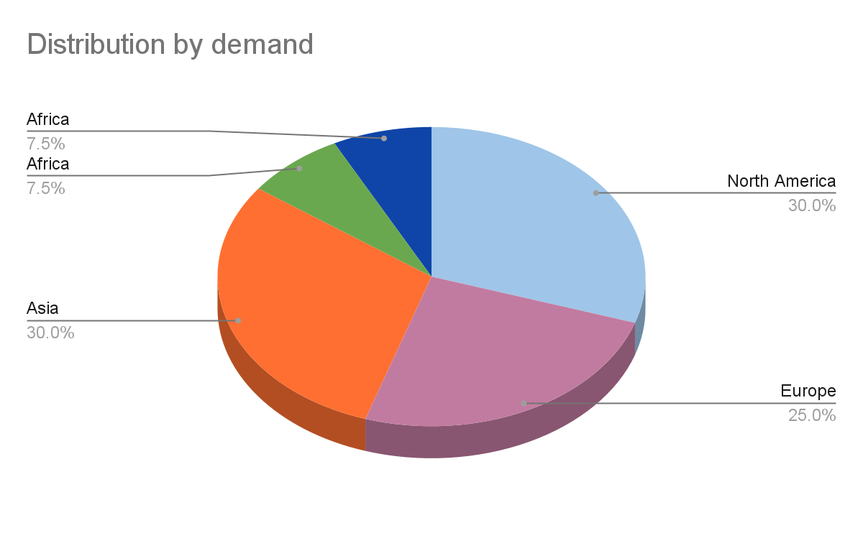

1. **Language:**

English is considered the default and primary language of the software considering it is a language spoken and understood by people all across the world, thus making the platform accessible for a broader user base. The platform will be further modified to accommodate multi-language support and translation of course materials into multiple languages, so learning can become accessible to all regardless of what language one speaks.

The proposed product also aims at having sign language incorporated into the course. As an educator delivers content, the platform will use Speech to text or Speech-to- Sign Language Conversion using Deep Learning/Artificial Intelligence to generate sign language side-by-side. For example:



1. **Technological proficiency:**

It is assumed that everyone accessing the platform will have basic technical knowledge, and further customizations will be made for tech-savvy users.

For example, initially, a user is met with the platform assuming a foundational level of technical knowledge. Then as a user navigates the platform, the technical abilities and resources are accessed and the platform adapts accordingly.

### **Psychographic Characteristics of the Target Audience**

1. **Learning Styles**

The educational gamification platform is designed to cater to diverse learning styles, acknowledging the fact that every student is unique and may have different ways of absorbing and processing information. By adding things that help people who like to see, hear, and do things differently, the platform makes sure that learning is interesting and covers different ways people like to learn.

Visual learners benefit from interactive visuals and graphics, auditory learners from immersive audio components, and kinesthetic learners from hands-on, interactive activities. This strategy strives to engage and resonate with students having different learning preferences, creating an educational environment that embraces inclusivity and embraces a diverse range of learners.

1. **Motivation**

One of the key driving factors for Educational Gamification platforms is to target students who thrive in a gamified learning environment instead of the traditional learning approaches. By integrating game-like elements for education eg teaching by creating an interactive interface, challenges, rewards, and competition, the platform aims to enhance motivation. This method aims to make learning more fun and rewarding, helping students remember and understand things better. Using gamification techniques increases students' natural desire to achieve and compete, giving them a motivational boost that can make their learning journey more positive and engaging.

1. **Technology Adaptation**

Our platform embraces and adapts for students comfortable with technology-enhanced learning experiences as well as everyone with basic proficiency. It analyzes the digital proficiency of the target audience, and then leverages cutting-edge technology to create an interactive and dynamic learning environment, for example, while learning in the form of games, if someone has a VR headset, they have the option of playing the game in Virtual Reality. This not only aligns with the tech-savvy nature of today's students but also acts interesting for those who are not able to concentrate in the traditional learning environment. The platform facilitates a seamless integration of educational content with modern technological tools, ensuring an engaging and relevant learning experience.

1. **Collaboration/Competitiveness**

An integral aspect of our platform is its emphasis on collaborative learning and teamwork among students. By including features that facilitate group activities, challenges, and interactive tasks, the platform promotes a sense of community and shared achievement as well as motivation by watching others succeed. It promotes a healthy spirit of competition to encourage students to keep learning. Collaborative learning not only enhances the overall educational experience but also prepares students for real-world scenarios where teamwork and communication are vital skills. The platform's design fosters an environment where students can learn from each other, share insights, and collectively succeed in their educational endeavours.

1. **Creativity and Curiosity**

Our educational gamification platform includes elements that inspire students to think outside the box and express their innovative ideas. Creative challenges, interactive projects, and open-ended tasks provide opportunities for students to explore their artistic and creative abilities. A creative environment within the platform helps students not only enhance their problem-solving skills but also develop a sense of confidence in their own unique perspectives. The platform includes fun activities like simulations, interesting situations, and interactive content to make students curious and encourage them to ask questions and explore. This helps students naturally want to learn more, connect ideas, and better understand the subject.

This approach extends beyond traditional learning methods, empowering students to approach challenges with innovative thinking and fostering a lifelong appreciation for creativity.

## **Competitor Analysis**

The Education Gamification Market has experienced significant growth as educators, institutions, and edtech companies recognize its transformative potential in education. Gamification provides an engaging and immersive learning experience, particularly appealing to the tech-savvy generation of students. Gamified learning platforms often include personalized feedback, progress tracking, and creating an interactive and social learning environment. It also accommodates various learning styles depending on the student, allowing learnng at their own pace, and meeting the diverse needs of today's learners. Consequently, the education gamification market has seen substantial investments and innovation, offering a range of products and services from educational apps and platforms to virtual reality experiences, harnessing gamification for effective learning outcomes.

The influence of the Education Gamification Market extends beyond traditional classrooms to corporate training, professional development, and lifelong learning. Organizations increasingly adopt gamified training modules to enhance employee skills, and improve engagement, and overall productivity. This approach is especially relevant in the digital age, where attention spans are decreasing, and traditional teaching methods may be less effective. Furthermore, gamification platforms often gather valuable data on user performance, enabling teachers and organizations to continually monitor for optimized learning experiences. As the education gamification market evolves, it has the potential to revolutionize knowledge acquisition, making learning more accessible, enjoyable, and effective for learners of all ages and backgrounds.

1. **Duolingo**:
2. **Bunchball**:
3. **Prodigy**
4. **Top Hat:**
5. **MPS Interactive**

## 

## **Business Values**

References:

Img: https://www.signfordeaf.com/