

**FINANCIAL ERP**

**A PROJECT REPORT**

***Submitted by***

**Meshvi Shah**

**190770107620**

***In partial fulfillment for the award of the degree of***

**BACHELOR OF ENGINEERING**

**In**

**Department of Computer Engineering**

**Silver Oak College of Engineering & Technology,**

**Ahmedabad-382481**

**Gujarat Technology University, Ahmedabad**

**May, 2023**





**Silver Oak College of Engineering & Technology,**

**Ahmedabad**

**Gota Gam, Ahmedabad, Gujarat, India, 382481.**

**CERTIFICATE**

This is to certify that the project report submitted along with the project entitled **Financial ERP** has been carried out by **Meshvi Shah** under my guidance in partial fulfillment for the degree of Bachelor of Engineering in Computer Engineering, 8th Semester of Gujarat Technological University, Ahmadabad during the academic year 2022-23.

A/Prof. Ekta Vyas Dr. Satvik Khara

**Internal Guide Head of the department**

**INDUSTRY LETTER HEAD**

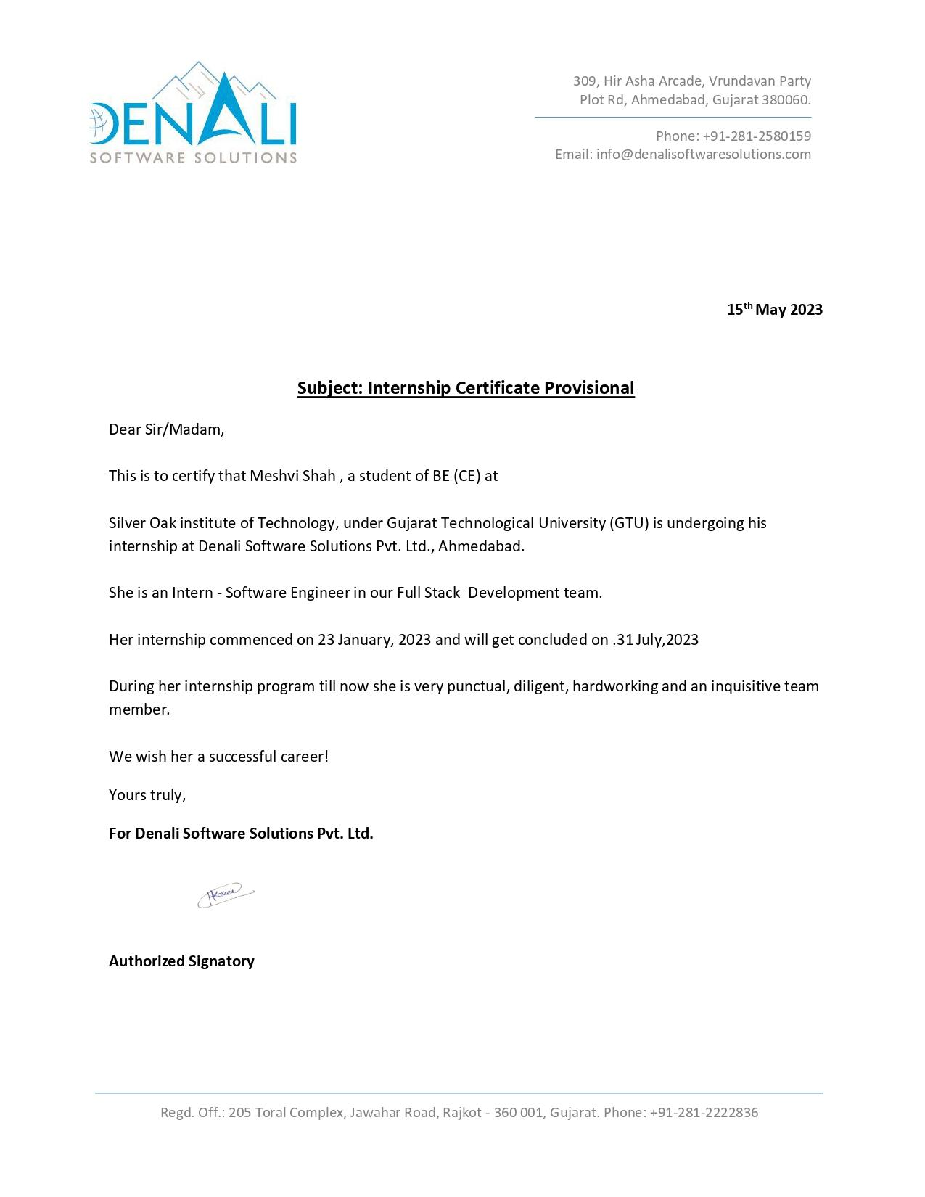

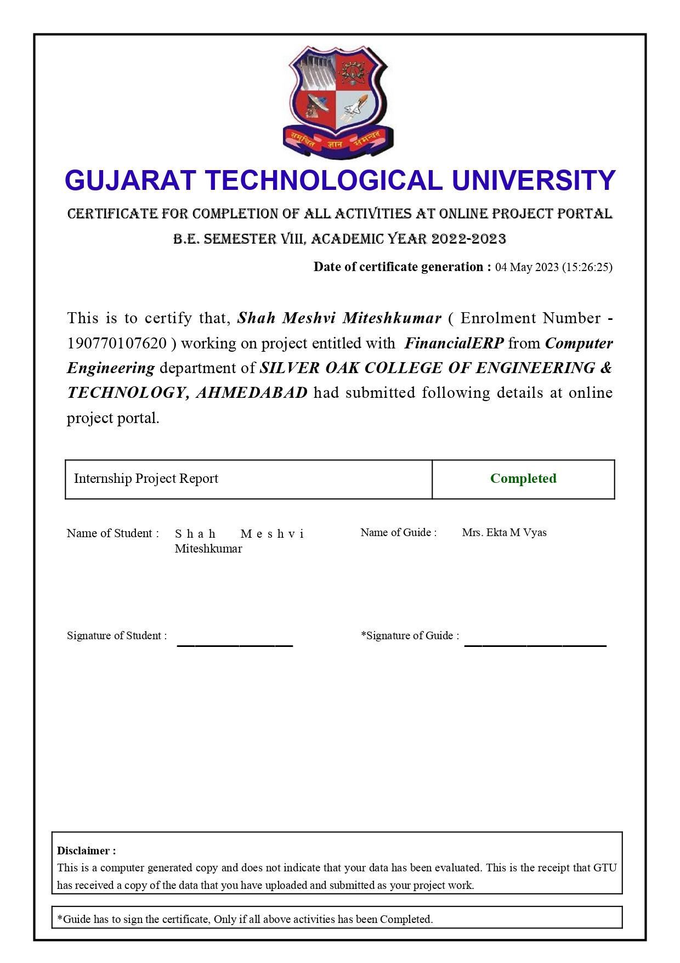





**Silver Oak College of Engineering & Technology, Ahmedabad**

**DECLARATION**



We hereby declare that the Internship report submitted along with the Internship entitled **Trainee** submitted in partial fulfillment for the degree of Bachelor of Engineering in Computer Engineering to Gujarat Technological University, Ahmedabad, is a Bonafede record of original project work carried out by me at Denali software Solutions(Alliance Tek Inc Ltd.) under the supervision of Prof. VISHAL NAYI and that no part of this report has been directly copied from any students’ reports or taken from any other source, without providing due reference.

Name of Student Sign of the Student

Meshvi Shah

**ACKNOWLEDGMENT**

I am thankful to Silver Oak College of Engineering & Technology for giving me an opportunity to develop this project. A/Prof. EKTA VYAS(Internal Guide) is the main force behind all these. The project became successful only because of their valuable suggestions, proper co-operation and complete guidance in developing this project. It was also the support from the staff members who spend their valuable time in providing us all the relevant and confidential college information which has helped us in preparing our project I am thankful to my guide who is the real source of inspiration and encouragement. His constant help, thoughtful suggestions and deep interest has enabled me to make this project successful. I also express my sincere thanks to our H.O.D, who allowed to use all the resources of the institute.

I am thankful to all our staff members who helped continuously and inspired me in the project.

Yours sincerely,

Meshvi Shah

(190770107620)

***ABSTRACT***

*The objective of this project is to provide services with an automated notification system that manages user payment Reminder and requirements. The project will focus on utilizing advanced technological tools and strategies to ensure smooth communication and coordination between our team of chartered accountants and their clients. By implementing an automated notification system and effective user management strategies, we will ensure that our clients stay informed and up-to-date with any changes that may affect their financial situation.*

*Financial ERP solutions provide companies with a centralized platform to manage financial operations, streamline workflows, and improve data accuracy. With a financial ERP system, businesses can automate time-consuming manual processes, reduce the risk of errors, and increase efficiency. Additionally, financial ERP systems provide real-time insights into financial performance, enabling companies to make informed decisions based on accurate and up-to-date information.*

**List of Figures**

Figure 2.2.1 SDLC…………………………………………………………………………4

Figure 3.7.1 Gantt Chart…………………………………………………………………..15

Figure 4.5.2.1 Admin Use Case System………………………………...………………..19

Figure 4.5.2.2 Employee Use Case System……………………………….………………19

Figure 4.5.2.3 Activity Diagram……...…………………………………………………...20

Figure 4.5.3.1Sequence Diagram (Signup)………….…...………………………………..21

Figure4.5.3.2 Sequence Diagram (Login)………….……………………………………...21

Figure4.5.3.3Sequence Diagram (Forgot Password)……………………………………...22

Figure 4.5.3.4 Sequence Diagram (Logout) ……………….……………………….…....22

Figure 5.2.1 Class diagram …..…………………………………………………………...27

Figure5.2.2 Real time Database…………………………………………...……………...28

Figure 6.3.1 Login ………………………………………….....………………………….31

Figure 6.3.2 User create account…………………………………………..……………...32

Figure 6.3.3 Features?…………………………………………....……………………….33

Figure 6.3.4 Dashboard …………………………………………………… …………….33

Figure 6.3.5 Employee List………………………………………………………………31

Figure 6.3.6 Add Employe ……………………………………………….. ……………. 34

Figure 6.3.7 Client List……………………………………………...…………………… 35

Figure 6.3.8 Add Client………………………………………………...……………… 36

Figure 6.3.9 Task List……………………………………………..……………….…… 36

Figure 6.3.10 Tender List…………………………………………...……………….… 37

Figure 6.3.11 Profile Setting …………………………………………...………………. 37

**ABBREVIATIONS**

**SDLC** **Software Development Life Cycle**

**UI** **User Interface**

**VC** **ViewController**

**TABLE OF CONTENT**

**Acknowledgement i**

**Abstract ii**

**List of Figures iii**

**List of Abbreviations iv**

1. **Overview of the Company 01**

1.1 About Company 1

1.2 Different product / scope of work 1

1.3 Services 1

**2.Overview of different department of the organization and Layout of the process being carried out in company 03**

2.1 List the technical specifications of major equipment used in each department 2

2.2 Prepare schematic layout which shows the sequence of operation for manufacturing

of end Product 3

2.3 Explain in details about each stage of production 4

**3. Introduction to Project 07**

3.1 Project Summary 5

3.2 Purpose 5

3.3 Objective 6

3.4 Scope 6

3.5 Technology and Literature Review 7

3.6 Project Planning 7

3.6.1 Project Development Approach and Justification 7

3.6.2 Project Effort and Time, Cost Estimation 8

3.6.3 Roles and Responsibilities 9

3.7 Project Scheduling (Gantt Chart) 11

**4. System Analysis 06**

4.1 Study of Current System 12

4.2 Problem and Weaknesses of Current System 12

4.3 Requirements of New System 13

4.4 System Feasibility 13

4.4.1 Does the system contribute to the overall objectives of the organization? 13

4.4.2 Can the system be implemented using the current technology and within the

given cost and schedule constraints 14

4.5 Activity of new System 15

4.5.1 Use Case 15

4.5.2 Use Case Diagram 16

4.5.3 Activity Diagram 16

4.5.4 Sequence Diagram 16

4.6 Modules and their description of system 17

4.6.1 signup/Login Module 17

4.6.2 User Navigation Module 17

4.6.3 Service Provider Module 17

4.7 Selection of Hardware And Software Characteristics 18

**5.System Design 08**

5.1 System Design & Methodology 18

5.2 Data Base Design 18

5.3 System Procedular Design 20

5.3.1 Design Pseudo code or algorithm for method or operation 21

1. **Implementation 05**

6.1 Implementation Platform 26

6.2 Technology Specification 27

6.3 Results 28

**7. Testing 03**

7.1 Testing Plan / Strategy 31

7.2 Test Results and Analysis 32

7.2.1 Test Cases 32

**8. Conclusion and Discussion 02**

8.1 Overall Analysis of Internship 34

8.2 Dates of surprise visit by institute mentor 34

8.3 Date of Continuous evaluation 34

8.4 problem Encountered and possible solution 34

8.5 Summary of internship 35

8.6 Conclusion 36

**References**

**Chapter 1**

**OVERVIEW OF THE COMPANY**

**1.1 ABOUT COMPANY**

Denali Software Solutions has completed hundreds of projects that include mobile applications, enterprise content management, business intelligence solutions, business process management, customer relationship management and many more. We’ve even used technology to Transform Businesses completely.

Sunil Jagani is driven to fuel business prosperity by helping businesses define the processes and systems that reinforce their people’s success and business, making operations easier and more effective.

**1.2 DIFFERENT PRODUCT/ SCOPE OF WORK**

It provides the work in many fields like Smart City, Organ Transplant Care, Learning Management System, School Management System, Online Learning For Schools, Forex Solution, Insurance Transportation And Language Services, Records Management System, Law Enforcement Application, ERP Solutions etc

The famous work that company had done are Anglo-American, Macquarie University, FIJI Airways, Brightstar, SSE, mayflower, Xerox, PepsiCo, KFC etc

**1.3 SERVICES**

Denali Software Solutions provides services in the following field: Web Development, Dedicated Development Team, Product Development, Ecommerce Development, Custom Software Development, Mobile Apps Development, Software Testing & QA, UI/UX Design.

**1.4 CAPACITY OF PLANT**

It has a capacity of approx. 30-35 employees.

**Chapter 2**

**OVERVIEW OF DIFFERENT DEPARTMENT OF THE COMPANY**

**2.1 LIST THE TECHNICAL SPECIFICATIONS OF MAJOR**

**EQUIPMENT USED IN EACH DEPARTMENT.**

**Backend**

Java

Node Js

PHP

.Net

**Frontend**

Angular

React

**Database**

Microsoft SQL Server

MySQL

mongoDB

Oracle

**Clouds & DevOps**

AWS

Google Cloud

Azure

**Mobile**

IOS

Android

**2.2 PREPARE SCHEMATIC LAYOUT WHICH SHOWS THE SEQUENCE OF OPERATION FOR MANUFACTURING OF END PRODUCT.**

The production is carried out in following steps

1. Planning

2. Analysis

3. Design

4. Implementation

5. Testing and Integration

6. Maintenance

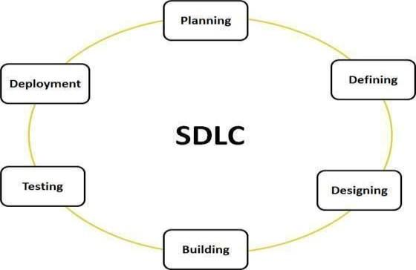

**Figure 2.2.1 SDLC**

**2.3 EXPLAIN IN DETAILS ABOUT EACH STAGE OF PRODUCTION.**

1. **Requirement Gathering and Analysis**

We have collected all the information regarding the project. Once requirement gathering is done, an analysis is done to check the feasibility of the development of a product. Once the requirement is clearly understood, the SRS (Software Requirement Specification) document is created. This document should be thoroughly understood by the developers and also be reviewed by the customer.

1. **Design**

In this phase, the requirement gathered in the SRS document is used as an input and software architecture that is used for implementing system development is derived

1. **Implementing or Coding**

Implementation/Coding started according to the requirement. The Software design is translated into source code. All the components of the software are implemented in this phase. Swift, UIkit etc. are used for implementation. We used MVC Structure for implementation.

1. **Testing**

Testing starts once the coding is complete and the modules are released for testing. In this phase, the developed software is tested thoroughly and any defects found are assigned back to get them fixed. Testers refer to the SRS document to make sure that the software is as per the customer’s standard.

1. **Deployment**

Once the product is tested, it is deployed in the production environment or first [UAT (User](https://www.softwaretestinghelp.com/what-is-user-acceptance-testing-uat/) [Acceptance testing)](https://www.softwaretestinghelp.com/what-is-user-acceptance-testing-uat/) is done depending on the customer expectation.

1. **Maintenance**

After the deployment of a product in the production environment, maintenance of the product i.e., if any issue comes up and needs to be fixed or any enhancement is to be done is taken care of by the developers.

**Chapter 3**

**INTRODUCTION TO PROJECT**

**3.1 PROJECT SUMMARY**

Financial ERP is a powerful web-based application designed to help CA firms manage their financial operations more efficiently. It provides a comprehensive suite of tools and features that enable firms to streamline their workflow and improve their bottom line. The application's centralized dashboard allows the owner to monitor all aspects of the business in real-time, including employee productivity, task assignments, and financial transactions.

One of the key features of Financial ERP is its ability to automate various administrative tasks. For example, it can automatically send emails to clients once a service has been completed, reducing the time and effort.

**3.2 PURPOSE**

The purpose of Financial ERP is to provide CA firms with a comprehensive and

user-friendly platform for managing their financial operations. The application aims to streamline administrative tasks, such as task assignments, employee management, and client communication, allowing firms to focus on their core competencies and grow their business.

The platform's customization and scalability make it an ideal solution for CA firms

of all sizes, from small startups to large established firms. The application's security protocols ensure the safety and confidentiality of sensitive financial information, providing peace of mind to firms and their clients.

Overall, the purpose of Financial ERP is to provide a comprehensive and reliable

solution for managing all aspects of a CA firm's financial operations.

**3.3 OBJECTIVE**

Streamline financial operations and improve efficiency.

Reduce costs by eliminating redundant tasks, improving cash flow management, and optimizing financial processes.Improve decision-making.

Provide a salable and customization solution that can meet the specific needs.

different organizations and adapt to changing business requirements.

Enhance security by providing robust security features, such as encryption,multi-factor

authentication, and regular security updates.

**3.4 SCOPE**

Our software is easy to use for both beginners and advanced users.

**1.** The scope of Financial ERP is to provide a web-based platform that enables CA firms

to manage their financial operations effectively. The application's features and functionalities are designed to streamline administrative tasks and improve efficiency, including task assignments, employee management, client communication, and financial reporting.

1. In addition to its core features, Financial ERP also provides scalability and customization, allowing firms to tailor the platform to their specific needs and requirements. The application's robust security protocols ensure the safety and confidentiality of sensitive financial information, providing peace of mind to firms and their clients.

**3.** Financial ERP allows firm owners to create employee and client profiles, assign tasks, and track progress and deadlines in real-time. The application also automates various aspects of financial management, such as sending automatic emails to clients, reducing the time and effort required for these tasks.

**3.5 TECHNOLOGY AND LITERATURE REVIEW**

**Literature Review/Background Study** We don’t have such an existing system proper like this but there is a similar system is there in the market. We studied all the existing systems and they also provided the features but some Users faced the problem and from that we got an idea to build the project. Also, many Users faced problems regarding the user-friendly system. However, we got the idea to provide the service with necessary features and a more user- friendly way.

**Technology**

**NodeJs** - a JavaScript runtime built on Chrome's V8 JavaScript engine.

**ReactJs** - a JavaScript library for building user interfaces.

**MongoDB** - a NoSQL document-oriented database.

**Redux** - a predictable state container for JavaScript apps.

**3.6 PROJECT PLANNING**

Project Planning is concerned with identifying and measuring the activities, milestones and deliverable produced by the project. Project planning is undertaken and completed sometimes even before any development activity starts. Project planning consists of following essential activities:

➢ Scheduling manpower and other resources needed to develop the system.

➢ Staff organization and staffing plans.

➢ Risk identification, analysis, and accurate planning.

➢ Estimating some of the basic attributes of the project like cost, duration and efforts.

Finally, effective communication is essential for successful project planning. A communication plan should be established, outlining the key stakeholders, their roles and responsibilities, and the frequency and format of communication. In conclusion, project planning is a critical process that requires careful consideration and attention to detail. A well-executed project plan can help ensure that the project is completed on time, within budget, and with the desired outcomes.

**3.6.1 Project Development Approach and Justification**

A Software process model is a simplified abstract representation of a software process, which is presented from a particular perspective. A process model for software engineering is chosen based on the nature of the project and application, 14 the methods and tools to be used, and the controls and deliverable that are required. All software development can be characterized as a problem-solving loop which in four distinct stages is encountered:

➢ Requirement analysis

➢ Design

➢ Coding

➢ Testing

➢ Deployment

**3.6.2 Project Effort and Time, Cost Estimation**

**Effort Estimation**

Each company determines the output it expects from its team members. Let us call the average output of a team member per man-hour as the unit output. Assume that one has to deliver an end-to-end login module's functionality for an application. The time spent on the login functionality should include the corresponding time required for gathering the requirements, doing a requirement analysis, architecture inputs, form design, object/class design, implementing the business rules, data validation and storage, framework (i.e., code for login module's constants, enumerations, utilities), testing, debugging, deployment up to user acceptance, etc. Now, the estimator has to figure out how many man-hours it would take to complete the login module, keeping all these factors in mind.

The sequence of work and dependencies should be considered as they do cause delays in completion. For example, form design should be done first (all the way up to acceptance by the customer), then object design (up to acceptance by the architect), followed by coding (for business rules, calculations, and data validations), internal testing, and user acceptance testing. A wise estimator would always take support from other people to understand the scope of work to do a given task.

Implanting the business rules, data validation and storage, framework (i.e., code for login module's constants, enumerations, utilities), testing, debugging, deployment up to user acceptance, etc. Now, the estimator has to figure out how many man-hours it would take to complete the login module, keeping all these factors in mind. The sequence of work and dependencies should be considered as they do cause delays in completion. For example, form design should be done first (all the way up to acceptance by the customer), then object design (up to acceptance by the architect), followed by coding (for business rules, calculations, and data validations), internal testing, and user acceptance testing. A wise estimator would always take support from other people to understand the scope of work to do a given task.

**Cost Estimation**

Like all estimation models for software, the COCOMO models require sizing information. Three different sizing options are available as part of the model hierarchy: object points, function points, and lines of source code. Like function points, the object point is indirect software that is computed using counts of the number of

**1.** Screens (at the user interface),

**2.** Reports,

**3.** Components likely to be required to build the application.

Once complexity is determined, the number of screens, reports, and components are weighted according to Table above. The object point count is then determined by multiplying the original number of object instances by the weighting factor in table above and summing to obtain a total object point count.

When component-based development or general software reuse is to be applied, the percent of reuse (%reuse) is estimated and the object point count is adjusted: NOP = (object points) X [(100 - %reuse) / 100]. Where NOP is defined as new object points. To derive an estimate of effort based on the computed NOP value, a “productivity rate” must be derived. PROD=NOP / person-month.For different levels of developer experience and development environment maturity. Once the productivity rate has been determined, an estimate of project effort can be derived as Estimated effort = NOP/PROD. There are three types of software project: Organic project, Semi-detached project, Embedded project.

Cost required to develop project=effort*rs/month

Effort Estimation (E):

In Organic=2.4 (KLOC) 1.05 PM

In semi detached=3.0(KLOC) 1.12 PM In Embedded=3.6(KLOC) 1.20 PM

Duration Estimation (D):

In Organic=2.5(effort) 0.38 months

In semidetached=2.5(effort) 0.35 months In Embedded=2.5((effort) 0.32 months Person

Estimation: P=E/D

**Advantages of COCOMO:**

COCOMO is factual and easy to interpret.

One can clearly understand how it works.

Accounts for various factors that affect the cost of the project.

Works on historical data and hence is more predictable and accurate.

**Disadvantages**

The COCOMO model ignores requirements and all documentation.

It ignores customer skills, cooperation, knowledge and other parameters.

It oversimplifies the impact of safety/security aspects.

It ignores hardware issues It ignores personnel turnover levels.

It is dependent on the amount of time spent in each phase.

**3.6.3 Roles and Responsibilities**

This phase defines the role and responsibilities of each and every member involved in developing the system. To develop this system there was only one group with two members working on the whole application. Each member was responsible for each and every part of developing the system. Each of the group members has sufficient knowledge in several programming languages.

**3.7 Project Scheduling (Gantt Chart)**

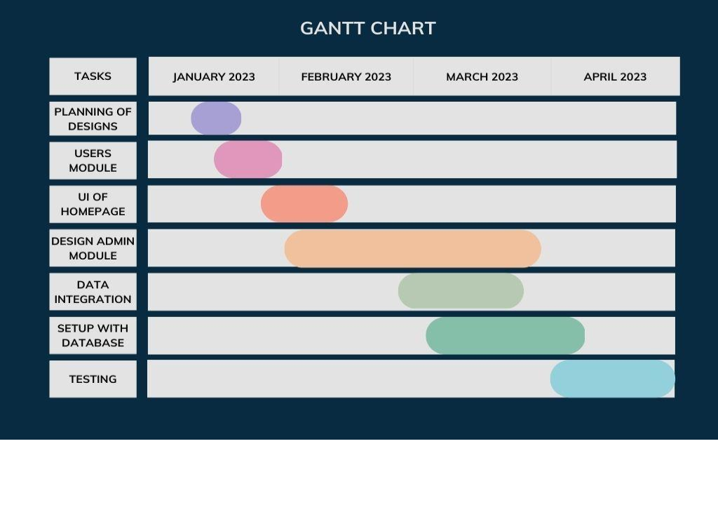

**Fig 3.7.1 Gantt Chart**

**Chapter 4**

**SYSTEM ANALYSIS**

**4.1 Study of Current System**

Currently there are few systems in the market that provide Employee Management on the basis requirements.

**4.2 Problem and Weakness of Current System**

Currently, the Financial ERP application provides more features than necessary, which can make it complex and challenging to use. Additionally, some features may not be required by all CA firms, leading to unnecessary clutter and confusion. Therefore, it may be helpful to review and prioritize the application's features, considering the specific needs of the users. tender notifications enable users to stay up-to-date with new tender opportunities and potentially increase their revenue which is not available in the current System.

**4.3 Requirements of New System**

In the new system the user receive tender notifications that enable users to stay up-to-date with new tender opportunities and potentially increase their revenue

**4.4 System Feasibility**

**4.4.1** **Does the system contribute to the overall objectives of the organization?**

By providing a centralized platform for managing financial operations, the application helps CA firms save time and reduce errors in their daily operations, which can improve their overall efficiency and productivity. Additionally, the application's task assignment and deadline tracking features enable better employee management, ensuring that tasks are completed on time and within budget.

**4.4.2 Can the system be implemented using the current technology and**

**within the given cost and schedule constraints.**

We have implemented this project using the existing version of all the technologies used in it. We have not invested a single coin in this project. We have tried to cover all the user requirements to provide the maximum comfort to them, so we can achieve the long-term objectives with the maximum unique features. As requirements are gathered an overall version of system functions and features begins to materialize.

At project inception, software engineers ask a set of questions that establish

Basic understanding of the problem.

The people who want to use our services.

**4.5 Activity of New System**

**4.5.1 Use Case In Actors:**

**Employee**  a user who can see Task and Add Client related Document.

**Admin**  a user who has created an account on the application for his Firm.

**The Use Cases:**

**Create Account**: Firm Owner create account to add employee add

employee and client

**Add and assign a task**: assign task to employee and set deadline.

**Document:** add Document according to year and service.

**Tender**:Get tender details

**Manage Account:** registered users can manage their own account

settings, including personal information.

**4.5.2 Use case Diagram:**

A use case diagram is used to illustrate the dynamic nature of a system and capture its requirements, both internal and external. It shows the actors and elements responsible for implementing the use cases, as well as the interactions between them. This diagram depicts how an external entity interacts with a specific part of the system.

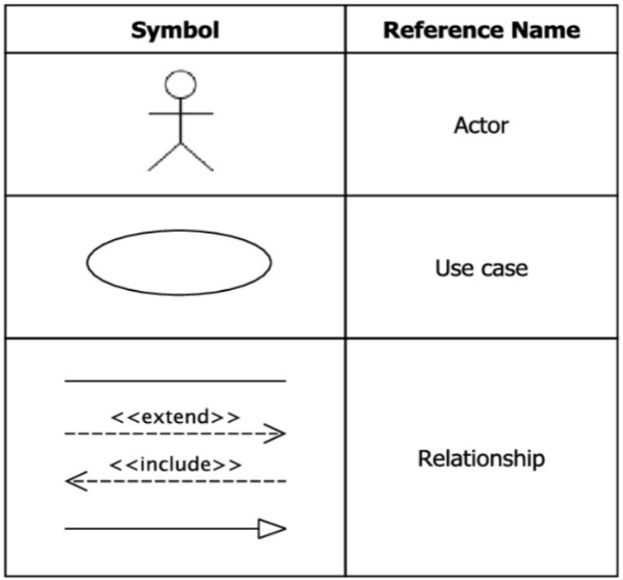

**Symbols and components of Use Case Diagram**

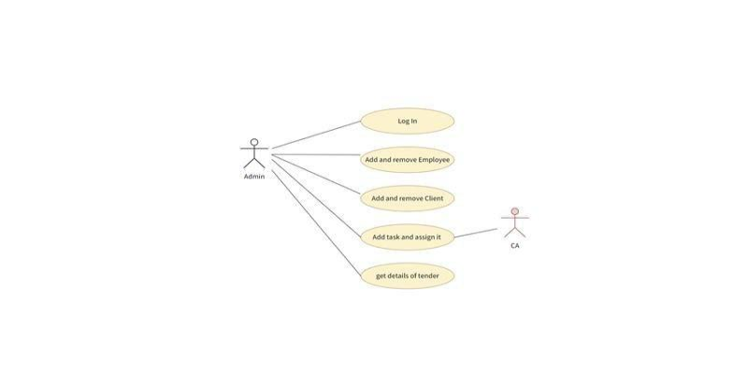

Fig 4.5.2.1 Admin Use Case

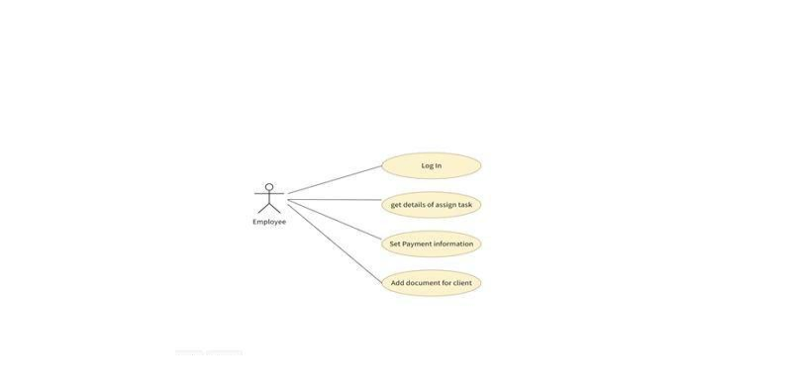

Fig 4.5.2.2 Employee Use case

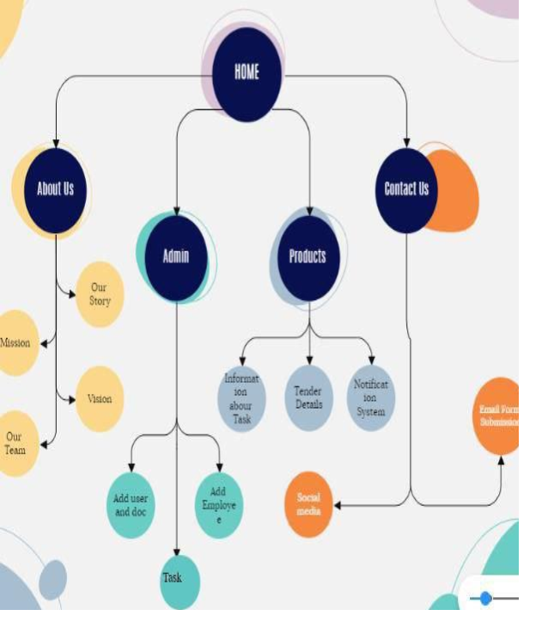

Figure 4.5.2.3 Activity Diagram

**4.5.3 Sequence Diagram**

**User Signup**

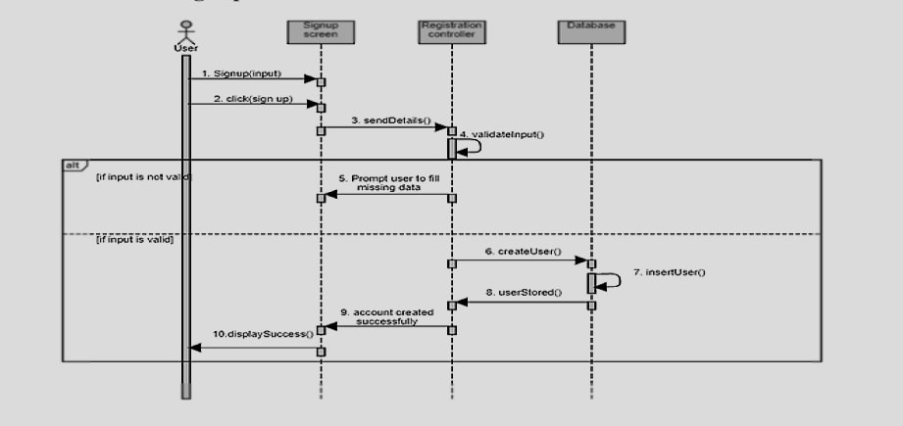

Figure 4.5.3.1 Sequence Diagram (Signup)

**User Login**

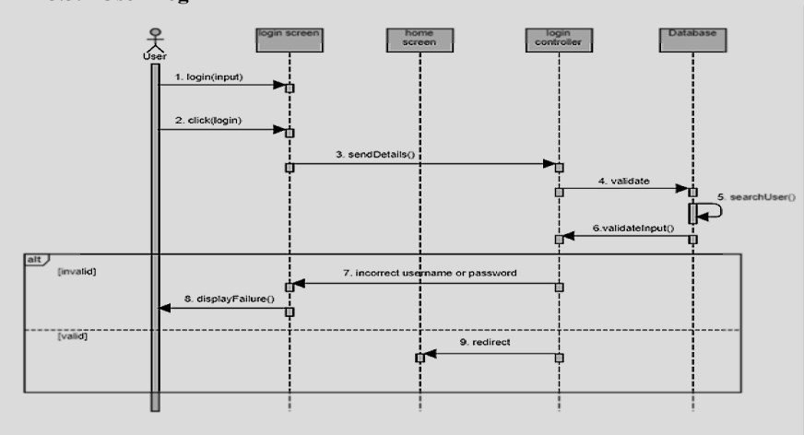

Figure 4.5.3.2 Sequence Diagram (Login)

**User Forgot Password**

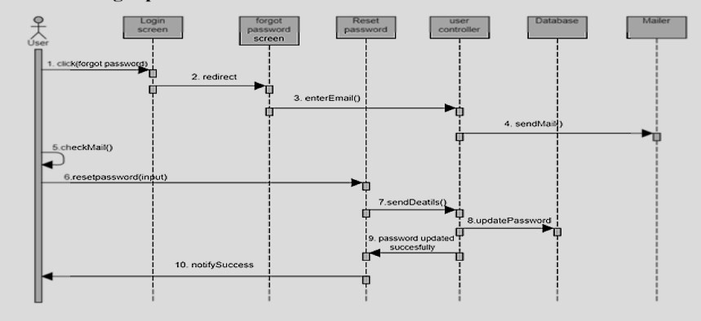

Figure 4.5.3.4 Sequence Diagram (Forgot Password)

**User Logout**

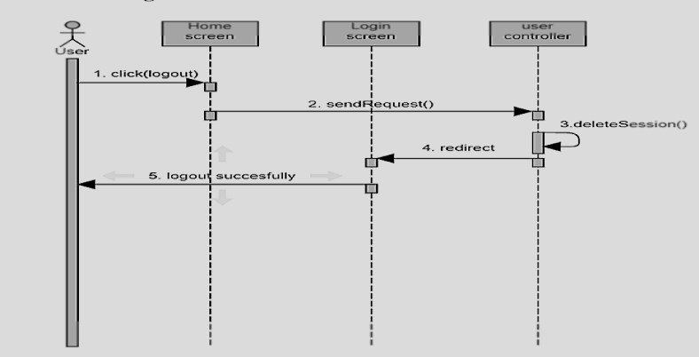

Figure 4.5.3.5 Sequence Diagram (Logout)

**4.6 MODULES AND THEIR DESCRIPTION OF SYSTEM**

**4.6.1 Signup/ Login Module**

**Login**

Clicking on Login on the home screen allows the user to log in to the system. This Login screen would be a central place to allow users logging in to the system. This would redirect them to the Dashboard screen.

**Signup**

Customers should be able to register themselves using the sign up screen. This should be a separately designed page where users would be redirected when they click on Create New Account link in Login Dialog. Users should straightaway be able to login to the system once they create their account with Financial ERP.

**4.6.2 User Navigation ‘s Module**

**Dashboard**

With this application, Admin can easily navigate to all the inner modules of the application, including add in employee,task,service,client and track any task, and managing cash flow.

**4.6.3 Service Provider Module**

**Add New Employee**

With this application module, Admin has the ability to add employees to the platform.

To add a new employee, the user can click on the "Add Employee" button, which will take them to a page where they can input all the necessary information about their employee, including the name,role, and other information. They can also upload photos of the employee.

Once the user has filled out all the required fields and uploaded any desired media, they can click on the "Submit" button toAdd Employee. The new employee will then be added to the platform and the admin can see a list of employees to search and view.

**Add Task**

One of the main features of this module application is that users can Add task and assign them to employees.

To add a task, the user can click on the "Add task" button, which will take them to a page where they can input all the necessary information about their recipe, including the name,employee name, and instructions.

**Add Client**

With this application module, Admin has the ability to add clients

to the platform.

To add a new employee, the user can click on the "Add client" button, which will take them to a page where they can input all the necessary information about their employee, including the name,service, and other information. They can also upload photos of the employee.

Once the user has filled out all the required fields and uploaded any desired media, they can click on the "Submit" button toAdd clients. The new clients will then be added to the platform and the admin can see a list of clients to search and view.

**4.7 SELECTION OF HARDWARE AND SOFTWARE CHARACTERISTICS**

**Hardware Requirements**

Minimum 2.27Ghz processor

RAM: 8GB minimum Software Requirement

**Software Requirements**

VS code (IDE)

MongoDB Atlas Postman

Figma

**Chapter 5**

**SYSTEM DESIGN**

**5.1 System Design & Methodology**

Systems design is the process of defining the architecture, components, modules, interfaces, and data for a system to satisfy specified requirements. The System Design Description report provides summary or detailed information about a system design represented by a model. Systems design is therefore the process of defining and developing systems to satisfy specified requirements of the user.

**5.2 Database Design**

Database design is the process of creating a structured set of data that can be easily accessed, managed, and updated. A well-designed database can improve data consistency, accuracy, and security, while also increasing efficiency and reducing errors in data processing.

There are several steps involved in designing a database, including:

**1.** Determining the purpose and scope of the database: This involves identifying the specific data that needs to be stored, the users who will access the data, and the tasks that the database will need to perform.

**2.** Defining the data model: This involves creating a conceptual model of the data structure, including the tables, fields, and relationships between them.

**3.** Normalizing the data: This involves organizing the data in a way that reduces redundancy and improves data consistency.

Overall, database design is a critical aspect of building effective information systems, and it requires careful planning and attention to detail to ensure that the resulting database meets the needs of the users and the organization.

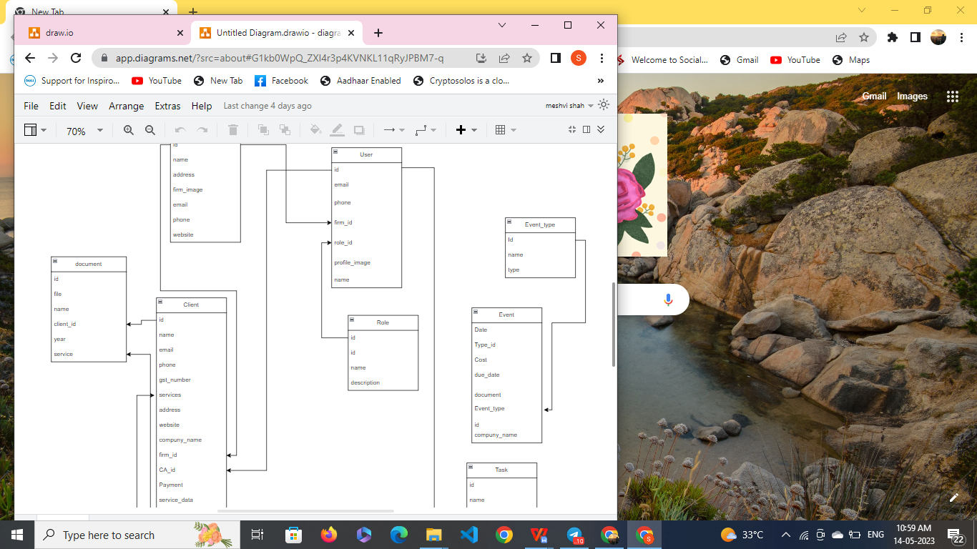

Figure 5.2.1 Class diagram

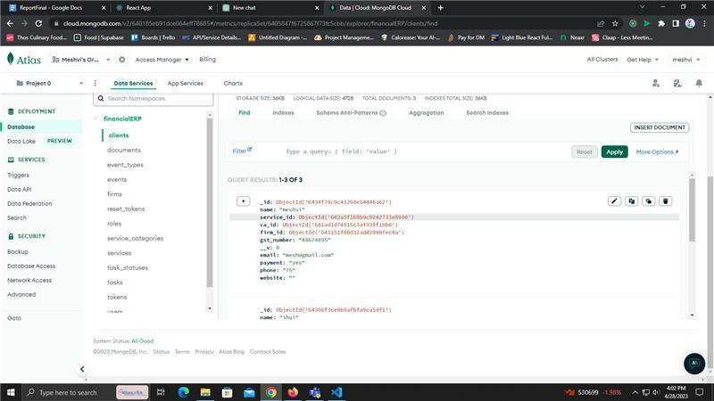

Figure 5.2.2 Realtime Atlas Database

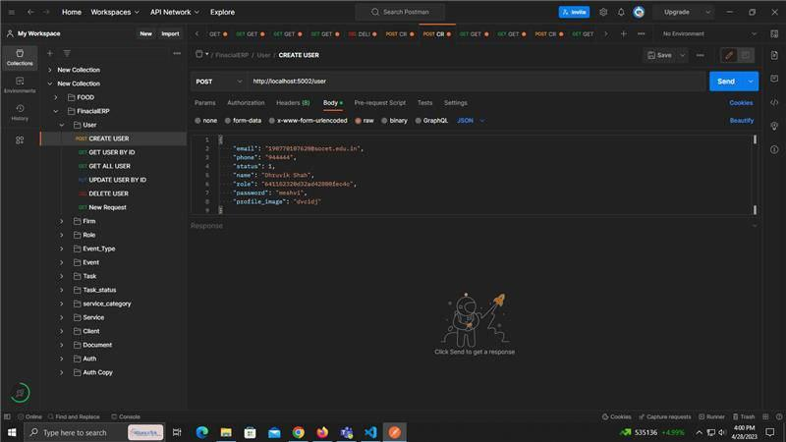

Figure 5.2.3 Postman

**5.3 SYSTEM PROCEDURAL DESIGN**

**5.3.1 Design Pseudo code or algorithm for method or operation**

**Owner Side**

Step 1: Enter Username Password

Step 2: Click on Login Button for Login

Step 3: If username and password both is correct then it will login successfully

Step 4: It shows DashBoard

Step 5: Owner can navigate to different modules

Step 6: Owner can add employee

Step 7:Owner can add client

Step 8: Owner can add task and assign it.

Step 9: Owner can edit own profile

Step 10: User can Logout

**Chapter 6**

**IMPLEMENTATION**

**6.1 IMPLEMENTATION PLATFORM**

Our project is suitable for all types of users like single and multi-users.

Multi users are allowed to operate the Application at the same time.

We provide an interface which is user friendly.

We have GUI (graphical user interface) by which all types of users can easily access the application.

One user at a time and also multiple users can access the website at the same time

and use all the services.

If we don’t provide the GUI in the website then users won’t like our website.

For better performance and reliability, we have to include GUI in the website.

So, for the more security and performance we have to use the GUI

**6.2 TECHNOLOGY SPECIFICATION**

**User Authentication**

Identification and authentication are used to establish a user's identity.

Each user is required to log in to the system.

**Password Protection**

Every user who is to be allowed to access the portal is given his own username and password and given his own access rights so that only authorized and authenticated users can access the project.

**Confidentiality**

We provide confidentiality to all the users.

In that one user cannot access the data of the other users.

For that we provide one key to each user to secure its data.

**Scalability**

We provide the scalable website to make sure that every user can access the

application in a proper order.

**6.3 RESULTS**

**Login**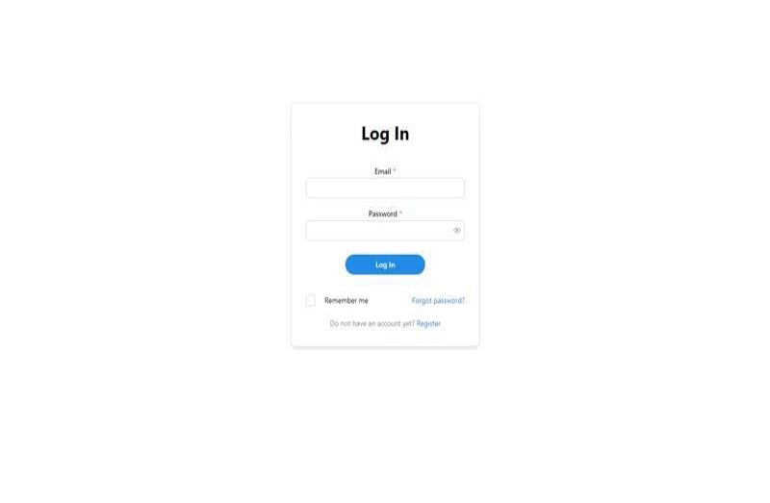

figure 6.3.1 Login

**Register**

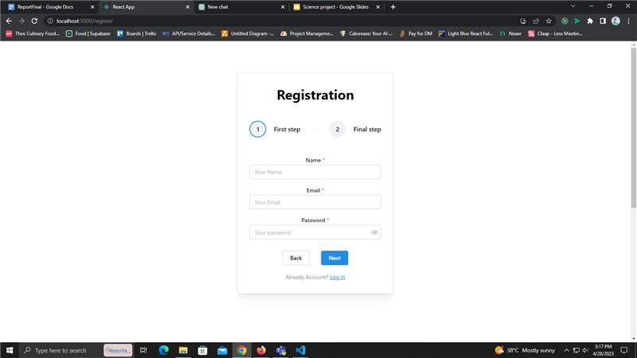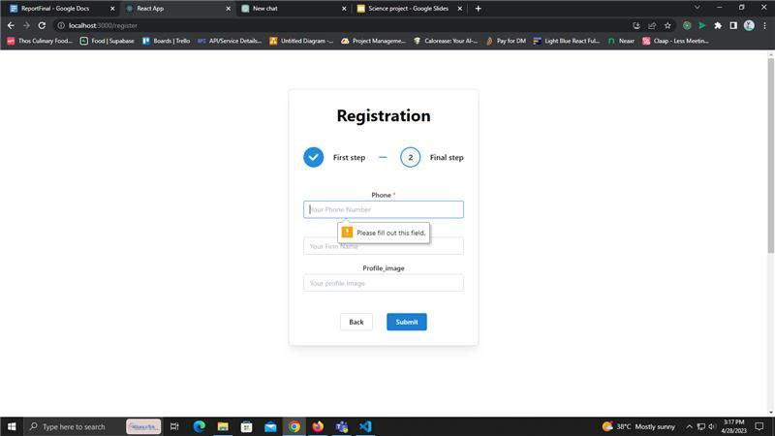

Figure 6.3.2 User Create Account

**Features**

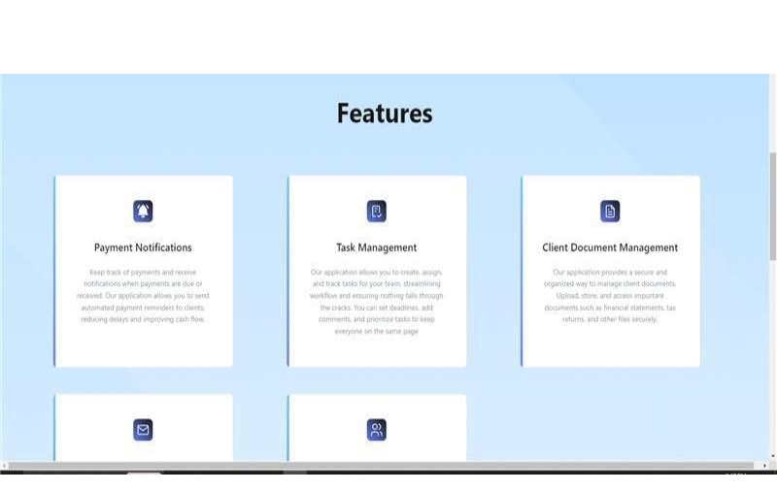

Figure 6.3.3 Features

**Dashboard**

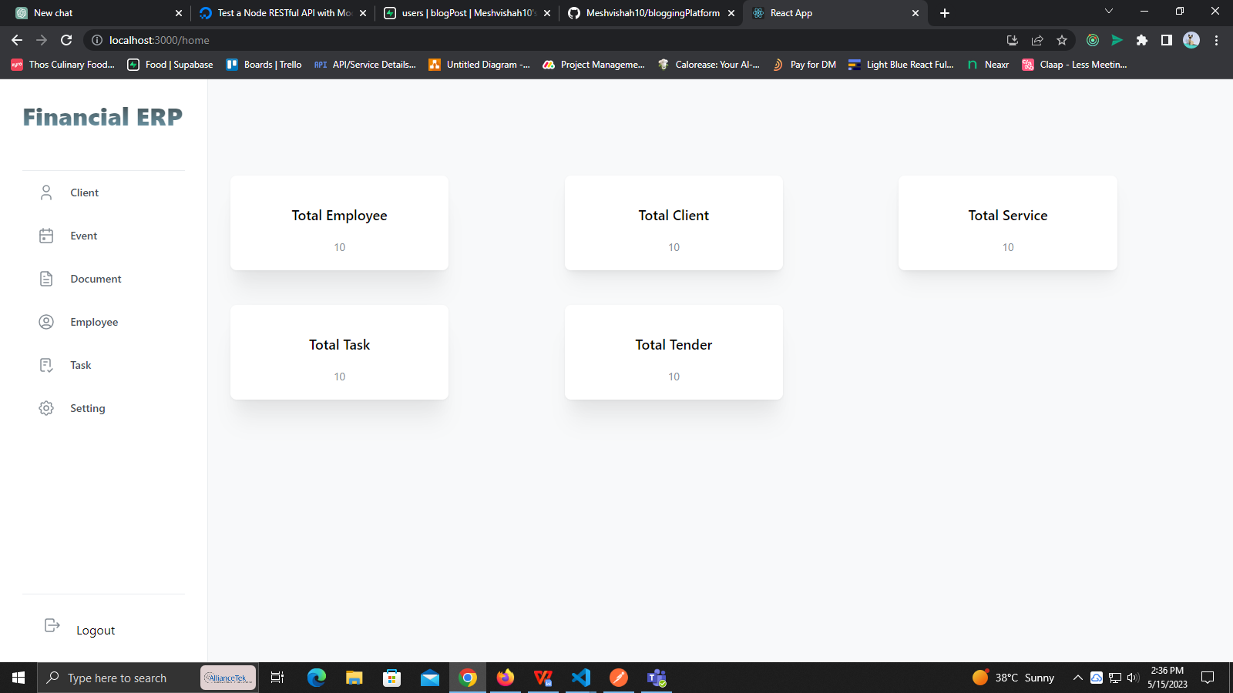

Figure 6.3.4 Dashboard

**Employees Table**

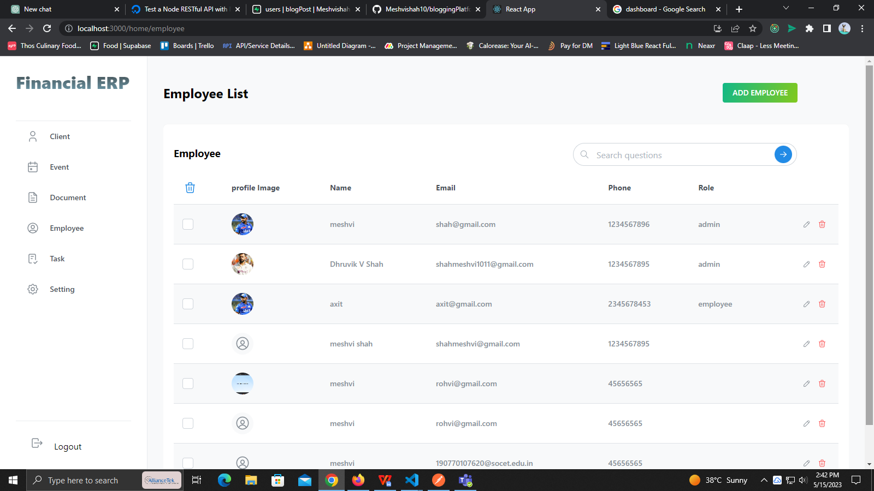

Figure 6.3.5 Employees list

**Add** **Employee**

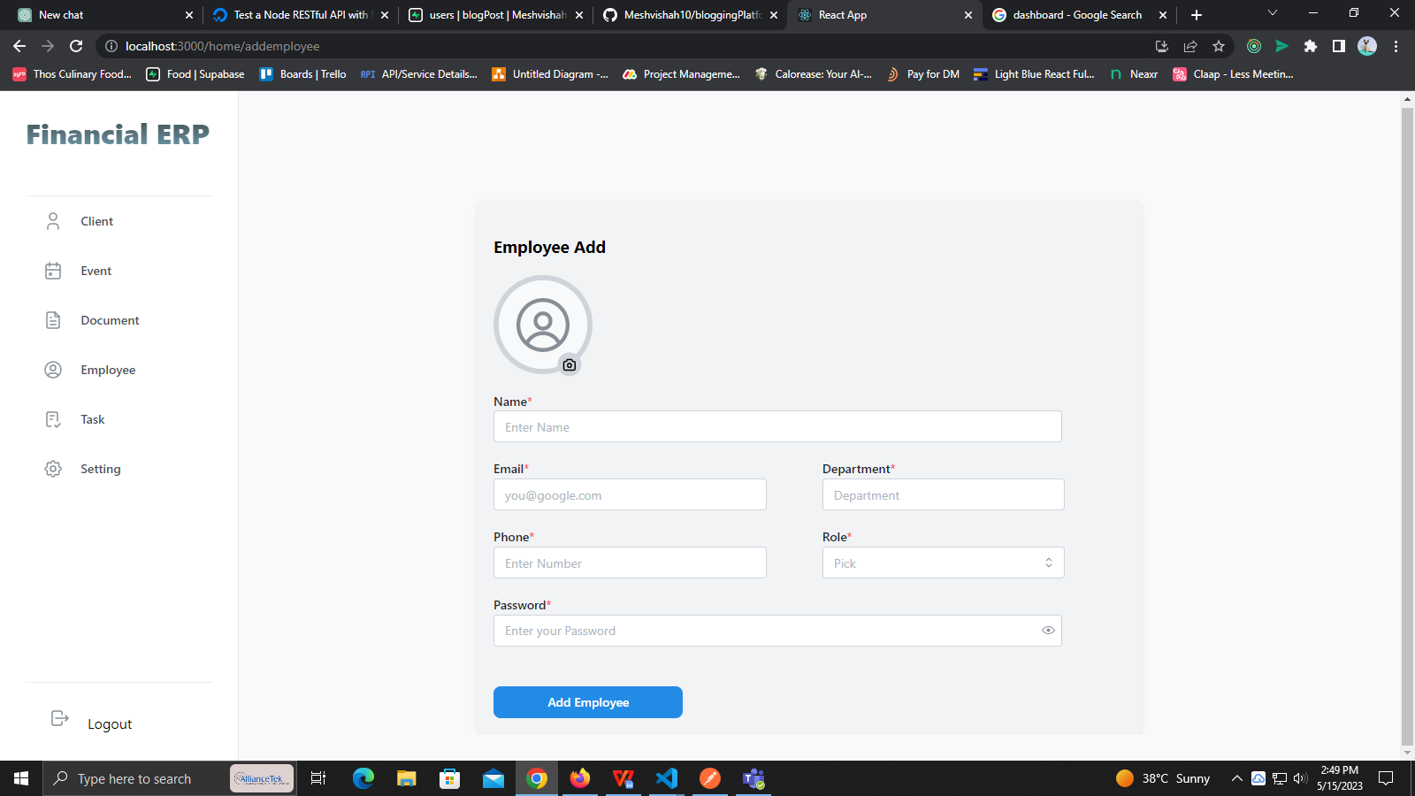

Figure 6.3.6 Add Employee

**Client Table**

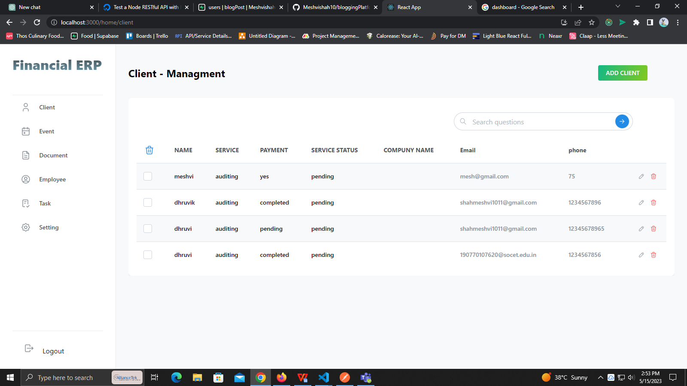

Figure 6.3.7 Client Table

**Add Client**

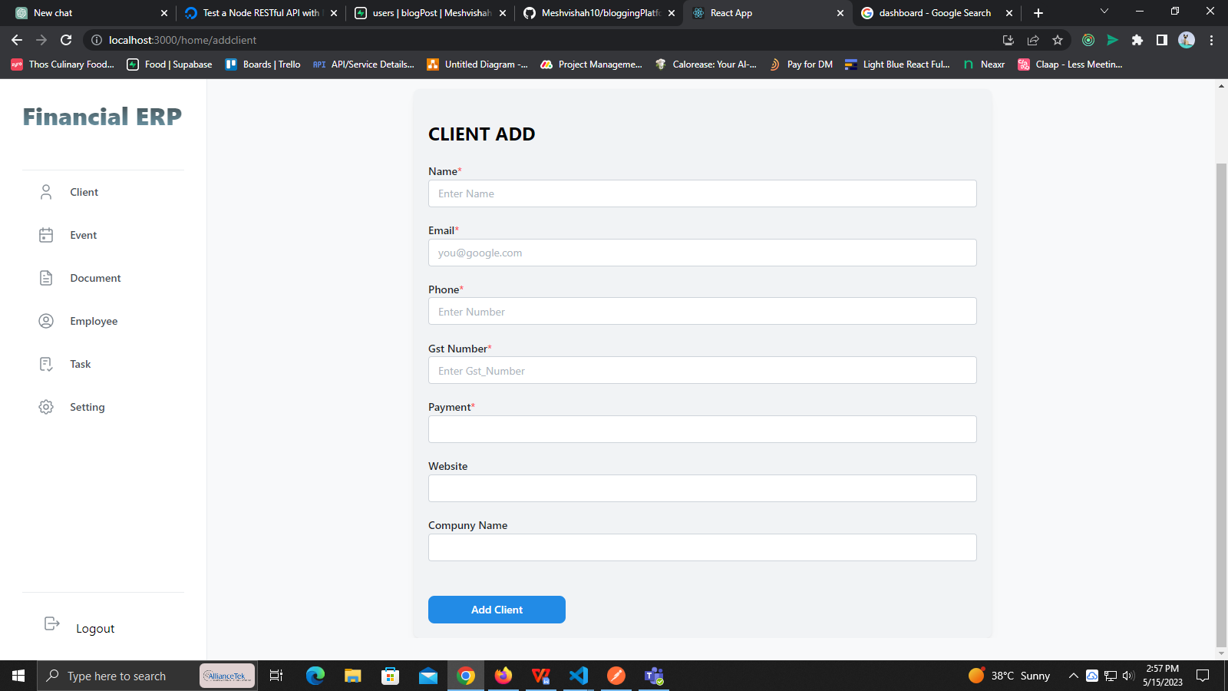

Figure 6.3.8 Client Add

**Task List**

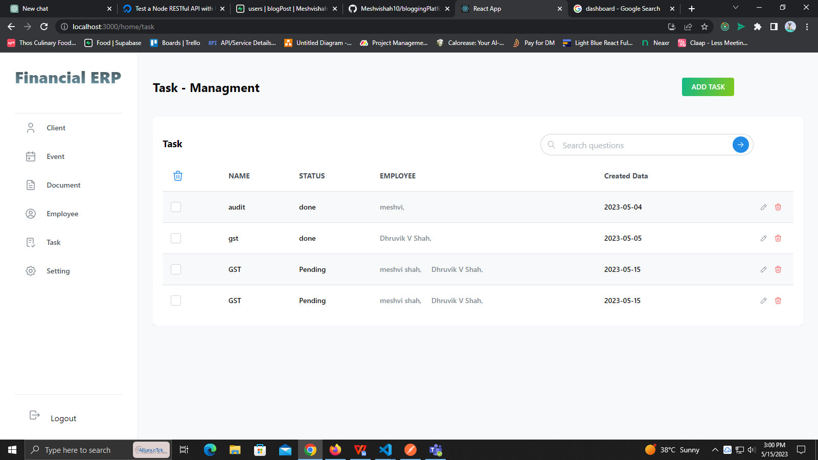

Figure 6.3.9 Task List

**Tender**

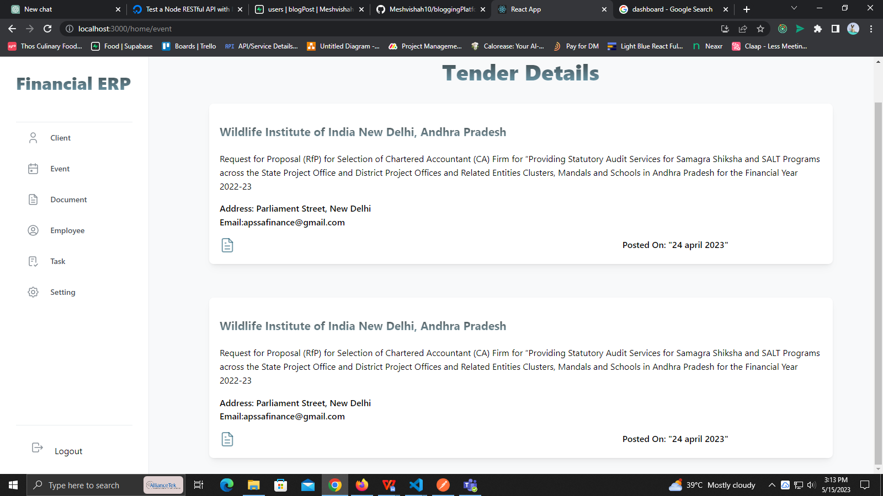

Figure 6.3.10 Tender List

**Profile Setting**

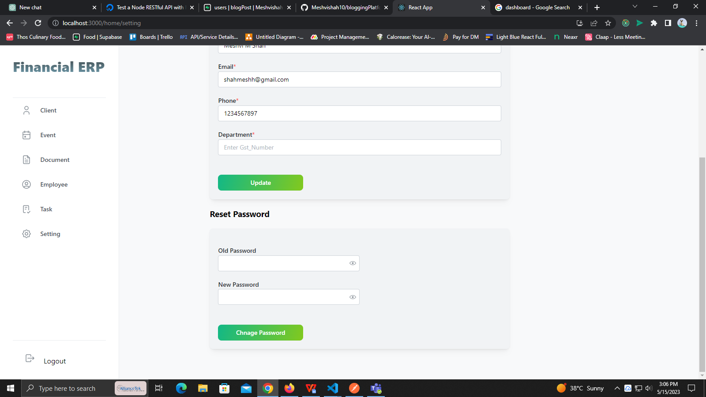

Figure 6.3.11 Profile Setting

**Chapter 7**

**TESTING**

**7.1 TESTING PLAN/ STRATEGY**

In this project we have done the manual testing to verify that all our functionality works properly or not. The testing process is carried out when we had completed the implementation of all the functionality So here the testing had been done at the end of the internship.

In this project, we have done the functional testing that check each functionality works properly or not. All the testing procedure is carried out manually. All the testing procedure is carried out form 23rd March to 25th March.

First of all, we create the test cases for each functionality and what should be our expected output should be note down. Then we check all the functionality and check the actual output and compare with expected output. If match then we can pass the test case else we have to gave the remarks that what changes should have to done.

**7.2 Test Results and Analysis**

**7.2.1 Test Cases**

Table 7.2.1 Test Case

|  |  |  |  |  |
| --- | --- | --- | --- | --- |
| **Test ID** | **Test Condition** | **Expected Output** | **Actual Output** | **Remark** |
| 1 | Email Should be  Sent after User Request for reset or Forget Password | Send the Email with all details and can reset Password | Perfectly Send the  Email with all details | No |
| 2 | Customer  Authentication  Functionality | Login, Logout, Create Account should be done properly. | Done Properly all the Authentication functionality | No |
| 3 | Search Employee | Properly user can Search the employee with all the proper details. | All the details Shown be saved properly and Along with the Details | No |
| 4 | Add task | User can add task and assign it to employee. | Owner only can add task. | No |
| 5 | User login state maintaining | Once the user logged to the app via their id the user should be logged in until user won’t logout. | It is working perfectly. | No |
| 6 | User Profile update. | Users profile should show all the post made by the user. | User can check their posts perfectly. | No |

**Chapter 8**

**CONCLUSION AND DISCUSSION**

**8.1 OVERALL ANALYSIS OF INTERNSHIP**

During the internship at Denali Software Solutions allowed me to gain valuable insight into the world of iOS development. During my time there, I had the opportunity to work on a recipe-based application called CookFiesta which utilized Swift, UIKit, and Firebase as its database. As an intern, I was tasked with various responsibilities such as designing and implementing new features, debugging issues, and collaborating with other developers to ensure the success of the project. This internship provided me with hands-on experience in the field and helped me develop skills that will undoubtedly be useful in my future career.

**8.2 DATES OF SURPRISE VISIT BY INSTITUTE MENTOR**

➢ Mentor: - Prof. Ekta Vyas

➢ Date: - 01/04/2023

**8.3 DATES OF CONTINUOUS EVALUATION (CE-I AND CE-II)**

➢ CE-1 11/03/2023

➢ CE-2 01/04/2023

**8.4 PROBLEM ENCOUNTERED AND POSSIBLE SOLUTIONS**

During the integration of the firebase the user data are getting merged with other users But later we figured it out that why that was happening Later difficulties faced while designing user profile which came up with so many complexity But my mentor helped me with that .

**8.5 Summary of Internship**

Working as part of a team was an essential part of my internship experience. I had the opportunity to collaborate with other developers, designers, and project managers to ensure that Financial ERP was delivered on time and met the client's requirements.

Effective communication was crucial throughout the development process, from discussing project requirements to presenting new features to stakeholders. Through this experience, I learned the importance of clear and concise communication and how to work effectively as part of a team.

**8.6 Conclusion**

Overall, my internship at Denali Software Solutions was an invaluable experience that

allowed me to gain practical experience in Web development and learn new skills that will undoubtedly benefit me in the future. Working on Financial ERP was an exciting challenge that pushed me out of my comfort zone and allowed me to grow as a developer.

I am grateful for the opportunity to work with such a talented team and look forward to

applying the skills and knowledge I gained during my internship to future projects.

**REFERENCES**

1. <https://www.mongodb.com/docs/manual>
2. <https://www.w3schools.com/>
3. https://legacy.reactjs.org/docs/getting-started.html