OFFICIAL SMARTPHONE CATALOG
Product Gallery, Specifications & Pricing List • All Brands (Vivo • Motorola • Samsung)

■ VIVO SMARTPHONES
Total Models Listed: 25 models with official photos, memory tiers, and pricing.
 | vivo X Fold6  Series: Fold Series • Tag: NEW Flagship  Variants / Memory: 12GB + 512GB  Price / MOP: ₹2,19,999  Ultra-slim horizontal foldable flagship with 200MP ZEISS optics and underwater folding resistance.

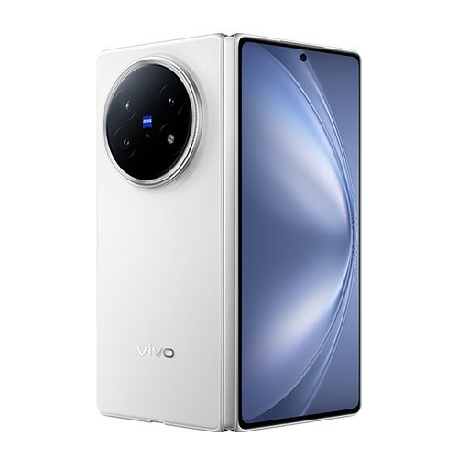 | vivo X Fold5  Series: Fold Series • Tag: Premium Fold  Variants / Memory: 16GB + 512GB  Price / MOP: ₹1,49,999  High-performance foldable phone featuring dual LTPO AMOLED displays and ZEISS T* lens coating.

 | vivo X300 Ultra Master Edition  Series: X Series • Tag: Master Edition  Variants / Memory: 16GB + 512GB  Price / MOP: ₹2,09,999  Ultimate professional imaging flagship with 1-inch sensor, 200MP APO telephoto and custom kit.

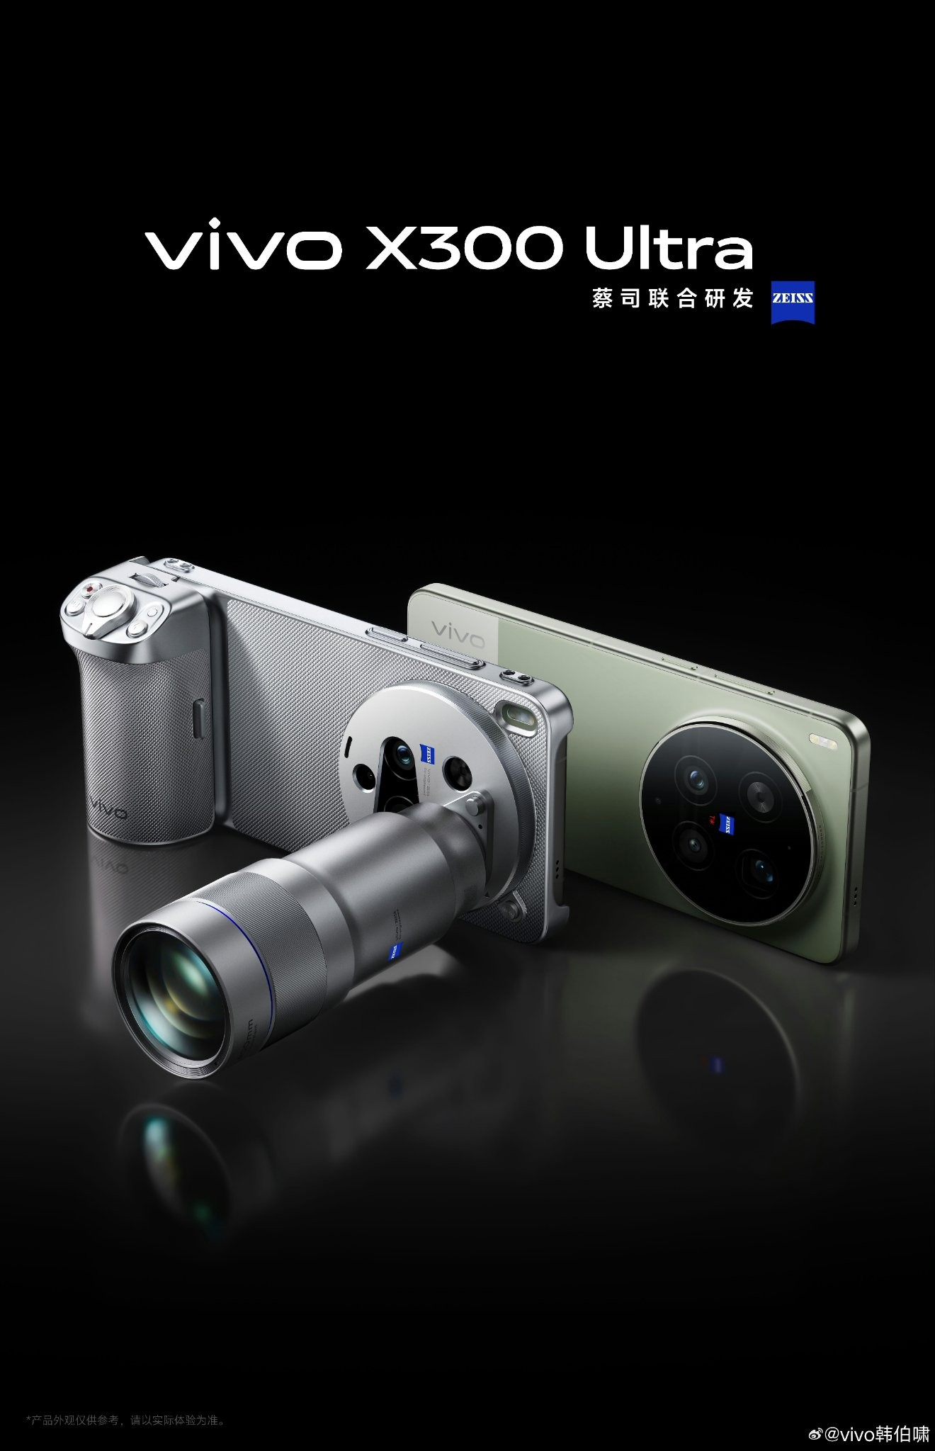 | vivo X300 Ultra  Series: X Series • Tag: Flagship Imaging  Variants / Memory: 16GB + 512GB  Price / MOP: ₹1,59,999  Pro-grade photography powerhouse with advanced telephoto macro and Dimensity top-tier chipset.

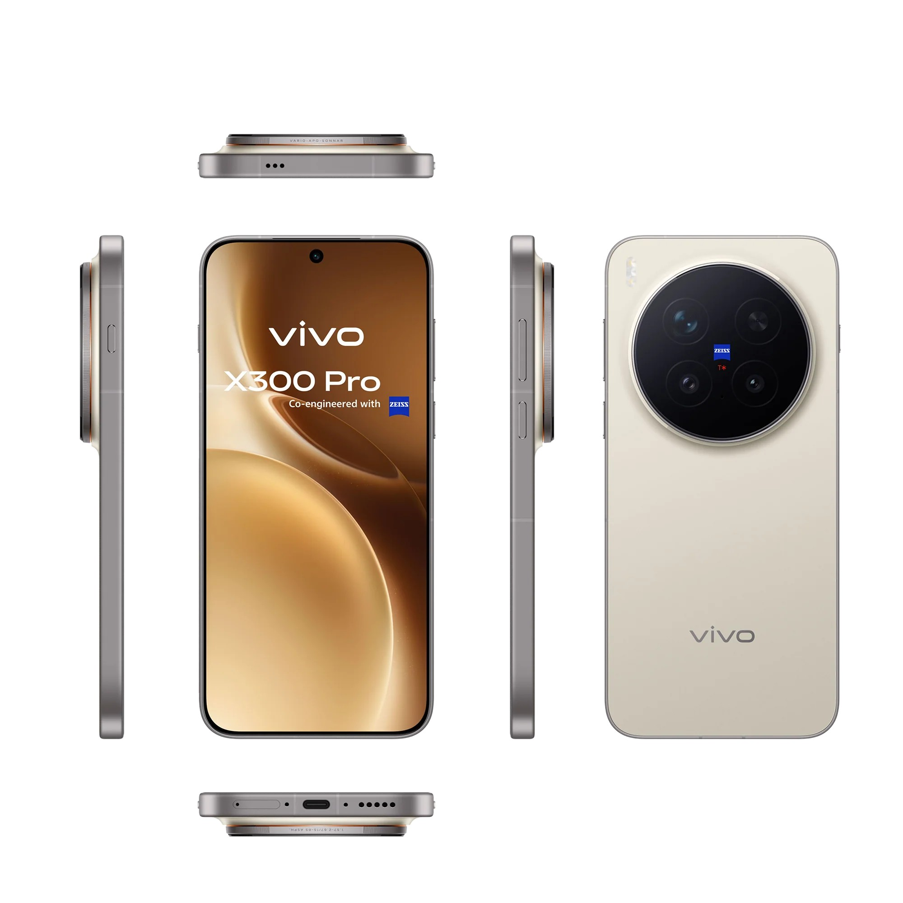 | vivo X300 Pro  Series: X Series • Tag: Pro Imaging  Variants / Memory: 16GB + 512GB  Price / MOP: ₹1,19,999  ZEISS co-engineered imaging flagship with periscope telephoto, 6000mAh battery, and 90W fast charging.

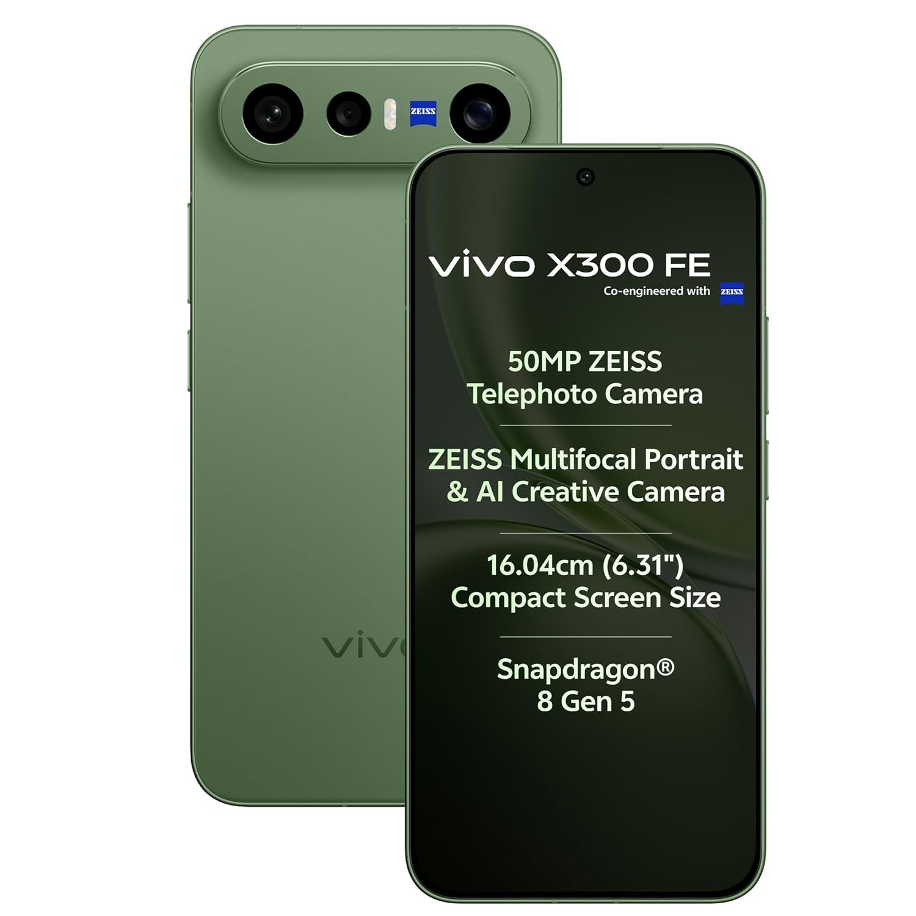 | vivo X300 FE  Series: X Series • Tag: Fan Edition  Variants / Memory: 8GB+256GB / 12GB+256GB / 12GB+512GB  Price / MOP: ₹89,999 / ₹94,999 / ₹99,999  Accessible flagship experience delivering premium ZEISS portraits and top-tier display quality.

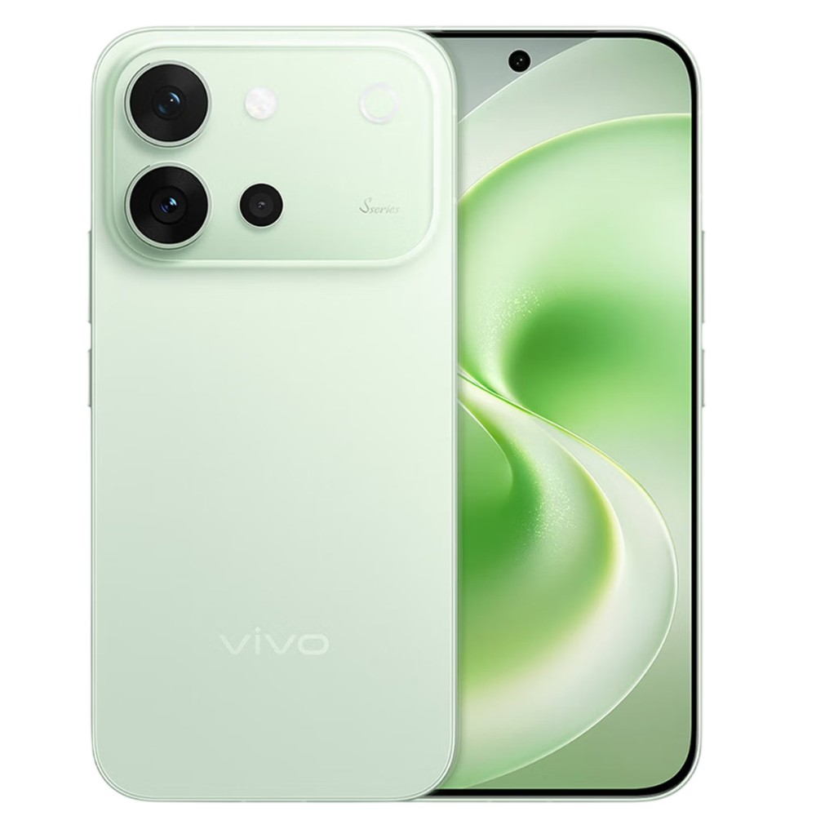 | vivo V80  Series: V Series • Tag: NEW  Variants / Memory: 8GB+128GB / 8GB+256GB / 8GB+512GB  Price / MOP: ₹62,999 / ₹69,999 / ₹79,999  Studio-grade portrait flagship with smart Aura Light, ultra-slim body, and 50MP front/rear cameras.

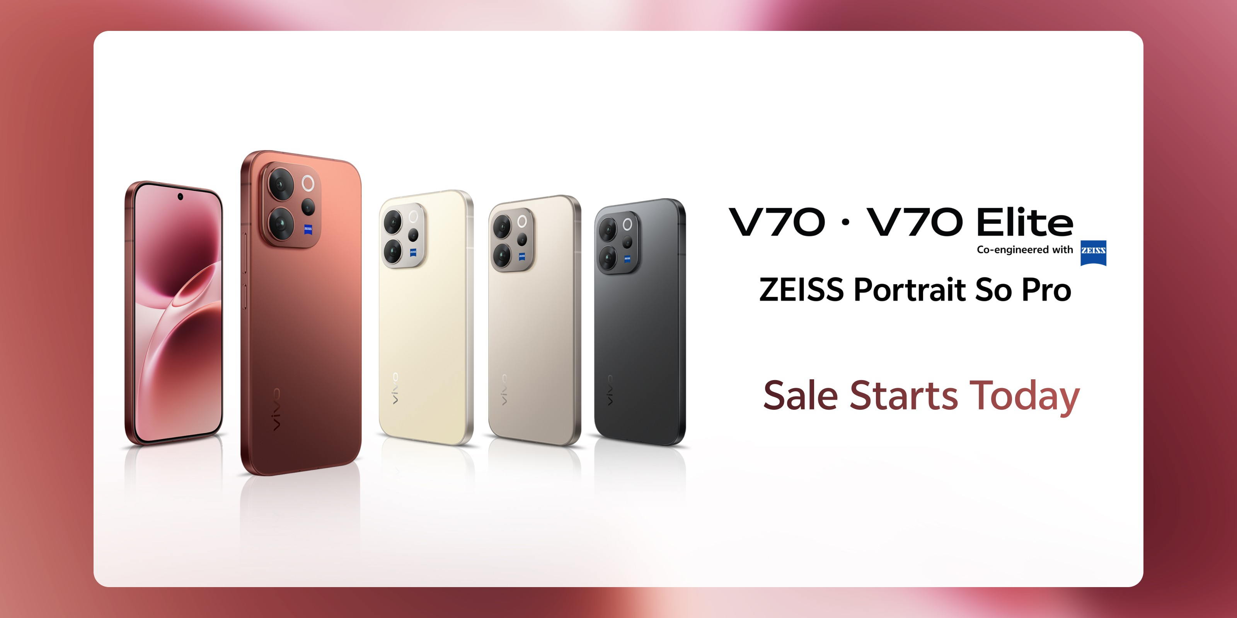 | vivo V70 Elite  Series: V Series • Tag: Elite Edition  Variants / Memory: 8GB+256GB / 12GB+256GB  Price / MOP: ₹66,999 / ₹71,999  Refined glass and metal design with Snapdragon 7 Gen series processor and telephoto portrait lens.

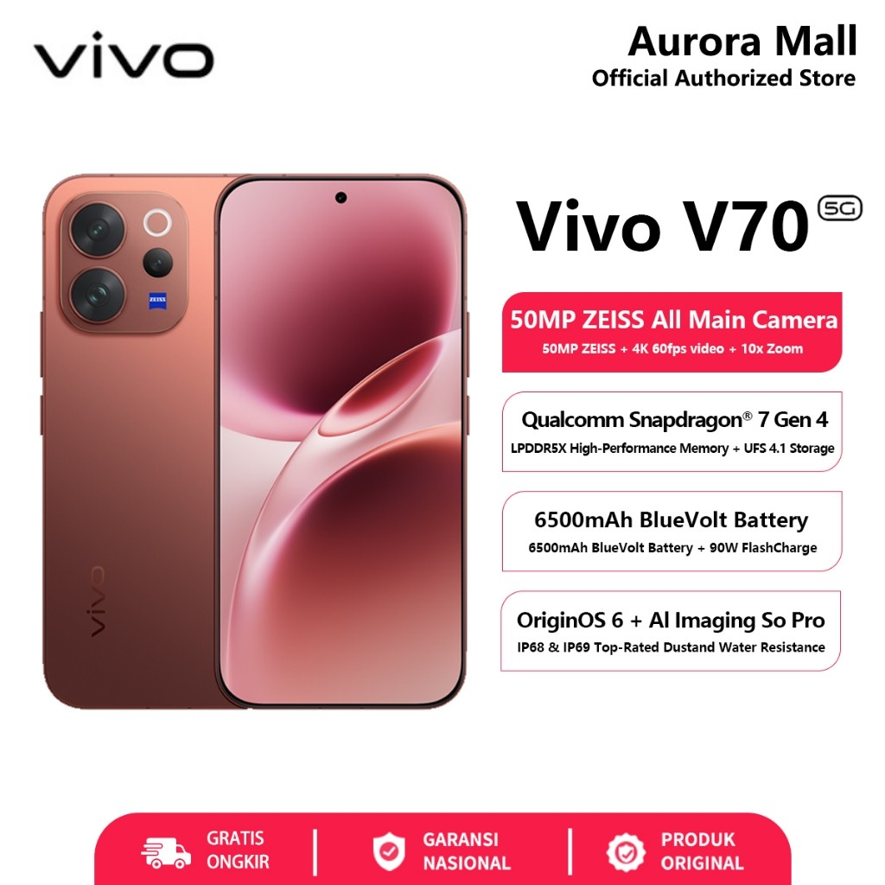 | vivo V70  Series: V Series • Tag: Portrait Pro  Variants / Memory: 8GB+256GB / 12GB+256GB  Price / MOP: ₹59,999 / ₹64,999  Ultra-slim 3D curved AMOLED display with ZEISS natural color imaging and all-day battery life.

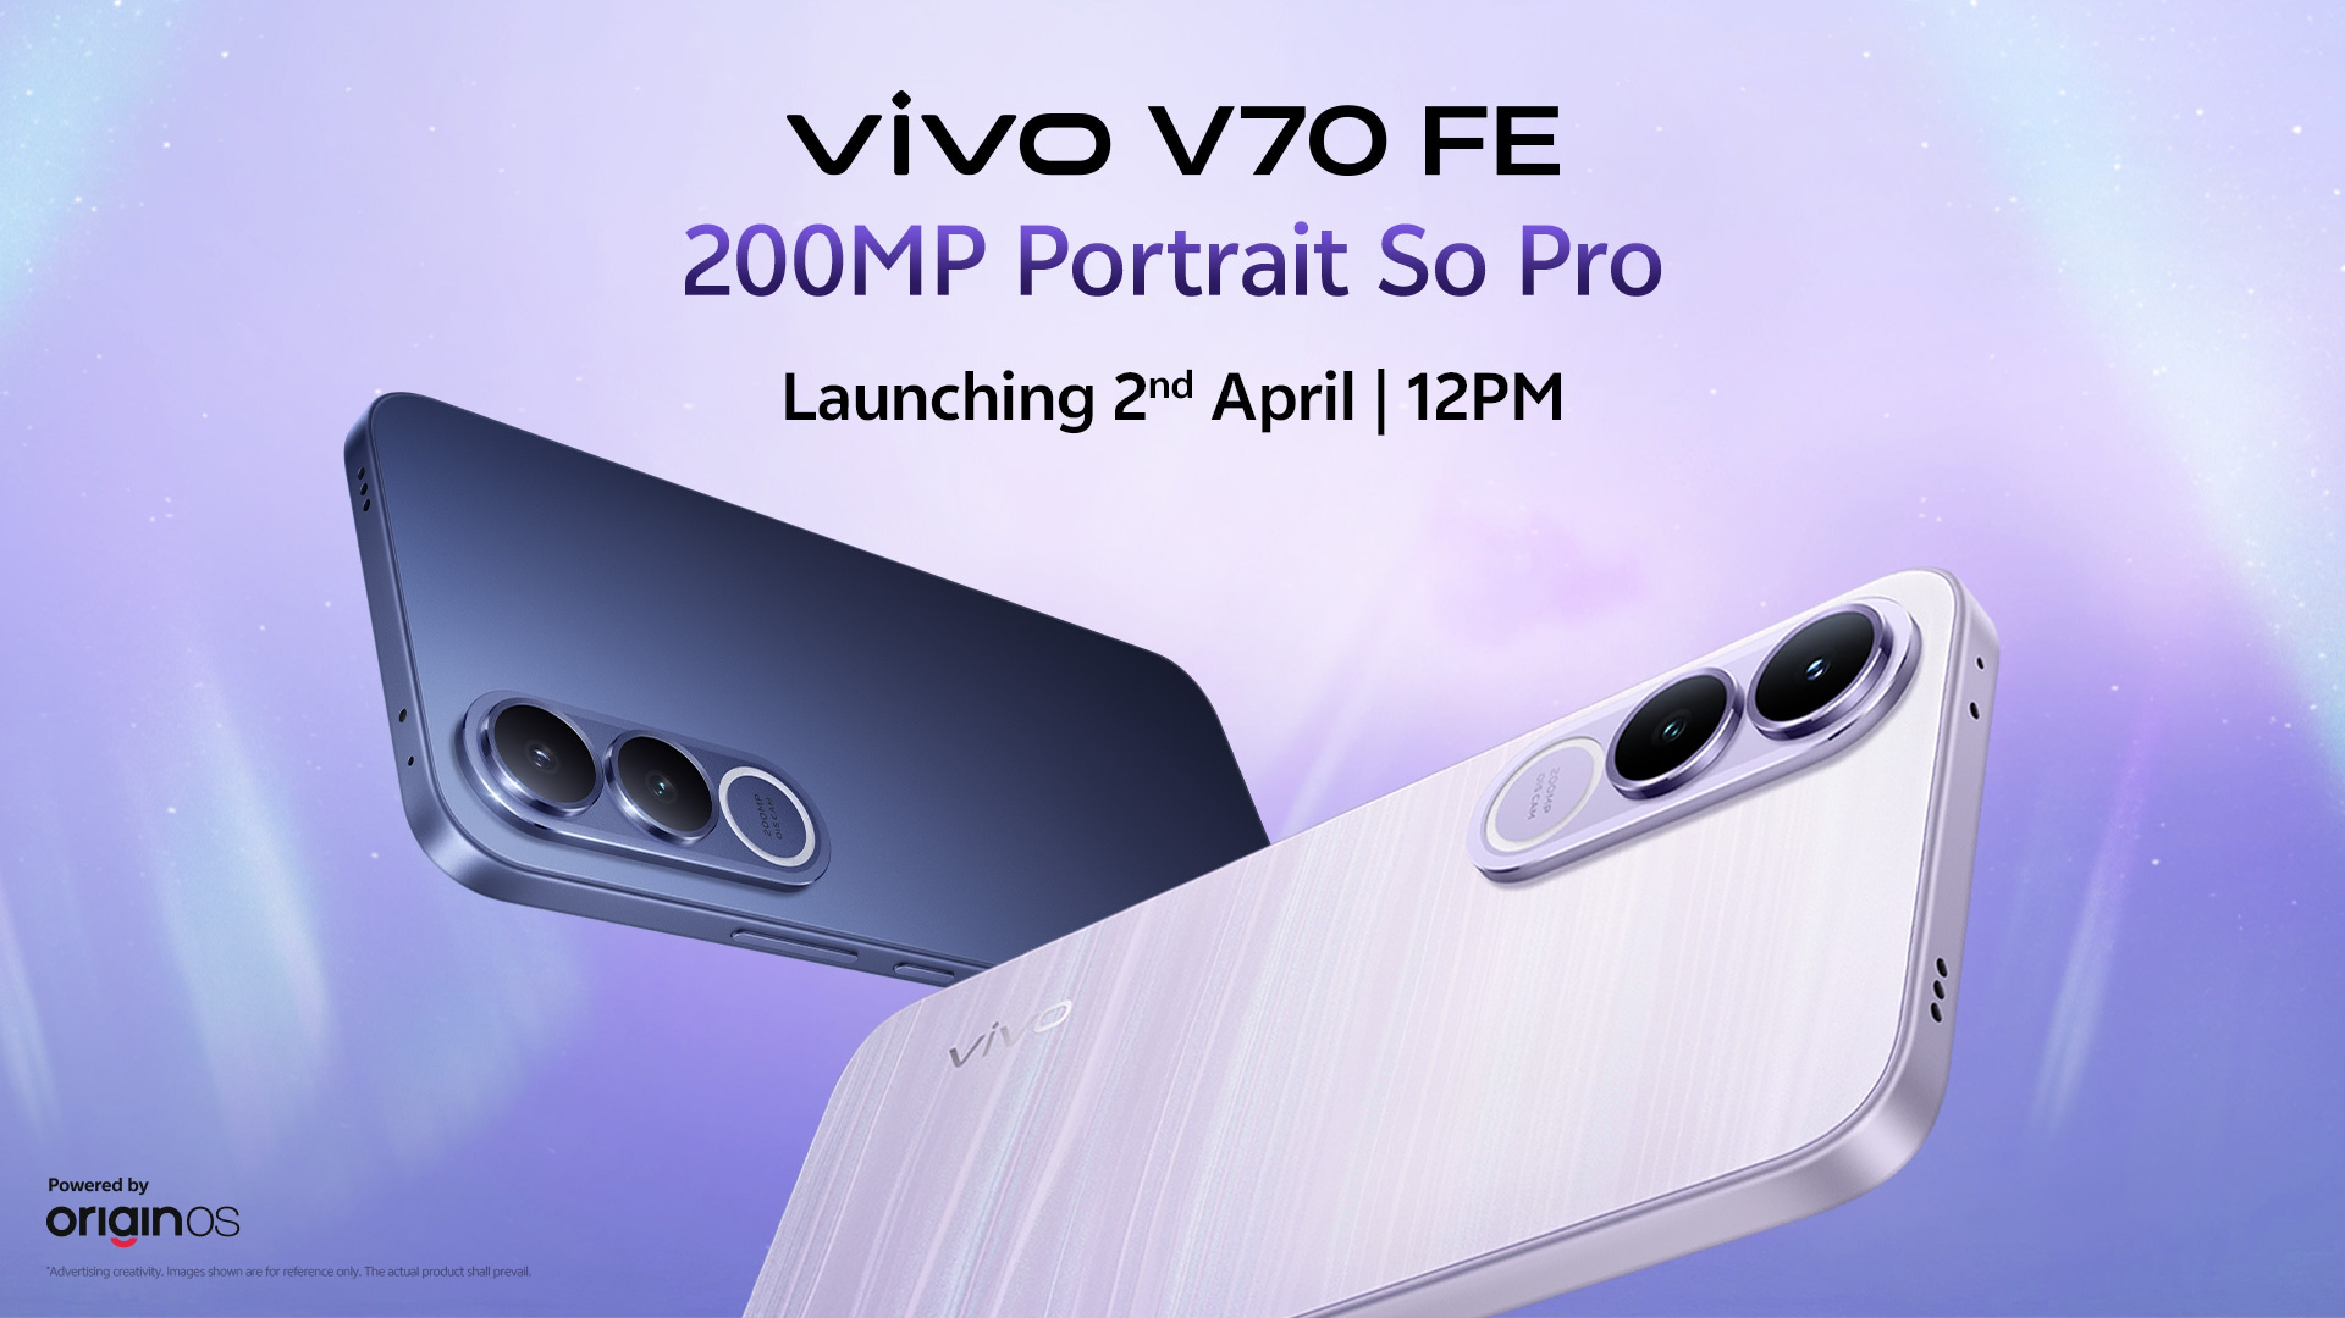 | vivo V70 FE  Series: V Series • Tag: Sleek Performance  Variants / Memory: 8GB+128GB / 8GB+256GB / 12GB+256GB  Price / MOP: ₹44,999 / ₹49,999 / ₹51,999  Feature-packed V-series offering vibrant AMOLED screen, fast charging, and dual 50MP cameras.

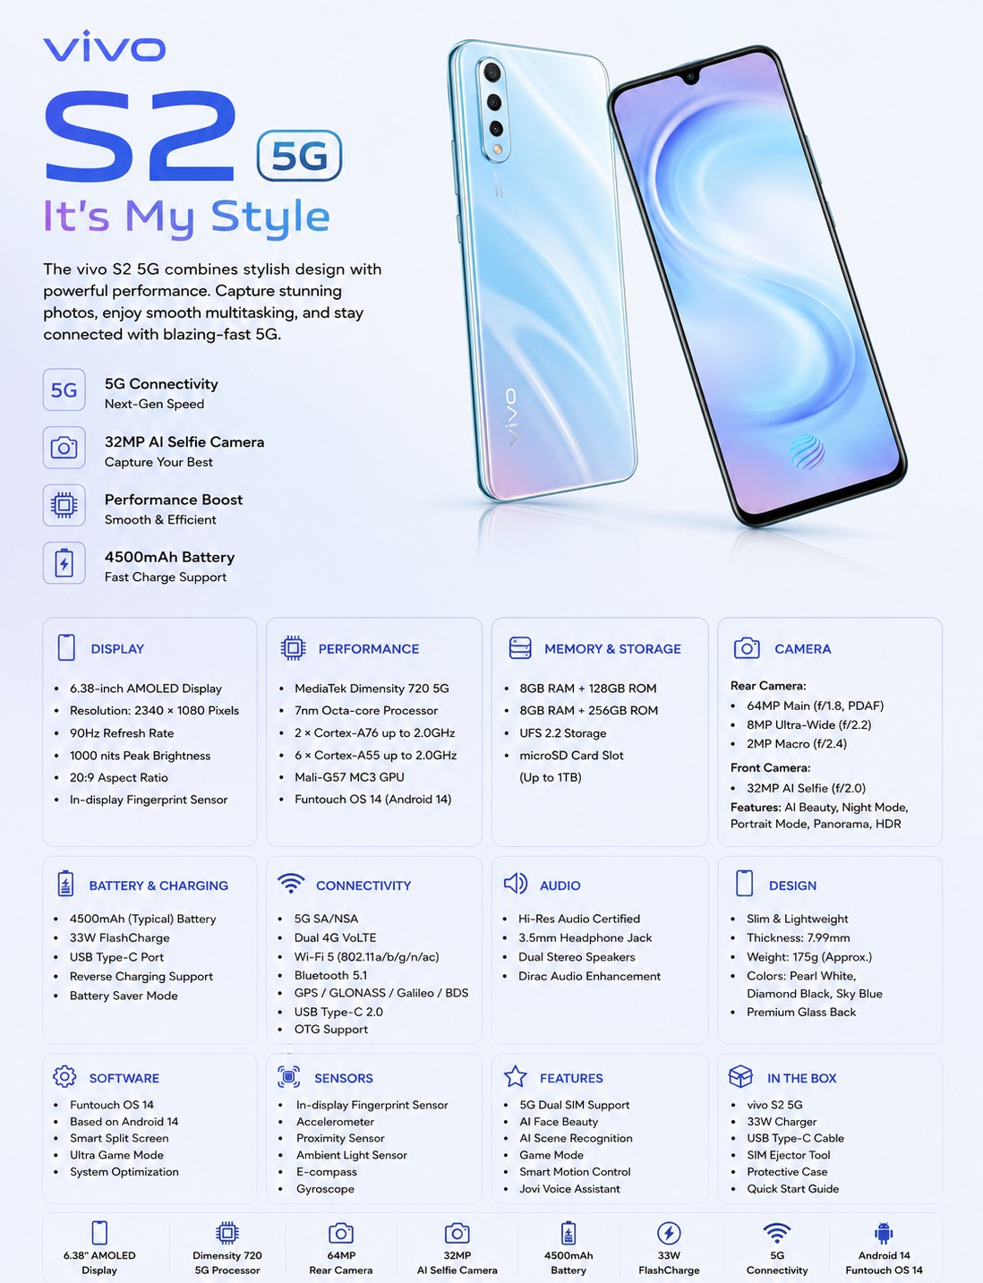 | vivo S2 5G  Series: S Series • Tag: Selfie Expert  Variants / Memory: 8GB+128GB / 8GB+256GB  Price / MOP: ₹42,999 / ₹48,999  Aesthetic style leader with dual soft spotlight, front autofocus 50MP selfie shooter, and sleek chassis.

 | vivo S2 FE  Series: S Series • Tag: NEW  Variants / Memory: 6GB+128GB / 8GB+128GB  Price / MOP: ₹38,999 / ₹42,999  Youthful design with bright AMOLED display, eye-catching pastel gradient finishes, and fast charge.

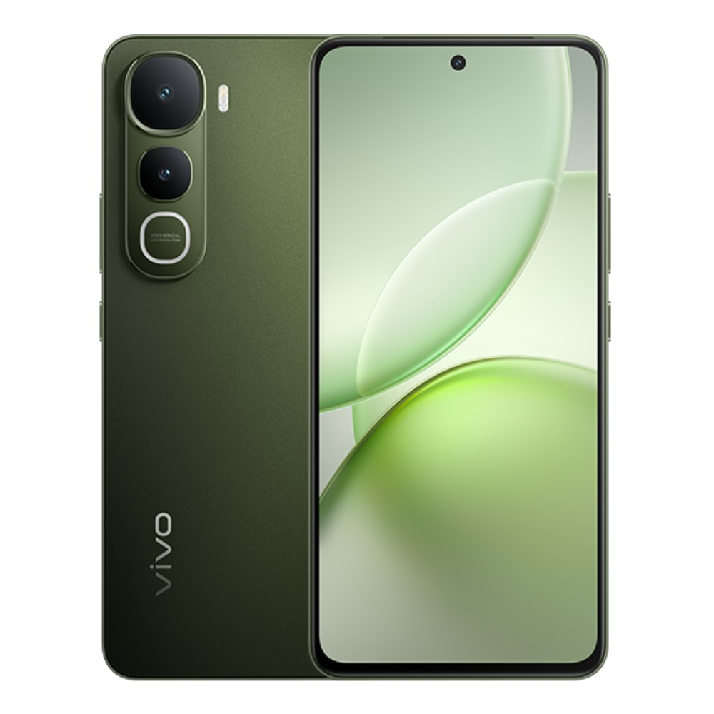 | vivo Y400  Series: Y Series • Tag: All-Rounder  Variants / Memory: 8GB+128GB / 8GB+256GB  Price / MOP: ₹31,999 / ₹34,999  Durable 5G all-rounder with large 6000mAh battery, stereo speakers, and 50MP Sony main sensor.

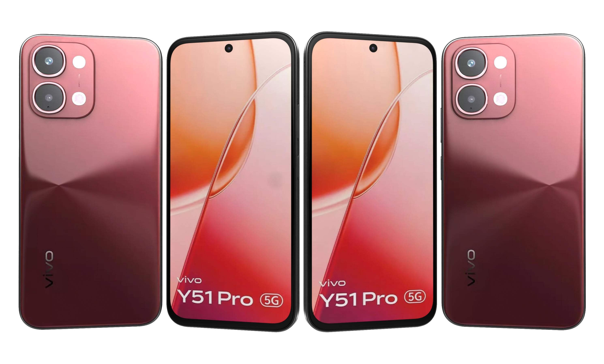 | vivo Y51 Pro  Series: Y Series • Tag: Big Battery  Variants / Memory: 8GB+128GB / 8GB+256GB  Price / MOP: ₹34,999 / ₹37,999  Built for longevity with massive battery capacity, military-grade shock resistance, and 5G connectivity.

 | vivo Y31  Series: Y Series • Tag: Value 5G  Variants / Memory: 4GB+128GB / 6GB+128GB / 6GB+256GB  Price / MOP: ₹19,999 / ₹27,999 / ₹31,999  Smooth 120Hz display, clean Funtouch OS interface, and reliable everyday multitasking.

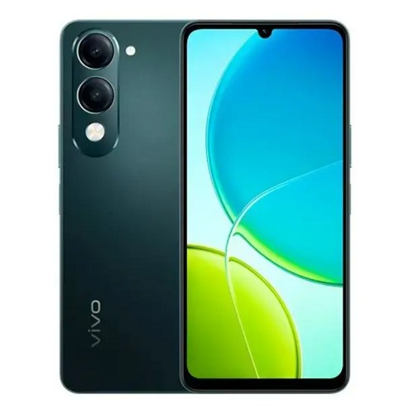 | vivo Y31T 5G  Series: Y Series • Tag: Turbo 5G  Variants / Memory: 4GB+128GB / 6GB+128GB / 6GB+256GB  Price / MOP: ₹26,999 / ₹31,499 / ₹34,999  Turbocharged budget 5G phone designed with high-efficiency chipset and ultra-long battery backup.

 | vivo Y21 5G  Series: Y Series • Tag: Slim 5G  Variants / Memory: 4GB+64GB / 4GB+128GB / 6GB+128GB / 8GB+128GB  Price / MOP: ₹20,999 / ₹23,999 / ₹27,999 / ₹22,999  Popular slim form factor with flat edges, side fingerprint scanner, and 5G support.

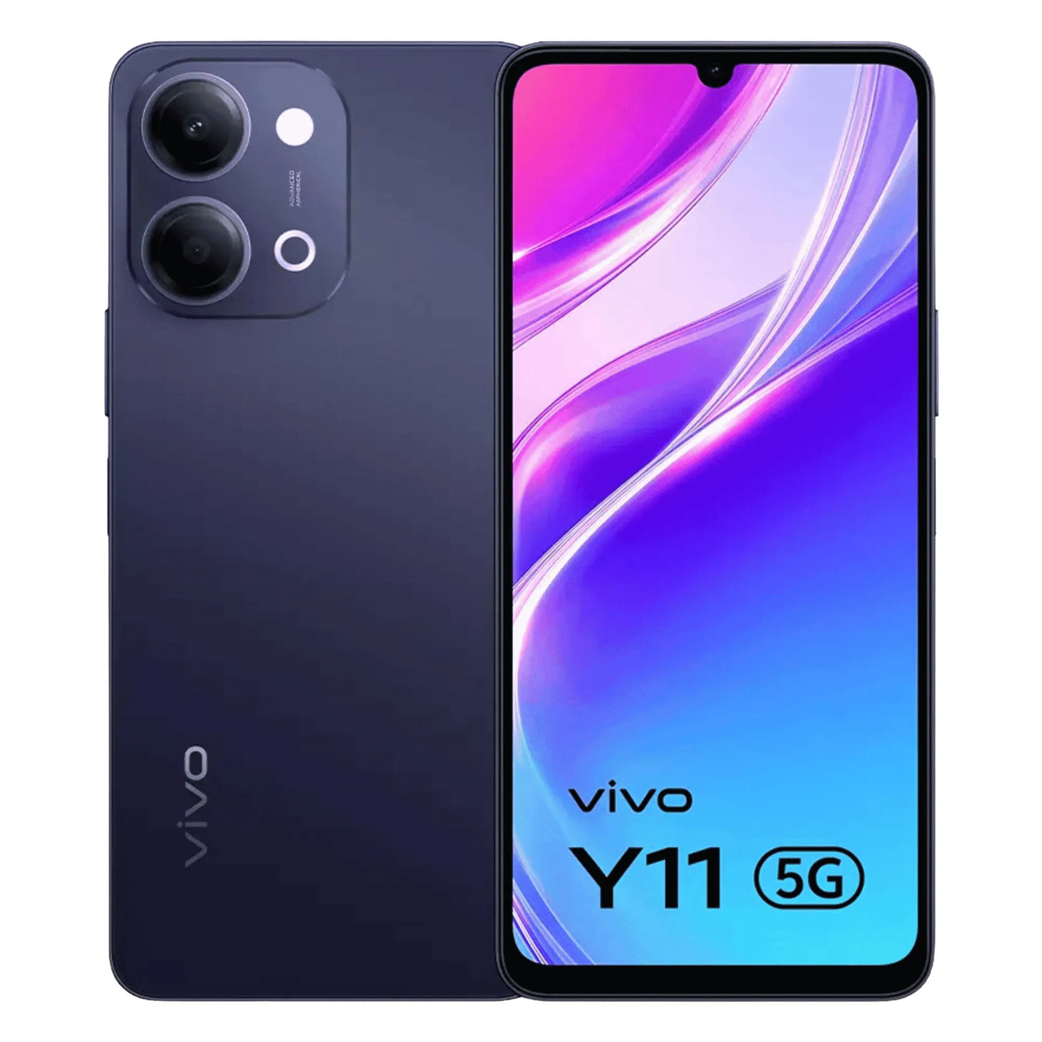 | vivo Y11 5G  Series: Y Series • Tag: Budget 5G  Variants / Memory: 4GB+64GB / 4GB+128GB  Price / MOP: ₹18,999 / ₹22,499  Accessible entry-level 5G smartphone with clear sunlight display and long-lasting 5000mAh battery.

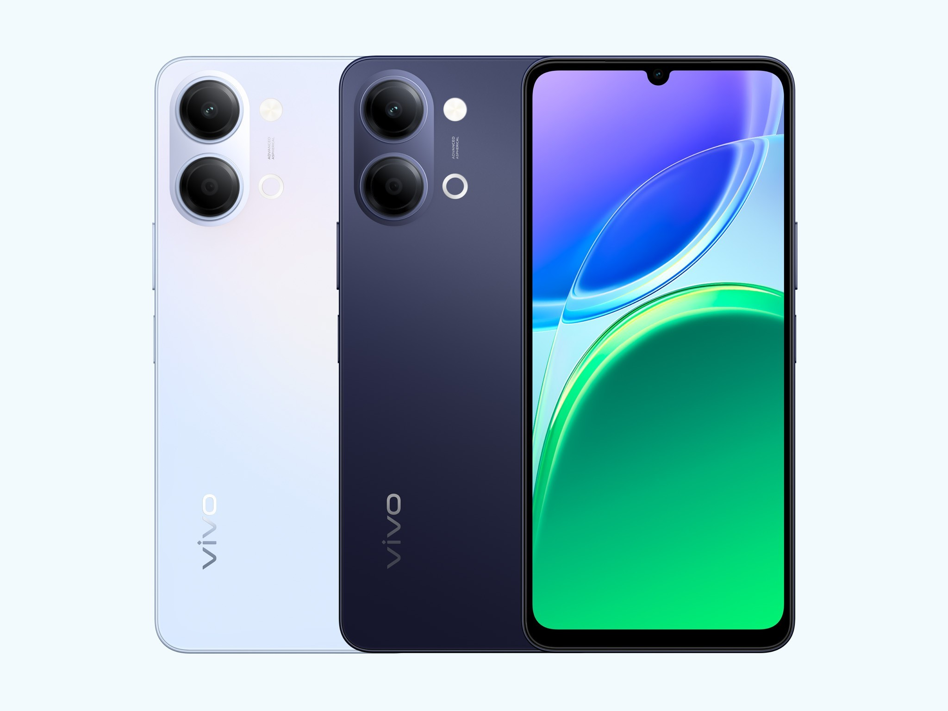 | vivo Y05  Series: Y Series • Tag: Entry Level  Variants / Memory: 4GB+64GB  Price / MOP: ₹15,999  Durable budget smartphone featuring expandable storage, modern matte finish, and all-day power.

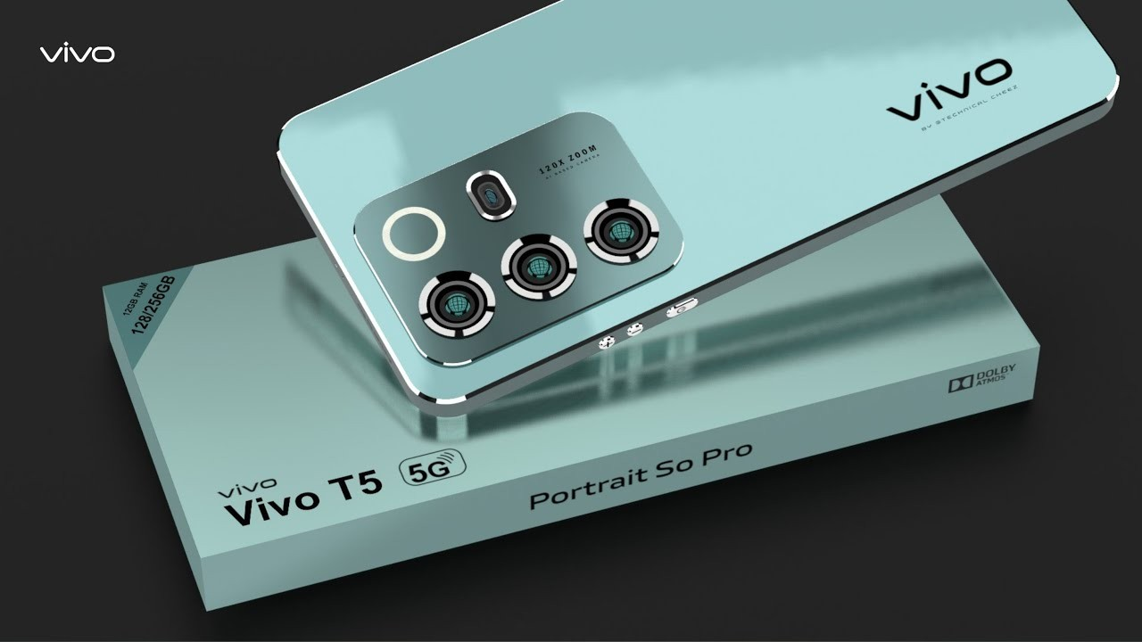 | vivo T5  Series: Series T • Tag: Performance King  Variants / Memory: 6GB+128GB / 8GB+128GB / 8GB+256GB / 12GB+256GB  Price / MOP: ₹34,999 / ₹39,999 / ₹44,999 / ₹49,999  Gaming and speed centric phone powered by MediaTek Dimensity 7000-series with AMOLED 120Hz display.

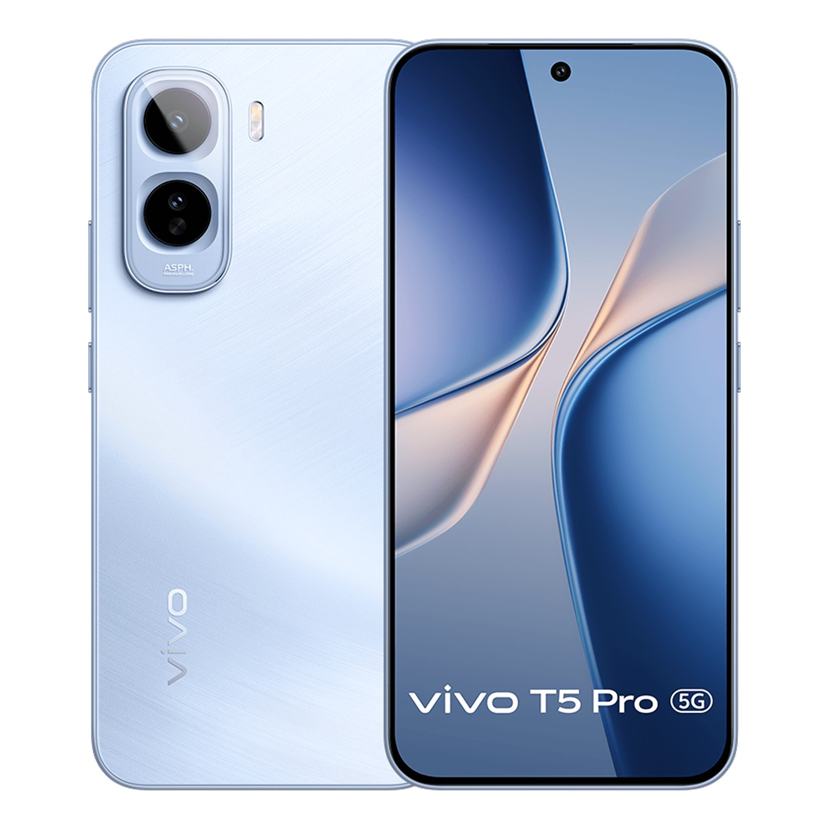 | vivo T5 Pro 5G  Series: Series T • Tag: Turbo Flagship  Variants / Memory: 8GB+128GB / 8GB+256GB  Price / MOP: ₹41,999 / ₹46,999  Curved 3D AMOLED display, Sony OIS camera, Snapdragon performance, and 80W FlashCharge.

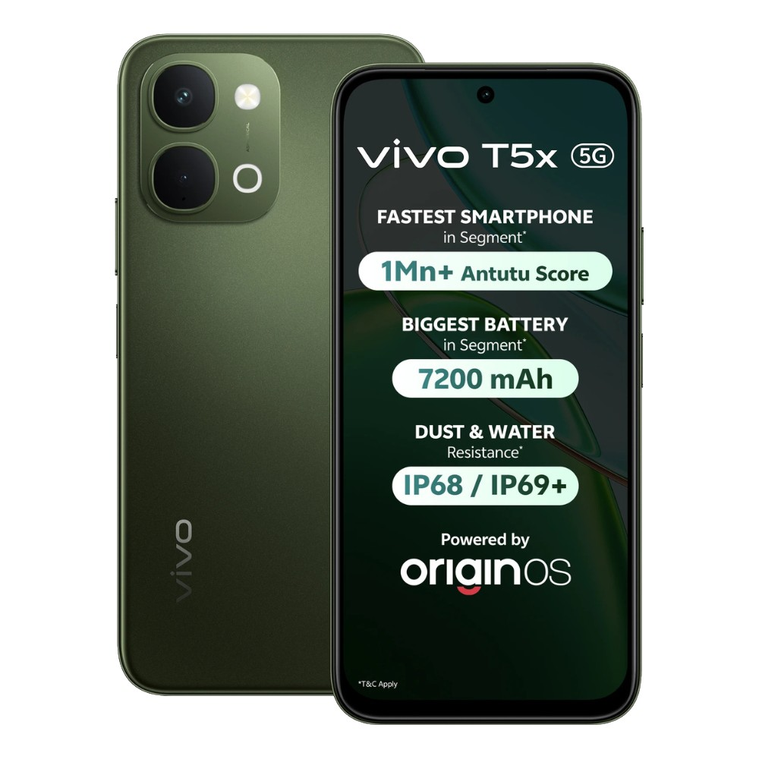 | vivo T5x 5G  Series: Series T • Tag: Powerhouse  Variants / Memory: 6GB+128GB / 8GB+128GB / 8GB+256GB  Price / MOP: ₹27,999 / ₹30,999 / ₹34,999  Massive 6000mAh battery paired with fast 4nm 5G chipset and audio booster dual speakers.

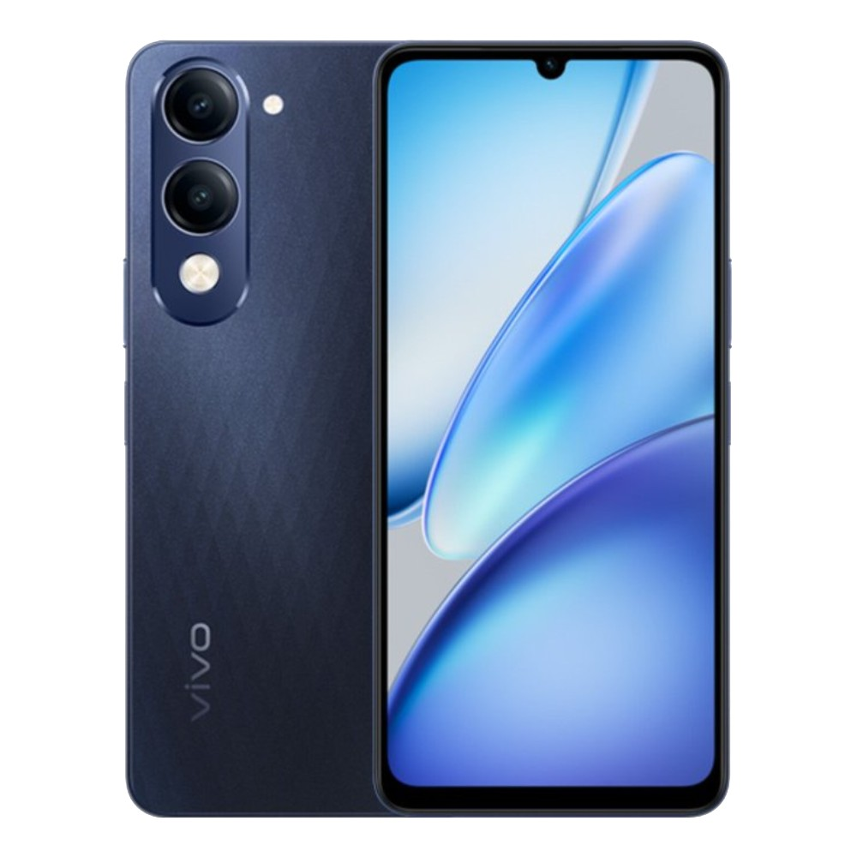 | vivo T5 Lite 5G  Series: Series T • Tag: Budget Speed  Variants / Memory: 4GB+64GB / 4GB+128GB / 6GB+128GB / 6GB+256GB  Price / MOP: ₹17,999 / ₹20,499 / ₹22,999 / ₹26,999  Fast 5G performance at an accessible price point with slim profile and splash resistance.

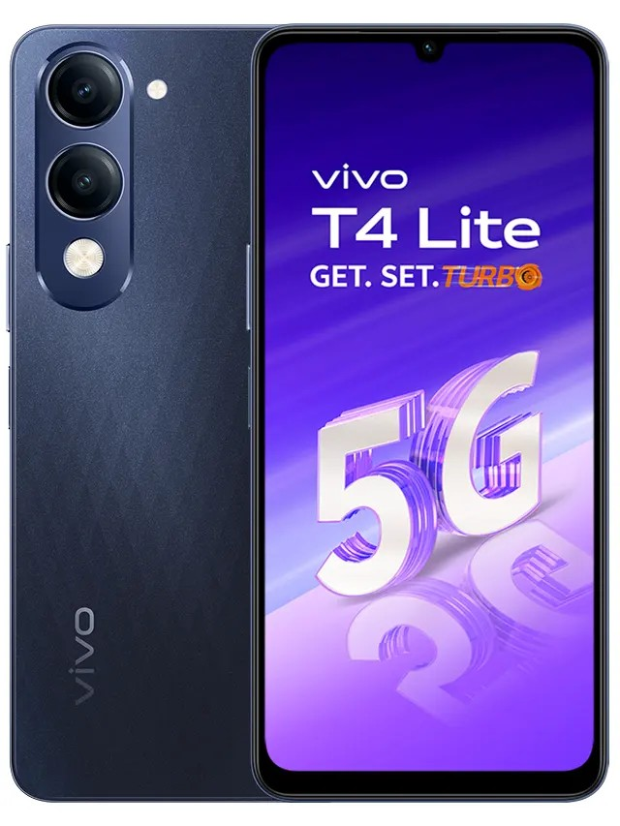 | vivo T4 Lite  Series: Series T • Tag: Value Entry  Variants / Memory: 4GB+64GB / 4GB+128GB / 6GB+128GB / 6GB+256GB  Price / MOP: ₹16,999 / ₹18,999 / ₹20,999 / ₹23,999  Clean design with reliable daily performance, robust battery life, and smooth refresh rate.

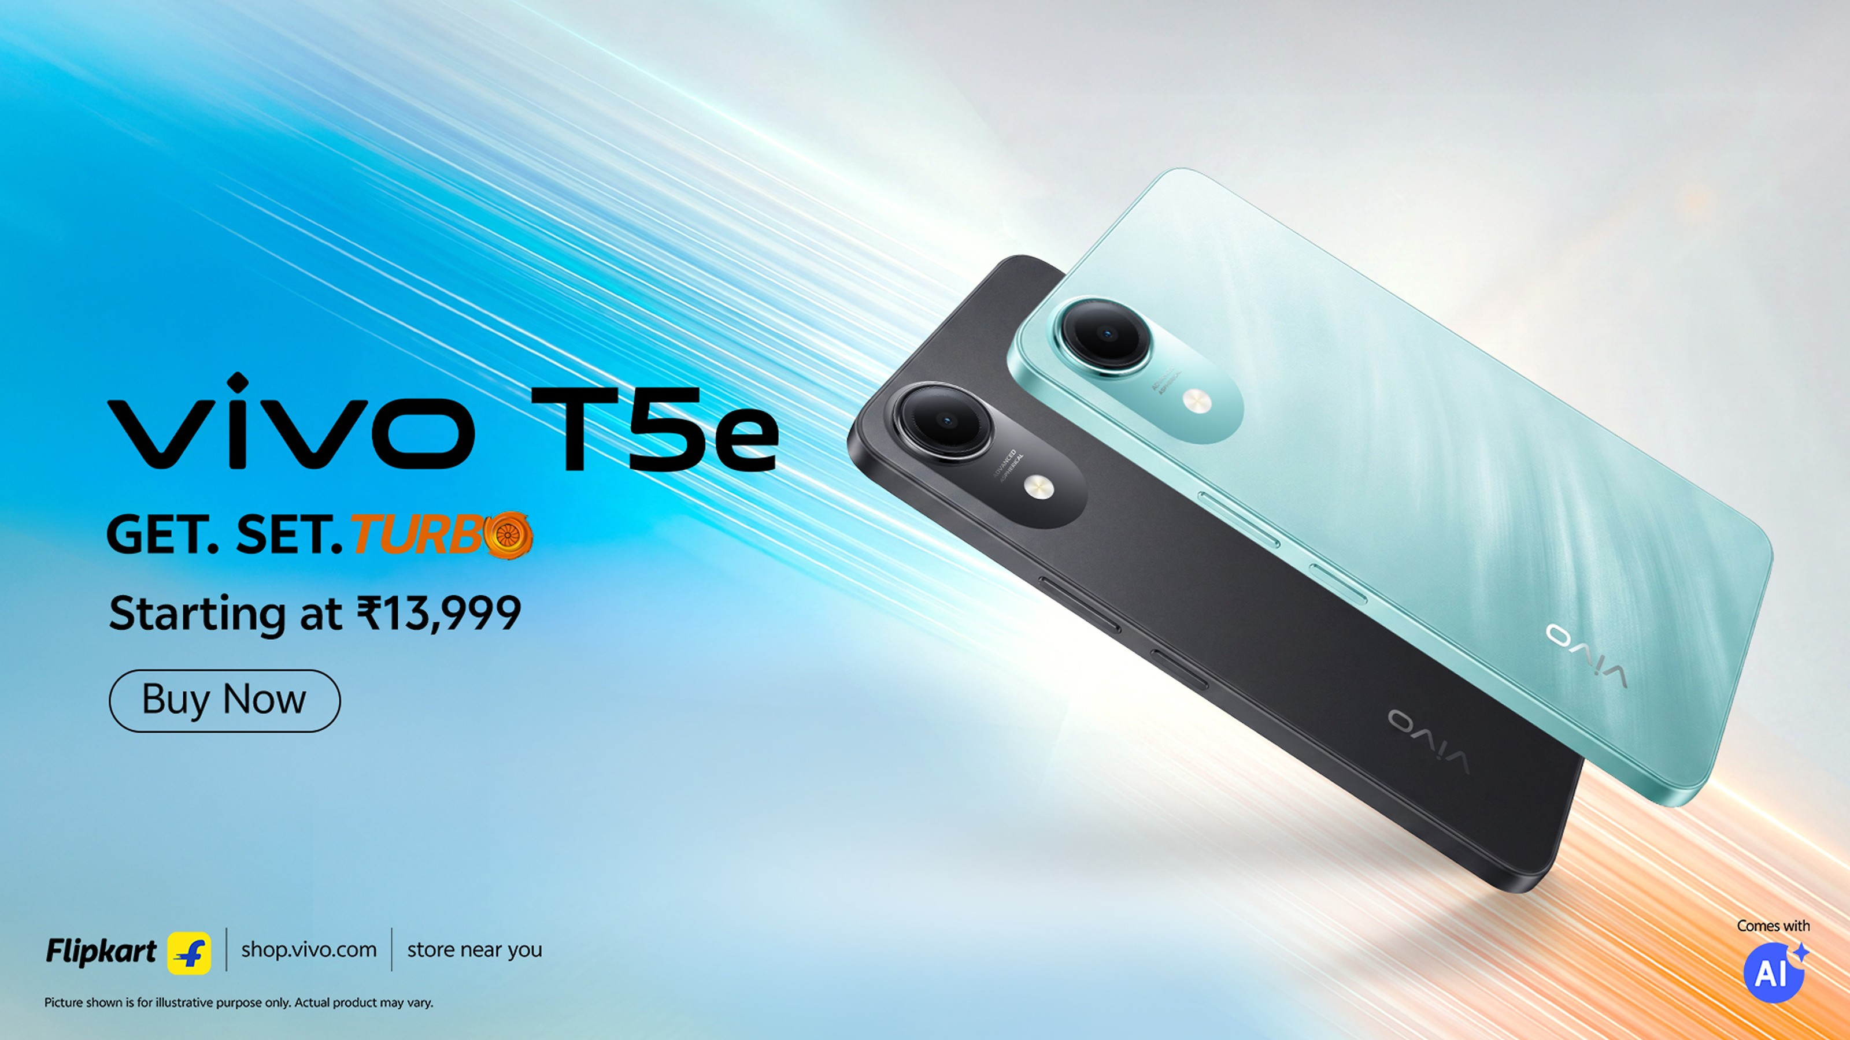 | vivo T5e  Series: Series T • Tag: Essential 5G  Variants / Memory: 4GB+64GB  Price / MOP: ₹13,999  Most affordable 5G entry in the T-series lineup offering solid battery and clear display.

■ MOTOROLA SMARTPHONES
Total Models Listed: 19 models with official photos, memory tiers, and pricing.
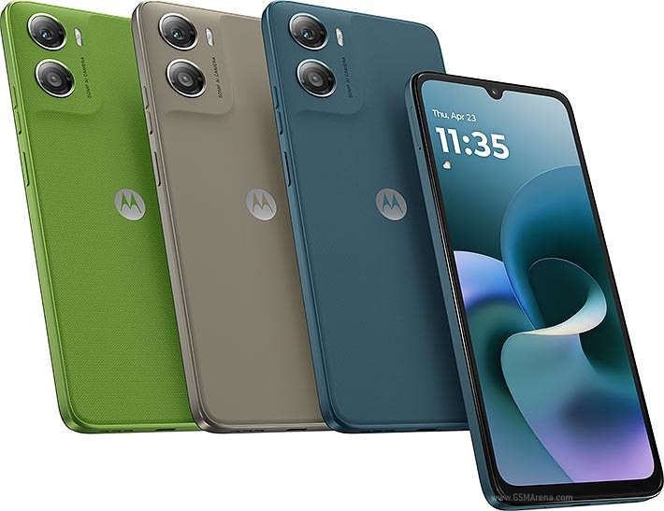 | Moto G06 Power  Series: Moto G Series • Tag: Mega Battery  Variants / Memory: 4GB + 64GB  Price / MOP: MOP ₹15,999 (NEP ₹13,999)  Gigantic 7000mAh battery, 6.88-inch 120Hz display, 50MP AI camera, and Dolby Atmos stereo sound.

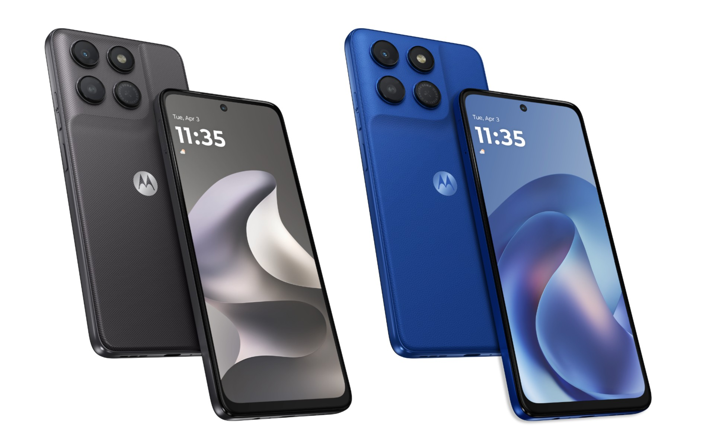 | Moto G37  Series: Moto G Series • Tag: Fast & Slim  Variants / Memory: 4GB + 64GB (5200 mAh / 20W)  Price / MOP: MOP ₹18,999 (NEP ₹14,999)  5200mAh battery with 20W TurboPower charger in-box, vegan leather finish, and 5G connectivity.

 | Moto G37 Power  Series: Moto G Series • Tag: 7000 mAh Monster  Variants / Memory: 4/64GB | 4/128GB | 8/128GB  Price / MOP: ₹19,999 / ₹21,999 / ₹25,999  Colossal 7000mAh battery backed by 30W TurboPower fast charging for multi-day endurance.

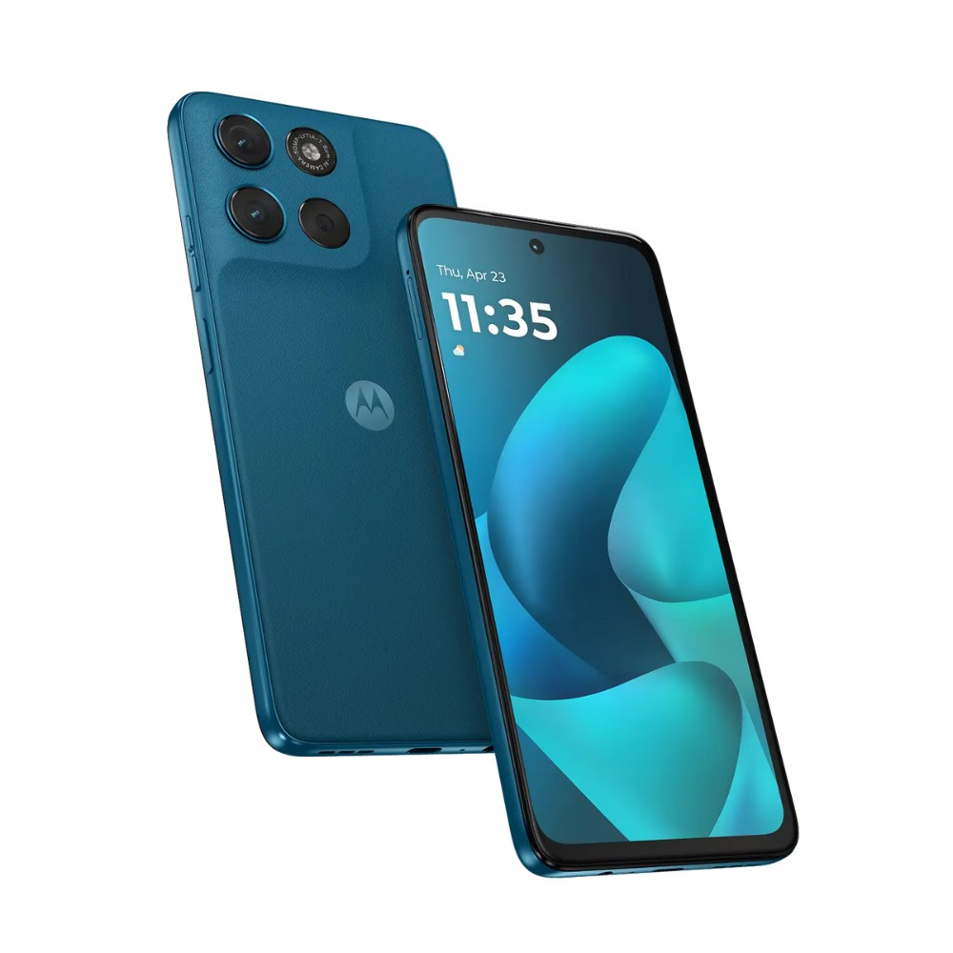 | Moto G57  Series: Moto G Series • Tag: Smooth 120Hz  Variants / Memory: 8GB + 128GB  Price / MOP: MOP ₹21,999  FHD+ 120Hz display, 50MP Quad Pixel camera with OIS, stereo speakers, and clean Hello UI.

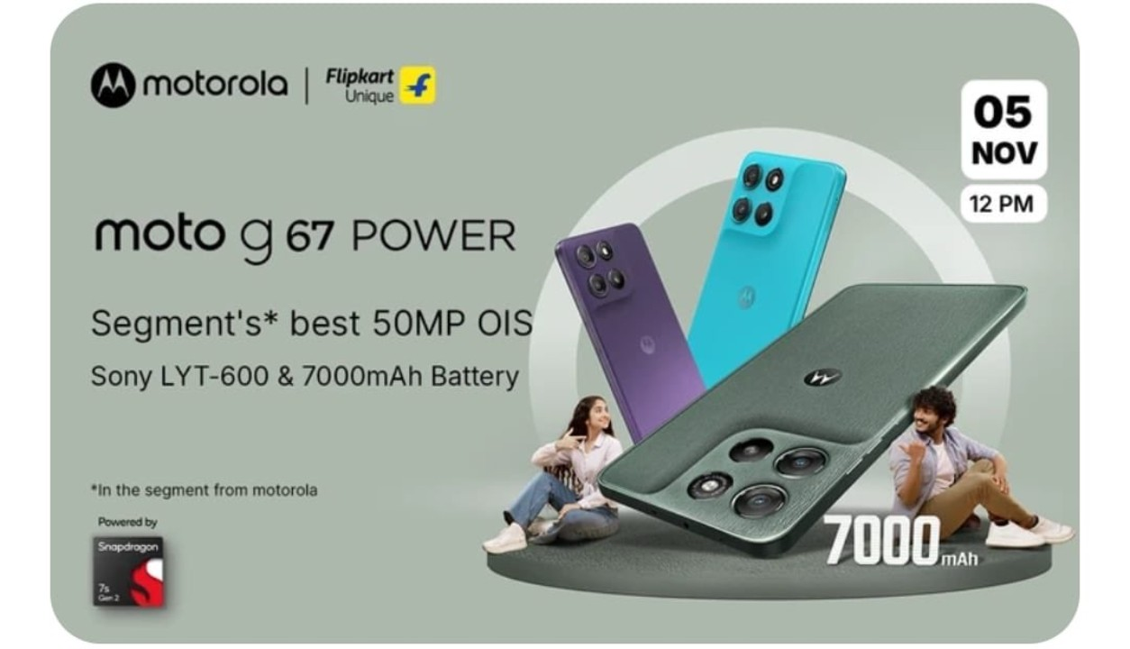 | Moto G67 Power  Series: Moto G Series • Tag: Power Champion  Variants / Memory: 8+128GB / 12+256GB  Price / MOP: ₹22,999 / ₹27,999  Dimensity 7000-series 5G processor, massive 6000mAh battery, and up to 12GB physical RAM.

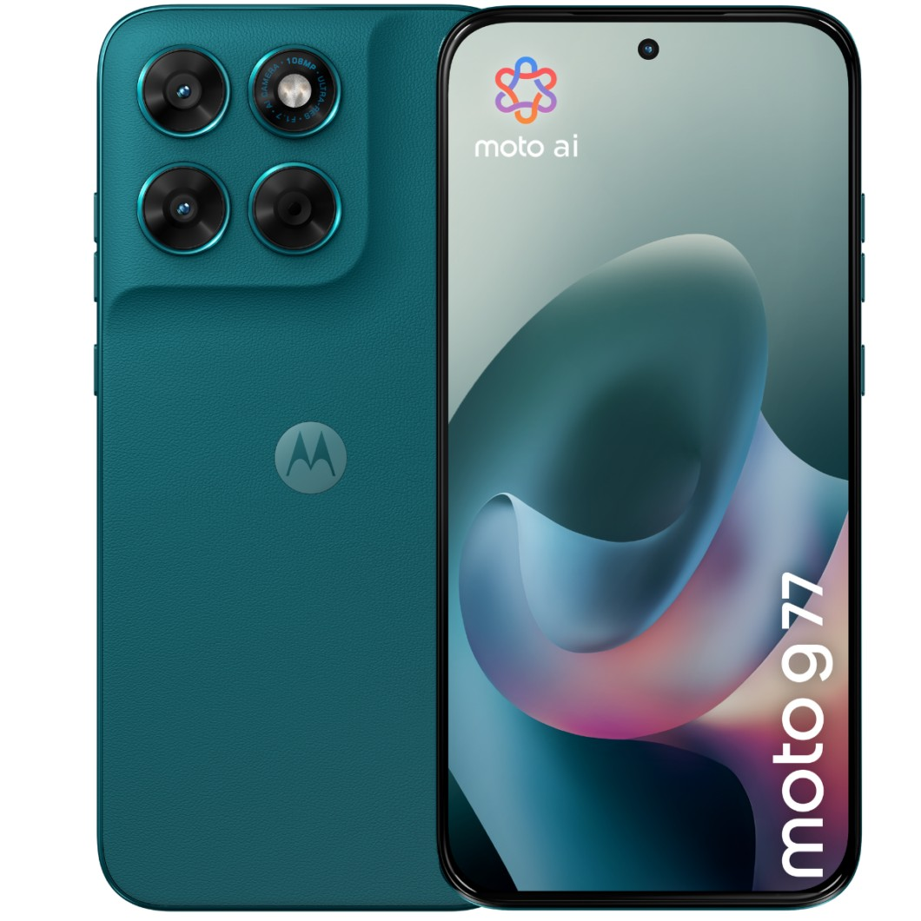 | Moto G77  Series: Moto G Series • Tag: Military Grade  Variants / Memory: 4/128GB / 8/128GB  Price / MOP: ₹24,999 / ₹27,999  IP68 water resistance + MIL-STD-810H durability certification with Sony LYT600 camera sensor.

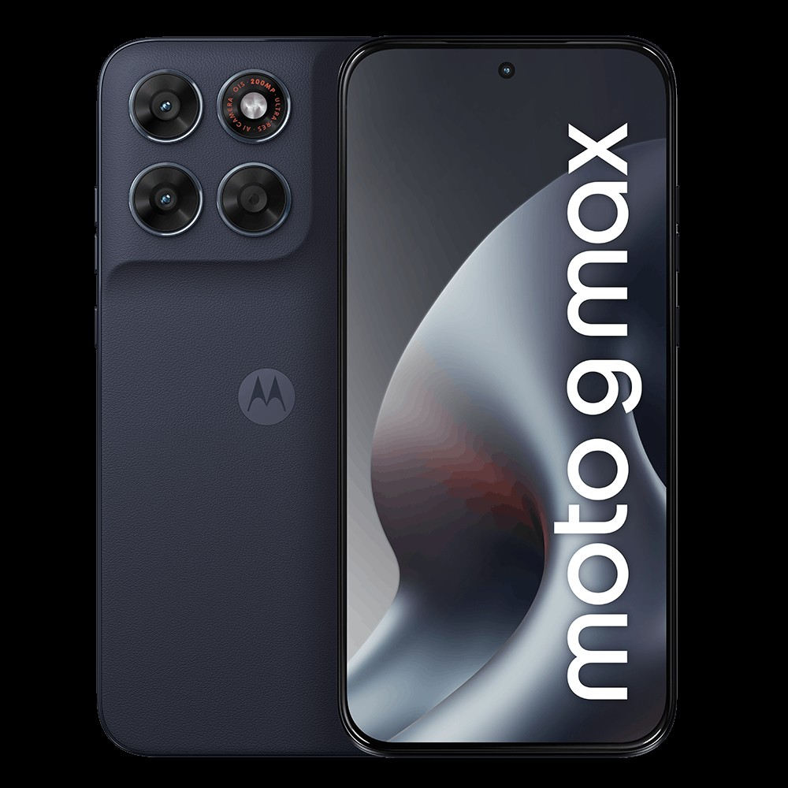 | Moto G Max  Series: Moto G Series • Tag: Max Screen  Variants / Memory: 4+128GB / 6+128GB  Price / MOP: ₹25,999 / ₹27,999  Expansive cinematic display, built-in productivity features, and multi-day battery life.

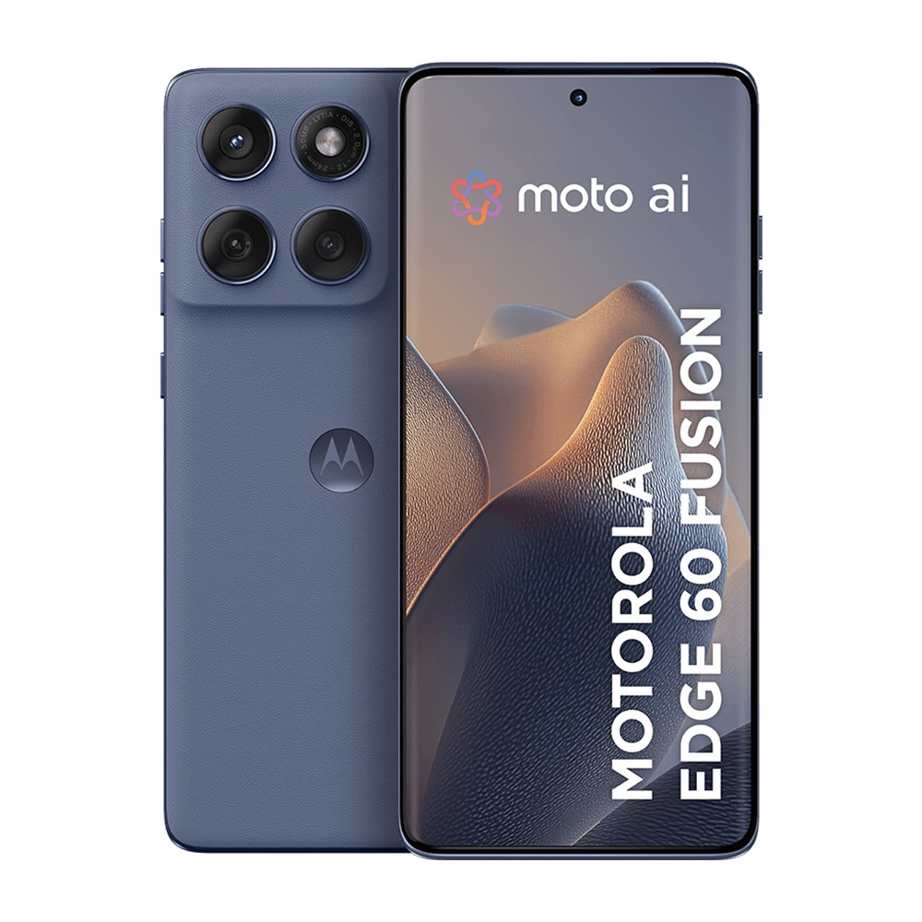 | Motorola Edge 60 Fusion  Series: Edge Series • Tag: Curved pOLED  Variants / Memory: 8/128GB / 8/256GB / 12/256GB  Price / MOP: ₹22,999 / ₹24,999 / ₹29,999  Quad-curved 144Hz pOLED display, 50MP Sony LYT-700C OIS camera, IP68 water resistance, and 68W charging.

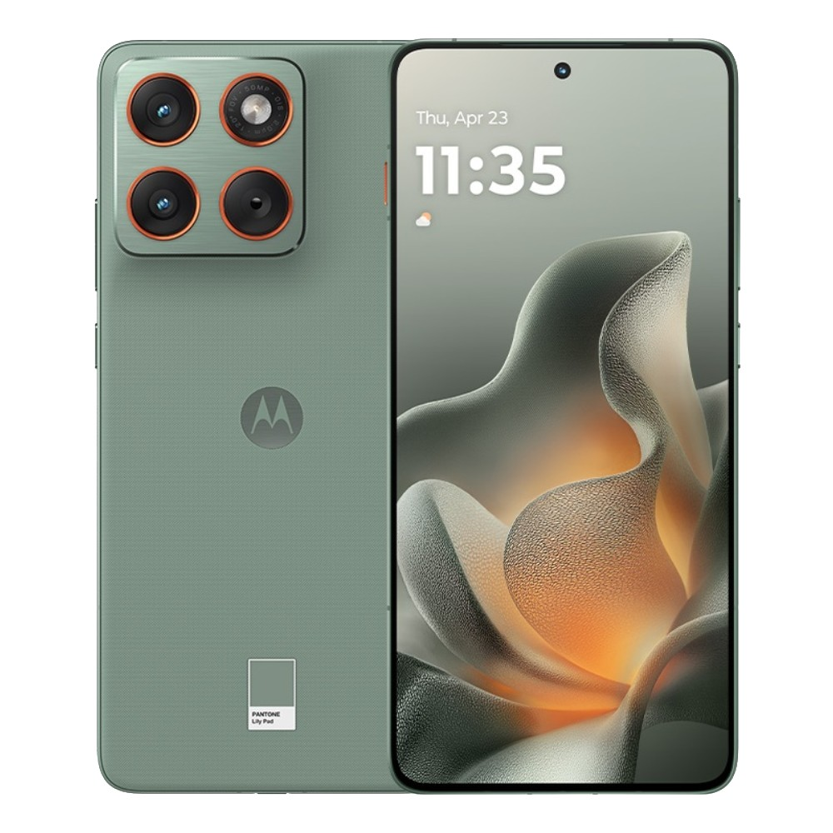 | Motorola Edge 70  Series: Edge Series • Tag: NEW Flagship  Variants / Memory: 8GB + 256GB  Price / MOP: MOP ₹29,999  Next-generation Edge design with 1.5K pOLED screen, Moto AI camera suite, and sleek vegan leather back.

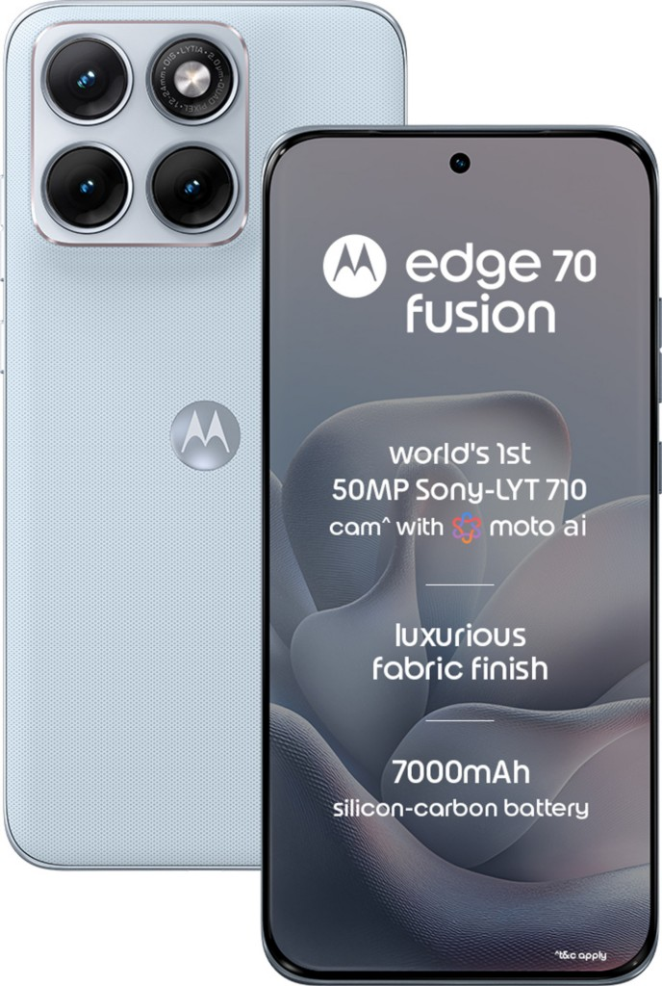 | Motorola Edge 70 Fusion  Series: Edge Series • Tag: Best Seller  Variants / Memory: 8/128GB / 8/256GB / 12/256GB / 12/512GB  Price / MOP: ₹30,999 / ₹32,999 / ₹34,999 / ₹38,999  Flagship curved aesthetics with Pantone color options, 50MP Sony dual camera, and fast 68W charging.

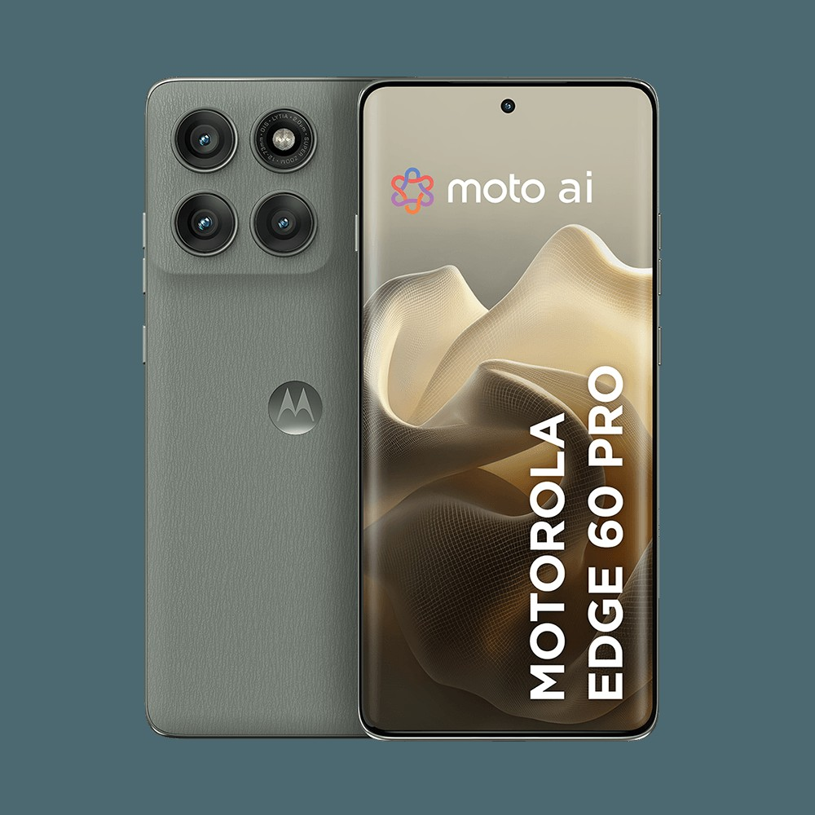 | Motorola Edge 60 Pro  Series: Edge Series • Tag: Pro Performance  Variants / Memory: 8/256GB / 12/256GB / 16/512GB  Price / MOP: ₹29,999 / ₹33,999 / ₹37,999  Snapdragon 8-series performance, 125W TurboPower wired charging + 50W wireless charging support.

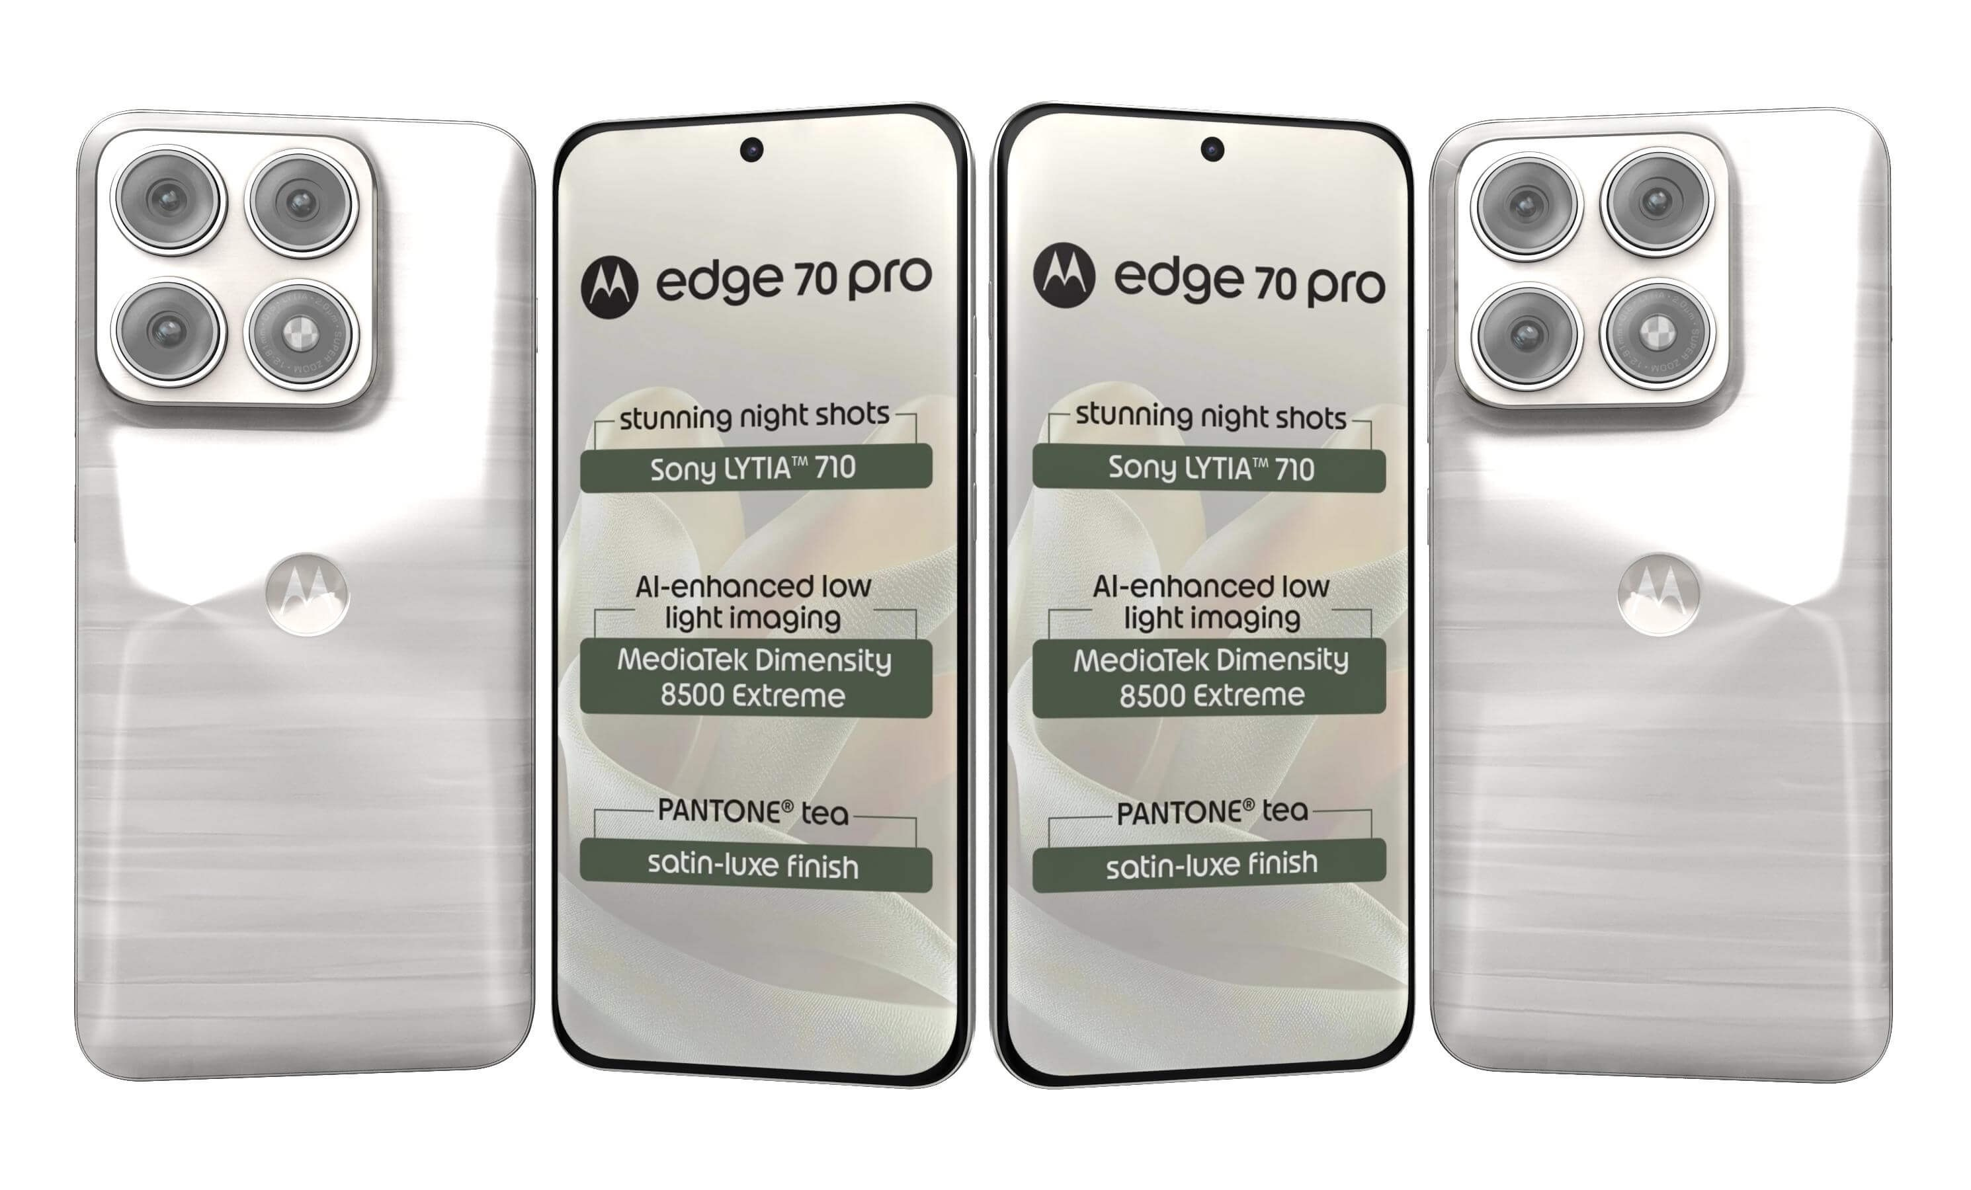 | Motorola Edge 70 Pro  Series: Edge Series • Tag: Pro Flagship  Variants / Memory: 8/256GB / 12/256GB  Price / MOP: ₹39,999 / ₹42,999  Triple 50MP cameras with 3x periscope telephoto lens, 144Hz curved screen, and 125W fast charging.

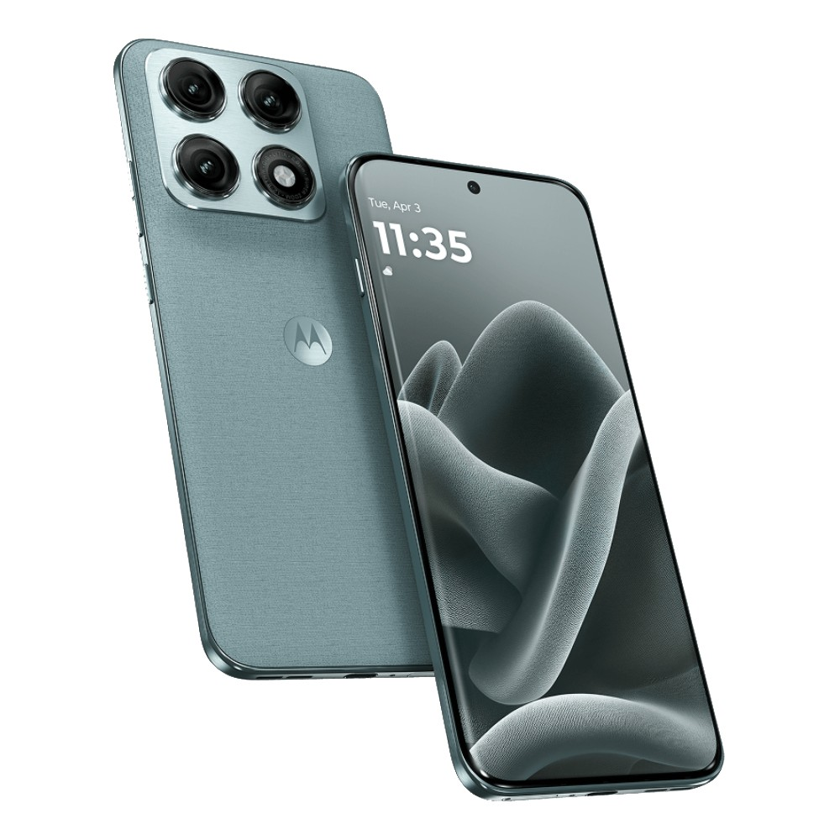 | Motorola Edge 70 Pro +  Series: Edge Series • Tag: Pro Plus Flagship  Variants / Memory: 12GB + 256GB  Price / MOP: MOP ₹47,999 (Offer ₹44,999)  Enhanced telephoto zoom capabilities, AI photo enhancement engine, and ultra-premium glass build.

 | Motorola Edge 70 MAX  Series: Edge Series • Tag: Ultimate Flagship  Variants / Memory: 8/256GB / 12/256GB  Price / MOP: ₹54,999 / ₹59,999  Maximized battery, flagship processor, lossless 100x hybrid zoom, and top-of-the-line Gorilla Glass Armor.

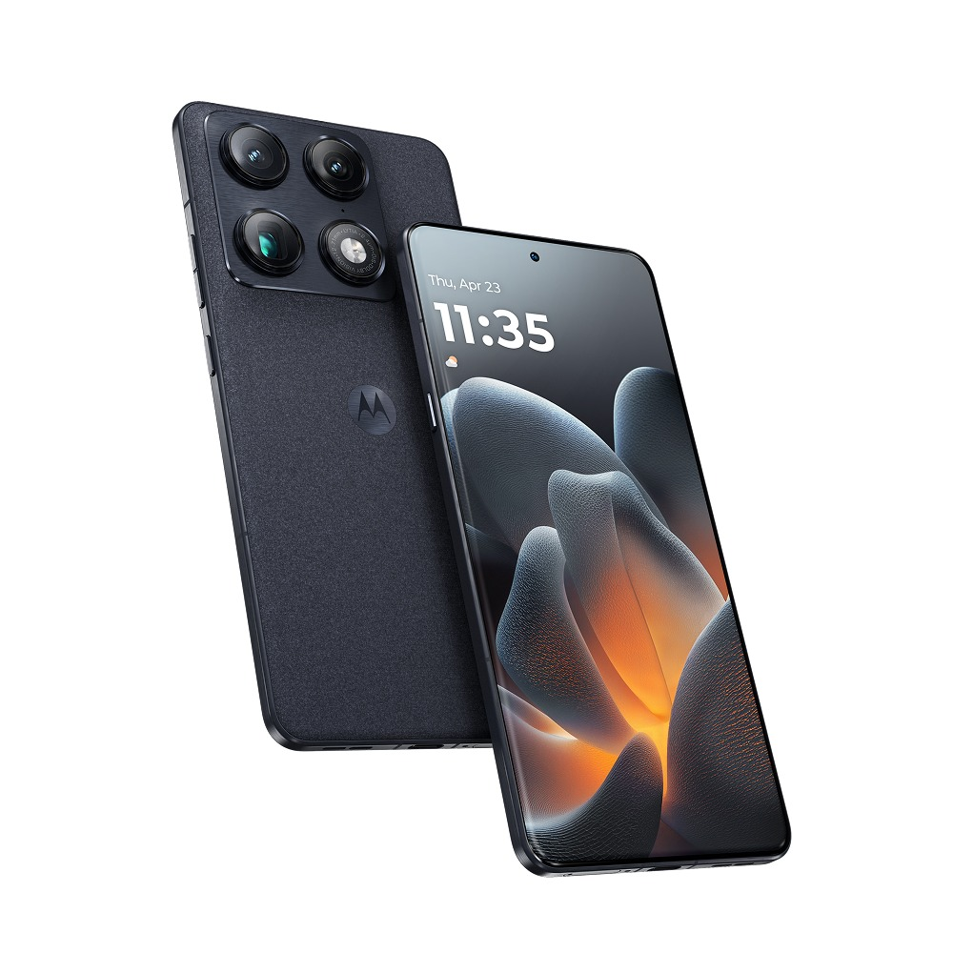 | Motorola Signature  Series: Signature • Tag: Luxury Signature  Variants / Memory: 12/256GB / 16/512GB / 16/1TB  Price / MOP: ₹59,999 / ₹64,999 / ₹69,999  Handcrafted real wood & Italian leather back finishes with titanium-reinforced frame and 1TB storage.

 | Motorola Razr 60  Series: Razr Series • Tag: Flip Iconic  Variants / Memory: 8GB + 256GB  Price / MOP: MOP ₹49,999  Full-size external cover display, zero-crease teardrop hinge, compact clamshell design, and Moto AI.

 | Motorola Razr 60 Swarovski  Series: Razr Series • Tag: Limited Edition  Variants / Memory: 12GB + 256GB  Price / MOP: MOP ₹54,999  Bespoke edition embedded with genuine Swarovski crystals and bespoke matching accessories.

 | Motorola Razr 60 Ultra  Series: Razr Series • Tag: Ultra Flip  Variants / Memory: 16GB + 512GB  Price / MOP: MOP ₹79,999 (Scheme ₹74,999)  Largest 4.0-inch 165Hz cover screen, Snapdragon 8 Gen 3/4 flagship chip, and 50MP telephoto camera.

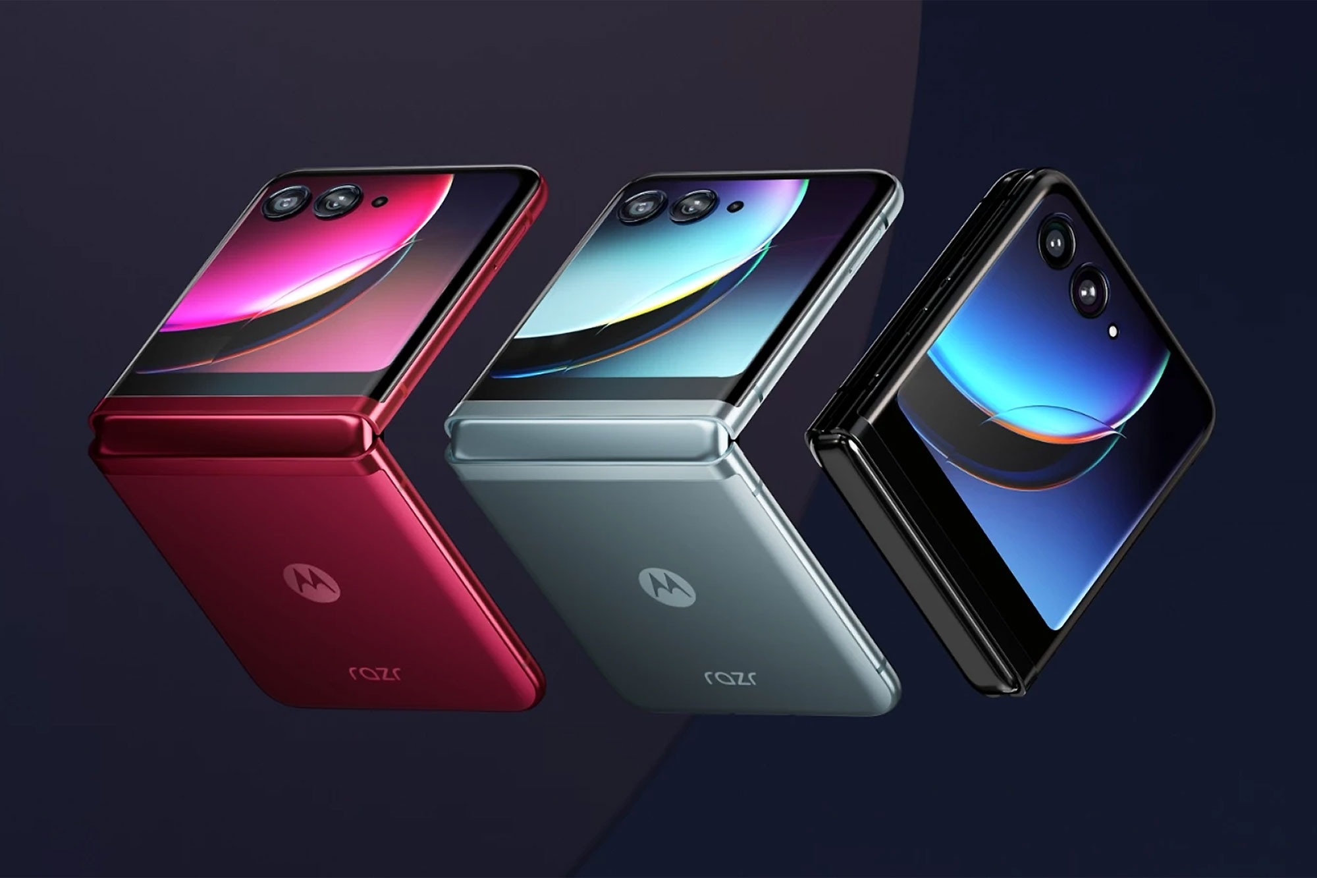 | Motorola Razr Fold  Series: Razr Series • Tag: Book Foldable  Variants / Memory: 12/256GB / 16/512GB / FIFA Edition  Price / MOP: ₹1,49,999 / ₹1,59,999 / ₹1,69,999  Motorola's book-style horizontal foldable featuring dual stylus support, carbon-fiber hinge, and FIFA collector edition.

■ SAMSUNG GALAXY SMARTPHONES
Total Models Listed: 39 models with official photos, memory tiers, and pricing.
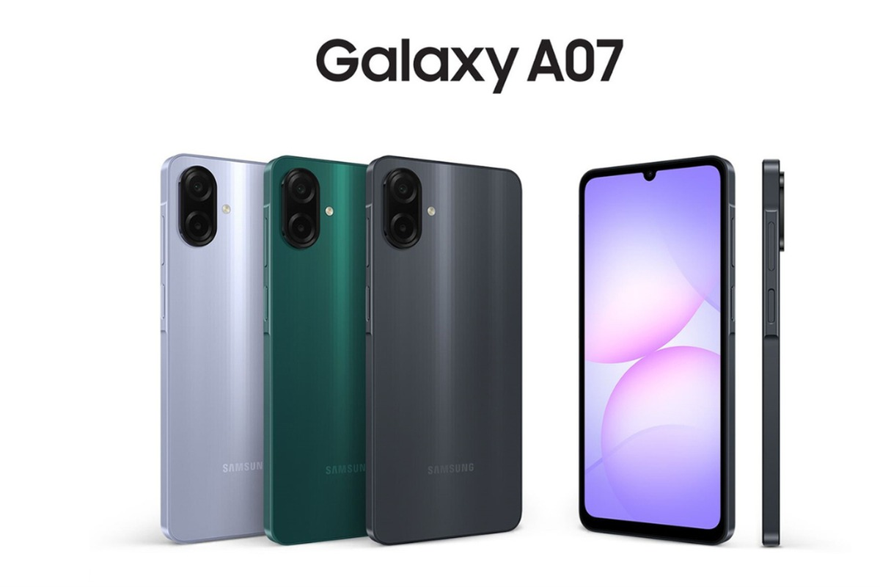 | Samsung Galaxy A07 LTE  Series: A Series • Tag: Affordable  Variants / Memory: 4GB + 64GB  Price / MOP: MOP ₹13,499  Reliable entry phone with large Infinity-U screen, 50MP camera, and 5000mAh battery.

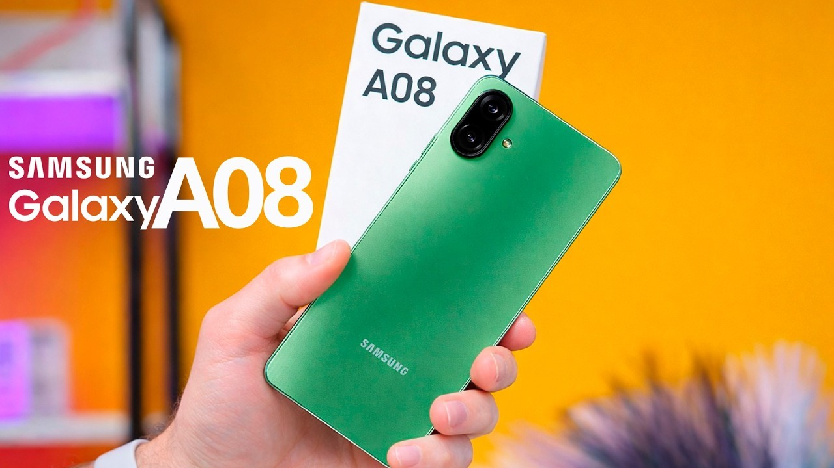 | Samsung Galaxy A08 LTE  Series: A Series • Tag: Essential  Variants / Memory: 4GB + 64GB  Price / MOP: MOP ₹18,499  Modern floating camera design, enhanced processor, and 4 years of guaranteed OS updates.

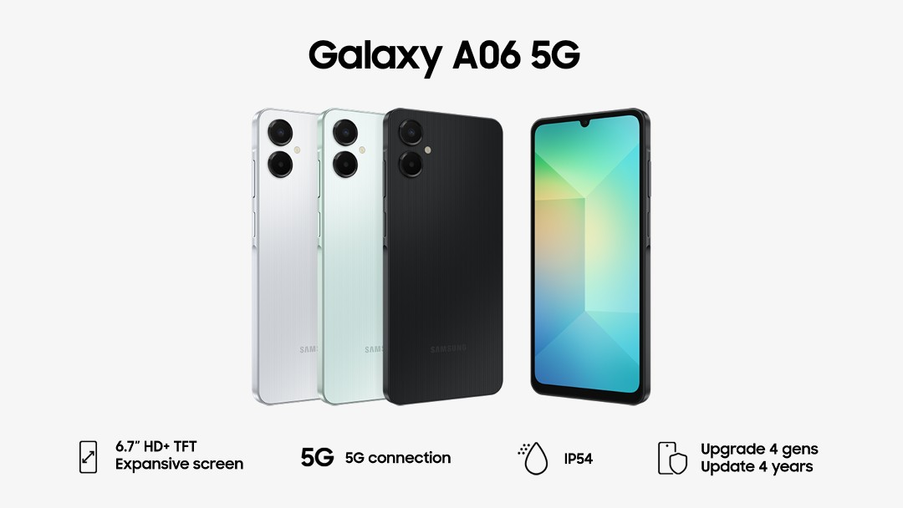 | Samsung Galaxy A06 5G  Series: A Series • Tag: Budget 5G  Variants / Memory: 4/64GB | 4/128GB | 6/128GB  Price / MOP: ₹15,999 / ₹17,999 / ₹19,999  High-speed 5G connectivity for all, featuring 90Hz display and Samsung Knox Vault security.

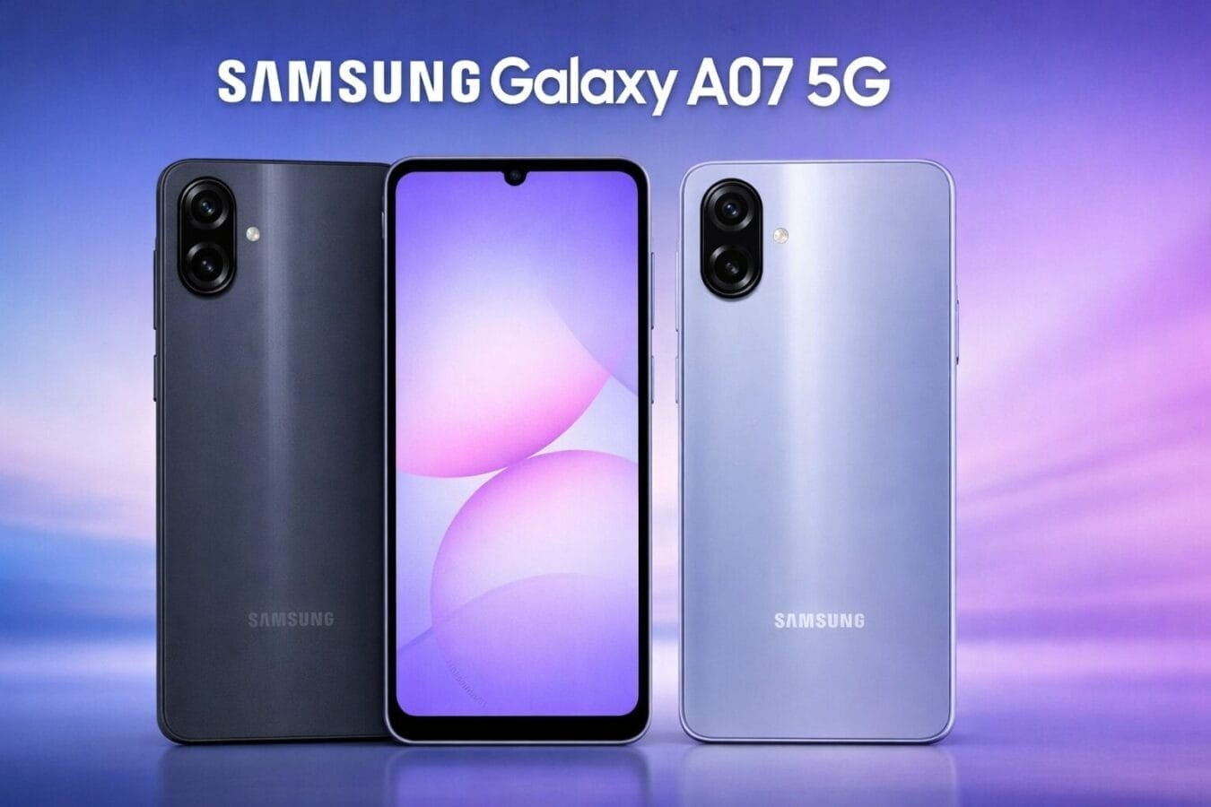 | Samsung Galaxy A07 5G  Series: A Series • Tag: Next-Gen 5G  Variants / Memory: 4/128GB / 6/128GB  Price / MOP: ₹20,499 / ₹23,499  Bright 6.6-inch 90Hz display, dual rear camera setup, and slim Key Island ergonomic frame.

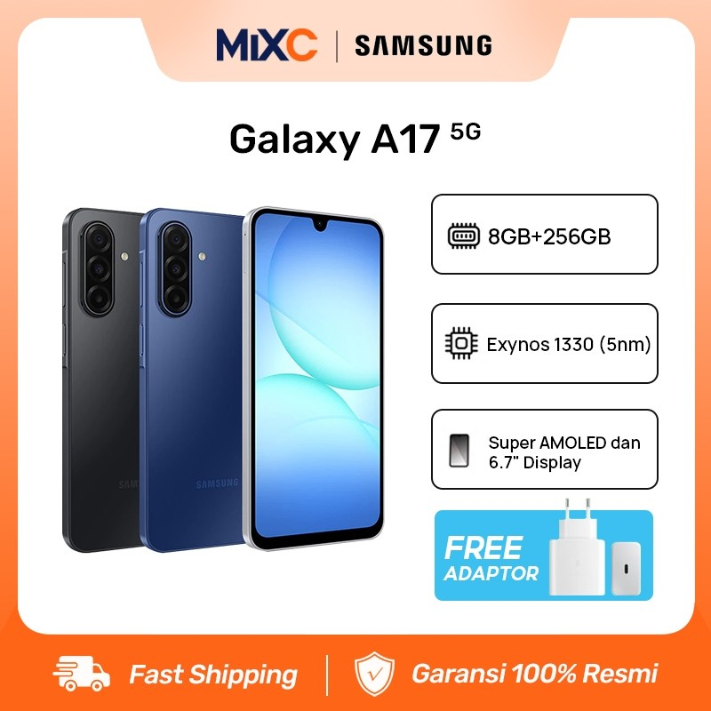 | Samsung Galaxy A17 5G  Series: A Series • Tag: Super AMOLED  Variants / Memory: 6/128GB | 8/128GB | 8/256GB  Price / MOP: ₹27,499 / ₹30,499 / ₹35,999  Super AMOLED 90Hz screen, 50MP triple camera with ultra-wide lens, and 6 OS upgrade guarantee.

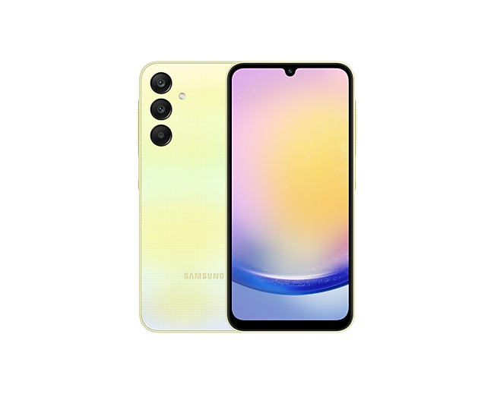 | Samsung Galaxy A27 5G  Series: A Series • Tag: OIS Camera  Variants / Memory: 6/128GB | 8/128GB | 8/256GB  Price / MOP: ₹33,499 / ₹38,499 / ₹44,999  120Hz Super AMOLED display, 50MP OIS camera, stereo speakers, and premium glass-like back.

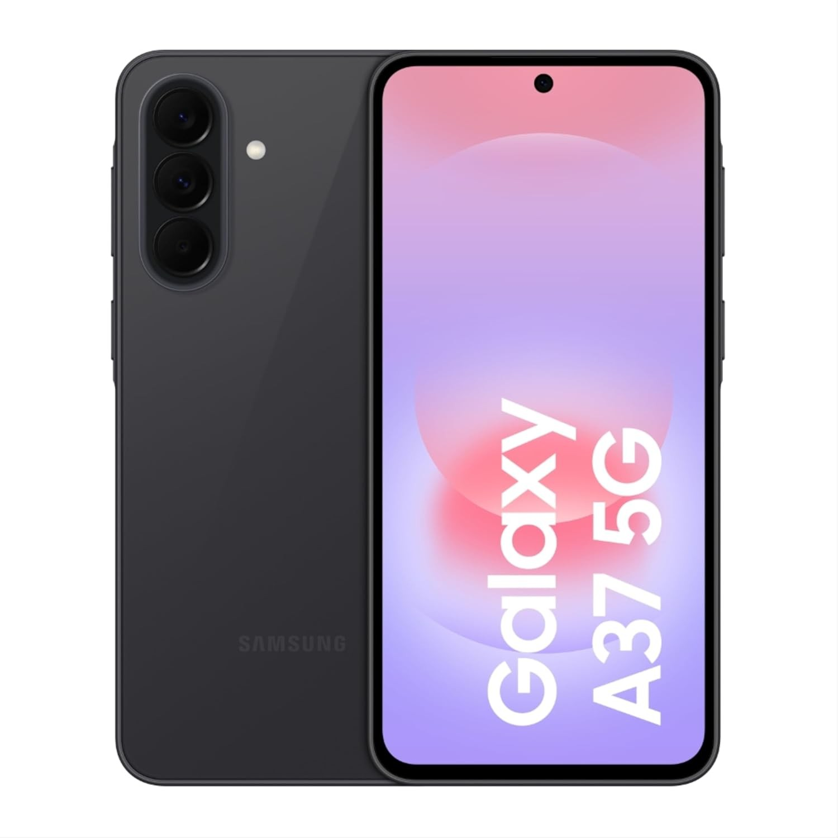 | Samsung Galaxy A37 5G  Series: A Series • Tag: IP67 Water Resistant  Variants / Memory: 8/128GB | 8/256GB | 12/256GB  Price / MOP: ₹42,999 / ₹50,499 / ₹59,999  IP67 dust and water resistance, Corning Gorilla Glass Victus+, and advanced Exynos processor.

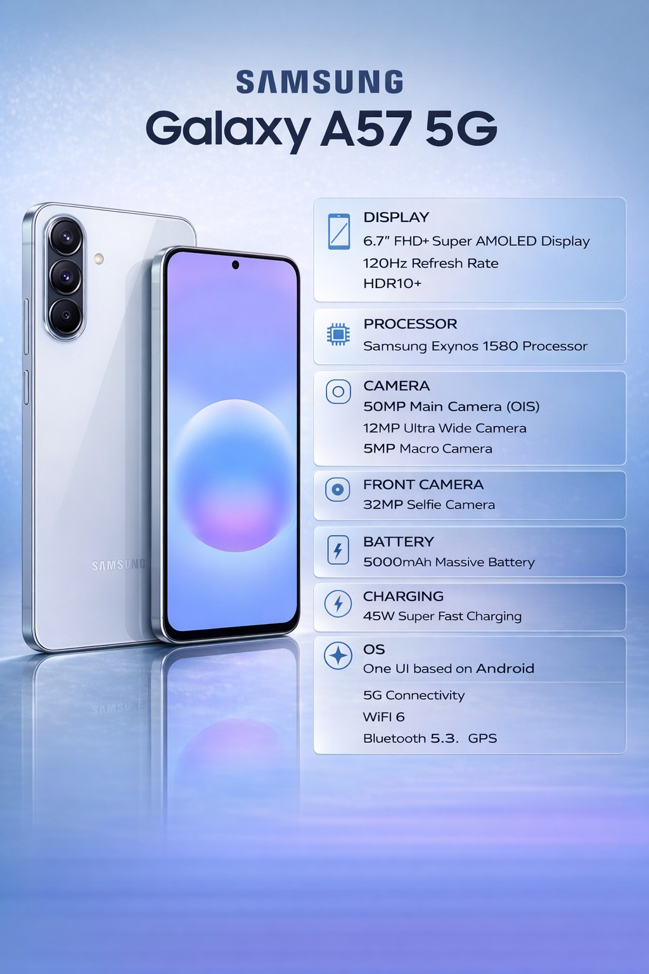 | Samsung Galaxy A57 5G  Series: A Series • Tag: Near Flagship  Variants / Memory: 8/256GB / 12/256GB  Price / MOP: ₹54,499 / ₹62,999  Metal frame, Vision Booster AMOLED screen, 50MP flagship sensor with big pixels, and Knox security.

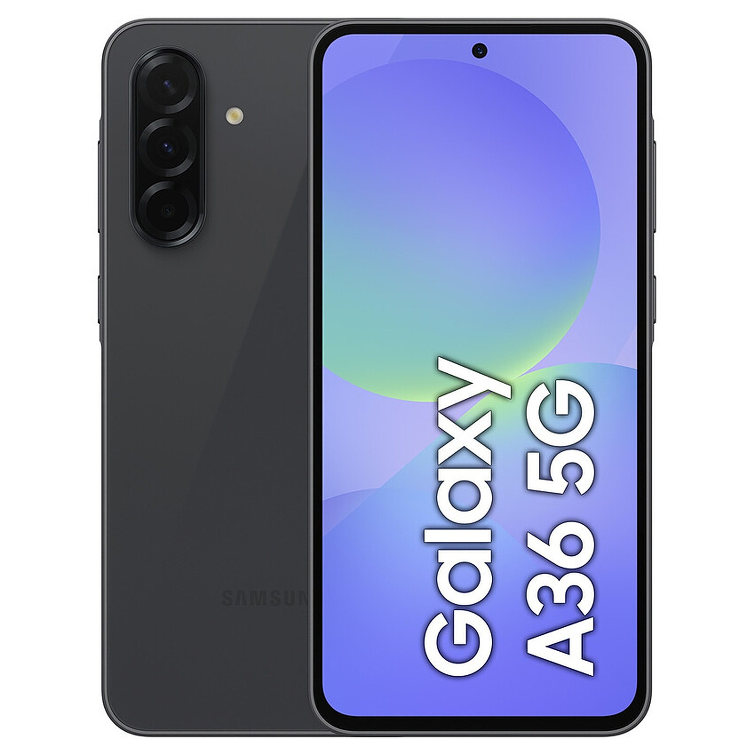 | Samsung Galaxy A36 5G  Series: A Series • Tag: Value Mid-Range  Variants / Memory: 8/128GB | 8/256GB | 12/256GB  Price / MOP: ₹36,999 / ₹40,999 / ₹46,499  Sleek floating lens design, 120Hz AMOLED panel, and solid 5000mAh battery.

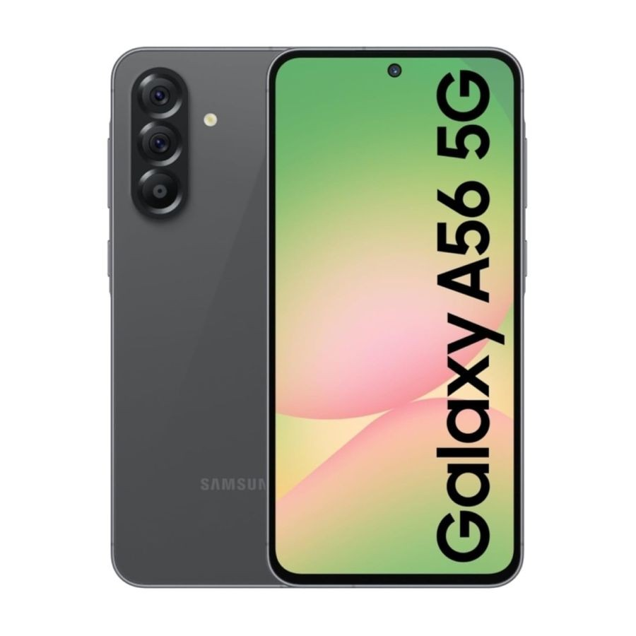 | Samsung Galaxy A56 5G  Series: A Series • Tag: Metal Build  Variants / Memory: 8/128GB | 8/256GB | 12/256GB  Price / MOP: ₹44,999 / ₹48,999 / ₹54,499  Brushed metal side rails, 4K video recording on front & back, and 45W fast charging.

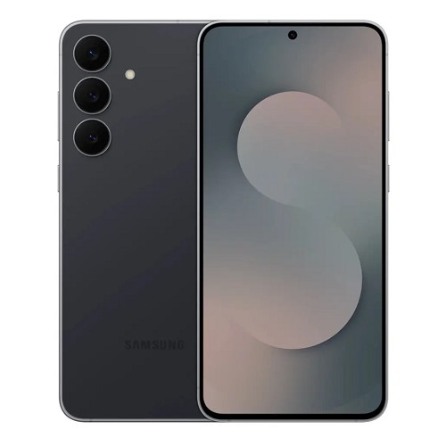 | Samsung Galaxy S26 FE 5G  Series: S Series Flagship • Tag: Fan Edition  Variants / Memory: 8GB+128GB / 8GB+256GB  Price / MOP: ₹69,999 / ₹72,999  Galaxy AI suite, 6.7-inch Dynamic AMOLED 2X 120Hz display, and 3x optical telephoto camera.

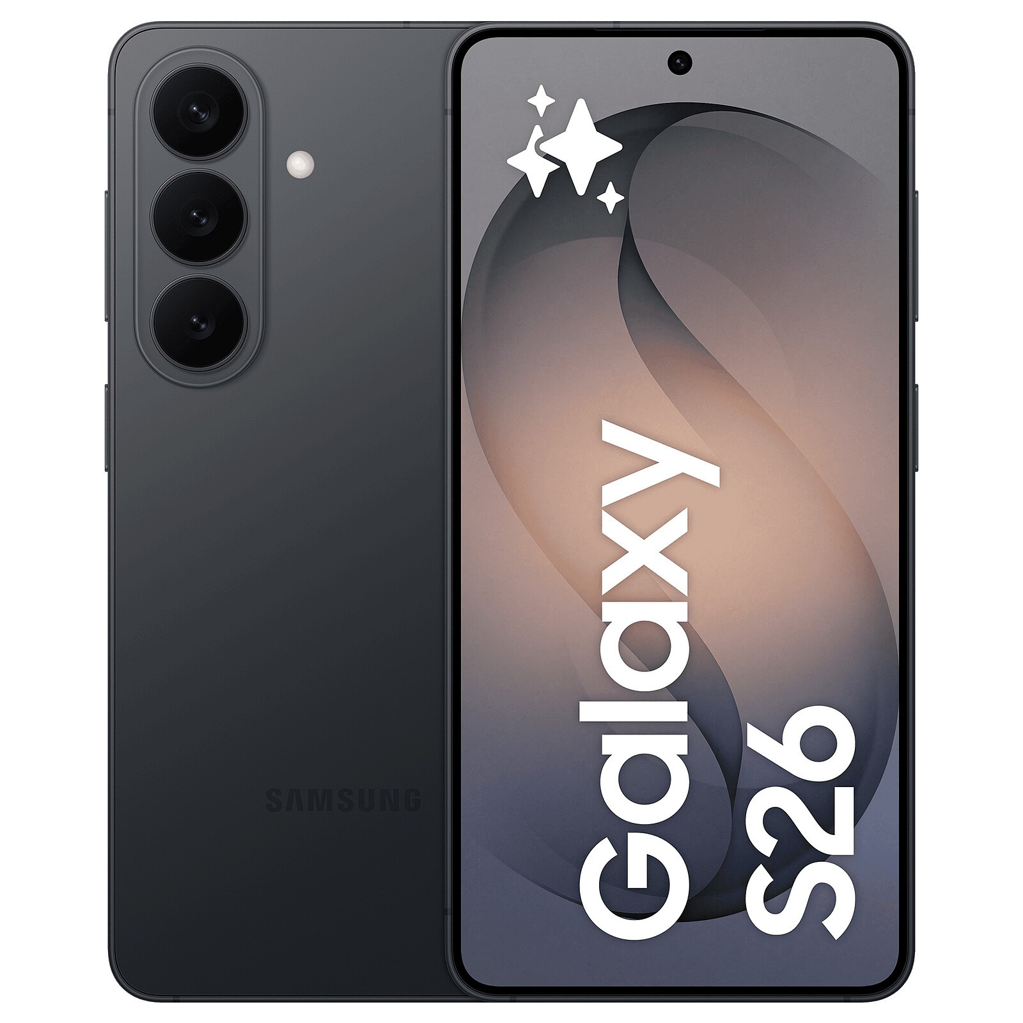 | Samsung Galaxy S26 5G  Series: S Series Flagship • Tag: Compact Flagship  Variants / Memory: 12GB+256GB / 12GB+512GB  Price / MOP: ₹89,999 / ₹1,09,999  Armor Aluminum frame, Snapdragon 8 Gen 5 / Exynos 2600, Galaxy AI, and bright 2600-nit screen.

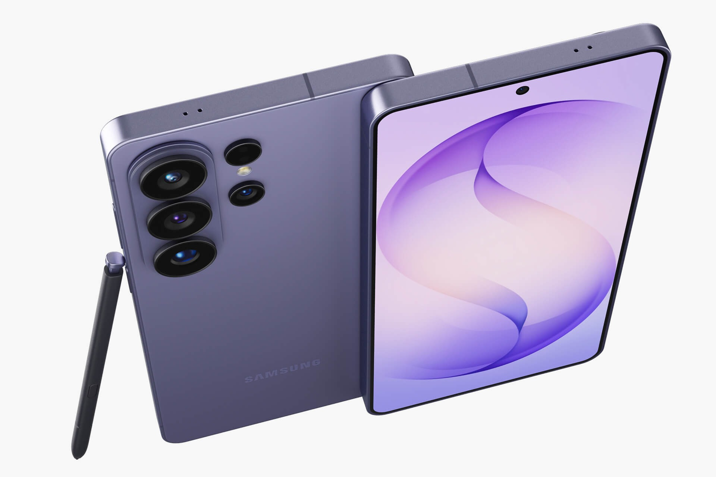 | Samsung Galaxy S26 Plus 5G  Series: S Series Flagship • Tag: Plus Flagship  Variants / Memory: 12GB+256GB / 12GB+512GB  Price / MOP: ₹1,34,999 / ₹1,54,999  QHD+ 6.7-inch display, 4900mAh battery, 45W super fast charging, and full Galaxy AI ecosystem.

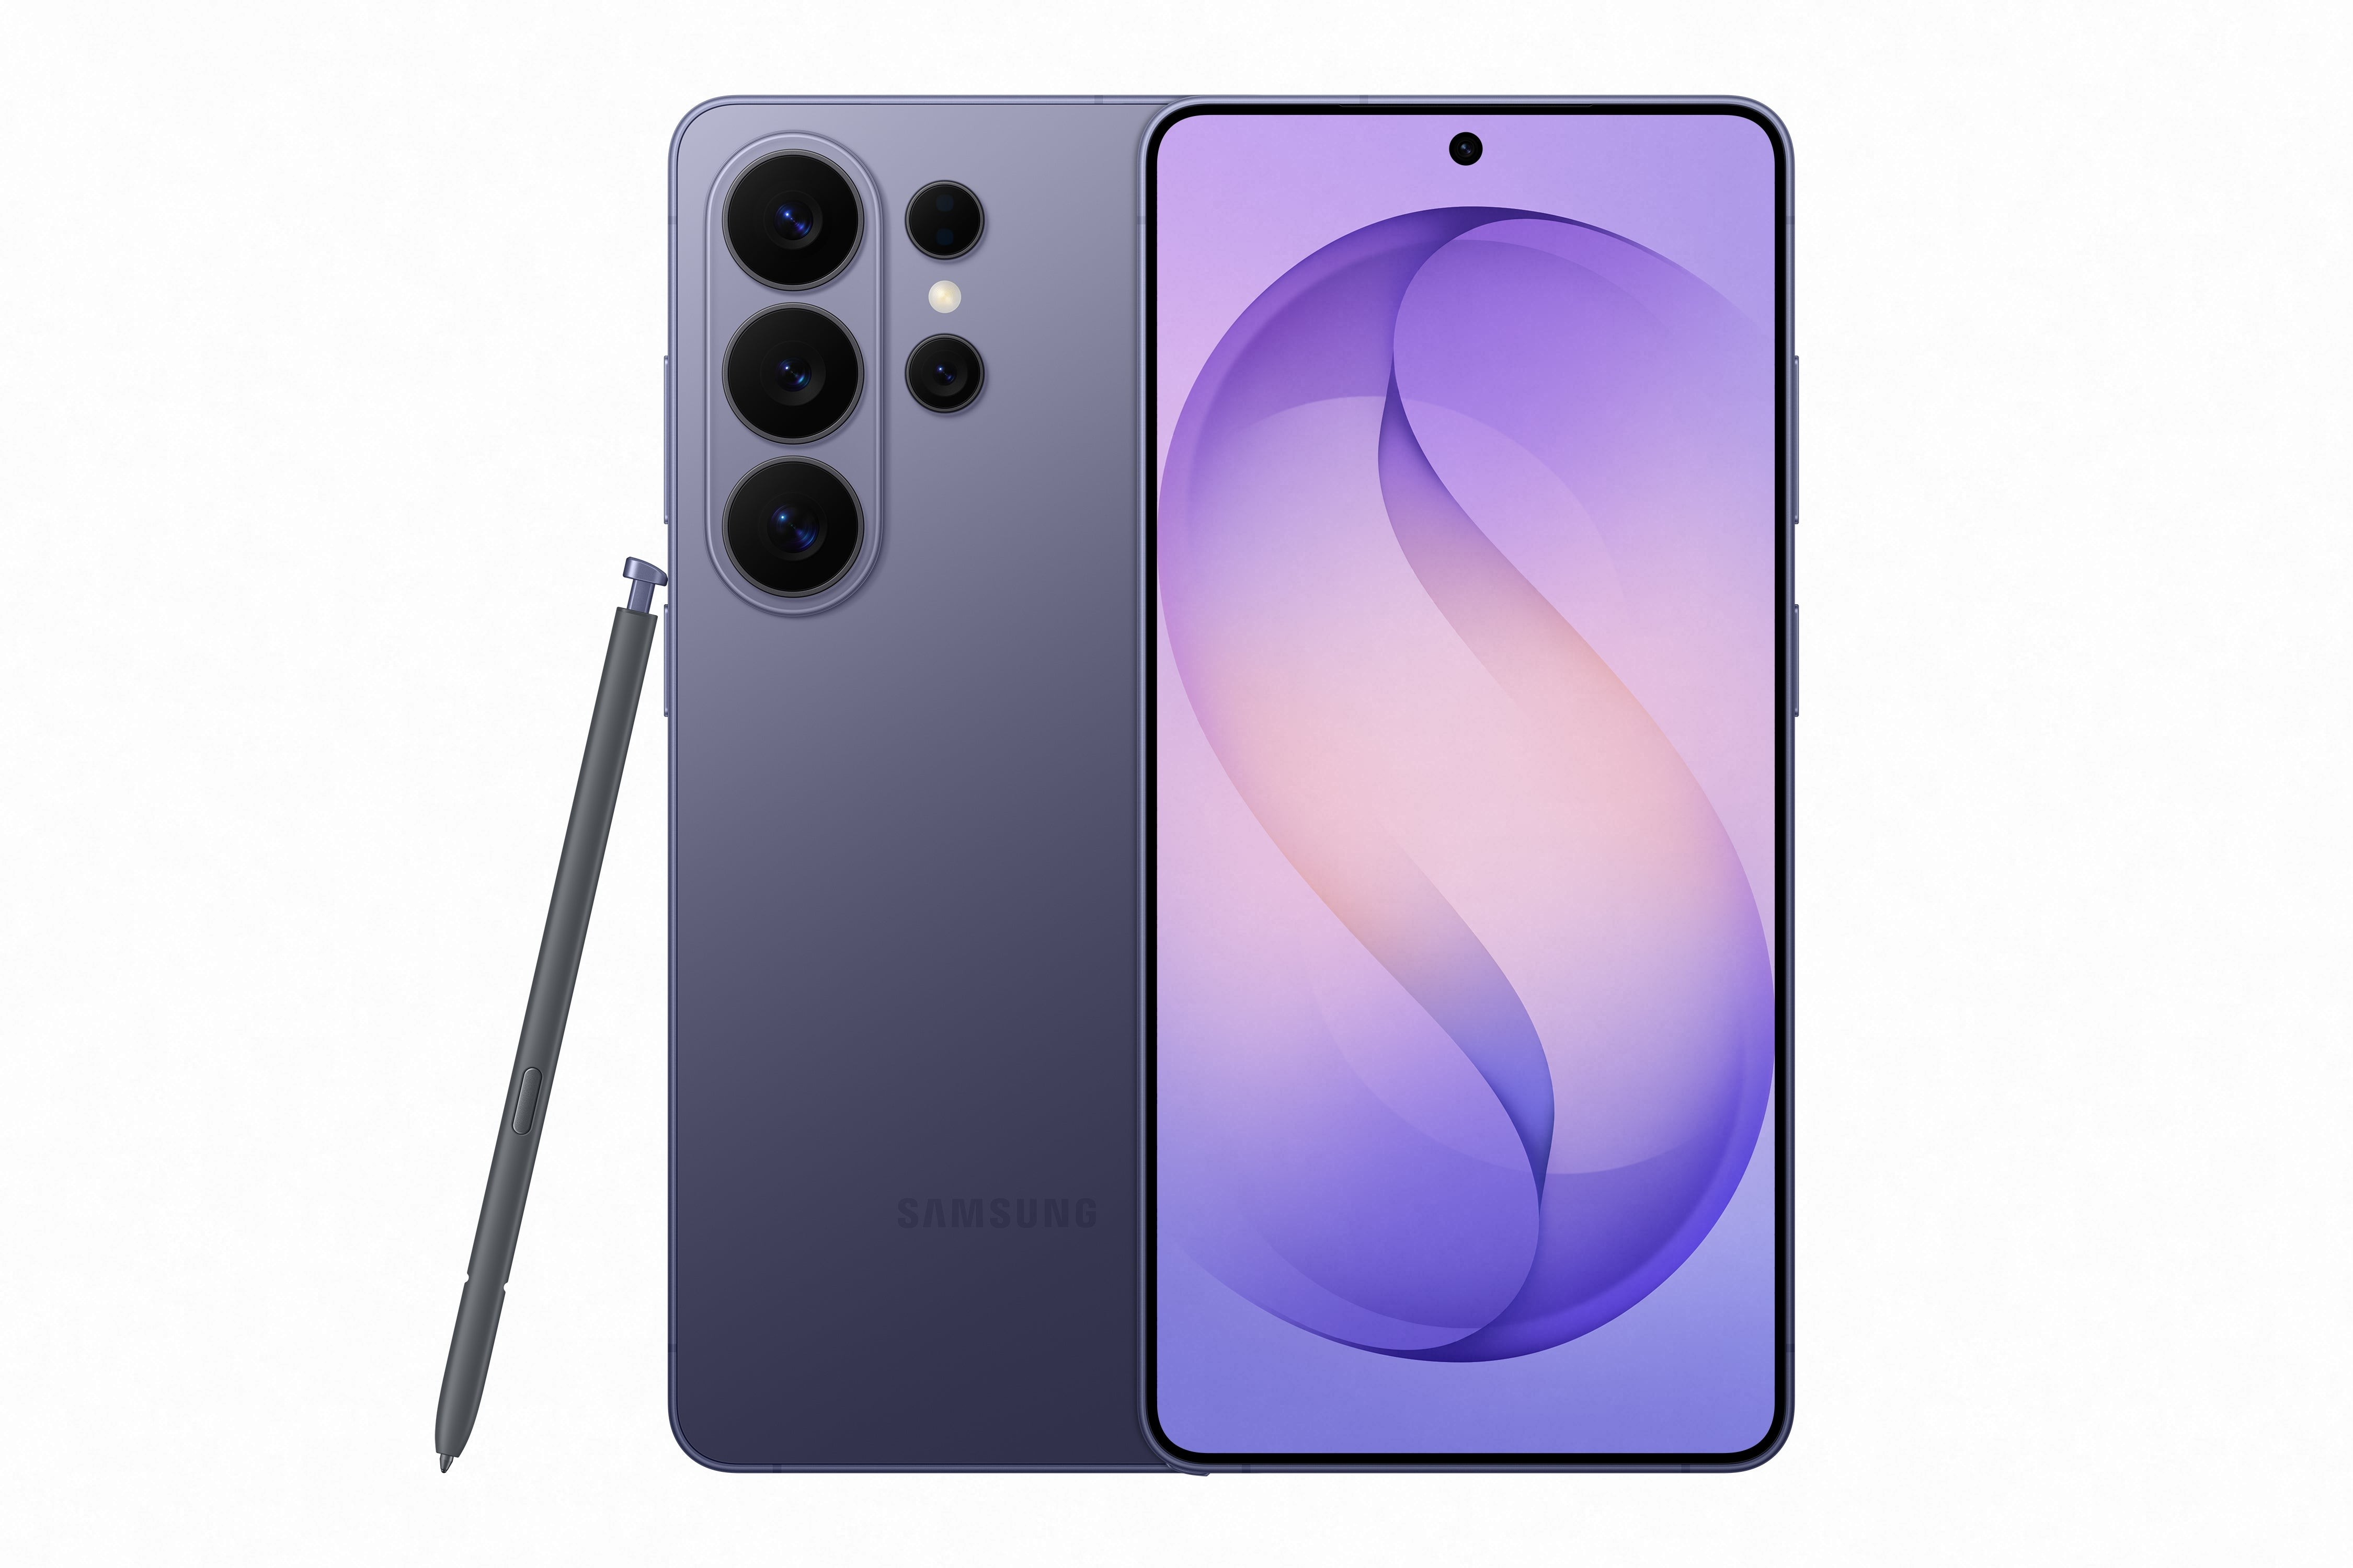 | Samsung Galaxy S26 Ultra 5G  Series: S Series Flagship • Tag: Ultimate AI Flagship  Variants / Memory: 12/256GB | 12/512GB | 16/1TB  Price / MOP: ₹1,39,999 / ₹1,59,999 / ₹1,99,999  Built-in S-Pen, Titanium grade frame, 200MP Quad-Telephoto camera with 100x Space Zoom, and anti-reflective display.

 | Samsung Galaxy Z Flip 8 5G  Series: Z Series Foldable • Tag: Next-Gen Flip  Variants / Memory: 12GB+256GB / 12GB+512GB  Price / MOP: ₹1,14,999 / ₹1,34,999  Edge-to-edge Flex Window cover display, 50MP dual camera with ProVisual Engine, and IP48 water resistance.

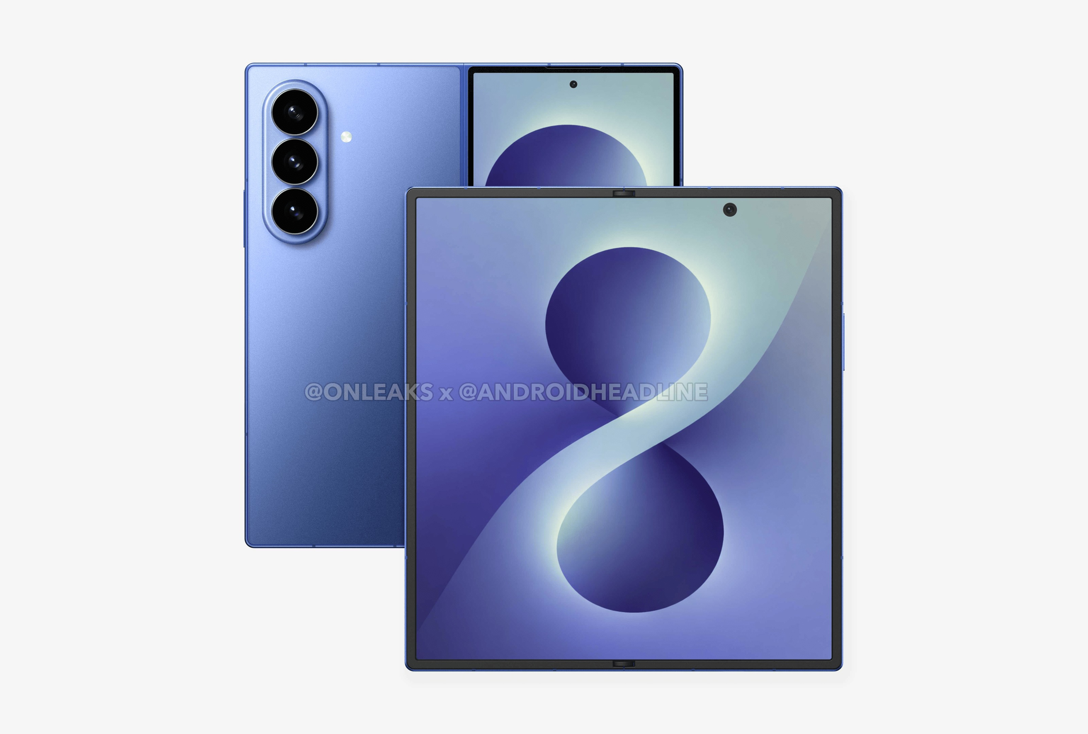 | Samsung Galaxy Z Fold 8 5G  Series: Z Series Foldable • Tag: Next-Gen Fold  Variants / Memory: 12/256GB | 12/512GB | 16/1TB  Price / MOP: ₹1,74,999 / ₹1,94,999 / ₹2,34,999  Immersive 7.6-inch folding screen, dual-rail hinge, S-Pen fold edition support, and multi-active window.

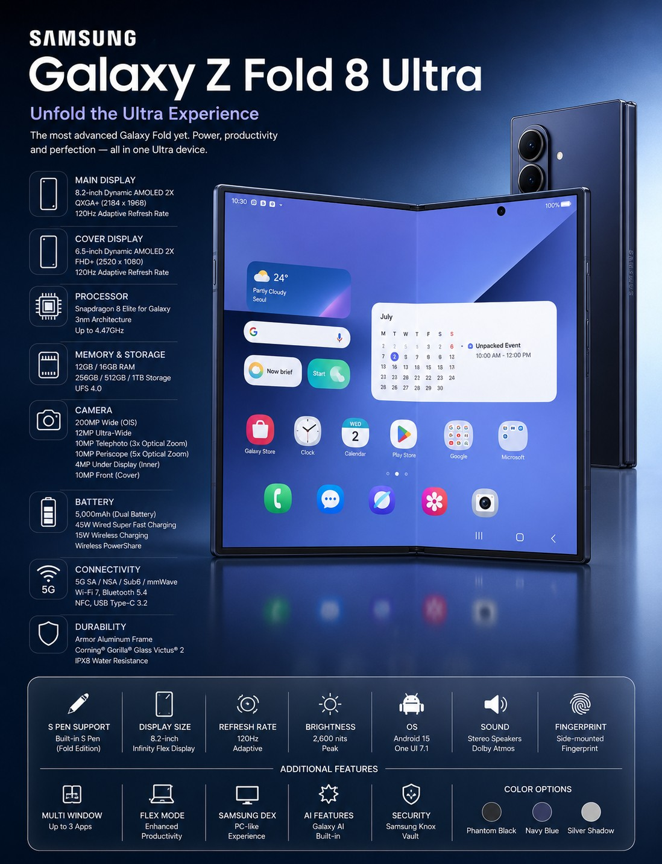 | Samsung Galaxy Z Fold 8 Ultra 5G  Series: Z Series Foldable • Tag: Ultra Foldable  Variants / Memory: 12/256GB | 12/512GB | 16/1TB  Price / MOP: ₹1,94,999 / ₹2,14,999 / ₹2,54,999  Thinnest and widest folding flagship with 200MP main sensor, Titanium chassis, and peak brightness.

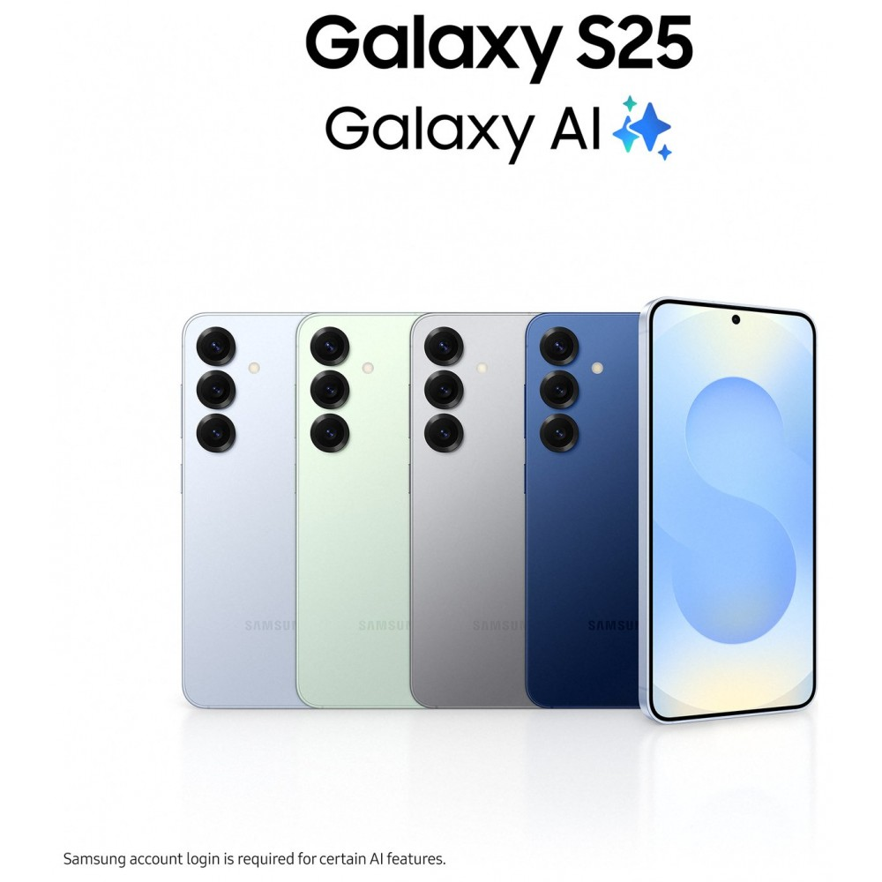 | Samsung Galaxy S25 5G  Series: S Series Flagship • Tag: Compact Flagship  Variants / Memory: 12/128GB | 12/256GB | 12/512GB  Price / MOP: ₹74,999 / ₹84,999 / ₹1,04,999  120Hz Dynamic AMOLED 2X, enhanced cooling vapor chamber, and full Galaxy AI suite.

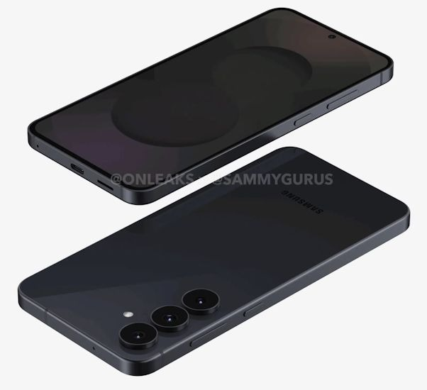 | Samsung Galaxy S25 FE 5G  Series: S Series Flagship • Tag: Fan Edition  Variants / Memory: 8/128GB | 8/256GB | 8/512GB  Price / MOP: ₹58,999 / ₹64,999 / ₹76,999  Pro-grade camera capabilities with Nightography, aluminum frame, and long software lifecycle.

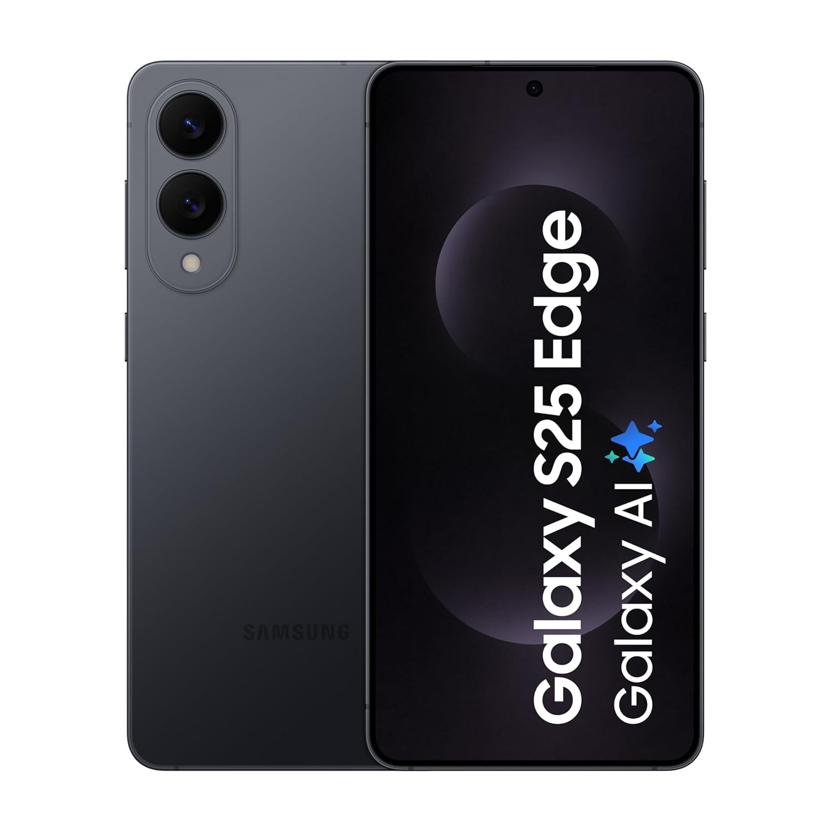 | Samsung Galaxy S25 Edge 5G  Series: S Series Flagship • Tag: Curved Flagship  Variants / Memory: 12GB+256GB / 12GB+512GB  Price / MOP: ₹84,999 / ₹96,999  Curved edge AMOLED display with immersive viewing angles and lightweight aerospace aluminum frame.

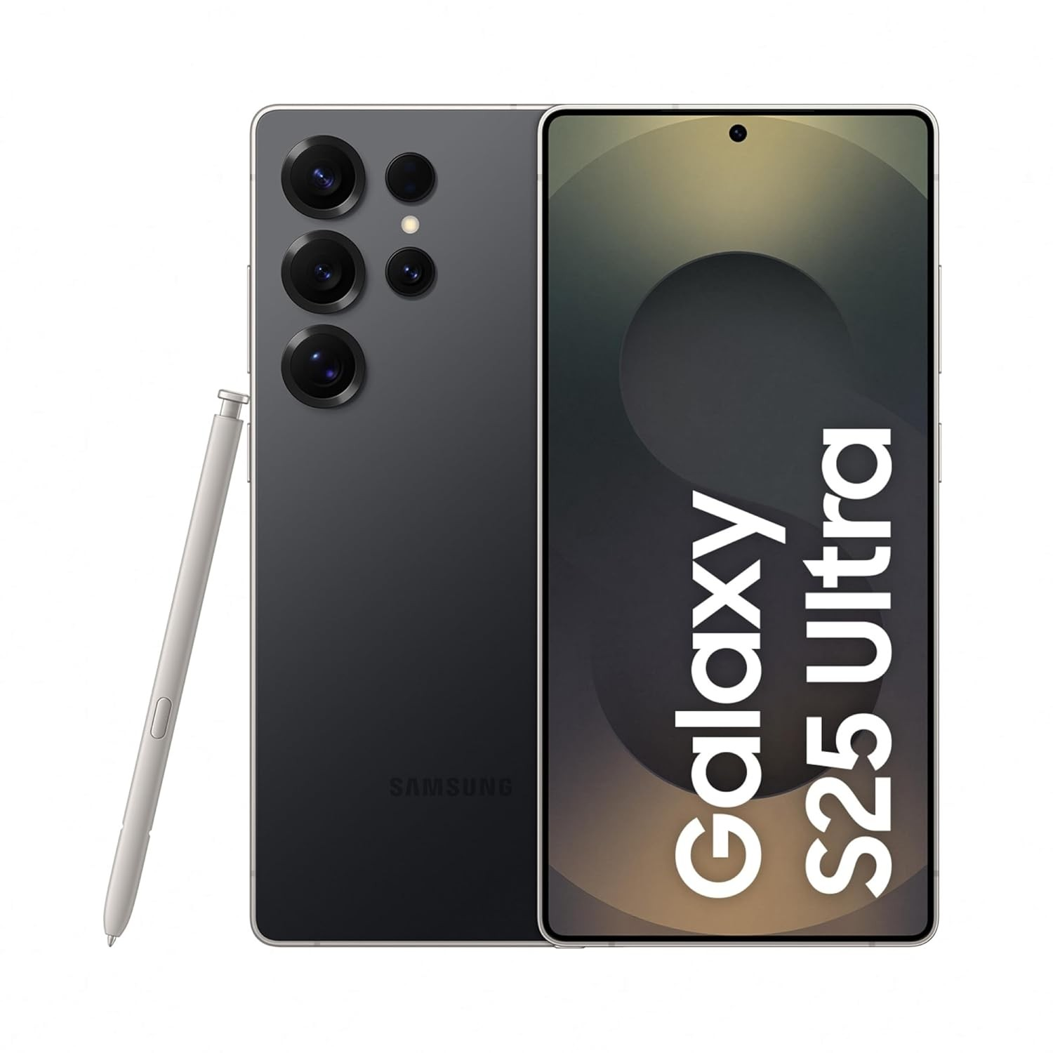 | Samsung Galaxy S25 Ultra 5G  Series: S Series Flagship • Tag: Ultra AI Flagship  Variants / Memory: 12/256GB | 12/512GB | 12/1TB  Price / MOP: ₹1,19,999 / ₹1,39,999 / ₹1,65,999  200MP camera with 5x optical telephoto, flat anti-glare display, built-in S-Pen, and Titanium build.

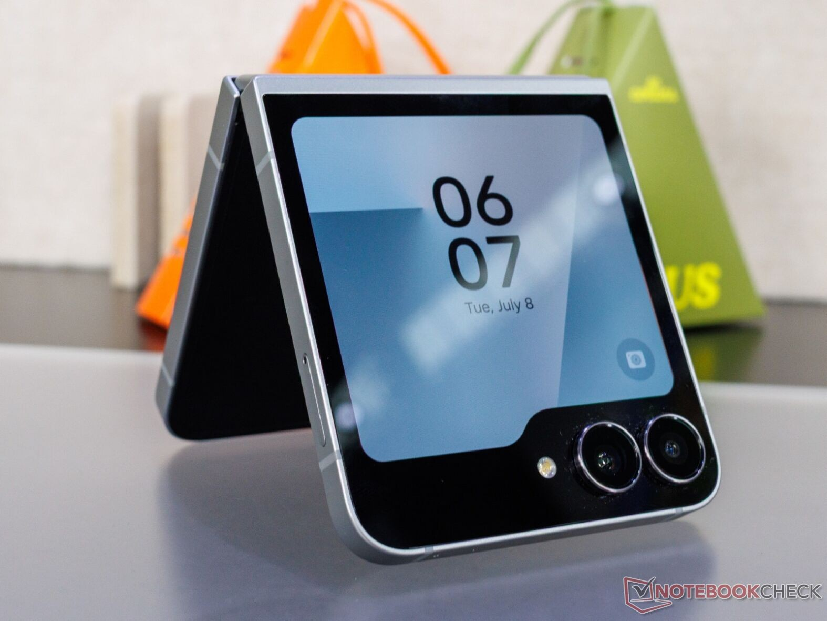 | Samsung Galaxy Z Flip 7 FE 5G  Series: Z Series Foldable • Tag: Accessible Flip  Variants / Memory: 8GB+128GB / 8GB+256GB  Price / MOP: ₹89,999 / ₹95,999  Foldable style within reach, featuring large cover screen, FlexCam hands-free shooting, and pocket fit.

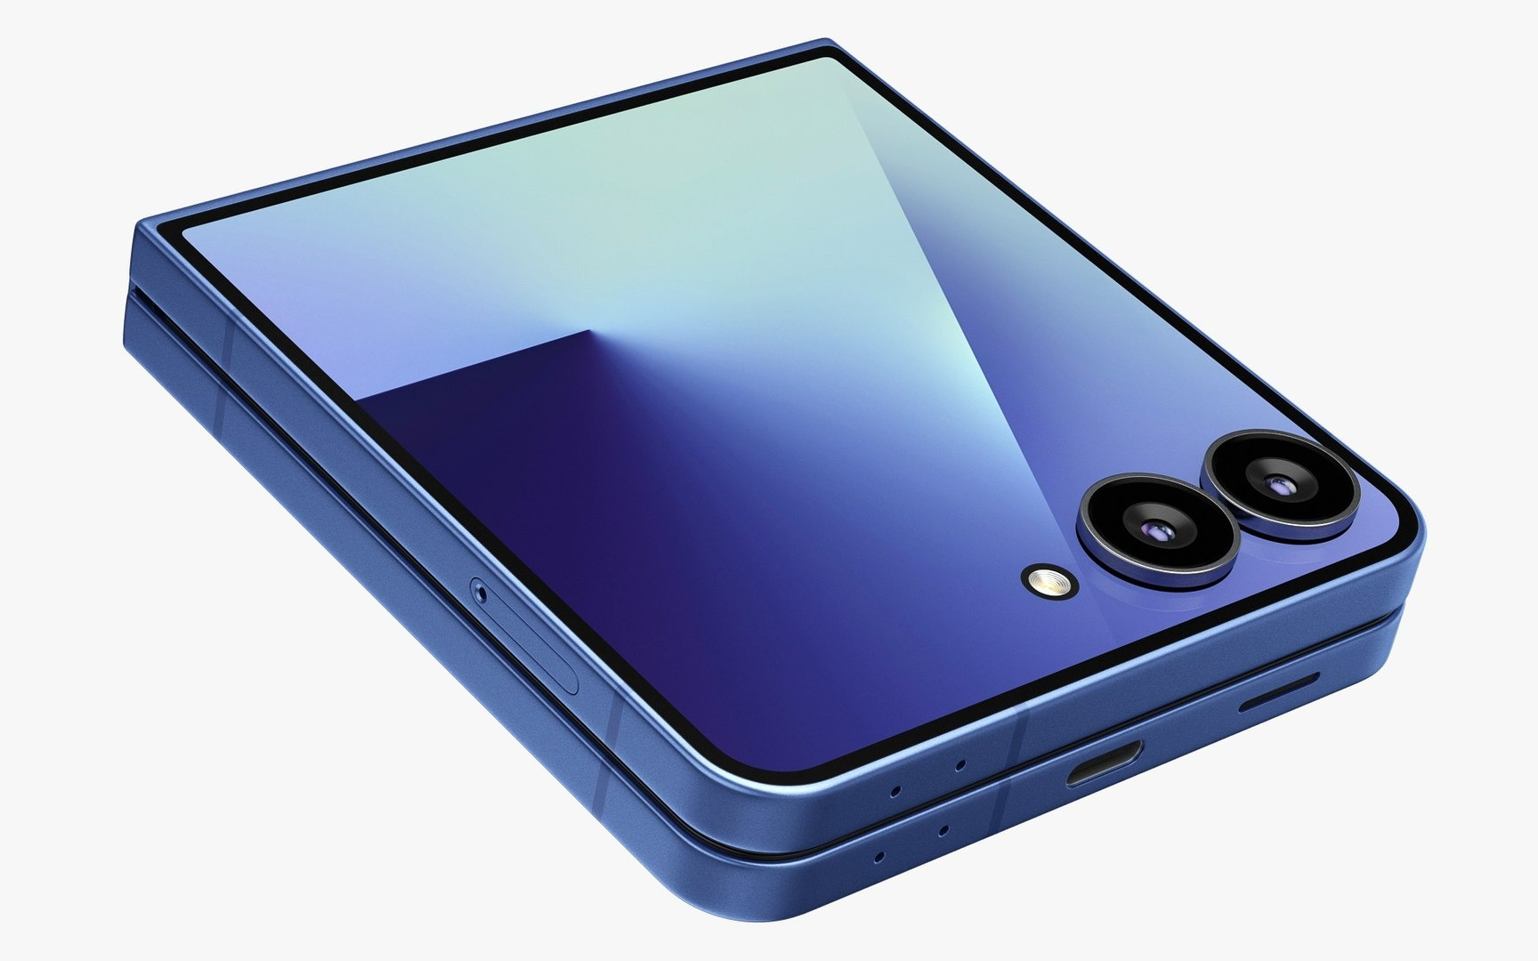 | Samsung Galaxy Z Flip 7 5G  Series: Z Series Foldable • Tag: Flagship Flip  Variants / Memory: 12GB+256GB / 12GB+512GB  Price / MOP: ₹1,09,999 / ₹1,21,999  Ultra-sleek clamshell with 50MP camera, dual preview photography, and personalized cover screen widgets.

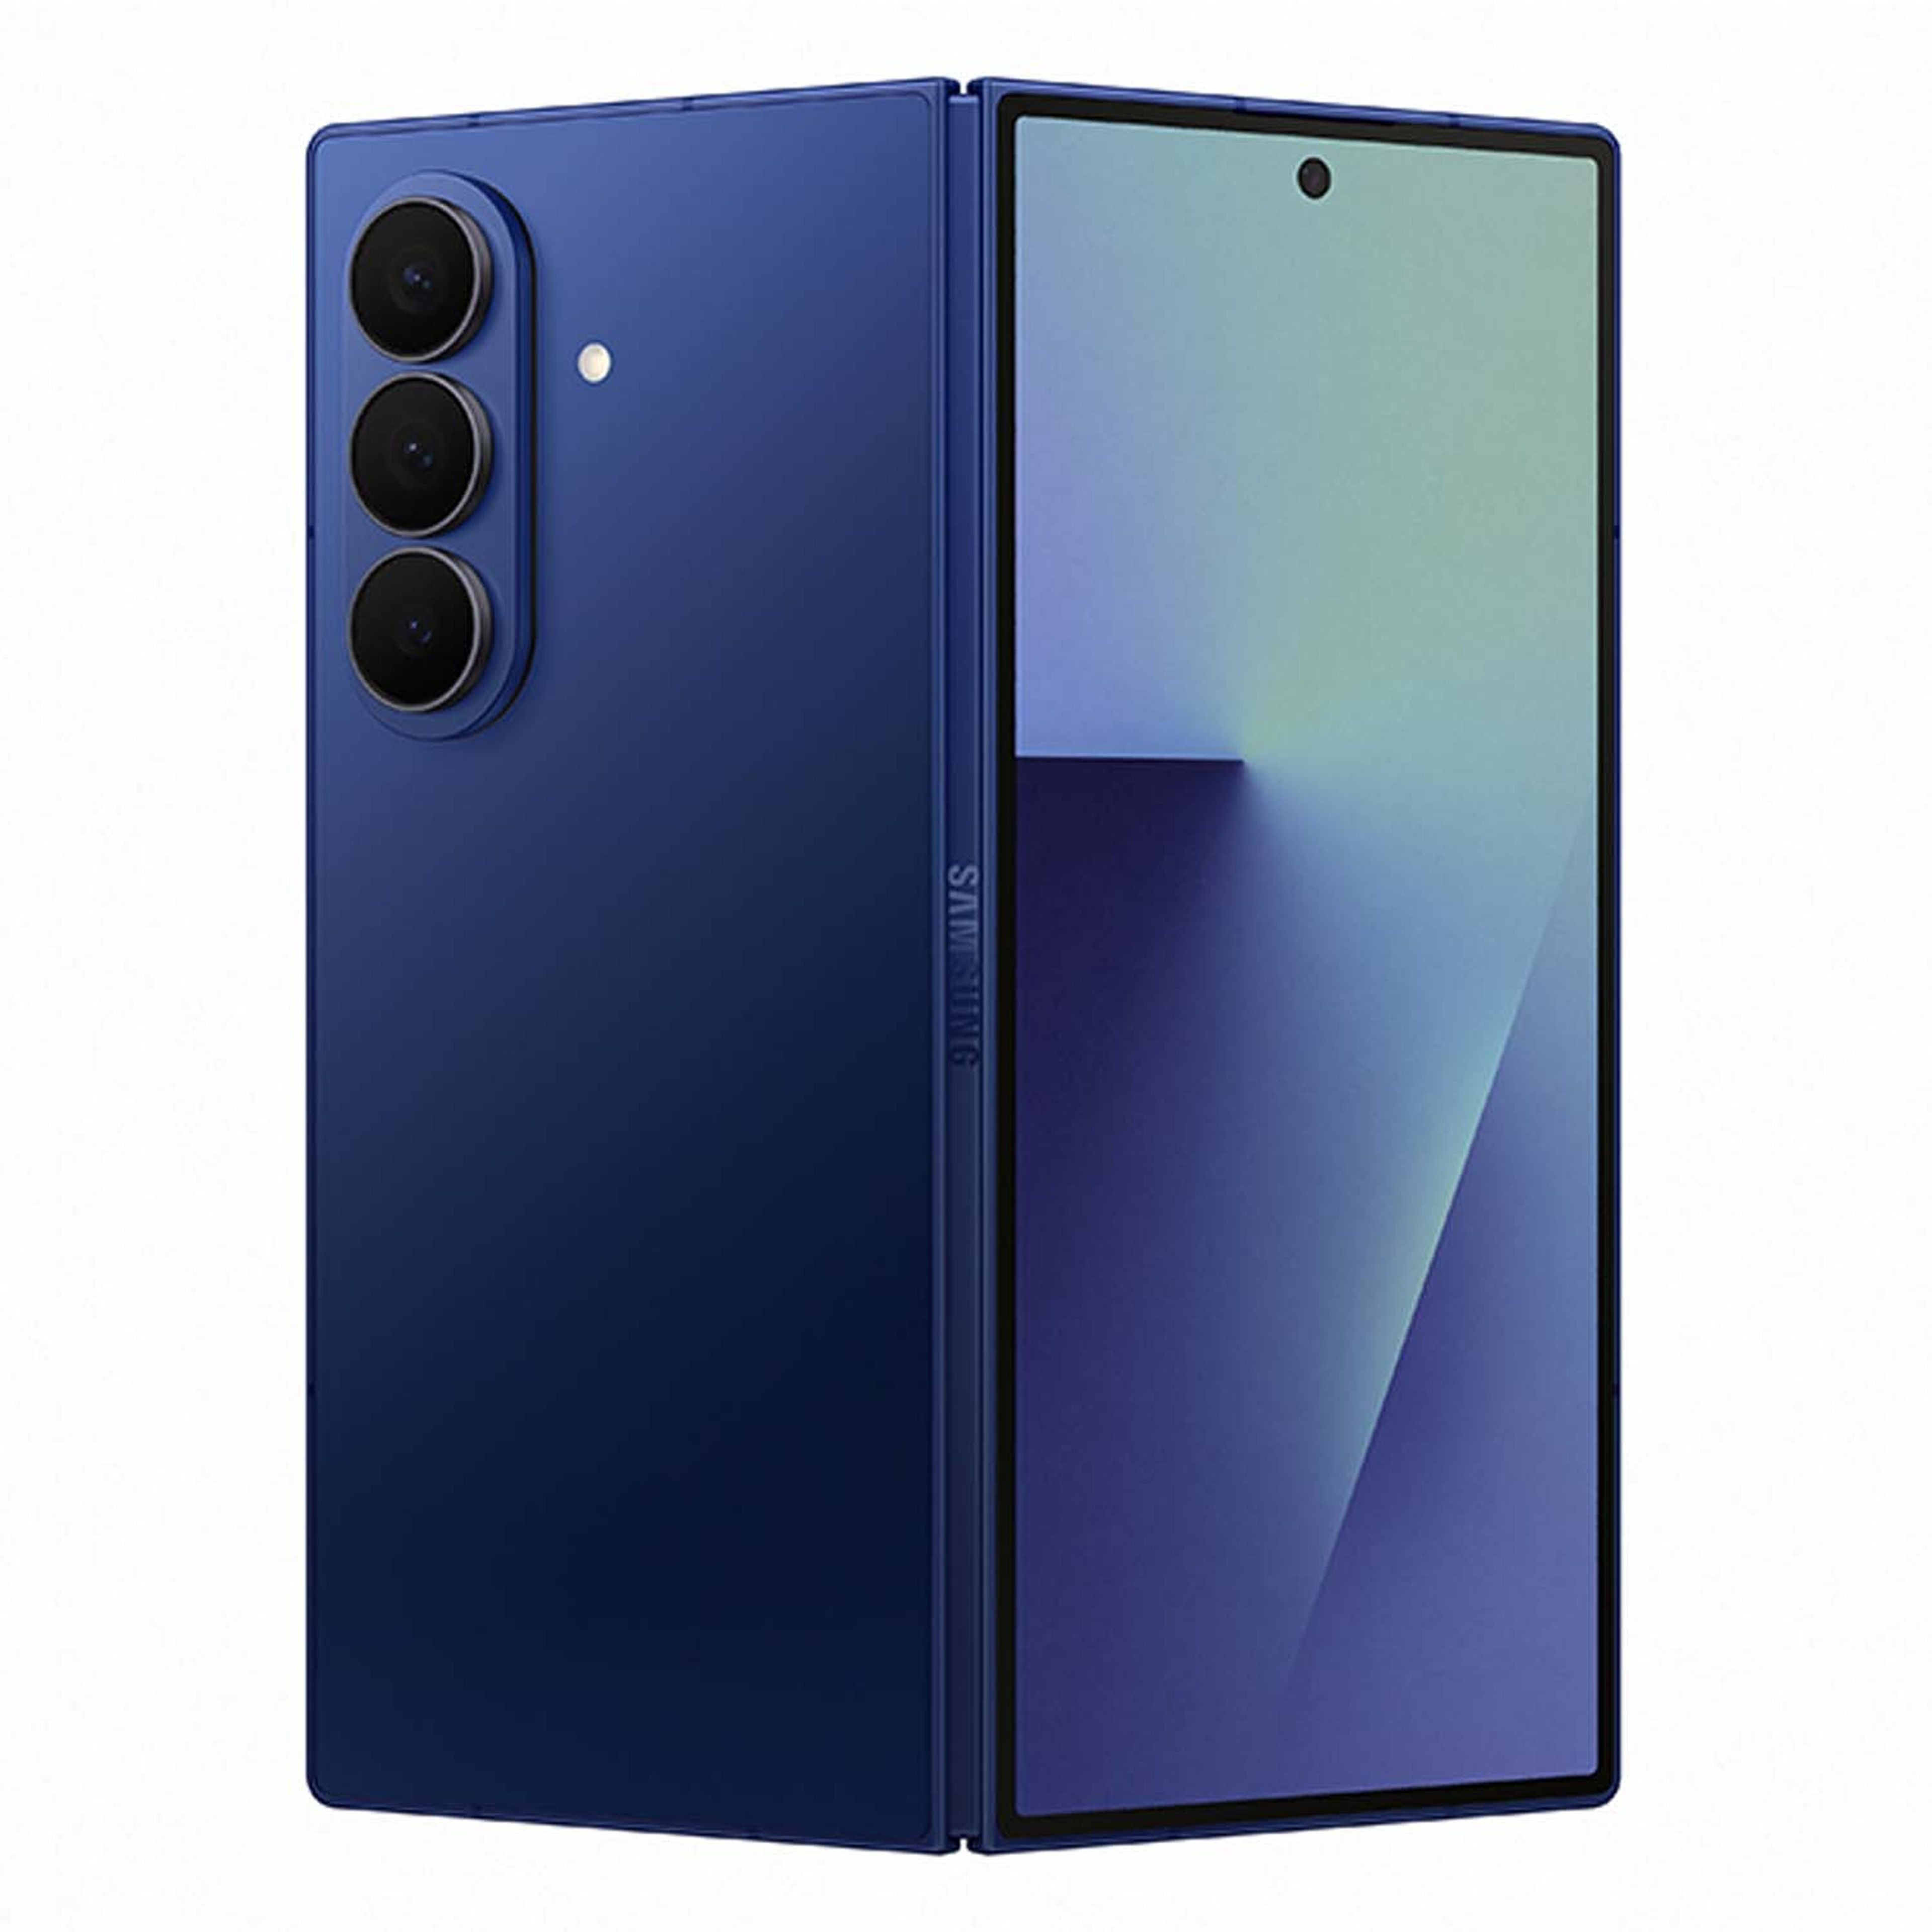 | Samsung Galaxy Z Fold 7 5G  Series: Z Series Foldable • Tag: Flagship Fold  Variants / Memory: 12/256GB | 12/512GB | 16/1TB  Price / MOP: ₹1,74,999 / ₹1,86,999 / ₹2,16,999  Ultimate portable workstation with 7.6-inch main screen, enhanced multi-tasking taskbar, and Galaxy AI.

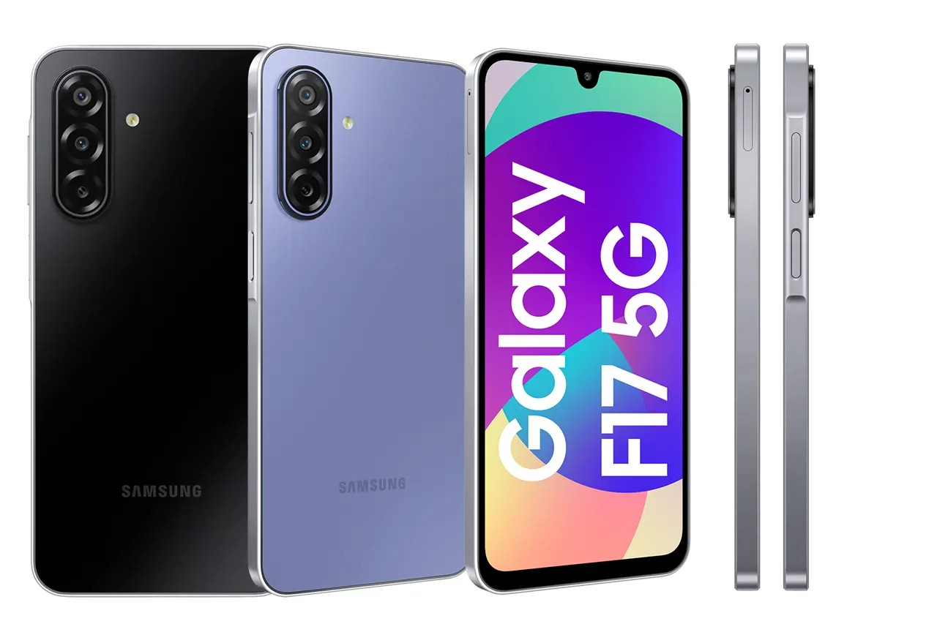 | Samsung Galaxy F17 5G  Series: F Series • Tag: Super AMOLED  Variants / Memory: 4/128GB | 6/128GB | 8/128GB  Price / MOP: ₹22,999 / ₹25,999 / ₹28,999  FHD+ Super AMOLED 90Hz display, 6000mAh battery, and Voice Focus clear calling technology.

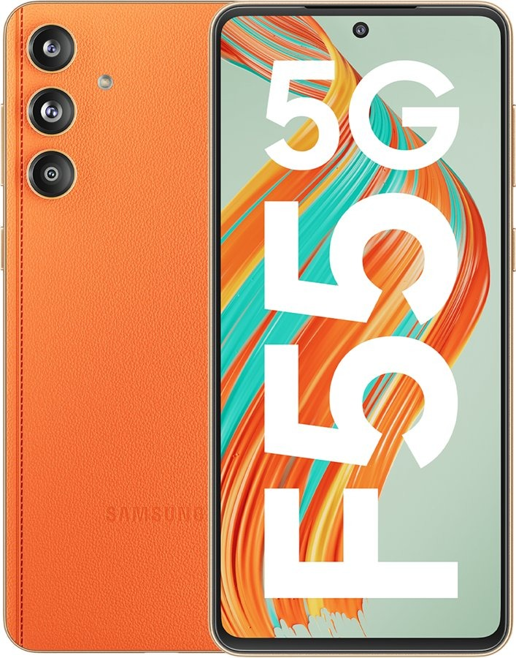 | Samsung Galaxy F70e 5G  Series: F Series • Tag: Vegan Leather  Variants / Memory: 4GB+128GB / 6GB+128GB  Price / MOP: ₹18,499 / ₹21,499  Stitched vegan leather design, slim 7.8mm profile, 50MP OIS camera, and 45W fast charge.

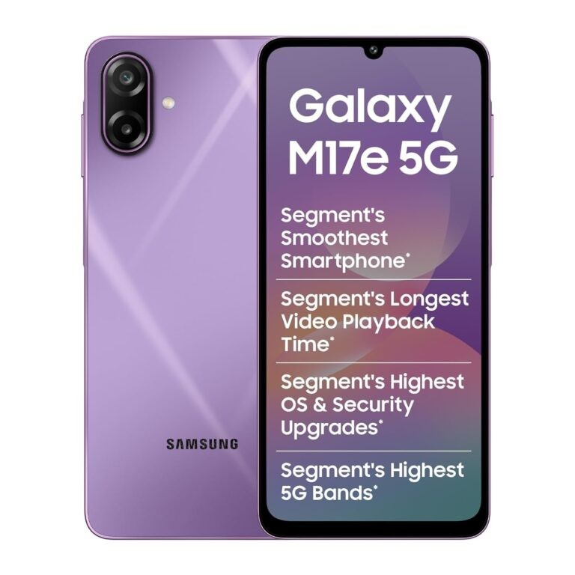 | Samsung Galaxy M17e 5G  Series: M Series • Tag: Monster Battery  Variants / Memory: 4GB+128GB / 6GB+128GB  Price / MOP: ₹18,499 / ₹21,499  Long-life 6000mAh battery, 50MP AI camera, Knox Vault hardware security, and smooth 90Hz display.

 | Samsung Galaxy F36 5G  Series: F Series • Tag: 120Hz AMOLED  Variants / Memory: 6/128GB | 8/128GB | 8/256GB  Price / MOP: ₹21,999 / ₹23,999 / ₹27,999  120Hz Super AMOLED screen, 50MP No Shake OIS camera, and 4 generations of Android upgrades.

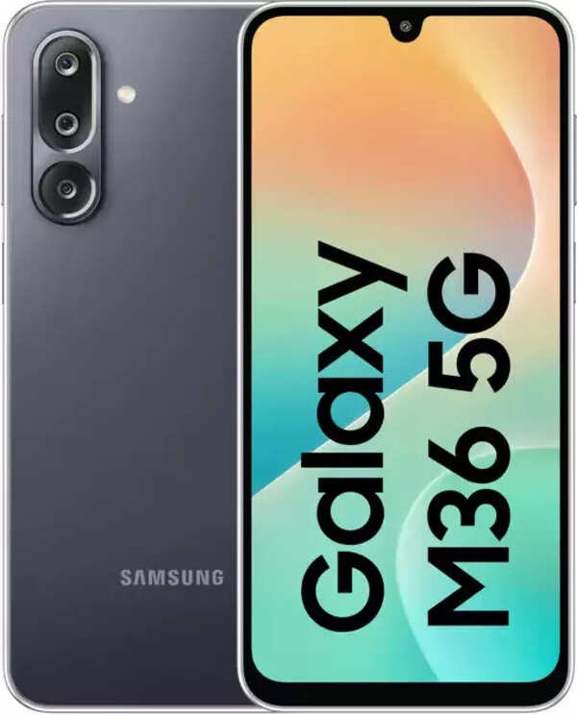 | Samsung Galaxy M36 5G  Series: M Series • Tag: Power 5G  Variants / Memory: 6/128GB | 8/128GB | 8/256GB  Price / MOP: ₹21,999 / ₹23,999 / ₹27,999  Corning Gorilla Glass Victus+ display protection, Dolby Atmos sound, and 6000mAh battery.

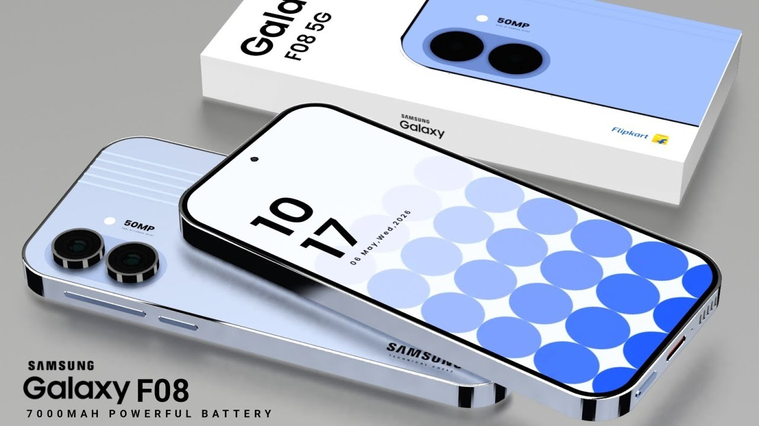 | Samsung Galaxy F08 LTE  Series: F Series • Tag: Value Battery  Variants / Memory: 4GB + 64GB  Price / MOP: MOP ₹16,999  6.7-inch HD+ screen, 50MP dual camera, and leather pattern rear finish.

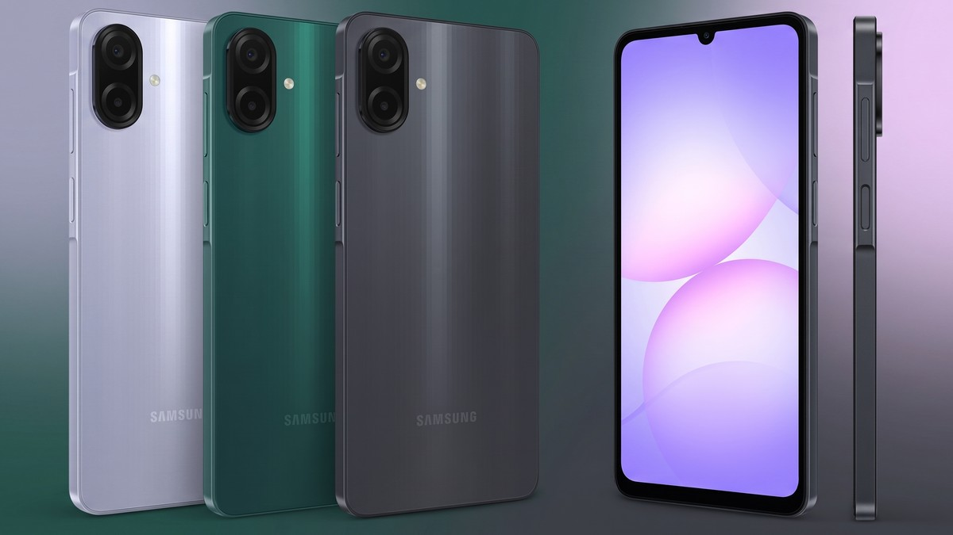 | Samsung Galaxy M08 LTE  Series: M Series • Tag: Daily Driver  Variants / Memory: 4GB + 64GB  Price / MOP: MOP ₹16,999  Clean One UI core experience, 5000mAh battery, 25W fast charging support, and face unlock.

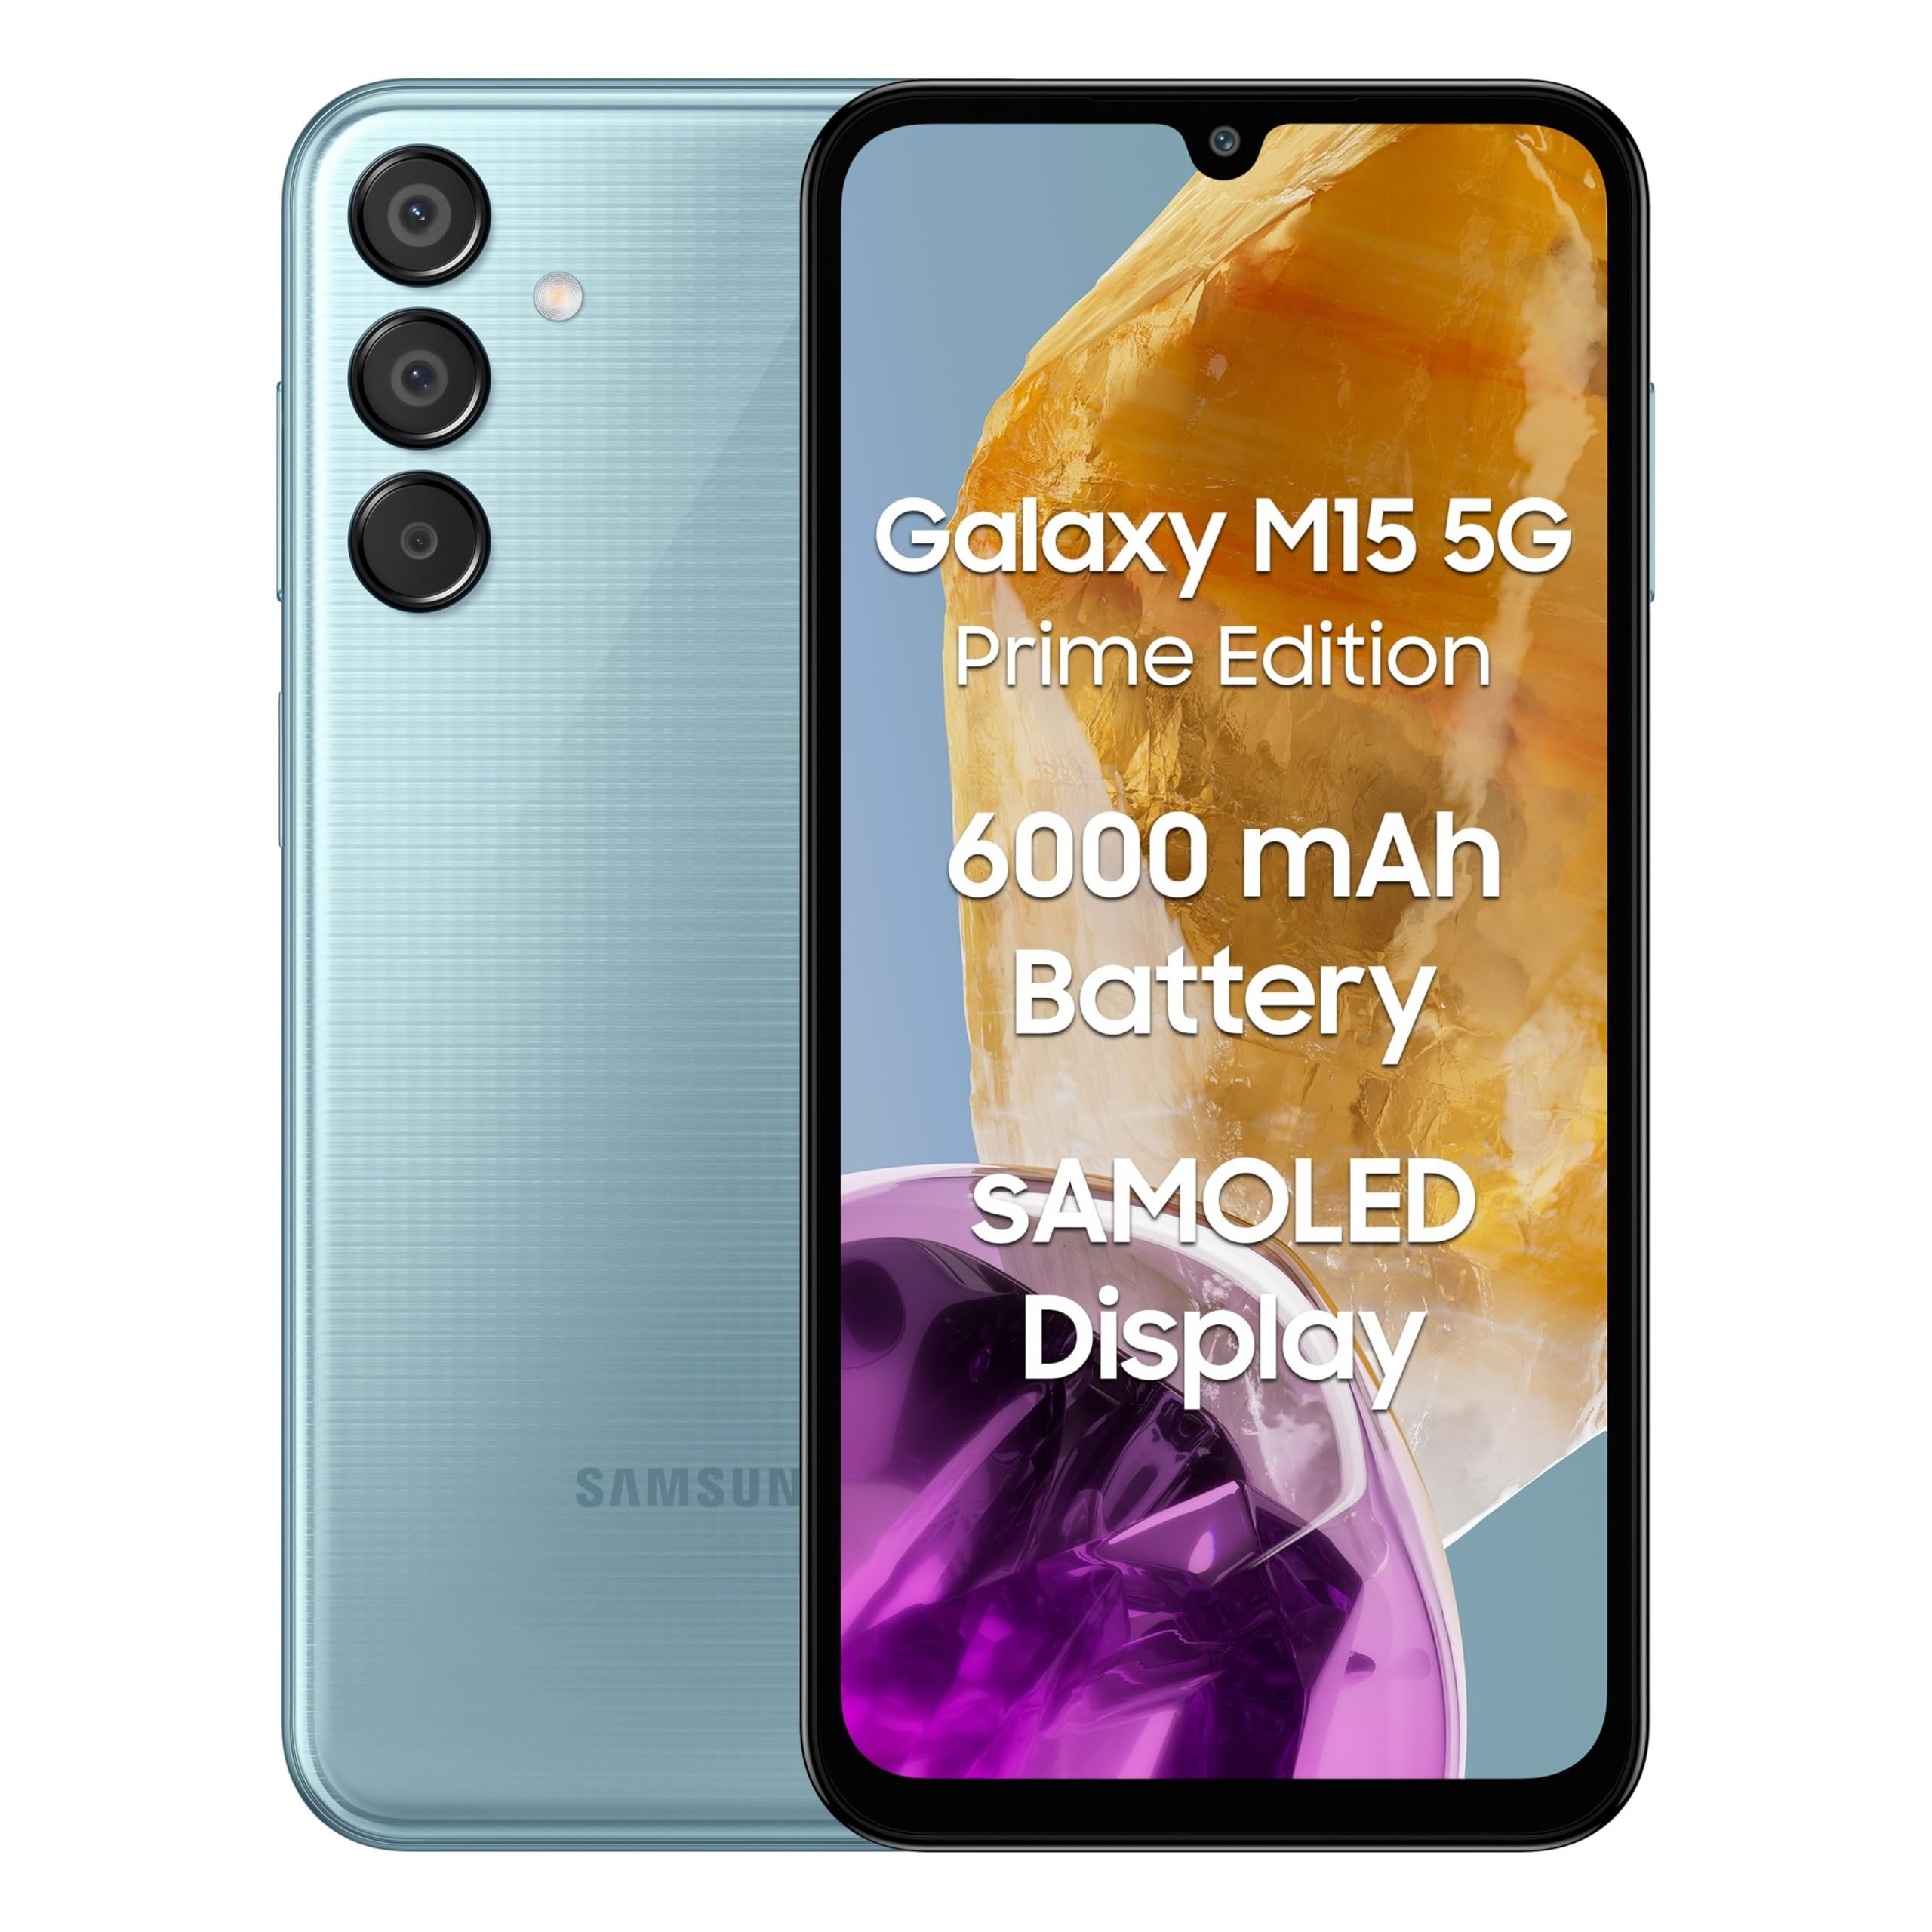 | Samsung Galaxy M17 5G  Series: M Series • Tag: Monster 5G  Variants / Memory: 4/128GB | 6/128GB | 8/128GB  Price / MOP: ₹19,999 / ₹22,999 / ₹25,999  Super AMOLED display with Vision Booster, 50MP triple camera, and massive 6000mAh battery.

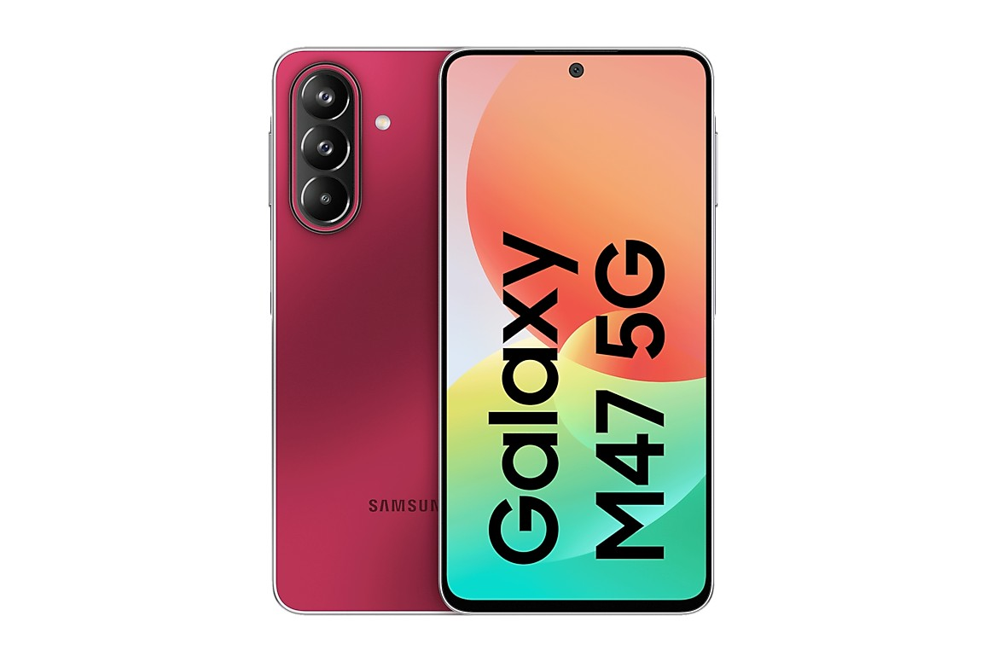 | Samsung Galaxy M47 5G  Series: M Series • Tag: Mid-Range Power  Variants / Memory: 6/128GB | 8/128GB | 8/256GB  Price / MOP: ₹35,999 / ₹39,999 / ₹44,999  Snapdragon processor, 120Hz display, high-resolution triple cameras, and NFC payment support.

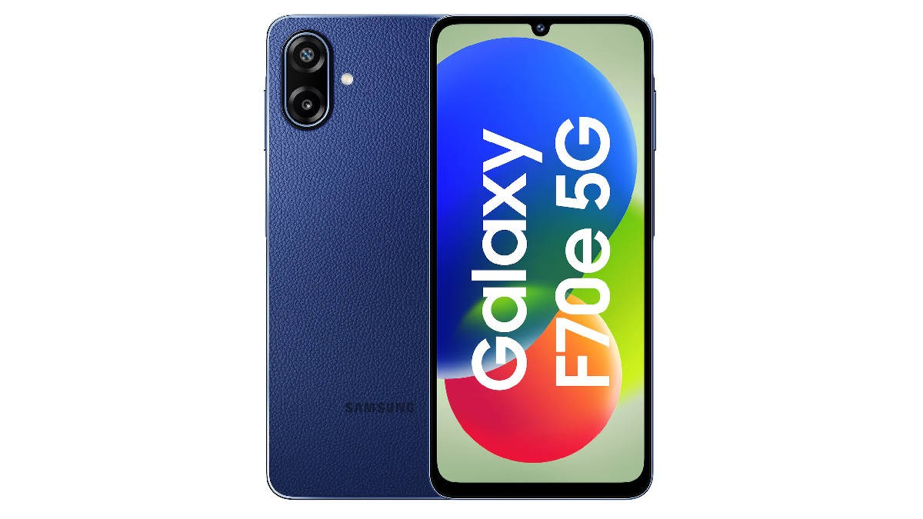 | Samsung Galaxy F70 Pro 5G  Series: F Series • Tag: Pro Mid-Range  Variants / Memory: 6/128GB | 8/128GB | 8/256GB  Price / MOP: ₹35,999 / ₹39,999 / ₹44,999  108MP OIS main camera with 4K recording, 6000mAh battery, and Super AMOLED+ panel.

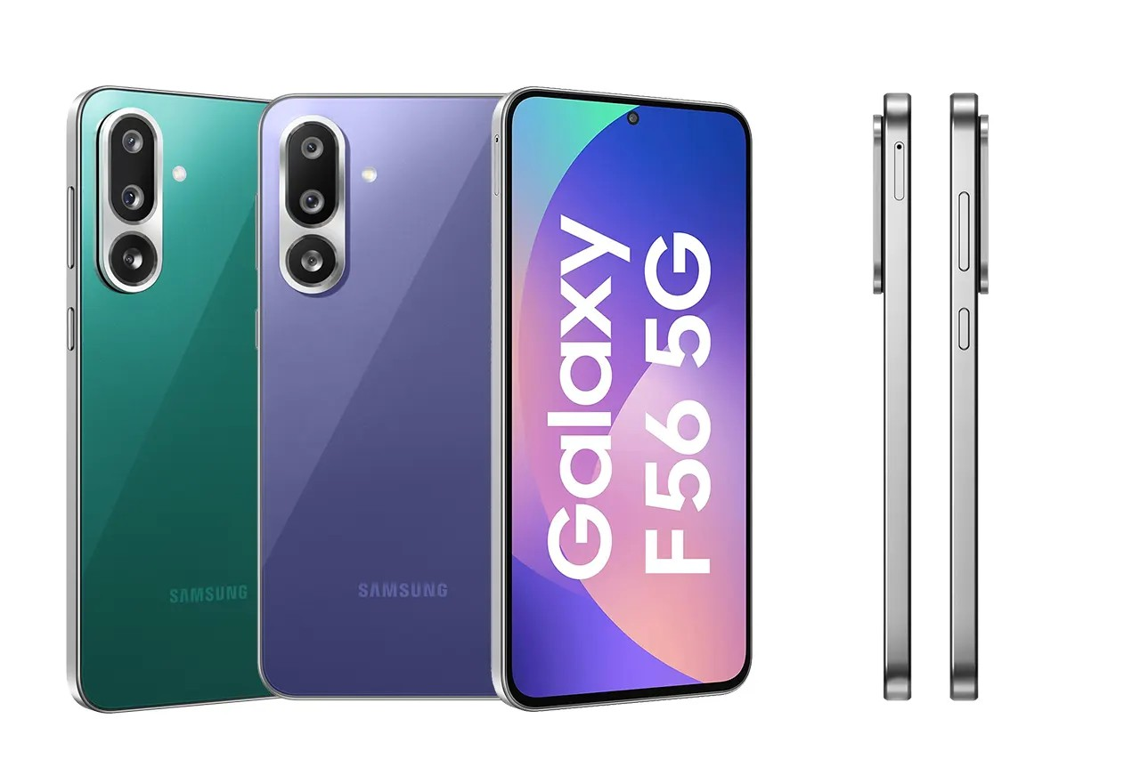 | Samsung Galaxy F56 5G  Series: F Series • Tag: Vegan Leather  Variants / Memory: 8GB+128GB / 8GB+256GB  Price / MOP: ₹24,999 / ₹27,999  Ultra-thin 7.8mm vegan leather build, 50MP selfie camera, 50MP OIS rear camera, and 45W fast charge.

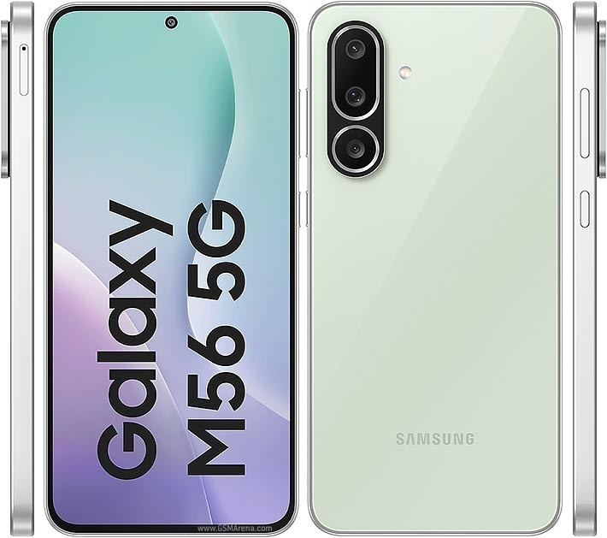 | Samsung Galaxy M56 5G  Series: M Series • Tag: Slim Monster  Variants / Memory: 8GB+128GB / 8GB+256GB  Price / MOP: ₹27,999 / ₹30,999  120Hz Super AMOLED+ display, Snapdragon 7 Gen 1, 50MP front camera, and 45W charging.

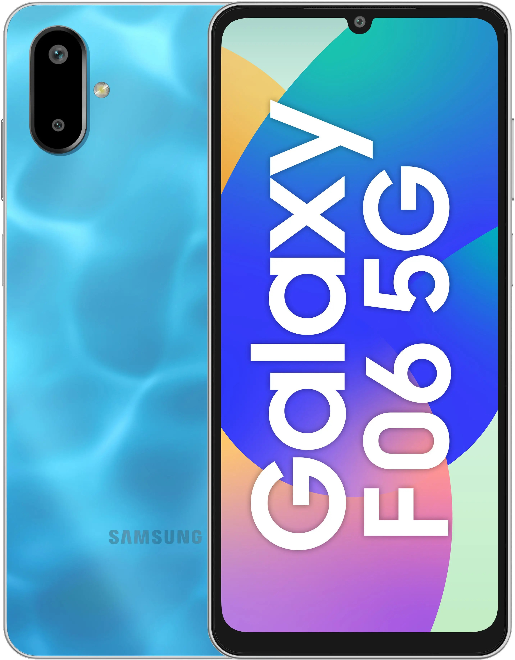 | Samsung Galaxy F06 5G  Series: F Series • Tag: Budget 5G  Variants / Memory: 4/64GB | 4/128GB | 6/128GB  Price / MOP: ₹12,499 / ₹13,999 / ₹15,999  Affordable 5G connectivity with MediaTek Dimensity chipset, 5000mAh battery, and dual cameras.

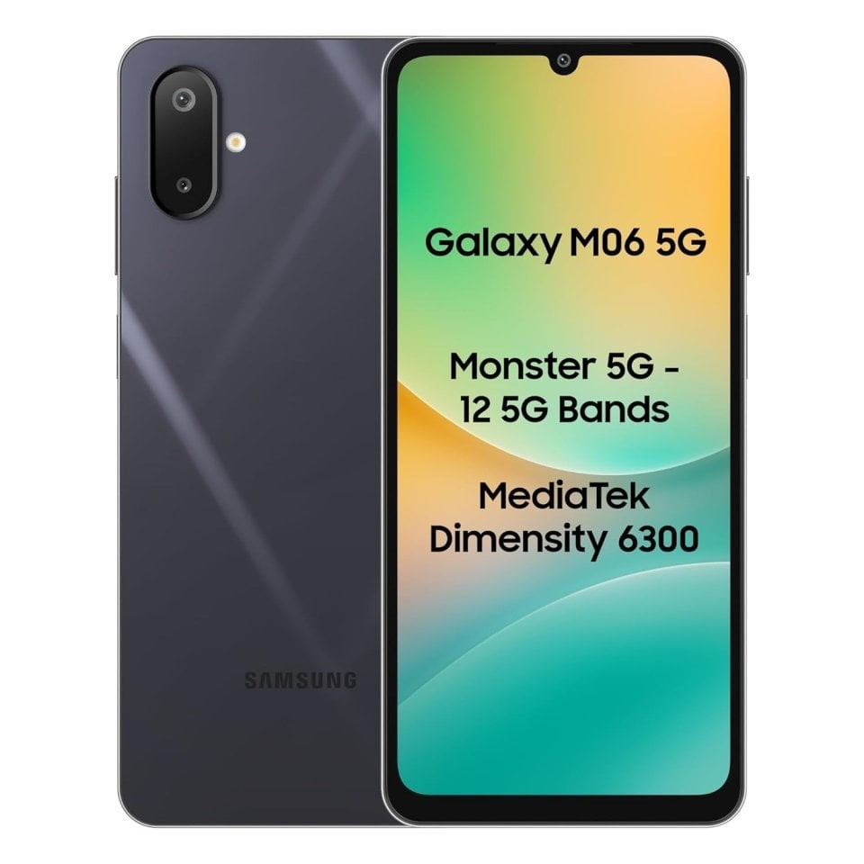 | Samsung Galaxy M06 5G  Series: M Series • Tag: Budget 5G  Variants / Memory: 4/64GB | 4/128GB | 6/128GB  Price / MOP: ₹12,499 / ₹13,999 / ₹15,999  Dual 5G SIM standby, large HD+ display, side fingerprint sensor, and clean design.

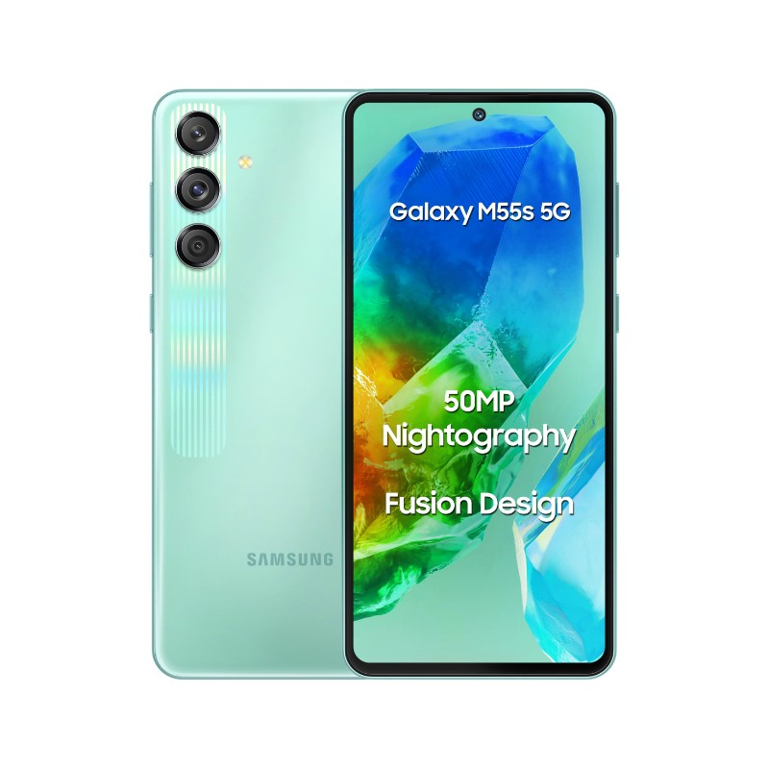 | Samsung Galaxy M55s 5G  Series: M Series • Tag: Fusion Design  Variants / Memory: 8GB+128GB / 8GB+256GB  Price / MOP: ₹20,999 / ₹23,999  Fusion mesh design pattern, 120Hz Super AMOLED+ screen, 50MP selfie camera, and 45W charging.

