Problem1a result:

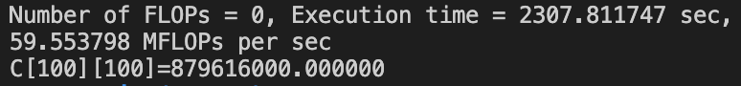

Problem1b result:

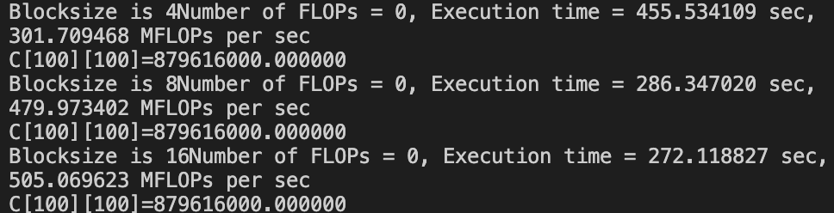

Problem2 result:

