New Scoring, Annotation and Collaboration features in Mesquite
August 2005 (Mesquite version 1.06betaG85)

New features in Mesquite are designed to facilitate editing of morphological data for phylogenetic work. These include an image viewer integrated into the matrix editor to assist with scoring, and enhanced annotations to permit authors to document the basis of their scoring.

Other new features are designed specifically for collaborative work, which poses special challenges. The ideal system would involve a central database which would accept simultaneous editing by multiple contributors. While we do not yet have such a system, we have taken the first steps toward it in Mesquite. Mesquite now records a history of which authors edited which aspects of the data when, and uses this history in reconciling matrix versions edited separately by different contributors. We have also made a prototype of a version of Mesquite acting as a front end of a database. We are working toward a system in which data are stored in a database with Mesquite as a front end but which optionally permits standalone editing (for both on-line and off-line work).

Many of these new features are in the collab package, although some are integrated into the basic Mesquite packages.

Important settings
For collaborative work with this version of Mesquite, we strongly encourage that you check the following under the Defaults menu of the log window or the Projects & files window:

Set Author... — Indicate your name and your author code. Use a consistent author code that is distinct from others in your working group. Once you have set this, it will be remembered by Mesquite on this user account on this computer. If multiple users use a single account on one machine, this may cause confusion. There is currently a BUG if you reset the author during a single run of Mesquite. Please quit Mesquite, restart Mesquite, set the author, then quit Mesquite, then restart it before using it as a different author.

Automatic NEXUS backups ... — If you have collab installed, then the number of automatic backups is enforced to be 4 or more, even if the dialog box says "0". Sorry. Every time you save a file, the previously saved version of the file is saved in the backups directory. A file named "Name.nex" will be have its previous version saved as backups/Name.nexBKP1. If saved again, the previous versions will be named Name.nexBKP1, Name.nexBKP2, Name.nexBKP3 and so on (from most recent to oldest).

Record History of Changes — Make sure this is turned on to enable later merging of collaborators' versions.
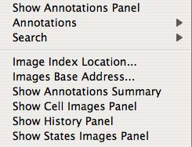 Menu items in Matrix menu — These items control annotation and image display.

Annotations
Many items can be attached to characters, taxa and character state codings; these might be considered collectively to be annotations. However, in Mesquite jargon "Annotations" refers specifically to the notes with comment, reference and possibly an image. In version 1.05 these were viewed and edited using the pencil tool in the Character Matrix Editor. New features are here:

Annotations Panel — selecting "Show Annotations Panel" under Matrix in the Character matrix editor places an editing panel for annotations directly within the matrix editor window. This avoids proliferation of windows. The annotations panel operates as does the separate annotations window. The annotations now support remote images — for one of these, touch the (+) button with the yellow streak and enter a URL for the image. As before, if a cell in the matrix has an annotation, a small square is shown in the cell's upper right corner.

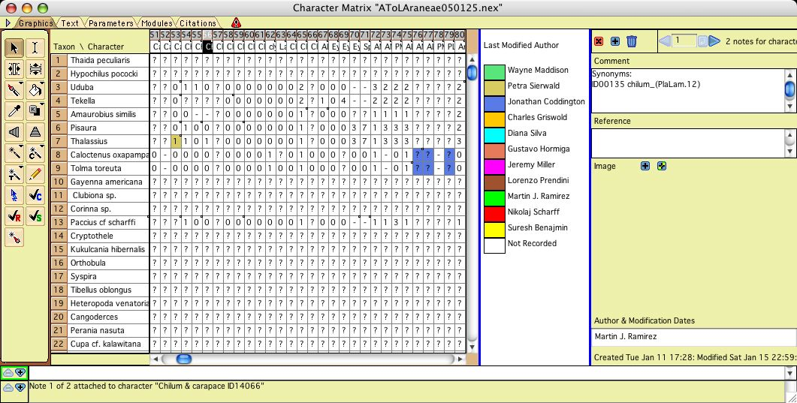
Fig. 1. Character Matrix Editor with Annotations Panel at right. The cells of the matrix are colored by which author is recorded to have modified the cell most recently.

Annotations summary — selecting "Show Annotations Summary" under Matrix in the Character matrix editor shows a table summarizing the annotations for a cell in the matrix. You currently cannot do anything with the panel (i.e. can't double click a line to show the annotation).

Character state annotations — Annotations can now be attached to individual states of a character. To do this, go to the State Names Editor (by choosing Edit State Names in the Matrix menu) of and select Show State Annotations in the State_Names menu.

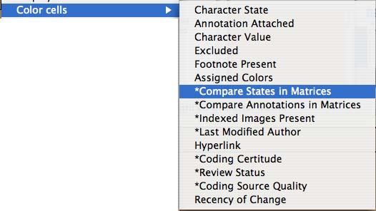Submenu for coloring cells

Images
Images can be associated with cells of the matrix in two ways: within annotations and via index files. These serve to assist with scoring and to document it.

Images in annotations — First, images can be embedded within annotations (see above). You do this by creating an annotation then hitting one of the (+) buttons beside "Image". The blue button allows you to attach a local image file; the blue and yellow button allows you to attach a remote file via a URL. These references to files are then included in the annotation specification in the NEXUS file. If you move the files, Mesquite will not be able to find them.

Indexed images — Second, there is a new system of using an index or database to store images. Currently, it uses a simple system involving index files that indicate where to find images for particular characters and taxa. It would be simple to subsitute a database query. One advantage of this system is that Mesquite stores only the address of the index; if the image file moves that can be indicated in the index. Indexed images can be used for the cells of a matrix (i.e. to represent the coding of a character in a particular terminal taxon) via the Cell Images Panel and also to represent "typical" images of the states of a character via the State Images Panel.

There are two locations you need to specify to display indexed images: the first is the location of the indices themselves. This you indicate by selecting the menu item Image Index Location... The second is the location of the images in relation to the indices. This you indicated by selecting the menu item Images Base Address... The following dialog box will appear:

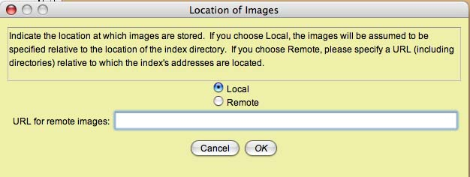
If the images are stored locally, relative to the location of the indices, then select local. If the images are stored remotely, on a server, indicate remote and indicate the server (e.g., http://salticus.zoology.ubc.ca/ATOLSpiders/Images).

Cell Images Panel — selecting "Show Cell Images Panel" in the Matrix menu of the Character Matrix Editor will reveal a panel showing images for the cells of the matrix. If needed you will be asked to select a directory in which the image indices reside. The panel will show images found using the indices. When you move the mouse over a cell or select a cell, its images will be shown. Double clicking on an image will display it in an image viewing application.
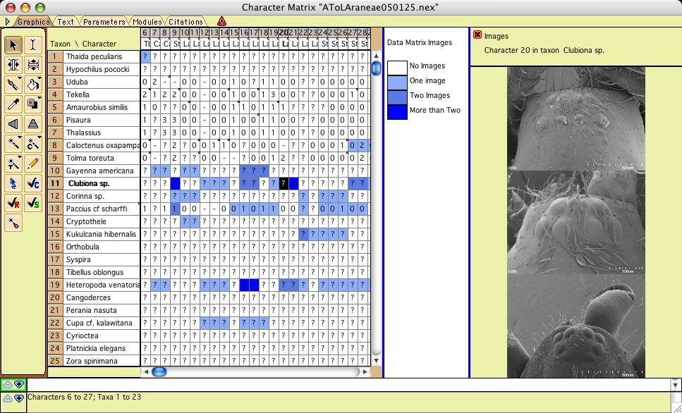
Fig. 2. Character Matrix Editor with Cell Images Panel at right, showing images for Character 20 in "Clubiona sp." (These are not actually the images for this species; we were simply practicing with the system.). The Cells of the matrix are colored according to how many indexed images are attached. NOTE: this is an old screenshot; the image panel now shows names and comments.

State Images Panel — selecting "Show State Images Panel" in the Matrix menu of the Character Matrix Editor will reveal a panel showing images for the states of each character. If needed you may be asked to select a directory in which the image indices reside. The panel will show images found using the indices. When you move the mouse over the column for a character, images illustrating its states will be shown. There may also be a comment about the state. Double clicking on an image will display it in an image viewing application.

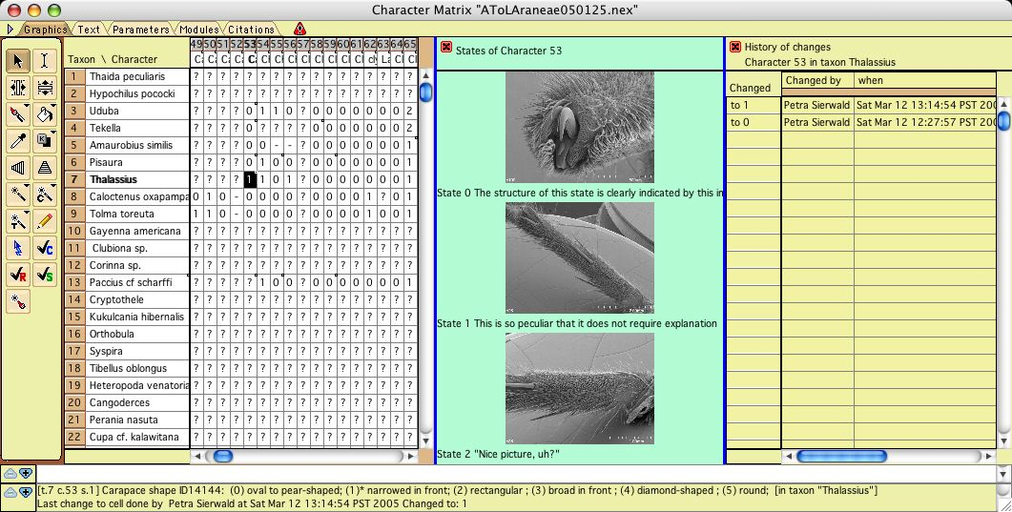
Fig. 3. Character Matrix Editor with State Images Panel (center) and History Panel (at right). The state image panel is showing the character states for character 53 (these are merely practice images). The History panel shows the recorded history of changes to the state coded for character 53 in Thalassius. NOTE: this is an old screenshot; the image panel is no longer green.

Format of image indices — The format of these files is likely to change, and so only a brief. Currently four index files are needed, (1) mapping characters to standard views, (2) mapping terminal taxa to taxon or specimen names among the images, (3) mapping standard views and image-taxa to image file paths, and (4) mapping characters and states to image file paths. The images can be located near index files in whatever directory structure you want.

Labels
Cells in the matrix or characters can be marked to indicate their status. Cells can be marked as to the source of the data (e.g., from the literature, observed by collaborator) and a judgment of the certitude of the scoring. Characters can be marked to show their review status. These are assigned by the three tools with check marks and letters C (Certitude of cell), S (Source of data), and R (review status of character) (Fig. 4). To assign, click on a cell or character and choose from the drop-down menu. To view the marks in color, select the corresponding menu items from the Color Cells submenu of the Matrix menu.
Fig. 4. Tools for Certitude, Review Status, and Source.

Character Order
To permit a preferred order of characters to be recovered after the characters have been intentionally or accidentally reordered, character orderings can be stored. There are two types of character orderings: default order and stored orders.

Default Order — the default order automatically records the order in which characters are created. You can use the sort tool in the List of Characters window on this column (the first column in Fig. 5) to return to this order. You can also designate the current order of characters to be the default by selecting the heading of this column and choosing "Set Current Order As Default" from the drop down menu. A default order is also recorded for taxa.

Stored Orders — To view and manage stored character orders, select Stored Character Order from the Show Column submenu of the List menu of the List of Characters window. This is the last column in figure 5. If there is no current stored order, then column will list all "1". To store the current character order, select the column heading and choose Store Current Order from the drop down menu. If the character subsequently are reordered, you can recover this stored order by selecting Load from the drop down menu. After the stored order is loaded, you can place the character in that order by sorting the characters using the sort tool on the Stored Order column.
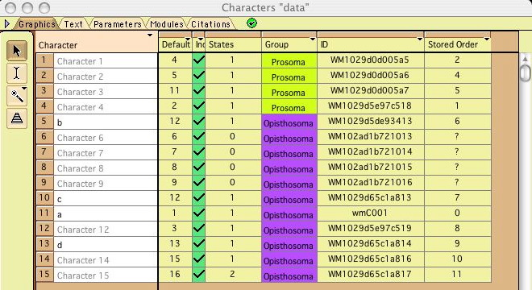
Fig. 5 List of Characters window showing Default order (first column), character group assignments (fourth column), unique ID's, and Stored Order (last column).

Collaboration

Insofar as we don't yet have a database to which Mesquite links as a substitute for NEXUS files, collaborative work in a single matrix involves passing NEXUS files among different authors. Safest would be to permit only one author at a time to work on the file, and then pass this master file in series from author to author. However, authors will often want to be editing simultaneously, and not wait for a slow author who currently has the master file.

We have therefore designed a system which permits authors to edit their own versions independently. Its use is as follows:
(1) There is one collaborator who serves as the Data Administrator.
(2) The Data Administrator requests the collaborators to update to this collaborative version of Mesquite (build g51 or later), and set the Author for their machines (see Important Settings, above).
(3) The Data Administrator prepares the original master file (see Preliminaries, below).
(4) The Data Administrator distributes copies of the master file to the collaborators. The collaborators edit the files.
(5) Periodically, the Data administrator collects files from the collaborators, merges their changes into the master file. This process uses Mesquite's new methods to compare and merge matrices.
(6) The Data Administrator redistributes copies of the master file. Collected files and each distributed version of the master file should be saved. It is recommended that a consistent file name scheme be adopted (e.g., master files have date distributed in filename, e.g. araneae050320.nex, while files returned by collaborators should have their name/initials embedded e.g. araneaeMR050320.nex).

The merging process — will be described in more detail below. By comparing differences in the master and contributor's files and using a recorded history of changes, Mesquite can recognize changes in character state codings to the cells of a contributor's matrix, and incorporate the most recent changes into the master matrix. It can also recognize and deal with a contributor's additions of characters, reordering of characters, additions of annotations, and editing of annotations.

Limitations — However, because of the diversity of information that can be stored in a NEXUS file and the myriad ways to change it, we could not possibly have provided a complete incorporation system without many months of delays. There are therefore the following limitations in Mesquite's automatic incorporation of a contributor's changes:
(1) A contributor's changes in character weights, parsimony type sets, stochastic model assignments will not be incorporated into the master file. Trees, Taxa Association blocks, and many other aspects of the NEXUS file will also not be incorporated. It is best to assume that the incorporation includes only state codings, character addition and rearrangement, and annotations. There are no plans to fix this.
(2) Taxa can be reordered by contributors, but this is not recommended. It will force the reordering on the master matrix. There are no plans to fix this.
(3) If taxa are added or deleted by contributors the incorporation will not work. If taxa are renamed by contributors the incorporation will probably not work (this is considered a BUG and will be fixed). Contributors should request the Administrator to add, delete or rename taxa in the master file. There are no plans to fix this.
(4) Characters can be added or moved, but should not be deleted by contributors. This deletion will not be recognized by Mesquite. Contributors should request the Administrator to delete characters in the master file. There are no plans to fix this.
(5) Incorporation of changes in state names, character names and taxon names may or may not work at the moment. This would be considered a BUG and will be fixed.
(6) Incorporation of the markings for Certitude, Source, and Review Status may or may not work at the moment. This would be considered a BUG and will be fixed.
(7) Characters should not be recoded by contributors using the Recode Characters feature under Alter/Transform of the Matrix menu. Mesquite will not recognize this as a recoding, and hence associated information may be scrambled. Contributors should request the Administrator to recode characters. There are no plans to fix this.
(8) There are no restrictions on who can edit what part of the matrix. That is, there is no way to "lock" a series of taxa or characters to restrict which authors can edit them. We may be able to enable this if it appears to be a high priority, but it will not be trivial to do.
(9) There are many strange things that collaborators might do to a file, and several steps to the process of incorporation. Mistakes can be made by users that Mesquite does not anticipate. Mesquite cannot anticipate all of the brilliant but unexpected actions a user might attempt. Please limit your matrix editing to those aspects that Mesquite can handle. By incorporating frequently, contributors and the Data Administrator can learn what is and what isn't OK. Save frequent backups.

The bottom line for contributors is: Contributors should not add taxa, or delete characters or taxa, or use Recode Characters. They should not expect all aspects of the NEXUS file to be incorporated. Contributors should focus on scoring and annotating.

Preliminaries — The Data Administrator needs to prepare the first version of the master file so that it is ready to be used by contributors. Primarily this involves assigning Unique ID's and storing some preferred character orders. Instructions about character orders are given above.

Assigning Unique ID's to taxa and characters is important so that Mesquite can recognize them even if they have been reordered or renamed. To assign Unique ID's to an existing matrix, open its List of Characters window, and select Unique ID's (Characters) from the Show Column submenu of the List menu. A column (see Fig. 5) will show unique ID's. If any are unassigned, you should touch on the column heading and select Fill Missing Unique ID's from the drop down menu to ask Mesquite to choose unique IDs. Do the same for taxa in the List of Taxa window.

After you have assigned Unique ID's, this version of Mesquite (build 1.05+g51 or later) should assign ID's automatically to any newly created taxa or characters.

History of changes — This version of Mesquite stores in the NEXUS file a history of changes of character state scorings. This is important to allow Mesquite to detect which changes are most recent. Make sure Record History of Changes is checked in the Defaults menu of the Log window or Projects and files window. Currently there is no way to place an initial history on matrices that have been scored prior to use with the collaborative versions (build 1.05+g39 or later) of Mesquite. If you need this ability, please say so.

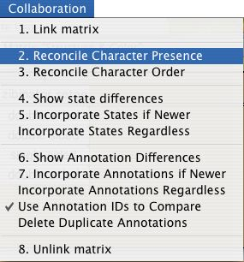 Figure 6. The Collaboration menu

Incorporating a contributor's changes — The primary tools for doing this appear in the Collaboration menu (Figure 6). The steps are as follows:
(1) Save a copy of the master file to archive the previous version.
(2) Open the master file.
(3) Use Link File in the Edit menu to link in the contributor's file. A message should appear, stating that there is a duplicate block of taxa. If this does not appear, or a message appears stating that there seems to be an block of taxa 80% or more identical, then something has gone wrong (e.g. contributor has changed the taxa block), and incorporation will not work.
(4) Ensure that the Character Matrix window for the Master matrix is the frontmost window.
(5) Use Reconcile Character Presence and Reconcile Character Order (Figures 7 and 8).
(6) Request to show state differences (Figure 9), and incorporate them.
(7) Request to show annotation differences (Figure 10), and incorporate them.
(8) Unlink the contributor's file using the Close File submenu.
(9) Save the new version of the Master matrix.

Figures 7-10 show the incorporation process. Details on the automatic incorporation of states and annotations are given below.
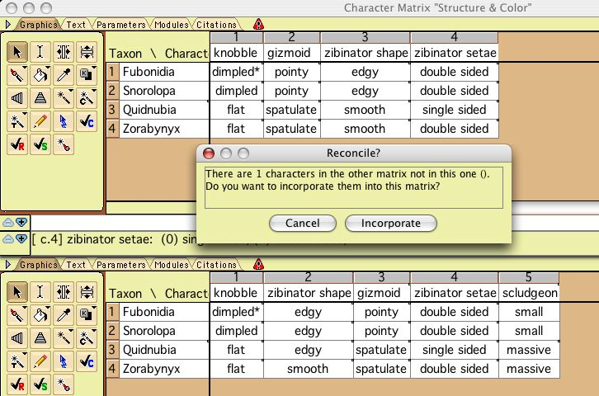
Figure 7. Reconciling character presence

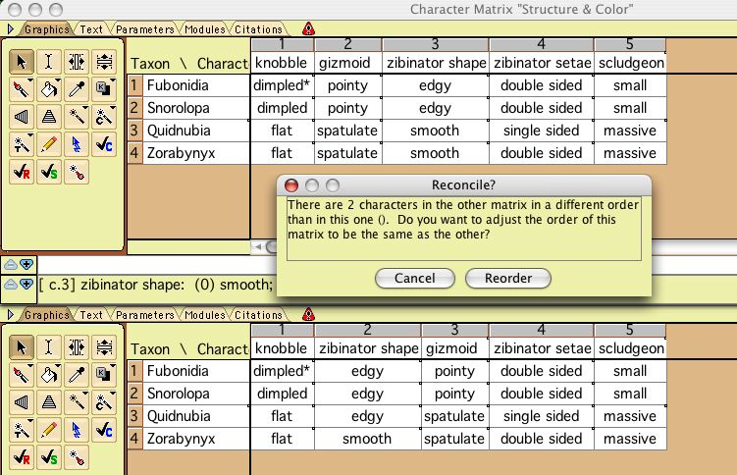
Figure 8. Reconciling character order

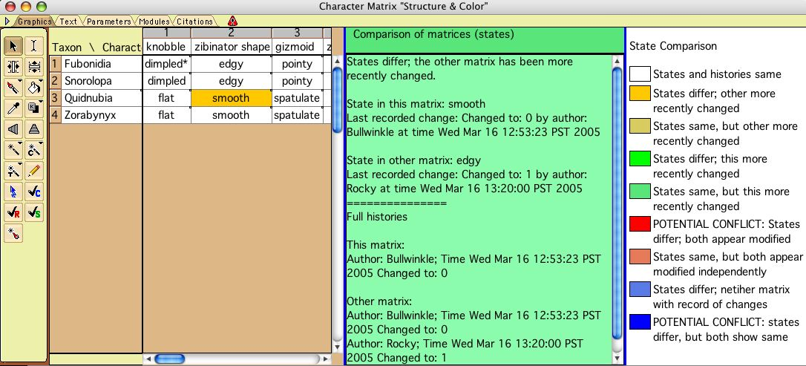
Figure 9. Showing state differences. The cells of the matrix are colored to show differences. Dark red and dark blue show what may be conflicts due to independent editing by different contributors.

Incorporating states — Remember when incorporating to have the window with the master matrix foremost. That way you'll be incorporating into the master matrix.

If you select Incorporate States if Newer, Mesquite will incorporate the state scoring at a cell in the contributor's matrix into the master matrix if
— both matrices have a record of change history and the contributor's is more recent, OR
— the master matrix has no record of change history but the contributor's matrix has a record of change history.
There is a BUG in this: Mesquite should but does not yet ask you to confirm this incorporation.

If you select Incorporate States Regardless, then Mesquite ignores the history of changes and incorporates the states from the contributor's matrix without checking recency. There is a BUG in this: Mesquite should but does not yet ask you to confirm this incorporation.

These automatic incorporations operate on only the selected cells of the matrix, or on all cells if none are selected. You might find it useful to select cells of a particular color to incorporate only those. You can select cells of only a particular color using the Select Same Color tool (a magic wand-paintbrush).

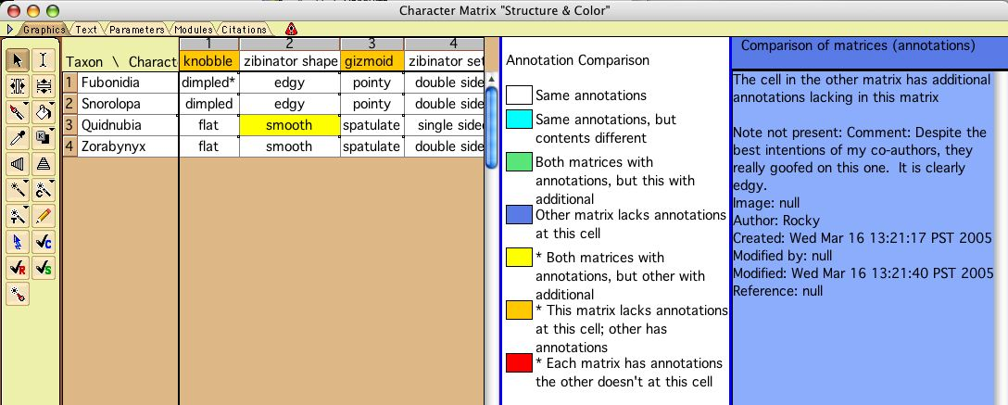
Figure 10. Showing annotation differences. The cells of the matrix are colored to show differences.

Incorporating annotations — Remember when incorporating to have the window with the master matrix foremost. That way you'll be incorporating into the master matrix.

Note: incorporation of annotations for taxa is currently BROKEN. Taxa annotations will accumulate each time a contributor's file is linked. We recommend against adding annotations to taxa until this is fixed.

Annotation incorporation poses special problems because a full history of annotations changes is not stored. The system depends on unique ID's for the annotations to recognize which annotations are descended from one another. If you have annotations created with previous versions of Mesquite (prior to 1.05+g50), please save the file with this version (g50 or later) to generate the unique ID's before giving it to contributors.

If you select Incorporate Annotations if Newer, Mesquite will incorporate a contributor's newly added annotations AND changes to existing annotations if they show a more recent modified data in the contributor's matrix than in the master matrix. If you select Incorporate Annotations Regardless, will incorporate a contributor's newly added annotations AND changes to existing annotations regardless of modification times. There is a BUG in this: Mesquite should but does not yet ask you to confirm this incorporation.

There is an option in the menu as to whether or not to use Annotation ID's. In general you should choose to use ID's (which is the default). If not checked, Mesquite does not use recorded id's to decide if two annotations are the same, but rather compares their contents directly. This is not recommended unless you are incorporating a matrix that diverged from the master before version 1.05+g50 of Mesquite.

As with state incorporation, annotation incorporations operate on only the selected cells of the matrix, or on all cells if none are selected.

