StratAdds for Mesquite
User and developer manual:

Project Manager: Michel Laurin
Developers: Eloise Faure, Eva Lony, Raphaël Lovigny, Alexis Ménégoz, Ying Ting

1. Export Tree 2
2. Run Export 5
3. References 9
4. How to cite this module 9

1. Export Tree
User perspective
What is it useful for?
The Export Tree module allows the user to export the chosen characters from a tree into a text-format document. The module has no effect on the tree.

How does it work?
To use the Export Tree module, you should access the “Tree” menu in the tree window and select “Utilities”, and then, “Export character by Tree”. When the menu “Save as…” appears choose the name of your file and the place to save it.

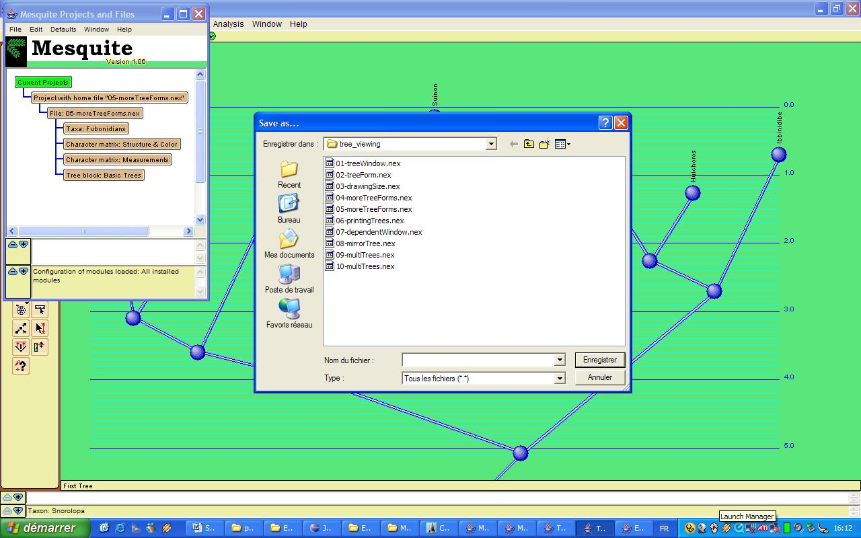

Choose a data matrix (if necessary).

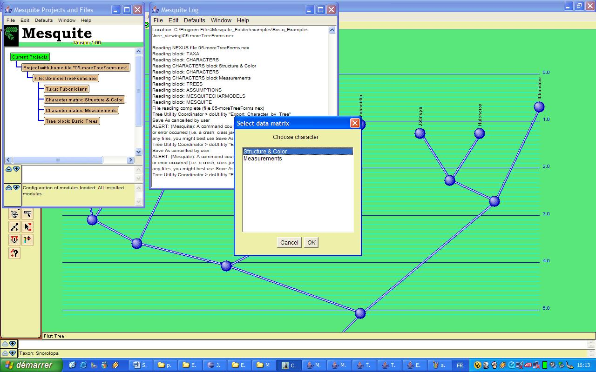

Then select the character(s) you want to export (you can select a single one or a multiple characters). Then click “Ok”.

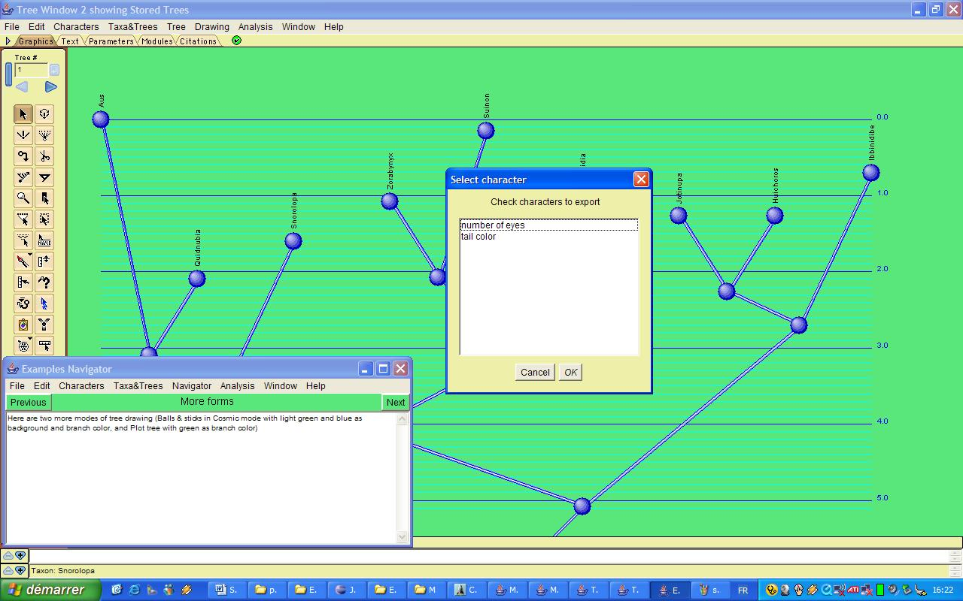

The character data in the output file is sorted by taxa in the same order as in the tree in the active tree window (taxa present in the data matrix but not in the tree will be omitted from the output file). The output can then be transferred to standard statistical packages to perform various analyses, such as PVR analysis with variance partitioning (Desdevises et al., 2003; Cubo et al., 2005), or a Mantel test (Mantel, 1967; Laurin, 2004).

Developer perspective

Where is the code?
The all code of Export Tree is in the package “mequite.stratAdd”.

How does it work?
The first part of the code is based on the mesquite classes used to create a new option for a menu, and another part of the code calls the mesquite classes used to read the NEXUS file (which contains information about the opened tree).

What can be improved?
The module seems to work with all kinds of trees, but our tests are not exhaustive.

2. Run Export
User perspective
What is it useful for?
The Run Export module allows the user to export into an Excel file various indices of biodiversity of a clade in order to show them in a form of histogram. It is useful mostly if the Stratigraphic Tools for Mesquite (Josse et al., 2006) are also installed, and the file includes a stratigraphic scale and extinct species of various gelological ages. However, this module also computes the Phylogenetic Diversity Index (PDI; Faith, 1992), that can be useful to compare extant clades (even in the absence of a fossil record) if there is branch length information. This index has been used in several recent studies (e.g. Virolainen et al., 1999; Pérez-Losada et al., 2002; Nehring and Puppe, 2004).

How does it work?
To use this function, click on the icon (circled here in red) and select the branch you wish to get a histogram of biodiversity. Six bibodiversity indices (including the PDI) of the clade in various geological periods are written in a file output.xls.

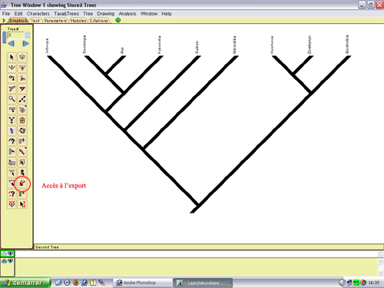

The selection is done while clicking on the desired branch which then appears in white.

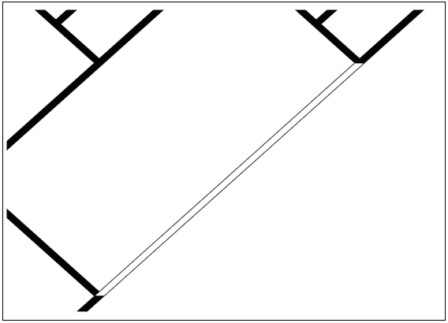

Then you will be asked which indice(s) you wish to export.

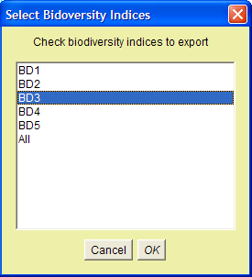

A window appears, giving the possibility to the user to export his selection, then to choose where he wants to export it.

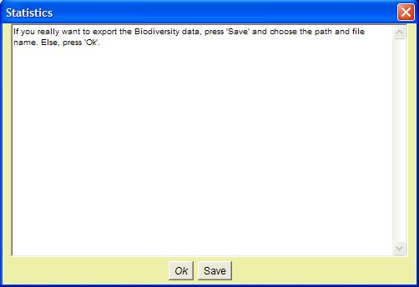

The created Excel file is reduced to its simplest expression, but it clearly shows the required statistics.
Here we can see the results obtained for a tree test:

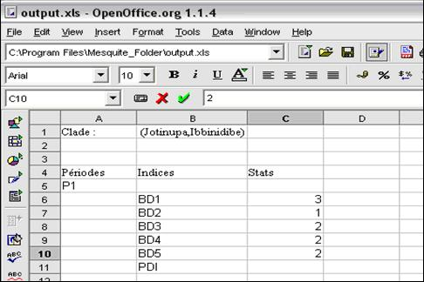
Developer perspective

Where is the code?
The all code of Run Export is in the package “mequite.stratAdd”.

How does it work?
There are two classes :
- RunExportation: it recovers the data in the tree which contains the studied branch it writes the .xls file containing the data.
- Biodiv : it is a secondary class

What can be improved?
The module seems to work with all kinds of trees, but our tests are not exhaustive.

3. References

Cubo J, Ponton F, Laurin M, de Margerie E, and Castanet J. 2005. Phylogenetic signal in bone microstructure of sauropsids. Syst. Biol. 54: 562-574.
Desdevises Y, Legendre P, Azouzi L, and Morand S. 2003. Quantifying phylogenetically structured environmental variation. Evolution 57: 2467-2652.
Faith DP. 1992. Conservation evaluation and phylogenetic diversity. Biol. Conserv. 61: 1-10.
Josse S, Moreau T, and Laurin M. 2006. Stratigraphic tools for Mesquite. Available at http://tolweb.org/notes/?note_id=3669
Laurin M. 2004. The evolution of body size, Cope's rule and the origin of amniotes. Syst. Biol. 53: 594-622.
Mantel N. 1967. The detection of disease clustering and a generalized regression approach. Cancer res. 27: 209-220.
Nehring K, and Puppe C. 2004. Modelling phylogenetic diversity. Resour. Energy Econ. 26: 205-235.
Pérez-Losada M, Jara CG, Bond-Buckup G, and Crandall KA. 2002. Conservation phylogenetics of Chilean freshwater crabs Aegla (Anomura, Aeglidae): assigning priorities for aquatic habitat protection. Biol. Conserv. 105: 345-353.
Virolainen KM, Virola T, Suhonen J, Kiuitunen M, Lammi A, and Siikamäki P. 1999. Selecting networks of nature reserves: methods do affect the long-term outcome. Proc. R. Soc. Lond. B 266: 1141-1146.

4. How to cite this module

Eloise Faure, Eva Lony, Raphaël Lovigny, Alexis Ménégoz, Ying Ting and Michel Laurin. 2006. StratAdd module for Mesquite. Available at http://tolweb.org/notes/?note_id=3669

