Auto Email Churn Retention
Bryan Kristoffer M. Ferrer
2025/07/01
Version 1

Table Of Contents

https://www.perforce.com/blog/alm/how-write-software-requirements-specification-srs-document

Introduction

Purpose
Auto Email Churn Retention is a massive system that aims to automate the end-to-end workflow and process of targeted retention of customers with personalized email. This system includes generating the churn prediction model, utilizing the LLM for generating email, and utilizing google API for sending emails in bulk.

1.2 Intended Audience
The system is designed usage of marketing and analyst stakeholders. This system offers full control from bulk generation of emails up to bulk emailing to customers.

1.3 Intended Use
The system allows one click training of churn prediction model so that it can be used to target customers risk of churning, then utilize an LLM to generate personalized email per churning customer, then show report of the churning customers as well as the personalized email before being sent to churning customers’ emails.

1.4 Product Scope
The core objective of this project is to automate the end to end workflow from churn prediction model creation and utilize LLMs to generate personalized emails based on the importance of the features.

1.5 Definitions and Acronyms
- Machine Learning – A branch of artificial intelligence that enables computers to learn from data and make predictions.
- ROI (Return on Investment) – A measure of profitability indicating how much return an investment generates.
- Listing Price – The price at which a used car is advertised for sale.
- Predicted Market Value – The estimated fair price of a car based on the ML model's assessment of similar listings.

Overall Description

2.1 User Needs
Describe who will use the product and how. Understanding the various users of the product and their needs is a critical part of the SRS writing process.
Who will be using the product? Are they a primary or secondary user? What is their role within their organization? What need does the product need to fulfill for them?
Do you need to know about the purchaser of the product as well as the end user? For the development of medical devices and med device software, you may also need to know the needs of the patient.

2.2 Assumptions and Dependencies
What are we assuming will be true? Understating and laying out these assumptions ahead of time will help with headaches later. Are we assuming current technology? Are we basing this on a Windows framework? We need to take stock of these technical assumptions to better understand where our product might fail or not operate perfectly.
Finally, you should note if your project is dependent on any external factors. Are we reusing a bit of software from a previous project? This new project would then depend on that operating correctly and should be included.

System Features and Requirements

3.1 Functional Requirements
Identifier | Title | Summary | Reasoning
 | Churn Report | A summary of report of both churning and non-churning customers. Also including the feature importance based on Shapley Additive Explanations. | This is the main input to produce personalized emails.
 | Auto Email Churn Retention Website | A website to manage and control all the processes. See “Table 2 Website Functional Requirements” | This is the main interface to access the Auto Email Churn Retention project.
 | Machine Learning Churn Predictor | A machine learning model to determine if the customer is churning or not, as well as features contributing to the classification. | This is utilized to determine whether a customer will be churning or not, also including feature importance.
 | LLM RAG | A Generative AI that will generate the personalized email per churning customer. | This is utilized to automate the generation of personalized email.
 | Server | A backend infrastructure to host software, website, and process user requests. | Ensure smooth operation and constant availability of project.
 | Database | A storage system to store data. | Ensure smooth operation and constant availability of project.
Table 1 General Functional Requirements

Web Page | Web Page Description | Item # | Functionality Title | Functionality Description | Progress
Train Model | Control and start training of churn prediction model |  | Upload Training Data | Upload csv file for training | Done
 |  |  | View Training Data | View Training Data | Done
 |  |  | Train Model | Actually start training a churn prediction model | Done
 |  |  | View Modelling Results | View the results of training the churn prediction model | Done
Run Inference | Control and start scoring and emailing customers |  | Upload Scoring Data | Upload csv file for scoring | Done
 |  |  | View Scoring Data | View Scoring Data | Done
 |  |  | Run Inference | Score the scoring data using Churn Prediction Model to output Scored Table. | Done
 |  |  | View Scored Table | See results of churn report contents:  - Churn target  - Churn probability  - Top churning features | Done
 |  |  | Generate Emails | Generate personalized emails in bulk using LLM to output Scored Emails Table.
 |  |  | View Emails Scored Table | See results of churn report contents:  - Churn target  - Churn probability  - Top churning features  - Email Generated  - Email address
 |  |  | Send Emails | Select/Deselect targets and send emails in bulk
View Reports | View multiple tables relating to the system |  | View Historical Model Table | View the following contents:  - Model versions,  - train date  - metrics  - top features
 |  |  | View Historical Scoring Table | View the following contents:  - Churn target  - Model version  - Scoring date  - Top churn features  - Email generated
 |  |  | View Historical Emails Table | View the following contents:  - Churn target  - Model version  - Email date  - Email content
Table 2 Website Functional Requirements

3.2 External Interface Requirements
External interface requirements are specific types of functional requirements. These are especially important when working with embedded systems. They outline how your product will interface with other components.
There are several types of interfaces you may have requirements for, including:
- User
- Hardware
- Software
- Communications

3.3 System Features
System features are a type of functional requirements. These are features that are required in order for a system to function.

3.4 Nonfunctional Requirements
Nonfunctional requirements, which help ensure that a product will work the way users and other stakeholders expect it to, can be just as important as functional ones.
These may include:
- Performance requirements
- Safety requirements
- Security requirements
- Usability requirements
- Scalability requirements
The importance of each of these types of nonfunctional requirements may vary depending on your industry. In industries such as medical device, life sciences, and automotive, there are often regulations that require the tracking and accounting of safety.
IEEE provides guidance for writing software requirements specifications, if you’re a member.

Appendix

System Architecture
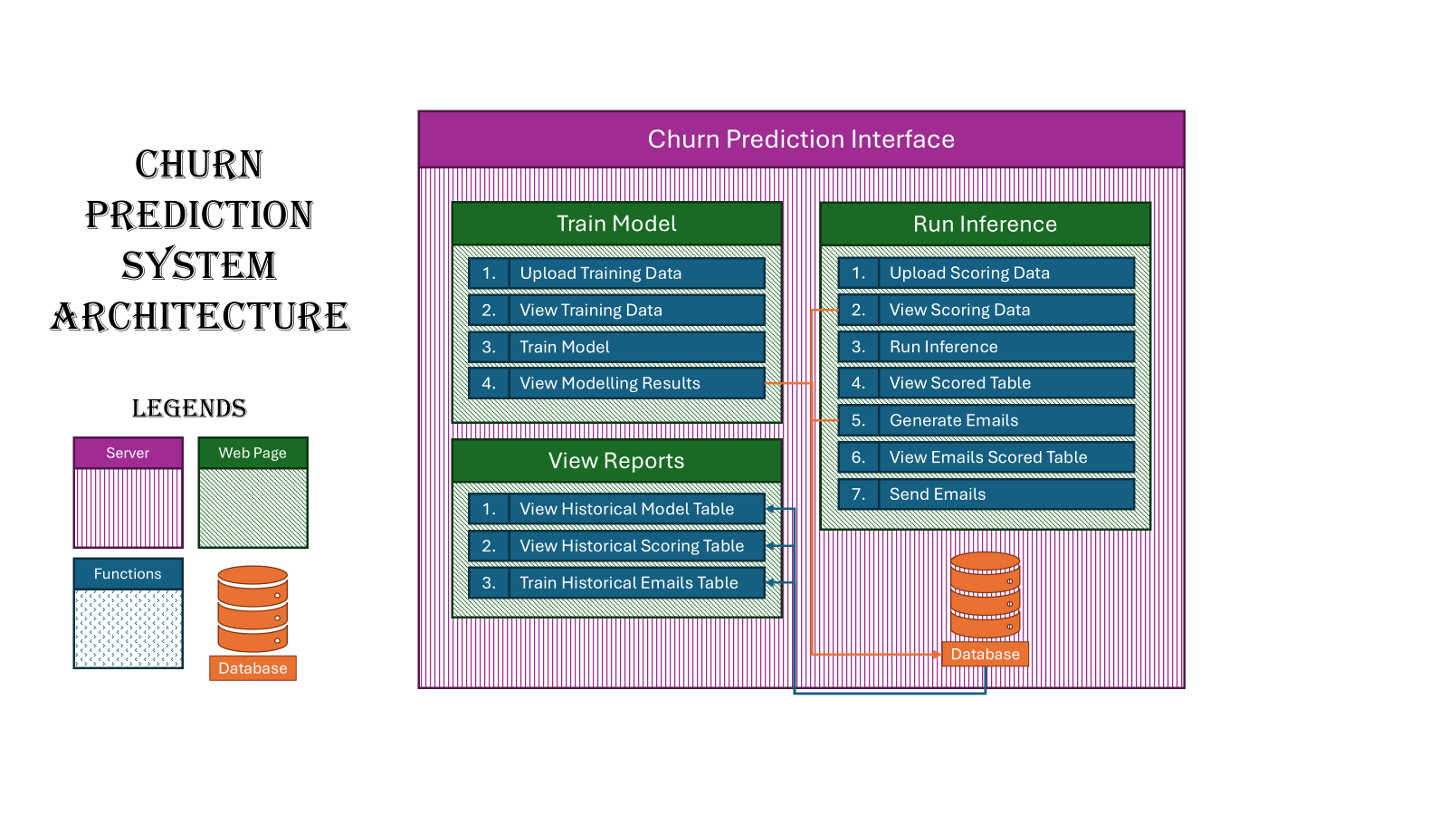
Figure 1 Production Architecture
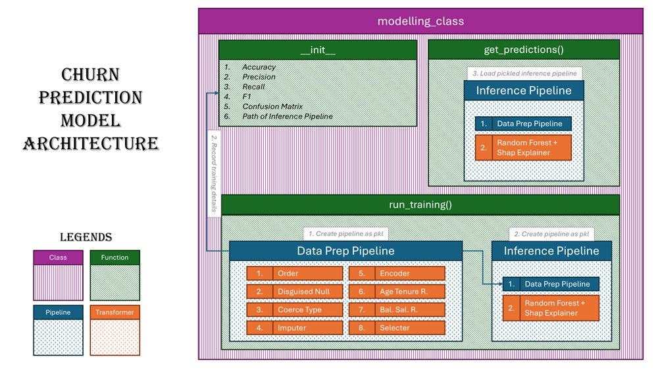
Figure 2 Model Architecture

