System Analyst.

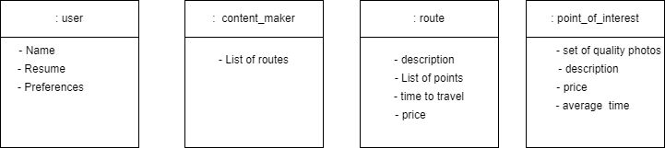

Domain model.

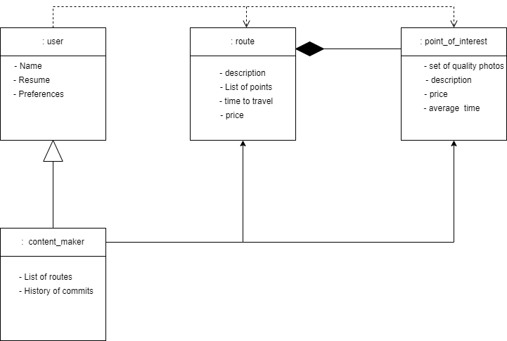

* A route cannot exist without points of interest.
* The content maker inherits all fields from the user. Content maker can create routes and waypoints.
* The user is aware of routes and points of interest.