# MessyBoot 5.2 by Kev Messy

**MessyBoot** is a collection of drivers, tools, diagnostics, utilities for Windows based PCs.Once burnt to a suitable 4.7GB DVD the **MessyBoot** is designed to work in either one of two different modes. It can be used as a standard CDFS type DVD-ROM for use within the Windows Operating System which has facilities to detect and install any missing drivers for the OS, **plus** Many other tools, ranging from burn-in tests to fully forensic data recovery. The DVD can also be used as a boot disc. Booting the PC to the **MessyBoot** DVD gives access to many non-windows tools such as RAM & Hard Disk testing, DMI Tools, Password Removal, **plus** two Live OS’s that run straight from the DVD; Mini Windows 7 and Mini Ubuntu Linux.

## 1. Bootable Tools

**These are tools that are accessible directly by booting to the DVD.**

### The Boot Tools Include:

* Password Removal / Recovery
* Disk Tools (Diagnostics / Rejuvenators / Data Recovery / Secure Erase)
* Hardware Testing (All Types)
* Burn-In Tools
* DMI Tools
* Mini Windows 7 (Bootable Live Image)
* Mini Linux (Bootable Live Image)

## 2. Windows Tools

**These are tools that can only be run from within Windows.**  
*(Can be run from within the Mini-Windows 7 image in the Bootable Tools menu for Testing/Diagnostics/Data Recovery).*

### The Windows Tools Include:

* Hardware Testing Tools
* Software Analysis Tools
* DriverPack Installer System
* Drivers Backup System
* Various Benchmarking Packages
* Data Recovery Tools
* Much, much more!

## Instructions:

Burn ISO to a single layer 4.7GB DVD-R, use and enjoy!

*For automatic driver installation, make sure you burn the correct ISO for your OS:*

### MESSY_52_W7-10.ISO

**NT6 Version**, compatible with the following versions of Windows:

* Windows 10 / 8.1 / 8 / 7 / Vista (32Bit & 64Bit)
* Windows Server 2008 / 2012 / 2016 (32Bit & 64Bit)

### MESSY_52_XP.ISO

**NT5 Version**, compatible with the following versions of Windows:

* Windows XP (32Bit/64Bit)
* Windows Server 2003 (32Bit/64Bit)

# Screenshots:

### 1. The MessyBoot Main Menu

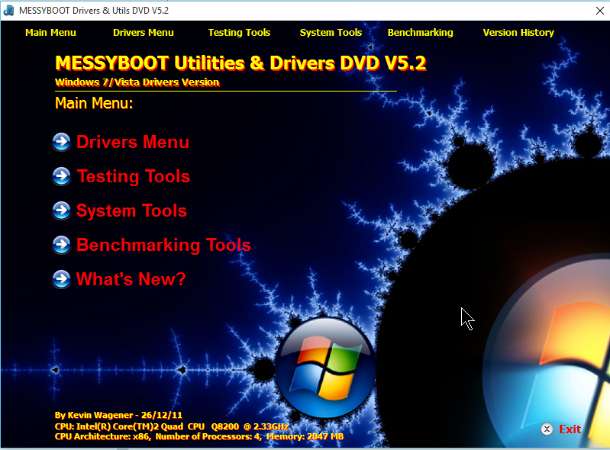

### 2. The MessyBoot Drivers Menu

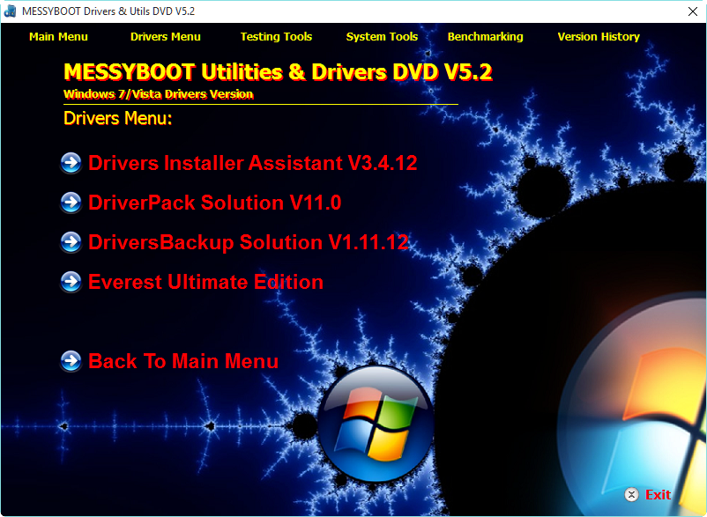

### 3. The MessyBoot Testing Menu

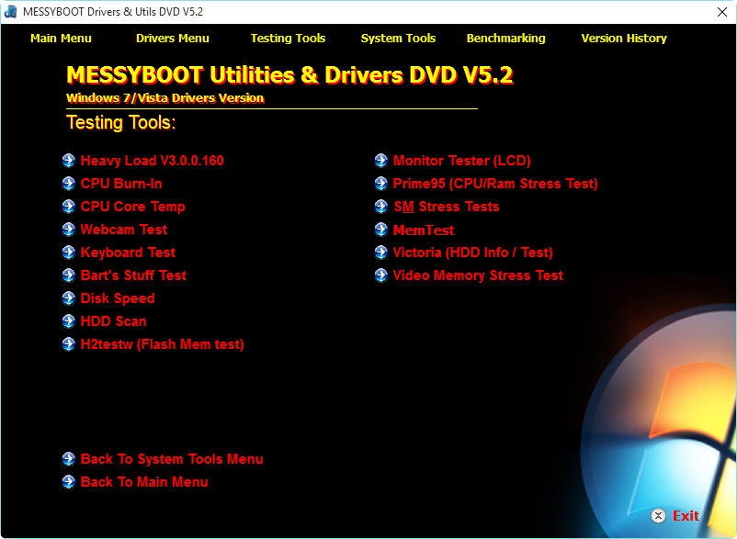

### 4. The MessyBoot System Tools Menu

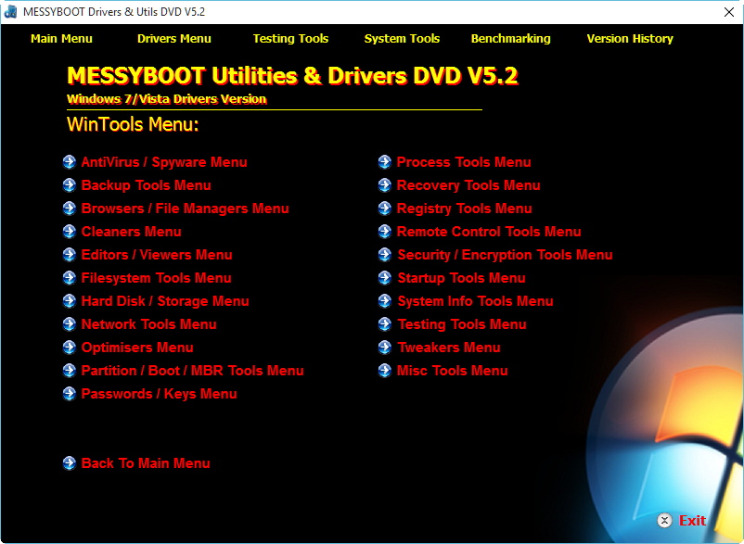

### 5. The MessyBoot Benchmarking Menu

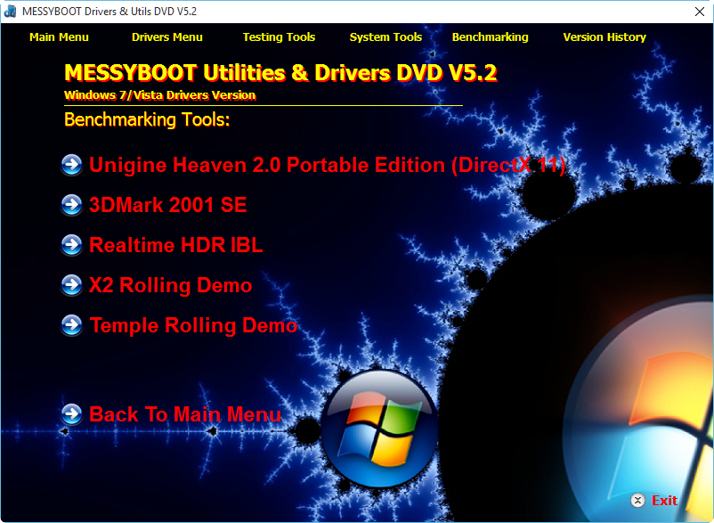

### 6. The MessyBoot What's New? Page

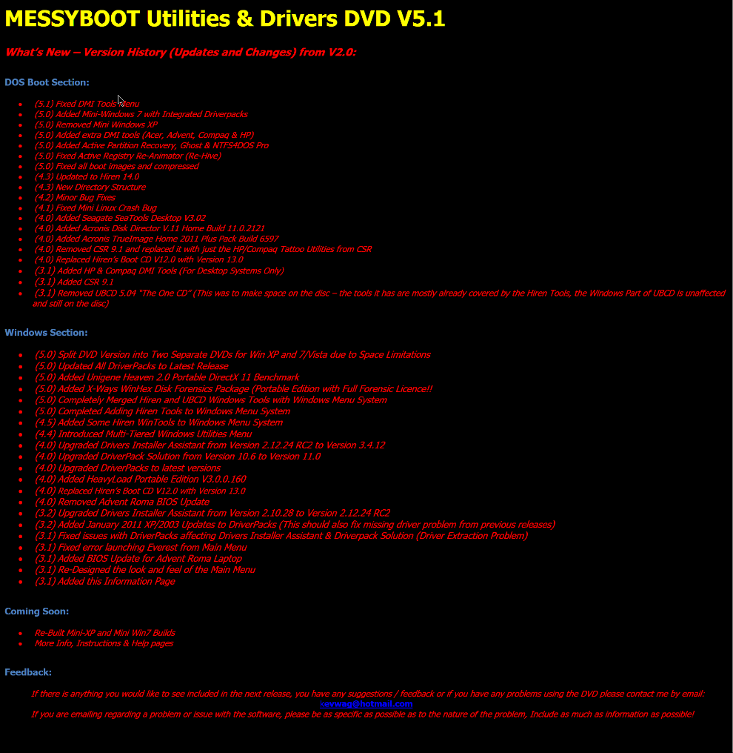

## Contact Messy

Email: ke.vs@hotmail.co.uk

Demonoid: http://www.demonoid.ooo/users/kevwag