### 4.3.2. Sequence Diagram

A **sequence diagram** in a Unified Modeling Language (UML) is a kind of interaction  
diagram that shows how processes operate with one another and in what order. It is a construct  
of a message sequence chart. A sequence diagram shows object interactions arranged in time  
sequence. It depicts the objects and classes involved in the scenario and the sequence of  
messages exchanged between the objects needed to carry out the functionality of the scenario.  
Sequence diagrams typically are associated with use case realizations in the Logical View of  
the system under development

4.3.2.1 **Sequence diagram for Login**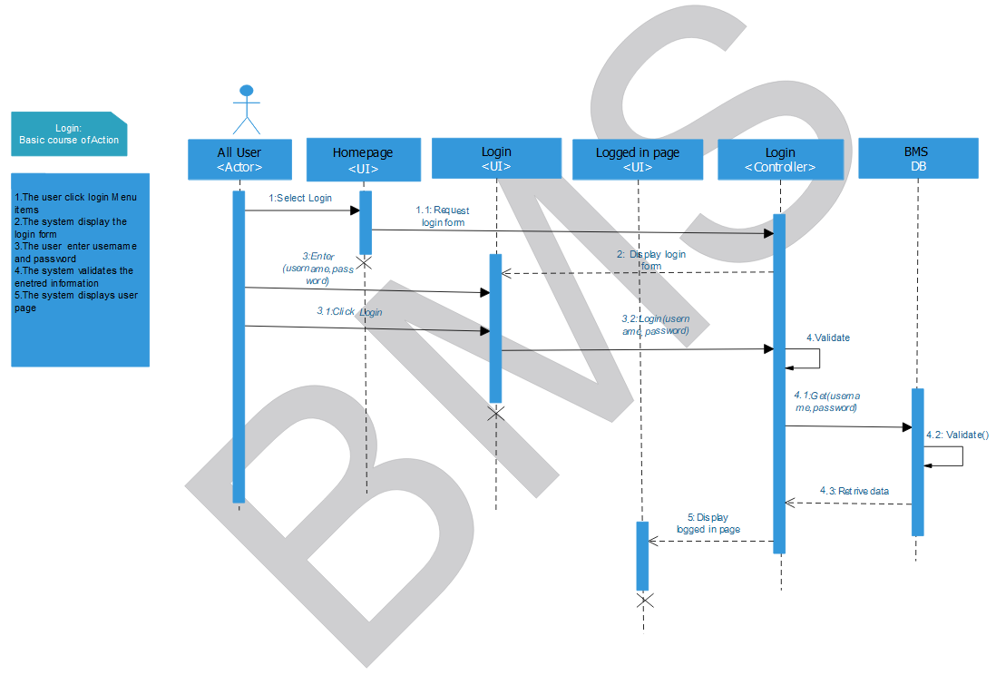Figure 4.33 Sequence diagram for login use case

4.3.2.2 **Sequence diagram for Add User**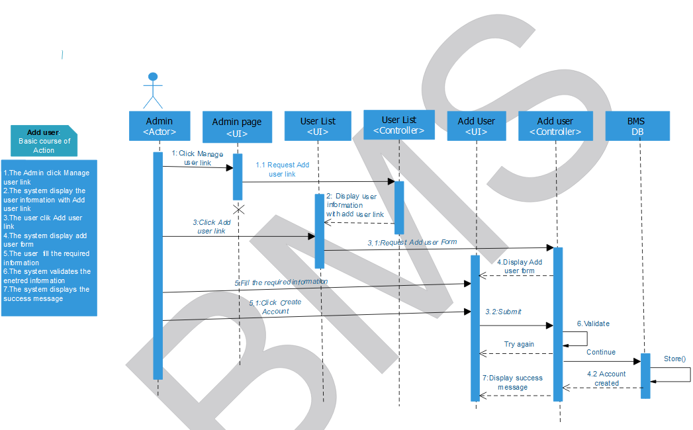

Figure 4.34 Sequence diagram for Add user use case

4.3.2.3 **Sequence diagram for update User**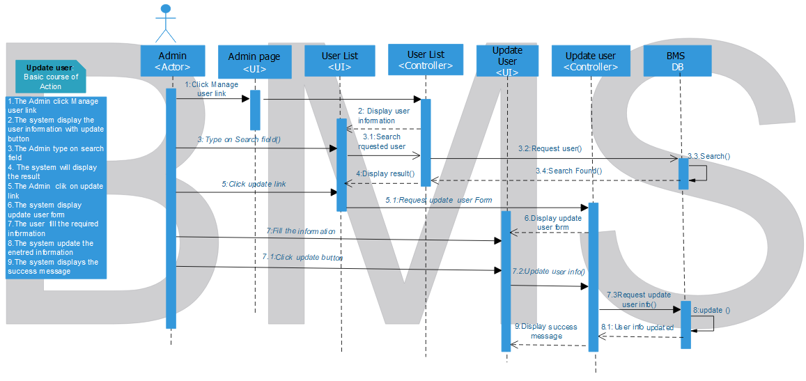 Figure 4.35 Sequence diagram for update user use case

4.3.2.4 **Sequence diagram for Delete User**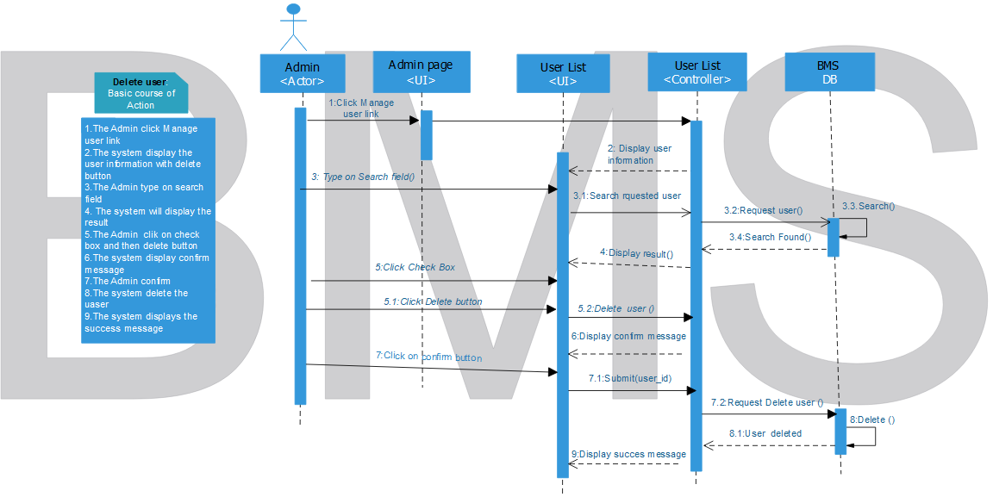 Figure 4.36 Sequence diagram for delete user use case

4.3.2.5 **Sequence diagram for Assign Directorate**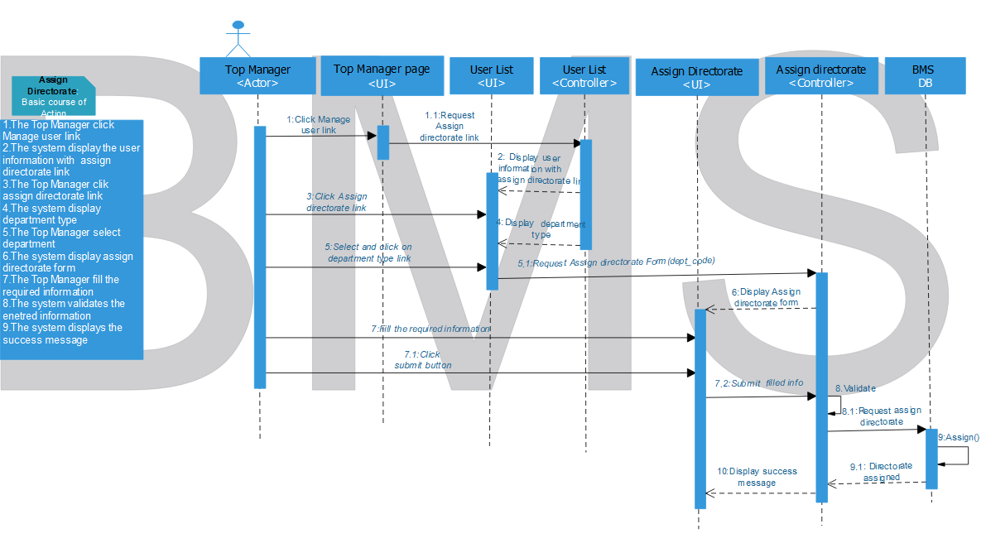

Figure 4.37 Sequence diagram for Assign directorate use case

4.3.2.6 **Sequence diagram for Request payment**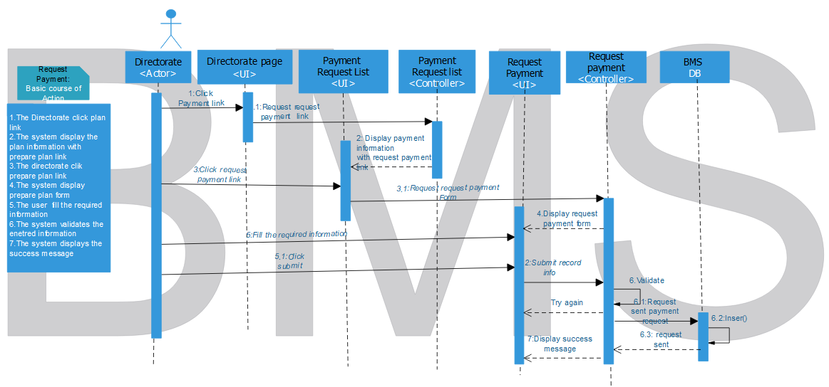 Figure 4.38 Sequence diagram for request payment use case

4.3.2.7 **Sequence diagram for Request Budget**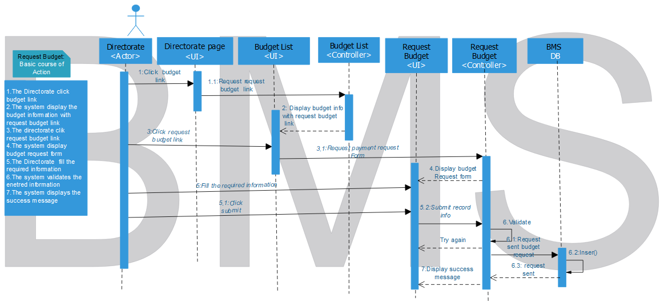 Figure 4.39 Sequence diagram for Request budget use case

4.3.2.8 **Sequence diagram for Prepare Plan**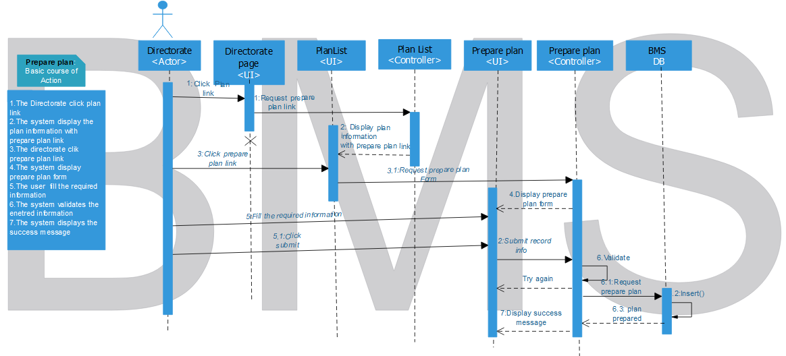

Figure 4.40 Sequence diagram for Prepare plan use case

4.3.2.9 **Sequence diagram for Register**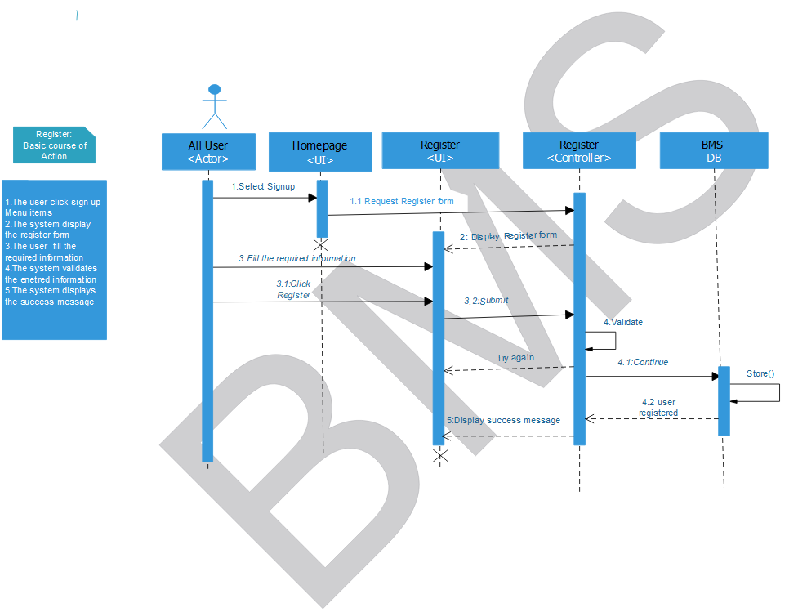 Figure 4.41 Sequence diagram for register use case

4.3.2.10 **Sequence diagram for Sign Request**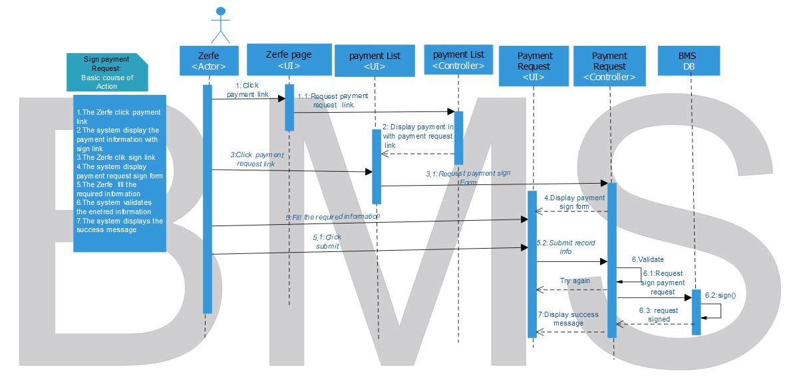 Figure 4.42 Sequence diagram for sign request use case

4.3.2.11 **Sequence diagram for Approve Budget**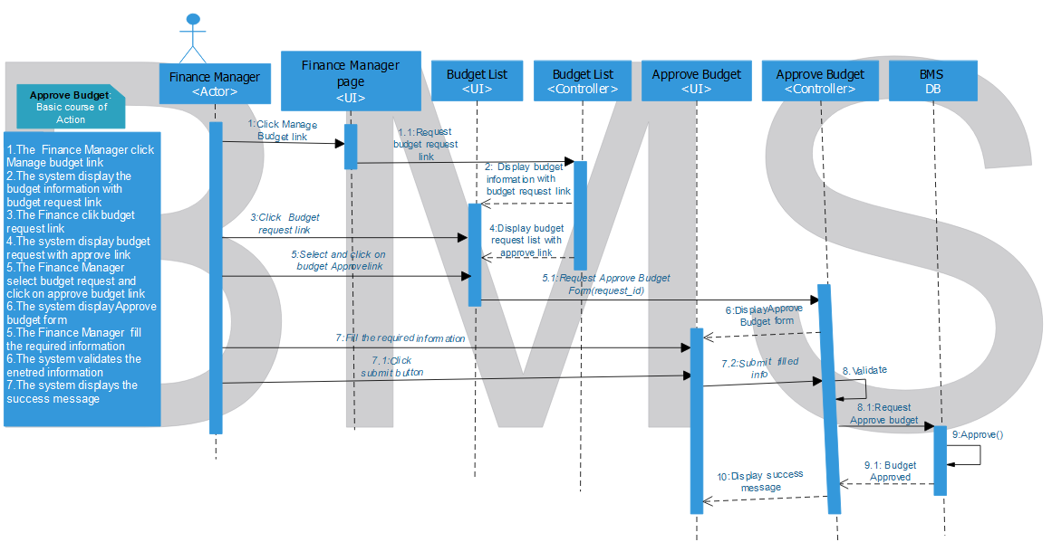

Figure 4.43 Sequence diagram for Approve budget use case

4.3.2.12 **Sequence diagram for Approve payment**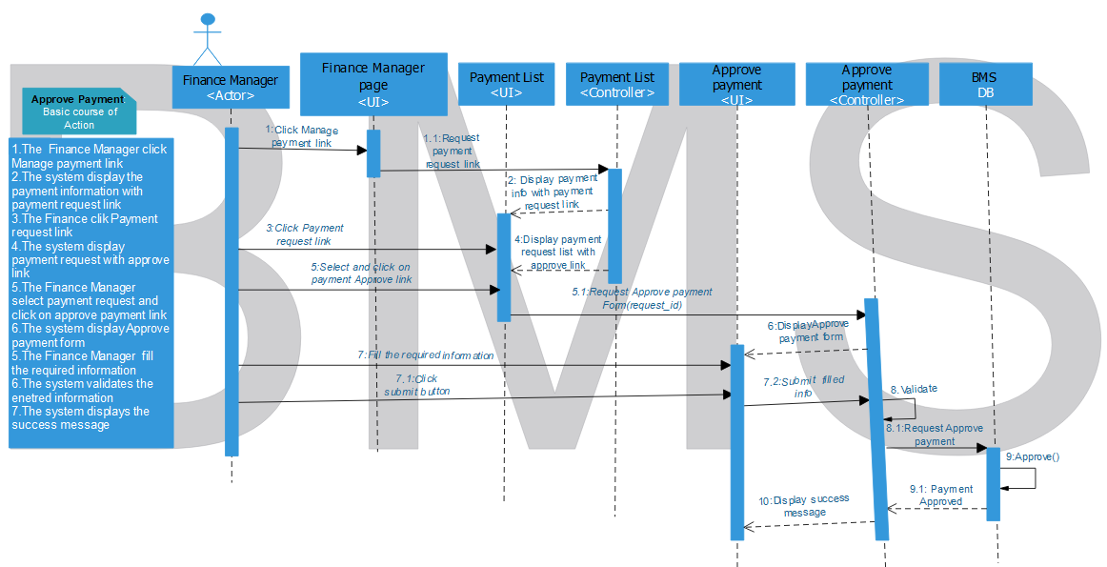 Figure 4.44 Sequence diagram for Approve payment use case

4.3.2.13 **Sequence diagram for Approve plan**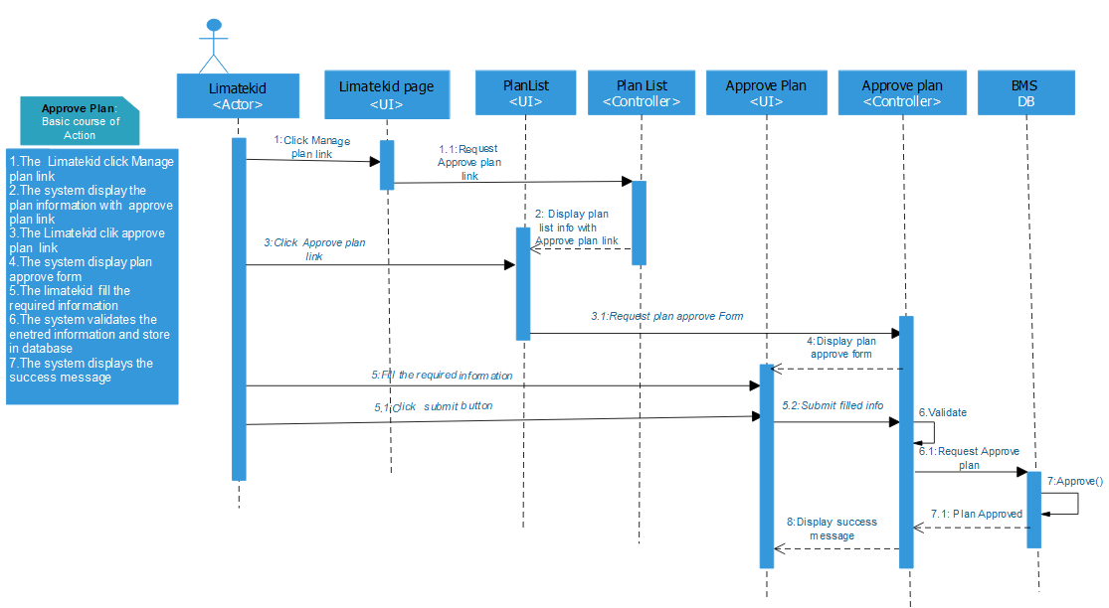 Figure 4.45 Sequence diagram for Approve plan use case

4.3.2.14 **Sequence diagram for Add Budget**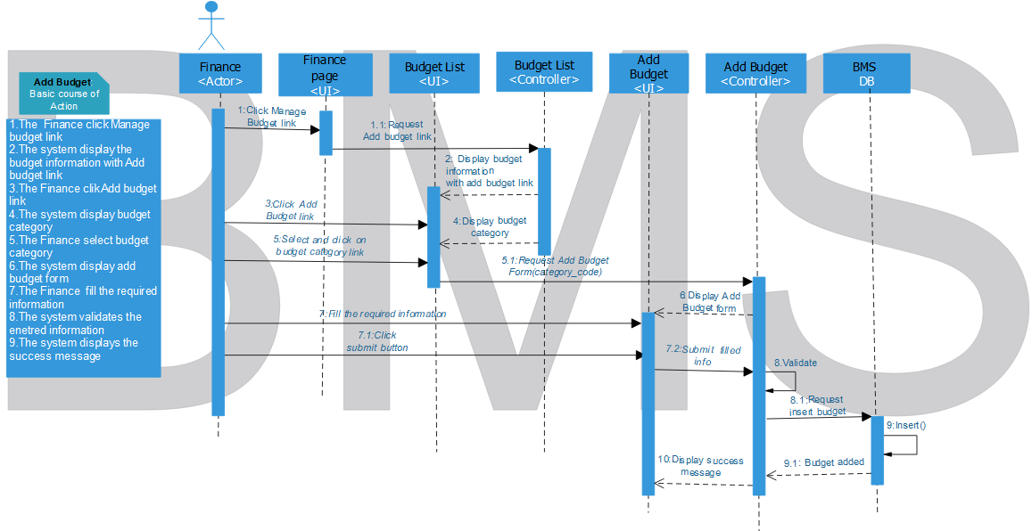 Figure 4.46 Sequence diagram for Add budget use case

4.3.2.15 **Sequence diagram for update Budget**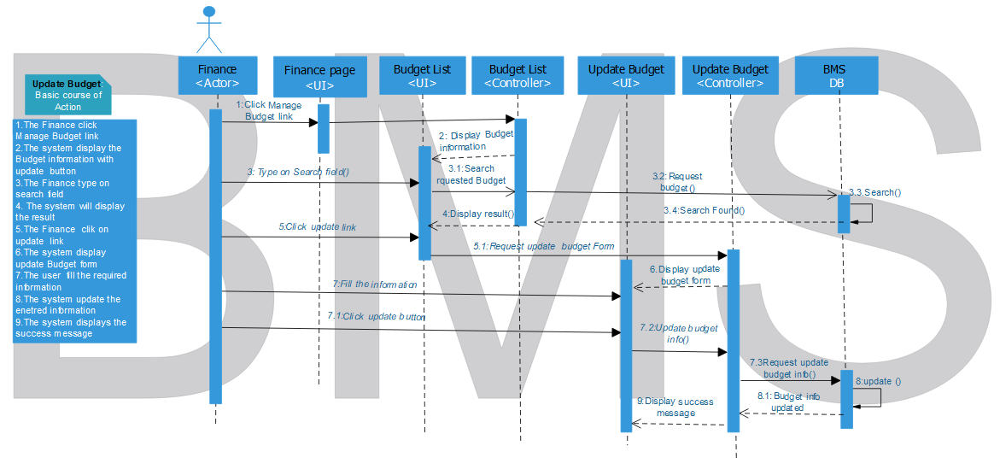

Figure 4.47 Sequence diagram for update budget use case

4.3.2.16 **Sequence diagram for Delete Budget**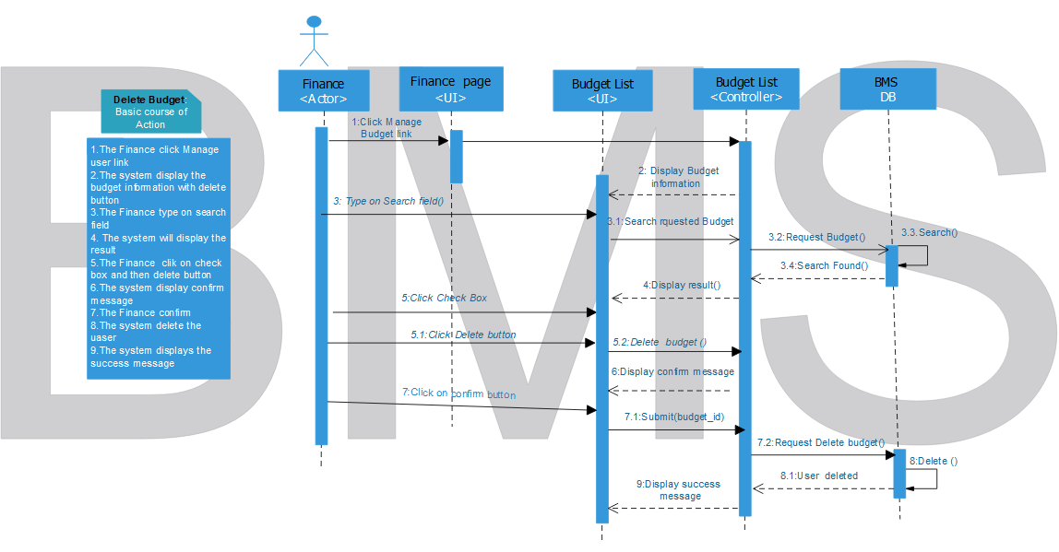 Figure 4.48 Sequence diagram for delete budget use case

4.3.2.17 **Sequence diagram for Record payment**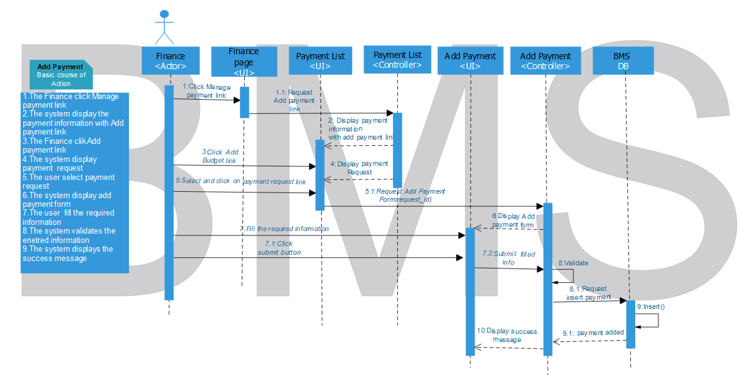 Figure 4.49 Sequence diagram for Record payment use case

4.3.2.18 **Sequence diagram for update payment**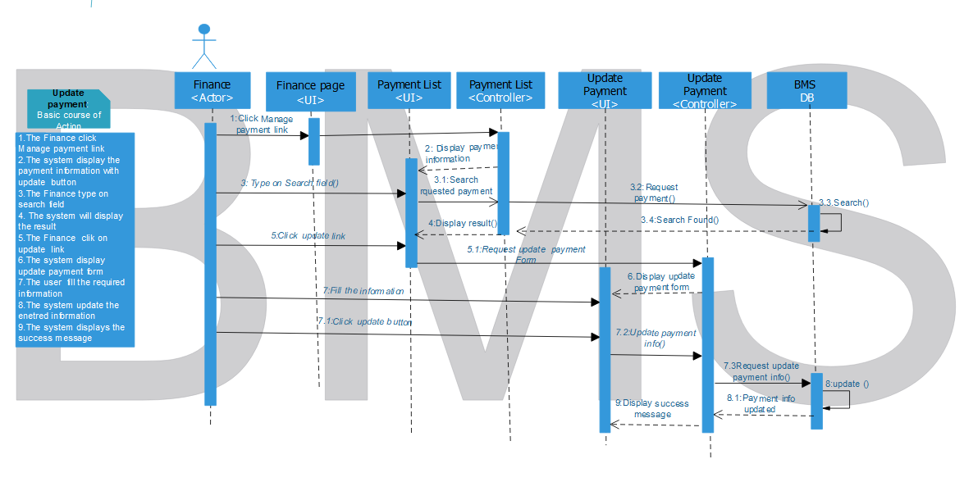 Figure 4.50 Sequence diagram for update payment use case

4.3.2.19 **Sequence diagram for Delete payment**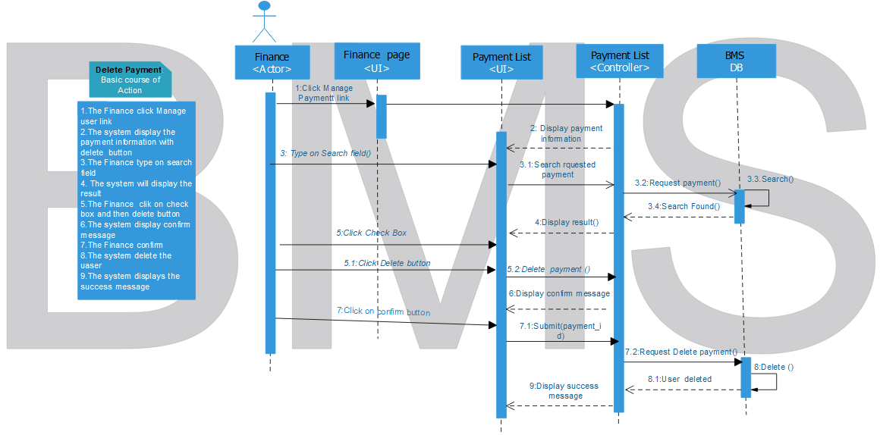 Figure 4.51 Sequence diagram for Delete payment use case