# COURSE: ADVANCE ENGINEERING MATHEMATICS

**ASSIGNMENT NO: 01**



Submitted By

Mesum Ali Irfani

Regn Number

450291

Submitted To

Dr Muhammad Safdar

Department of Robotics and Artificial Intelligence

SCHOOL OF MECHANICAL & MANUFACTURING ENGINEERING

NATIONAL UNIVERSITY OF SCIENCES AND TECHNOLOGY

**MOBILE ROBOT SELECTED FOR SIMULATION**

**ROBOT SELECTED :**

ROBOTONT- An Open-source and ROS-supported omnidirectional mobile robot for education and research [1].

**Harware Description and Working Principles:**

**Mechanical Assembly :**

The Mechanical Assembly of Robotont is shown in Figure1. The primary structure of the robot consists of a polycarbonate main chassis.

Inside the chassis are:

* Three wheel modules.’.
* Electronic circuit boards dedicated to various functions:
* Main microcontroller.
* Power management.
* Motor control.

Additionally, it houses the power supply and associated wiring.

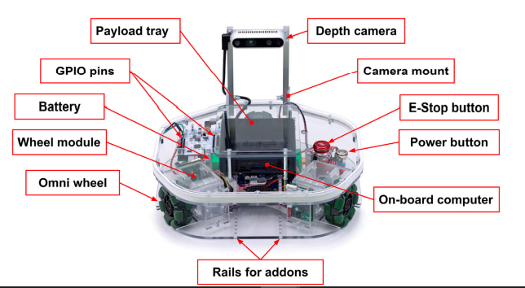

Figure 1 : Mechanical Assembly [1]

The Robotont robot features a polycarbonate main chassis housing essential components such as three wheel modules, electronic circuit boards, power management systems, and wiring. Each wheel module consists of a DC motor with encoders, a double roller omni wheel, and a motor driver, designed for easy replacement and maintenance. Power and emergency stop buttons are integrated into the chassis's top plate for accessibility and safety. Additionally, an opening in the top plate exposes the GPIO pins of the electronics board, while the onboard computer is mounted on top to facilitate connection with additional components and debugging. The placement of the battery and onboard computer at the center ensures even mass distribution on the wheels. A lightweight camera mount allows for easy detachment for storage and transportation. Rails on the front of the chassis offer mechanical modularity for attaching custom-purpose modules.

**ELECTRONICS :**

Robotont is centrally controlled by its onboard computer, which interfaces with three key subsystems: power management circuitry, an Intel RealSense RGB-D camera, and an STM32 NUCLEO-L476RG development board. The architecture of electronics is outlined in Figure 2.

Figure 2 : Connection Architecture of Robotant

The STM32 NUCLEO-L476RG development board manages low-level computations and connects to the three wheel modules. Each module contains a DC motor with an encoder, controlled by a custom motor driver board housing an MC33886 H-bridge chip. Encoders enable the microcontroller to calculate velocities, provide odometry, and generate motor control signals. A USB 2.0 bus handles data communication and power delivery from the onboard computer to the microcontroller.

**SOFTWARE :**

The software system for Robotont utilizes ROS to harness its wide range of capabilities. The core of this system is the robotont_driver ROS package, which includes the driver node. This node acts as a bridge between high-level ROS functionality and the low-level microcontroller-controlled motors and sensors.

Robotont is compatible with ROS Navigation which enable to have an autonomous behavior. This includes features like 2D SLAM and motion planning. ROS Navigation requires a cmd_vel/odom interface for velocity message reception and odometry data transmission. Therefore, the driver_node subscribes to the 'cmd_vel' topic and publishes on the 'odom' topic, providing the necessary interface. Additionally, the driver_node maintains bidirectional serial communication with the microcontroller. Computation of motor speeds from velocity commands and odometry based on wheel encoders is handled by the microcontroller firmware.

# **References**

|  |  |
| --- | --- |
| [1] | Raudme,Renno and Schumann, Sandra and Vunder, Veiko and Oidekivi, Maarika and Nigol, Madis Kaspar and Valner, Robert and Masnavi, Houman and Singh, Arun Kumar and Aabloo, Alvo and Kruusame, Karl, "ROBOTONT--Open-source and ROS-supported omnidirectional mobile robot for education and research," *HardwareX,* vol. 14, p. e00436, 2023. |