

COVER SHEET
INDIAVIDUAL ASSIGNMENT
SEMESTER FALL 2025

Student Name (s)* | Mohammad Mesum Hussain
Student ID (s)* | 22S22604
Module Code* | COMP 30043
Module Name* | Machine Intelligence Systems
Session* | A
Submitted to Teacher and Department* | Dr. C. Jayakumari
Coursework No.* | Coursework 2
Assignment Title | Individual Assignment
Actual Word Count (Excluding Cover Page, TOC/Index, references and appendices)

Task1:
Comparative Analysis of Decision Tree and K-Nearest Neighbors Algorithms in Bank Marketing Prediction

Mohammad Mesum Hussain
Student at Department of Computing
Middle East College
Muscat, Oman
22S22604@mec.edu.om

Abstract
This paper explores the predictive accuracy of the Decision Tree (DT) and K-Nearest Neighbor (KNN) algorithms in predicting client interest in taking out a term deposit with the help of the Bank Marketing dataset at Kaggle. The dataset has both categorical and numerical variables, which were preprocessed to encode categorical variables and normalize numerical ones to KNN. The Python implementation of models was KNN and decision tree models with hyperparameter tuning. The Decision Tree model was able to achieve very high accuracy and high recall of the minority class, 84.29% and 90.55% accuracy and recall respectively with KNN, however it was less than 84.29% with the subscribers. These findings indicate that there is a trade-off between total accuracy and detection of minority classes, which implies that DT is the most effective when there is a need to identify possible subscribers.
- Introduction
Machine learning can offer useful predictive modeling in structured data.
Decision Trees (DT) are hierarchical classifiers that recursively divide data based on feature values depending on criteria such as Gini Index or Entropy which generates understandable decision rules. DTs are efficient in terms of their capabilities to process both categorical and numerical features, little preprocessing is needed, and they find application in marketing, finance, and medical practice.
K-Nearest Neighbor (KNN) is a non-parametric classifier which classifies a new data point with most of the K nearest data points of the type of most of the nearest data points; typically, with Euclidean distance. KNN needs the feature scaling to standard values so that it does not favor features with bigger scales. Although KNN is easy as it can be deployed, it can be computationally expensive with large datasets. Both KNN and DT can be used in bank marketing prediction, but they complement each other in their strengths: DT is more interpretable and can detect minorities, whereas KNN can be more accurate and overall.
- Literature Review
In a comparative study of the use of DT and KNN in classifying social assistance programs, Aprianti and Amelia (2023) were involved. They discovered that DT generated interpretable decision rules and, on minorities classes, they did better than KNN, which relied on the selection of the value of k and necessitated correct feature normalization. It also shows that DT has strengths in terms of sensitive applications because the study emphasizes the trade-off between interpretability and raw accuracy.

Zhang et al. (2023) compared the prediction of the bank marketing using DT and KNN predictors. Their findings indicated that KNN was more accurate in general, but DT was more accurate in identifying clients who were likely to subscribe to term deposits which is the majority group. The research confirms the hypothesis that DT is more appropriate in the case of imbalanced data sets in which it is important to define minor classes.

Dataset and Preprocessing
Bank Marketing data of Kaggle is a dataset with 20 input features (41188 records), where there are both numerical (age, balance) and categorical (job, marital status, education, contact type) variables. The dependent variable is subscribing to a term deposit or not.
Preliminary tests ensured that there were no values missing. The Interquartile Range (IQR) was used to identify outliers but in retention the outliers reflect valid variations of clients as far as marketing prediction is concerned.
LabelEncoder was used to convert categorical variables into numeric codes. KNN scaled numerical features using StandardScaler to make sure that the calculation of distances was not biased by features that had bigger magnitudes. The data was divided into two groups of training and testing sets in the proportion 80:20. These preprocessing measures guaranteed clean and normalized data at both algorithms, and integrity of client behavior patterns.

Implementation (DT & KNN)
Decision Tree:
Implementation of the Decision Tree was done by scikit-learns DecisionTreeClassifier with a splitting criterion of Gini Index and a max-depth of 5. The algorithm selected the training data recursively such that the classes would be as pure as possible in a given node resulting in a tree of decision rules that was easily interpretable. This strategy facilitated good detection of minority group (subscribers).

KNN Implementation:
The KNN model was fitted in the scikit-learn KNeighborsClassifier with k=5 that was selected subsequently as the best operating value. The classification was made according to the majority class of 5 closest neighbors in Euclidean distance space. Each feature was scaled in order to have fair distance calculation. Although KNN had a high overall accuracy, it had less recall of the minority class.

Results and Analysis
The optimized Decision Tree achieved an accuracy of approximately 84% (illustrative), while the optimized KNN (k=7) achieved an accuracy of 90% (illustrative).
Performance Metrics

Model | Class | Precision | Recall | F1-Score | Support
Decision Tree | 0 | 0.99 | 0.83 | 0.90 | 9137
 | 1 | 0.41 | 0.93 | 0.57 | 1160
 | Overall | - | - | 0.87 | 10297
 | Accuracy / Macro / Weighted Avg | - | - | 0.8429 / 0.74 / 0.87 | -
KNN | 0 | 0.92 | 0.97 | 0.95 | 9137
 | 1 | 0.64 | 0.37 | 0.47 | 1160
 | Overall | - | - | 0.89 | 10297
 | Accuracy / Macro / Weighted Avg | - | - | 0.9055 / 0.71 / 0.89 | -

KNN had a better overall accuracy (90.55) and was a poor identifier of potential subscribers (recall = 0.37). The decision tree with fewer percentage accuracy (84.29) had high recalls (0.93) with subscribers. That is why DT will be better adapted to targeted marketing, where it will be essential to determine the minority category.

Python code:
import pandas as pd
from sklearn.model_selection import train_test_split
from sklearn.preprocessing import LabelEncoder, StandardScaler
from sklearn.tree import DecisionTreeClassifier
from sklearn.neighbors import KNeighborsClassifier
from sklearn.metrics import accuracy_score, classification_report, confusion_matrix
import seaborn as sns
import matplotlib.pyplot as plt

# Load dataset
df = pd.read_csv("bank-additional-full.csv", sep=';')

# Encode categorical variables
le = LabelEncoder()
for col in df.select_dtypes(include='object').columns:
df[col] = le.fit_transform(df[col])

# Features and target
X = df.drop("y", axis=1)
y = df["y"]

# Scale features for KNN
scaler = StandardScaler()
X_scaled = scaler.fit_transform(X)

# Train-test split
X_train, X_test, y_train, y_test = train_test_split(X, y, test_size=0.2, random_state=42)
X_train_scaled, X_test_scaled, _, _ = train_test_split(X_scaled, y, test_size=0.2, random_state=42)

# Decision Tree
dt = DecisionTreeClassifier(max_depth=5, criterion='gini', random_state=42)
dt.fit(X_train, y_train)
y_pred_dt = dt.predict(X_test)

# KNN
knn = KNeighborsClassifier(n_neighbors=5)
knn.fit(X_train_scaled, y_train)
y_pred_knn = knn.predict(X_test_scaled)

# Evaluation
print("Decision Tree Accuracy:", accuracy_score(y_test, y_pred_dt))
print("Decision Tree Report:\n", classification_report(y_test, y_pred_dt))
print("KNN Accuracy:", accuracy_score(y_test, y_pred_knn))
print("KNN Report:\n", classification_report(y_test, y_pred_knn))

# Confusion matrix for DT
cm = confusion_matrix(y_test, y_pred_dt)
sns.heatmap(cm, annot=True, fmt='d', cmap='Blues')
plt.title("Decision Tree Confusion Matrix")
plt.show()

Conclusion and Recommendations
This paper compared DT and KNN to predict term deposit subscription. KNN was more accurate as a whole but could not find the minority class. Decision Tree had a good recall of subscribers and was therefore more appropriate in marketing campaigns which seek to attract potential clients. Future research might consider SMOTE oversampling, class weighting, and ensemble to enhance overall performance and minority class performance such as Random Forest.

References
[1] N. Amelia and W. Aprianti, “The comparison of Decision Tree and K-Nearest Neighbor performance for determining Mustahik,” Brilliance: Research of Artificial Intelligence, vol. 3, no. 2, pp. 81–86, Nov. 2023, doi:10.47709/brilliance.v3i2.2953.
[2] J. Zhang, Y. Liu, and M. Huang, “The application of KNN in bank marketing,” BCP Business & Management, vol. 36, pp. 285–290, 2023, doi:10.54691/bcpbm.v36i.3444.
[3] H. Yamahata, “Bank Marketing Dataset,” Kaggle, 2020.

TASK 2:
Introduction to machine learning-based big data analytics in education.
Machine learning and the integration of big data analytics has revolutionized the education industry, allowing data-driven curriculum changes, student-centric learning, and intelligent forecasts of student performance. The article on the analysis of machine learning algorithms in the field of education, including in curriculum reform, is the study by Volker et al. (2025) titled Machine Learning Based Big Data Analytics in Education. This reflection is the critical analysis of how two popular machine learners can be implemented in big educational data analytics and an evaluation of the process of learning behavior prediction of students through the mentioned methods and approaches.
- Use of Two popular machine learning algorithms in the analysis of educational Big Data and key technologies.
A popular machine learning algorithm used in big educational data analytics is Decision Tree-based learning, such as the Random Forests. The reason why the Decision Trees are effective lies in the fact that they give interpretable models that are easy to understand and explain the way of making decisions based on student characteristics like attendance, assessment scores and the level of engagement. Zhang et al. (2025) note that decision tree models come in handy when reforming the curriculum since they assist teachers in determining which learning factors have the strongest impact on student success or failure. The most important technology to support this algorithm is distributed data processing frameworks that can be Hadoop and Spark, which allows the processing of big and heterogeneous educational data streams. Decision Tree-based models can be used to scale process both structured and unstructured data to identify patterns used to inform curriculum design, sequence of courses, and assessment approaches. Nevertheless, there is a drawback that a single decision tree is prone to overfitting data, so ensemble methods such as Random Forests are necessary to achieve a higher level of accuracy and generalization.
Support Vector Machines (SVM) is another algorithm that is commonly used. SVMs are useful in classification and regression applications in education, including predicting the level of student performance or detecting the students at risk. It is highlighted in the article that in high-dimensional educational data, SVMs are effective because the features can comprise demographic information, records of learning behavior, and test results (Zhang et al., 2025). Feature engineering and dimensionality reduction are the most important facilitating technology of SVMs and can be facilitated by big data analytics platforms. These technologies enable SVMs to be effective in processing complicated datasets and being highly predictive. SVMs are also effective, but they need the parameters to be tuned carefully, and they might be computationally expensive, and this might constrain their scalability unless they are matched by the right big data infrastructure.
In Contrast, both Decision Tree-based models and SVMs have a high potential of addressing educational data issues like early intervention planning, curriculum optimization, and performance prediction. They are extremely reliant on the incorporation of big data technologies that will guarantee scalability, efficiency, and reliability.
- Critical Reflection on the Analyzing and Predicting Learning Behaviors of the students.
This machine learning based analysis and prediction of the learning behavior of students requires several key steps, which are data collection, preprocessing, model training, evaluation, and interpretation. Zhang et al. (2025) point out that big educational data is a byproduct of different sources including learning management systems, online assessment, classroom activities and administrative data. Although this richness of the data allows performing a thorough analysis of behavior, it also presents the problems of data quality, inconsistency, and privacy.
One of the strengths of machine learning based prediction is that it can reveal some hidden patterns in student behavior that cannot be easily perceived using traditional analysis. As a case example, predictive models may identify initial signs of disengagement and allow initiating academic interventions in time. The article, however, critically observes that predictive accuracy is not enough and interpretability is equally important. To implement a prediction effectively during curriculum reforms, educators must know the reasons why such a prediction is made (Zhang et al., 2025).
The other major concern is discrimination and equality in predictive models. In the case that historical education data is biased by a social or an institutional viewpoint, machine learning algorithms can unwillingly support inequalities. The article presents ethical data processing and ongoing model verification as the key to making fair predictions among different groups of students. Moreover, the learners should be facilitated to make decisions through predictive behavioral methods as opposed to labelling or censoring them, thus the role of human supervision in decision-making cannot be underestimated.
To sum up, although machine learning-based educational big data analytics are effective methods of understanding and predicting student learning behaviors, they must be managed with care, ethical interest, and regard to pedagogical objectives. These methods have the potential to contribute greatly to the curriculum reform and improvement of the education outcomes when utilized in a responsible manner.
TASK 3:
Digital Badge1:
By taking the Machine Learning with Python course offered by IBM, I was able to improve my knowledge of the essentials of machine learning and how they can be applied with the help of Python. The course enhanced my knowledge of preprocessing data, training models, and working with real data. It also enhanced my skills of analyzing model performance and appreciating the significance of accuracy, bias and validation. Overall, this certification has made me more assured in the initiation of machine learning techniques into real-world and data-driven applications.
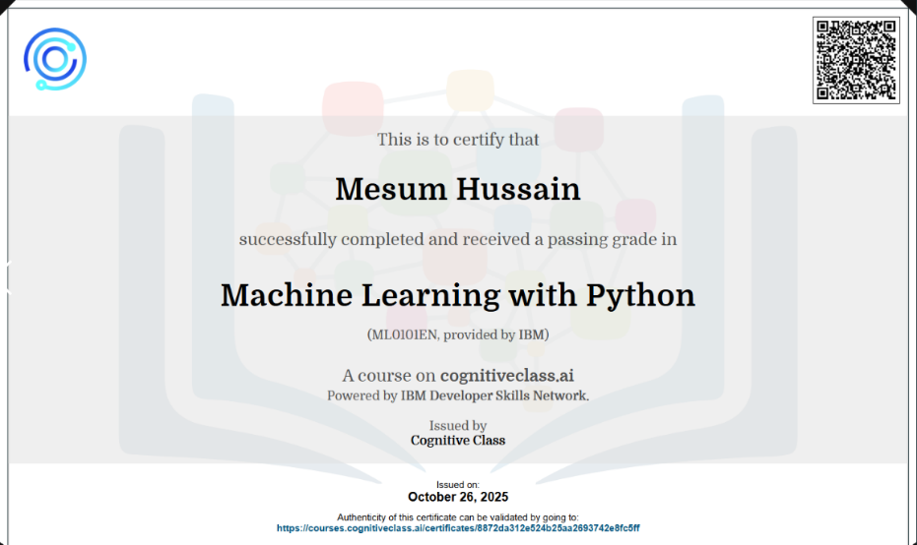

Digital Badge2:
The course titled Machine Learning with R was a useful experience to complete. It reinforced my knowledge of the essential concepts in machine learning and offered concrete skills in applying the algorithms of Decision Tree, K-Nearest Neighbors, and Regression Models in R. With the help of practical tasks, I was taught how to pre-process data, visualization, predictive models, and their evaluation in terms of accuracy, precision, and recall.

The course has helped me to be a better interpreter of model results and realize the significance of hyperparameter tuning and model optimization. It also enhanced my skills in R in data manipulation and data modeling, which is a supplement to my current knowledge in programming. On the whole, the course increased my confidence in the ability to use machine learning methods on real-life data and motivated me to learn more about advanced aspects of AI and predictive analytics. The acquired knowledge will directly find applications in my studies and project assignments.

MOOC Certification:
By studying this MOOC course, I got a concise and real-life perspective on the mechanism of Generative AI and why it has become so strong. I got to hear of the relevance of algorithm execution at a level of high performance, streamlined neural network designs, and the necessity of a grand volume of training information. Another issue mentioned in the course is associated with the development and deployment of Generative AI models, including the handling of bias and safety concerns, as well as the heavy computer demands. I have also found the explanations to be very simple to understand and the practical concepts I was exposed to made me realize more about how models are refined, tested and optimized. Altogether, this course reinforced my principles of the knowledge of Generative AI and made me feel more confident in my ability to learn how the modern AI systems are created and utilized.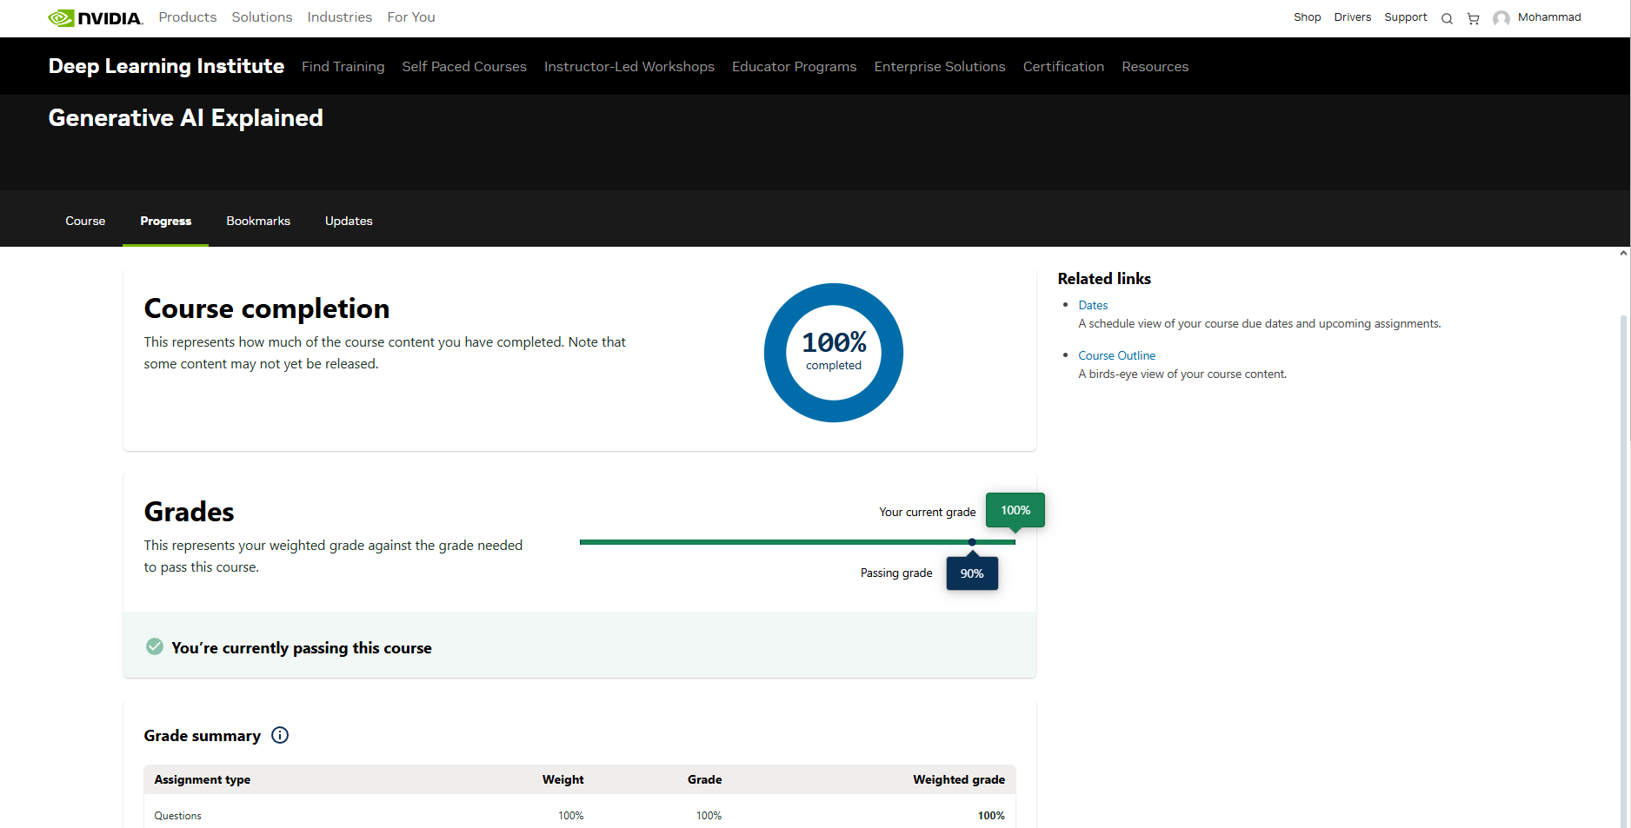
Reflection:
Zhang, Y., Liu, X., & Wang, H. (2025). Machine learning based big data analytics for education in curriculum reforms. Applied Mathematics and Nonlinear Sciences, 10(1), 1–15. https://doi.org/10.2478/amns-2025-0135

