

COVER SHEET
INDIAVIDUAL ASSIGNMENT
SEMESTER FALL 2025

Student Name (s)* | Mohammad Mesum Hussain
Student ID (s)* | 22S22604
Module Code* | COMP 30043
Module Name* | Machine Intelligence Systems
Session* | A
Submitted to Teacher and Department* | Dr. C. Jayakumari
Coursework No.* | Coursework 2
Assignment Title | Individual Assignment
Actual Word Count (Excluding Cover Page, TOC/Index, references and appendices)
(Fields marked with * are mandatory)

TASK 2:
Introduction to machine learning-based big data analytics in education.
Machine learning and the integration of big data analytics has revolutionized the education industry, allowing data-driven curriculum changes, student-centric learning, and intelligent forecasts of student performance. The article on the analysis of machine learning algorithms in the field of education, including in curriculum reform, is the study by Volker et al. (2025) titled Machine Learning Based Big Data Analytics in Education. This reflection is the critical analysis of how two popular machine learners can be implemented in big educational data analytics and an evaluation of the process of learning behavior prediction of students through the mentioned methods and approaches.
- Use of Two popular machine learning algorithms in the analysis of educational Big Data and key technologies.
A popular machine learning algorithm used in big educational data analytics is Decision Tree-based learning, such as the Random Forests. The reason why the Decision Trees are effective lies in the fact that they give interpretable models that are easy to understand and explain the way of making decisions based on student characteristics like attendance, assessment scores and the level of engagement. Zhang et al. (2025) note that decision tree models come in handy when reforming the curriculum since they assist teachers in determining which learning factors have the strongest impact on student success or failure. The most important technology to support this algorithm is distributed data processing frameworks that can be Hadoop and Spark, which allows the processing of big and heterogeneous educational data streams. Decision Tree-based models can be used to scale process both structured and unstructured data to identify patterns used to inform curriculum design, sequence of courses, and assessment approaches. Nevertheless, there is a drawback that a single decision tree is prone to overfitting data, so ensemble methods such as Random Forests are necessary to achieve a higher level of accuracy and generalization.
Support Vector Machines (SVM) is another algorithm that is commonly used. SVMs are useful in classification and regression applications in education, including predicting the level of student performance or detecting the students at risk. It is highlighted in the article that in high-dimensional educational data, SVMs are effective because the features can comprise demographic information, records of learning behavior, and test results (Zhang et al., 2025). Feature engineering and dimensionality reduction are the most important facilitating technology of SVMs and can be facilitated by big data analytics platforms. These technologies enable SVMs to be effective in processing complicated datasets and being highly predictive. SVMs are also effective, but they need the parameters to be tuned carefully, and they might be computationally expensive, and this might constrain their scalability unless they are matched by the right big data infrastructure.
In Contrast, both Decision Tree-based models and SVMs have a high potential of addressing educational data issues like early intervention planning, curriculum optimization, and performance prediction. They are extremely reliant on the incorporation of big data technologies that will guarantee scalability, efficiency, and reliability.
- Critical Reflection on the Analyzing and Predicting Learning Behaviors of the students.
This machine learning based analysis and prediction of the learning behavior of students requires several key steps, which are data collection, preprocessing, model training, evaluation, and interpretation. Zhang et al. (2025) point out that big educational data is a byproduct of different sources including learning management systems, online assessment, classroom activities and administrative data. Although this richness of the data allows performing a thorough analysis of behavior, it also presents the problems of data quality, inconsistency, and privacy.
One of the strengths of machine learning based prediction is that it can reveal some hidden patterns in student behavior that cannot be easily perceived using traditional analysis. As a case example, predictive models may identify initial signs of disengagement and allow initiating academic interventions in time. The article, however, critically observes that predictive accuracy is not enough and interpretability is equally important. To implement a prediction effectively during curriculum reforms, educators must know the reasons why such a prediction is made (Zhang et al., 2025).
The other major concern is discrimination and equality in predictive models. In the case that historical education data is biased by a social or an institutional viewpoint, machine learning algorithms can unwillingly support inequalities. The article presents ethical data processing and ongoing model verification as the key to making fair predictions among different groups of students. Moreover, the learners should be facilitated to make decisions through predictive behavioral methods as opposed to labelling or censoring them, thus the role of human supervision in decision-making cannot be underestimated.
To sum up, although machine learning-based educational big data analytics are effective methods of understanding and predicting student learning behaviors, they must be managed with care, ethical interest, and regard to pedagogical objectives. These methods have the potential to contribute greatly to the curriculum reform and improvement of the education outcomes when utilized in a responsible manner.
TASK 3:
Digital Badge:
By taking the Machine Learning with Python course offered by IBM, I was able to improve my knowledge of the essentials of machine learning and how they can be applied with the help of Python. The course enhanced my knowledge of preprocessing data, training models, and working with real data. It also enhanced my skills of analyzing model performance and appreciating the significance of accuracy, bias and validation. Overall, this certification has made me more assured in the initiation of machine learning techniques into real-world and data-driven applications.
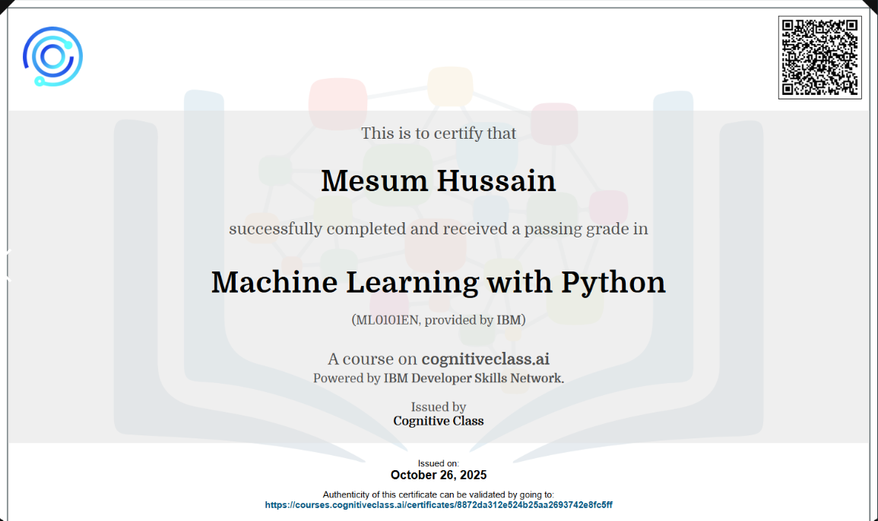
MOOC Certification:
By studying this MOOC course, I got a concise and real-life perspective on the mechanism of Generative AI and why it has become so strong. I got to hear of the relevance of algorithm execution at a level of high performance, streamlined neural network designs, and the necessity of a grand volume of training information. Another issue mentioned in the course is associated with the development and deployment of Generative AI models, including the handling of bias and safety concerns, as well as the heavy computer demands. I have also found the explanations to be very simple to understand and the practical concepts I was exposed to made me realize more about how models are refined, tested and optimized. Altogether, this course reinforced my principles of the knowledge of Generative AI and made me feel more confident in my ability to learn how the modern AI systems are created and utilized.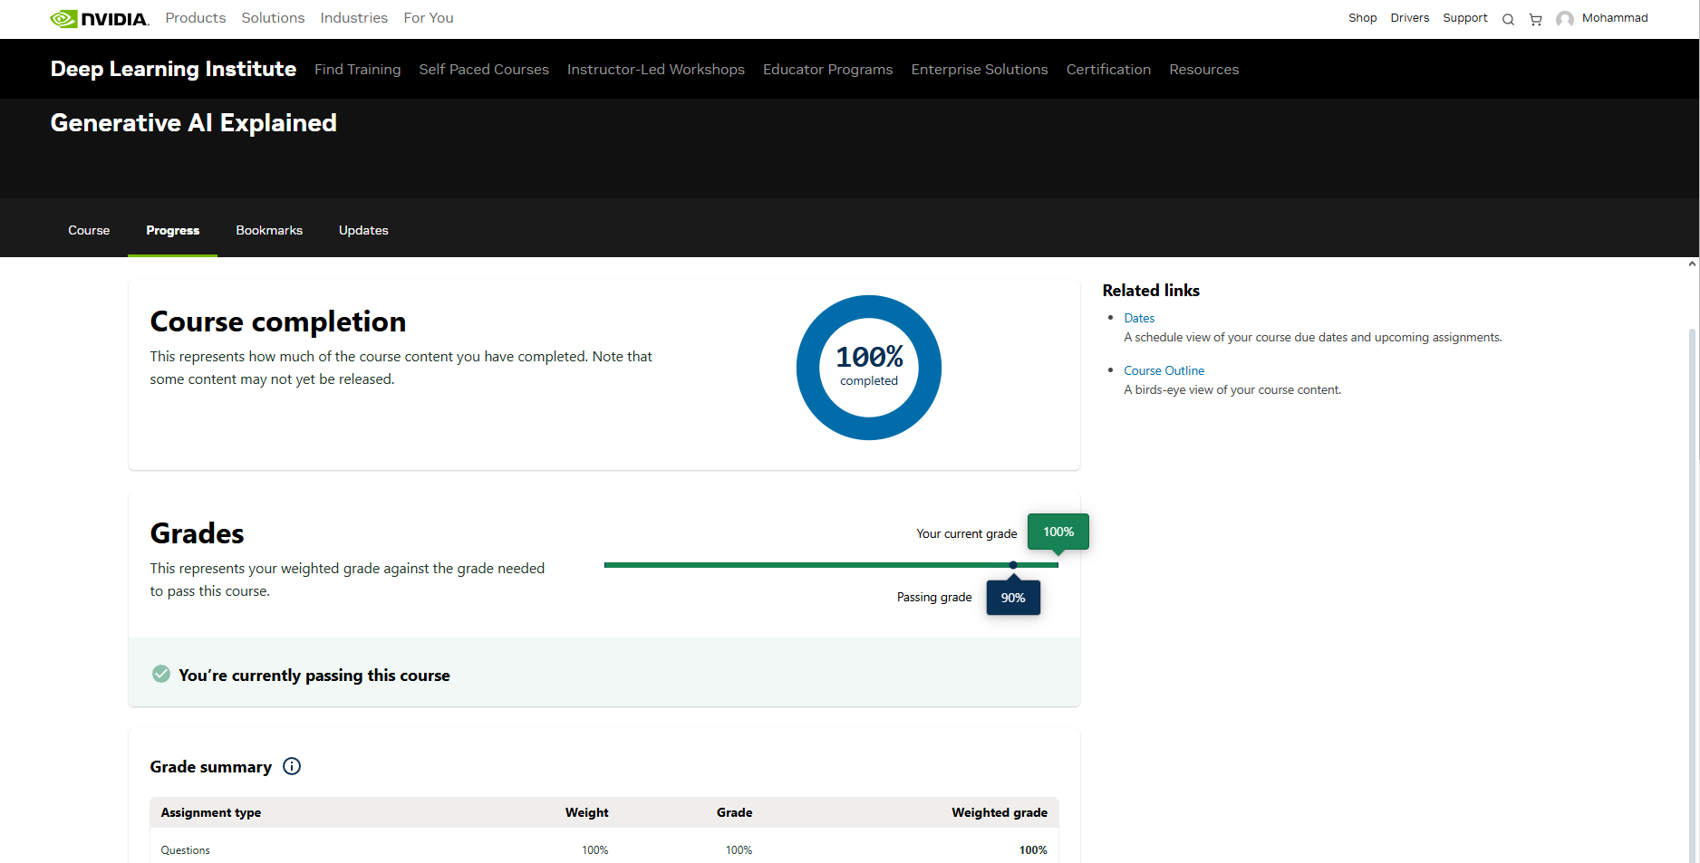
Reflection:
Zhang, Y., Liu, X., & Wang, H. (2025). Machine learning based big data analytics for education in curriculum reforms. Applied Mathematics and Nonlinear Sciences, 10(1), 1–15. https://doi.org/10.2478/amns-2025-0135

