|  |  |  |
| --- | --- | --- |
| **Mobile Programming Laboratory**  git push -u origin main  **Week 4: Layout and Design** |  | |
| Name: | ID: | Section: |
| Date: | Due: Wednesday Midnight | |

**Objective**

* To experiment with layouts such as Container, Align, Row, Column etc.
* To practice UI design

References

* <https://flutter.dev/docs/development/ui/layout>
* <https://flutter.dev/docs/development/ui/widgets/layout>

**Layout**

Single-child layout widgets

Can have only one child. The examples are **Container, Center, Padding** etc.

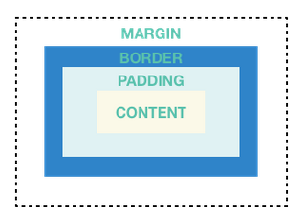

Multi-child layout widgets

Can have many children e.g. **Column, Row, ListView** etc.

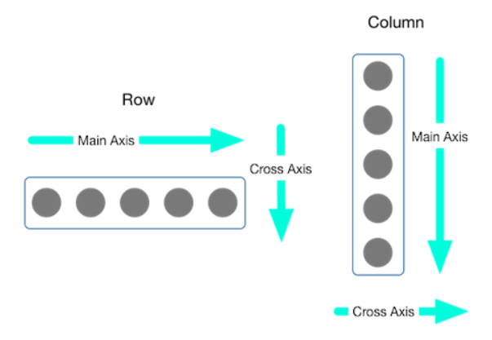

**Container**

 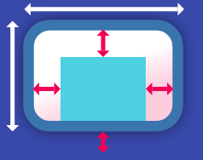

* A very general widget to contain another widget
* Good for providing padding, margins and borders
* Useful for defining background color or image
* Can only have a single child widget. However, we can use a child such as Row, Column, or others to contain multiple widgets.
* Can be sized by width and height, but when it has a child, its size fits its child and also its parent.
* Can align its child
* Can be decorated to have an image and borders using BoxDecoration

**Column**

 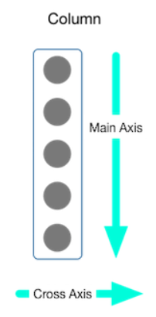

* A container arranges children vertically
* By default, the column’s height is the screen height and the column’s width is the max width of its children
* To fit the column’s height to its children, set mainAxisSize property to MainAxisSize.min
* Cannot scroll (use ListView instead)
* We can use ‘Expanded’ widget to let a column’s child to expand to cover the row’s height
* MainAxisAlignment: center, start, end, spaceAround, spaceBetween, spaceEvenly
* CrossAxisAlignment: center, start, end, stretch

**Row**

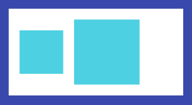 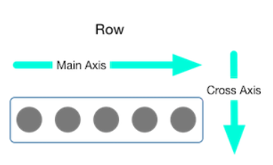

* A container arranges children horizontally
* By default, the row’s width is the screen width and the row’s height is the max height of the children
* To fit the row’s width to its children, set mainAxisSize property to MainAxisSize.min
* Cannot scroll (use ListView instead)
* We can use ‘Expanded’ widget to let a row’s child to expand to cover the row’s width
* MainAxisAlignment: center, start, end, spaceAround, spaceBetween, spaceEvenly
* CrossAxisAlignment: center, start, end, stretch

**Exercise** Design the following UI.

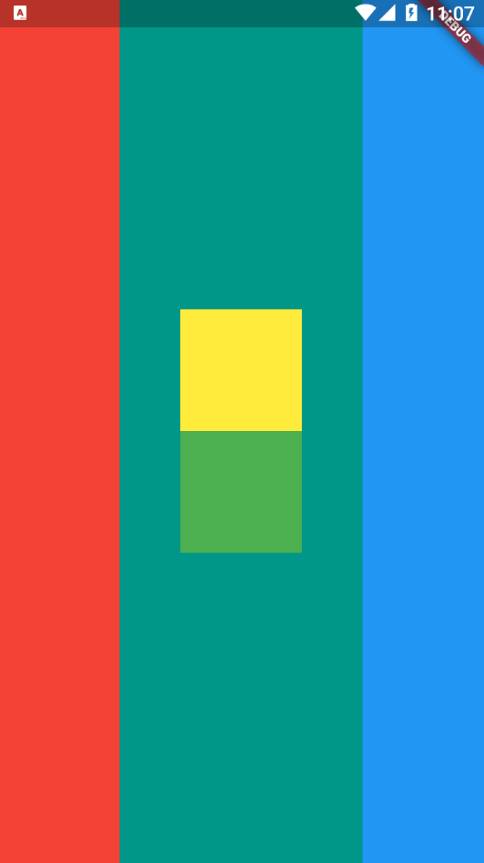 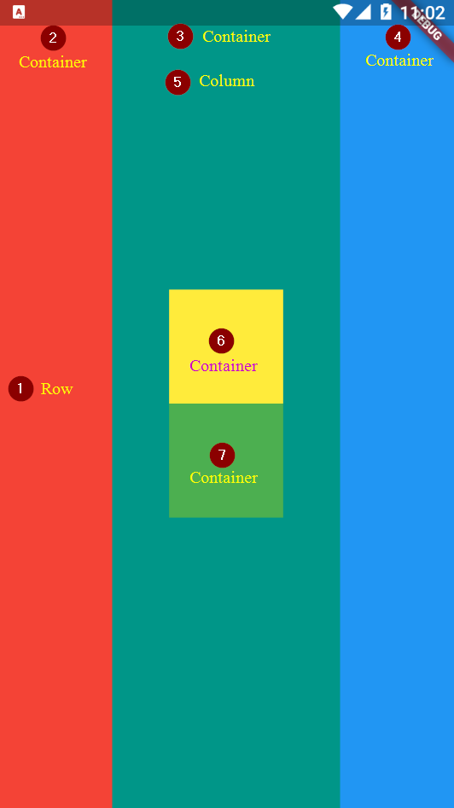

|  |
| --- |
| import 'package:flutter/material.dart';  class ContainerDemo extends StatelessWidget {    @override    Widget build(BuildContext context) {      return Scaffold(        body: Row(          children: [            Container(              color: Colors.red,              width: 100,            ),            Expanded(              child: Container(                color: Colors.teal,                width: 100,                child: Column(                    mainAxisAlignment: MainAxisAlignment.center,                    children: [                      Container(                        width: 100,                        height: 100,                        color: Colors.yellow,                      ),                      Container(                        width: 100,                        height: 100,                        color: Colors.green,                      ),                    ]),              ),            ),            Container(              color: Colors.blue,              width: 100,            ),          ],        ),      );    }  } |

**Exercise** Simple profile app design

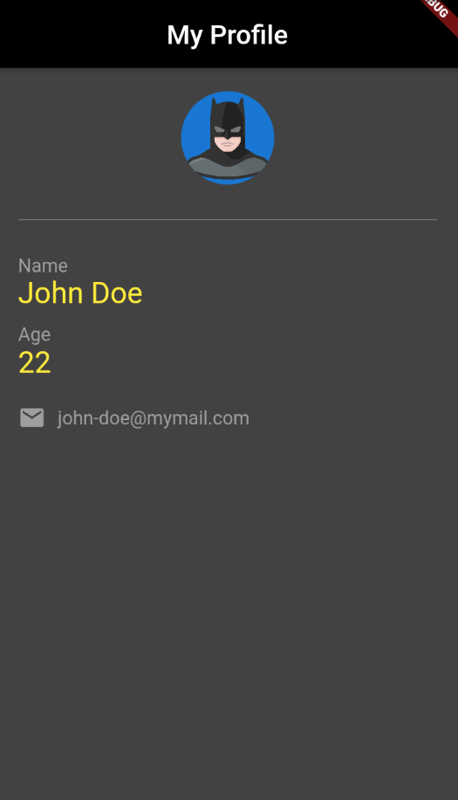 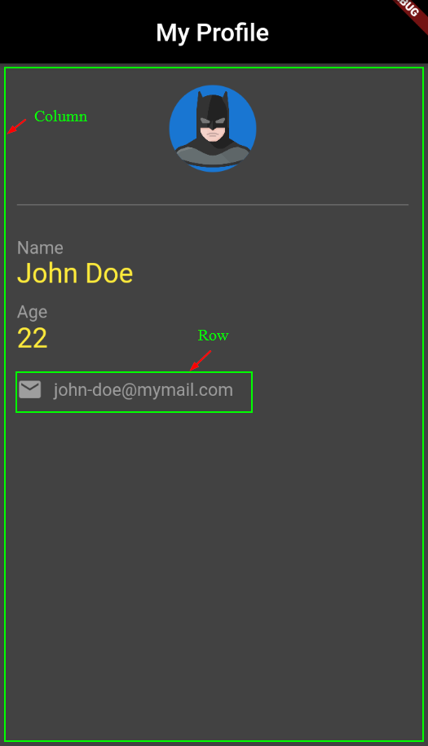

|  |
| --- |
| import 'package:flutter/material.dart';  class Layout2 extends StatelessWidget {    const Layout2({super.key});    @override    Widget build(BuildContext context) {      return Scaffold(        backgroundColor: Colors.grey[800],        appBar: AppBar(          title: const Text(            'My Profile',            // style: TextStyle(color: Colors.white),          ),          centerTitle: true,          backgroundColor: Colors.black,        ),        body: Padding(          padding: const EdgeInsets.all(20.0),          child: Column(            crossAxisAlignment: CrossAxisAlignment.start,            children: [              const Center(                child: CircleAvatar(                  backgroundImage: NetworkImage(                      'https://icons.iconarchive.com/icons/diversity-avatars/avatars/512/batman-icon.png'),                  radius: 40,                ),              ),              const Divider(                color: Colors.grey,                height: 60,              ),              const Text(                'Name',                style: TextStyle(color: Colors.grey),              ),              const Text(                'John Doe',                style: TextStyle(color: Colors.yellow, fontSize: 22),              ),              const SizedBox(height: 10),              const Text(                'Age',                style: TextStyle(color: Colors.grey),              ),              const Text(                '22',                style: TextStyle(color: Colors.yellow, fontSize: 22),              ),              const SizedBox(height: 20),              Row(                children: const [                  Icon(                    Icons.mail,                    color: Colors.grey,                  ),                  SizedBox(width: 10),                  Text(                    'john-doe@mymail.com',                    style: TextStyle(color: Colors.grey),                  ),                ],              ),            ],          ),        ),      );    }  } |

**Assignment 1** Design an app interface below

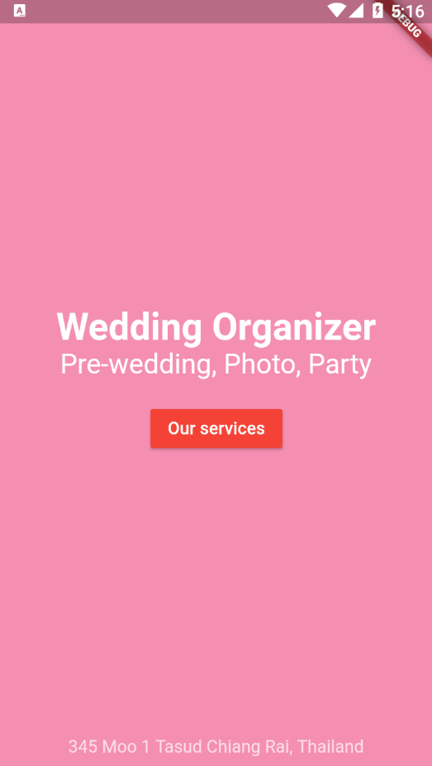

Your code

|  |
| --- |
|  |

**Assignment 2** Create a simple profile app below

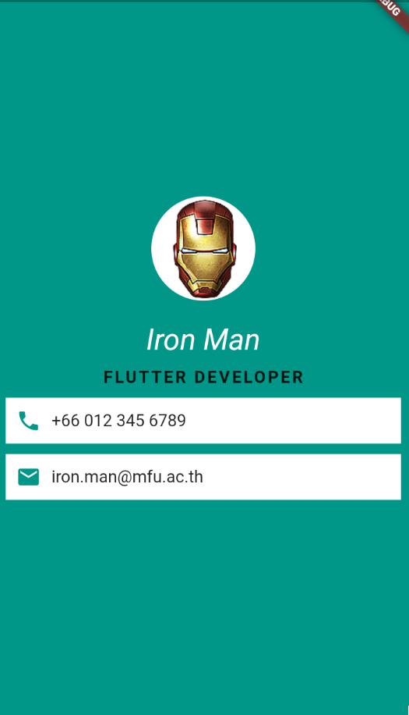

Your code

|  |
| --- |
|  |