|  |
| --- |
| Getting started |
| logo5etExplore |
| **Ludovic COTTRET**  **Etienne CAMENEN**  **Florence VINSON**  **Maxime CHAZALVIEL**  **Clément FRAINAY**  **Benjamin MERLET**  **Yoann GLOAGUEN**  **Nathalie POUPIN**  Fabien JOURDAN  2018 |

Metabolomics data analysis in the context of metabolic networks

**2017**

logo5

contact-metexplore@inra.fr

www.metexplore.fr

www.facebook.com/metexplore

@MetExplore

# A use case of MetExplore

**It is better to use Chrome web browser.**

MetExplore (Cottret et al., 2010) is a web server dedicated to the analysis of genome scale metabolic networks. A special care was taken to allow analyzing metabolomics data in the context of this network.

►Go on the MetExplore homepage and click on the "Click here" button

**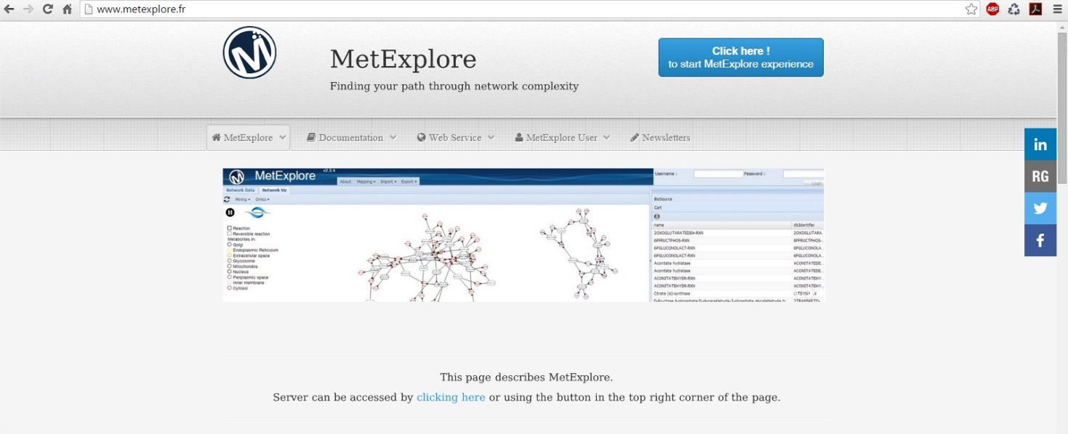**

Figure 19: MetExplore homepage

MetExplore is providing access to BioCyc networks, KEGG networks and networks imported from SBML files (Hucka et al., 2003). All these files are present in the "public BioSource" repository. Note that you can also register and upload your own SBML files. You will then be the only one to be able to access these networks and will have the opportunity to share them with others.

►In the list of biosources click on: "Saccharomyces cerevisiae"

►Right click on the line of KEGG version of the network then click on "select Biosource" (you can also double click on it

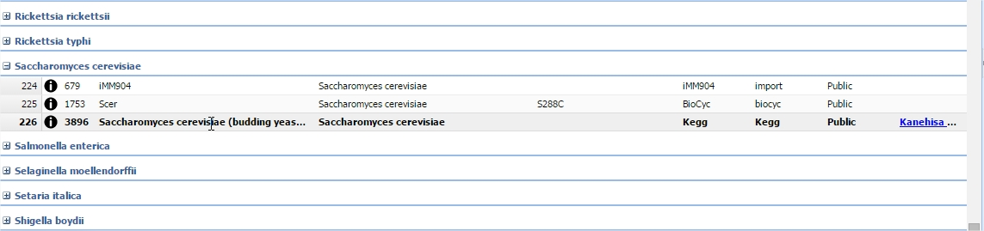

Figure 20: BioSource selection interface in MetExplore

The content of the metabolic network will be displayed in a tabular format.

Information on Compartments, Pathways, Reactions, Metabolites, Enzymes, Proteins and Genes are available.

**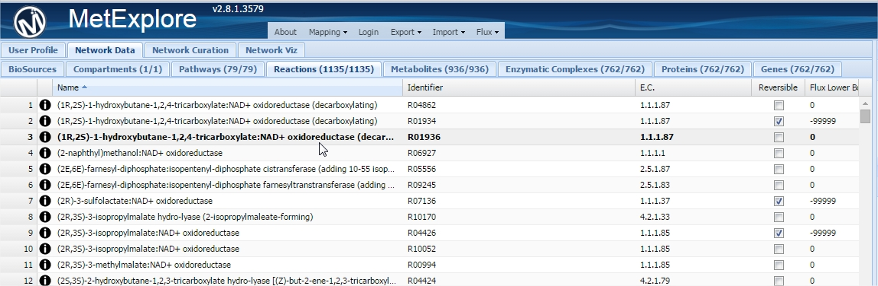**

Figure 21: MetExplore representation of metabolic network content.

We are going to perform this mapping on yeast and using the metabolite identifiers found in the KEGG database

► Select "Mapping" in the menu at the top of the page.

► Copy (ctrl+C on the excel table) and paste (click on the first line of the MetExplore table and Ctrl+V)

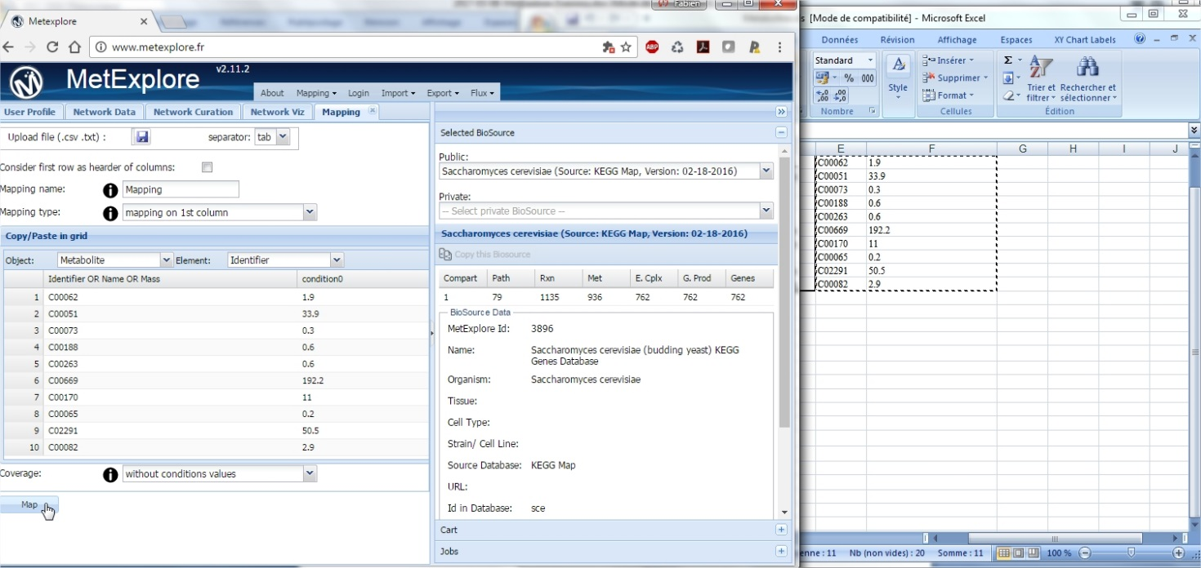

Figure 22: import metabolites in MetExplore

► Click on the "Map" button

Coming back to the tabular view, you will see which metabolites were mapped. (in the metabolite panel)

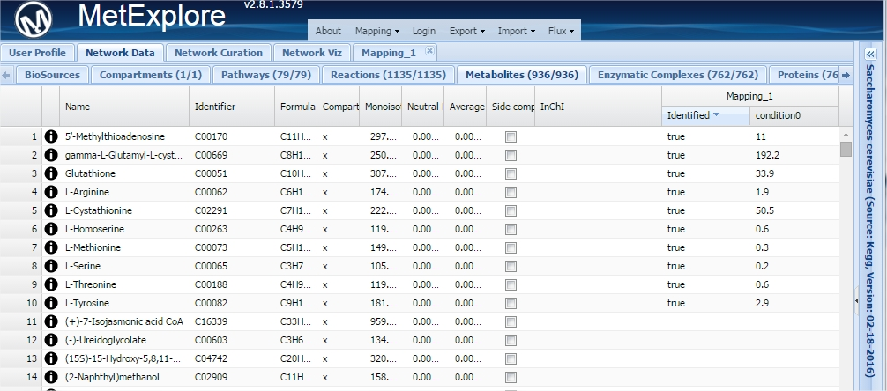

Figure 23: MetExplore output of a mapping.

By selecting lines in a table it is possible (when right clicking on it) to filter all the other tables based on this selection.

►Go to the pathways panel and select the 4 first pathways (they are ordered according to the pathway enrichment result)

►Right click and Click on "New Filter on selection"

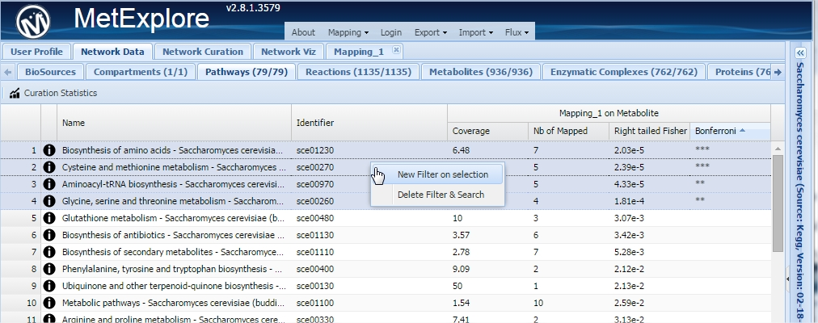

Figure 24: MetExplore filtering on pathways

Now, all the other panels will contain elements (reactions, metabolites...) corresponding to this pathway.

►Go to the reaction panel. Right click on the table and click on "Copy all to cart"

Now all selected reactions are in the car and can be used for visualization

►Select the "Network Viz" panel and cilck on PrtScr capture_1089 button to create the view.

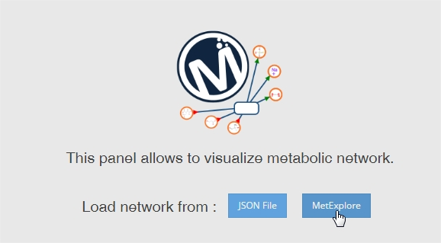

Figure 25: Network visualisation in MetExplore

►Click on the "Omics" menu and then on "Import mapping"

Metabolites mapped our now colored in blue.

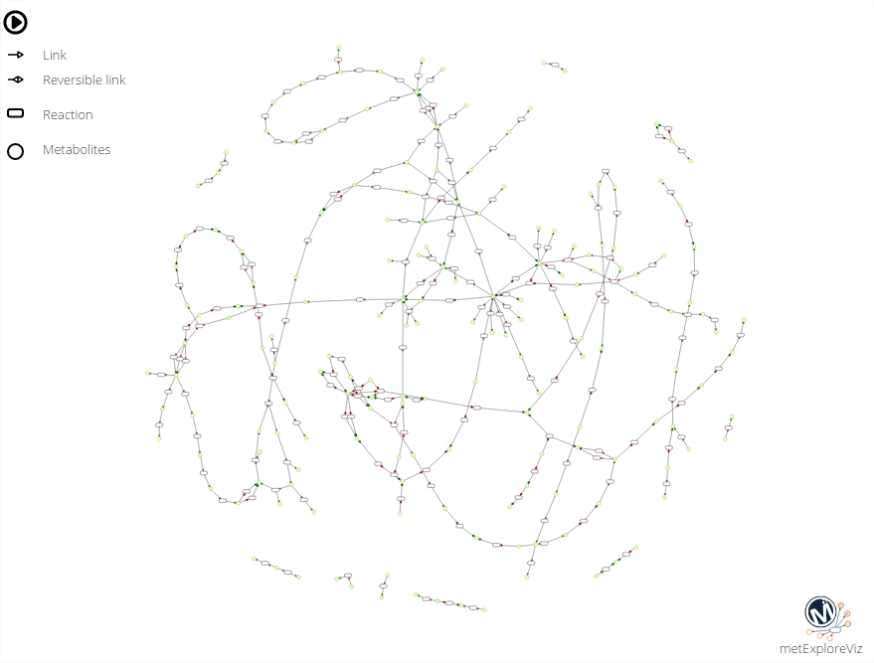

Figure 26: Network based on enriched pathways in MetExplore

►On the left of the panel in the "Omics" box select "Mapping\_1". It will highlight in red metabolites mapped.

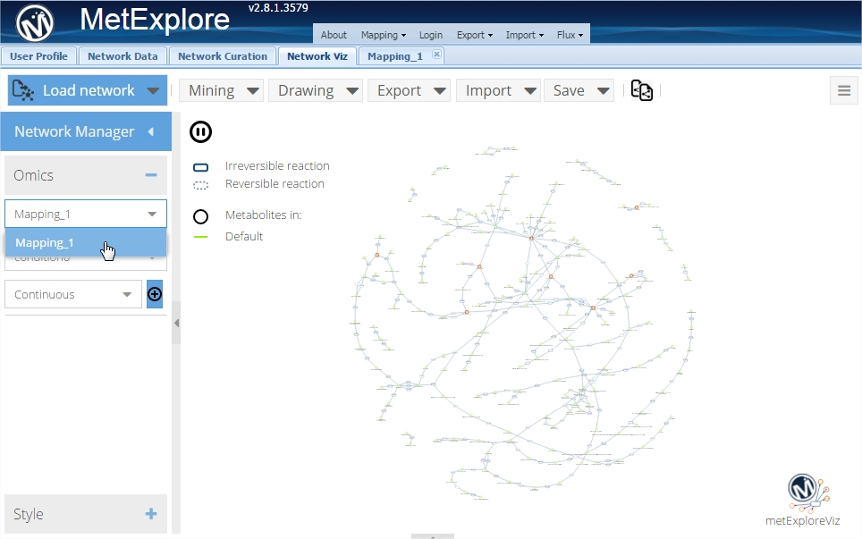

►Click on "Mining->Highlight subnetwork" to emphasize the union of all lightest paths between each pair on identified metabolites

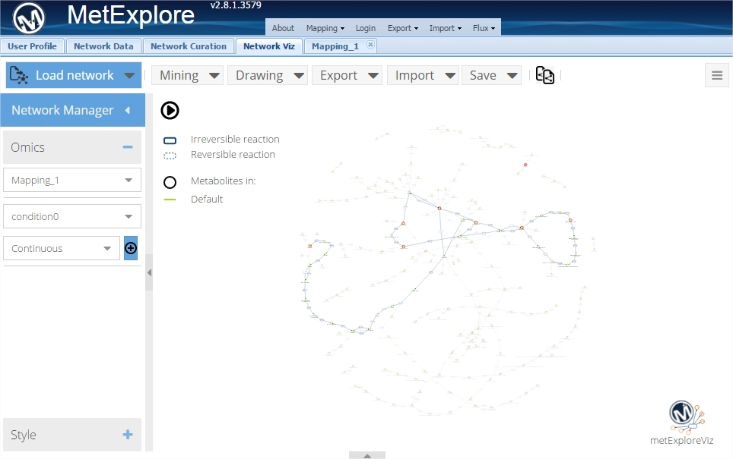

Figure 27: sub-network connecting identified metabolites

►Click on "Mining->Extract subnetwork" to keep only the subnetwork.

►Click on the "+" button to perform a continuous mapping of data on nodes.

Note that you can change the colors used.

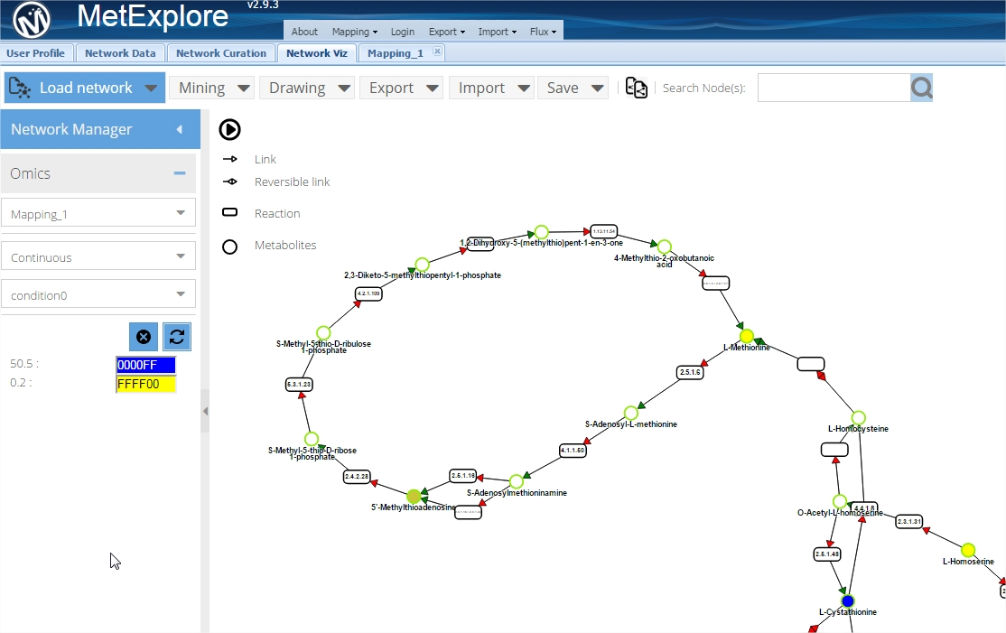

This computation is performed on a selection of reactions. It is also possible to do it on the entire network. It will allow connecting other metabolites.

In MetExplore, mapping can be saved in the database (function accessible through web services). Then it is possible to access the mapping through a single URL (here it is the mapping of Metabolights dataset MTBLS174 on Recon2 human metabolic network):

<http://metexplore.toulouse.inra.fr/metexplore2/?idMapping=38285>