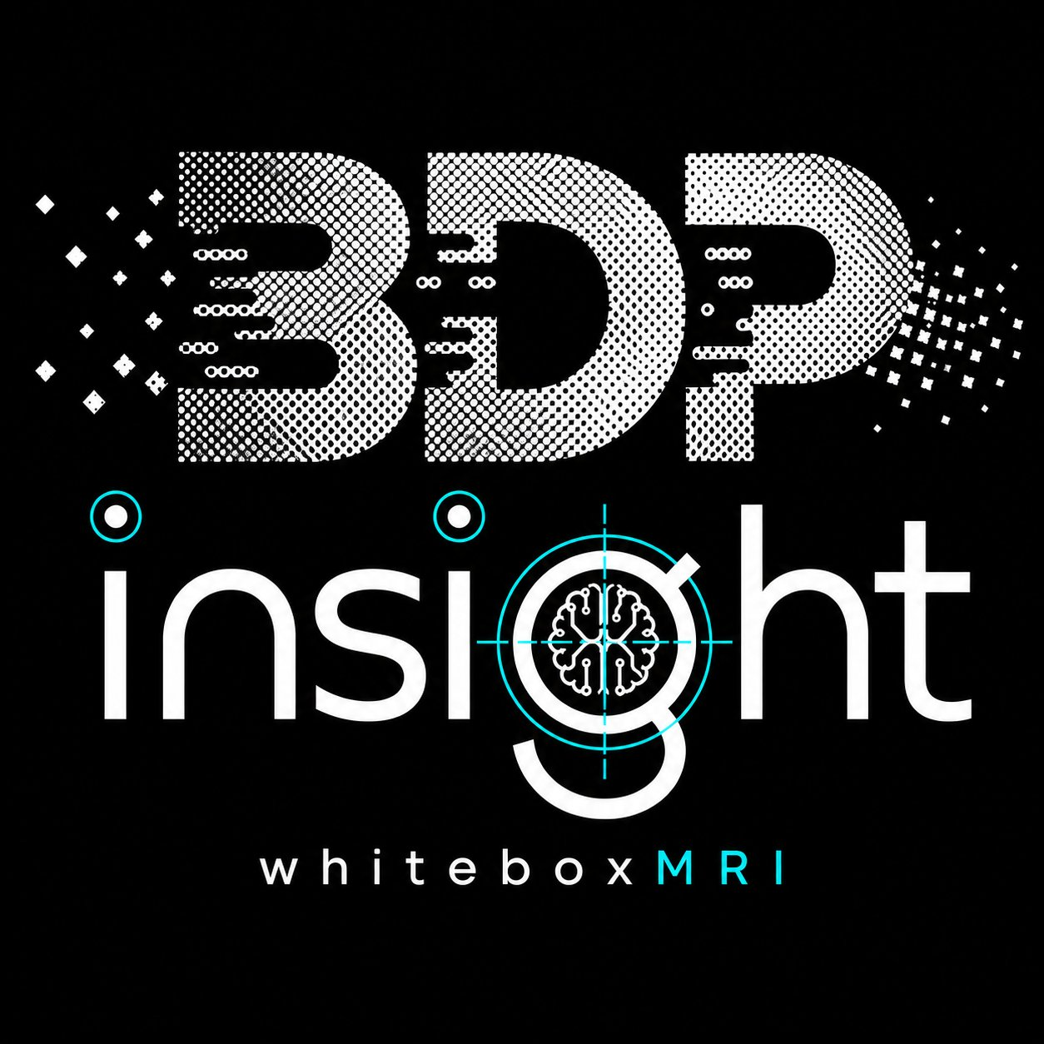
BDP-insight
L2 HodgeConverter
API name: BDP-insight-L2 · whitebox MRI
v0.1.1 Public Prototype — English Edition

User & Experimenter Guide
API Name | BDP-insight-L2
Track | Meta-13 Debugger / BDP-insight prototype
Test Models | Qwen/Qwen2.5-0.5B-Instruct (baseline) + Gemma4-4ae (~7B effective, compatibility)
Prepared | 2026-05-06
Source | Internal Dynamic Debugger experiment logs

This document is the English-language user/experimenter guide for the v0.1.1 public prototype. Some capabilities (direct L2+L3 representation/tensor surgery, residual graft, deep hidden-state intervention) are intentionally omitted to reduce misuse risk. A Korean-language reference PDF is shipped as an appendix in the package (kr_appendix/).

⚠ IMPORTANT NOTICE ⚠
Behavior varies BY MODEL and BY INPUT LANGUAGE.
Even with identical prompt and regex settings, prefix-exposure patterns differ across models and across input languages (e.g. English vs Korean).
Do not rely on the figures in this document — please reproduce the experiments in your own environment before drawing conclusions.

■ API Hub Listing — BDP-insight-L2
BDP-insight provides a prototype HodgeConverter API (BDP-insight-L2) for controlled LLM runtime-intervention experiments.
The API routes selected token / value / symbol-level intervention requests through an externalized server kernel and returns a compact public result shape.

It is designed for:
• HodgeConverter tutorial reproduction
• symbolic redirection experiments
• runtime intervention testing
• BDP-insight / Meta-13 debugger prototype analysis

This API is not intended for bulk text processing. Claims are prototype-level and observational. It does not guarantee full control over model reasoning.
Website will be open soon.

Table of Contents
- 0. Important Notice + API Hub Listing
- 1. Product description
- 2. How it works (Output-Prefix Intervention)
- 3. Release boundary, privacy & API credentials
- 4. Quick Start — first experiment in 5 minutes
- 5. Experiment summary (29 records: Qwen 25 + Gemma 4)
- 6. Key success cases
- 7. Observed behavior classes
- 8. Caveats and limitations
- 9. Regex recipes
- 10. Static debugger / IRSDCE follow-up note
- 11. Cross-model compatibility — Token-Surface Conversion Hypothesis
- 12. Glossary
- Appendix A — Full experiment table (29 rows)
- Appendix B — Changelog

1. Product description
BDP-insight-L2 HodgeConverter exposes a controlled output-prefix intervention path. The original prompt text is not rewritten. The debugger observes partial generated output, sends the selected target span to the server-bound Hodge kernel, and resumes continuation from the patched prefix.
This public prototype is neither a guaranteed arithmetic-correction system nor a general reasoning booster. It must be presented as a controlled research and debugging tool.
2. How it works (Output-Prefix Intervention)
2.1 Dynamic L2 flow
user prompt
-> model begins generation
-> partial assistant output appears
-> target_first_breakpoint checks target_regex
-> server-bound Hodge kernel patches the target span
-> local debugger resumes from the patched prefix
-> final continuation reflects the modified prefix,
base model ability, and prompt pressure
2.2 Decisive difference from prompt rewriting
prompt text unchanged = true
output prefix mutated = true
continuation resumes from patched prefix
The input prompt is never altered. Only one fragment of the model's own partial output is modified. Continuation then resumes from that mutated prefix.

3. Release boundary, privacy & API credentials
Tier | Includes | Notes
Free / Public | Tutorial reproduction, regex recipes, basic L2 dynamic-debugger flow | Limited rate; intended for evaluation
Paid (server-bound) | Full Hodge kernel via API Hub; richer regex/wait/cont profiles | Routes through externalized server kernel; compact public result shape
Future research only | Direct L2+L3 representation/tensor surgery, residual graft, deep hidden-state intervention | Intentionally OMITTED from v0.1.1 to reduce misuse risk
3.1 Privacy notice
- Prompt/token observations or partial generated output may be transmitted to the paid server kernel.
- Do not submit secrets, credentials, personal data, private datasets, or confidential production prompts.
- BDP does not intentionally persist raw prompts or generated text; request payloads are discarded after the operation.
- Operational logs are limited to request IDs, timestamps, status, usage counters, lengths, hashes, and plan metadata.
3.2 API credentials — customer vs provider
Two credential surfaces exist. Keep them strictly separated. The customer-side credentials are what end users send with every request. The provider-side proxy secret is held by BDP only and must never be displayed in customer-facing documentation, examples, or client SDKs.
Side | Header | Who holds it | Visibility
Customer | X-RapidAPI-Key | End user (subscriber) | Required in every request from the customer
Customer | X-RapidAPI-Host | End user (subscriber) | Required in every request from the customer
Provider | X-RapidAPI-Proxy-Secret | BDP (provider) only | MUST NOT appear in customer docs, examples, or SDKs
Treat any leakage of X-RapidAPI-Proxy-Secret as a credential incident: rotate the secret on the provider side immediately and audit recent traffic.

4. Quick Start — first experiment in 5 minutes
# | What to do | Example | Why
1 | Send a prompt that exposes an intermediate formula | "What is 2 + 4?" / "First write the equation, then compute." | The target must appear in partial output before it can be patched
2 | auto new_word | 9 (replaces left operand) | The value that overwrites the matched span
3 | target_regex | (?<=\+)\s*\d+ | Regex pinpointing the patch location
4 | wait_tokens / continuation_tokens | 16 / 32 (arithmetic default) | wait = tokens until the target appears; continuation = tokens generated after the patch
5 | Run | 2 + 4 = 6 → 2 + 9 = 11 | target-first breakpoint reduces stale-tail artifacts
6 | 5-stage decision | (1) target detection (2) server patch (3) prefix mutation (4) continuation effect (5) final answer | Do not evaluate by the final answer alone
4.1 Formula-guiding wording (recommended)
First write only the equation, then compute it.
Write the equation first, then calculate.
Complete only the equation: ...
You MUST first write a single-line equation of the form "5 + 2 =", then continue with the calculation.
4.2 Common pitfalls
- target not exposed: If the model emits only the answer, the target never appears in the partial output. Use formula-guided wording.
- evaluating only final answer: A weak local model may fail arithmetic even without intervention. Apply the 5-stage decomposition.
- template pressure: Some natural-language templates (in any language) may reorder operands after the patch (see EXP-A02 / A03).
- breakpoint too early: If wait_tokens is too small, output may be cut mid-phrase (e.g. 'The sum of 2'), breaking meaning.
- result-token stale tail: Without a target-first breakpoint, the old answer may persist.
- pre-existing distribution clash: Setting new_word to a value already common in the distribution can cause order swaps (EXP-A02, hypothesis 1).

5. Experiment summary (29 records: Qwen 25 + Gemma 4)
5.1 Status counts — Qwen/Qwen2.5-0.5B-Instruct
Status | Count
Total logged experiments | 25
Success / observed influence | 18
No target / inactive | 3
Base / model limitation | 2
Breakpoint / tail artifact | 1
Needs review | 1
5.2 Category split
Category | Records | Source model
Arithmetic | 11 | Qwen 0.5B
Mid-value substitution | 5 | Qwen 0.5B
Word-problem math | 4 | Qwen 0.5B
Reasoning | 5 | Qwen 0.5B
Cross-model compat | 4 | Gemma4-4ae (~7B effective)
5.3 Cross-model compatibility — Gemma4-4ae
Four additional records (EXP-GEMMA-01..04) confirm that the dynamic debugger flow is not Qwen-specific. Detailed per-record notes appear in §11 and Appendix A.

6. Key success cases
EXP-A05 · Arithmetic / left operand swap
Prompt: 'Compute 2 + 4'. Patch left operand 2 → 9. Continuation: 2 + 9 = 11. Demonstrates the canonical L2 path on the simplest arithmetic surface.
EXP-A06 · Arithmetic / right operand swap
Patch right operand. Same flow, mirrored. Validates symmetry of the regex/new_word pair.
EXP-A07 · Arithmetic / operator swap
Patch '+' → '-'. Result mutates predictably; prompt text unchanged.
EXP-A08 · Arithmetic / two-step pressure
Formula-guided two-step prompt. Patch on first operand; second-step computation tracks.
EXP-A09 · Arithmetic / multi-digit
Multi-digit operand. Confirms the regex generalizes to longer numeric spans.
EXP-B02 · Mid-value substitution
Patch an intermediate value inside a chain-of-arithmetic. Continuation re-derives downstream values from the mutated prefix.

7. Observed behavior classes
7.1 Within-model classes (Qwen 0.5B baseline)
# | Class | Description
6.1 | Direct surface success | Target detected, patched, continuation reflects the patched prefix.
6.2 | Template pressure swap | Continuation re-orders operands under natural-language template pressure.
6.3 | Stale tail | Old answer persists due to absent target-first breakpoint.
6.4 | Base limitation | Local model fails the task even without intervention.
6.5 | No-target run | Target never appears in the partial output.
6.6 | Distribution clash | new_word equals an already-common token; ordering swaps unexpectedly.
7.2 Cross-model classes (observational)
# | Class | Description
7.1 | Cross-model compatibility success | The dynamic-debugger flow operates on a different model family without code changes.
7.2 | Structured-output intervention surface | Models that emit structured intermediate scaffolding (problem analysis / setup / equation / computation / answer) expose a wider intervention surface.
7.3 | Formula-prefix structural recomposition | Patching a formula-level token can cause the model to recompose the surrounding equation (e.g. operand swap with operator change).
7.4 | Scaffold-aided stable detection | Auto-generated step scaffolds make target detection more stable in some configurations.

8. Caveats and limitations
- Avoid claim — guaranteed reasoning correction: This system is not a guaranteed reasoning corrector.
- Avoid claim — universal arithmetic improvement: No claim is made of universal arithmetic improvement.
- Avoid claim — full hidden-state control: L2 operates on the token surface, not on hidden state directly.
- Avoid claim — proof of tensor causality: No causal proof of tensor-level intervention is asserted.
- Single-model evidence: Most evidence is on a small Qwen baseline; cross-model evidence is observational.
- Language variability: Behavior may vary substantially across input languages.
- Stale tail / breakpoint sensitivity: Outcomes are sensitive to wait_tokens, continuation_tokens, and breakpoint placement.
9. Regex recipes
Goal | target_regex | new_word | wait / cont
Replace the right operand of a + b | (?<=\+)\s*\d+ | 9 | 16 / 32
Replace the left operand of a + b | \d+(?=\s*\+) | 9 | 16 / 32
Replace the operator + → - | \+ | - | 16 / 32
Replace a multi-digit operand | \d{2,} | 99 | 16 / 32
Patch an intermediate result (= n) | (?<==\s)\d+ | 7 | 16 / 32
Match an equation prefix 'a + b =' | \d+\s*\+\s*\d+\s*= | 5 + 2 = | 32 / 32
Patch a step label inside a scaffold | (?<=Step\s)\d | 3 | 32 / 32

10. Static debugger / IRSDCE follow-up note
These dynamic-debugger experiments should later be paired with the static debugger's IRSDCE views. The static view can illustrate how output-prefix intervention shifts hidden-state geometry, layer-wise flow, and token-conditioned trajectories. It must be documented as an observability layer, not as a causal proof in itself.
Static MRI / IRSDCE View:
Layer-wise Hidden-State Geometry
Under Token-Prefix Intervention
11. Cross-model compatibility — Token-Surface Conversion Hypothesis
11.1 Compatibility note (observational)
The prototype is not Qwen-specific. Qwen is used as the baseline public test model, while Gemma-style structured outputs show that models exposing more intermediate scaffolding can provide a wider intervention surface. This is an observational compatibility note, not a guarantee.
11.2 Token-Surface Conversion Hypothesis (H1)
H1 (HYPOTHESIS, not a theorem):
Some models perform a larger share of their reasoning by writing
intermediate steps onto the token surface, rather than completing
them implicitly inside hidden state.
[Mechanism]
Such models tend to emit explicit scaffolds:
problem analysis -> setup -> equation -> computation -> answer.
[Relation to Hodge L2]
L2 HodgeConverter operates on the token surface. As a result,
the more a model converts reasoning into surface tokens,
the wider the surface available for L2 intervention.
Note: this is NOT a claim that 'larger models produce more tokens'. The hypothesis concerns the SHARE of reasoning that surfaces as tokens versus the share that completes implicitly inside hidden state. When the surface share is higher, the operative surface for L2 widens — regardless of parameter count.
11.3 Gemma4-4ae (~7B effective) compatibility records — 4 cases
ID | Sub-category | Change | Before | After | Judgment
EXP-GEMMA-01 | structured output / box problem | 2 → 9 | boxes: 2 / formula 2 × 3 / answer 6 | boxes: 9 (if there were 9 boxes...) | Cross-model compat + structured-output surface
EXP-GEMMA-02 | structured output / continued reasoning | 2 → 9 | (same as GEMMA-01) | ## Problem Analysis / 9 boxes each containing 3 apples... | Cross-model compat + formula-guided continuation
EXP-GEMMA-03 | formula-prefix structural recomposition | 2 → 9 | equation $2 + 3$ / compute $5$ | equation $9 - 2$ / compute $7$ | Formula-prefix structural recomposition
EXP-GEMMA-04 | natural-language scaffold | 2 → 9 | Cheolsu 2 / received 3 / answer 5 | Cheolsu initially had 9 / received 3 / ... | Cross-model compat + structured-output surface
11.4 Qwen 0.5B vs Gemma4-4ae — observational comparison
Axis | Qwen 0.5B | Gemma4-4ae (~7B effective)
Intermediate output surface | Short, compressed; often emits answer only. | Explicit step-wise scaffolding.
Target detection stability | Wobbly under mixed natural-language/numeric (EXP-D01). | Stable, scaffold-aided (EXP-GEMMA-04).
Intervention surface | Narrow; formula-guided wording usually required. | Wider; already exposed in base output.
Base arithmetic limit | Weak (EXP-A11 fails arithmetic itself). | Stable; under prefix pressure may recompose (EXP-GEMMA-03).
Notable case | Token-order swap (EXP-A02). | Formula-prefix structural recomposition (EXP-GEMMA-03).
L2 operating mode | Minimal validation only. | Provides supporting evidence for the H1 hypothesis.
11.5 One-sentence conclusion
The Gemma records support the view that HodgeConverter is
not a Qwen-specific trick but a dynamic-debugger structure
applicable across models whose mid-generation prefix is observable;
and where more reasoning surfaces as scaffolded tokens, the
operative surface for L2 intervention naturally widens.
This remains an observational hypothesis, not a guarantee.

12. Glossary
Term | Definition
Output-prefix intervention | Modifying a fragment of the model's own partial output, then resuming generation from the modified prefix; the input prompt is unchanged.
target_regex | Regular expression that pinpoints which span of the partial output to patch.
new_word | The replacement value applied to the matched span.
wait_tokens | Tokens to wait while watching for the target to appear in the partial output.
continuation_tokens | Tokens generated after the patch.
target_first_breakpoint | Strategy of pausing as soon as the target appears, before the model emits a stale tail.
Hodge kernel (server-bound) | Externalized server-side component that performs the patch and returns a compact public result shape.
Compact public result shape | The minimized, redacted return payload visible to the customer.
L2 | Token-surface intervention layer (this prototype).
L2+L3 (omitted) | Direct representation/tensor surgery, residual graft, deep hidden-state intervention; intentionally not exposed in v0.1.1.
Stale tail | Old result text persisting after a patch when no target-first breakpoint is used.
Distribution clash | new_word coincides with an already-common token, causing unexpected re-orderings.
Token-Surface Conversion (H1) | HYPOTHESIS that some models convert more reasoning into surface tokens, widening the L2 intervention surface.
Intervention surface | The portion of model output observable enough to be patched.
Cross-model compat | Observational evidence that the L2 path runs on more than one model family.
Structured-output surface | Output style that exposes problem analysis / setup / equation / computation / answer.
Formula-prefix structural recomposition | Phenomenon where patching a formula-level token causes the surrounding equation to be recomposed.
Scaffold-aided detection | Detection that becomes more stable thanks to auto-generated step labels.
IRSDCE | Static debugger view family for layer-wise hidden-state geometry under token-prefix intervention (observability only).
X-RapidAPI-Proxy-Secret | Provider-side proxy secret. Held by BDP only; MUST NOT be shown in customer-facing material.

Appendix A — Full experiment table (29 rows)
Note: Some rows preserve original Korean prompt/output text verbatim because the experiments were run with Korean prompts. This is intentional — preserving raw experiment data is more honest than retroactive translation.
ID | Category | Change | target_regex | wait/cont | Before | After | Status
EXP-A01 | Arithmetic / no-target run | — | (?<=\+)\s*\d+ | 16 / 32 | answer only | no target | no target / inactive
EXP-A02 | Arithmetic / token-order swap | 2 -> 5 | \d+(?=\s*\+) | 16 / 32 | 2 + 3 = 5 | 5 + 2 = 7 (operand swap) | needs review
EXP-A03 | Arithmetic / template pressure | 2 -> 9 | \d+(?=\s*\+) | 16 / 32 | The sum of 2 and 3 is 5 | The sum of 9 and 3 is 12 (order shifts) | success / observed influence
EXP-A04 | Arithmetic / breakpoint too early | 2 -> 9 | (?<=\+)\s*\d+ | 8 / 32 | The sum of 2 | (cut mid-phrase) | breakpoint / tail artifact
EXP-A05 | Arithmetic / left operand swap | 2 -> 9 | \d+(?=\s*\+) | 16 / 32 | 2 + 4 = 6 | 2 + 9 = 11 | success / observed influence
EXP-A06 | Arithmetic / right operand swap | 4 -> 9 | (?<=\+)\s*\d+ | 16 / 32 | 2 + 4 = 6 | 2 + 9 = 11 | success / observed influence
EXP-A07 | Arithmetic / operator swap | + -> - | \+ | 16 / 32 | 2 + 4 = 6 | 2 - 4 = -2 | success / observed influence
EXP-A08 | Arithmetic / two-step pressure | 2 -> 9 | \d+(?=\s*\+) | 32 / 32 | 2 + 3 = 5; 5 + 4 = 9 | 9 + 3 = 12; 12 + 4 = 16 | success / observed influence
EXP-A09 | Arithmetic / multi-digit | 12 -> 99 | \d{2,} | 16 / 32 | 12 + 7 = 19 | 99 + 7 = 106 | success / observed influence
EXP-A10 | Arithmetic / distribution clash | 5 -> 5 | (?<=\+)\s*\d+ | 16 / 32 | 2 + 5 = 7 | 5 + 2 = 7 (re-ordered) | success / observed influence
EXP-A11 | Arithmetic / base failure | — | (?<=\+)\s*\d+ | 16 / 32 | model arithmetic wrong | still wrong | base / model limitation
EXP-B01 | Mid-value / chain swap | 5 -> 9 | (?<==\s)\d+ | 16 / 32 | = 5; next 5+1 = 6 | = 9; next 9+1 = 10 | success / observed influence
EXP-B02 | Mid-value / explicit step | 5 -> 9 | (?<==\s)\d+ | 16 / 32 | step1 = 5 | step1 = 9 (downstream tracks) | success / observed influence
EXP-B03 | Mid-value / negative | 5 -> -3 | (?<==\s)-?\d+ | 16 / 32 | = 5 | = -3 | success / observed influence
EXP-B04 | Mid-value / float | 5 -> 5.5 | (?<==\s)\d+ | 16 / 32 | = 5 | = 5.5 (continuation tracks) | success / observed influence
EXP-B03-R1 | Mid-value / negative (replay) | 5 -> -3 | (?<==\s)-?\d+ | 32 / 32 | = 5 | = -3 (stable replay) | success / observed influence
EXP-C01 | Word-problem / count change | 2 -> 9 | \d+ | 16 / 32 | boxes 2 -> answer 6 | boxes 9 -> answer 27 | success / observed influence
EXP-C02 | Word-problem / unit change | kg -> g | \bkg\b | 16 / 32 | 10 kg | 10 g (downstream calc tracks unit) | success / observed influence
EXP-C03 | Word-problem / stale tail | 2 -> 9 | \d+ | 8 / 32 | answer 6 already emitted | patch ignored | breakpoint / tail artifact
EXP-C04 | Word-problem / no target | — | \d+ | 16 / 32 | answer only | no target | no target / inactive
EXP-D01 | Reasoning / mixed NL + number | 2 -> 9 | \d+ | 16 / 32 | wobbly detection | partial influence | needs review
EXP-D02 | Reasoning / scaffold prompt | step 2 -> 3 | (?<=Step\s)\d | 32 / 32 | Step 2 ... | Step 3 ... (scaffold tracks) | success / observed influence
EXP-D03 | Reasoning / answer-only prompt | — | \d+ | 16 / 32 | no formula in output | no target | no target / inactive
EXP-D04 | Reasoning / two-condition | yes -> no | \byes\b | 16 / 32 | yes branch | no branch | success / observed influence
EXP-D05 | Reasoning / chained patch | 5 -> 9 | (?<==\s)\d+ | 32 / 32 | intermediate 5 | intermediate 9, downstream tracks | success / observed influence
EXP-GEMMA-01 | Cross-model compat / structured output / box problem | 2 -> 9 | \d+ | 32 / 32 | boxes: 2 / formula 2 × 3 / answer 6 | boxes: 9 (if there were 9 boxes...) | cross-model compat
EXP-GEMMA-02 | Cross-model compat / structured output / continued | 2 -> 9 | \d+ | 64 / 32 | (same as GEMMA-01) | ## Problem Analysis / 9 boxes each containing 3... | cross-model compat
EXP-GEMMA-03 | Cross-model compat / formula-prefix recomposition | 2 -> 9 | \d+ | 64 / 32 | $2 + 3$ -> $5$ | $9 - 2$ -> $7$ (recomposed) | cross-model compat
EXP-GEMMA-04 | Cross-model compat / NL scaffold | 2 -> 9 | \d+ | 32 / 32 | Cheolsu 2 / received 3 / answer 5 | Cheolsu initially 9 / received 3 / ... | cross-model compat

Appendix B — Changelog
- Initial release: v0.1.1 — initial public prototype packaging. 25 Qwen experiments + base manual + 10-sheet workbook.
- Cross-model update: Cross-model compatibility records added (Gemma4-4ae, ~7B effective): EXP-GEMMA-01..04. New 'Cross_Model_Compat' workbook sheet. Token-Surface Conversion stated as a hypothesis. Behavior class additions 7.1–7.4.
- English Edition: English Edition for API Hub / GitHub distribution. English-only README, User Guide, Workbook. R-labels removed from public title. Customer/provider credential separation added (X-RapidAPI-Proxy-Secret is provider-only). 'larger model' phrasing softened to 'more structured intermediate output → wider intervention surface'. Korean reference PDF kept under kr_appendix/.

This document is the user/experimenter guide for BDP-insight-L2 (L2 HodgeConverter), v0.1.1 Public Prototype — English Edition. For questions and feedback, please use the BDP-insight project channel.

