Date: 11 October 2023

Team ID: 329

PROJECT ID: Proj_227277_Team_1

NAME: Hemanth B

Create a Chat bot in python

**PHASE 2 – INNOVATION**

Consider exploring advanced techniques like deep learning models (e.g.,

DNN) and pre-trained language models (e.g., GPT - 3) for creating a better chat bot.

**pre-trained language model**

A pre-trained language model is a highly potent artificial intelligence tool that has been subjected to extensive training using vast quantities of textual data. In this initial phase, the model acquires an in-depth understanding of language, encompassing aspects such as grammar, vocabulary, and the intricate relationships between words and phrases. The pre-training process involves exposing the model to a diverse range of text sources gathered from the internet, which equips it with a broad and comprehensive knowledge of linguistic patterns.

One of the most significant advantages of pre-trained models lies in their capacity to generate text that is not only coherent but also contextually relevant. These models excel at capturing the subtleties of language, enabling them to comprehend and produce text that is in tune with various aspects of the given textual data. Additionally, they offer substantial time and computational resource savings by eliminating the necessity to start the training process from scratch.

Upon the completion of the pre-training phase, the model becomes amenable to fine-tuning for specific purposes. Fine-tuning is the process through which the model's comprehension is honed, rendering it adaptable to a variety of tasks, such as translation, sentiment analysis, and the development of chatbots. These models serve as flexible building blocks for a wide range of natural language processing assignments.

Prominent examples like GPT (Generative Pre-trained Transformer) and BERT (Bidirectional Encoder Representations from Transformers) have been pivotal in reshaping the landscape of language understanding and generation. They've set new industry standards and redefined the possibilities within the field. The pre-trained methodology ensures that the model is well-prepared to address real-world applications, marking a significant milestone in the field of artificial intelligence.

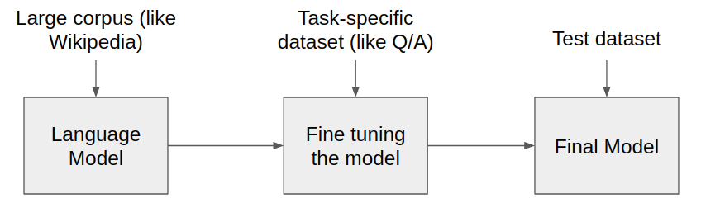

**DEEP LEARNING**

Deep learning is a specialized domain within machine learning, focusing on artificial neural networks and algorithms that draw inspiration from the structure and functioning of the human brain. It primarily centers on neural networks comprising three or more layers. These deep neural networks possess the remarkable capability to autonomously acquire and depict intricate patterns from vast datasets. The term "deep" in deep learning alludes to the presence of multiple layers through which data undergoes transformation.

Traditional machine learning algorithms require manual extraction of features from input data, which are then provided to the algorithm. In contrast, deep learning automates the process of learning features directly from the data. This feature learning is especially beneficial for handling unstructured data types such as images, audio, and text.

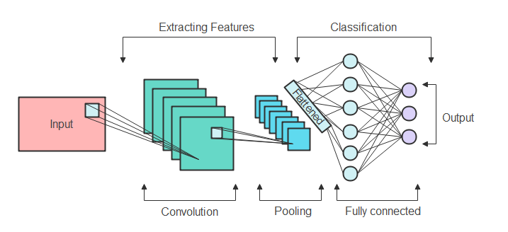 For our chatbot project, which will involve processing substantial amounts of text, we will employ deep learning techniques. This approach will enable the chatbot to automatically learn and handle the text data effectively.

**INNOVATION**

The innovation phase is dedicated to improving the current machine learning model design and integrating advanced methods to develop an enhanced chatbot.

**pre-trained language model:**

GPT-3, short for Generative Pre-trained Transformer 3, stands as a state-of-the-art language processing AI model crafted by OpenAI. It falls within the realm of transformer architecture, excelling at producing text that closely resembles human language by forecasting the next word in a sentence. GPT-3 has undergone pre-training on an extensive dataset, rendering it exceptionally adaptable for a wide array of natural language tasks, encompassing translation, dialogues, and content generation. Notably, with an extensive 175 billion parameters, GPT-3 stands as one of the most potent and sophisticated language models available today.

**STEP BY STEP INSTRUCTIONS TO INCORPORATE GPT-3 IN THE PROJECT:**

1. Acquire OpenAI API Access

2. Understand GPT-3's Capabilities

3. Structure Conversation Flow

4. Create Messages for System and User

5. Send API Requests

6. Explore and Polish

7. Handle Errors and Special Cases

8. Integrate Smoothly into Your Project

9. Monitor and Improve Effectiveness

Use GPT-3 for Chatbot When:

1. Versatility: Thanks to its pre-trained design, GPT-3 showcases remarkable versatility, capable of managing a diverse range of conversational subjects without requiring extensive, domain-specific training. This attribute makes it a fitting choice for general-purpose or multi-domain chatbots.
2. Natural Language Generation: If your chatbot's objective involves producing responses that closely mimic human language and participating in varied conversations, GPT-3 stands out for its proficiency in natural language generation. It consistently generates text that is not only coherent but also contextually appropriate.
3. Quick Prototyping: GPT-3 facilitates swift prototyping and experimentation. You can seamlessly incorporate it into your chatbot application without the laborious task of training a customized deep neural network (DNN) from the ground up.

**Deep learning model:**

The chatbot employs a Deep Neural Network (DNN) to comprehend user input. It discerns key terms within user text and normalizes them to their fundamental form, a process known as stemming. Subsequently, it translates these terms into numerical representations, as neural networks exclusively process numerical data. This procedure is referred to as One-Hot Encoding.

After converting all words into numerical representations, the chatbot employs 'TFlearn' to construct a neural network. This network undergoes extensive training with a plethora of examples, enabling it to grasp the intended meaning behind user queries. Subsequent to this training, the chatbot becomes proficient at selecting suitable responses based on user inquiries.

**STEP BY STEP INSTRUCTIONS TO INCORPORATE DNN IN THE PROJECT:**

1. Acquire the dataset from Kaggle: https://www.kaggle.com/datasets/grafstor/simple-dialogs-for-chatbot

2. Select a Deep Learning Framework

3. Blueprint the DNN Architecture

4. Prepare Data for Network Processing

5. Build and Configure the DNN Model

6. Divide Data into Training and Testing Portions

7. Conduct Training for the DNN Model

8. Assess and Refine Performance

9. Implement and Monitor Deployment

Use DNN for Chatbot When:

1. Customization: When the need arises for an exceptionally specialized chatbot tailored to specific domains or industries, a Deep Neural Network (DNN) empowers you to create a model finely tuned to the distinct demands of your chatbot, ensuring optimal performance.
2. Control Over Training: Deep Neural Networks (DNNs) provide you with precise control throughout the training process. You have the flexibility to fine-tune and iterate upon your model, guaranteeing its seamless alignment with the goals of your chatbot and the interactions it has with users.
3. Data Efficiency: With a sizable dataset tailored to your chatbot's intended use, the training of a Deep Neural Network (DNN) can harness this data resource efficiently. This results in a chatbot that excels at comprehending and delivering contextually relevant responses to user queries within the specified domain.

In conclusion, if your chatbot is geared towards managing distinct, domain-specific interactions and you possess a substantial dataset, opting for a customized Deep Neural Network (DNN) could be the optimal choice. Conversely, if you aim to create a versatile chatbot capable of engaging in diverse conversations while minimizing development time, GPT-3 presents itself as a potent and time-efficient solution.

In my chatbot project, the availability of a domain-specific dataset, such as the one provided on Kaggle (https://www.kaggle.com/datasets/grafstor/simple-dialogs-for-chatbot), presents a valuable opportunity. In this scenario, harnessing a Deep Neural Network (DNN) proves to be highly advantageous. By training a DNN on this dataset, you can create a chatbot finely attuned to grasp and respond to conversations within the specific context of that dataset's domain. This domain-specific expertise equips the chatbot to deliver responses that are not only more precise but also more pertinent, catering directly to the topics and dialogues inherent in the dataset. In contrast, GPT-3, designed as a general-purpose model, may not leverage the subtleties of your dataset as effectively as a custom-trained DNN, making DNNs the preferred choice when domain-specific knowledge is paramount for your chatbot application.