Genesis on the GPU
  - Hardware-Seeded Initialization and Verified Agreement in a Geometric World
Devon A. Generally
MetaCortex Dynamics LLC
ORCID 0009-0004-8164-2159
Version 1.1.0 • 22 October 2026
Status through 22 October 2026 at 21:21 ET • Second-step update prepared 22 October 2026
Published predecessor: https://doi.org/10.5281/zenodo.23580914
This version: https://doi.org/10.5281/zenodo.23584296

Abstract
We report hardware-situated genesis on an NVIDIA GeForce RTX 3070 and subsequent GPU conformance of the first-tick specification on its frozen V1/V2 vectors. A captured junction transition supplies the locus of a distinction on 480 flags and 720 overlap pairs. From an all-NO predecessor, twelve flags at the event junction read THIS; the witness contains 708 SAME readings and twelve NOT_SAME walls. The J17 world has committed two links: genesis and a second link that leaves the field unchanged. Separately, four execution obligations are IF_THEN for frozen V1/V2, with independent-builder comparison discharged for those vectors. V1/V2 used empty route lists; the second link exercised propagation and DRC(iv) on twelve admitted routes. [2, 3, 8, 9]
The verification target is whether event, incidence, field, agreement witness and predecessor bindings agree under the governing relations. This paper distinguishes inspected genesis artifacts from the later promoted results supplied in the current handoff. The V1/V2 comparison joins hand derivation, GPU output and a separate builder’s realization; independence is builder-attested and output equality locally witnessed. The retained genesis subset permits direct artifact checks, but is not a complete public GPU replay release. O_exec remains nonempty because JTP obligation construction remains MAYBE. [6, 8]
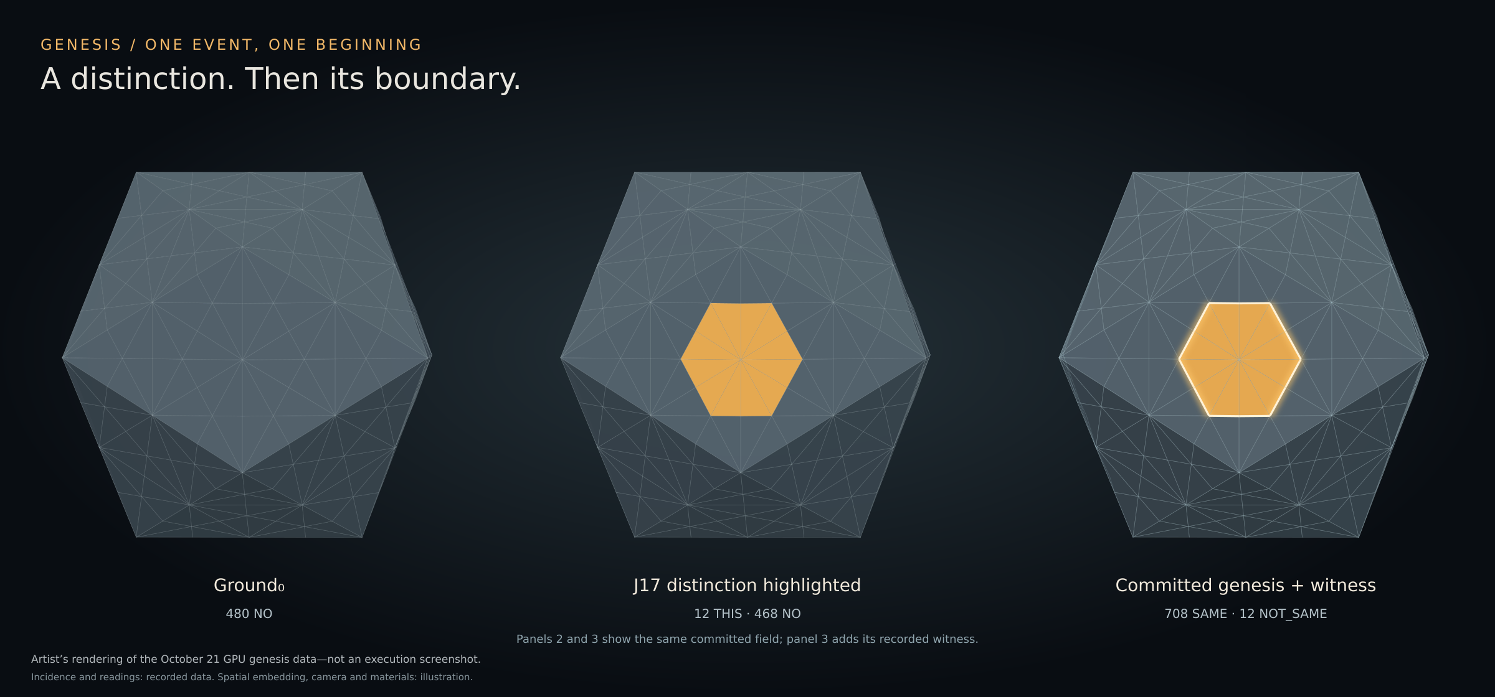
Figure 1. Ground₀, the genesis field, and its witness overlay. The latter two views depict the same committed state. Artist’s rendering of the October 21 GPU genesis data—not an execution screenshot. Coordinates are illustrative; incidence and markings come from retained data.

1 Carrier and event situated initialization
The program’s carrier is specified through incidence. The retained hardware motif table identifies twelve domains, thirty junctions and twenty witness faces. Its dual incidence has the familiar twelve-face, thirty-edge, twenty-corner counts of a Megaminx. The extracted carrier payload describes a combinatorial icosidodecahedron obtained by rectification of the dodecahedral–icosahedral dual pair. These descriptions refer to related incidence objects; their counts must not be interchanged. [1–3]
The refined flag-world has 42 sites, 120 edges and 80 triads. A flag is an incident triple f = (s, e, t), with site s belonging to edge e and edge e belonging to triad t. Six flags per triad give 480 flags. The overlap witness records 240 pairs of each of the three kinds δ, γ and τ, for 720 pairs in total. A pair differs in exactly one component of its flag triple. [1, 2]
No XYZ coordinate embedding enters the recorded semantic identity. The figures embed incidence for presentation; their rendered distances and angles do not define the world’s relations. The current handoff records the seated hardware frame as constitutional and chiral, with seating stabilizer {id} among the 120 symmetries, verified twice. Grounding refers to the real-world seating, not a direction. It also states that a flag is a cell whose reading is its state, and that occurrences are located by their own incidence coordinates rather than their type’s seat. These settled bindings are cited without re-derivation. [1, 8]

Ground and the captured locus
Write F for the finite flag set and q₀ : F → {NO, THIS} for the initial field. Ground₀ has q₀(f) = NO for every f. NO is a determined field reading. It is not missing input, UNREAD, or MAYBE. Ground₀ is retained as exact bytes with its own SHA-256 identity. [1, 2]
The captured 132-byte protocol record names Junction 17 in its header. The run binds that junction to the corridor between domains 4 and 9, represented in the field as C:HW_04|HW_09. Its payload byte is not used to index a flag or select an address. Given that bound event locus j, the genesis field is: [2, 3]
q₁(f) = THIS if site(f) = j; otherwise q₁(f) = NO.
Exactly twelve flags have site j. The resulting field therefore contains twelve THIS and 468 NO readings. This is a conditional determination from the captured event and the admitted incidence. It does not predict which physical junction will emit the first event. The event supplies that input; identifier ordering supplies no additional selection. [2]
Object | Recorded size | Function
Hardware motif | 12 domains · 30 junctions · 20 faces | Binds event locus and carrier incidence
Refined carrier | 42 sites · 120 edges · 80 triads | Supports flag triples
Field | 480 readings | Records the realized distinction
Witness | 720 overlap readings | Records agreement and walls

2 Agreement and the committed witness
For each retained overlap pair (f, f′), the witness reads SAME when q₁(f) and q₁(f′) are equal, and NOT_SAME when they differ. In this snapshot the field alphabet is {NO, THIS}; the witness alphabet is {SAME, NOT_SAME}. These are distinct typed readings. The field’s NO must not be confused with a failed agreement reading. [1, 2]
Overlap kind | SAME | NOT_SAME walls | Total
δ | 228 | 12 | 240
γ | 240 | 0 | 240
τ | 240 | 0 | 240
All kinds | 708 | 12 | 720

All twelve walls are δ overlaps, where the site component changes. They are exactly the overlaps crossing between the twelve THIS flags and the remaining NO flags. Relative to the all-NO predecessor, the transition opens twelve walls and discharges none; 708 overlap readings remain unchanged. The wall set is derived from the complete field and incidence rather than supplied as a separate placement list. [1, 2]
Run 018 reports one committed genesis chain link, binding the event record, field, witness and predecessor. Its commit support distinguishes the earlier construction stages, which have no COMMITTED_GENESIS fact, from the publication stage, which has exactly one. The later readout reconstitutes that same genesis record to retain its dependency; this is not an additional worldline link. [2]

Distance across the predecessor relation
The junction readout compares the committed field with Ground₀. For a junction j, let I(j) contain each flag incident to j through its site, edge or triad. Because site ⊂ edge ⊂ triad within a flag, this union reduces to triad containment. Each changed flag is counted once: [2]
d(j; q₀, q₁) = |{ f ∈ I(j) : q₀(f) ≠ q₁(f) }|.
The retained encoding represents each edit by one THIS entry. Cardinalities in this paper are observations of those entries. They are not identifier magnitudes. J17 has distance twelve. Its four neighbouring junctions in W12 and W13 each have distance four; the remaining 25 junctions have distance zero (domains are not ranked by the readout law). This explains why “flags changed at a junction” must include incident support, rather than only flags whose site equals that junction. [2]
Within each of J17’s two witness faces, the distances are (4, 12, 4). The face terms coexist in the carrier, while their distances depend on two successive fields. Thus the readout uses both incidence and genealogy. Nothing in this definition requires treating the drawing as Euclidean space or Worldline as a Euclidean axis.

3 The incircle result and the role correspondence
The Perfect-Square Incircle Law supplies a precise mathematical result. For a primitive Pythagorean triple with Euclid parameters m > n > 0, coprime and of opposite parity, the side lengths are a = m² − n², b = 2mn and c = m² + n². The inradius is [5]
r = (a + b − c)/2 = n(m − n),
so incircle area = π[n(m − n)]².
Area π requires n(m − n) = 1. Positive integrality gives n = 1 and m = 2, hence the unique primitive triple 3–4–5. With semiperimeter six, its vertex tangent lengths are 6−5 = 1, 6−4 = 2 and 6−3 = 3. The right-angle vertex has tangent length one. The paper’s constitutive-square theorem characterizes the square formed there by the vertex, adjacent tangency points and incenter. [5, §§3–6]
The incircle supplies the reading under which the capability-forced ranks are G, F and S. The current handoff states that the incircle is a projection, G occupies the right angle, and the operative metric belongs to the §6.1 readout as d_G, not to a ProjectionShell refinement. The promoted S/F binding assigns rank 1 to G, rank 2 to F and rank 3 to S. The edit observations (4, 12, 4) are therefore read through that governed correspondence; this paper does not identify them with side lengths of a rendered triangle. [5, 8]

What the genesis records establish
Run 018 binds the distance and witness-face readout laws by full hash. Its face readouts leave G at MAYBE when the minimum is tied; all twenty recorded faces have tied minima in this checkpoint. Run 019 applies the subsequently promoted S/F binding and records J17 as S on W12 and W13. The supporting terms are GOES_WITH(SF_FACE_ROLE,W_12,J_17,S) and GOES_WITH(SF_FACE_ROLE,W_13,J_17,S). The two neighbouring minima are not assigned G or F by a tie-breaker. [2, 3]
The current handoff confirms the promoted role law and the J17 result. On W12 and W13, J17 has unique rank 3 and therefore reads S. A tie among the other vertices is not a stop for a cell whose own rank is unique. The exact law identities remain in Appendix A. Attaching their full texts to the publication package makes this correspondence inspectable by an external verifier; it does not reopen their promotion. [8]
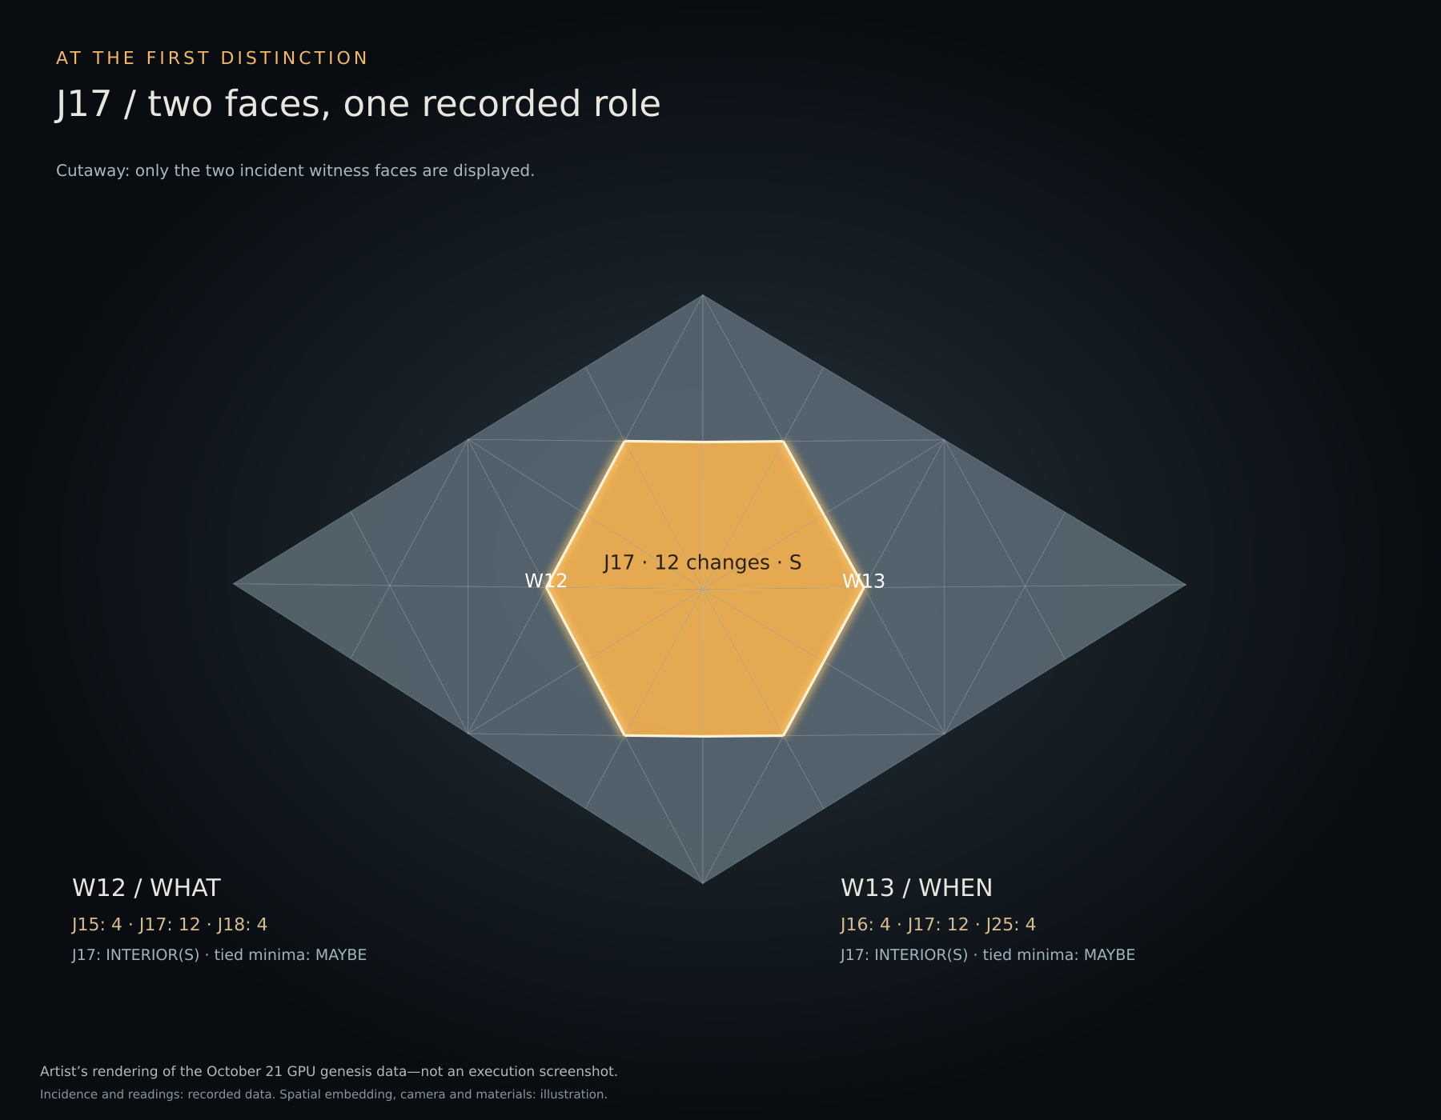
Figure 2. J17 and its two incident witness faces. Artist’s rendering of the October 21 GPU genesis data—not an execution screenshot. Rendered lengths do not supply the role law.

4 Execution semantics and observed scope
Programming with Geometry defines the five phases of snapshot, cell evaluation, route propagation, runtime governance and simultaneous commit. Active cells read one immutable snapshot; routes are standing incidence relations. Its fixed-program condition remains in force. For the flag-world markers, the current handoff explicitly rejects a program/state dichotomy: flags are cells, and their readings are state. The second-step construction inspected the candidate overlap routes and withheld cells without complete placement evidence. The admitted program and its twelve routes are reported in §4A; this does not establish execution of all 1,440 candidate routes. [4, 8]
Paper B’s HOST_ORDER_ERASURE result is conditional on valid schedules and the stated semantic functions. Its reported 70-vector conformance corpus and 71 byte-identical artifacts concern mal-fabric v0.3.0. They are inherited framework evidence, not 70 genesis tests or a proof that this particular GPU run implements every fabric law. [4, §§9–10, 12]
Run 018 identifies the GPU as an RTX 3070. It records .mal application consequences executed by a generic CUDA evaluator, with host parsing/lowering, custody and observation serialization, plus generic GPU hash dispatch. Its source, executable and stage identities are retained in the run record. The record’s source-bound scope claim is distinct from a new audit of all listed binaries: many of those bytes are outside the artist subset supplied here. [2]
Run 019 records 720 placed, admitted and evaluated snapshot comparators and no second world-transition receipt. That is the genesis-era checkpoint. The updated handoff records the subsequent first-tick CONFORM result as IF_THEN for V1/V2, promoted on October 22, with run record prefix 6089FDC4. The discharge map marks O_SOURCE_DERIVED_LOWERING, O_GPU_STEP_EXECUTION, O_COMMIT and O_VECTOR_CONFORMANCE IF_THEN for those frozen vectors. Both vectors used empty route lists and propagation returned NIL; DRC(iv) was not exercised. These results do not constitute the J17 world’s second step. The second step (§4A) subsequently exercised non-empty propagation. [3, 8, 9]

Verification performed for this paper
The accompanying read-only checker rehashed all thirty entries in the supplied SHA256SUMS file. It checked the exact 480-flag field domain, the all-NO predecessor, the J17 marking rule, all 720 unique overlap pairs and every agreement reading. It recomputed all thirty junction edit counts from the retained fields and incident support, checked all twenty tied-minimum face readouts, and checked that the committed record contains the supplied field. Every check passed. [6]
These checks establish internal consistency of retained artifacts. They do not rerun a native body, authenticate the original hardware capture independently, or reproduce the GPU executor. The checker is supplementary publication verification and adds no execution credit.

Independent construction evidence
Three verification scopes must remain distinct. Run 018 reports source/support checks and direct checks of distances and face outputs. The ref012 builder comparison reports 65/65 full-set agreements for the carrier construction and genesis quantities, with index prefix 1FA1397F…3FD79. The later RECORD_INDEPENDENT_BUILDER_COMPARISON_001 discharges the independent comparison obligation for frozen V1/V2: hand derivation, GPU and Claude’s realization agree byte for byte. Its record prefix is 99CC2107, realization first_tick_ib.py prefix E02C90DE and bundle prefix 99561FDE. Independence is builder-attested; equality is locally witnessed. The handoff reports these current results; manuscript preparation did not independently rerun either builder. [2, 8]

4A The second step and its unchanged field
The supplied run account reports the J17 world’s second step on 22 October 2026 across three governed runs. Before link 2, the available readout is over (Ground₀, g₁), the only successive field pair then committed. Earlier planning language that read the successor before producing it was circular and is withdrawn; the account reports that nothing executed under it. New run identities are cited in [9]; their bytes were not supplied in this revision session.

Marker location
The 480 THIS×WHAT occurrences are located by their own flag coordinates. Twelve are admitted: J17’s four flags on W12 and W13, where it has unique rank 3 and reads S, and two flags for each of the four neighbouring junctions on its outer witness face, where the neighbour alone has rank 3 in a (4, 0, 0) readout. No unique-rank F occurrence appears. [3, 8–10]
Occurrence class | Count | Readout and location
Admitted | 12 | Unique rank 3, S; marker capability {G, S}
Tied own rank | 108 | 84 on 14 untouched faces; 24 on six affected faces
Outside face-readout scope | 360 | Six flags in each of sixty CCD triads
Total | 480 | All marker occurrences accounted for

The 108 tied occurrences comprise all six flags on each of fourteen untouched faces, plus four tied-vertex flags on each of six affected faces. The retained genesis readouts contain fourteen (0, 0, 0) faces, four permutations of (4, 0, 0), and two permutations of (4, 12, 4). These counts correct the supplied insertion’s description of eighteen untouched faces. During preparation of this revision, the retained genesis face-readout data were checked for these counts. The subsequent document review confirmed arithmetic and agreement between the DOCX and PDF. A tied vertex is a boundary location requiring both dimensions’ capabilities; the marker carries {G, S} only. The cited requirement withholds candidates missing placement evidence, without selecting a location on the author’s behalf. The sixty CCD triads are outside the promoted face readout’s scope. [1, 9, 10]

Route topology
Each admitted marker has three overlap partners. Its δ partner is tied and withheld; its τ partner lies in an unlocated CCD triad; its γ partner is admitted. Of the 36 routes from twelve admitted markers, twelve reach comparators with both operands admitted and 24 reach comparators missing one located operand. The supplied run reports those 24 joins as NOT_SAME under the complete operator-role topology check. Applying the placement requirement to the comparators as well as the markers leaves six comparators, twelve markers and twelve routes, with no open join. All eight design-rule conditions are reported IF_THEN on that admitted program. [9, 10]

4A Execution and the boundary of the fixed point
STEP_FABRIC ran over g₁ on the admitted program. Each of the six comparators read a vertex’s two flags within one face: J17’s pairs were THIS/THIS and the neighbours’ outer-face pairs were NO/NO. All six returned SAME. No admitted cell writes a flag. The successor field equals g₁, with 708 SAME readings, twelve retained walls, zero opened and zero discharged; the receipt reads NO. Link 2 was committed on the GPU. The readout over (g₁, g₂) is (0, 0, 0) on all twenty faces, without a tie-break. [9]

What the result establishes
Non-empty route propagation and DRC(iv) have their own bounded execution result: twelve admitted routes at link 2. This extends the reported execution evidence beyond empty-route cases; it does not retroactively change the frozen V1/V2 vectors or establish all possible route topologies. [8, 9]
The committed field is unchanged by this admitted read-only program: g₂ = g₁. In that precise field-update sense, the tested program has a fixed point at g₁. The worldline nevertheless advances by one committed link. The supplied finding names this result FIXED_POINT. [9, 11]
An unchanged field does not establish an unchanged admission on tick 3. Placement uses predecessor-relative edit counts, and the newly available pair (g₁, g₂) gives tied zeros everywhere. Re-admission from that pair therefore cannot be asserted to recover the twelve-marker program without a separate governing persistence rule. Reapplying a retained read-only program would preserve the field, but retention and re-admission are distinct claims. No tick-3 invocation is reported here.

Next event and limits
The next planned field update is a second captured junction transition from the hardware lane, bound to its locus as the first was. Constructing its retained transition obligations and satisfying the hardware board-receipt boundary precede the proposed link 3. The supplied finding identifies this as the standing external-input path; this paper does not infer from one read-only program that every possible endogenous field change is impossible. [8, 11]
No new placement ruling is reported for link 2: missing-evidence withholding applies to tied markers, out-of-scope CCD markers and comparators without a located operand. A second event may alter edit counts, break some ties or create others. It does not by itself guarantee more admitted cells or any writer. Extending the readout to all eighty triads remains a proposal. The supplied finding reports tied four-edit readings for the neighbouring junction and domain at J17’s four CCD triads; that is not an executed extension of the readout. [10, 11]

5 External verification and remaining work
The public objective is verification. A third party should be able to identify the frozen inputs, reproduce the relevant construction, compare complete outputs and report a specific agreement or discrepancy. Contribution to the implementation is not a prerequisite.

Two reproducibility levels
Genesis artifact verification uses genesis_verification_supplement_001.zip [1, 6]: verify its hash lists, reconstruct the field and overlap relations, and compare exact readings. Its verify_genesis.py uses Python’s standard library; invoke it with the extracted bundle directory as argument. The result is artifact consistency, not GPU replay. The public 901-file repository subset at 60340c61 is a separate package with a separate checker. The deposit report records an independent-checker pass, but no execution of the repository verify.mjs in that session; coverage equivalence is unestablished.
GPU execution reproduction needs a release containing the exact source closure, lowering tools, generic evaluator, hash implementation, stage inputs, canonical encoders and recorded command lines. Run 018 identifies these objects and its stage order, but identification is not delivery. A public kit must include the bytes or stable retrievable references and distinguish semantic identities from hashes of serialized observation files. Reproduction on AMD, Apple Silicon or another NVIDIA target remains a separate verification result; this paper reports no cross-device run.

Checks for the public kit
The kit should expose the exact frozen V1/V2 inputs, expectations and three-route comparison, together with the genesis-specific field, witness and predecessor checks. Empty-route success must be labelled explicitly. Non-empty propagation and DRC(iv) have their own reported result from the J17 second step (§4A); the kit should expose it separately from V1/V2. Proposed additional rejection checks should be labelled as such rather than silently counted as executed evidence. [8]
A reusable event interface must bind protocol bytes, validated locus, incidence and field identity. Each new source needs its own provenance and locus correspondence; a timestamp alone supplies no carrier junction.

Publication completion items
Evidence item | Status through 21:21 ET
Governing law texts | Promoted; attach exact texts for external verification
Frozen V1/V2 | Four O_exec items IF_THEN; empty routes only
Independent V1/V2 comparison | DISCHARGED; builder-attested independence
J17 second step | Link 2 committed; twelve routes; unchanged field (§4A)
JTP obligation construction | MAYBE; O_exec remains nonempty
Public evidence and repository home | 901 files at mal-fabric/flag_world_001_first_tick/ (60340c61); tree ids preserved
Public replay kit | Not released

Next: construct the junction-transition obligations for a second captured event, its field edit and link 3. The hardware board-receipt obligation gates frame emission. Second-step records were uncommitted at the supplied cutoff and are not part of the earlier 60340c61 release. [8, 9]

References and exact evidence locators
[1] Genesis artist bundle 001, packaged 22 October 2026; retained unchanged in genesis_verification_supplement_001.zip. Includes README.md, MANIFEST.json, SHA256SUMS.txt, PACKAGING_CHECKS.json and carrier/run data. The separate 901-file evidence subset is public at mal-fabric flag_world_001_first_tick/ (commit 60340c61; tree identities preserved). A replay kit — source closure, evaluator, encoders, command lines — is not released.
[2] RUN_RECORD_018_GPU_SELF_WITNESS_AND_G_READOUT. 21 October 2026. gpu_self_witness_018/RUN_RECORD_018.json. Sections governing_bindings, realization, reproducibility, genesis, readout and independent_checks. Associated field, witness, receipt and committed.genesis.json are in the same directory.
[3] s_f_binding_019/RUN_RECORD_019.json. 21 October 2026. Sections authority, roles, snapshot_reading_counts, receipts and source_contacts. Hardware locus: jtp_locus_017/inputs/frame.json and frame.json.source.bin; incidence sources under hardware_carrier_012/.
[4] D. A. Generally, Programming with Geometry: Synchronous Spatial Execution and Host-Order Erasure in Operator-Witness Fabrics. Programming_with_Geometry_Paper_B_FINAL.docx, inspected copy. Static companion: DOI 10.5281/zenodo.22677712. Fabric releases: 10.5281/zenodo.22678128, 10.5281/zenodo.22711890 and 10.5281/zenodo.22713736. Paper B records v0.3.0 promotion at commit 98289c348421943ab0e440d45ec1d7e7cbbbc2b2.
[5] Generally, Devon A., The Perfect-Square Incircle Law: Incircle Areas of Primitive Pythagorean Triangles. Perfect_Square_Incircle_Law.docx, inspected copy, §§3–6. Public record supplied by the author: https://zenodo.org/records/20946692. Equality between this inspected document and the published bytes has not been checked for this paper.
[6] verify_genesis.py and verification.json, deposited in genesis_verification_supplement_001.zip; published with the predecessor paper at DOI 10.5281/zenodo.23580914, as reported by the author. Standard-library read-only artifact check; no runtime or hardware execution. Thirty file hashes, 480 field readings, 720 overlaps, thirty junction distances and twenty face readouts checked.
[7] Author’s October 21 genesis account supplied in the conversation. Historical narrative only; the October 22 handoff [8] controls execution scope, with repository status superseded by [12].
[8] HANDOFF_FLAG_WORLD_FIRST_TICK_2026-10-21.md, status through 22 October 2026 at 21:21 ET. Updated identity supplied by the author: b9618192a5d0f8d4bc3e4b7ecaf44efd45e6ddabbd6aaa33563ea9de6f704867. Updated bytes were not supplied in this revision session. The inspected earlier 18:00 handoff remains genealogy; second-step claims here follow the supplied insertion and record locators [9–11].
[9] RUN_RECORD_021.md (supplied prefix/suffix 8E3EBD0A…DEF2F8; full hash not supplied); RUN_RECORD_022.md, SHA-256 478B51F4EF89D4ACA7AAF0192840B1CB8F3864DF8FEA056510E46AAE2F2674AA; RUN_RECORD_023.json, SHA-256 6A07ACE68BD15DA5F084269FA7FDD57021EC89B30EAE44ED4BF9F9B697B79B0D; with committed.world.json. RTX 3070, 22 October 2026, mal-fabric working tree flag_world_001_first_tick/j17_step_021/, j17_step_022/ and j17_step_023/. Reported uncommitted at the insertion’s cutoff. Bytes not inspected here; claims attributed to the supplied run account.
[10] Document 116, L06. SHA-256 FFF676FC92D57CB564A2045754939794CE4CB0BE71DA286E5B709A623E3F9513. Supplied requirement: materialized cells require source-bound capability evidence; containment and location come from the governing fabric; missing placement evidence withholds the candidate. Full document not inspected here.
[11] FINDING_J17_LINK_2_IS_A_FIXED_POINT_2026-10-22.md. Supplied SHA-256 d9a7b21a241d4aec6a6462bdcc0b5bdfb5b48271b9c4b198df4a697d97217a95. Finding reported by the author; full bytes not inspected here. This revision distinguishes its recorded unchanged-field result from an unexecuted tick-3 admission claim.
[12] Supplied review of Draft 0.2, 22 October 2026, identifying its DOCX by SHA-256 dddab3c918ba773c99bc1b0c1284b3d43fe04d9cfe46da4569e24e206428680e (locally matched). Reports promoted ONE HOME disposition BCC7E80D…6074AF covering 901 evidence files; subsequent author updates bind the mal-fabric home and public availability of the 901-file subset at commit 60340c61, with engine-run evidence tree ids preserved. Updated project handoff SHA-256: 15e17ad1b0251127451e43799e5ec69bc22a3e15da2354ad82ecd501287be3a3. The updated handoff bytes and full home-disposition receipt were not supplied to manuscript preparation; status is attributed to this review, not claimed as a fresh repository inspection.

Appendix A Governing identities
The following identities are copied from the retained run records. Their presence binds a locator; it does not mean the full referenced law text was included or reverified in this paper.
DECISION_RECORD_GPU_SELF_WITNESS_001
2CBBA4AD971D11AC2B2B4867ECCC4D58917A16602C096FE64308D0B8F487BCE7
DECISION_RECORD_FLAG_WORLD_D_G_001
3419D528150A8616AF0DCF0446FC59FAD0FF83F1C872C93A0BC8CC70BF0A8718
SPEC_WITNESS_FACE_G_READOUT_001 v0.1.0
057C30E280CC17A4D3AA6079A3B6E203DEA3FE306BD8557A67F3CEC615C05355
DECISION_RECORD_S_F_BINDING_001
276EBD71EBB5286A58C1542C18D2F15639525233DCA280363BD67B15A1983108

Appendix B Retained output identities
These SHA-256 values identify exact file bytes in the supplied subset. The committed object hash and its internal worldline link identity are separate objects. Full byte verification must use the correct object and serialization.
Ground predecessor — ground_predecessor_015/GROUND_0_012.field.json
B263644E59A696999C02DFD25386A5ABEFDB2D0FC4317A0FE2CCCD90502EBAD3
Captured protocol bytes — jtp_locus_017/inputs/frame.json.source.bin
4472CFC5B73C1BA745D3129E7111C0FA394C7C6CEE42D1E6E7E9691E5FF7228B
Hardware motif table — hardware_carrier_012/parents/motif_junction_table_v1.h
25AF837405F450986FBD24A425D2197BD5E5D9D4BF952F74BE43CFB992B10F64
Genesis field — gpu_self_witness_018/current.field.json
1B69800444F0A83B09976F8EDF7411865D4721B12423B343BE69C31B4856AA0A
Agreement witness — gpu_self_witness_018/current.witness.json
4861769871804EF03EF02F4EDFE368BBC79F43871F35D85209043BEE0BFE87E9
Committed genesis observation — gpu_self_witness_018/committed.genesis.json
FDA614876C99126FCE2AFE6AC8E42A77863880485E02D4B4EDA4AA817446BD2C
Junction edit observations — gpu_self_witness_018/d_G.junctions.json
50FBEA253E47697A09EE361AC90EE729D835E2A3C80CAF690CB534C85BE76393
Run 018 record — gpu_self_witness_018/RUN_RECORD_018.json
66E9573678D0F8F08A71E5146193BF9780C38E7F526E6C77F2709CC8D6AE1B12
Run 019 record — s_f_binding_019/RUN_RECORD_019.json
24CB42A0145B5B19C3936AD3552E8131EE18685A7182AC308CAD19D53E78B8D9
Worldline link identity recorded inside the committed object:
1CE68E601743BEBAA458D727DB920E40EAF4A7CCB0F1603087085DE9FB7D8163
The preceding manuscript was promoted by Devon A. Generally on 22 October 2026. The author has reported its publication at DOI 10.5281/zenodo.23580914. Version 1.1.0, deposited as a new version of that Zenodo record, preserves version 1.0.0 unchanged under its own DOI and adds the supplied 21:21 ET run account, with the scope distinctions in §4A. New source-record bytes have not been inspected here; no new promotion or execution is implied by preparing this revision.

Appendix C Discharge and subsequent execution
The frozen V1/V2 discharge map remains unchanged. The subsequent J17 link-2 result is reported separately, without extending the scope of the prior promotion receipts.
Obligation | Current scope and status
O_SOURCE_DERIVED_LOWERING | IF_THEN for frozen V1/V2
O_GPU_STEP_EXECUTION | IF_THEN for frozen V1/V2
O_COMMIT | IF_THEN for frozen V1/V2
O_VECTOR_CONFORMANCE | IF_THEN for frozen V1/V2
O_INDEPENDENT_BUILDER_COMPARISON | DISCHARGED for frozen V1/V2
O_JTP_OBLIGATION_CONSTRUCTION | MAYBE; now on the next-event critical path
O_LATER_TICKS_AND_REENTRY | Link 2 committed; FIXED_POINT field result (§4A); not blanket discharge of future ticks

V1/V2 use empty route lists and propagation returns NIL. Link 2 separately reports non-empty propagation on twelve admitted routes and DRC(iv) IF_THEN, leaving g₂ = g₁. The new run records [9] were not committed at the supplied cutoff. The public 60340c61 subset must not be described as containing them.
Publication item | Status
Repository home | mal-fabric flag_world_001_first_tick/, by promoted disposition BCC7E80D…; engine-run evidence tree identities preserved; 901-file subset public at 60340c61
Public replay kit | Not released

Promotion receipt
B7A617CAB8F2E60B6027FD1A0143C692ECCE8E5BFDB87052898756310EA10339
DISCHARGE_MAP_001_PROPOSED.md — 14,790 bytes
B3DF7A97852FCE3DB07A9B3F5503194CDA6C88578C722EA4B2A8EB544D0313A6
DISCHARGE_MAP_001_PROPOSED.json — 20,481 bytes
150F1FA95B7488CE671835AB48517ED4D92C02D7506FB38B381C45141E884A0F
Earlier supplied handoff file — 18:00 ET
C4CFA936AB43AC926EE899237118D52863B3EB63472377D9105E234C16210957
The receipt and map identities above are Devon-supplied exact bindings. Their original bytes were not attached here and have not been rehashed in manuscript preparation. The earlier 18:00 handoff identity is calculated from supplied bytes; its repository status is superseded by the review and updated handoff identity below. Neither an unavailable local rehash nor a PROPOSED filename reopens an attested promotion. Home: mal-fabric, flag_world_001_first_tick/, by promoted disposition BCC7E80D…; evidence tree ids preserved from the engine run. The evidence subset is public at 60340c61; the replay kit is not released. [12]

