**Study 1**

Study 1 will probe if, how, and why knowledge of bonds between third parties impacts trust and generosity. Participants will play a series of repeated investment games with partners who are ostensibly established members of an online gaming community. Participants will be informed that players are typically displayed alongside their five closest friends on the website, but due to privacy settings, the identity of a given player’s friend is only visible to that player’s current partner (i.e., the participant) if the partner has previously interacted with that individual on the website (**Figure 1**).

In Set 1, participants will repeatedly play trust games (Berg et al., 1995) with several individuals to learn which players are trustworthy (Chang, 2010; Fareri, 2012; Fareri, 2015). In trust games, the participant is given a sum of money and informed that she must choose an amount of that money for the experimenter to triple and send to the other player, who can then choose to return any amount of the now-tripled sum to the participant. In Set 2, participants will play analogous games with new partners. Some new partners will be identified as friends of trustworthy partners from Set 1, and others will be identified as friends of untrustworthy partners from Set 1 (**Figure 1b**). Half of participants will be assigned to the Public Condition, in which they will be told that players who are friends with one another on the website will be able to chat about other players’ behavior (e.g., about the participant’s own behavior) between the end of Set 2 and the beginning of the next set of games (i.e., a fictional ‘Set 3’). The remaining half of participants–those in the Private Condition–will be led to believe that no communication between players is possible during the study. All participants will be led to believe that they may encounter their partners from Sets 1 and 2 later in the experiment (i.e., in the fictive ‘Set 3’).

The results of Study 1 will elucidate how, when, and why indirect relationships impact trust and generosity. If individuals monitor and encode information about others’ relationships to manage their own reputations, then participants in the Public Condition should offer more to their new partners than those in the Private Condition, irrespective of whether the new partners are associated with trustworthy or untrustworthy individuals. Alternatively, if participants track third party relationships only to better predict others’ behavior, then in Set 2, participants should offer more to friends of trustworthy than untrustworthy players, irrespective of other players’ capacity to gossip. If participants use third party relationship knowledge both to predict others’ behavior and to manage their own reputations, then there should be an interaction between the trustworthiness of the new player’s friend and the possibility of gossip, such that participants offer their Set 2 partner the greatest amount when the partner is both a friend of a trustworthy individual and when they believe that others can gossip about them before potential subsequent encounters.

Study 1 will also shed light onto how our direct experiences interact with our knowledge of third party relationships in order to inform future behavior. For instance, do we use information about the company that others keep only to bias our original judgments of their trustworthiness, or might it also lead us to disregard directly acquired information about their behavior (Chang, 2010)? If the latter is the case, then participants should initially offer less to new partners with untrustworthy friends, and be slow to learn that such individuals are themselves trustworthy.

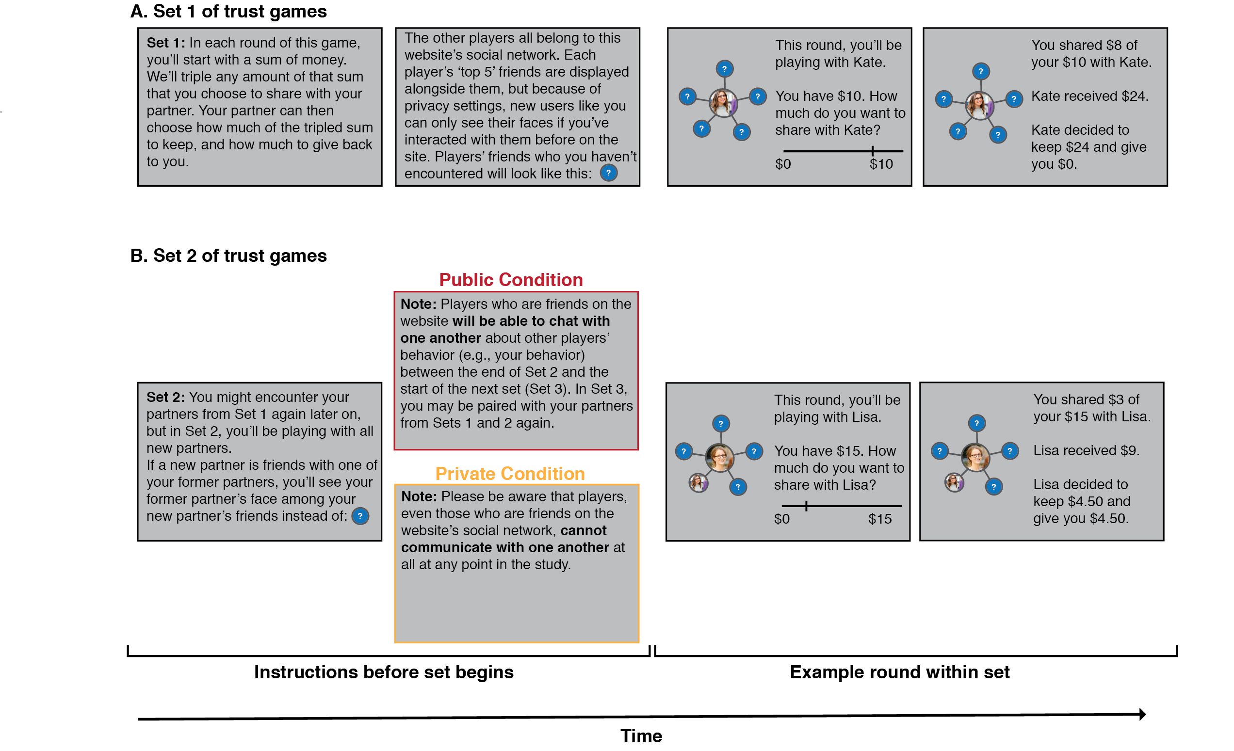

**Figure 1**. Study 1 paradigm. Participants will play trust games with fictional members of an online gaming community. **A.** In the first set of trust games, participants will play repeated trust games with unfamiliar partners, and learn about the relative trustworthiness of each individual. Participants will be informed that players are usually displayed with their five closest friends in the community, but that they will only be able to see the identities of those friends if they have encountered them before on the website; otherwise, a question mark will be displayed in lieu of the person’s face. **B.** In the second set of trust games, participants will play with new partners. Some of these partners’ friends will now be visible to the participant (i.e., those whom the participant played with in Set 1). All participants will all be informed that they may encounter their partners from Sets 1 and 2 later on in the study. Those in the Public condition will be led to believe that players who are friends with one another on the website can chat between sets about other players’ behavior (e.g., about the participant’s behavior). Those in the Private condition will be led to believe that no communication between players is possible during the experiment.