CONSTRUCTION CONTRACT SIGNED FOR COMPLETION OF SPORTS FACILITIES

*2,000 sq m great hall can be used as 3 sports courts, for 900 exam seats (with 300 in 1,300 sq m pavilion), for a 2,000 delegate seated conference or 1,000 guest seated banquet*

Waterford Institute of Technology (WIT) has signed a contract with Tom O’Brien Construction to complete the multi-purpose sports arena building at WIT’s West Campus, Carriganore.

Students starting at WIT in September 2016 will be the first to fully benefit from the sports facilities on offer.

The proposed investment of €5.2m will complete construction and fit out of the multi-purpose sports building.

The completion of this building will complement the existing grass, all-weather and support facilities on campus. The completed facility, which has seen a €16.3m investment since 2009, will provide up-to-date modern and scientific sports facilities, gymnasiums, teaching and learning lecture rooms for the Institute’s student and staff community. WIT will shortly go to tender for furniture, fixtures, and equipment.

It includes a 2,000 sq m ‘aula maxima’ or great hall where large scale official WIT events can be hosted. This facility will also be suited to host conferences and large external sporting, business and social events for the region.

In late 2015, the Minister for Education and Skills, Jan O'Sullivan agreed to make funding available, which is fully repayable by the Institute on a sustainable basis, in order to complete Phase 3 of Carriganore in addition to the amounts already allocated.

Speaking at the contract signing President of WIT, Professor Willie Donnelly said: “The Institute would like to thank the Minister for Education and Skills and the Department for their support in enabling the Institute to complete the Carriganore project.”

“The Carriganore facility when open will provide WIT students with sports facilities to match the best in Europe. We are also committed to providing access to these resources to local clubs, societies and schools. It will play an important role in promoting a healthier active lifestyle in the region,” he said.

Chairman of Diverse Campus Services, Mr Frank O’Regan, further outlined the impact this building will have on the student and staff community by stating “this is a celebratory event for WIT. I speak for the Directors, Management and Staff of Diverse Campus Services in welcoming this great opportunity at Carriganore. Diverse Campus Services has a strong tradition of supplying excellent new services to the WIT community, and this arena building will create many exciting possibilities.”

Tom O’Brien of Tom O’Brien Construction commented that he was delighted to secure the contract and work with Waterford Institute of Technology on this prestigious landmark building. As a local contractor based in Bilberry, Waterford, in partnership with his sub-contractors, the majority from the region, this will be a major boost to his company, Waterford City and the region.

Henry J Lyons Architects welcomes the decision to commence the final phase of the facility. “The completion of the facility at Carriganore will benefit the students and staff at WIT and will also benefit wider Waterford and south east region. The multifunctional nature of the facility means a broad range of events and sport related facilities will be available to the Institute and the wider community at a very accessible location in Waterford,” stated Turlough Clancy, Associate, Henry J Lyons Architects.

It is planned to complete the project in mid-2016.

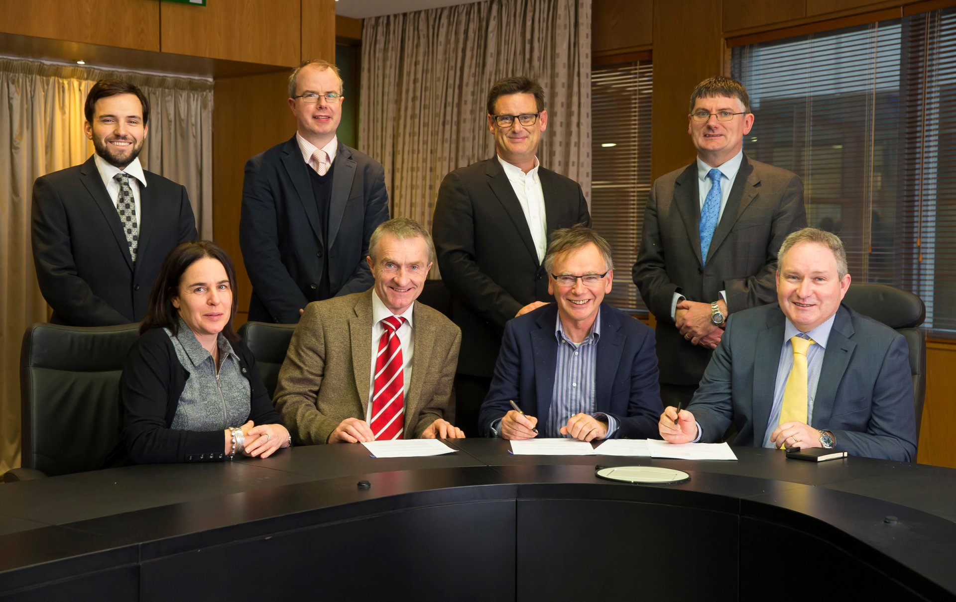*Pictured at Waterford Institute of Technology at the contract signing front from left, Elaine Sheridan Secretary Diverse Campus Services (DCS), Frank O'Regan Chairman (DCS), Prof Willie Donnelly President WIT, Tom O'Brien of Tom O’Brien Construction, Back Row, Thomas O'Brien of Tom O'Brien Contractors, Ger McKenna of Edward Cotter Partnership, Turlough Clancy of Henry J Lyons Architects and Paul Q*

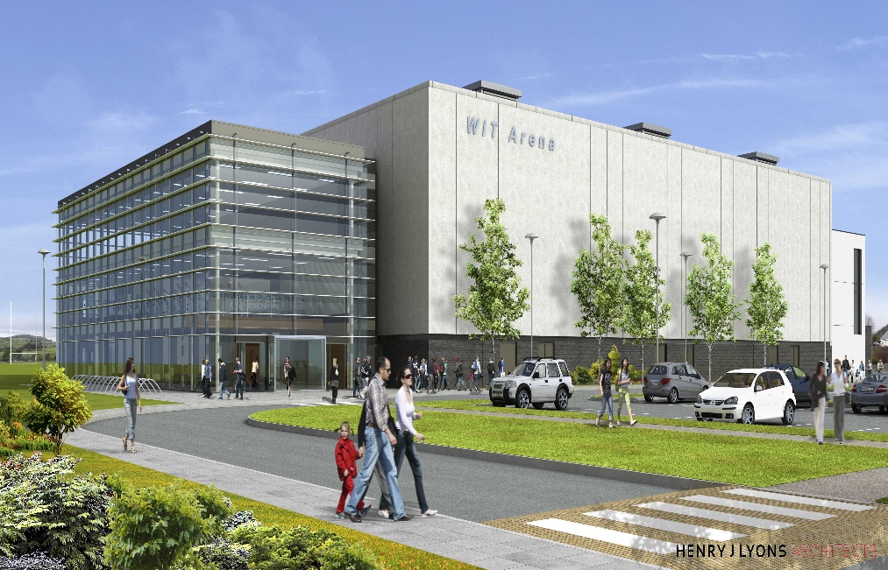

## Facilities overview

### Outdoor & Team Changing

4 Sand based Grass Pitches – fully floodlit

3G All-Weather Pitch fully floodlit

External Training Area

8 Inter County Standard Dressing Rooms

2 Official Changing Dressing Rooms

2 Medical Rooms

2 Physiotherapy Rooms

Team Meeting Room

### Indoor facilities for events

Multi Purpose Hall (Total area = 2,000m2)

3 Sports Courts

900 Exam Seats – with 300 in Pavilion

2000 Seated Conference

1000 Seated Banquet

Fitness Suite & Studios

Elite Strength & Conditioning Unit

Labs/Training Suites x 5 – 180 attendees

Catering & Hospitality over 2 levels

Pavilion with internal and external viewing gallery

Reception/Administration Office/Foyer