**Assignment 7**

**Chapter 3**

**P3**

**Sum of the three 8bits bytes:** 01010011

01100110

01110100

1 00101101

Since we have 1 extra bit we need to wrap it around and we get: 00101110

- **In the second step,** we swap the bits with their complements and we get**: 11010001**

- UDP uses the 1s complement of the sum for its checksum calculation to reliably detect errors in data transmission while maintaining computational simplicity and efficiency.

-The receiver after getting the check sum adds up all the bytes if all 1s acquired then there is not an error in the sum. On the other hand if there are 1 or more 0s then there is an error.

- Using checksum method we can detect 1 bit error, however some cases 2 bit errors pass through undetected.

**P4**

1. Adding 01011100 and 01100101 will get 11000001. Therefore, the 1s complement of sum is 00111110.
2. Adding 11011010 and 01100101 will get 01000000. Therefore, the 1s complement of sum is 10111111.
3. Adding 01011101 and 01100100 will get 11000001.

**Assignment 6**

**P26**

1. Yes it is possible, as long as there is a peer who is willing to send the required file to Bob and Bob has enough space to receive the file.
2. It is possible. He must make sure that all the computers have distinct IP address and act as an independent participant in the swarm.

**P28**

1. There will be no connection. This is because client will search for the server which doesn’t exist. Therefore, TCP connection will not be established.
2. Unlike TCP, UDP connection will be established. UDP Client doesn’t need to activate the server before client.
3. No connection will occur due to port number mismatch. An error will occur in client side for TCP connection, and the server will not receive the request from the client side for UDP connection.

**Assignment 5**

**Chapter 2**

**P12**

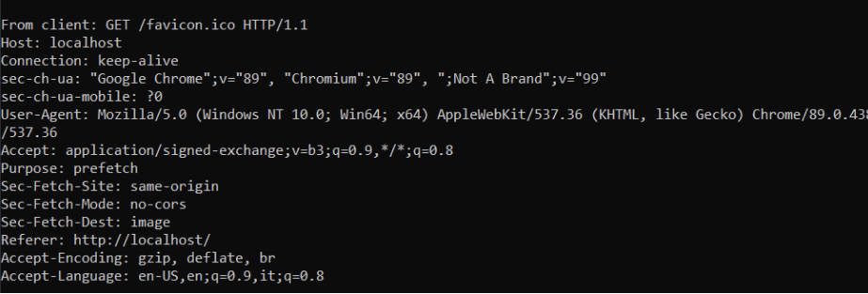

**P15**

Mail From: is for indicating the sending and return path of the message, while From: is a header field that identifies the author or sender of the mail.

**P20**

We can use the command ipconfig/displaydns that will print out all the web servers requested by the users in the department. Then, we can analyze from that.

**Assignment 2**

**Problem 8:**

1. 10Mbps / 200kbps = 50
2. 1/50 x 0.1 = 0.002
3. P[n users are transmitting at the same time]=1−Sum[ Binomial(120, i)×0.1^i×0.9^120-i ,i=0,n]
4. Using the above binomial formula

120∑n=51 P[n users are transmitting at the same time]

**Problem 25:**

1. 20000000m/2.5 x 10^8 m/sec = 0.08 sec

R x d = 5 x 0.08 = 400000 bits

1. 800000 bits / 5Mbps = 0.16sec

dtrans > dprops, therefore, 400000 bits will be in the link at any given time.

1. Bandwidth-delay product shows us the bit capacity of the link.
2. 20000km / 400000 bits = 50 m , No it is not longer.
3. (m x s)/R

**What is the difference between Abstraction and Encapsulation?**

Abstraction refers to the concept of hiding the underlying complexities of the network infrastructure and presenting a simplified view to the users or higher-level applications. Encapsulation, on the other hand, involves packaging data and protocols into units (such as packets) for transmission over the network, providing a protective layer and ensuring reliable delivery.

1. Ping another computer.

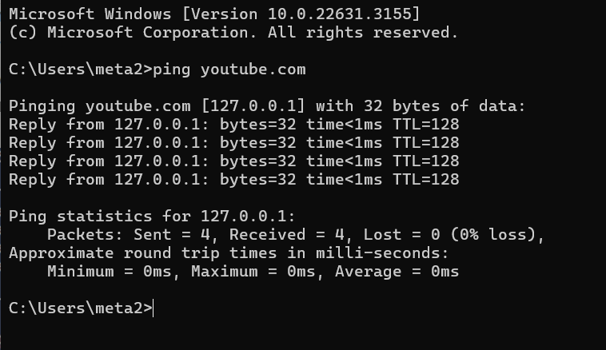

1. Tracert a server.

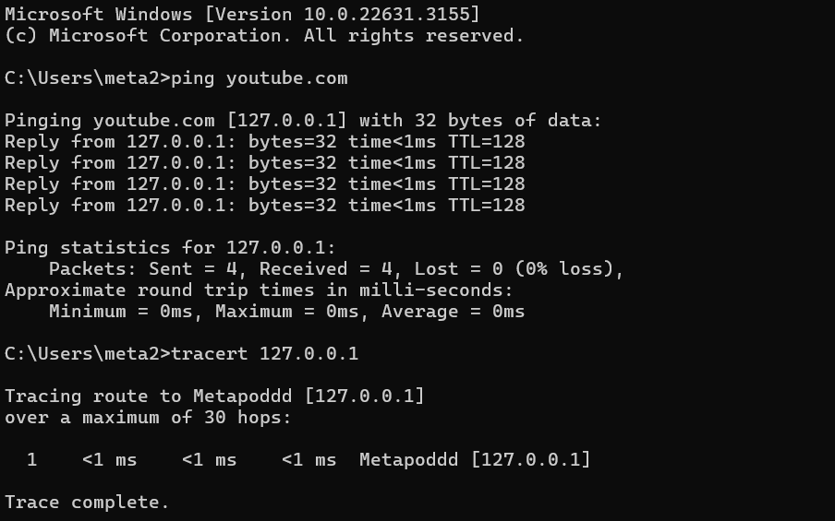

1. Download lab resource.