Update 1.2.0 introduces MASSIVE improvements to MeshFusion Pro.
Alongside general performance and stability enhancements, this update adds a fourth type of MeshFusionSource — support for Skinned Meshes.
These objects are something in between static and dynamic, but the workflow remains just as simple and intuitive as with all other components in MeshFusion Pro.
One important detail to keep in mind is the bounding box behavior of Skinned Mesh Renderers. If the bounding box moves outside the camera’s view (as shown in the image below), the combined mesh will not be rendered.
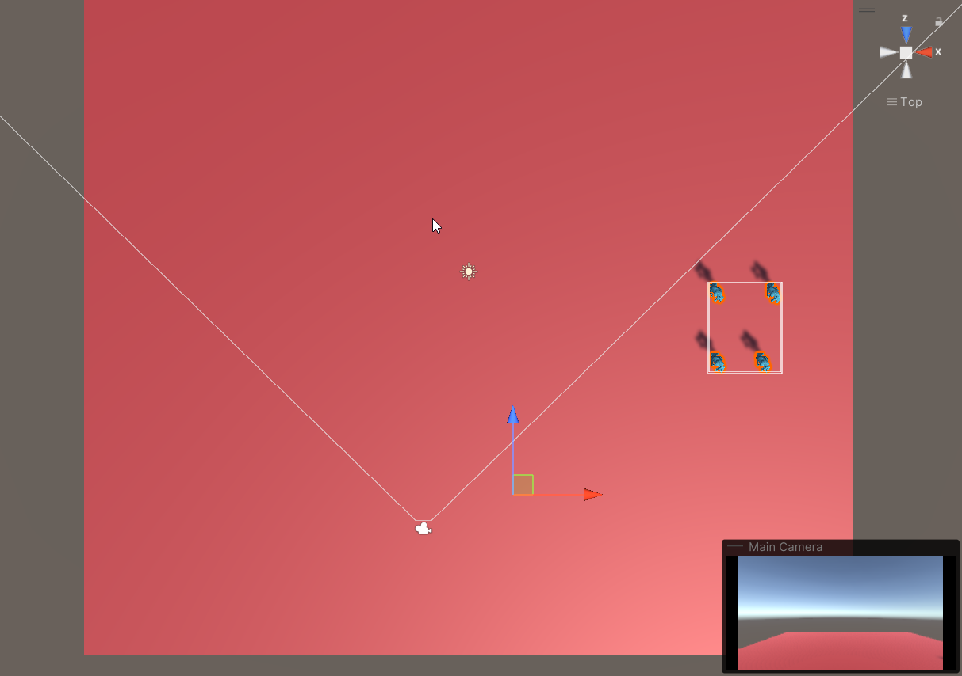

And when we’re talking, for example, about combining characters, it’s quite common for them to move away from their original positions. In such cases, a situation may occur where the character enters the camera’s view (see the screenshot below) but still isn’t rendered — simply because the bounding box hasn’t moved from its original position.
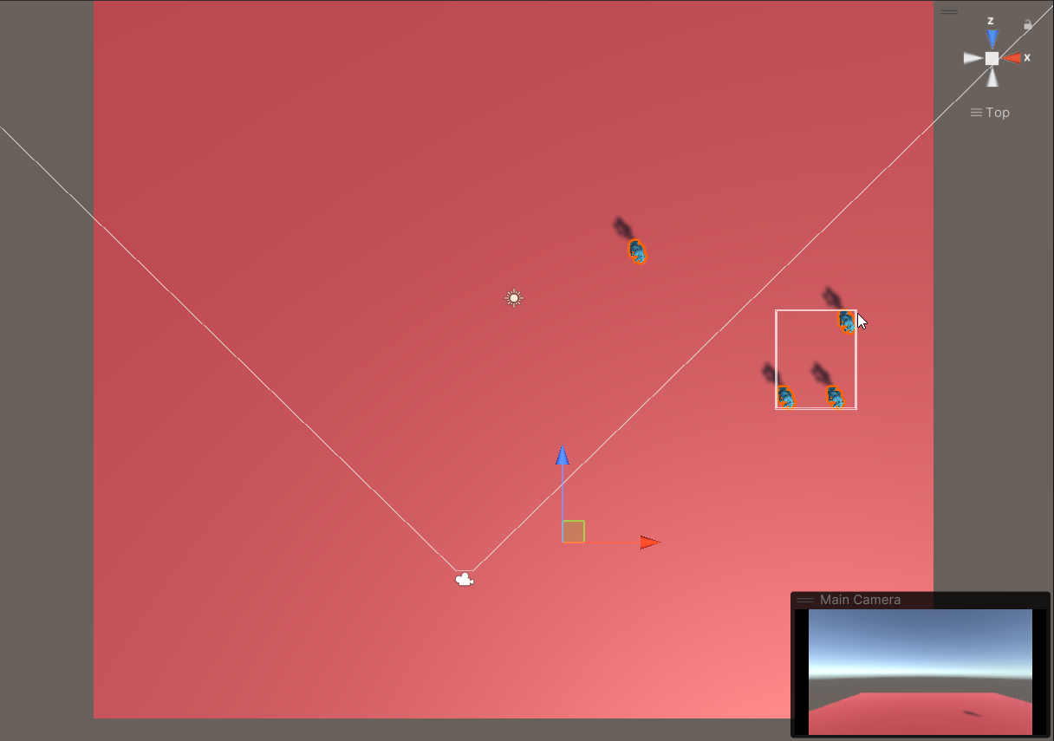

There are two ways to handle this situation:
- Enable the “Update When Offscreen” flag on the original SkinnedMeshRenderers. This ensures that your objects and all their animations continue to update even when they’re outside the camera view.
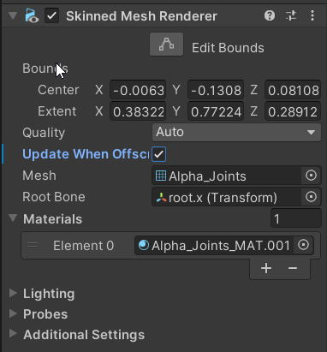
- Attach a SourceTracker to the original SkinnedMeshRenderers and configure the Position Threshold. In this case, the bounding box will only update when the object moves beyond a certain distance, and animations will only play when the object is within the camera view.
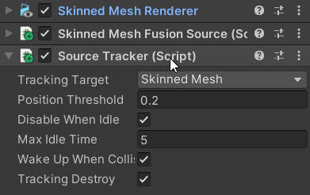

Using SourceTracker can be more performance-friendly, but slightly less precise due to the potential for a small “margin of error.”
Which approach to choose depends entirely on your specific needs. Don’t be afraid to experiment — with MeshFusion Pro, it’s super easy! 😊

