RDF expressions in SCAM4
In SCAM4, Named Graphs are used to administer sets of statements together. Hence, the metadata, the entry as well as the resource when it is one of the built in types are represented as Named Graphs.

Metadata
Metadata is not specified by SCAM, any property is allowed. However, some properties are more common than others, below is a list of properties that we foresee will be frequently used.

Property | stub | Languagetag | Cardinality | datatype | Resource | Comment
dcterms:titel | X | X | *
dcterms:description | X | X | *
dcterms:format | X |  | ? |  |  | Use internet mimetypes as values.
rdf:type | X |  | * |  | X | Conceptual or intentional type, examples include assignment, paper, person, task etc.
foaf:name | X | X | ?
foaf:mbox |  |  | ? |  | X | email address.
rdfs:label | X |  | ?
rdfs:comment | X |  | ?
dcterms:subject |  |  |  |  | X | Use for classifications?
lom:keyword?? |  | X | * |  |  | Use for keywords/tags?
dcterms:rights or cc:rights |  |  | ? |  | X | License or similar.

Entry
The Entry contains information that expresses statements on the resource, the metadata as well as on the entry itself. The following properties are all interpreted by SCAM. All but the read and write properties are automatically inserted and managed by SCAM, i.e. only the read and write properties can be changed manually. Further properties may be introduced by the user or client program at will. It should be noted that all properties on the resource could in principle be provided in the metadata instead. That they are provided in the Entry is due to their administrative character, e.g. access control of the resource should be controlled in the entry, not in the metadata.
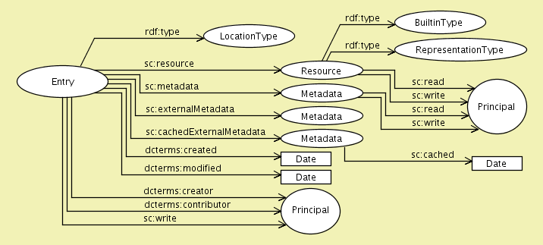
In the table below, when a value is default it can be left out.

Propeties on the Entry resource
Property | Stub | Cardinality | datatype | Resource | Comments
rdf:type | X | ? |  | X | Point to a LocationType, i.e. one of sc:Local, sc:Link, sc:LinkReference, or sc:Reference. (sc:Local is default.)
sc:resource | X | 1 |  | X | Points to the resource of the Entry.
sc:metadata | X | ? |  | X | Points to a resource representing the metadata of the Entry.
sc:externalMetadata | X | ? |  | X | Points to a resource representing external metadata, only when LocationType is sc:Reference or sc:LinkReference.
sc:cachedExternalMetadata | X | ? |  | X | Points to a resource where the external metadata is cached, only when LocationType is sc:Reference or sc:LinkReference.
dcterms:created |  | 1 | xsd:DateTime |  | Date of creation
dcterms:modified | X | 1 | xsd:DateTime |  | Date of modification
dcterms:creator | X | 1 |  | X | A Principal that created the entry
dcterms:contributor |  | * |  | X | A Principal who made a contribution to the entry
sc:write |  | * |  | X | A Principal who have full rights to administer this entry. A Principal that are given write access here have implicitly write access on both the metadata and the resource.  Corresponds to the AccessProperty.administer in the API.

Properties on the Resource resource

Property | Stub | Cardinality | Datatype | Resource | Comments
rdf:type | X | ? |  | X | Indicates if the resource is one of the builtin types: sc:Context, sc:List, sc:Principal, sc:ResultList, sc:Group, sc:None (default).
rdf:type | X | ? |  | X | Indicates the resources representation type, one of:  sc:InformationResource (default), sc:ResolvableInformationResource,  sc:Unknown, or sc:NamedResource.
sc:read |  | * |  | X | Read access to the resource, must be a Principal.  Corresponds to the AccessProperty.readResource in the API.
sc:write |  | * |  | X | Write access to the resource, must be a Principal.  Corresponds to the AccessProperty.writeResource in the API.

Propeties on the Metadata resource
Property | Stub | Cardinality | Datatype | Resource | Comments
sc:read |  | * |  | X | Read access to the resource, must be a Principal.  Corresponds to the AccessProperty.readMetadata in the API.
sc:write |  | * |  | X | Write access to the resource, must be a Principal.  Corresponds to the AccessProperty.writeMetadata in the API.

Properties on the ExternalMetadata resource

Property | Stub | Cardinality | Datatype | Resource | Comments

Properties on the CachedExternalMetadata resource
Property | Stub | Cardinality | Datatype | Resource | Comments
sc:cached |  | 1 | xsd:DateTime | X | Date when the external metadata was cached in SCAM.

Resource
Only builtin resources are represented as Named Graphs in SCAM4.

Context
The Context Named Graph is an index of entries and relations to resources and metadata these entries manage.

List
The List Named Graph is an rdf:Seq referring to it's children via their entry URIs.

ResultList
The ResultList is a Named Graph containing information such as:
- resource query
- metadata query
- entry query
- query execution order if more than one query is given.
- querytarget (which contexts, entire repository, federated search etc.)
- post filtering options based on entry information
- whether to paginate the results
- how to sort the results
TODO, provide an RDF expression.

Principal
TODO

Group
Same as for List above with the exception that only Principals are allowed as children.

