Report

- Build environment for test.
We can protect files using sign technology in kernel level.
First, install Ubuntu2020 OS in vmware workstation.
- Set its ipaddress to 172.160.19.30/16.
- Install Wireshark and start using following command.
# apt install wireshark
# wireshark
- Install sshd and apache service.
# apt install openssh-server
# apt install apache2
Second, install Kali OS in vmware workstation.
- Set its ipaddress to 172.160.19.40/16.
After all we can test in local network(172.160.0.0/16).

- Configure wireshark to capture traffic of ssh connection.
- Setting wireshark to capture ssh connection traffic in Ubuntu.
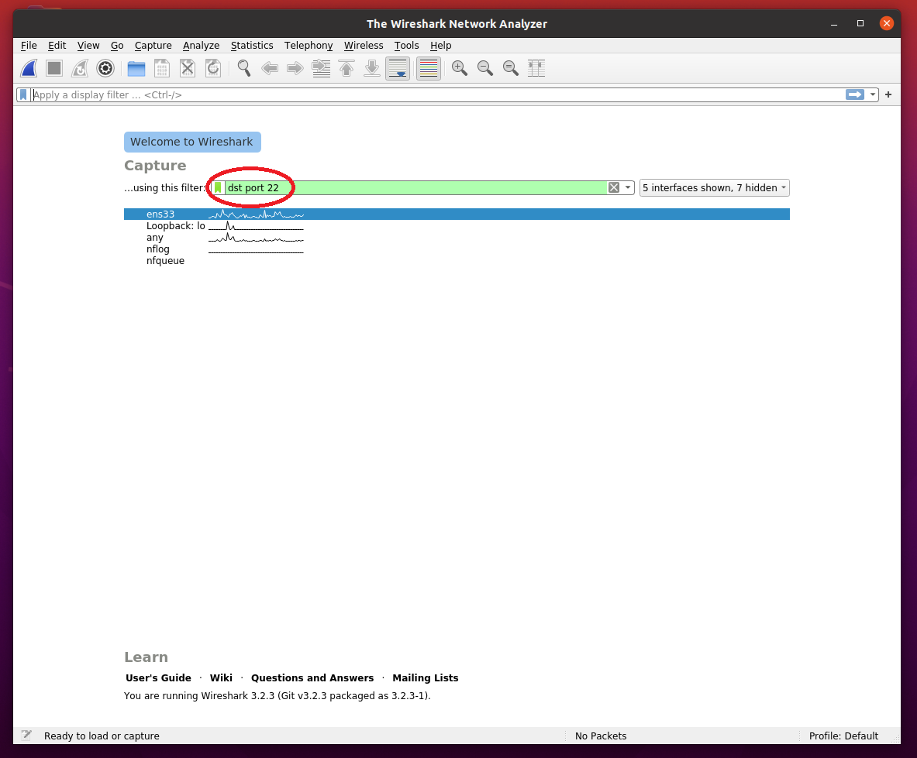

- In Kali, attempt ssh connection to Ubuntu sshd server.
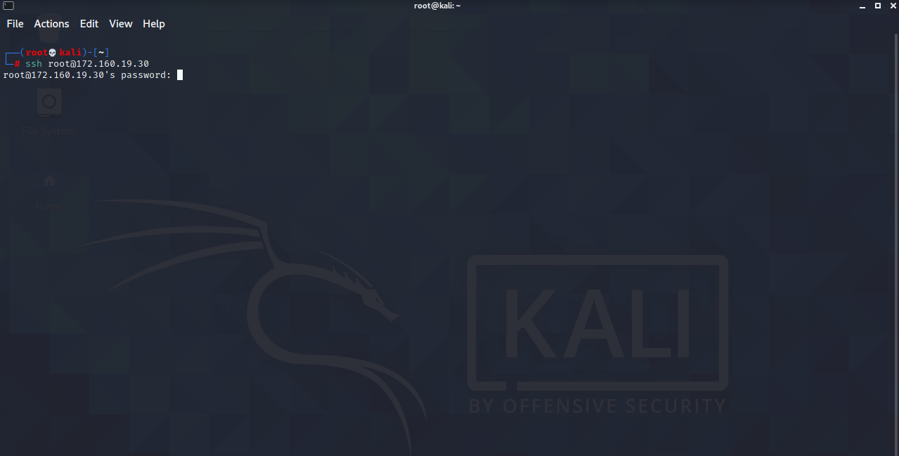

- Now we can see ssh connection request packet in wireshark UI.
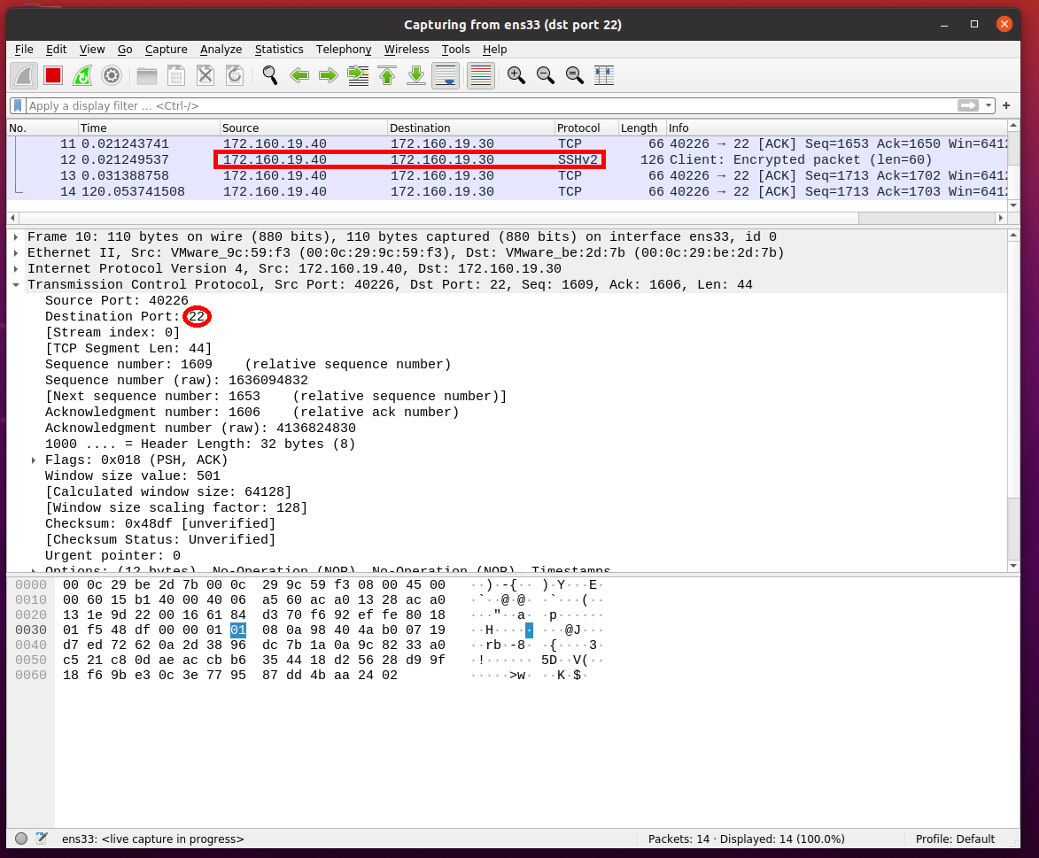

We simulated how to monitor traffic between two nodes via wireshark.

- Simulate web attack and build security system.
Web services often hosted as 80 port.
When they attack, they use that port and send attack http request.
First, simulate web attack in Kali.
We can simulate web attack using tools inside Kali.
There are many good tools to test, scan and attack web sites and we can test by using any of them.
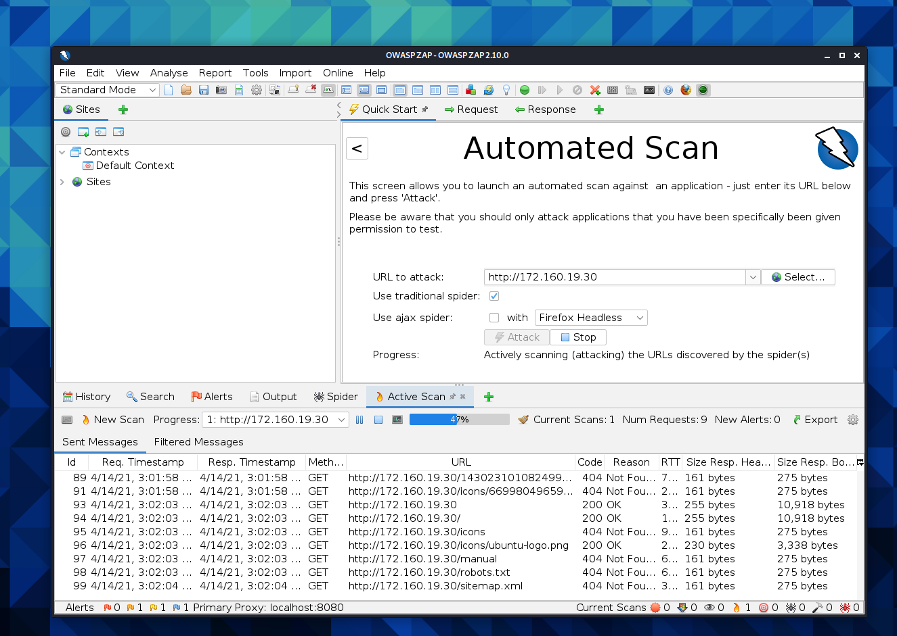

Second, detect web attack using wireshark.
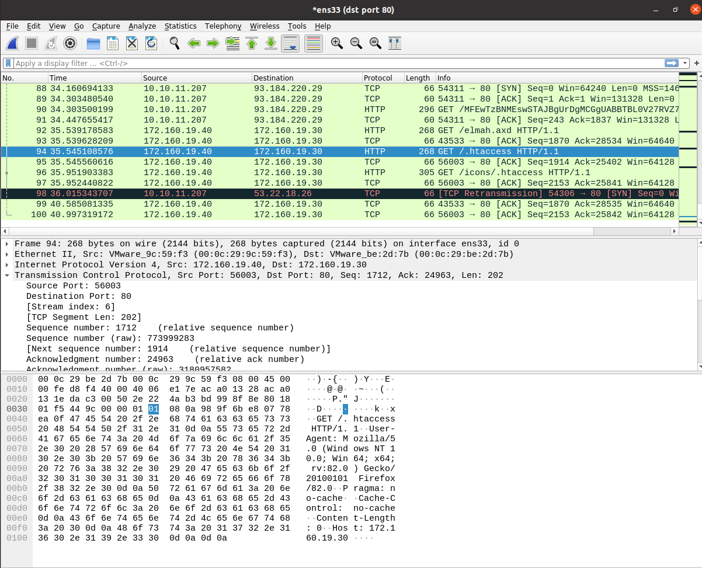

- Too much traffic at short time means attack.
If person access to site, the request created and not so fast.
But if one need attack tool, it will make much traffic in few seconds.
So we can detect easily auto access such as web attack and stop it.
- Analysis traffic.
There are several types of web attack and if we need stop it perfectly, we have to analysis all traffic but it is too difficult as manual and it will affect to web server performance.
So it is good to use standard tool to detect real time.
Last, build security system
There are several methods to prevent web attack.
- Use standard web application firewall.
Modsecurity is well known WAF(web application firewall) and help you to build easily web security system.
- Build security system as manual using iptables.
Iptables can manage all traffic and it allows accept or drop packets by its setting rule.
- Drop traffic by IP address.
After detecting source address of attacker through wireshark, we can drop all traffics from it.
# iptables -A INPUT -p tcp -s ATTACKER_IPADDRESS[172.160.19.40] -j DROP
[-p mean protocol, -s mean source address of packet, -j mean jump]
That iptables rules will drop all traffics from ATTACKER_IPADDRESS.
- Drop traffic by port.
We can build web security by allow port of trustable IP address.
# iptables -P INPUT DROP
[-P mean default rules of INPUT chain]
This will drop all input traffics.
# iptables -A -p tcp -s ALLOW_ADDRESS –dport 80 -j ACCEPT.
[--dport means destination port of traffic]
After that rule, only allowed address can access that port.

That’s all and thanks for your reading.

