- What are the database requirements? (for example)
- The university offers one or more programs.
- A program is made up of one or more courses.
- A student must enroll in a program.

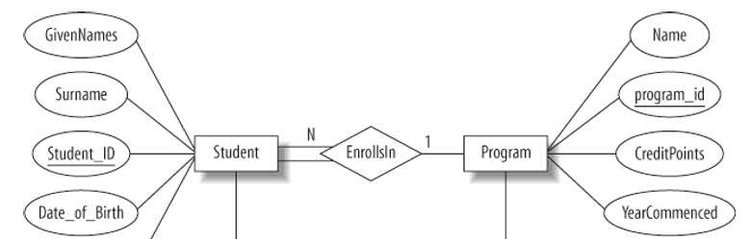
- We need the ER diagram derived from database requirements (for example)

- What are the entities sets in the database? For example
  - Student
  - Department
  - Course
  - Instructor

- What are the attributes in the database? For example
  - Student:
Student name, Student ID, enrollment date, batch
  - Department:
Department name, Location
  - Course:
Course code, Course name, credit hours, duration, prerequisites
  - Instructor:
Instructor ID, Instructor name, email, room number, telephone

- What are the primary keys? What are the foreign keys?
  - Student ID is the primary attribute for students.
  - The Department name is the primary attribute for the department.
  - Instructor ID is unique for each instructor.
  - Course code is the key attribute for each course.

- What are the relationships between entities? For example:

- One department offers multiple courses, so this is a one to many relationships.

