1. Demonstrate on How to create and setup Metamask account and  
   wallet?

Ans. First Step is Going to Google Chrome Extension. Search Metamask & Download Extension.

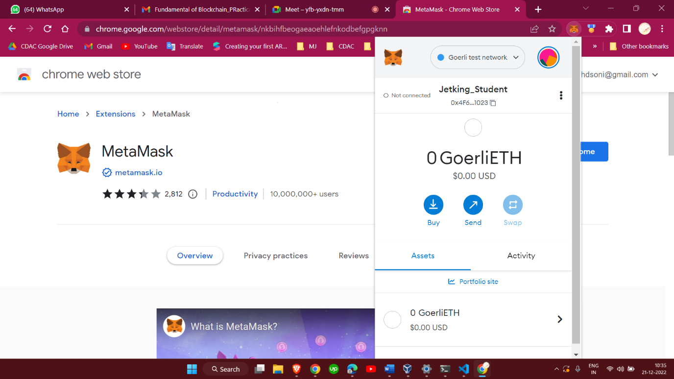

1. How to add and switch main network to Goreli test network in  
   Metamask?

Ans. First Going to Metamask. Tap Network Button. Then Click Show/Hide Button and Click Show Testnetwork. Then Click Add network. Then after scroll down and select Goerli test network.

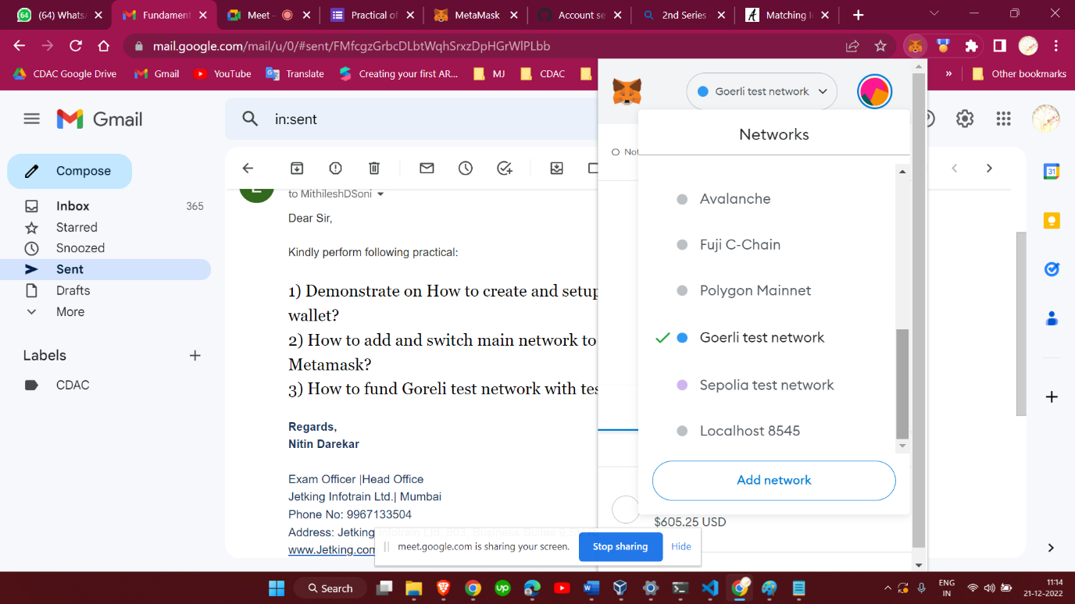

1. How to fund Goreli test network with test ether in Metamask?

If I like to add fund in my Goerli test network then I’ll visit Goreli Facet website.

<https://goerlifaucet.com/>

Now I copy my Goreli Account Hashcode.

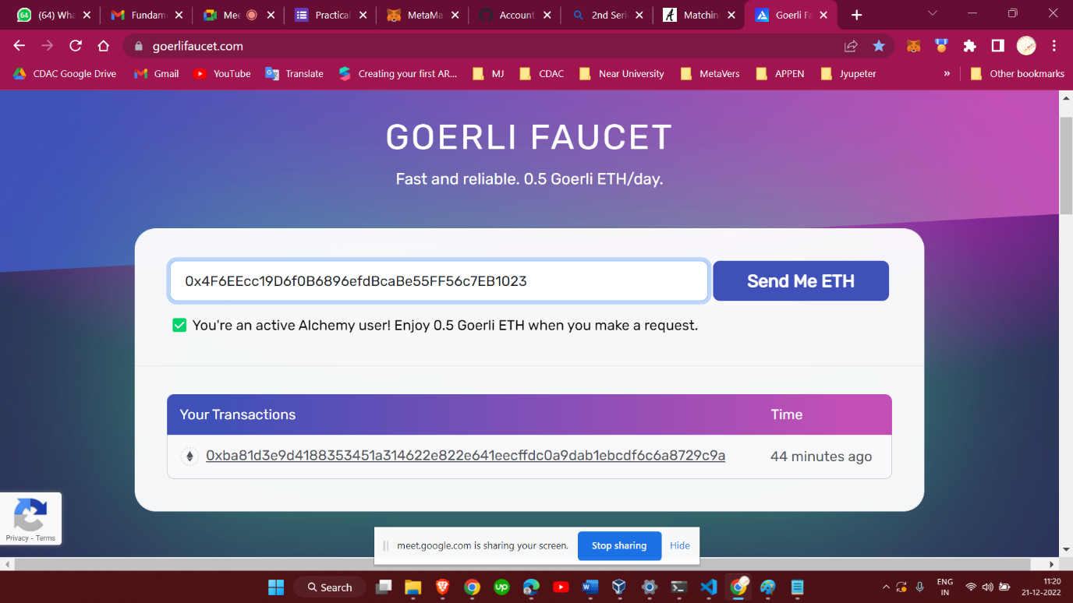

After I pest my Goerli account address, then Goreli Faucet give me test token.

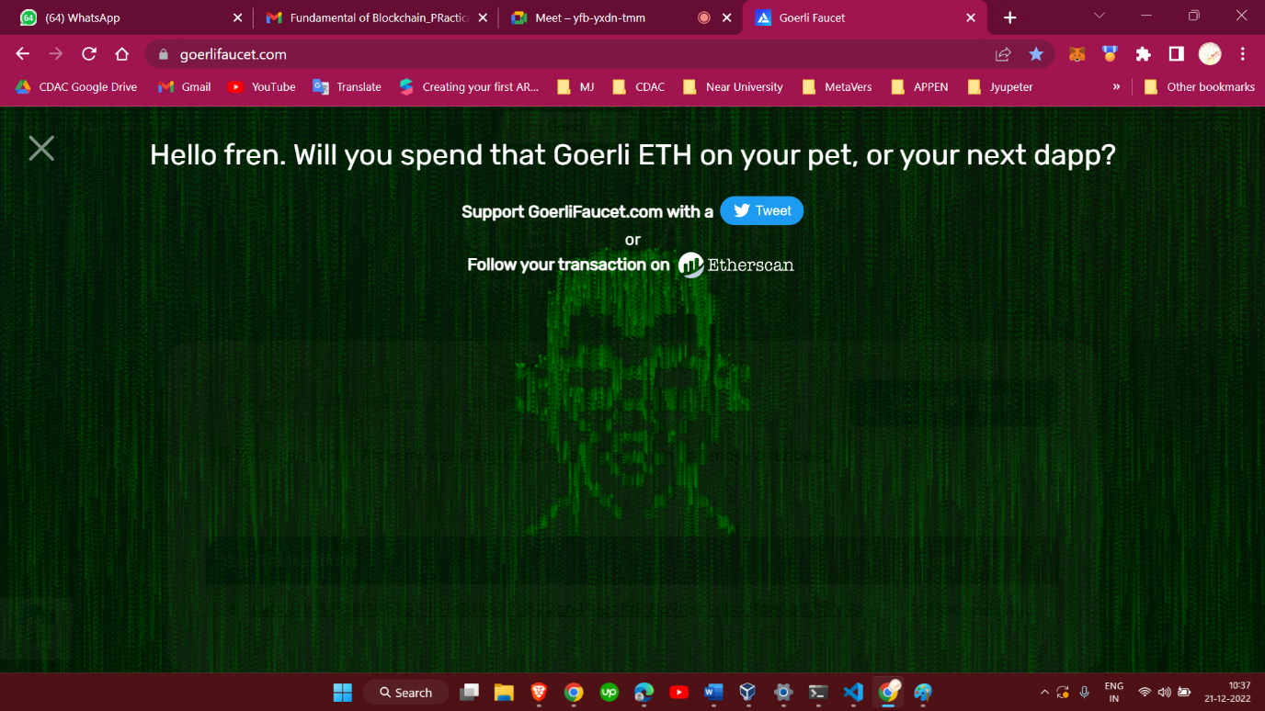

Now I receive Test Token From Goerli Faucet.

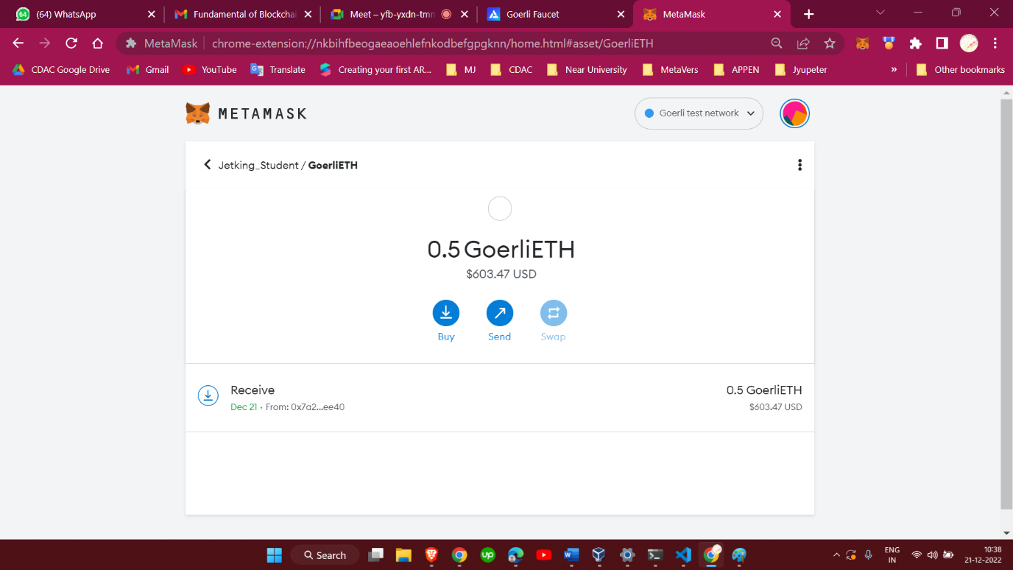

Thanks & Regards,

Mithilesh D Soni