Software Requirements Specification (SRS)

1. Introduction

1.1 Purpose
This document defines the functional and non-functional requirements for the Reconciliation Platform. The system streamlines monthly reporting, reconciliation, invoicing, and collaboration between Dizlee, Zain OpCos, and Partners.

1.2 System Overview
The system is a web application that allows users to:
- Upload and manage monthly Excel reports and invoices
- Consolidate OpCo figures and reconcile OpCo vs Partner data per period
- Create and track invoices (Dizlee → OpCo; Partner → Dizlee) with acknowledgement and payment-confirmation status
- View role-based dashboards and period-based reporting
- Send and track in-app notifications and report reminders
Payment processing happens outside the application; the platform records status and evidence only.

2. Scope

2.1 In scope
- Reconciliation between OpCos and Partners per period (YYYY-MM)
- Report upload, parsing, list/monitoring, and change requests
- Consolidation of OpCo monthly figures
- Invoice lifecycle: Dizlee creates OpCo invoices; Partners upload invoices; acknowledge and payment confirmation
- In-app notifications (compose, attachments, history, read tracking) and report reminders
- Role-based dashboards
- Admin: users, email settings (stored), reminder settings, OpCo–partner links, reconciliation tolerance, currencies/FX, invoice bank details
- Search, sort, and filter within each module (Reports, Invoices, etc.)
- Excel export from Consolidation (and report/invoice downloads as applicable)

3. Stakeholders / User Types
Role (system code) | Organization | Primary activities
DIZLEE | Dizlee | Reconciliation, consolidation, invoices to OpCos, notifications, reporting
OPCO | Zain operating companies | Upload reports; view invoices issued by Dizlee; notifications
PARTNER | External partners | Upload reports and invoices; notifications
ADMIN | Platform administration | Users, settings, links, currencies, tolerance

4. System Modules

4.1 Common functionalities
Feature
Login (email + password, NextAuth JWT)
Main menu navigation (role-based)
Change password
Forgot password

4.2 OpCo module
- Dashboard — submission and invoice summary for the OpCo
- Upload Report — monthly Excel
- Reports history — view/filter own reports; request changes
- Invoices — view Dizlee-issued invoices; acknowledge; confirm payment
- Notifications — inbox, read status

4.3 Partner module
- Dashboard
- Upload Report / Reports history
- Upload Invoice / Invoices list
- Notifications

4.4 Dizlee module
- Dashboard — cross-OpCo and cross-Partner KPIs
- Reports history — all reports; approve/reject change requests
- Invoices — list, create Client→OpCo invoices, monitoring panel
- Reconciliation — compare OpCo vs Partner per lane; confirm
- Consolidation — generate monthly OpCo rollup; export Excel
- Notifications — compose to OpCos/Partners; report reminders; history
- Reporting — period-based invoice/report overview

4.5 Administration module
- User management (create, edit, delete, roles)
- Email notification settings (SMTP fields stored; no outbound send)
- Reminder settings
- OpCo–partner links
- Reconciliation tolerance (%)
- Currencies and USD rates
- OpCo invoice bank details

5. Functional Requirements

5.1 Report handling
- OpCos and Partners shall upload reports in Excel format for a period (YYYY-MM).
- System shall parse line items (usage, optional usage_usd via FX rates).
- Dizlee shall view all reports; OpCo/Partner shall view only their own.
- System shall support report change requests (submit, list pending, approve/reject).
- System shall support consolidation of OpCo figures per period (partner/service grouping).

5.2 Reconciliation
- Dizlee shall reconcile OpCo vs Partner reports for a selected period, OpCo, and Partner.
- System shall compare line items (including USD compare with configurable tolerance %).
- System shall highlight mismatches; on confirm, OpCo value is the confirmed value per business rule.
- One reconciliation record per (period, opco_id, partner_id).

5.3 Invoice management
- Dizlee shall create invoices to OpCos (Client → OpCo).
- Partners shall upload invoices to Dizlee (Partner → Dizlee).
- Invoices shall be tied to period and OpCo/Partner scope.
- System shall track invoice status and payment status on the invoice record (e.g. acknowledge, mark paid / OpCo payment confirmed).
- OpCo and Partner users shall view invoices scoped to their organization only.

5.4 Notifications and reminders
- System shall support in-app notifications to OpCo and Partner users (subject, body, optional attachments).
- System shall maintain notification history and per-recipient read status.
- Admin shall configure reminder settings; Dizlee shall use report reminders (grouped missing uploads).
- Outbound SMTP email is not sent in the current release (see §9).

5.5 Reporting and export
- System shall provide role-based dashboards and a Dizlee Reporting page.
- System shall export Consolidation results to Excel.
- List screens shall support search, sort, and filter within that module.

6. Non-Functional Requirements

6.1 Platform
- Web-based application (Next.js monolith in web/)
- Browser access over HTTPS in production

6.2 Language
- English only (UI)

6.3 UI/UX
- Responsive layout; role-specific navigation

6.4 Performance
- List views shall support pagination, search, sorting, and filtering
- Large Excel parses run in API request (no background job queue today)

6.5 Security
- Role-based access control; OpCo/Partner data isolated by opcoId / partnerId on session

8. Constraints
- System must follow the monthly period and lane model (YYYY-MM, OpCo, Partner).
- System must support multiple OpCos and Partners.
- System must support multiple services/revenue lines within parsed reports.
- Money movement is external; the platform records status only.

9. Planned later
Item | Notes
Outbound email (SMTP) | Admin email settings UI exists; messages are not sent via SMTP. Planned for a later phase.

10. Glossary
Term | Definition
Dizlee | Primary operator; role code CLIENT in the system
OpCo | Zain operating company (e.g. Kuwait, Oman, Sudan)
Partner | External partner (e.g. content provider)
Period | Calendar month: YYYY-MM
Lane | One OpCo + Partner + Period for reporting/reconciliation
Consolidation | Consolidation is the process of taking all OpCo-uploaded monthly reports for one OpCo and one period, and producing one official OpCo-side roll-up of revenue/usage figures.  Each linked Partner has its own OpCo report file for that month. Consolidation combines those separate uploads into a single dataset grouped by:  - Partner  - Service ID  - Description  - Unit  For each group, the system sums local-currency usage and USD amounts (from stored usage_usd or FX conversion).
Reconciliation | OpCo vs Partner compare and confirmed rows for a lane

11. Use Cases
Use cases are separated per actor. Each actor has their own dedicated use case table. Business rules applicable to each use case are included within the use case table.
Common Use Cases

UC-01-COMMON-USECASE: User Login
Element | Detail
Name | User Login
ID | UC-01-COMMON-USECASE
Description | Allows the Admin, Dizlee, Partner, OPCO to authenticate into the system using valid credentials and be redirected to the respective dashboard.
Actors | Admin, Dizlee, Partner, Opco
Organization Benefits | Ensures secure, role-based access for Admin, Dizlee, Partner, Opco
Frequency of Use | Multiple times daily.
Triggers | Admin, Dizlee, Partner, Opco opens the login page and submits credentials.
Preconditions | Admin, Dizlee, Partner, Opco account exists in the system.
Postconditions | Admin, Dizlee, Partner, Opco is authenticated and redirected to the respective dashboard.
Main Course | - The user opens the web application.  - If the user is not signed in, the system displays the login screen.  - The user views the Email field and Password field, a Change user button, a Sign in button, and a Forgot password option.  - User enters email and password  - User fills in Email and Password, then clicks Sign in.  - System validates the entered credentials  - The system checks email and password. The account must be active and not deleted. If invalid, the form shows “Invalid credentials.” and the user stays on the login page.  - System identifies the user’s role  - On success, the system creates a session and reads the role from the account: Admin, Dizlee , OpCo, or Partner  - User is redirected to their home screen  - The system sends the user to their role-specific landing page:
Alternate Course | N/A
Exception Courses | EX1: Invalid credentials entered  - Trigger: User submits email and password, but authentication fails (wrong password, unknown email, inactive account, or deleted account).  - System displays a red error on the sign-in form: “Invalid credentials.”  - User remains on the login page and is prompted to re-enter credentials or use Forgot password?  EX2: Email field is blank  - Trigger: User clicks Sign in without entering an email.  - System displays a field-level validation message on the Email field (browser required-field validation).  - Login is not submitted; user must enter an email before trying again.  EX3: Password field is blank  - Trigger: User clicks Sign in without entering a password.  - System displays a field-level validation message on the Password field (browser required-field validation).  - Login is not submitted; user must enter a password before trying again.  Note: EX2 and EX3 can occur together if both fields are empty the browser blocks submit and highlights the first invalid field.
Business Rules | BR-1: Users shall access the system and its modules based on their assigned role (Admin, Dizlee, OpCo, or Partner) and shall not access modules belonging to another role.  BR-2: Users shall have access to User Management and System Configuration modules.  BR-3: Only ACTIVE users shall be permitted to access the system; INACTIVE and deleted users shall not be allowed access.  BR-4: OpCo users shall only access data belonging to their assigned OpCo. Partner users shall only access data belonging to their assigned Partner.  BR-5: Only Admin users shall be authorized to create, edit, deactivate, or soft-delete user accounts.  BR-6: Each user account shall have a unique email address; duplicate email addresses shall not be permitted.

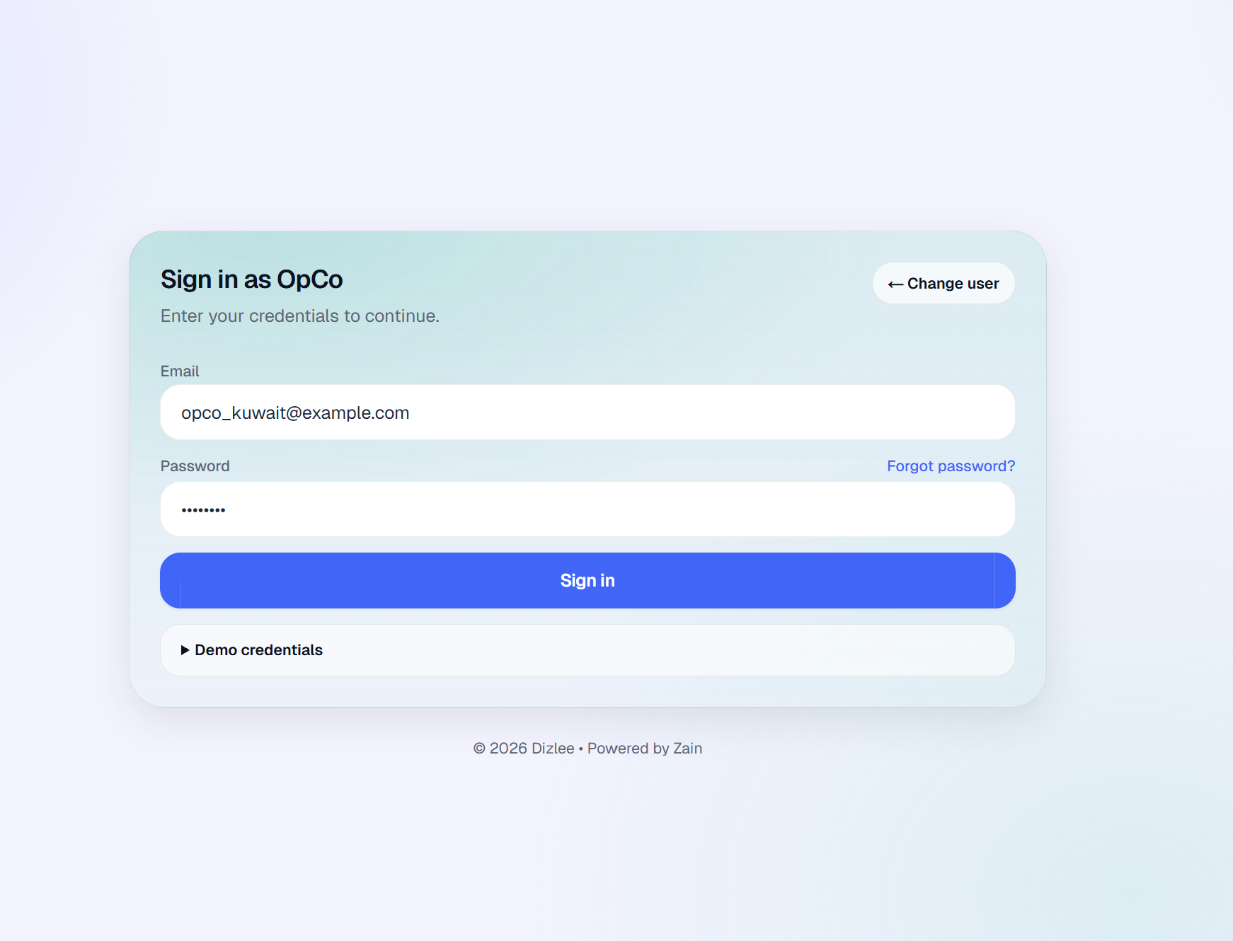

UC-02-COMMON-USECASE: Change Password
Element | Detail
Name | Change Password
ID | UC-02-COMMON-USECASE
Description | Allows the Admin, Dizlee, Partner, Opco to update their account password by providing the current password and a new password.
Actors | Admin, Dizlee, Partner, Opco
Organization Benefits | Enables Admin, Dizlee, Partner, Opco to maintain account security by updating passwords as needed.
Frequency of Use | On demand.
Triggers | Admin, Dizlee, Partner, Opco selects the Change Password option from profile/settings.
Preconditions | Admin, Dizlee, Partner, Opco is logged into the system.
Postconditions | Admin, Dizlee, Partner, Opco shall be able to change the password
Main Course | - User navigates to the Change Password screen  - Signed-in user opens the profile menu (header) and selects Change password from settings. User must already be logged in.  - User enters current password  - User types their existing password in the Current password field.  - User enters new password  - User types a new password in the New password field.  - User confirms new password  - User re-enters the new password in the Confirm new password field.  - System validates that the current password is correct  - System checks the current password against the account. If wrong, change is rejected and user stays on the screen with an error.  - System validates that the new password and confirm password match  - System checks that New password and Confirm new password are identical. If they do not match, change is rejected.  - System updates the password  - If all checks pass, the system saves the new password (hashed) for the user account.  - System displays a success confirmation message  - User sees a success message that the password was updated. They continue using the application with the new password
Alternate Course | AP-1 — User does not know current password  - User opens Change password but cannot enter the current password.  - User goes to Forgot password on the login page  - User receives a reset link by email and sets a new password via Reset password.  - User signs in with the new password.  AP-2 — User cancels change  - User opens Change password.  - User leaves the page (profile menu, sidebar, or browser back) without submitting.  - Password is not changed; the session stays as-is.  AP-3 — User opens Change password while not signed in  - User tries to open /change-password without a session.  - System redirects to login.  - After login, user can open Change password again from the profile menu.  AP-4 — Validation fails, user retries on the same screen  - User submits the form.  - System rejects it (wrong current password, passwords don’t match, or new password fails policy).  - User corrects the fields and submits again (Main Course from step 2).
Exception Courses | EX1: Current password is incorrect  - User submits the form with a wrong current password.  - System rejects the change and displays an error (e.g. current password is incorrect).  - User remains on the Change Password screen and may re-enter credentials or use Forgot password.  EX2: New password and confirm password do not match  - User enters different values in New password and Confirm new password.  - System displays a validation error (e.g. passwords do not match).  - Password is not updated; user must correct the fields and submit again.  EX3: Current password field is blank  - User submits without entering the current password.  - System displays a field-level validation message and does not update the password.  EX4: New password field is blank  - User submits without entering a new password.  - System displays a field-level validation message and does not update the password.  EX5: Confirm new password field is blank  - User submits without confirming the new password.  - System displays a field-level validation message and does not update the password.  EX6: New password does not meet password policy  - User enters a new password that fails policy (e.g. fewer than 8 characters, or missing uppercase, lowercase, number, or special character).  - System displays a validation error describing the requirement.  - Password is not updated until a compliant password is entered.  EX7: User is not signed in  - User tries to open Change Password without an active session.  - System redirects to the login page.  - Password is not changed until the user signs in and opens Change Password again.
Business Rules | BR-1: A user may change only their own account password; one user may not change another user’s password on their behalf through self-service.  BR-2: Only users who are eligible for platform access (active, not removed from the platform) may change or maintain their account password.  BR-3: All platform passwords must comply with the organization’s defined password complexity policy (minimum length and character-type requirements).

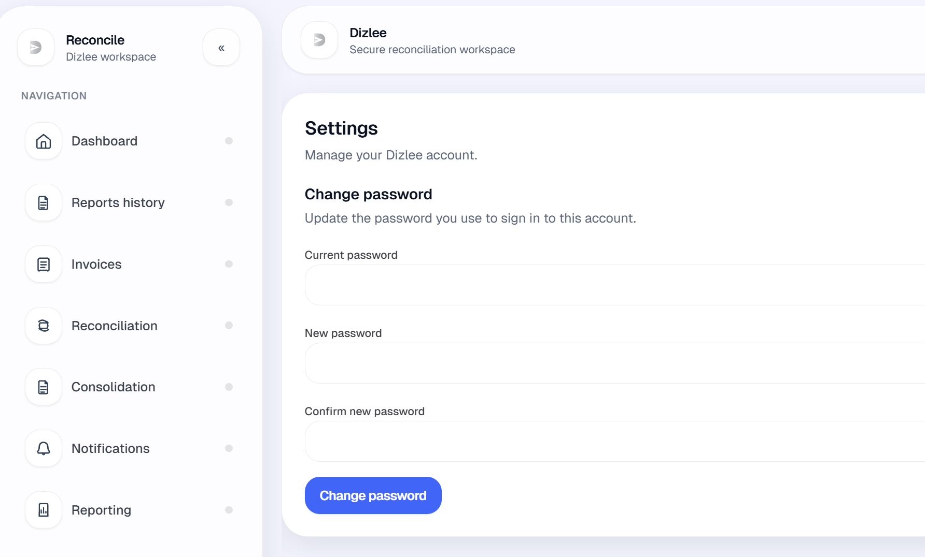
UC-03-COMMON-USECASE: Forgot Password
Element | Detail
Name | Forgot Password
ID | UC-03-COMMON-USECASE
Description | Allows the Admin to initiate a standard password reset process via their registered email.
Actors | Admin, Dizlee, Partner, Opco
Organization Benefits | Provides a self-service recovery mechanism to avoid account lockouts.
Frequency of Use | On demand.
Triggers | Admin, Dizlee, Partner, Opco selects 'Forgot Password' on the login page.
Preconditions | Admin, Dizlee, Partner, Opco account exists in the system.
Postconditions | Admin, Dizlee, Partner, Opco shall be able to change password
Main Course | - User clicks Forgot password? on the login page.  - The system displays the Forgot Password screen.  - User enters their registered email address.  - System validates internally whether a matching account exists.  - If the account exists and is eligible, the system sends a password reset link to that registered email.  - System displays: “Password reset instructions have been sent to your registered email.”  - User opens the email and clicks the password reset link.  - System validates that the reset link is valid and not expired.  - System displays the Reset Password screen.  - User enters a new password.  - User confirms the new password.  - System validates that the new password and confirm password match and meet password policy.  - System updates the password and displays: “Your password has been reset successfully. Please login with your new password.”
Alternate Course | AP1 — User returns to login without resetting  - User opens Forgot Password.  - User clicks Back to login without submitting, or abandons the flow.  - No reset email is sent; password is unchanged.  AP2 — User remembers password before completing reset  - User is on Forgot Password or Reset Password.  - User goes to login and signs in with the existing password.  - No password change occurs unless reset is completed.  AP3 — Reset link expired or already used; user requests a new link  - User clicks an expired or used reset link.  - System rejects the link.  - User returns to Forgot password, enters email again, and receives a new link (if eligible).  AP4 — User completes reset and signs in with new password  - User completes Main Course through step 13.  - User goes to login.  - User signs in with the new password (Main Course — Sign-in).
Exception Courses | EX1: Email field is blank  - User submits without entering an email.  - System displays a field-level validation message.  - No reset email is sent.  EX2: Email format is invalid  - User enters an invalid email (e.g. missing @).  - System displays a field-level validation message.  - No reset email is sent.  EX3: No eligible account matches the email  - User submits an email that is not registered or not eligible for recovery.  - System does not disclose that the account does not exist.  - System may still display the same confirmation message; no reset email is sent.  EX4: Reset link is missing, invalid, expired, or already used  - User opens Reset Password without a valid token, or uses an expired/used link.  - System displays an error (e.g. link invalid or expired).  - Password is not updated; user must request a new link.  EX5: New password and confirm password do not match  - User submits different values in the two password fields.  - System displays a validation error (e.g. passwords do not match).  - Password is not updated.  EX6: New password does not meet password policy  - User enters a password that fails policy (e.g. fewer than 8 characters, or missing required character types).  - System displays a validation error.  - Password is not updated.  EX7: New password or confirm password field is blank  - User submits with one or both password fields empty.  - System displays a field-level validation message.  - Password is not updated.
Business Rules | BR-01: A user may recover access only for their own account, using the email address registered to that account.  BR-02: Only users who are eligible for platform access (registered on the platform and not removed) may receive password recovery.  BR-03: All platform passwords must comply with the organization’s password complexity policy.  BR-04: Password recovery is permitted only when the user can demonstrate control of the registered email address (via the reset link sent to that address)  BR-05: A password reset link issued after Forgot password is valid for 24 hours from the time it is generated. After expiry, the link cannot be used; the user must request a new reset link. Each link is single-use, once a new password is set successfully, that link is invalidated.

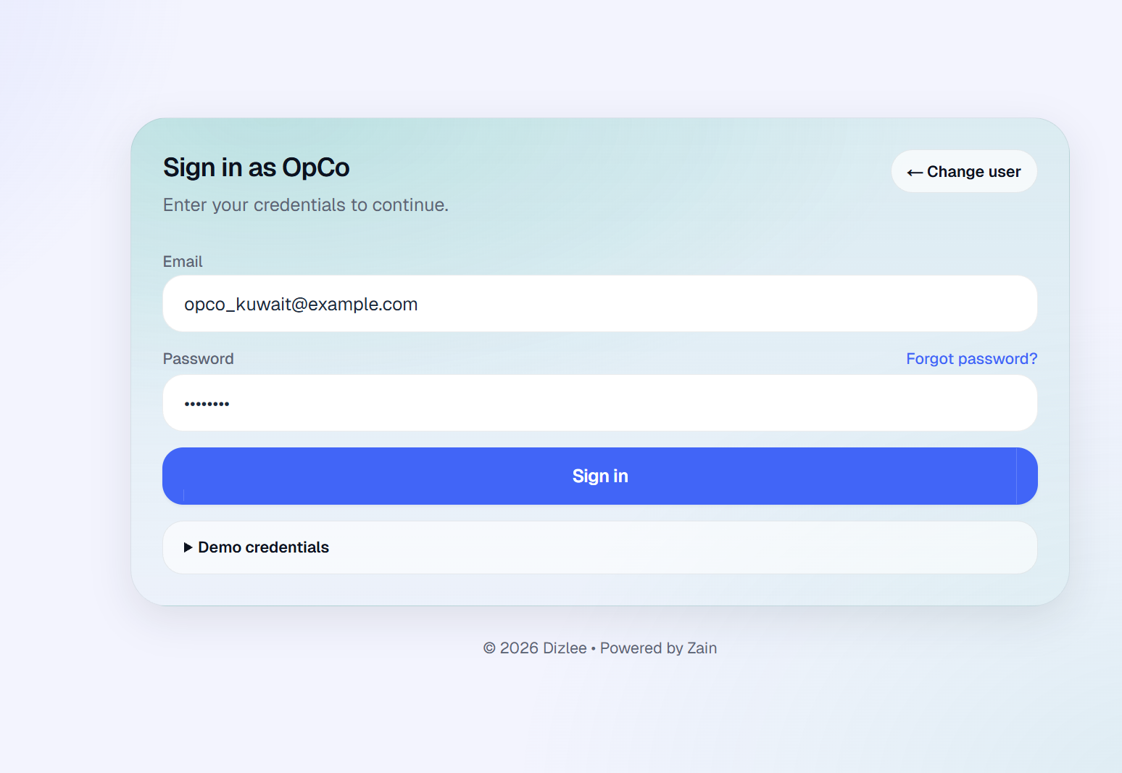
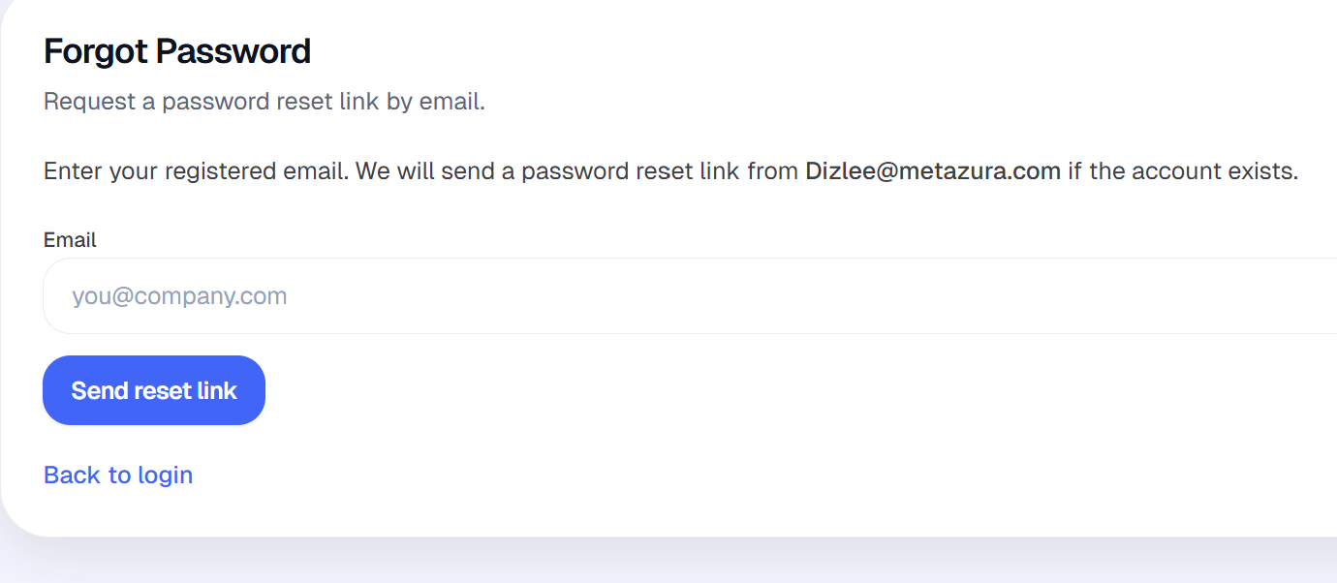

11.1 Admin Use Cases
UC-01-ADMIN: Access Side Navigation Bar
Element | Detail
Name | Access Side Navigation Bar
ID | UC-01-ADMIN
Description | Allows the Admin to navigate to different modules within the system using the side navigation bar.
Actors | Admin
Organization Benefits | Provides efficient navigation to User Management and System Configuration modules.
Frequency of Use | Multiple times per session.
Triggers | Admin opens the application or interacts with the side navigation bar.
Preconditions | Admin is logged into the system.
Postconditions | Admin is navigated to the selected module.
Main Course | - Admin signs in and is redirected to User Management (Admin landing screen after login).  - The system wraps Admin screens in the shared workspace shell with workspace title “Admin”.  - On large screens and above, the system displays the left sidebar.  - The sidebar shows:  - Dizlee logo  - “Reconcile” and “Admin workspace” when expanded  - Section label “NAVIGATION”  7 navigation items in this order:  Audit logs  Users  Email Settings  Email Templates  Reminder Settings  OpCo partners  Reconciliation tolerance  Each item shows an icon; expanded mode also shows the label. Collapsed mode shows icon only with a tooltip on hover.  - Admin clicks the desired navigation item.  - The system opens the selected module in the main content area with its page title and content.  - The clicked item is highlighted as active when it matches the current screen exactly.  - Also shown (not part of the 9 navigation items):  - Top header: Dizlee branding, Search button (not linked to navigation), profile menu with name, email, Change password, and Log out. No notifications bell for Admin.  - Sidebar footer: Settings is shown as “Settings”  - Currencies & USD rates  Invoice bank details
Alternate Course | AC1: Admin is already on the selected screen  - Admin clicks the navigation item for the screen already open.  - The item remains active.  - No change of module occurs.  AC2: Admin collapses the sidebar  - Admin clicks Collapse in the expanded sidebar.  - Sidebar shrinks to icon-only mode; labels are hidden.  - Collapsed state is remembered for the next visit.  - Navigation items still work the same way.  AC3: Admin expands the sidebar from collapsed state  - Admin clicks Expand on the sidebar edge.  - Sidebar expands with labels visible again.  - Expanded state is remembered for the next visit.
Exception Courses | EX1: Screen smaller than large breakpoint  - The side navigation bar is not displayed.  - Admin cannot use sidebar navigation on smaller screens in the current build.  - No mobile menu or drawer is implemented.  EX2: Admin session is missing or expired  - Admin tries to open an Admin module without a valid session.  - System redirects to the login screen.  - Side navigation is not shown until Admin signs in again.  EX3: Admin clicks Settings in the sidebar footer  - Settings is disabled for Admin.  - No navigation occurs.
Business Rules | BR-1: Users shall access the system and its modules based on their assigned role; Admin navigation shows only Admin modules.  BR-2: Admin shall have access to User Management and System Configuration modules (Audit logs, Email Settings, Email Templates, Reminder Settings, OpCo partners, Reconciliation tolerance, Currencies & USD rates, Invoice bank details).

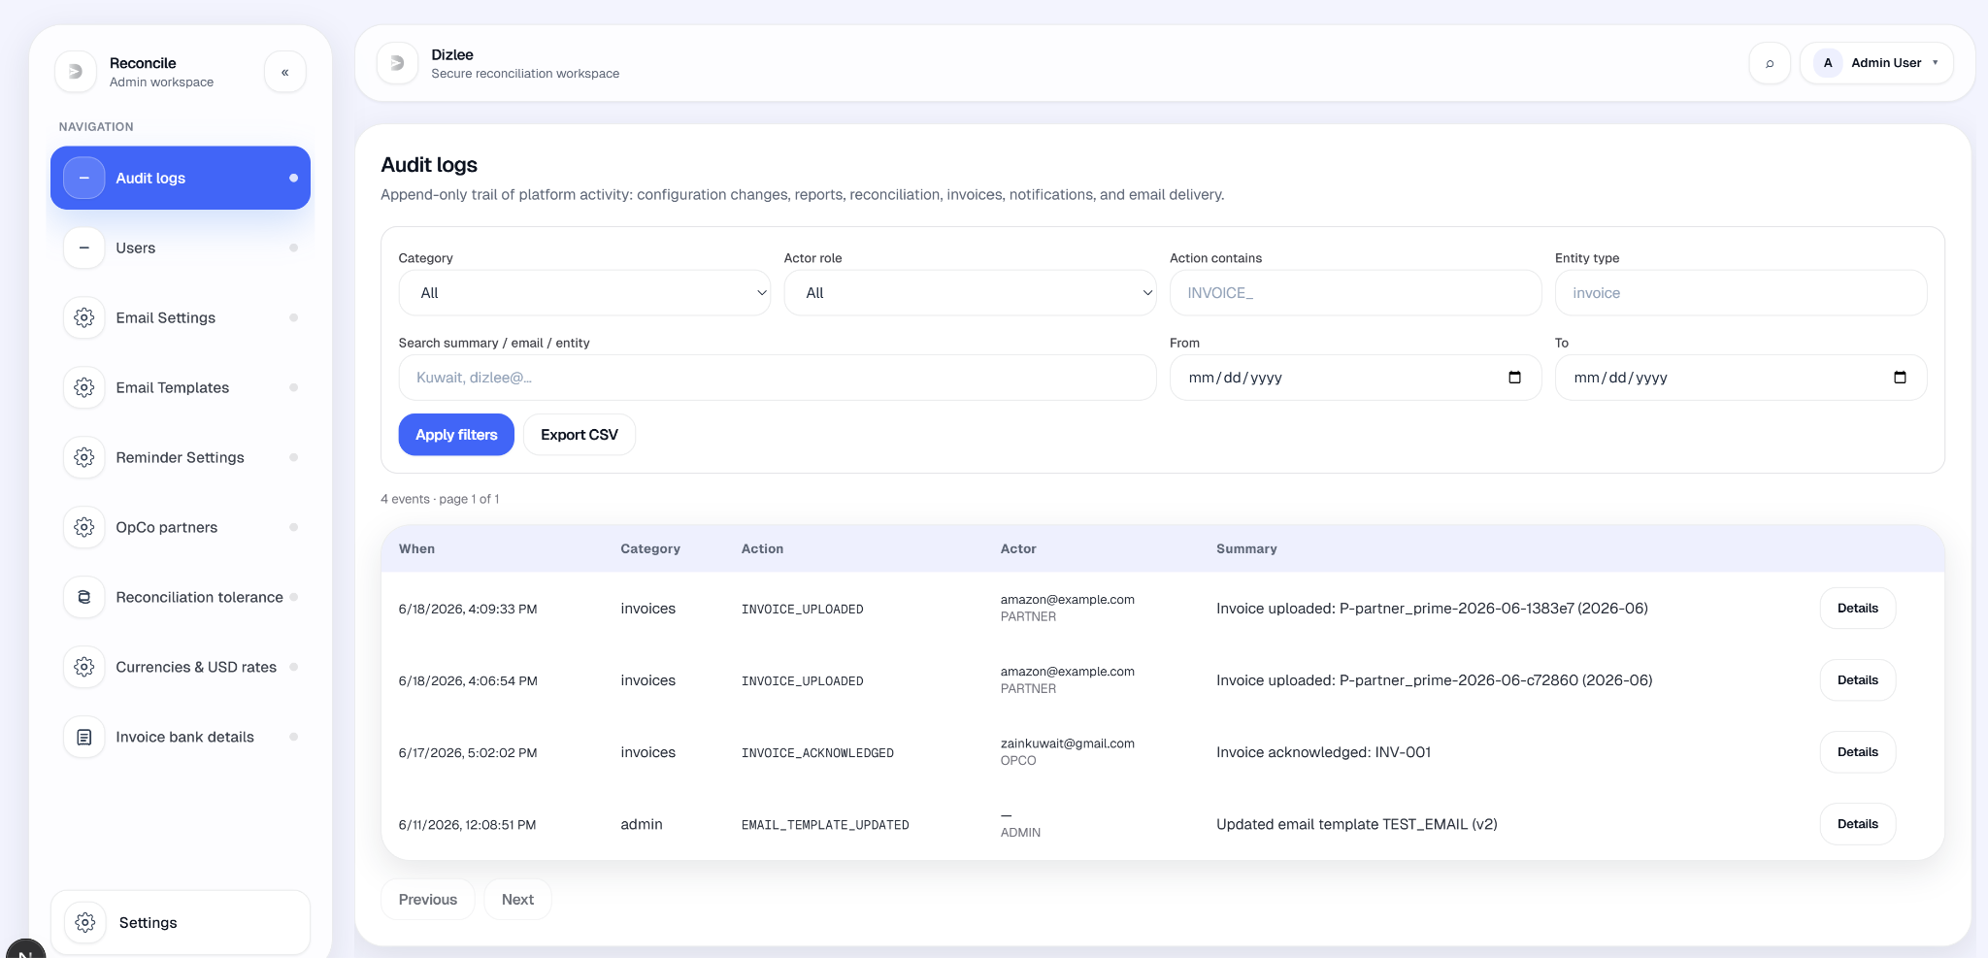

UC-02: Create User
Element | Detail
Name | Create User
ID | UC-02
Description | Allows an Admin to create a new user account by entering user details and assigning a role.
Actors | Admin
Organization Benefits | Enables controlled onboarding of system users with appropriate role-based access.
Frequency of Use | On demand.
Triggers | Admin selects 'Create User'.
Preconditions | Admin is logged in.
Postconditions | New user account is created and saved in the system.
Main Course | - Admin navigates to User Management from the side navigation (Users).  - Admin clicks Create user (top-right of the screen).  - System opens the Create user modal with description: “Required fields must not be blank (per SRS validation rules).”  - Admin enters Name.  - Admin enters Email (email-type field).  - Admin selects Role from: Dizlee (CLIENT), OPCO, or PARTNER.  - (Admin role is not offered in this modal, comment in system: Admin accounts are managed separately.)  - Admin selects Status: ACTIVE or INACTIVE (default ACTIVE).  - System validates that Name and Email are not blank (server-side).  - System checks that the email is not already used by an active (non-deleted) accoutt.  - System saves the new user with the selected role and status.  - (No password is captured or set in this flow.)  - System writes an audit log entry for user creation.  - System closes the modal, shows toast “User created.”, and refreshes the users table with the new row (Name, Email, Role, Status).
Alternate Course | AC1: Admin cancels without creating  - Admin opens the Create user modal.  - Admin closes the modal (without clicking Create).  - No user is created; the users table is unchanged.
Exception Courses | EX1: Name is blank  - Admin clicks Create with an empty Name.  - System returns validation error with message “Name is required.” (shown in error toast).  - User is not created; modal stays open.  EX2: Email is blank  - Admin clicks Create with an empty Email.  - System returns validation error with message “Email is required.” (shown in error toast).  - User is not created; modal stays open.  EX3: Email already exists  - Admin enters an email already used by an existing active user.  - System returns error “Email already exists.” (shown in error toast).  - User is not created; modal stays open.  EX4: Email format is invalid  - Admin enters an invalid email in the Email field (e.g. missing @).  - Browser email validation may block submit, or invalid value is sent and creation fails.  - User is not created until a valid email is entered.  EX5: Non-Admin attempts create  - A non-Admin session calls the create-user action.  - System rejects the request (Admin role required).  - No user is created.
Business Rules | BR-1: Only Admin shall create user accounts.  BR-2: Duplicate email addresses shall not be allowed when creating a user.  BR-3: Users shall be assigned a role at creation; Create User offers Dizlee, OpCo, or Partner only (Admin accounts are not created through this screen).

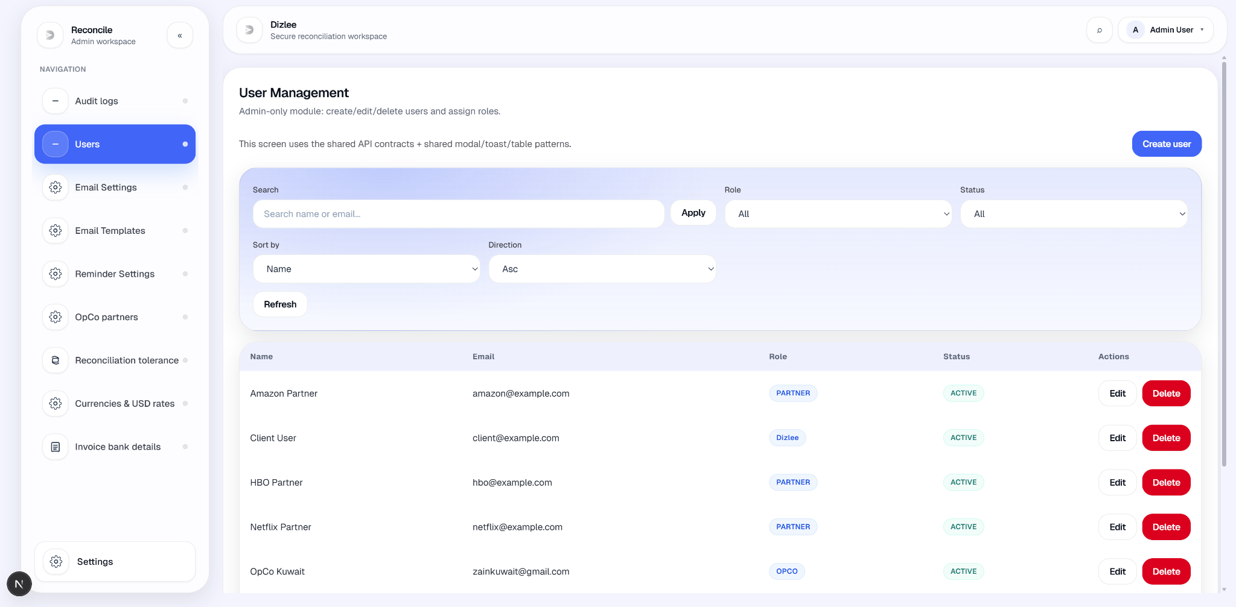
UC-03: Edit User
Element | Detail
Name | Edit User
ID | UC-03
Description | Allows an Admin to modify an existing user's details.
Actors | Admin
Organization Benefits | Enables Admin to keep user records accurate and up to date.
Frequency of Use | On demand.
Triggers | Admin selects 'Edit User' for an existing user.
Preconditions | Admin is logged in; the user record exists, is not soft-deleted, and is listed on User Management (Admin accounts are not shown in this list).
Postconditions | User details are updated and saved; audit entry USER_UPDATED is written (before/after snapshot); table refreshes; toast “User updated.” is shown.
Main Course | - Admin navigates to User Management from the side navigation (Users).  - Admin locates the user in the table (columns: Name, Email, Role, Status, Actions). Optional filters: search text, role, status, sort.  - Admin clicks Edit in that row’s Actions column.  - System opens the Edit user modal with  - description: “Update requires selecting an existing record (per SRS validation rules).”  - System pre-fills the user’s current Name, Email, Role, and Status.  - Admin modifies one or more fields:  - Name  - Email (email-type field)  - Role: Dizlee, OPCO, or PARTNER only (Admin is not in the role dropdown)  - Status: ACTIVE or INACTIVE  - Admin clicks Save.  - System checks the user still exists and is not soft-deleted.  - If email was changed, system checks the new email is not already used by another active user.  - System saves the updated fields and writes audit log USER_UPDATED with before/after values.  - System closes the modal, shows toast “User updated.”, and refreshes the users table with the updated row.
Alternate Course | AC1: Admin cancels without saving  - Admin opens Edit user.  - Admin closes the modal without clicking Save.  - No changes are saved; the table is unchanged.  AC2: Admin saves with no effective change  - Admin opens Edit user and clicks Save without changing values.  - System still runs the update and audit log.  - User record remains the same; success toast is shown.
Exception Courses | EX1: Name or Email cleared to blank  - Admin clears Name or Email and clicks Save.  - System does not apply empty Name or Email to the update (those fields are skipped server-side).  - Other fields (e.g. Role, Status) may still be saved; no dedicated “field required” message is shown on edit.  EX2: Email changed to an address already in use  - Admin changes Email to one already used by another active user.  - System returns “Email already exists.” (error toast).  - Update does not proceed; modal stays open.  EX3: User record not found or soft-deleted  - Admin attempts to save edits for a user that no longer exists or was soft-deleted.  - System returns “User not found.” (error toast).  - Update does not proceed.  EX4: Non-Admin attempts update  - A non-Admin session attempts the update action.  - System rejects the request (Admin role required).  - No changes are saved.  EX5: Invalid email format  - Admin enters an invalid email.  - Browser email validation may block save, or invalid value is rejected on save.  - Update does not complete until email is valid.
Business Rules | BR-1: Only Admin shall edit user accounts.  BR-2: Duplicate email addresses shall not be allowed when updating a user’s email.  BR-3: Users shall retain a valid assigned role after editing; Edit User allows Dizlee, OpCo, or Partner only (Admin accounts are not managed on this screen).

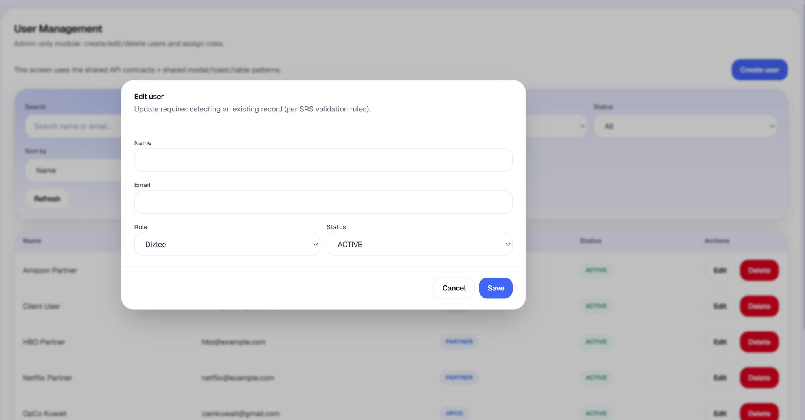
UC-04: Delete User
Element | Detail
Name | Delete User
ID | UC-04
Description | Allows Admin to remove an existing Dizlee, OpCo, or Partner user account from active use.
Actors | Admin
Organization Benefits | Enables Admin to remove inactive or unauthorized users from portals while keeping records for audit and compliance..
Frequency of Use | On demand.
Triggers | Admin selects 'Delete User' for an existing user.
Preconditions | Admin is logged in; the user exists, is not soft-deleted, is not an Admin account, and appears in the User Management list.
Postconditions | User is deleted: hidden from portals and the User Management list, status set to INACTIVE, login disabled (password cleared); record is retained in the database; audit entry USER_DELETED is written; success toast “User deleted.” is shown.
Main Course | - Admin navigates to User Management from the side navigation (Users).  - Admin locates the user in the table (Name, Email, Role, Status, Actions).  - Admin clicks Delete in that row’s Actions column.  - System opens the Delete user confirmation modal with:  - Title: Delete user  - Description: “Are you sure you want to delete [user’s email]?”  - Body text: “The user will be removed from all portals but their record is kept in the database for audit and compliance.”  - Admin clicks Delete in the modal footer to confirm.  - System soft-deletes the user (sets deleted timestamp, marks INACTIVE, clears password hash, records who deleted).  - System writes audit log USER_DELETED (noted as soft delete).  - System closes the modal, shows toast “User deleted.”, and refreshes the users table (deleted user no longer appears).
Alternate Course | AC1: Admin cancels the deletion  - Admin opens the Delete user modal.  - Admin closes the modal without clicking Delete.  - No change is made; the user record stays active.
Exception Courses | EX1: User record not found  - Admin confirms delete for a user that no longer exists.  - System shows error toast “User not found.”  - Deletion does not proceed.  EX2: User is already deleted  - Admin attempts to delete a user already soft-deleted.  - System returns “User not found.”  - Deletion does not proceed.  EX3: Target user is an Admin account  - Admin attempts to delete an Admin user.  - System returns “Admin users cannot be deleted.”  - Deletion does not proceed. (Admin users are not shown in the User Management list in normal use.)  EX4: Admin attempts to delete their own account  - Admin confirms deletion of the account they are logged in with.  - System returns “You cannot delete your own account.”  - Deletion does not proceed.  EX5: Non-Admin attempts delete  - A non-Admin session attempts the delete action.  - System rejects the request (Admin role required).  - No user is deleted.
Business Rules | BR-01: Only Admin shall delete (deactivate/remove) user accounts.  BR-02: Deleted user records shall be retained in the system for audit and compliance; deletion is a soft remove from portals, not permanent erasure.  BR-03: Admin user accounts shall not be deleted through this action.  BR-04: An Admin shall not delete their own account while logged in.

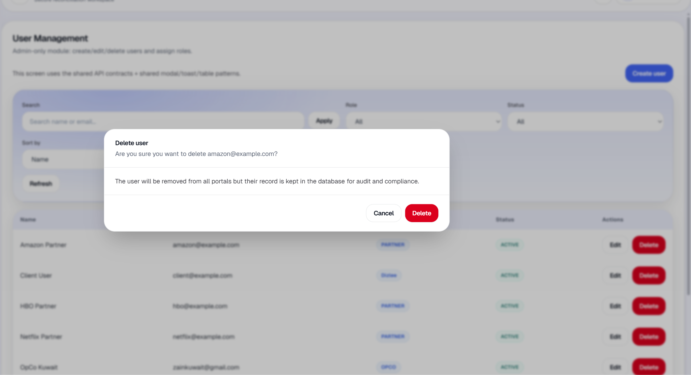
UC-05: Set Email Notification Settings
Element | Detail
Name | Set Email Notification Settings
ID | UC-05
Description | Allows Admin to view and save platform email/SMTP notification settings stored in the database, and optionally send a test email to verify delivery.
Actors | Admin
Organization Benefits | Admin can configure outbound email behaviour (enable/disable, sender, SMTP host/port) and verify SMTP before notifications and reminders use it.
Frequency of Use | On demand / during initial setup.
Triggers | Admin can configure outbound email behaviour (enable/disable, sender, SMTP host/port) and verify SMTP before notifications and reminders use it..
Preconditions | Admin is logged in.
Postconditions | Admin can configure outbound email behaviour (enable/disable, sender, SMTP host/port) and verify SMTP before notifications and reminders use it.
Main Course | - Admin navigates to Email Notification Settings from the side navigation (Email Settings).  - System displays the settings form inside page Email Notification Settings with description: “Admin-only system setting.”  - System loads current saved values (or defaults if none):  - Enabled -Disabled or Enabled  - Sender address (placeholder example: dizlee@metazura.com)  - SMTP host (placeholder example: smtp.titan.email)  - SMTP port (placeholder example: 587)  - On-screen note: outbound mail is sent as Dizlee;  - SMTP username and password are set in server environment variables, not stored in the database.  - Admin updates one or more fields.  - Admin clicks Save.  - System persists Enabled, Sender address, SMTP host, and SMTP port to the application settings record.  - System writes audit log SETTINGS_EMAIL_UPDATED.  - System shows toast “Email settings saved.”
Alternate Course | AC1: Admin reloads without saving  - Admin changes fields but clicks Reload instead of Save.  - System reloads settings from the database.  - Unsaved changes in the form are discarded.  AC2: Admin sends a test email after saving  - Admin sets Enabled to Enabled and saves.  - Admin enters a recipient in Send test email to.  - Admin clicks Send test email.  - System sends a test message using the configured SMTP (and env credentials).  - System shows success toast with recipient confirmation, or an error if send fails.  - Audit entry EMAIL_TEST_SENT is written on success.  - (Send test email button is disabled when email is Disabled, busy, or test recipient is blank.)
Exception Courses | EX1: Configuration fields left blank on save  - Admin leaves Sender address, SMTP host, or SMTP port blank and clicks Save.  - System still saves (blank values stored as empty/null).  - No “must not be blank” validation is enforced on save in the current build.  EX2: Settings record missing on load  - System cannot load application settings.  - Screen shows red error panel with the error message.  - Form is not shown.  EX3: Save fails  - Admin clicks Save and the update fails.  - System shows error toast with the failure message.  - Settings are not updated.  EX4: Test email with no recipient  - Admin clicks Send test email with an empty recipient (if enabled).  - System shows toast “Enter the email address to receive the test.”  - No test email is sent.  EX5: Test email send fails  - Admin sends a test email but SMTP/env configuration is wrong or mail cannot be delivered.  - System shows error toast with send failure message.  - Saved settings remain unchanged.  EX6: Non-Admin attempts access  - A non-Admin session tries to open or save email settings.  - System rejects the request (Admin role required).  - Settings are not shown or saved.
Business Rules | BR-01: Admin shall have access to System Configuration modules, including Email Notification Settings.  BR-02: SMTP authentication credentials (username/password) shall not be stored in the database; they shall be configured only in server environment variables.

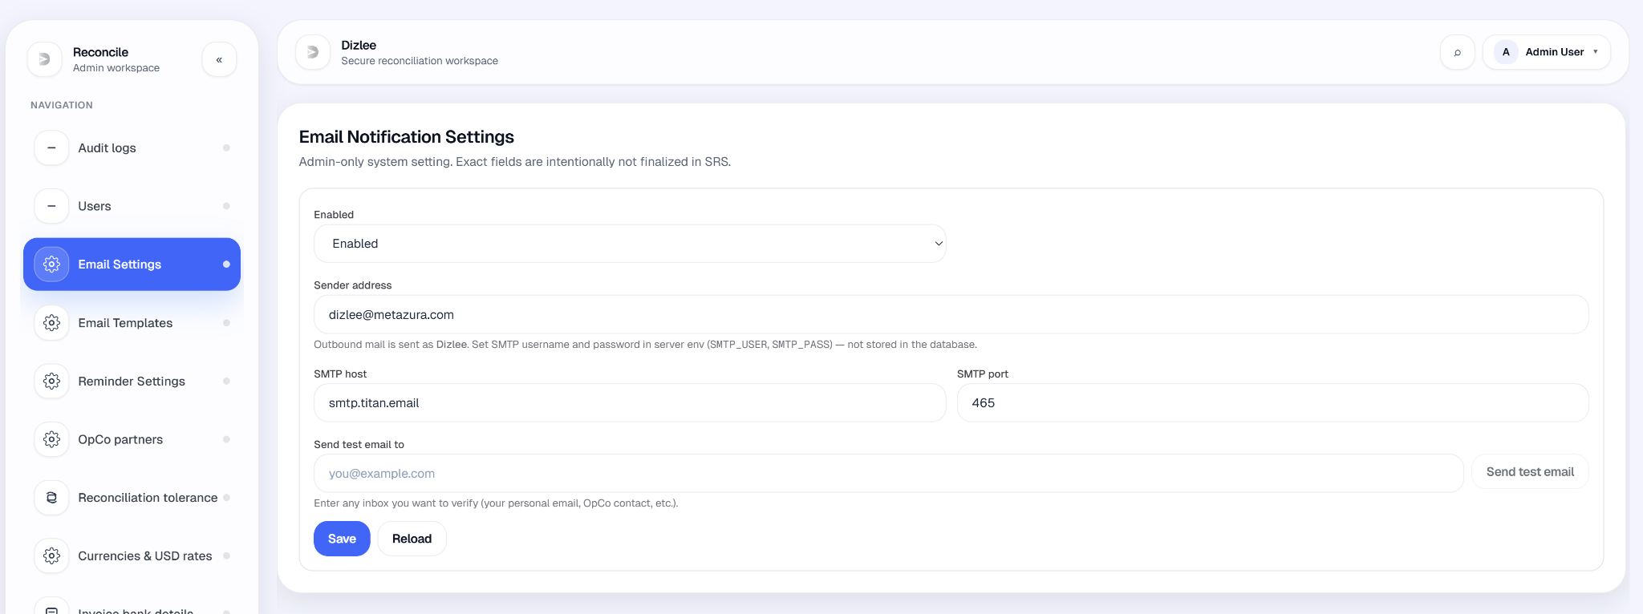
UC-06: Set Reminder Settings
Element | Detail
Name | Set Reminder Settings
ID | UC-06
Description | Allows Admin to configure and save platform reminder settings (enable/disable and reminder value) stored in the database for future automated reminder communications.
Actors | Admin
Organization Benefits | Admin can prepare reminder scheduling configuration (duration value) for follow-up on report and invoice submissions once the reminder unit is finalized.
Frequency of Use | On demand.
Triggers | Admin selects Reminder Settings from the Admin side navigation.
Preconditions | Admin is logged in.
Postconditions | Reminder settings are saved in the database; audit entry SETTINGS_REMINDERS_UPDATED is written; success toast “Reminder settings saved.” is shown.
Main Course | - Admin navigates to Reminder Settings from the side navigation (Reminder Settings).  - System displays the Reminder Settings page with description: “Admin-only system setting.  - Reminder duration/unit is intentionally open in SRS.”  - System loads current saved values:  - Enabled - Disabled or Enabled  - Reminder value - numeric (placeholder example: 3)  - Reminder unit - TBD (only option available)  - Admin updates Enabled and/or Reminder value.  - Admin clicks Save.  - System persists Enabled, Reminder value, and Reminder unit (always stored as TBD) to the application settings record.  - System writes audit log SETTINGS_REMINDERS_UPDATED.  - System shows toast “Reminder settings saved.”
Alternate Course | AC1: Admin reloads without saving  - Admin changes fields but clicks Reload instead of Save.  - System reloads settings from the database.  - Unsaved changes are discarded.
Exception Courses | EX1: Reminder value left blank on save  - Admin leaves Reminder value empty and clicks Save.  - System still saves (reminder value stored as empty/null).  - No “Reminder Duration is required.” message is shown in the current build.  EX2: Settings record missing on load  - System cannot load application settings.  - Screen shows red error panel with the error message.  - Form is not shown.  EX3: Save fails  - Admin clicks Save and the update fails.  - System shows error toast with the failure message.  - Settings are not updated.  EX4: Non-Admin attempts access  - A non-Admin session tries to open or save reminder settings.  - System rejects the request (Admin role required).  - Settings are not shown or saved.
Business Rules | BR-01: Admin shall have access to System Configuration modules, including Reminder Settings.  BR-02: The organization shall be able to configure reminder duration settings for notifications

UC-07: Send Automatic Submission Reminders
Element | Detail
Name | Send Automatic Submission Reminders
ID | UC-07
Description | The system automatically identifies missing report (and optionally invoice) uploads for the active period and sends reminders to OpCos and Partners according to Reminder Settings saved in UC-23
Actors | System (scheduled job); Admin (indirect — settings from UC-23)
Organization Benefits | Follow-up on missing submissions without manual Dizlee action each month.
Frequency of Use | Recurring (e.g. daily while reminders are enabled).
Triggers | Scheduler runs; Enabled = true in UC-23 settings.
Preconditions | UC-23 settings saved with Enabled on; valid reminder value/unit (when unit is finalized); admin-linked OpCo–Partner lanes exist.
Postconditions | Eligible OpCos/Partners receive reminder notification(s); delivery logged; duplicates avoided per business rule.
Main Course | - Scheduler runs.  - System loads reminder settings from Reminder Settings.  - If disabled, process ends.  - System determines target reporting period.  - System builds missing-lane lists (same logic as report monitoring: OpCo report per linked partner, Partner report per linked OpCo).  - For each missing lane, system checks whether elapsed time meets Reminder value + unit from Reminder Settings.  - System composes message from reminder templates (period, org name, missing/submitted lists).  - System creates in-app notification for the OpCo or Partner.  - If email is configured, system sends email and records delivery log.  - System records reminder event and skips lanes already reminded in the current cycle.
Alternate Course | AC1: No missing lanes → no sends.  AC2: Email unavailable → in-app only; log skip/failure.
Exception Courses | EX1: Reminders disabled or settings incomplete → no run.  EX2: Send/template failure → log and retry per policy.  EX3: No recipients for org → skip and log.
Business Rules | BR-01 (from UC-23): duration from admin settings. Only admin-linked OpCo–Partner lanes. One reminder per lane per cycle (unless repeat policy defined).

UC-08: View and export audit logs
Element | Detail
Name | View and export audit logs
ID | UC-07
Description | Allows an Admin to search, review, and export the platform audit trail of security and business events (auth, settings, reports, reconciliation, consolidation, invoices, notifications, email).
Actors | Admin
Organization Benefits | Supports compliance, incident investigation, and traceability of who changed what and when.
Frequency of Use | As required (investigations, audits).
Triggers | Admin selects Audit logs from Admin navigation.
Preconditions | Admin is signed in.
Postconditions | Filtered audit events are displayed; optional CSV export downloaded.
Main Course | - 1. Admin opens Audit logs.  - 2. System loads paginated events (50 per page).  - 3. Screen shows columns: When, Category, Action, Actor, Summary.  - 4. Admin may filter by Category (auth, admin, reports, reconciliation, consolidation, invoices, notifications, email), Actor role, Action text, Entity type, Search (summary/email/entity), From/To dates.  - 5. Admin clicks Apply filters.  - 6. System refreshes the grid.  - 7. Admin may open Details on a row (summary, actor, entity, IP, metadata JSON).  - 8. Admin may click Export CSV (current filters) to download.9. Admin navigates Previous/Next pages.
Alternate Course | AC1: No filters → all events (paginated).
Exception Courses | EX1: Load fails → error panel. EX2: Non-Admin access → rejected.
Business Rules | BR-6: Admin has access to system configuration and audit. Audit events are append-only (read/export; not editable).

UC-09: Configure OpCo–Partner links
Element | Detail
Name | Configure OpCo–Partner links
ID | UC-07
Description | Allows an Admin to define which Partners are linked to each OpCo. Linked pairs drive upload dropdowns, monitoring lanes, consolidation readiness, and report validation.
Actors | Admin
Organization Benefits | Ensures each OpCo only works with approved partners; prevents invalid OpCo–Partner report combinations.
Frequency of Use | On demand (when org structure changes).
Triggers | Admin selects OpCo partners from Admin navigation..
Preconditions | Admin signed in; OpCos and Partners exist in master data.
Postconditions | Partner links saved for selected OpCo; audit SETTINGS_OPCO_PARTNERS_UPDATED.
Main Course | - 1. Admin opens OpCo partners.  - 2. System shows guidance: linked partners control upload portals and rejected unlinked pairs.  - 3. Admin selects an OpCo (aggregate opco_all excluded).  - 4. System shows checkbox list of all Partners.  - 5. Admin ticks/unticks partners for that OpCo.  - 6. Admin clicks Save for this OpCo.  - 7. System validates OpCo and partner IDs.  - 8. System updates opco_partner_links (add, restore, or soft-remove links).  - 9. System writes audit log.  - 10. Toast: Partner links saved.
Alternate Course | AC1: Reload without save → discards unsaved checkbox changes. AC2: Save with zero partners → valid (no links for that OpCo).
Exception Courses | EX1: No OpCos → amber message. EX2: Invalid partner ID → validation error. EX3: opco_all → rejected.
Business Rules | BR-1: Report uploads, monitoring, and consolidation use admin-linked OpCo–Partner pairs only. Unlinked pair uploads are rejected.

UC-10: Set reconciliation tolerance
Element | Detail
Name | Set reconciliation tolerance
ID | UC-10
Description | Allows an Admin to set the negligible difference % used when comparing OpCo vs Partner amounts in reconciliation, usage compare, field comparison, and dashboard overview.
Actors | Admin
Organization Benefits | Balances strict matching with acceptable rounding/FX noise; reduces false mismatches.
Frequency of Use | Rare (policy change).
Triggers | Admin selects Reconciliation tolerance from Admin navigation.
Preconditions | Admin signed in.
Postconditions | Tolerance % saved in app_settings; audit SETTINGS_RECONCILIATION_TOLERANCE_UPDATED.
Main Course | 1. Admin opens Reconciliation tolerance.  2. System explains: relative difference up to X% of the larger value counts as matched (e.g. 4% → 100 vs 103 matches; 100 vs 105 does not).  3. System loads current Negligible difference (%).  4. Admin enters 0–100 (up to 2 decimals) or leaves blank for 0% strict.  5. Admin clicks Save.  6. System validates range.  7. System persists reconciliation_negligible_percent.  8. Toast: Reconciliation tolerance saved.
Alternate Course | AC1: Reload → reloads from database.
Exception Courses | EX1: Invalid number → error toast; not saved. EX2: Non-Admin → forbidden..
Business Rules | BR-1: Tolerance applies platform-wide to compare/match logic. 0% = strict equality only. Used by UC-14 reconciliation.

UC-11: Manage currencies and monthly USD rates
Element | Detail
Name | Manage currencies and monthly USD rates
ID | UC-11
Description | Allows an Admin to define currencies, set LC per 1 USD rates per calendar month, enable/disable currencies for OpCo use, and review rate change history.
Actors | Admin
Organization Benefits | Standardizes FX for OpCo report upload, USD conversion, consolidation, and reconciliation.
Frequency of Use | Monthly (rates) + occasional (new currencies).
Triggers | Admin selects Currencies & USD rates from Admin navigation.
Preconditions | Admin signed in.
Postconditions | Currency definitions and/or monthly rates updated; change log entries written.
Main Course | 1. Admin opens Currencies & USD rates.  2. Admin selects Period (MM YYYY).  3. System lists currencies with Code, Label, LC per 1 USD, Enabled.  4. Admin edits row and Save per currency, or Add currency (code 3–8 letters, label, positive rate).  5. System validates and stores currency_definitions + currency_monthly_rates for that period.  6. System records entries in currency rate change log.  7. Admin reviews period history and change log for the month.  8. Admin may Remove a currency (with confirm).
Alternate Course | AC1: Switch period → reloads rates for that month.
Exception Courses | EX1: Invalid code/rate → validation error. EX2: Remove currency in use → per API rules.
Business Rules | BR-1: Rates are per period, not a single global rate. OpCo report currency and USD conversion use the rate for the report period.

UC-12: Manage email templates
Element | Detail
Name | Manage email templates
ID | UC-12
Description | Allows an Admin to view and edit email templates (password reset, test email, notifications, invoice sent, report/invoice reminders) with version history and revert.
Actors | Admin
Organization Benefits | Consistent branded messaging; controlled changes with audit trail via versions.
Frequency of Use | On demand.
Triggers | Admin selects Email Templates from Admin navigation.
Preconditions | Admin signed in; templates seeded/available.
Postconditions | New template version saved; optional revert creates another version.
Main Course | 1. Admin opens Email Templates.  2. System lists templates (label, kind, version, enabled).  3. Admin selects template to Edit.  4. Admin edits Subject, Body ({{placeholder}} syntax), Enabled, optional Change note.  5. Admin clicks Save.  6. System creates new version in email_template_versions.  7. Toast: Template saved (new version created).  8. Admin may view version history, open a past version, or Revert (creates new version from old content).
Alternate Course | AC1:Disable template → saved with enabled = false.
Exception Courses | EX1: Save fails → error toast.
Business Rules | BR-1: Templates used by password reset, test email (UC-22), notification email dispatch, and reminder compose. UC-22 = SMTP; UC-28 = message content.

UC-13: Set default invoice bank details
Element | Detail
Name | Set default invoice bank details
ID | UC-13
Description | Allows an Admin to configure default bank details rows shown on Dizlee → OpCo invoices (Bank Details section).
Actors | Admin
Organization Benefits | Correct payment instructions on Client-issued OpCo invoices without retyping each time.
Frequency of Use | On demand (bank detail changes).
Triggers | Admin selects Invoice bank details from Admin navigation.
Preconditions | Admin signed in; templates seeded/available.
Postconditions | Defaults saved in app_settings; audit SETTINGS_OPCO_INVOICE_BANK_DETAILS_UPDATED.
Main Course | 1. Admin opens Invoice bank details.  2. System explains rows appear on OpCo invoice template; Dizlee users see them pre-filled on new invoices after save.  3. Admin edits label/value rows in Bank details editor.  4. Admin clicks Save.  5. System persists JSON bank details. 6. Toast: Invoice bank details saved.
Alternate Course | AC1: Clear all values → resets form to empty template (save required). AC2: Refresh → reload from database.
Exception Courses | EX1: Save fails → error toast.
Business Rules | BR-1: Defaults apply to new Dizlee → OpCo invoices opened after save; existing invoices unchanged.

11.2 Dizlee User Use Cases
UC-01-CLIENT: Access Side Navigation Bar
Element | Detail
Name | Access Side Navigation Bar
ID | UC-01-CLIENT
Description | Allows the Dizlee user to move between Dizlee modules using the left side navigation bar in the Dizlee workspace.
Actors | Dizlee User
Organization Benefits | Provides efficient access to reconciliation, invoices, reports, consolidation, notifications, and reporting from one persistent navigation panel on desktop.
Frequency of Use | Multiple times per session.
Triggers | Provides efficient access to reconciliation, invoices, reports, consolidation, notifications, and reporting from one persistent navigation panel on desktop.
Preconditions | Dizlee user is authenticated with role CLIENT and is permitted to access Dizlee modules only.
Postconditions | Dizlee user is on the selected Dizlee module; the matching navigation item is shown as active (blue accent) when the current screen exactly matches that item.
Main Course | - Dizlee user signs in and is redirected to the Dizlee Dashboard (landing screen after login).  - The system wraps Dizlee screens in the shared workspace shell with workspace title “Dizlee” (sidebar header shows “Reconcile” / “Dizlee workspace” when expanded).  - On large screens and above, the system displays the left sidebar.  - The sidebar shows section label “NAVIGATION” and 7 navigation items in this order:  - Dashboard  - Reports history  - Invoices  - Reconciliation  - Consolidation  - Notifications  - Reporting  - Each item shows an icon; expanded mode also shows the label. Collapsed mode shows icon only with a tooltip on hover.  - Dizlee user clicks the desired navigation item.  - The system opens the selected module in the main content area.  - The clicked item is highlighted as active when it matches the current screen exactly.
Alternate Course | AC1: Dizlee user is already on the selected screen  - Current screen already matches the clicked navigation item.  - Item stays active (blue highlight).  - No module change occurs.  AC2: Dizlee user collapses the sidebar  - Dizlee user clicks Collapse («) in the expanded sidebar.  - Sidebar shrinks to icon-only mode; labels hidden.  - Collapsed state is remembered for the next visit.  - Navigation items still work the same way.  AC3: Dizlee user expands the sidebar from collapsed state  - Dizlee user clicks Expand (›) on the sidebar edge.  - Sidebar expands with labels visible again.  - Expanded state is remembered for the next visit.  AC4: Dizlee user opens Notifications from the header bell  - Dizlee user clicks the notifications bell in the header (not the sidebar).  - System opens Notifications with the inbox tab selected.  - This is an alternate entry to the same module as sidebar Notifications.
Exception Courses | EX1: Screen smaller than large breakpoint  - The side navigation bar is not displayed.  - Dizlee user cannot use sidebar navigation on smaller screens in the current build.  - No mobile menu or drawer is implemented.  EX2: Dizlee session is missing or expired  - Dizlee user tries to open a Dizlee module without a valid session.  - System redirects to the login screen.  - Side navigation is not shown until the Dizlee user signs in again.  EX3: Dizlee user clicks Settings in the sidebar footer  - Settings control is disabled for Dizlee.  - No navigation occurs.
Business Rules | BR-1: Users shall access the system and its modules based on their assigned role; Dizlee navigation shows only Dizlee modules.  BR-2: Dizlee users shall see all available Dizlee modules: Dashboard, Reports history, Invoices, Reconciliation, Consolidation, Notifications, and Reporting.

UC-02: View Dashboard (Dizlee)
Element | Detail
Name | View Dashboard (Dizlee)
ID | UC-02
Description | Allows a Dizlee user to view the reconciliation and reporting overview dashboard for a selected month, with billing, report monitoring, charts, and recent activity across OpCos and Partners.
Actors | Dizlee User
Organization Benefits | Provides a centralized, period-based overview of invoice collections, report submission gaps, reconciliation status, and recent uploads across the platform.
Frequency of Use | Daily.
Triggers | Dizlee user logs in (lands on Dashboard) or selects Dashboard from the side navigation.
Preconditions | Dizlee user is logged in with role CLIENT.
Postconditions | Dizlee Dashboard is displayed with data for the selected period; loading bar shows “Dashboard updated.” when refresh completes.
Main Course | - Dizlee user opens Dashboard (default after login, or from sidebar Dashboard).  - System shows page title “Dizlee Dashboard” with description “Role-specific dashboard with summary cards/widgets.”  - System displays Period selector (month/year); default is the current MONTH and YEAR..  - Changing period reloads all dashboard data.  - System loads four data sets in parallel for the selected period:  - Dashboard summary (reports count, invoices count, latest upload time)  - Dashboard insights (reports by OpCo/Partner, reconciliation overview, recent uploads)  - Client billing overview  - Client report monitoring (missing OpCo/Partner reports)  - While loading, system shows skeleton placeholders and LoadingBar; on success, “Dashboard updated.”  - Billing & revenue  - Subtitle: paid OpCo collections on platform; revenue in USD using admin exchange rates.  - View invoices button.  - KPI cards: Invoices, Total revenue (paid OpCos), Invoices paid, Pending collection (clickable where linked).  - Warning if paid invoices lack FX rate (excluded from USD total).  - Donut charts: Revenue by OpCo (paid), Payment status.  - Panels: Sent to OpCos / Received from partners with paid vs missing counts; links to OpCos without an invoice / Partners without an invoice.  - Reports & reconciliation  - Subtitle: OpCo and partner report uploads, reconciliation status, and recent activity.  - View reports button and Latest upload timestamp (or — if none).  - Stat cards: Reports submitted, OpCo reports missing, Partner reports missing (missing cards link to Reports monitoring).  - Donut charts: Reports submitted by OpCo, Reports submitted by Partner.  - Reconciliation Overview list: OpCo vs Partner lanes with status (Matched, In Progress, Mismatches Found, Pending), match-rate bar, View All link to Reconciliation; each row is clickable into compare view.  - Upload activity  - Recent uploads list: actor role (OpCo/Partner), lane label, timestamp.  - Dizlee user views the dashboard and may:  - Change Period to refresh all sections.  - Click KPI cards, chart links, or View invoices / View reports / View All to open related modules with filters applied.
Alternate Course | AC1: Dizlee user changes period  - Dizlee user selects a different month in Period.  - System reloads all dashboard sections for that month.  - KPIs, charts, and lists update for the new period.  AC2: Dizlee user drills down from a widget  - Dizlee user clicks a linked KPI or reconciliation row.  - System navigates to Invoices, Reports, or Reconciliation with period or monitoring context preserved.
Exception Courses | EX1: No data for selected period  - System still renders the dashboard (no full-page empty state).  - KPIs show 0 or — where applicable.  - Widget-level messages appear as implemented:  - Donut charts: “No data yet.”  - Reconciliation Overview: “No reconciliation activity yet.”  - Recent uploads: “No uploads yet.”  - Revenue by OpCo may show “No data yet.” in chart area.  EX2: Data load fails  - One or more dashboard API calls fail.  - System shows red error panel with the error message (dashboard body not rendered).  - Dizlee user remains on Dashboard until retry (e.g. change period or refresh page).  EX3: Dizlee session missing  - Dizlee user opens Dashboard without a valid session.  - System redirects to login.  - Dashboard is not shown.
Business Rules | BR-01: Dizlee users shall have access to the Dizlee Dashboard and all Dizlee-facing modules linked from it.  BR-02: The dashboard shall present OpCo-wise and Partner-wise summaries (report donuts, missing report counts, reconciliation lanes, billing by OpCo).

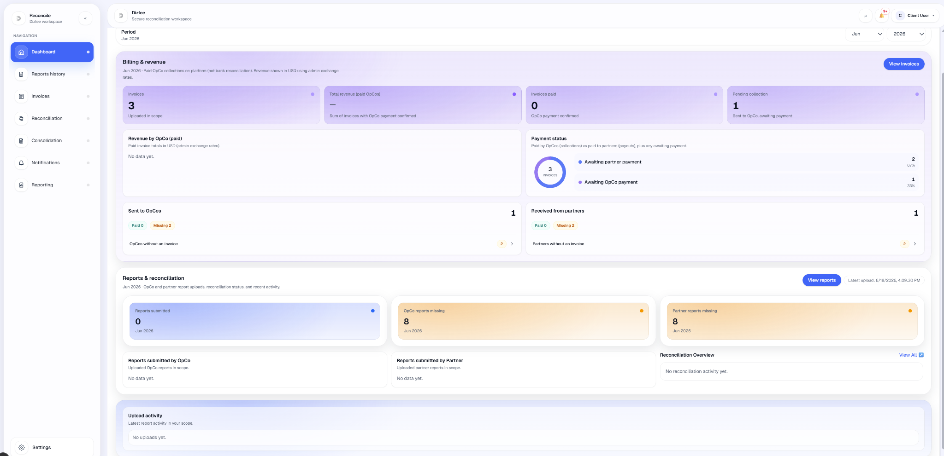

UC-03: View Reports (Dizlee)
Element | Detail
Name | View Reports (Dizlee)
ID | UC-03
Description | Allows a Dizlee user to filter, sort, paginate, and review uploaded reports from OpCos and Partners on the Reports tab of the Reports history screen.
Actors | Dizlee User
Organization Benefits | Enables Dizlee users to access and review all OpCo and Partner report submissions in scope for reconciliation and oversight.
Frequency of Use | Daily / on demand.
Triggers | Dizlee user selects Reports history from navigation (or arrives from Dashboard View reports / missing-report links with period pre-set).
Preconditions | User is logged in as a Dizlee User.
Postconditions | Dizlee user views the reports table for the applied filters and can open report details or file preview.
Main Course | - Dizlee user navigates to Dizlee - Reports (Reports history in sidebar).  - System shows page title “Dizlee - Reports” and three tabs: Reports (default), Reupload requests, Reports monitoring. This use case covers the Reports tab only.  - System displays filter panel:  - Period (MM YYYY) — defaults to current period on first load  - OpCo (dropdown, optional)  - Partner (dropdown, optional)  - Sort by — Uploaded, Period, or Filename  - Direction — Asc or Desc (default Uploaded / Desc)  - Apply and Refresh buttons  - Dizlee user sets filters/sort and clicks Apply (or Refresh).  - System loads reports (page size 10) matching Period, OpCo, and Partner filters.  System displays a data table with columns:  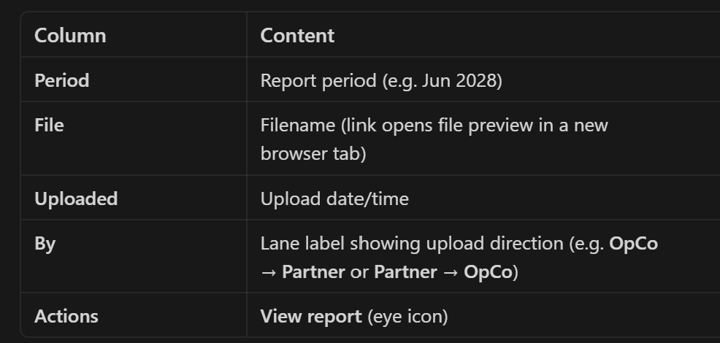  - Footer shows Page X / Y, Prev / Next, and Total record count.  - Dizlee user clicks View report on a row.  - System opens Report details modal showing: Period, OpCo / Partner lane, Uploaded by (OpCo, Partner, Dizlee, or Admin), File (preview link), file size, and upload timestamp.  - Dizlee user may close the modal or open the file preview from the modal or table.
Alternate Course | AC1: No extra filters beyond defaults  - Dizlee user opens Reports without changing filters.  - System shows reports for the current period only (not all periods).  - Default sort is Uploaded, Desc (most recent first).  AC2: Dizlee user changes sort  - Dizlee user selects Sort by and Direction in the filter panel.  - Dizlee user clicks Apply.  - System re-sorts the grid (sort is via dropdowns, not column header clicks).  AC3: More than 10 records  - Result set exceeds one page.  - System paginates at 10 records per page (fixed).  - Dizlee user uses Prev / Next to move between pages.  AC4: Dizlee user arrives from Dashboard  - Dizlee user clicks View reports or a missing-report card on the Dashboard.  - System opens Reports history with Period (and optionally Reports monitoring tab) pre-applied from that context.  AC5: Dizlee user switches away and returns  - Dizlee user refocuses the browser tab or window.  - System auto-refreshes the reports list (page 1) with current filter settings.
Exception Courses | EX1: No reports match filters  - System shows empty state “No reports” with “Try adjusting filters or upload a report as OpCo/Partner.”  - No rows are displayed.  EX2: Reports load fails  - API returns an error.  - System shows red error panel with the message.  - Table is not shown.  EX3: Dizlee session missing  - Dizlee user opens Reports history without a valid session.  - System redirects to login.  - Reports are not shown.
Business Rules | BR-16: Dizlee users shall have access to view reports submitted by OpCos and Partners across the platform (within active, non-deleted records).  BR-15: Dizlee users shall access this module based on their CLIENT role only.

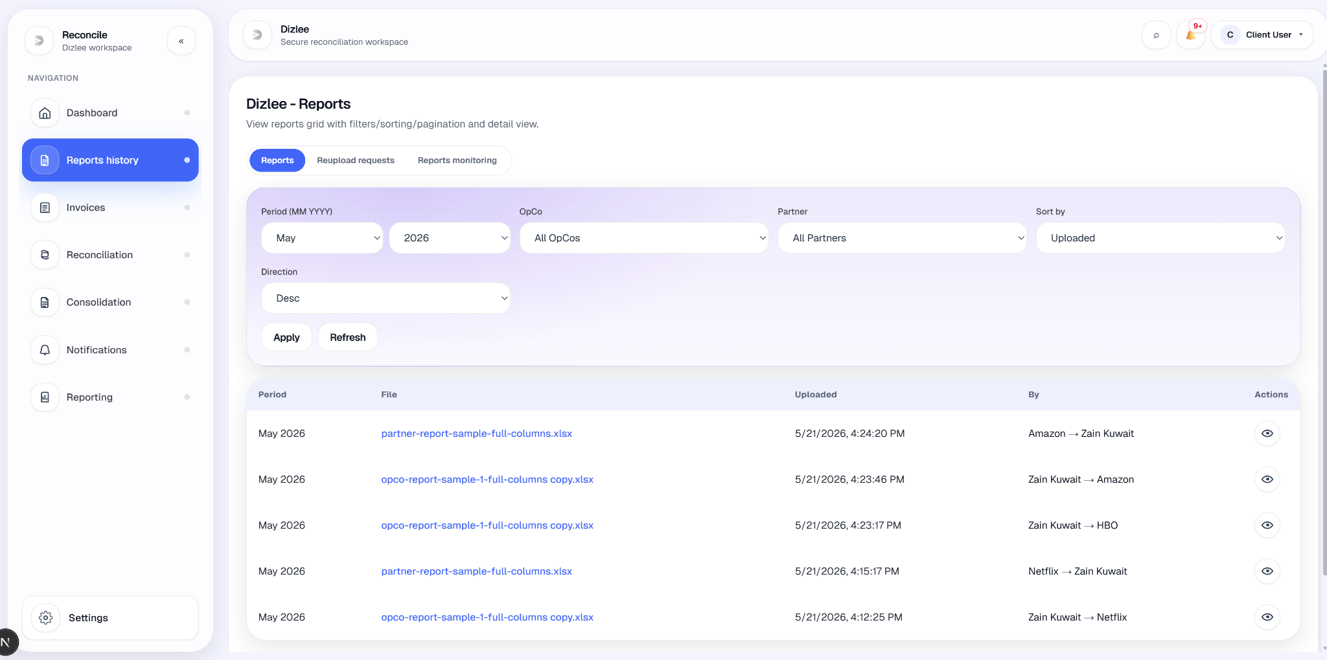

UC-04: View Invoices (Dizlee)
Element | Detail
Name | View Invoices (Dizlee)
ID | UC-04
Description | Allows a Dizlee user to filter, sort, paginate, and review invoices from OpCos and Partners, including invoice status and payment status, on the All invoices tab.
Actors | Dizlee User
Organization Benefits | Enables Dizlee users to track Dizlee→OpCo and Partner→Dizlee invoice submissions and their processing/payment status.
Frequency of Use | Daily / on demand.
Triggers | Dizlee user selects Invoices from navigation (or arrives from Dashboard billing links with period/payment filters pre-set).
Preconditions | Dizlee user is logged in with role CLIENT.
Postconditions | Dizlee user views the invoices table with status and payment details and can open an invoice for full review.
Main Course | - Dizlee user navigates to Dizlee - Invoices (Invoices in sidebar).  - System shows page title “Dizlee - Invoices” and three tabs: All invoices (default), Lifecycle tracker, Invoice monitoring. This use case covers All invoices only.  - System shows helper text: “Partner invoices you (Partner → Dizlee). You invoice OpCos (Dizlee → OpCo).”  - System displays filter panel:  - Period (MM YYYY) — defaults to current period  - OpCo (optional)  - Partner (optional)  - Payment status — All, Paid, or Pending  - Sort by — Uploaded or Period  - Direction — Asc or Desc (default Uploaded / Desc)  - Refresh button  - Filters auto-reload the list when changed (after initial load).  - System loads invoices (page size 10) for the selected period and filters.  - System displays a data table with columns:  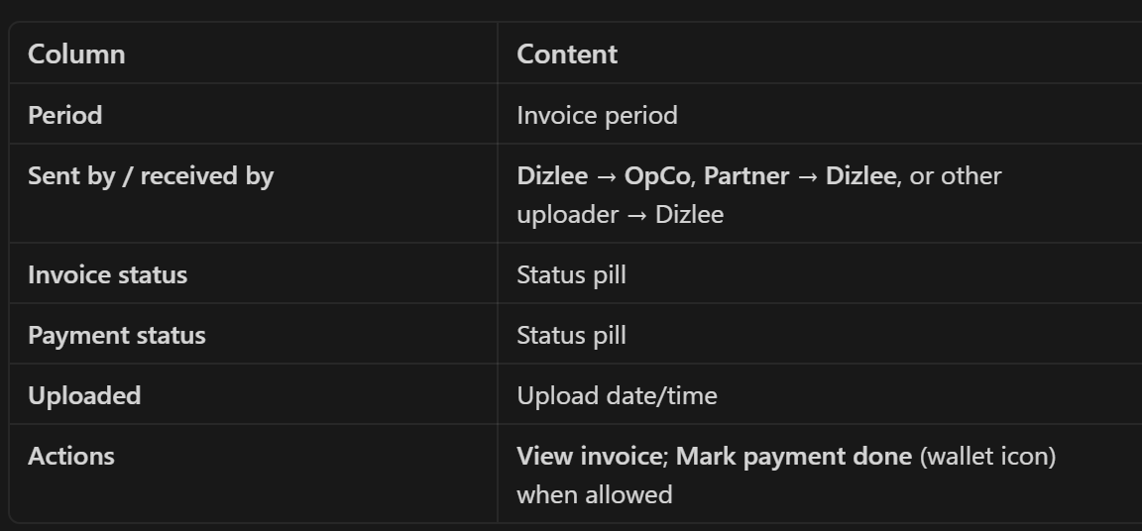  - Footer shows Page X / Y, Prev / Next, and Total count.  - Dizlee user clicks View invoice.  - System opens the Invoice detail screen showing:  - Invoice number  - Invoice and Payment status  - Digital invoice preview (Dizlee-created invoices) or uploaded file viewer (partner/file uploads)  - Mark payment done when eligible  - For Partner → Dizlee invoices, system auto-acknowledges the invoice when the detail screen is opened (if not already acknowledged).
Alternate Course | AC1: No extra filters beyond defaults  - Dizlee user opens All invoices without changing filters.  - System shows invoices for the current period only.  - Default sort is Uploaded, Desc.  AC2: Dizlee user filters by payment status from Dashboard  - Dizlee user clicks a billing KPI on the Dashboard (e.g. Invoices paid or Pending collection).  - System opens All invoices with Period and/or Payment status pre-set and highlighted “From dashboard”.  AC3: More than 10 records  - Result set exceeds one page.  - System paginates at 10 records per page (fixed).  - Dizlee user uses Prev / Next.  AC4: Dizlee user marks payment from the grid  - On an eligible Partner → Dizlee or Dizlee → OpCo invoice (acknowledged, not yet paid), Dizlee user clicks Mark payment done in the table.  - System updates payment status and shows “Payment marked done.”  - Table refreshes.
Exception Courses | EX1: No invoices match filters  - System shows empty state “No invoices” with “Try adjusting filters or upload an invoice as OpCo/Partner.”  - Not the message “No invoices found.”  EX2: Invoices load fails  - System shows red error panel with the message.  - Table is not shown.  EX3: Invoice detail not found  - Dizlee user opens an invalid or deleted invoice.  - Detail screen shows error and prompts returning to the invoices list.  EX4: Mark payment not allowed  - Invoice not acknowledged, already paid, or uploaded by OpCo.  - Mark payment done is disabled with tooltip (e.g. “Available after invoice is acknowledged”).
Business Rules | BR-01: The system shall maintain invoice status and payment status on each invoice record and display them in the grid and detail view.  BR-02: Dizlee users shall have access to view invoices across OpCos and Partners (active, non-deleted records in scope).

UC-05: Update Invoice Status
Element | Detail
Name | Update Invoice Status
ID | UC-05
Description | Allows a Dizlee user to update invoice status for Partner → Dizlee invoices by acknowledging them when the invoice detail is opened. There is no manual status dropdown in the current build.
Actors | Dizlee User
Organization Benefits | Moves partner invoices from received to acknowledged in the lifecycle so payment can be recorded and partners can be notified.
Frequency of Use | As required during invoice processing.
Triggers | Dizlee user opens a Partner → Dizlee invoice from the invoices list (View invoice).
Preconditions | Invoice exists, is not soft-deleted; invoice was uploaded by a Partner; invoice is not already acknowledged
Postconditions | IInvoice status is set to ACKNOWLEDGED; lifecycleAcknowledgedAt is recorded; activity log ACKNOWLEDGED is written with Dizlee actor; partner notification may be sent; audit event INVOICE_STATUS_UPDATED is recorded.
Main Course | - Dizlee user navigates to Dizlee - Invoices → All invoices tab.  - Dizlee user locates a Partner → Dizlee invoice and clicks View invoice.  - System opens the Invoice detail screen showing invoice number, Invoice and Payment status, and invoice preview or uploaded file.  - System detects the invoice is from a Partner and is not yet acknowledged.  - System automatically updates invoice status to ACKNOWLEDGED (no user dropdown or separate Save step).  - System records:  - Acknowledgement timestamp on the invoice  - Activity log: “Invoice acknowledged by Dizlee”  - Audit trail with previous and new status  - Optional in-app notification to the Partner (“Invoice acknowledged • [invoice number]”)  - Detail screen refreshes to show updated Invoice status.  - Dizlee user may then Mark payment done on the same screen or from the grid (separate payment action, once acknowledged).  B — Lifecycle tab  - Dizlee User selects the Lifecycle tab.  - System shows Invoice lifecycle tracker for invoices in the current filtered result set (same search/period/sort as above; user may Refresh first).  - User selects an invoice from the Invoice dropdown (invoice number • period • Partner).  - System displays a lifecycle stepper with four stages:  - Created  - Sent  - Acknowledged  - Payment done  - Completed steps show a checkmark; the next incomplete step is highlighted.  - System loads and displays the Activity log for that invoice (e.g. upload, status changes, payment events).  - User reviews lifecycle progress and activity entries.
Alternate Course | AC1: Update payment status instead of invoice status  - Invoice is already ACKNOWLEDGED (auto or previously).  - Dizlee user clicks Mark payment done on the grid or detail screen.  - System sets payment status to PAID, logs PAYMENT_MARKED_PAID, and may notify the partner.  - This is payment update, not invoice-status update (related use case UC-13B).  AC2: Invoice already acknowledged  - Dizlee user opens a Partner invoice that is already ACKNOWLEDGED.  - System does not run acknowledgement again.  - Status remains unchanged.  AC3: Dizlee user leaves without marking payment  - Dizlee user opens detail (acknowledgement runs if applicable), then navigates back.  - Invoice status stays ACKNOWLEDGED; payment status unchanged unless Mark payment done was used.  AC4: Dizlee → OpCo invoice  - Dizlee user opens a Dizlee → OpCo invoice.  - System does not auto-acknowledge on open (OpCo acknowledges on the OpCo portal).  - Dizlee invoice status is not updated through this use case.
Exception Courses | EX1: Invoice not found or deleted  - Dizlee user opens an invalid or soft-deleted invoice.  - Detail screen shows an error; status is not updated.  EX2: Manual non-acknowledgement status change attempted  - A client calls the status API with a status other than acknowledgement.  - System returns “Only acknowledgement updates are supported.”  - Status is not changed.  EX3: Payment status via status API  - Payment status is sent through the invoice-status update API.  - System rejects: “Use the payment action to mark payment done.”  - Payment must use Mark payment done instead.
Business Rules | BR-01: The system shall maintain invoice status and payment status on each invoice; acknowledgement and payment are separate steps in the lifecycle.  BR-02: Dizlee users shall acknowledge Partner → Dizlee invoices to confirm receipt before marking payment done.

UC-5B: Confirm invoice payment status
Element | Detail
Name | Confirm invoice payment status
ID | UC-5B
Description | Allows users to record off-platform payment confirmation on an invoice (platform does not process funds). Dizlee can mark payment done on eligible invoices via the UI. OpCo payment confirmation is supported by the API but has no UI action in the current build..
Actors | Dizlee User; OpCo User (for own OpCo invoices)
Organization Benefits | Records operational payment acknowledgement on the invoice for billing and reconciliation without a separate collections ledger..
Frequency of Use | As required during the monthly cycle.
Triggers | Dizlee user clicks Mark payment done on an invoice (grid or detail). OpCo: opening a Dizlee → OpCo invoice triggers acknowledgement only (separate from payment).
Preconditions | Invoice exists and is not soft-deleted; invoice is acknowledged before payment can be confirmed.
Postconditions | paymentStatus set to PAID; lifecyclePaymentConfirmedAt recorded; activity log PAYMENT_MARKED_PAID; audit INVOICE_PAYMENT_RECORDED; optional notification sent; success toast shown (Dizlee UI path).
Main Course | - Dizlee user navigates to Dizlee - Invoices → All invoices.  - Dizlee user opens an invoice (View invoice) or uses the wallet action in the grid.  - System shows current Invoice status and Payment status on the detail screen (or grid).  - For Partner → Dizlee invoices, system may have auto-acknowledged on open (UC-13); payment is allowed only after ACK.  - Dizlee user clicks Mark payment done (detail button or grid wallet icon).  - Eligible invoices:  - Partner → Dizlee (Dizlee confirms payment to partner)  - Dizlee → OpCo (Dizlee confirms payment on invoice sent to OpCo)  - System validates role CLIENT, invoice acknowledged, not already paid, and invoice type allowed.  - System sets payment status to PAID, writes activity log “Payment marked done by Dizlee…”, audit event, and may notify Partner or OpCo.  - System shows toast “Payment marked done.” and refreshes the invoice display.  Main Course — OpCo User  - OpCo user navigates to Invoices and opens a Dizlee → OpCo invoice (View invoice).  - System auto-acknowledges the invoice on open if not yet acknowledged (status Acknowledging… then Acknowledged).  - System displays invoice and payment status; if Dizlee has marked payment, shows “Payment done (Dizlee)”.  - There is no “Confirm payment” / “Mark paid” button for OpCo in the current UI.  - Backend API pay-by-opco exists (OpCo scoped to own opcoId, Dizlee → OpCo invoice, must be acknowledged) but is not wired to any screen.
Alternate Course | AC1: User views only, no payment action  - User opens invoice detail and leaves without Mark payment done.  - Payment status unchanged (acknowledgement may still occur per UC-13 / OpCo auto-ack).  AC2: Payment already recorded  - Payment status is already PAID / SETTLED / CONFIRMED.  - Mark payment done is disabled (Dizlee) or shows Payment done (Dizlee) (OpCo view).  - API returns “Payment is already marked done for this invoice.” if called again.
Exception Courses | EX1: User lacks scope  - OpCo tries to act on another OpCo’s invoice, or wrong invoice type.  - System returns “Access denied.” / “This invoice cannot be paid through this action.”  - No update.  EX2: Invoice not acknowledged  - Dizlee user tries Mark payment done before ACK.  - Action disabled in UI with tooltip “Available after invoice is acknowledged”; API returns “Invoice must be acknowledged before payment can be marked done.”  EX3: Non-Dizlee calls Dizlee payment API  - Non-CLIENT role calls Dizlee pay action.  - System returns “Only Dizlee can confirm payment.”  EX4: Invoice not found  - Invalid or soft-deleted invoice.  - System returns “Invoice not found.”
Business Rules | BR-01: Invoice payment status (and invoice status) shall be maintained on the invoice record; there is no separate collections ledger.  BR-02: Dizlee shall confirm payment on Partner → Dizlee and Dizlee → OpCo invoices when recording off-platform settlement.  BR-OPCO-PAY: OpCo shall only confirm payment on Dizlee → OpCo invoices for their own OpCo (backend rule; UI not yet exposed).

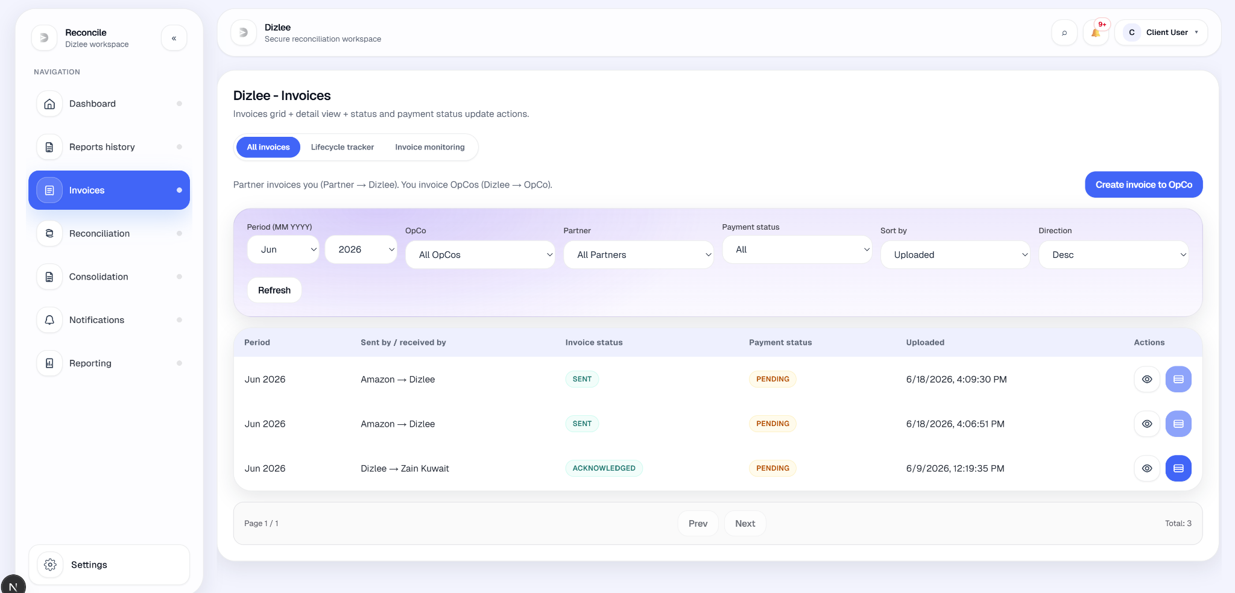
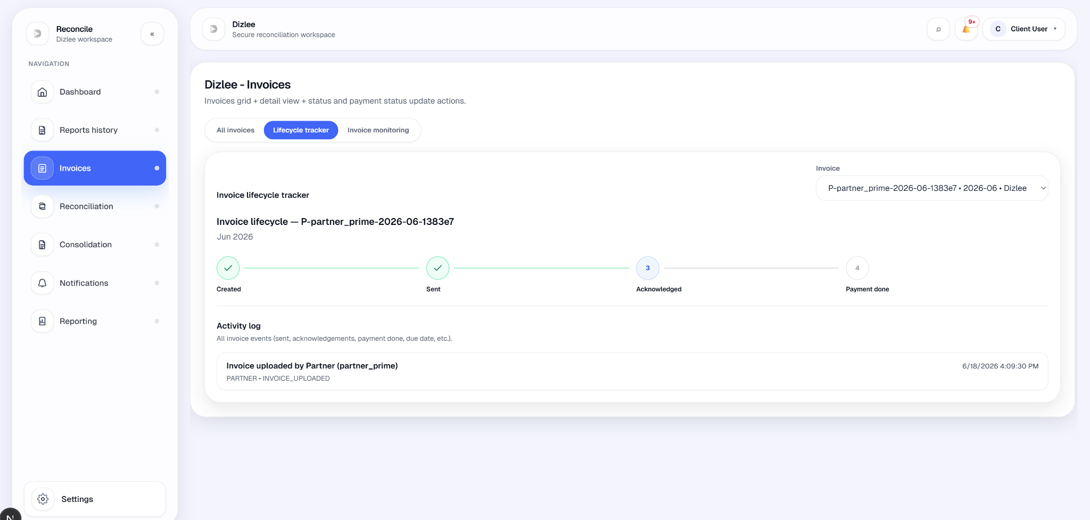
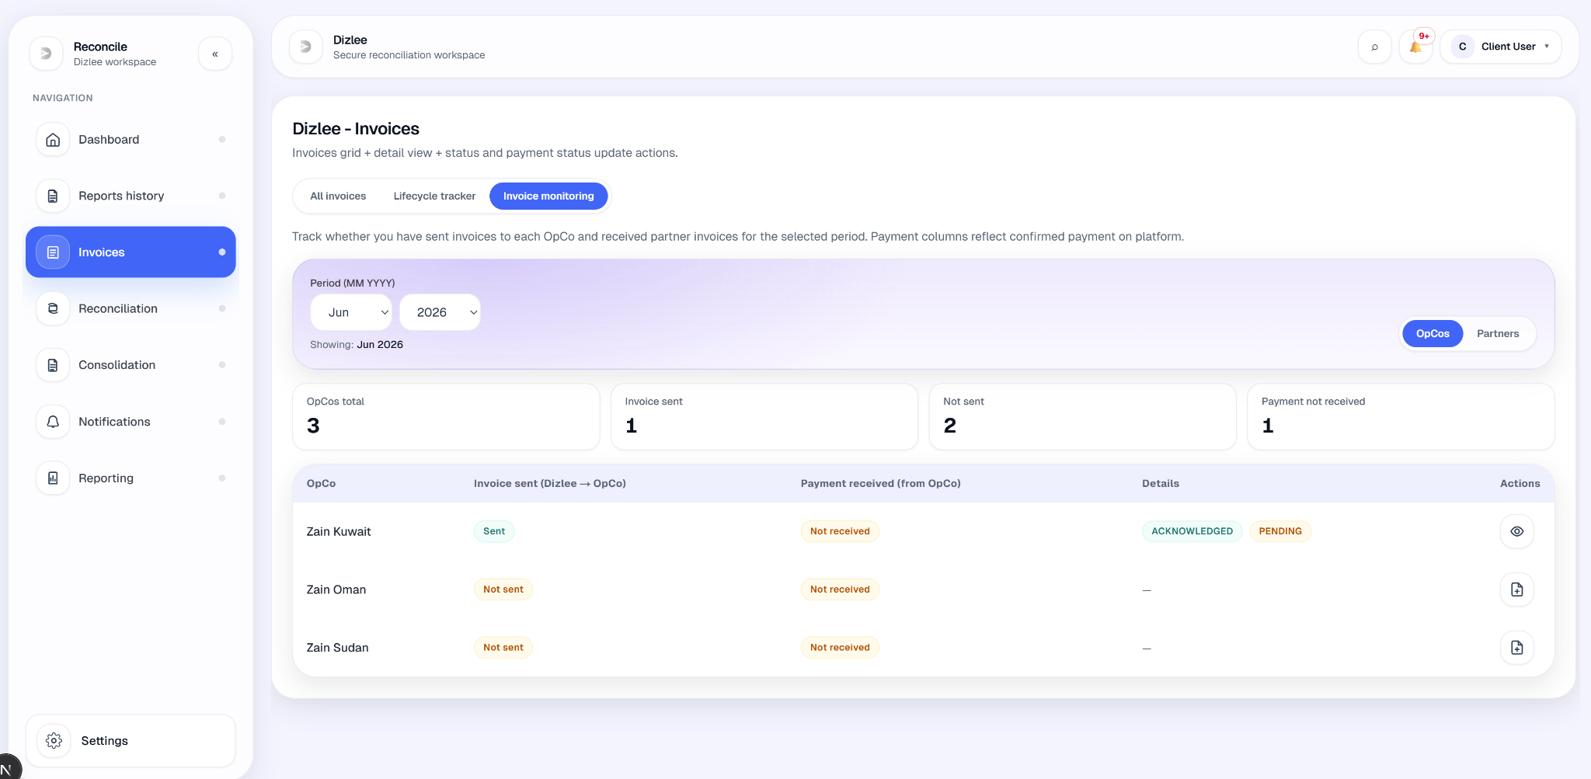

UC-06: Perform Reconciliation of Reports
Element | Detail
Name | Perform Reconciliation of Reports
ID | UC-06
Description | Allows a Dizlee User to reconcile OpCo vs Partner data for a period (YYYY-MM), OpCo, and Partner (lane). The system compares parsed line items (gross revenue in USD when usage_usd is present), applies an admin match tolerance %, highlights mismatches, and stores confirmed rows.
Actors | Dizlee User
Organization Benefits | Validates financial alignment between OpCo and Partner uploads before invoicing and downstream reporting.
Frequency of Use | Monthly, per lane.
Triggers | Dizlee user opens Reconciliation and clicks Run reconciliation on a ready lane (Compare Reports tab), or opens a saved result from History.
Preconditions | OpCo and Partner report uploads exist for the period and lane; lane is defined by Admin → OpCo partners links.
Postconditions | A reconciliations record is saved (unique per period + opco_id + partner_id) with reconciliation_confirmed_rows; status is DRAFT on run; audit event RECONCILIATION_SAVED or RECONCILIATION_CONFIRMED on upsert.
Main Course | - Dizlee user opens Reconciliation from side nav (tabs: History, Compare Reports).  - On Compare Reports, user selects Period (MM YYYY), Search by (OpCo reports or Partner reports), picks an OpCo or partner, and applies search (search icon or dropdown change).  - System lists OpCo–partner lanes for that scope with OpCo report, Partner report, State (MISSING / NO OPCO REPORT / NO PARTNER REPORT / READY / RECONCILED), and Outcome when saved.  - When both reports exist and lane is READY, user clicks Run reconciliation.  - System compares the selected OpCo and Partner report uploads:  - Rows keyed by normalized service name (same names summed).  - Amounts compared in USD (usage_usd preferred; else legacy usage).  - Admin negligible % tolerance: relative difference within tolerance → MATCHED; else MISMATCHED; one-sided rows → MISSING_IN_PARTNER / MISSING_IN_OPCO.  - On mismatch, OpCo value is stored as the confirmed value per row.  - System persists reconciliation as DRAFT with confirmed rows, shows toast (“Reconciliation saved (mismatches found).” or “…fully matched.”), and opens the reconciliation view screen.  - View screen shows period, OpCo, Partner, linked report filenames, matched/mismatch counts, and Gross revenue comparison table. User may Refresh or Alert users (Partner, OpCo, or both) when mismatches exist.
Alternate Course | AC1: All within tolerance  - Compare yields only MATCHED rows.  - System still saves DRAFT and shows “Reconciliation saved (fully matched).”  AC2: Lane already reconciled  - Lane shows RECONCILED; Run reconciliation is hidden.  - User opens View reconciliation (History or Compare table).  AC3: Missing uploads  - Lane shows NO OPCO REPORT or NO PARTNER REPORT.  - User may send Alert users (missing-report template) or reminder notifications to OpCo or Partner from row actions.  AC4: Update status to CONFIRMED (partial UI)  - Update status modal supports DRAFT / CONFIRMED and optional notes.
Exception Courses | EX1: Missing period, OpCo, or Partner  - API validation fails.  - Messages include “Period is required.”, “OpCo is required.”, “Partner is required.”  EX2: Reports not found or incompatible  - Examples: “Partner report not found for this selection.”, “OpCo report not found…”, “Partner and OpCo reports must be for the same OpCo.”, “No matching line items on the selected OpCo report for this partner…”, “No OpCo line items for this OpCo and partner this period…”  - No reconciliation saved.  EX3: Access denied  - Non-Dizlee/non-Admin role.  - “Access denied.”  EX4: Revert CONFIRMED to DRAFT  - Upsert with DRAFT when record is already CONFIRMED.  - “Reconciliation is already CONFIRMED and cannot be reverted to DRAFT.” (409)  EX5: View opened without required context  - Reconciliation view missing period/opco/partner/report IDs.  - Invalid link empty state — “Open a reconciliation from History using the view action.”
Business Rules | BR-01: Reconciliation shall be performed per period and per OpCo–Partner lane.  BR-02: OpCo and Partner uploads for the same lane shall be compared to identify matched and mismatched amounts.  BR-03: When amounts differ beyond tolerance, the OpCo value shall be the confirmed value stored for that row.  BR-04: Confirmed reconciliation values shall be available for downstream billing/reporting processes.  BR-05: At most one reconciliation record per (period, OpCo, Partner).

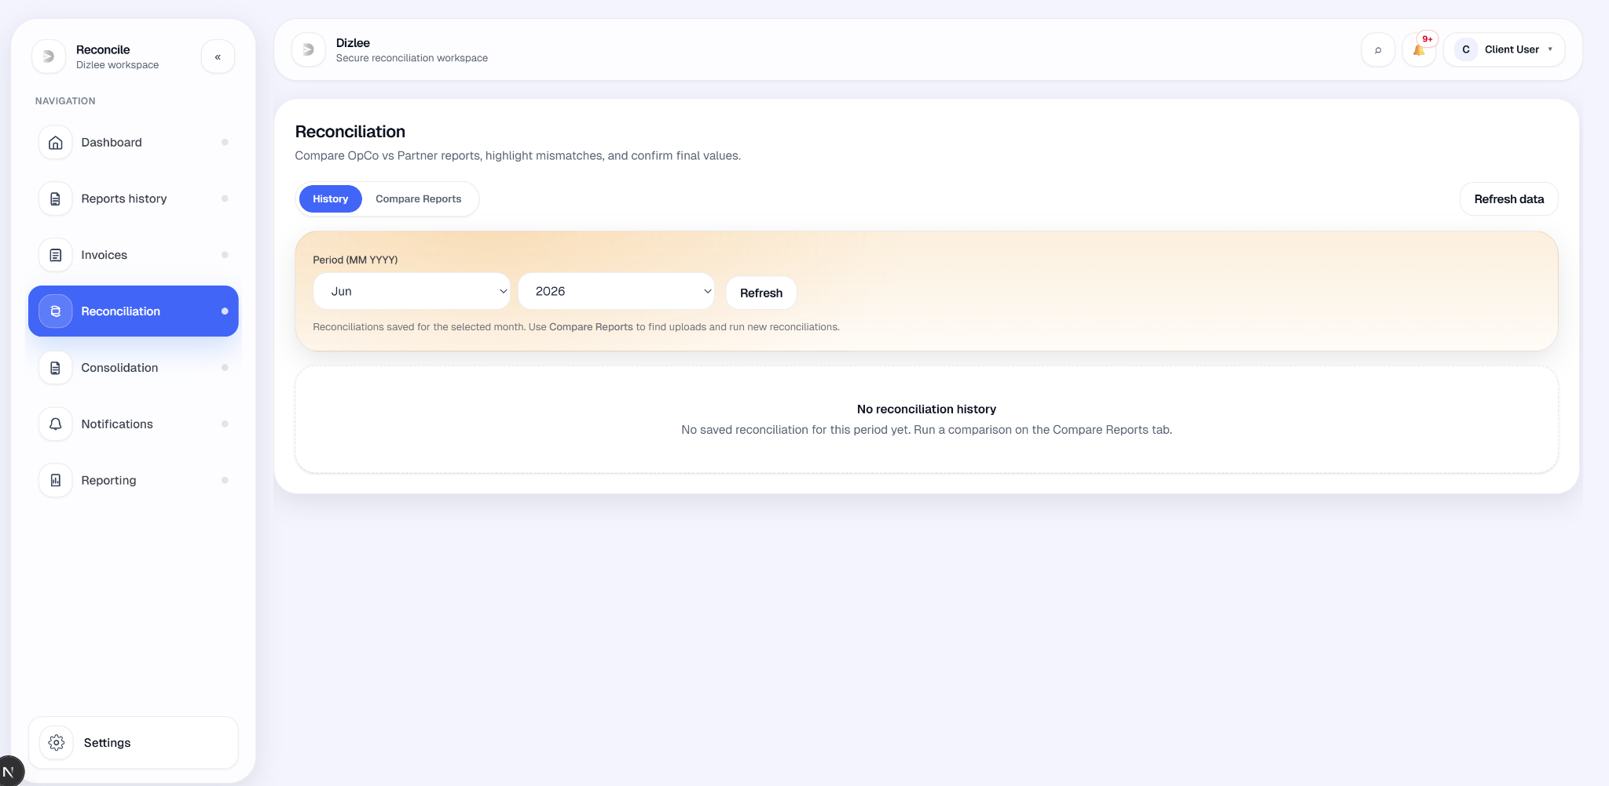
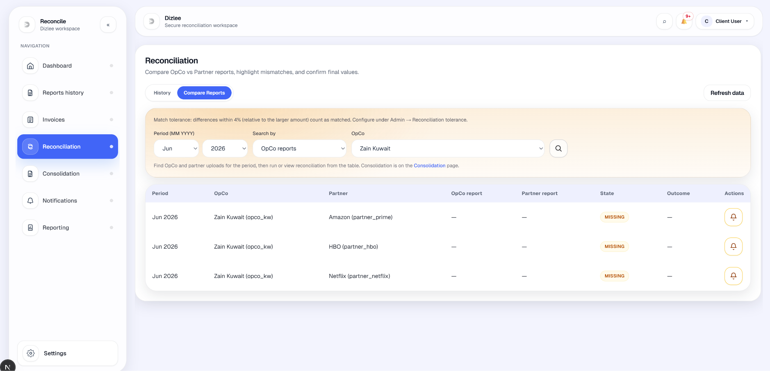

UC-6B: Consolidation (OpCo monthly)
Element | Detail
Name | Consolidation (OpCo monthly)
ID | UC-6B
Description | Allows a Dizlee User to generate, view, and export the OpCo monthly consolidation for a selected period and OpCo. Consolidation aggregates line items from all OpCo-uploaded partner reports for that month into one stored roll-up (partner + service + description + unit), with LC and USD totals. This gives Dizlee a single OpCo-side dataset for operational review, reconciliation support, and downstream billing workflows.
Organization Benefits | Provides a single authoritative OpCo monthly view across all linked partners; confirms submission completeness before roll-up; supports reconciliation against Partner reports; enables Excel export for finance and audit; creates a stored artifact (one record per OpCo per month) for reporting and traceability.
Actors | Dizlee User
Preconditions | For the selected OpCo and period, every partner linked to that OpCo must have at least one OpCo report uploaded with line items.
Postconditions | opco_monthly_consolidations and opco_monthly_consolidation_rows stored (unique per period + OpCo); status GENERATED; optional Excel download; audit CONSOLIDATION_GENERATED.
Main Course | - Dizlee user opens Consolidation from side nav (tabs: Generate, History).  - On Generate, user selects Period (MM YYYY) and OpCo (specific OpCo only; not “all OpCos”).  - User clicks Generate consolidated report.  - If a consolidation already exists for that period and OpCo, system shows Consolidation already exists — user may View existing, Regenerate, or Cancel.  - System validates readiness: each OpCo-linked partner has an OpCo report with line items for that month.  - System aggregates all OpCo line items for the period/OpCo (by partner name + service ID + description + unit), sums local currency (LC) and USD (stored usage_usd or FX conversion), and saves/replaces the consolidation record and rows.  - System shows toast “Consolidated report generated.” and displays the grouped table: partner → service rows → Total revenue per partner (USD with LC sub-line; revenue basis label when present).  - User may click Download Excel (columns: Partner Name, Services, Amount (USD), Amount (LC), plus partner total rows). Filename pattern: opco_consolidated_{opcoId}_{period}.xlsx.  - On History, user can View (modal preview) or Download Excel for any past consolidation.
Business Rules | BR-01: OpCo monthly consolidation shall aggregate OpCo-side figures across all partners linked to that OpCo for the period.  BR-02: Consolidation shall not be generated until every linked partner has an OpCo report upload for that month.  BR-03: At most one consolidation record per (period, OpCo); regeneration replaces prior rows.  BR-04: Consolidated figures support lane reconciliation and downstream reporting as the OpCo rollup for the month.  BR-05: OpCo figures shall be consolidated month-wise, partner-wise, and service-wise.  BR-06: Consolidation may be generated only when every Partner linked to the OpCo has uploaded an OpCo report with line items for that period.  BR-07: At most one consolidation exists per OpCo + period (regenerate replaces the prior roll-up).

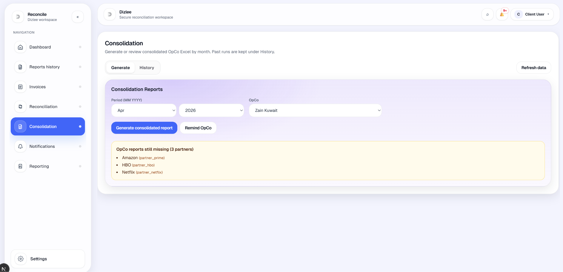

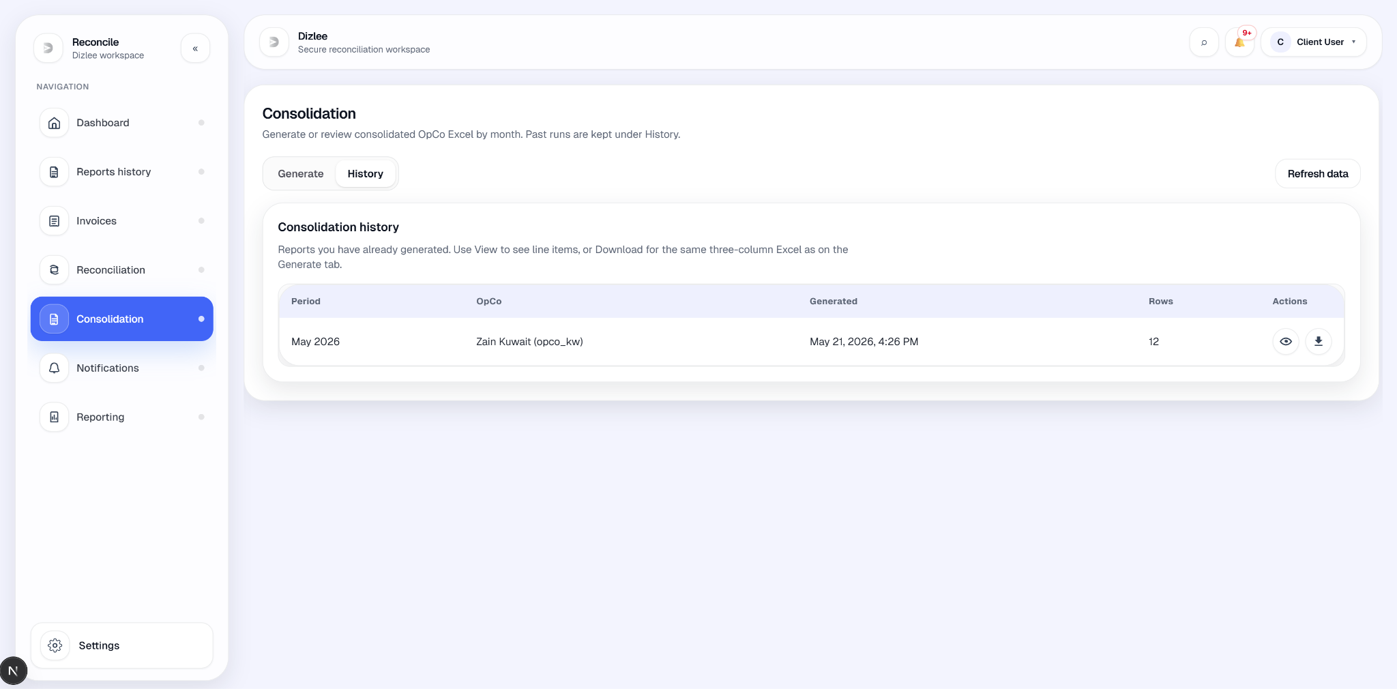
UC-07: Send in-app notification to OpCos
Element | Detail
Name | Send in-app notification to OpCos
ID | UC-07
Description | Allows a Dizlee User to compose and send an in-app notification to one or more OpCos. Messages are stored in the platform and appear in the OpCo inbox. Optional attachments are stored with the notification.
Actors | Dizlee User
Organization Benefits | Enables timely operational communication with OpCos (report reminders, reconciliation updates, general notices).
Frequency of Use | As required.
Triggers | Dizlee user composes a message on the Notifications screen (Intimations tab) and clicks Send.
Preconditions | OpCo records exist in the system (opco_all is not offered as a recipient).
Postconditions | Notification record created with status SENT, recipient rows for selected OpCos, optional attachment files stored; success toast shown; OpCo users see the message in OpCo → Notifications inbox.
Main Course | - Dizlee user opens Notifications from side nav (default tab is Inbox; user switches to Intimations).  - Under Recipients, user selects the OpCos sub-tab (vs Partners).  - User checks one or more OpCos (or Select all / Unselect all).  - User picks an optional Template (from admin compose templates if configured, else built-in: Upload report reminder, Upload invoice reminder, General message), which pre-fills Subject and Body.  - User edits subject and message; may add Attachments (optional: PDF, CSV, JPEG, PNG — max 5 files, 10 MB each, 25 MB total).  - User may click Preview, then Send.  - System validates subject, body, at least one recipient, and attachment limits.  - System persists notification + OpCo recipient rows (+ attachments); audit NOTIFICATION_SENT.  - Toast “Intimation sent successfully.”; form clears.  - OpCo users open Notifications → OpCo Inbox and see the message (unread until marked read).
Alternate Course | AC1: Subset of OpCos only  - User selects specific OpCos (not Select all).  - Only selected OpCos receive the notification.  AC2: Review history before composing  - User opens separate Notification History page (sent-list with filters by date, OpCo, partner, status).  - User returns to Intimations to compose a new message.  - (No in-screen link from Intimations tab to History in current UI.)  AC3: OpCos and Partners together  - User selects OpCos on OpCos tab and may also select Partners on Partners tab.  - Single send delivers to both groups (out of scope for this UC ID, but supported).  AC4: Reminders tab (related)  - User uses Reminders tab to find missing reports/invoices for a period and send pre-built reminders to OpCos (or Partners).  - Same sendNotification API; toast “Reminder sent successfully.”
Exception Courses | EX1: Empty subject or body  - Client blocks send.  - Toast “Subject and body can't be empty.”  EX2: No recipients selected  - API validation fails.  - “Select at least one recipient.”  EX3: Attachment limits exceeded  - Too many files, file too large, or total size too large.  - Client and/or API messages: “You can attach at most 5 files.”, “Each file must be 10 MB or smaller.”, “Combined attachment size must be 25 MB or smaller.”, or unsupported type (“Allowed types: PDF, CSV, JPEG, PNG, GIF, WebP.”)  EX4: Access denied  - Non-Dizlee/non-Admin role.  - Send rejected.
Business Rules | BR-01: The system shall support in-app notifications to OpCos and Partners.  BR-02: Reminder behaviour and admin reminder settings are configurable separately (Admin); operational reminders may also be sent from the Reminders tab.

UC-08: Send in-app notification to Partners
Element | Detail
Name | Send in-app notification to Partners
ID | UC-08
Description | Allows a Dizlee User to compose and send an in-app notification to one or more Partners. Messages are stored in the platform and appear in the Partner inbox. Optional attachments are stored with the notification.
Actors | Dizlee User
Organization Benefits | Supports communication with Partners on report submission, invoices, reconciliation, and other operational matters.
Frequency of Use | As required.
Triggers | Dizlee user composes a message on Notifications (Intimations tab) with Partners selected, and clicks Send.
Preconditions | Partner records exist in the system.
Postconditions | Notification created with status SENT and Partner recipient rows; optional attachments stored; success toast shown; Partner users see the message in Partner → Notifications inbox.
Main Course | - Dizlee user opens Notifications and switches to the Intimations tab.  - Under Recipients, user selects the Partners sub-tab (vs OpCos).  - User checks one or more Partners (or Select all / Unselect all).  - User picks an optional Template (admin compose templates if configured, else built-in: Upload report reminder, Upload invoice reminder, General message), which pre-fills Subject and Body.  - User edits subject and message; may add Attachments (optional: PDF, CSV, JPEG, PNG, GIF, WebP — max 5 files, 10 MB each, 25 MB total).  - User may click Preview, then Send.  - System validates subject, body, at least one recipient, and attachment limits.  - System persists notification + Partner recipient rows (+ attachments); audit NOTIFICATION_SENT.  - Toast “Intimation sent successfully.”; form clears.  - Partner users open Notifications → Partner Inbox and see the message (unread until marked read).
Alternate Course | AC1: Subset of Partners only  - User selects specific Partners (not Select all).  - Only those Partners receive the notification.  AC2: Review history first  - User opens separate Notification History page (filterable sent list, including by partner).  - User returns to Intimations to compose.  - (No direct link from Intimations to History in current UI.)  AC3: Reminders tab — Partner targets  - On Reminders, user picks period and Reports or Invoices.  - System lists missing Partner lanes/uploads; user sends per-partner or bulk reminders.  - Toast “Reminder sent successfully.”; UI may show “Send Reminder again” after send.  AC4: Combined OpCo + Partner send  - User selects Partners and also OpCos on the other recipients tab.  - One send delivers to both groups (UC-15 + UC-16 in one action).
Exception Courses | Same validation as UC-15:  EX1: Empty subject or body → “Subject and body can't be empty.”  EX2: No recipients → “Select at least one recipient.”  EX3: Attachment count/size/type limits → client/API validation messages.  EX4: Non-Dizlee/non-Admin role → access denied.
Business Rules | BR-01: The system shall support in-app notifications to OpCos and Partners.  BR-02: Reminder configuration is managed by Admin; operational Partner reminders may also be sent from the Reminders tab.

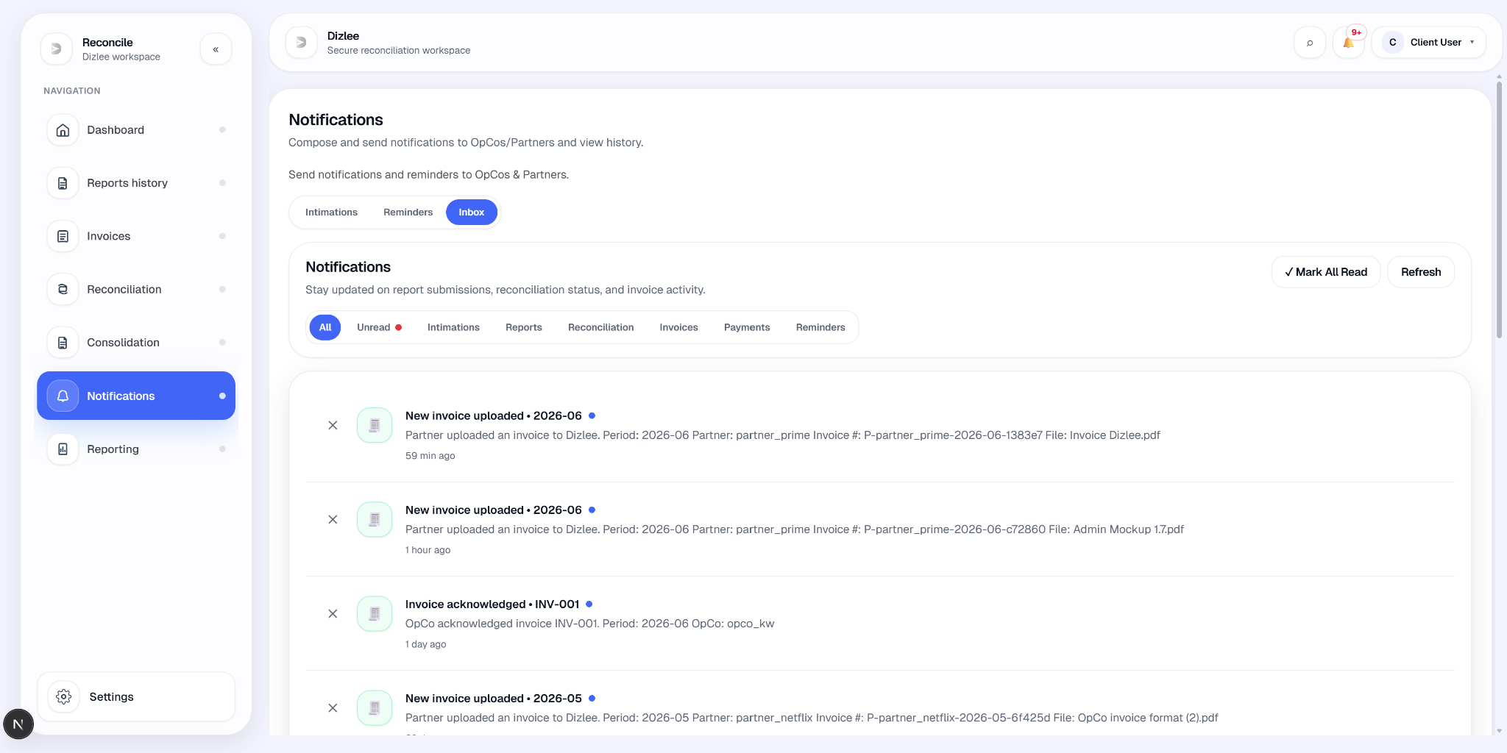
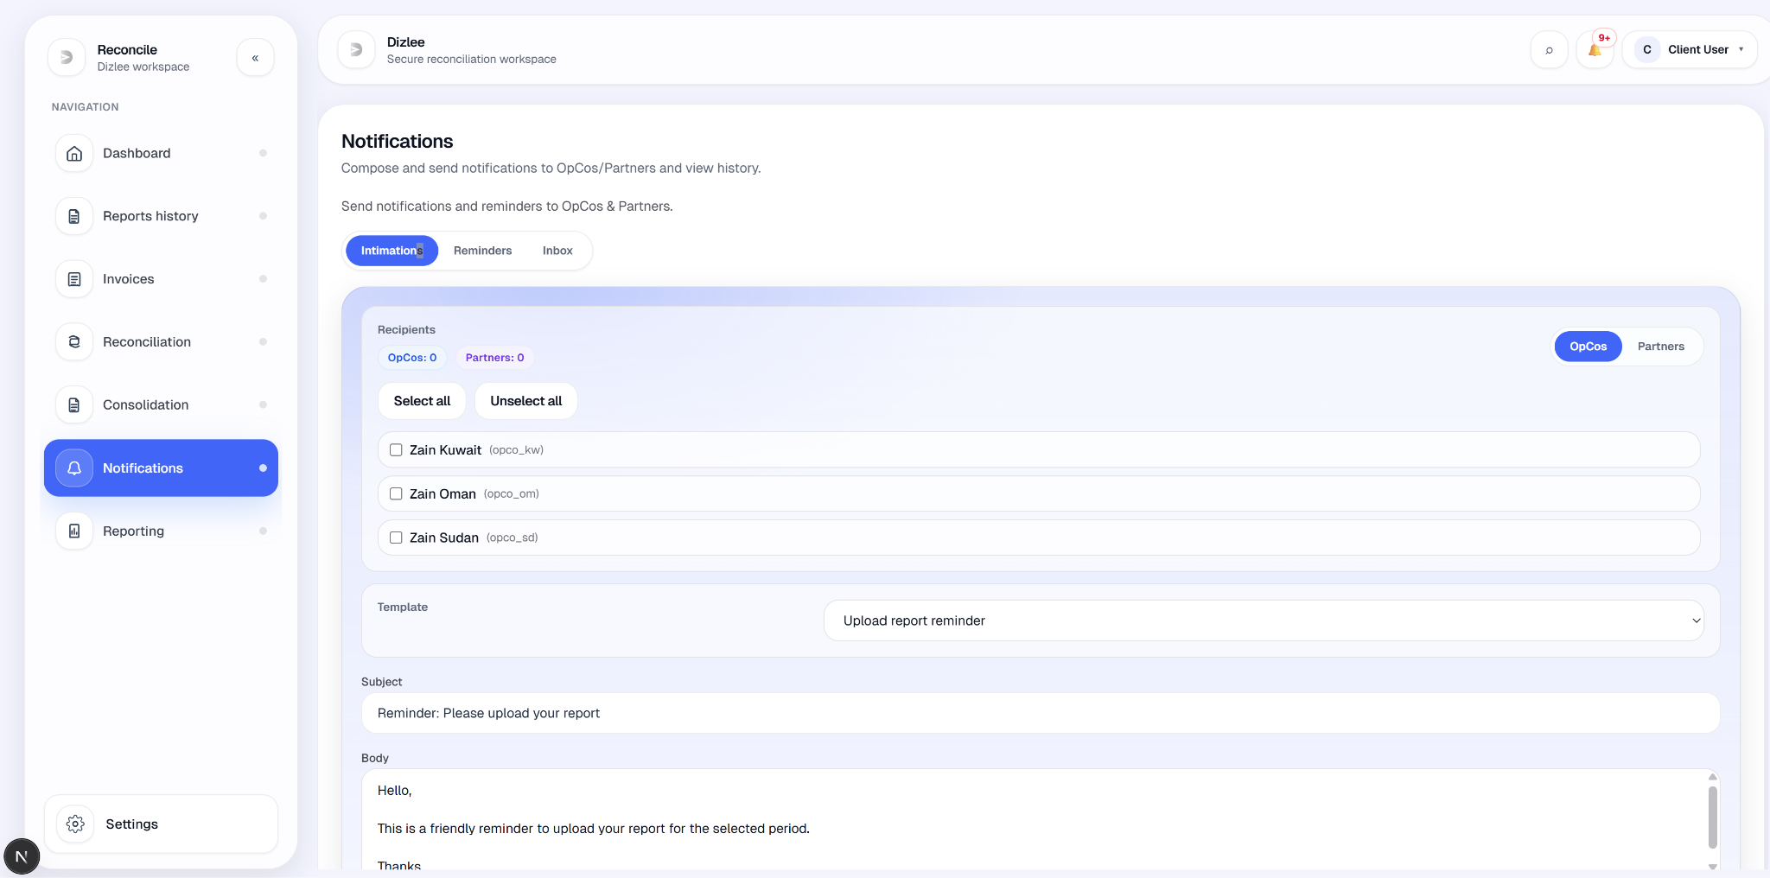

UC-09: Report reminders
Element | Detail
Name | Report reminders
ID | UC-09
Description | Admin can configure reminder settings (stored for future use). Dizlee can review OpCos/Partners with missing report uploads for a period and send manual in-app report reminders from Notifications → Reminders. Reminders use the same notification API as UC-15/16 (not automated SMTP scheduling).
Actors | Admin (settings); Dizlee User (send reminders)
Organization Benefits | Supports follow-up on missing monthly OpCo and Partner report submissions.
Frequency of Use | Per operational cycle (typically monthly)
Triggers | Admin saves Reminder Settings; Dizlee opens Notifications → Reminders with Reports selected and sends reminders.
Preconditions | OpCo–partner links and monitoring data exist; Dizlee selects a period. Admin settings row may exist (defaults created on first save).
Postconditions | Admin: reminders_enabled, reminder_value, reminder_unit persisted. Dizlee: one or more SENT in-app notifications created for targeted OpCos and/or Partners.
Main Course | Main Course — Admin  - Admin opens Reminder Settings from admin side nav.  - Admin sets Enabled (true/false), Reminder value (numeric, optional  - Admin clicks Save.  - System persists settings; toast “Reminder settings saved.”; audit “Updated reminder settings”.  Main Course — Dizlee User (report reminders)  - Dizlee user opens Notifications and selects the Reminders tab.  - User selects Period (MM YYYY) and Reminder for: Reports (default).  - System auto-loads missing lanes via report monitoring (no separate “Find missing” click required; Refresh re-runs).  - System shows two panels:  - OpCo reports missing — OpCos with missing partner-scoped OpCo uploads (lane count pill, e.g. 3/5 lanes).  - Partner reports missing — Partners with missing OpCo-scoped partner uploads.  - Each group lists Missing and Submitted lane tags per OpCo or Partner.  - User sends reminders:  - Bulk: Send Reminder at panel top → Send reminder preview modal (edit subject/body) → confirm.  - Single: per-row Send Reminder (sends immediately for that OpCo or Partner).  - Messages use reminder templates (kind: reminder) when configured, else built-in copy (period, missing/submitted lists for single OpCo/Partner).  - System creates in-app notifications (sendNotification); toast “Reminder sent successfully.”  - UI marks row Reminded (session state); Send Reminder again allowed.  - OpCo/Partner users see reminders in their Notifications inbox.
Business Rules | BR-01: Report reminders shall be delivered as in-app notifications to OpCos and Partners.  BR-02: The organization shall be able to configure reminder duration settings (enabled, value, unit) via Admin.

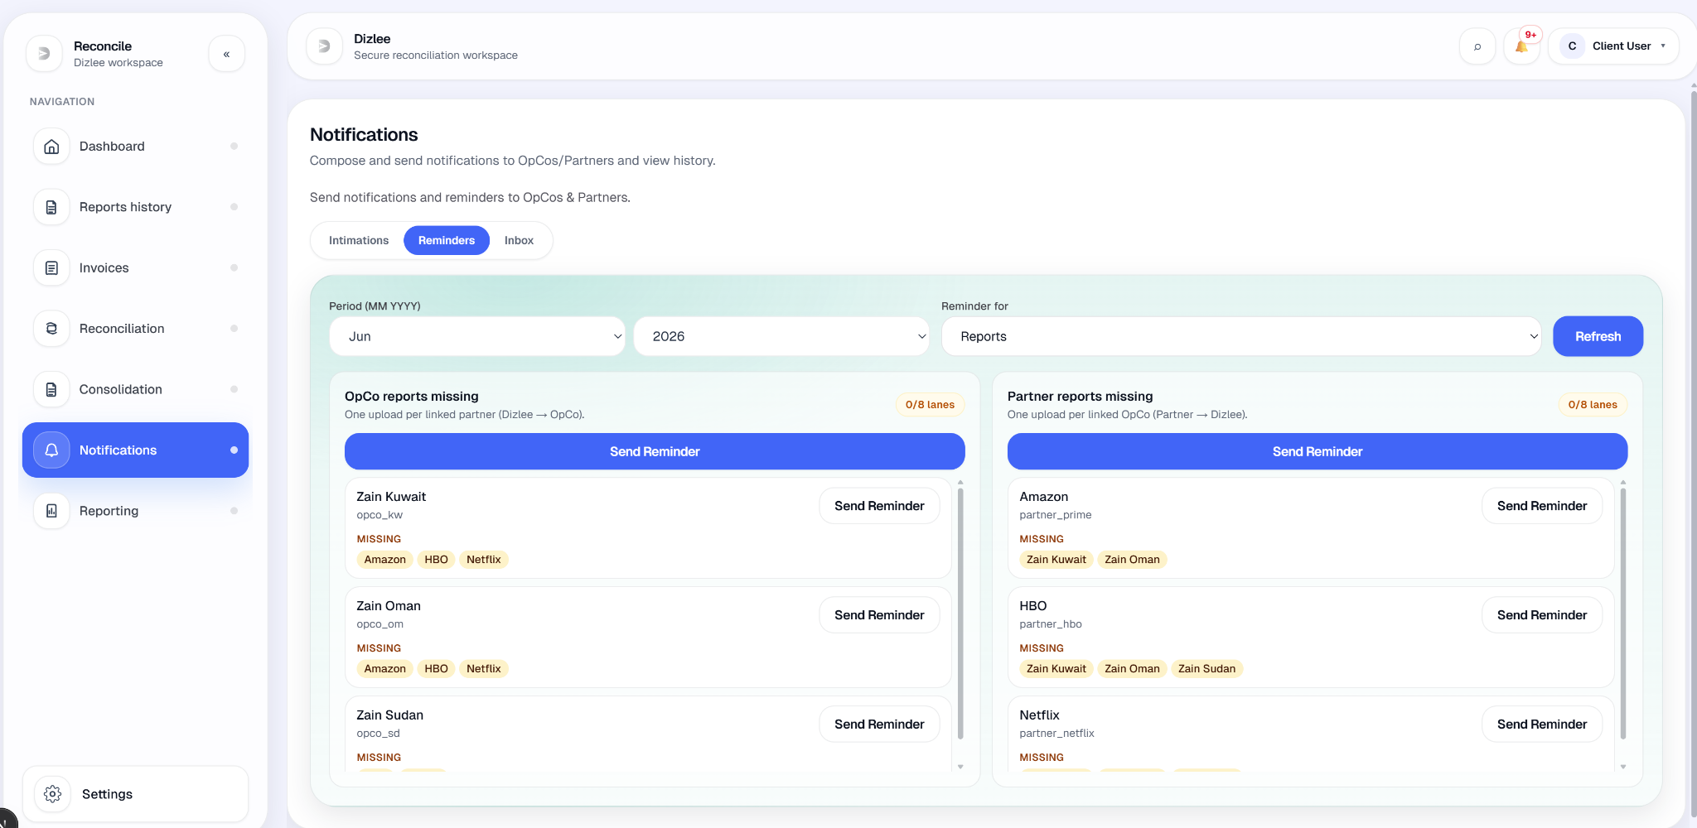

UC-9A: View Notification History
Element | Detail
Name | View Notification History
ID | UC-9A
Description | Allows a Dizlee User to browse a paginated list of in-app notifications visible to their scope, filter and open detail (subject, body, recipients, attachments). Intended for sent-notification audit; current API scope limits what Dizlee sees (see note below).
Actors | Dizlee User
Organization Benefits | Visibility into past communications and ability to review message content before follow-up sends.
Frequency of Use | On demand.
Triggers | Dizlee user opens the Notification History page.
Preconditions | Dizlee user is logged in.
Postconditions | User views filtered notification list and/or detail modal; may remove a notification from their own view (dismiss).
Main Course | - Dizlee user opens Notification History (separate page under client notifications; not linked from Intimations tab).  - System loads a paginated table (10 per page, default newest first), scoped to notifications where Dizlee (CLIENT) is a recipient.  - Grid columns: Created, Subject, Files (attachment count), Status (SENT / DRAFT), Recipients (OpCo and/or Partner IDs), Actions.  - User may filter:  - Search subject/body (click Apply)  - From / To date  - Recipient OpCo / Recipient Partner  - Status (All / SENT / DRAFT)  - Direction (Newest / Oldest)  - User clicks Refresh (or Apply for search) to reload with filters.  - User clicks View on a row.  - Detail modal shows Created, Status, Recipients, Subject, Body, and downloadable Attachments (if any).  - User may paginate with Prev / Next.
Alternate Course | AC1: No filters  - User opens page without changing filters.  - List shows all notifications in scope, sorted newest first.  AC2: Follow-up send  - User navigates back to Notifications → Intimations (or Reminders) manually.  - User composes a new message (UC-15 / UC-16 / UC-17).  - (No “compose follow-up” action on history screen.)  AC3: Remove from list  - User clicks Delete on a row and confirms “Remove this notification from your inbox?”  - System removes CLIENT recipient/read rows for that notification; toast “Notification removed.”
Exception Courses | EX1: No notifications in scope  - Empty state: “No notifications” — “Send a notification to see it appear here.”  EX2: No rows match filters  - Same empty state after Refresh / Apply.  EX3: List API error  - Error banner with API message.
Business Rules | BR-01: Notifications shall be stored and retrievable as in-app records for authorized roles.  BR-02: Reminder-related messages are included when they are stored as notifications (same history mechanism).

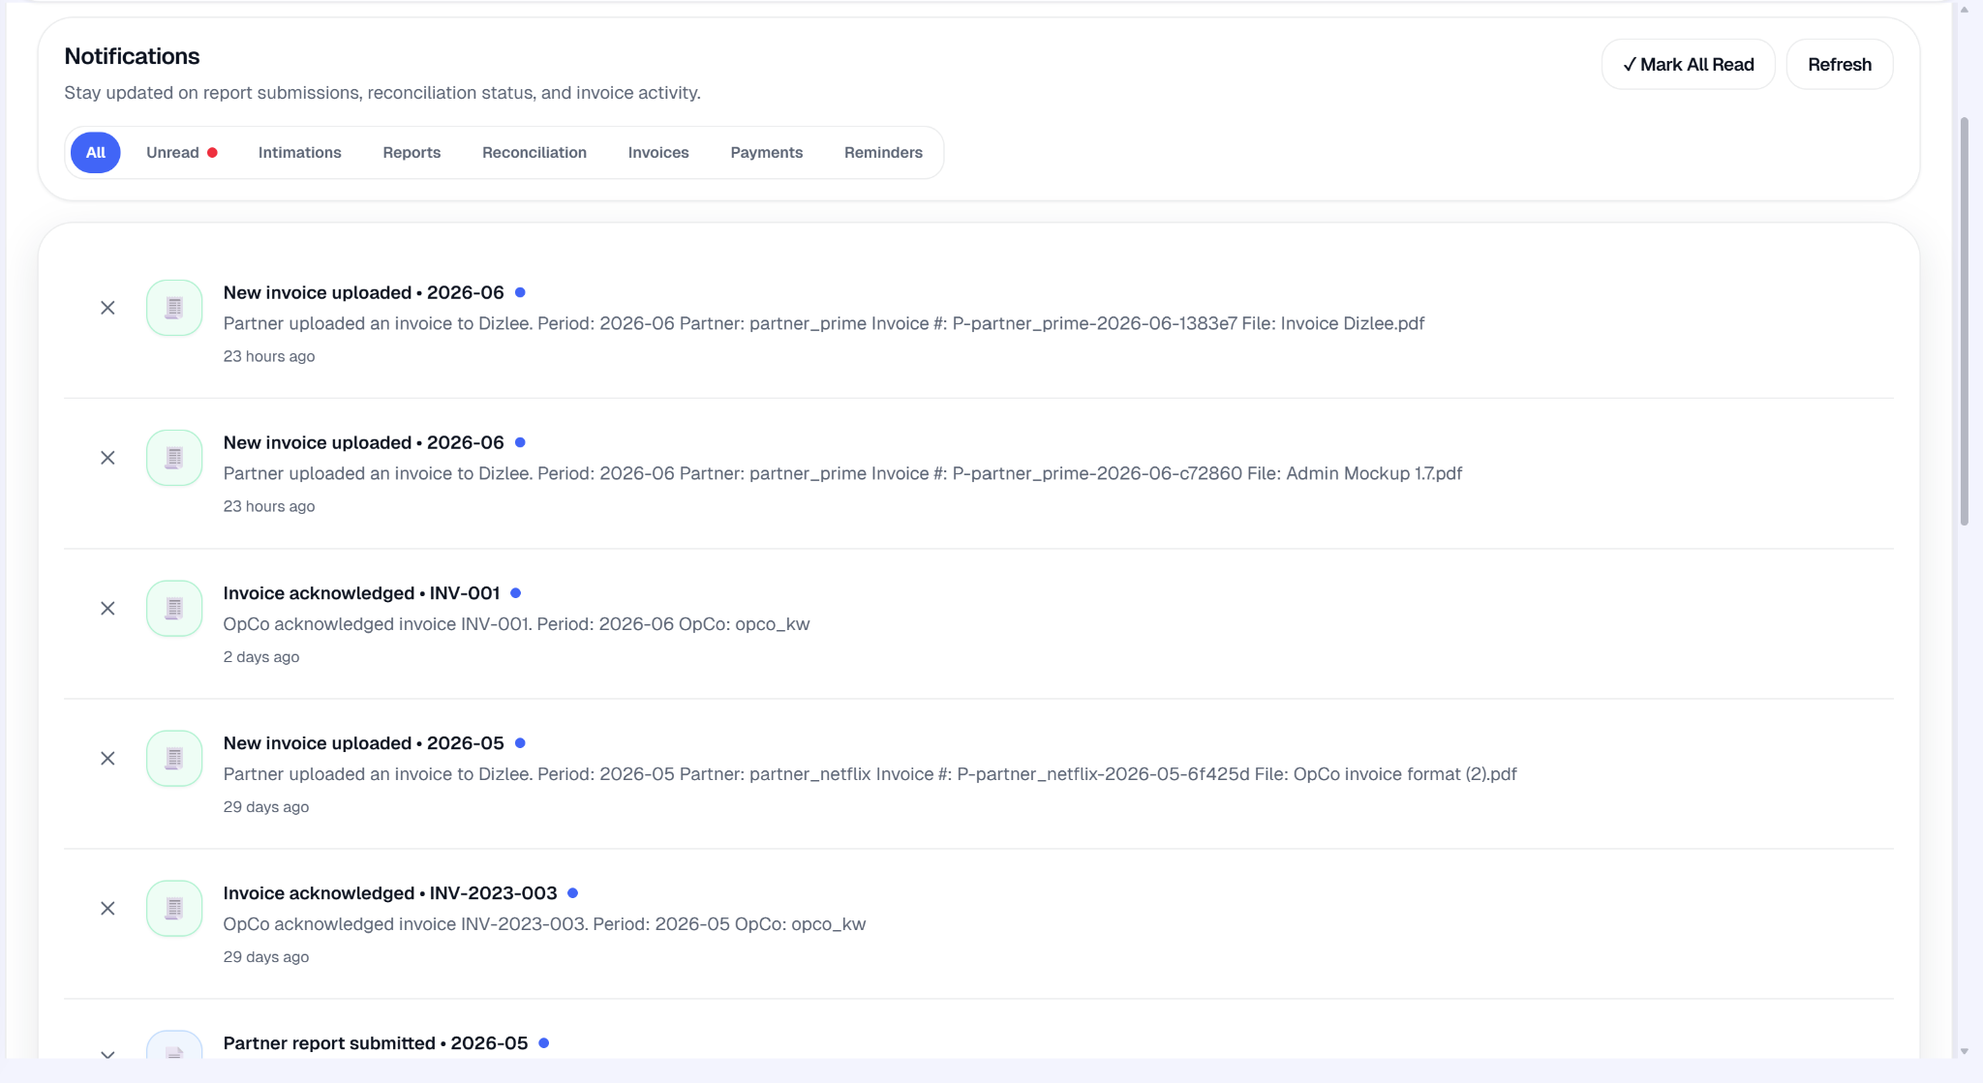
11.3 OpCo User Use Cases

UC-01-COMMON-USECASE: User Login
Element | Detail
Name | User Login
ID | UC-01-COMMON-USECASE
Description | Allows the Admin, Dizlee, Partner, OPCO to authenticate into the system using valid credentials and be redirected to the respective dashboard.
Actors | Admin, Dizlee, Partner, Opco
Organization Benefits | Ensures secure, role-based access for Admin, Dizlee, Partner, Opco
Frequency of Use | Multiple times daily.
Triggers | Admin, Dizlee, Partner, Opco opens the login page and submits credentials.
Preconditions | Admin, Dizlee, Partner, Opco account exists in the system.
Postconditions | Admin, Dizlee, Partner, Opco is authenticated and redirected to the respective dashboard.
Main Course | - The user opens the web application.  - If the user is not signed in, the system displays the login screen.  - The user views the Email field and Password field, a Change user button, a Sign in button, and a Forgot password option.  - User enters email and password  - User fills in Email and Password, then clicks Sign in.  - System validates the entered credentials  - The system checks email and password. The account must be active and not deleted. If invalid, the form shows “Invalid credentials.” and the user stays on the login page.  - System identifies the user’s role  - On success, the system creates a session and reads the role from the account: Admin, Dizlee , OpCo, or Partner  - User is redirected to their home screen  - The system sends the user to their role-specific landing page:
Alternate Course | N/A
Exception Courses | EX1: Invalid credentials entered  - Trigger: User submits email and password, but authentication fails (wrong password, unknown email, inactive account, or deleted account).  - System displays a red error on the sign-in form: “Invalid credentials.”  - User remains on the login page and is prompted to re-enter credentials or use Forgot password?  EX2: Email field is blank  - Trigger: User clicks Sign in without entering an email.  - System displays a field-level validation message on the Email field (browser required-field validation).  - Login is not submitted; user must enter an email before trying again.  EX3: Password field is blank  - Trigger: User clicks Sign in without entering a password.  - System displays a field-level validation message on the Password field (browser required-field validation).  - Login is not submitted; user must enter a password before trying again.  Note: EX2 and EX3 can occur together if both fields are empty the browser blocks submit and highlights the first invalid field.
Business Rules | BR-1: Users shall access the system and its modules based on their assigned role (Admin, Dizlee, OpCo, or Partner) and shall not access modules belonging to another role.  BR-2: Users shall have access to User Management and System Configuration modules.  BR-3: Only ACTIVE users shall be permitted to access the system; INACTIVE and deleted users shall not be allowed access.  BR-4: OpCo users shall only access data belonging to their assigned OpCo. Partner users shall only access data belonging to their assigned Partner.  BR-5: Only Admin users shall be authorized to create, edit, deactivate, or soft-delete user accounts.  BR-6: Each user account shall have a unique email address; duplicate email addresses shall not be permitted.



UC-02-COMMON-USECASE: Change Password
Element | Detail
Name | Change Password
ID | UC-02-COMMON-USECASE
Description | Allows the Admin, Dizlee, Partner, Opco to update their account password by providing the current password and a new password.
Actors | Admin, Dizlee, Partner, Opco
Organization Benefits | Enables Admin, Dizlee, Partner, Opco to maintain account security by updating passwords as needed.
Frequency of Use | On demand.
Triggers | Admin, Dizlee, Partner, Opco selects the Change Password option from profile/settings.
Preconditions | Admin, Dizlee, Partner, Opco is logged into the system.
Postconditions | Admin, Dizlee, Partner, Opco shall be able to change the password
Main Course | - User navigates to the Change Password screen  - Signed-in user opens the profile menu (header) and selects Change password from settings. User must already be logged in.  - User enters current password  - User types their existing password in the Current password field.  - User enters new password  - User types a new password in the New password field.  - User confirms new password  - User re-enters the new password in the Confirm new password field.  - System validates that the current password is correct  - System checks the current password against the account. If wrong, change is rejected and user stays on the screen with an error.  - System validates that the new password and confirm password match  - System checks that New password and Confirm new password are identical. If they do not match, change is rejected.  - System updates the password  - If all checks pass, the system saves the new password (hashed) for the user account.  - System displays a success confirmation message  - User sees a success message that the password was updated. They continue using the application with the new password
Alternate Course | AP-1 — User does not know current password  - User opens Change password but cannot enter the current password.  - User goes to Forgot password on the login page  - User receives a reset link by email and sets a new password via Reset password.  - User signs in with the new password.  AP-2 — User cancels change  - User opens Change password.  - User leaves the page (profile menu, sidebar, or browser back) without submitting.  - Password is not changed; the session stays as-is.  AP-3 — User opens Change password while not signed in  - User tries to open /change-password without a session.  - System redirects to login.  - After login, user can open Change password again from the profile menu.  AP-4 — Validation fails, user retries on the same screen  - User submits the form.  - System rejects it (wrong current password, passwords don’t match, or new password fails policy).  - User corrects the fields and submits again (Main Course from step 2).
Exception Courses | EX1: Current password is incorrect  - User submits the form with a wrong current password.  - System rejects the change and displays an error (e.g. current password is incorrect).  - User remains on the Change Password screen and may re-enter credentials or use Forgot password.  EX2: New password and confirm password do not match  - User enters different values in New password and Confirm new password.  - System displays a validation error (e.g. passwords do not match).  - Password is not updated; user must correct the fields and submit again.  EX3: Current password field is blank  - User submits without entering the current password.  - System displays a field-level validation message and does not update the password.  EX4: New password field is blank  - User submits without entering a new password.  - System displays a field-level validation message and does not update the password.  EX5: Confirm new password field is blank  - User submits without confirming the new password.  - System displays a field-level validation message and does not update the password.  EX6: New password does not meet password policy  - User enters a new password that fails policy (e.g. fewer than 8 characters, or missing uppercase, lowercase, number, or special character).  - System displays a validation error describing the requirement.  - Password is not updated until a compliant password is entered.  EX7: User is not signed in  - User tries to open Change Password without an active session.  - System redirects to the login page.  - Password is not changed until the user signs in and opens Change Password again.
Business Rules | BR-1: A user may change only their own account password; one user may not change another user’s password on their behalf through self-service.  BR-2: Only users who are eligible for platform access (active, not removed from the platform) may change or maintain their account password.  BR-3: All platform passwords must comply with the organization’s defined password complexity policy (minimum length and character-type requirements).


UC-03-COMMON-USECASE: Forgot Password
Element | Detail
Name | Forgot Password
ID | UC-03-COMMON-USECASE
Description | Allows the Admin to initiate a standard password reset process via their registered email.
Actors | Admin, Dizlee, Partner, Opco
Organization Benefits | Provides a self-service recovery mechanism to avoid account lockouts.
Frequency of Use | On demand.
Triggers | Admin, Dizlee, Partner, Opco selects 'Forgot Password' on the login page.
Preconditions | Admin, Dizlee, Partner, Opco account exists in the system.
Postconditions | Admin, Dizlee, Partner, Opco shall be able to change password
Main Course | - User clicks Forgot password? on the login page.  - The system displays the Forgot Password screen.  - User enters their registered email address.  - System validates internally whether a matching account exists.  - If the account exists and is eligible, the system sends a password reset link to that registered email.  - System displays: “Password reset instructions have been sent to your registered email.”  - User opens the email and clicks the password reset link.  - System validates that the reset link is valid and not expired.  - System displays the Reset Password screen.  - User enters a new password.  - User confirms the new password.  - System validates that the new password and confirm password match and meet password policy.  - System updates the password and displays: “Your password has been reset successfully. Please login with your new password.”
Alternate Course | AP1 — User returns to login without resetting  - User opens Forgot Password.  - User clicks Back to login without submitting, or abandons the flow.  - No reset email is sent; password is unchanged.  AP2 — User remembers password before completing reset  - User is on Forgot Password or Reset Password.  - User goes to login and signs in with the existing password.  - No password change occurs unless reset is completed.  AP3 — Reset link expired or already used; user requests a new link  - User clicks an expired or used reset link.  - System rejects the link.  - User returns to Forgot password, enters email again, and receives a new link (if eligible).  AP4 — User completes reset and signs in with new password  - User completes Main Course through step 13.  - User goes to login.  - User signs in with the new password (Main Course — Sign-in).
Exception Courses | EX1: Email field is blank  - User submits without entering an email.  - System displays a field-level validation message.  - No reset email is sent.  EX2: Email format is invalid  - User enters an invalid email (e.g. missing @).  - System displays a field-level validation message.  - No reset email is sent.  EX3: No eligible account matches the email  - User submits an email that is not registered or not eligible for recovery.  - System does not disclose that the account does not exist.  - System may still display the same confirmation message; no reset email is sent.  EX4: Reset link is missing, invalid, expired, or already used  - User opens Reset Password without a valid token, or uses an expired/used link.  - System displays an error (e.g. link invalid or expired).  - Password is not updated; user must request a new link.  EX5: New password and confirm password do not match  - User submits different values in the two password fields.  - System displays a validation error (e.g. passwords do not match).  - Password is not updated.  EX6: New password does not meet password policy  - User enters a password that fails policy (e.g. fewer than 8 characters, or missing required character types).  - System displays a validation error.  - Password is not updated.  EX7: New password or confirm password field is blank  - User submits with one or both password fields empty.  - System displays a field-level validation message.  - Password is not updated.
Business Rules | BR-01: A user may recover access only for their own account, using the email address registered to that account.  BR-02: Only users who are eligible for platform access (registered on the platform and not removed) may receive password recovery.  BR-03: All platform passwords must comply with the organization’s password complexity policy.  BR-04: Password recovery is permitted only when the user can demonstrate control of the registered email address (via the reset link sent to that address)  BR-05: A password reset link issued after Forgot password is valid for 24 hours from the time it is generated. After expiry, the link cannot be used; the user must request a new reset link. Each link is single-use, once a new password is set successfully, that link is invalidated.




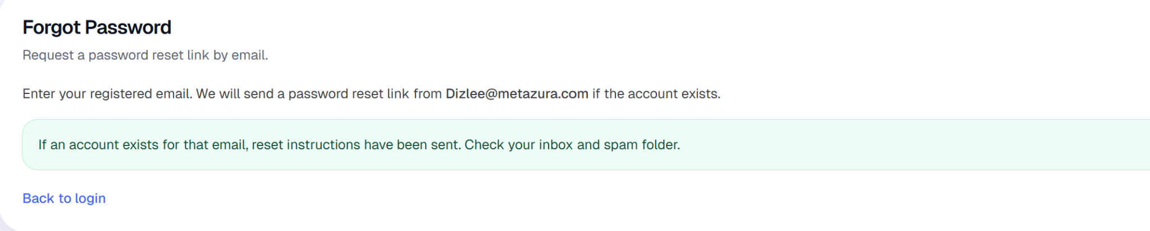

11.3 OpCo User Use Cases

UC-01-OPCO: Access Side Navigation Bar
Element | Detail
Name | Access Side Navigation Bar
ID | UC-01-OPCO
Description | Allows an OpCo User to navigate OpCo modules via the side navigation bar (and header shortcuts).
Actors | OpCo User
Organization Benefits | Efficient access to Dashboard, report upload/history, invoices, and notifications.
Frequency of Use | Multiple times per session.
Triggers | OpCo user logs in or clicks a navigation item.
Preconditions | OpCo user is authenticated with a valid OPCO session (opcoId on account).
Postconditions | User is on the selected module screen; active nav item is highlighted when the path matches exactly.
Main Course | - After login, system redirects OpCo user to Dashboard.  - System shows AppShell with side navigation (OpCo workspace), 5 items:  - Dashboard  - Upload Report  - Reports history  - Invoices  - Notifications  - Footer Settings for OpCo (workspace settings e.g. currency, password change).  - Header shows notifications bell with unread badge (links to Notifications).  - User clicks a nav item.  - System navigates to that module; matching item shows active styling.
Alternate Course | AC1: Already on selected screen  - User clicks the current nav item again.  - Next.js navigates to the same route  AC2: Collapsed sidebar  - User collapses sidebar to icon rail (desktop).  - Nav items remain available as icon links with tooltips; user can expand again.  AC3: Notifications via header  - User opens Notifications from the header bell instead of the sidebar.
Exception Courses | - N/A for navigation itself. Unauthenticated users are blocked by layout/auth before the shell renders
Business Rules | BR-01: Navigation options shall be restricted to the OpCo role (no Dizlee/Admin/Partner modules in OpCo nav).

UC-02-OPCO: View Dashboard (OpCo)
Element | Detail
Name | View Dashboard (OpCo)
ID | UC-02-OPCO
Description | Allows an OpCo User to view a period-scoped summary of partner report submission status and Dizlee → OpCo invoice status for their OpCo.
Actors | OpCo User
Organization Benefits | Quick view of monthly submission progress and invoice acknowledgement/payment status.
Frequency of Use | Daily / on login.
Triggers | OpCo user logs in (lands on Dashboard) or opens Dashboard from side nav.
Preconditions | OpCo user is logged in with valid opcoId.
Postconditions | Dashboard displays report and invoice summary for the selected period and scoped OpCo.
Main Course | - The OpCo User opens the Dashboard (default landing after login).  - The system loads an overview for the selected period (MM YYYY), scoped to the signed-in OpCo.  - The User may change the period using the period picker; the dashboard reloads for that month.  - The system displays:  - 4a. Summary cards  - Partners to report for  - Reports submitted  - Reports missing  - (Cards may link to Upload Report and Reports history.)  - 4b. Reports table — one row per linked Partner, with columns:  - Partner Name  - Report Status (Submitted / Not submitted)  - Submitted Date (date and time)  - Default sort: Partner Name (A–Z). User may change sort (Ascending / Descending) by clicking a column header.  - 4c. Invoice from Dizlee — invoices from Dizlee to this OpCo for the period in step 3, with columns:  - Invoice Number  - Invoice Status  - Payment Status  - Invoice received date  - Default sort: Invoice Number. User may sort by any column via column header. Max 10 rows per page; paging if more than 10 invoices exist.  - A View invoices link opens the full Invoices list.  - If an invoice exists but is not acknowledged, the system may show an Acknowledge invoice notice with a link to Notifications (acknowledgement also occurs when the user opens the invoice detail).  - The OpCo User reviews the dashboard summary for the selected period.
Alternate Course | AC1: Period change  - User picks another month.  - Loading bar runs; toast line “Dashboard updated.” when complete.  AC2: Partial data  - Some partners submitted, others not table and stat cards reflect per-partner status (not a single empty page).
Exception Courses | EX1: API / access error  - Non-OpCo or missing opcoId.  EX2: No linked partners  - Reports table shows “No linked partners.”  - Stat cards show 0 expected/submitted/missing.  EX3: No Dizlee invoice for period  - Invoice section shows, for number, dates, invoice status, and payment status (widget empty state, not “No data available” for the whole page).
Business Rules | BR-01: OpCo users shall only see data for their assigned OpCo (reports and invoices filtered by session opcoId).  BR-02: Invoice status and payment status from the invoice record shall be visible on the dashboard.

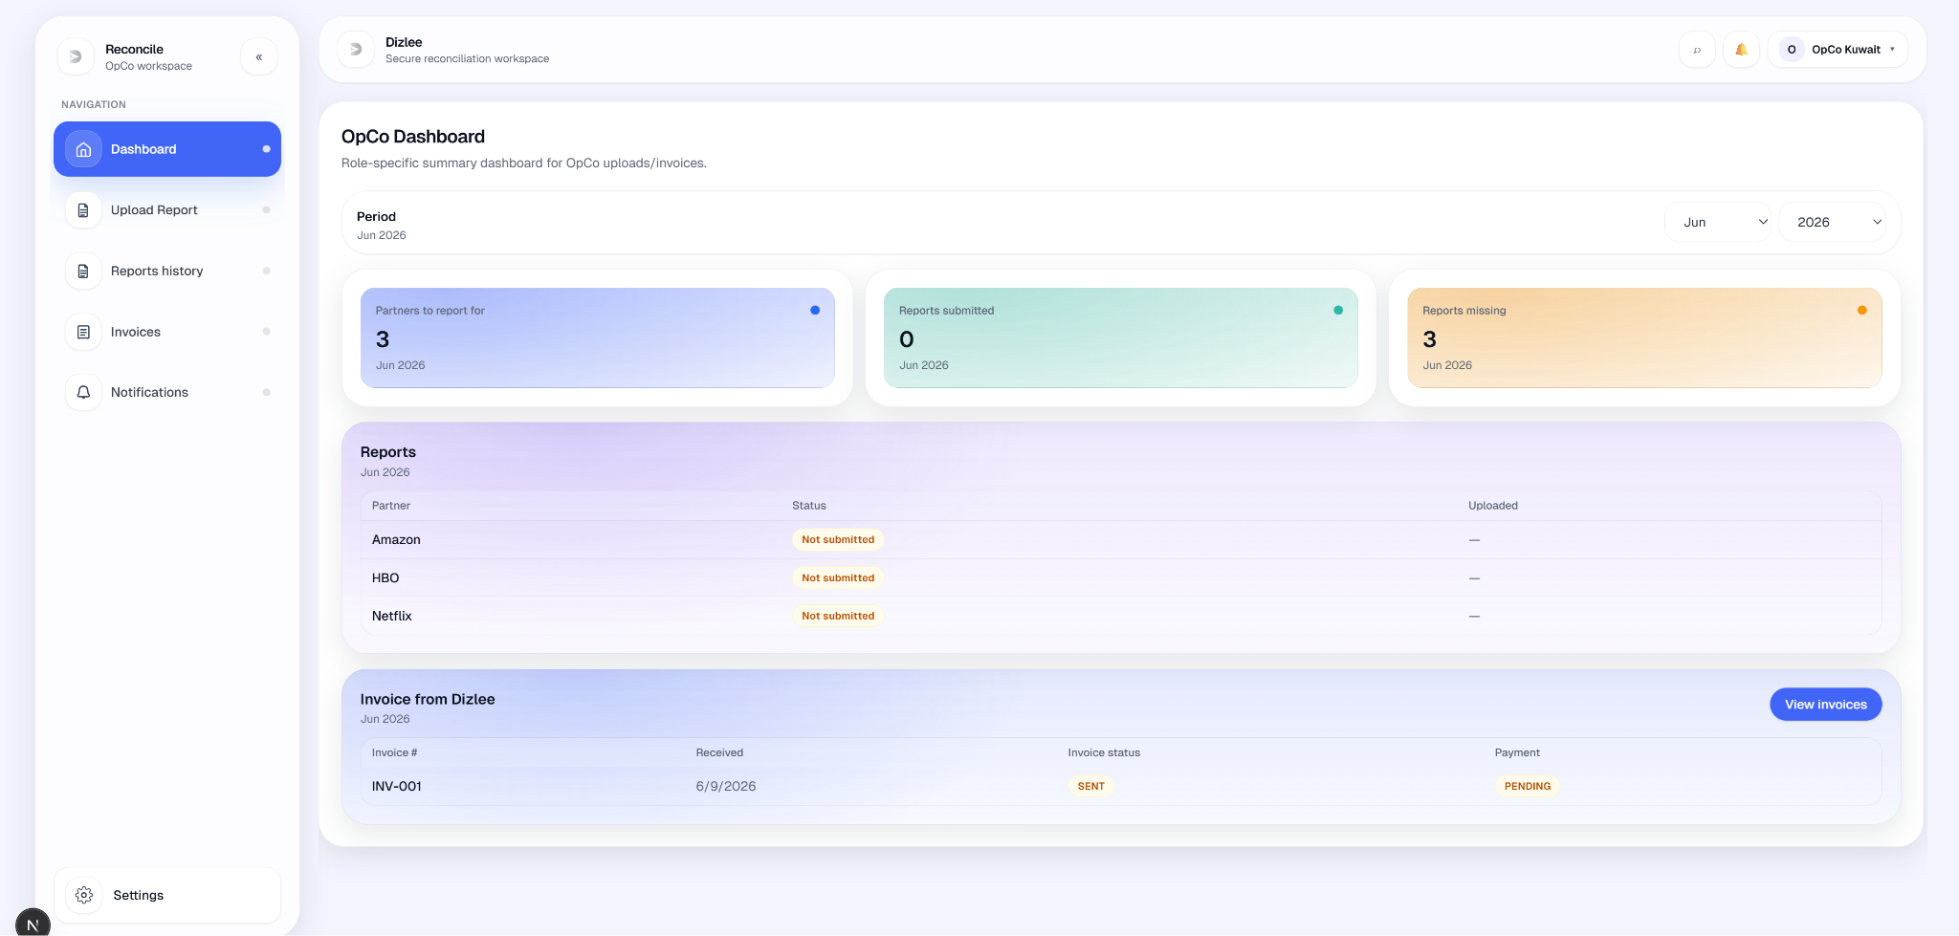

UC-03-OPCO: Upload Report (OpCo)
Element | Detail
Name | Upload Report (OpCo)
ID | UC-03-OPCO
Description | Allows an OpCo User to upload a monthly Excel report for a period and partner, parsed into line items (services from the file) and stored for reconciliation.
Actors | OpCo User
Organization Benefits | Centralizes OpCo report collection required for reconciliation and downstream billing.
Frequency of Use | Monthly.
Triggers | User selects the 'Upload Report' option.
Preconditions | OpCo user is logged in; report currency configured under OpCo Settings; OpCo is linked to the selected partner; USD rate exists for that currency and period (admin).
Postconditions | Report record and line items stored (status: SENT); Dizlee notified; audit REPORT_UPLOADED; user redirected to Reports history.
Main Course | - OpCo User opens the Upload Report screen.  - The screen shows the following fields:  - Month (dropdown list — Jan–Dec)  - Year (dropdown list; default current calendar year)  - Partner (dropdown list — linked Partners only)  - Excel file upload (.xlsx / .xls)  - If report currency is not configured, the system shows a warning with a link to OpCo settings (user must set default report currency before upload).  - OpCo User selects the reporting period (MM YYYY).  - Period selector rules:  - Month: 12 months (Jan–Dec); future months in the current year are hidden.  - Year: 11 years shown (current year and the previous 10 years).  - Default on open: current calendar month (not a future month).  - User cannot select a period after the current month.  - OpCo User selects the Partner the report applies to.  - Partner list rules:  - Only Partners linked to this OpCo by Admin (OpCo–Partner settings).  - Sorted alphabetically by Partner name.  - Selection is mandatory.  - OpCo User selects an Excel file (.xlsx or .xls).  - OpCo User clicks Upload.  - The system validates:  - Period selected  - Partner selected  - File selected  - Report currency set in OpCo settings  - OpCo User session scope (OpCo ID from login)  - The system parses the Excel file (OpCo template Type 1 or Type 2): service rows and gross revenue columns → line items (serviceId, description, usage, partner name from selection). Empty or invalid files are rejected.  - The system stores the report with metadata (period, OpCo from session, Partner, filename, line items), converts amounts to USD using the admin FX rate for the period, and saves status SENT.  - The system shows Uploaded successfully (toast and upload overlay) and navigates to Reports history.
Alternate Course | AC1: Report currency missing  - User tries upload without currency in OpCo settings.  - Toast “Set your report currency under OpCo settings before uploading.”; upload blocked.  AC2: User leaves without uploading  - User navigates away (no dedicated Cancel button).  - No report saved.  AC3: Duplicate for same month/partner  - Report already exists for same period + OpCo + partner.  - API 409: “A report for this month/scope already exists. Please use Replace upload from the Reports list to correct it.”
Exception Courses | EX1: No file selected  Toast “Please select a file.”  EX2: Partner not selected  - Toast “Please select the partner this report applies to.”  - Field error: “Partner is required.” (API: “Partner is required for OpCo reports.”)  EX3: Excel parse failure / no rows  - Examples: “No data rows found. Use an OpCo template block (Type 1 or Type 2)…”, column/header mismatch messages.  - Error banner + toast; upload does not proceed.  EX4: Partner not linked  - API: “This OpCo is not linked to that partner. Ask an admin to update OpCo partner settings.”  EX5: FX / currency not enabled  - No USD rate for period, or currency disabled.  - API validation on defaultReportCurrency.
Business Rules | BR 01: OpCo users may upload reports only for their own OpCo.  BR 02:The Partner dropdown lists only partners linked to the OpCo by Admin.  BR 03:OpCo must select one partner per upload; unlinked partners cannot be used.  BR 04:Partners are listed in name order.  BR 05:If no partners are linked, the OpCo cannot upload until Admin updates OpCo partners settings.  BR 06: The system does not accept a duplicate report for the same month and partner scope. If a report already exists, the upload fails with a message that a report for that month/scope already exists.  BR 07: After a report is uploaded, it cannot be overwritten through the upload screen. Corrections require a reupload request, Dizlee approval, then Replace upload.  BR 08: Each OpCo report upload shall be scoped to one period and one partner (one lane per month).  BR 09: Upload shall be allowed only for admin-linked OpCo–partner pairs.  BR 10: Admin sets the maximum allowed upload file size for reports.  BR 11: OpCo and Partner uploads (including replace) must not exceed that limit.  BR 12: Oversized files are rejected with an error; no report is saved.  BR 13: Upload file name must be 1–255 characters (including extension).

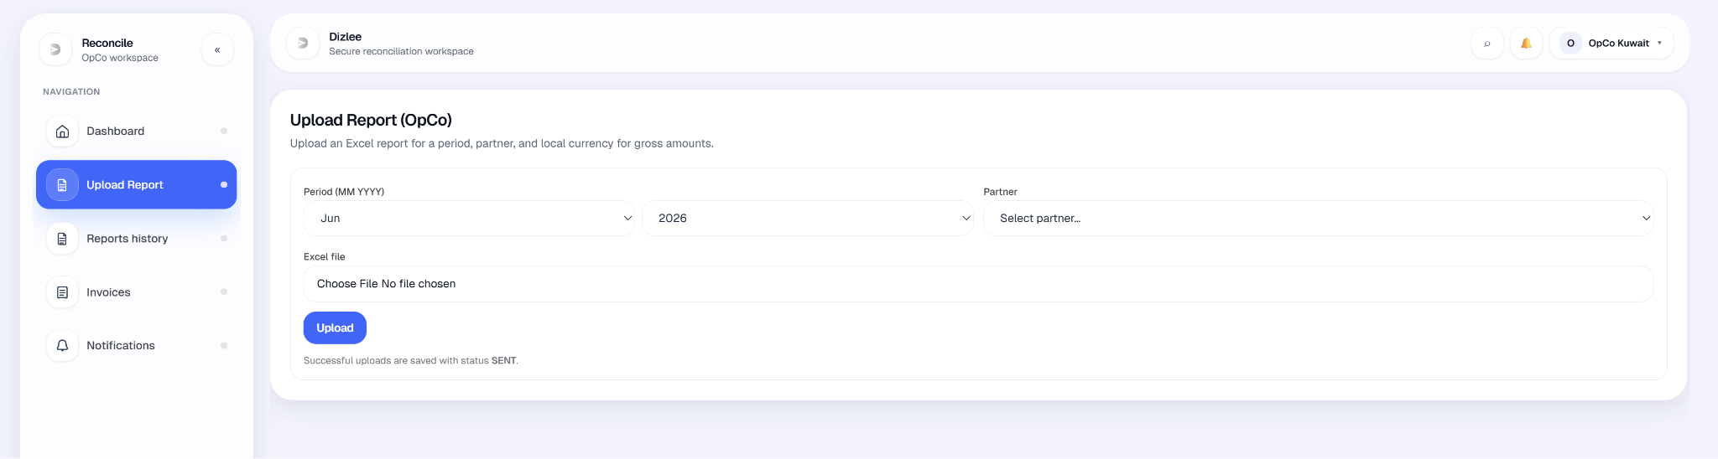

UC-04-OPCO: Request Report Upload (OpCo)
Element | Detail
Name | Request Report Upload (OpCo)
ID | UC-04-OPCO
Description | An OpCo user asks Dizlee to allow replacing an already uploaded OpCo report file for a given period and partner. The original file stays locked until Dizlee approves; after approval, the OpCo may use Replace upload once.
Actors | OpCo, Dizlee
Organization Benefits | Corrects upload mistakes without breaking the one-report-per-month rule; keeps an audit trail and Dizlee control before data changes.
Frequency of Use | Occasional, when an uploaded report needs correction.
Triggers | OpCo User opens Reports history, finds a report, and chooses Request file change.
Preconditions | OpCo User is signed in.  At least one OpCo-uploaded report exists for the Partner that needs to be changed.  No pending or approved reupload request already exists for that report.  .
Postconditions | A report change request is created with status PENDING.  Dizlee receives an in-app notification with period, OpCo, partner, current filename, reason, and request id.  The report file remains locked; OpCo cannot replace it until Dizlee approves.  In Reports history, the action icon shows Reupload request pending (disabled) until Dizlee decides.
Main Course | - OpCo User opens Reports history.  - The system shows a paginated list of OpCo-uploaded reports (period, partner, file, uploaded date, status) with filters for period and sort.  - OpCo User locates the report to correct.  - OpCo User clicks Request file change (document icon) in the row actions.  - The system opens Request file change with period, filename, and a reason field.  - OpCo User enters a reason and clicks Send request.  - The system validates that the report exists, belongs to the OpCo, was uploaded by OpCo, and that reason is not empty.  - The system creates a change request with status PENDING and sends a notification to Dizlee.  - The system shows success (Request sent to Dizlee) and refreshes the list.  - The row action changes to pending state until Dizlee approves or rejects.
Alternate Course | A1 — Already pending  OpCo tries to request again while one is PENDING → system rejects: A request is already pending for this report. Action stays disabled in the grid.  A2 — Already approved  A request is APPROVED but replace not done yet → Request file change is hidden; Reupload corrected file is shown instead.  A3 — Dizlee approves (follow-on)  Dizlee approves in Reports history → Reupload requests → OpCo gets notification → OpCo uses Reupload corrected file (separate UC: replace upload).  A4 — Dizlee rejects (follow-on)  Dizlee rejects → OpCo notified → original file stays locked → OpCo may submit a new request later (no active PENDING/APPROVED request).  A5 — Cancel modal  OpCo closes the modal without sending → no request created.
Exception Courses | E1- Reason is empty  Send request disabled / validation error: reason required.  E4 - Pending or approved request already exists  Conflict error; request not created.  E5 - Network/server failure  Error message; user stays on modal/history; may retry.
Business Rules | BR-01: OpCo may request reupload only for reports they uploaded (uploadedByRole = OpCo for their OpCo).  BR-02: Only one active reupload request per report at a time (status PENDING or APPROVED blocks a new request).  BR-03: A reason is mandatory for every request.  BR04: OpCo cannot replace the file directly from upload screen or history without Dizlee approval (one-report-per-month rule preserved).  BR-05: Approval applies to that report only; after successful replace, the change request is marked COMPLETED and the report is locked again.  BR-06: Dizlee is notified in-app; email is optional only if admin email is enabled (same pattern as other notifications).

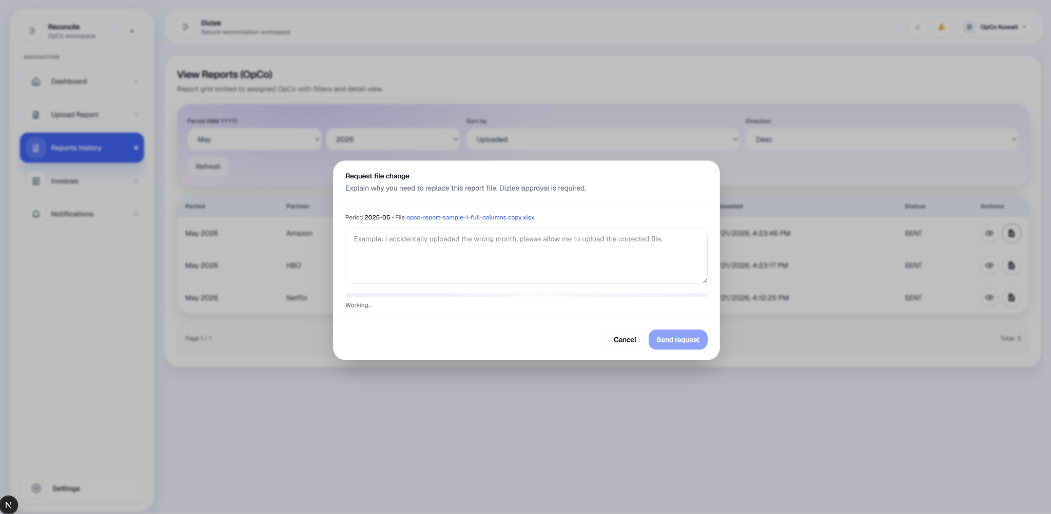

UC-05-OPCO: View Reports (OpCo)
Element | Detail
Name | View Reports (OpCo)
ID | UC-05-OPCO
Description | Allows an OpCo User to list, filter, sort, and open their own uploaded reports for the assigned OpCo.
Actors | OpCo User
Organization Benefits | Review submission history and open report detail or preview.
Frequency of Use | On demand.
Triggers | OpCo user opens Reports history from side nav (page title: View Reports (OpCo)).
Preconditions | OpCo user is logged in with valid opcoId.
Postconditions | User views the filtered/sorted report grid and may open detail or file preview for a row.
Main Course | - OpCo user navigates to Reports history.  - System loads a paginated grid (10 per page) of reports where uploadedByRole = OPCO and opcoId matches the session (default sort:  Period - Current Month,  Sort by - Uploaded  Sort order - Desc ( newest first).  - User may set Period (MM YYYY), Sort by (Uploaded / Period / Filename), and Direction (Asc / Desc).  - User clicks Refresh to apply filters and sort.  - Grid columns: Period, Partner, File (link), Uploaded, Status, Actions.  - User opens a report:  - File link → report preview (new tab), or  - View action → Report details modal (period, uploaded by, file link, size, uploaded timestamp).  - User may paginate with Prev / Next.
Alternate Course | AC1: No filters changed  - User opens page; initial load shows reports for default period filter value after first refresh on mount.  AC2: Request reupload (related)  - User requests file change from row actions (Dizlee approval required).  - After APPROVED, Reupload corrected file action becomes available (separate replace flow).
Exception Courses | EX1: No reports for criteria  - Empty state: “No reports”. “Upload a report to see it here.” (not “No reports found.”)  EX2: List API error  - Red error banner with API message.  EX3: Access denied  - Missing opcoId → redirect to access denied before page loads.
Business Rules | BR-01: OpCo users shall only view reports belonging to their own OpCo (and only OpCo-uploaded reports, not Partner uploads).

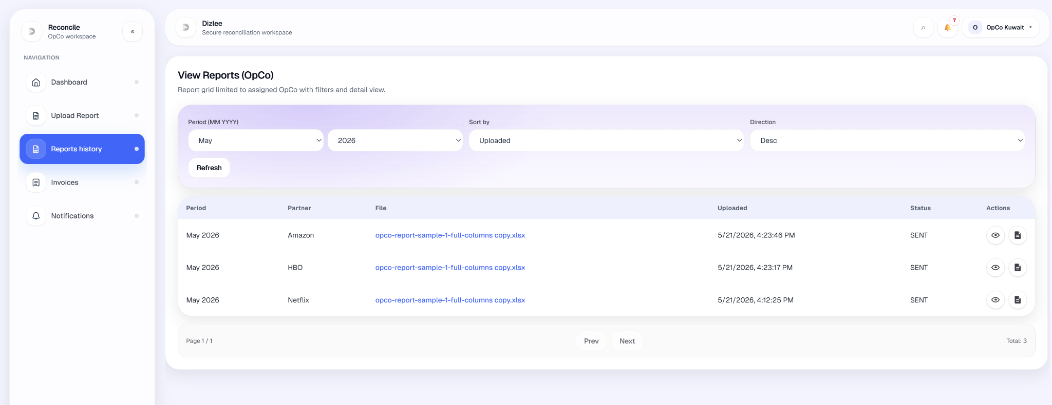

UC-06-OPCO: Find reports in Reports history

Element | Detail
Name | Find reports in Reports history
ID | UC-06-OPCO
Description | OpCo User narrows and orders their uploaded reports in Reports history using period and sort, then locates a specific report in the list.
Actors | OpCo User
Organization Benefits | Quickly find a report by month, filename, or upload date without leaving the history screen.
Frequency of Use | Whenever needed to see past reports.
Triggers | OpCo User opens Reports history.
Preconditions | OpCo User is signed in.  User has access to Reports history (OpCo-uploaded reports only).
Postconditions | Grid shows reports matching the selected period filter (if set) and sort order.  User can open a report (preview, view details, or reupload actions) from the filtered list.  No report data is changed by filtering or sorting.
Main Course | - OpCo User opens Reports history.  - System shows a paginated table: period, partner, file, uploaded date, status, and actions.  - User sets Period (MM YYYY) to limit results to one reporting month (optional).  - User sets Sort by (Uploaded / Period / Filename) and Direction (Asc / Desc).  - User clicks Refresh.  - System reloads the list for that OpCo with the chosen period and sort.  - User scans the table or uses Prev / Next pagination to find the report.  - User selects a row action (view, request reupload, etc.) as needed.
Alternate Course | AC1 — No reports for period: Table shows empty state (No reports , Upload a report to see it here).  AC2 — Change sort only: User changes sort/direction and clicks Refresh again → list reorders.  AC3 — Default period on load: Screen loads with a default period; user may change it and refresh.
Exception Courses | E1: List load fails → error message; previous list may remain.
Business Rules | BR-01: OpCo sees only their own OpCo-uploaded reports (not Partner uploads for the same OpCo).  BR-02: Period filter is exact month match (MM YYYY).  BR-03: Sort applies to the current filter and current page size (10 per page).  BR-04: Filtering/sorting does not include soft-deleted reports.

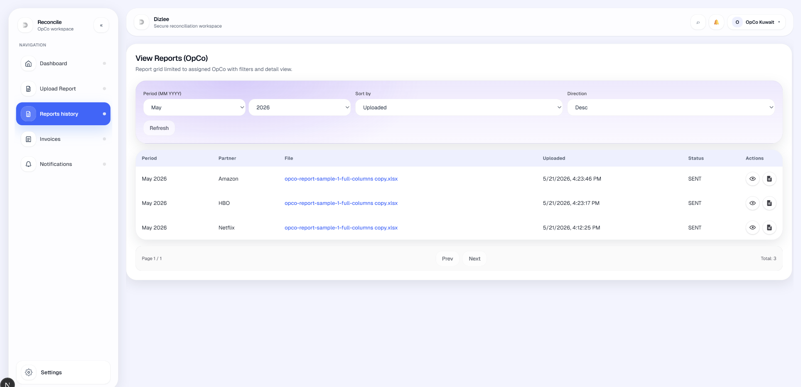

UC-07-OPCO: Print Invoice

Element | Detail
Name | Print Invoice (OpCo)
ID | UC-07-OPCO
Description | OpCo User opens a Invoices and prints it or saves it as PDF using the standard print layout.
Actors | OpCo
Organization Benefits | Provides a printable copy for finance, approval, and records.
Frequency of Use | As needed
Triggers | OpCo User opens an invoice from the Invoices list.
Preconditions | OpCo User is signed in.  Invoice is a Dizlee → OpCo invoice for that OpCo.  Invoice has a structured printable document (system invoice template).  Invoice is available to view.
Postconditions | User has printed the invoice or saved it as PDF via the browser.  Invoice data and status in the system are unchanged by printing.
Main Course | - OpCo User opens Invoices and selects an invoice to view.  - The system loads the invoice detail screen and shows the invoice in a print-friendly layout (header, bill-to, line items, totals, payment/bank details where applicable).  - OpCo User clicks Print / Save as PDF.  - The system opens the browser print dialog with the invoice formatted for printing.  - OpCo User prints the invoice or selects Save as PDF in the browser.  - The user completes or cancels the print action and remains on the invoice view.
Alternate Course | A1: User cancels the print dialog → no print output; invoice view unchanged.
Exception Courses | E1: Invoice not found; print not available.  E2: Invoice fails to load → error message; user cannot print.
Business Rules | BR - Only OpCo users for the invoice’s OpCo may print that invoice.  BR-01: Printed output must match the data shown on the invoice preview screen.  BR-02: Printing does not update payment status or other invoice workflow states.

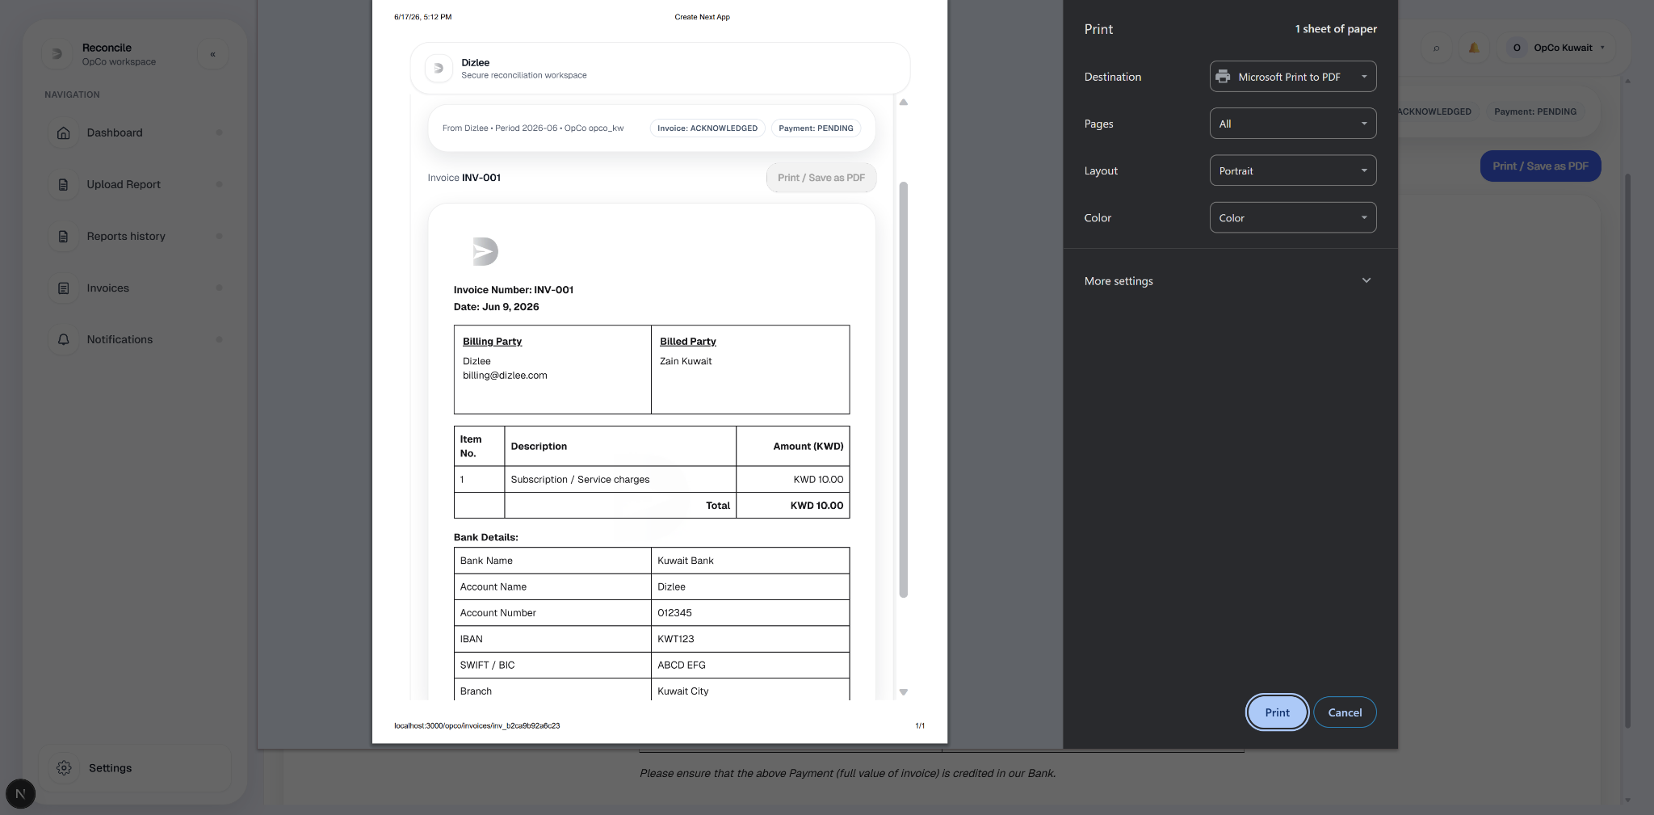

UC-08-OPCO: View and respond to invoices (OpCo)
Element | Detail
Name | View and respond to invoices (OpCo)
ID | UC-11-OPCO
Description | Allows an OpCo User to view Dizlee → OpCo invoices, acknowledge receipt (automatic on detail open), and see payment status. OpCo does not upload invoices in the current application..
Actors | OpCo User
Organization Benefits | Track Dizlee invoice status and record operational acknowledgement; visibility when payment is recorded off-platform.
Frequency of Use | On demand.
Triggers | User selects Invoices from navigation.
Preconditions | OpCo user is logged in with valid opcoId.
Postconditions | User views invoice list and/or detail; acknowledgement may be updated automatically; payment status displayed (read-only unless backend API used without UI).
Main Course | - OpCo user navigates to Invoices (page title: View Invoices (OpCo)).  - System lists Dizlee-issued invoices (uploadedByRole: CLIENT) scoped to the user’s OpCo (paginated, 10 per page).  - Grid columns: Period, Dizlee, Payment status (PAID / PENDING), Uploaded, View invoice.  - User may filter by Search (invoice number, Apply required) and Period (MM YYYY); clicks Refresh to reload.  - User opens View invoice → invoice detail screen.  - System auto-acknowledges on open if not yet ACK (acknowledgeInvoice API): pills show Acknowledging… then Acknowledged; activity log and notification to Dizlee.  - Detail shows Invoice / Payment status pills, period, OpCo, and invoice preview (structured document or uploaded file viewer).  - If Dizlee has marked payment done, pill “Payment done (Dizlee)” is shown.
Alternate Course | AC1: No search/filter  - User opens list without changing filters.  - Initial load after mount shows invoices (default period filter applied on first refresh).  AC2: Already acknowledged  - User reopens invoice.  - Acknowledged shown immediately; no duplicate ack attempt for same invoice id in session.  AC3: OpCo upload route/opco/invoices/upload redirects to invoice list — no upload UI (matches SRS: OpCo does not upload).
Exception Courses | EX1: No invoices  Empty state: “No invoices” — “Upload an invoice to see it here.” (copy is misleading for OpCo; list is empty).  EX2: Invoice not found / wrong scope  Detail error message from API (e.g. “Invoice not found.”, “Access denied.”).  EX3: Acknowledge fails  Error toast from acknowledge API; invoice may remain unacknowledged.
Business Rules | BR-01: OpCo users shall only see invoices for their own OpCo (Dizlee → OpCo only).  BR-02: Invoice status and payment status shall be shown on the invoice record and UI.

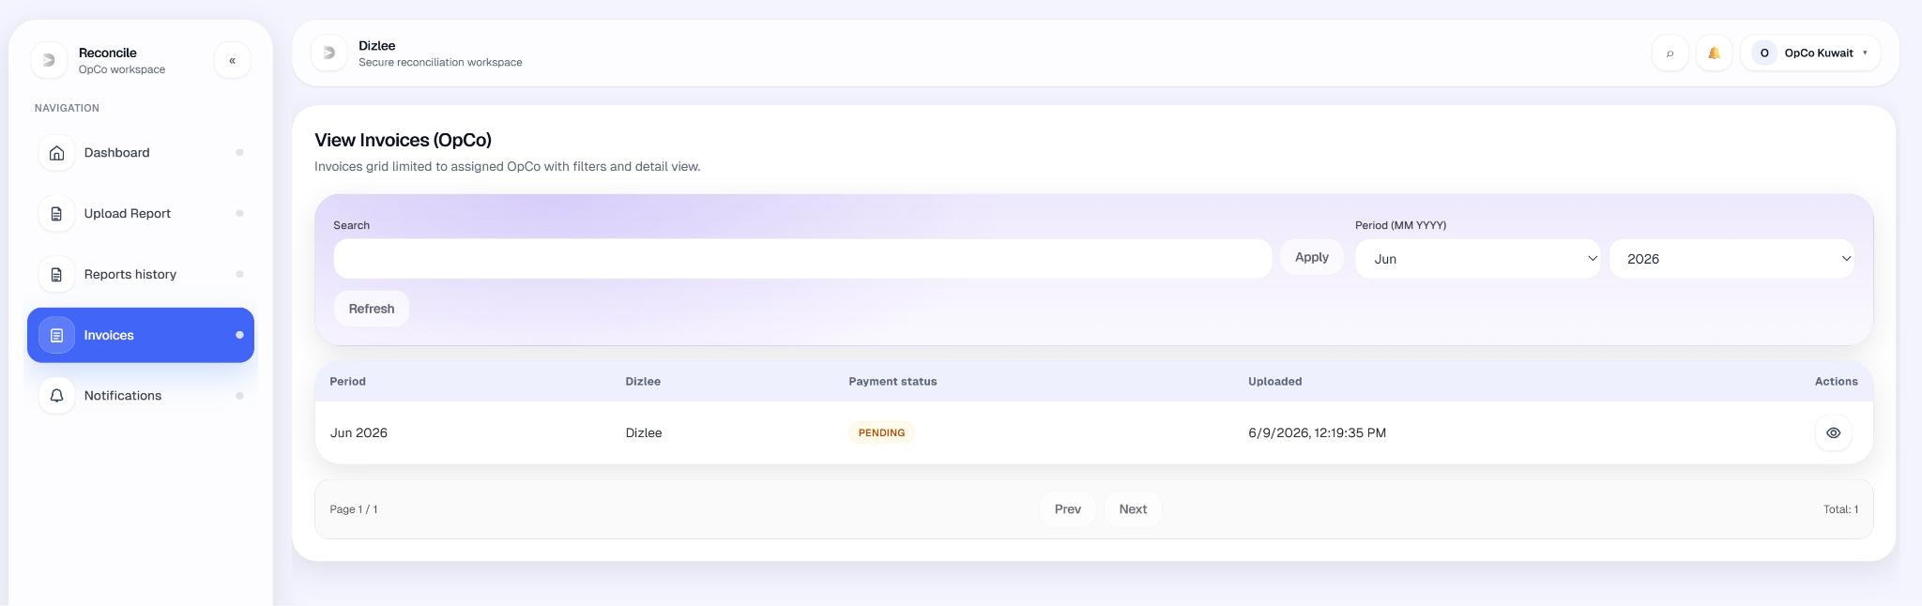

11.4 Partner User Use Cases
UC-01-PARTNER: Access Side Navigation Bar
Element | Detail
Name | Access Side Navigation Bar
ID | UC-01-PARTNER
Description | Allows the Partner User to navigate to available modules using the side navigation bar.
Actors | Partner User
Organization Benefits | Gives Partner Users quick access to Dashboard, Reports, Invoices, and Notifications.
Frequency of Use | Multiple times per session.
Triggers | Partner User opens the application after sign-in or uses the side navigation bar.
Preconditions | Partner User is logged into the system.
Postconditions | Partner User is navigated to the selected module.
Main Course | - After login, the system shows the Partner workspace with the side navigation bar.  - The bar lists Partner modules: Dashboard, Upload Report, Reports history, Upload Invoice, Invoices, and Notifications.  - Partner User selects a module.  - The system opens that screen.  - The active item is highlighted in the sidebar.
Alternate Course | AC1 — Already on selected screen: System stays on or refreshes the current screen.  AC2 — Collapsed sidebar (desktop): User expands the sidebar or uses icon-only links with labels on hover.  AC3 — Settings: User opens Settings from the sidebar footer (account settings, e.g. change password) — not in the main NAVIGATION list.
Exception Courses | EC1 — Not authenticated: User is redirected to login.  EC2 — Unauthorized route: User is denied access to modules outside the Partner role.
Business Rules | BR-15: Navigation is limited to modules allowed for the Partner role.  BR-16: Partner Users only see data scoped to their partner account.

UC-02-PARTNER: View Dashboard (Partner)
Element | Detail
Name | View Dashboard (Partner)
ID | UC-02-PARTNER
Description | Allows a Partner User to view a role-specific dashboard with summary data for the selected period: report submission status per linked OpCo, and Partner → Dizlee invoice status.
Actors | Partner User
Organization Benefits | Gives Partner Users a quick view of report and invoice submission status for the selected month.
Frequency of Use | Daily / on login.
Triggers | Partner User signs in (lands on Dashboard) or opens Dashboard from the side navigation bar.
Preconditions | Partner User is signed in and has a valid partner account.
Postconditions | Dashboard is shown with data scoped to that Partner and the selected period.
Main Course | 1. The system identifies the user as a Partner User.  2. The system opens the Partner Dashboard (default landing after login).  3. The system shows a period selector (MM YYYY) and loads overview data for that month.  4. The system displays summary cards: OpCos to report for, Reports submitted, and Reports missing.  5. The system displays a Reports table mentioning the following columns  - OPCO Name  - Report Status (Submitted/Not submitted)  - Submitted Date (Date and time)  The table will be sorted by “Opco name” by default, and the user will have the option to change the sort order (Ascending or Descending) by clicking on the column name  listing each linked OpCo with status Submitted or Not submitted and upload date where applicable.  6. The system displays a section with heading “ Invoice to Dizlee” which will show the invoices submitted by the partner to Dizlee for the selected month in point3 above  The table will show the following columns  - Invoice Number  - Invoice status  - Payment Status  - Invoice submitted date  The table will be sorted by “Invoice Number” by default and the user will have an option to sort by any column by clicking on the column name. The maximum number of records to be shown in this page are 10 with paging option will be displayed if more records are present.  for the period with invoice number (if any), invoice status, payment status, and submitted date.  7. Partner User reviews the dashboard; they may change the period to refresh the view for another month.
Alternate Course | AC1 — Dizlee invoice request: If Dizlee sent an invoice-upload reminder for the period and no invoice is submitted, the system shows an alert with a link to Notifications.  AC2 — Stat card shortcuts: User clicks a summary card to go to Upload Report or Reports history.  AC3 — View invoices: User clicks View invoices from the invoice section to open the Invoices list.
Exception Courses | EX1 — No linked OpCos: Reports table shows No linked opcos. Summary counts may be zero.  EX2 — No invoice for period: Invoice section shows empty placeholders (—) for invoice number and statuses.  EX3 — Dashboard load failure: System shows an error message; dashboard data is not displayed.  EX4 — Not authenticated / no partner scope: User cannot access the dashboard.
Business Rules | BR-01: Partner Users only see data for their assigned Partner entity and linked OpCos.  BR-02: Report metrics count only Partner-uploaded reports for the selected period.  BR-03: Invoice summary shows the Partner → Dizlee invoice for the selected period (if submitted).  BR-04: Dashboard invoice status and payment status reflect the latest stored values for that invoice.

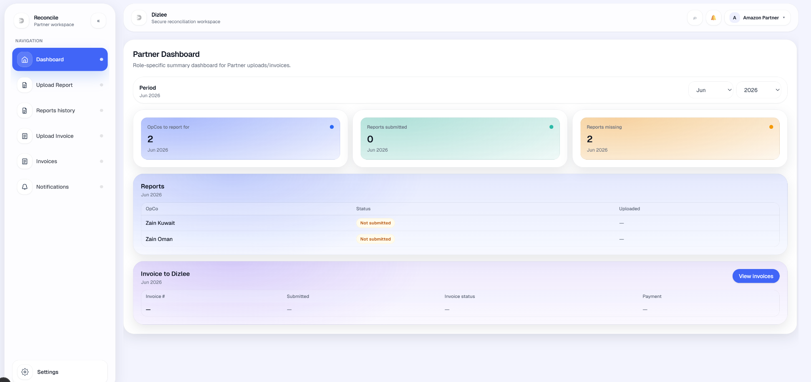
UC-03-PARTNER: Upload Report (Partner)
Element | Detail
Name | Upload Report (Partner)
ID | UC-03-PARTNER
Description | Allows a Partner User to upload a monthly Excel report for a selected period and OpCo. The system parses report rows, stores structured line items, and associates them with the Partner account.
Actors | Partner User
Organization Benefits | Centralizes Partner reports needed for reconciliation against OpCo data.
Frequency of Use | Monthly (per linked OpCo).
Triggers | Partner User selects Upload Report from the side navigation bar (or from dashboard shortcuts).
Preconditions | 1. Partner User is signed in with a valid partner scope.  2. Partner is linked to at least one OpCo (for OpCo dropdown).  3. No existing Partner-uploaded report for the same period + OpCo + Partner (unless using approved reupload flow).
Postconditions | 1. Report is stored with period, OpCo, Partner, filename, parsed line items, and status SENT.  2. Success confirmation is shown; user is redirected to Reports history.
Main Course | 1. Partner User opens Upload Report screen  2. The screen shows following columns  - Month (List of months, List)  - Year (by default current year, text field)  - Opco (List)  - File upload  2. System shows Period (MM YYYY), OpCo (linked OpCos only), and Excel file selector.  3. User selects reporting period. (How many records will be displayed in the selector and what is the criteria of showing that)  4. User selects OpCo the report applies to.  5. User selects an Excel file (.xlsx / .xls).  6. User clicks Upload.  7. System validates mandatory fields (period, OpCo, file) and Partner session scope.  8. System parses the Excel file (Partner template); rejects empty or invalid files.  9. System stores the report with metadata (period, OpCo, Partner from session, filename, line items).  10. System shows Uploaded successfully and navigates to Reports history.
Alternate Course | AC1 — Cancel / navigate away: User leaves without uploading → no report is saved.  AC2 — No Service field on screen: Service identifiers come from Excel rows during parse, not a separate form field.  AC3 — Duplicate report exists: User must use Request reupload from Reports history after Dizlee approval (not a new upload on this screen).
Exception Courses | EX1 — OpCo not selected: Validation error; upload blocked.  EX2 — No file selected: Validation error; upload blocked.  EX3 — Excel parse fails / no data rows: Error shown; upload blocked.  EX4 — Duplicate for same period + OpCo + Partner: Conflict error (report for this month/scope already exists).  EX5 — OpCo not linked to Partner: Validation / access error.  EX6 — Network or server error: Upload fails; no report saved.
Business Rules | BR-01: Partner only uploads for their own Partner account.  BR-02: OpCo list shows only OpCos linked to the Partner by Admin.  BR-03: Only one Partner report per month + OpCo + Partner; duplicates are rejected.  BR-04: Upload accepts Excel only (Partner template with required columns e.g. Merchant, Service name, Gross amount (LC)).  BR-05: New uploads are saved with status SENT.  BR-06: File must meet size and filename rules when enforced.

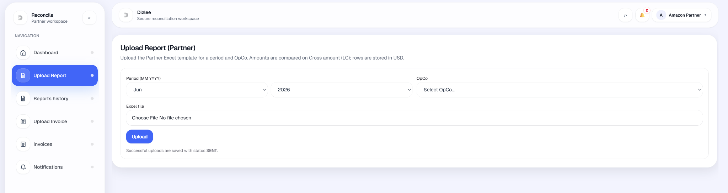

UC-04-PARTNER: View Reports (Partner)
Element | Detail
Name | View Reports (Partner)
ID | UC-04-PARTNER
Description | Allows a Partner User to review Partner-uploaded reports in Reports history, filter by period, sort the list, open report details/preview, and manage reupload requests.
Actors | Partner User
Organization Benefits | Lets Partner Users verify submission history and access report content for their linked OpCos.
Frequency of Use | On demand.
Triggers | Partner User selects Reports history from the side navigation bar (screen title: View Reports (Partner)).
Preconditions | Partner User is signed in with a valid partner scope.
Postconditions | Partner User sees a list of their uploaded reports (matching filters) and can open a selected report or related actions.
Main Course | 1. Partner User opens Reports history (Uploads tab).  2. System displays a paginated grid of Partner-uploaded reports: period, OpCo, file name, uploaded date, status, and actions.  3. User sets Period (MM YYYY) and/or Sort by (Uploaded / Period / Filename) and Direction (Asc / Desc).  4. User clicks Refresh.  5. System reloads the list for that Partner with the selected period and sort.  6. User selects a report:  • clicks View report (details modal), or  • clicks the file name to open report preview (line items; Download Excel available there).  7. User reviews report information.
Alternate Course | AC1 — No filter applied / default period: System shows reports for the default period after refresh; user may change period and refresh again.  AC2 — RS Reports tab: User switches to RS Reports to view Dizlee RS Report notifications received by the Partner (separate from upload grid); optional month filter + Refresh.  AC3 — Request reupload: From a row, user requests file change (see UC-07B-PARTNER).  AC4 — Pagination: User uses Prev / Next to move between pages.
Exception Courses | EX1 — No reports for criteria: Empty state No reports — Upload a report to see it here.  EX2 — List load failure: Error message; grid not updated.  EX3 — Report not accessible: Preview/download denied if report is outside Partner scope.
Business Rules | BR-01: Partner Users only see reports uploaded by Partner for their partner account.  BR-02: Period filter is an exact month match (MM YYYY).  BR-03: There is no free-text search by report name on this screen; locating reports uses period filter, sort, and pagination.  BR-04: Filter/sort changes apply after user clicks Refresh (not automatic on every keystroke).

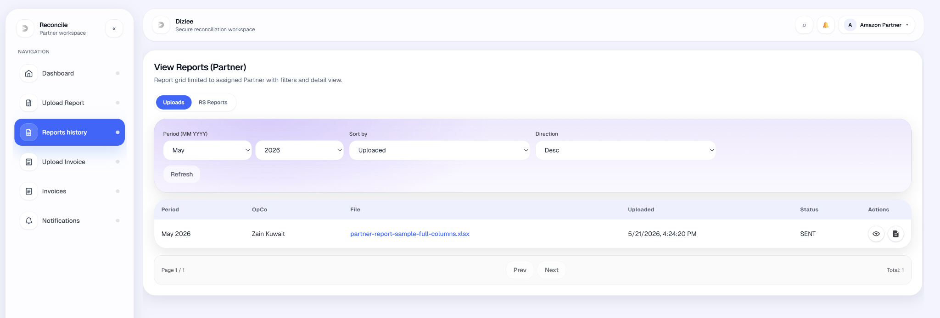

UC-05-OPCO: Request Report Upload (Partner)
Element | Detail
Name | Request Report Upload (Partner)
ID | UC-05-Partner
Description | A Partner user asks Dizlee to allow replacing an already uploaded Partner report file for a given period and partner. The original file stays locked until Dizlee approves; after approval, the Partner may use Replace upload once.
Actors | Partner, Dizlee
Organization Benefits | Corrects upload mistakes without breaking the one-report-per-month rule; keeps an audit trail and Dizlee control before data changes.
Frequency of Use | Occasional, when an uploaded report needs correction.
Triggers | Partner User opens Reports history, finds a report, and chooses Request file change.
Preconditions | Partner User is signed in.  At least one Partner-uploaded report exists for the OPCOs that needs to be changed.  No pending or approved reupload request already exists for that report.  .
Postconditions | A report change request is created with status PENDING.  Dizlee receives an in-app notification with period, OpCo, partner, current filename, reason, and request id.  The report file remains locked; Partner cannot replace it until Dizlee approves.  In Reports history, the action icon shows Reupload request pending (disabled) until Dizlee decides.
Main Course | - Partner User opens Reports history.  - The system shows a paginated list of Partner-uploaded reports (period, partner, file, uploaded date, status) with filters for period and sort.  - Partner User locates the report to correct.  - Partner User clicks Request file change (document icon) in the row actions.  - The system opens Request file change with period, filename, and a reason field.  - Partner User enters a reason and clicks Send request.  - The system validates that the report exists, belongs to the Partner, was uploaded by Partner, and that reason is not empty.  - The system creates a change request with status PENDING and sends a notification to Dizlee.  - The system shows success (Request sent to Dizlee) and refreshes the list.  - The row action changes to pending state until Dizlee approves or rejects.
Alternate Course | A1 — Already pending  Partner tries to request again while one is PENDING → system rejects: A request is already pending for this report. Action stays disabled in the grid.  A2 — Already approved  A request is APPROVED but replace not done yet → Request file change is hidden; Reupload corrected file is shown instead.  A3 — Dizlee approves (follow-on)  Dizlee approves in Reports history → Reupload requests → Partner gets notification → Partner uses Reupload corrected file (separate UC: replace upload).  A4 — Dizlee rejects (follow-on)  Dizlee rejects → Partner notified → original file stays locked → Partner may submit a new request later (no active PENDING/APPROVED request).  A5 — Cancel modal  Partner closes the modal without sending → no request created.
Exception Courses | E1- Reason is empty  Send request disabled / validation error: reason required.  E4 - Pending or approved request already exists  Conflict error; request not created.  E5 - Network/server failure  Error message; user stays on modal/history; may retry.
Business Rules | BR-01: Partner may request reupload only for reports they uploaded  BR-02: Only one active reupload request per report at a time (status PENDING or APPROVED blocks a new request).  BR-03: A reason is mandatory for every request.  BR04: Partner cannot replace the file directly from upload screen or history without Dizlee approval (one-report-per-month rule preserved).  BR-05: Approval applies to that report only; after successful replace, the change request is marked COMPLETED and the report is locked again.  BR-06: Dizlee is notified in-app; email is optional only if admin email is enabled (same pattern as other notifications).

UC-06-PARTNER: Upload Invoice (Partner)
Element | Detail
Name | Upload Invoice (Partner)
ID | UC-06-PARTNER
Description | Allows a Partner User to upload an invoice file to Dizlee for a selected reporting period. The invoice is stored with Partner scope, file metadata, and initial workflow statuses.
Actors | Partner User
Organization Benefits | Lets Partners submit invoices to Dizlee for the relevant period in one place.
Frequency of Use | Monthly.
Triggers | Partner User selects Upload Invoice from the side navigation bar.
Preconditions | 1. Partner User is signed in with a valid partner scope.  2. User has an invoice file ready to upload.
Postconditions | 1. Invoice is stored for Partner → Dizlee (no OpCo on the invoice record).  2. Original file is stored for later view/download by authorized users.  3. Dizlee is notified of the new upload.  4. User is redirected to Invoices with a success message.
Main Course | 1. Partner User opens Upload Invoice.  2. System shows Period (MM YYYY) and Invoice file selector; Partner scope is shown from the session.  3. User selects the period.  4. User selects a file (PDF).  5. User clicks Upload.  6. System validates period, Partner scope, and file size (max 10 MB).  7. System stores the invoice with status SENT and payment status PENDING, and saves the uploaded file.  8. System notifies Dizlee of the new invoice.  9. System shows Uploaded successfully and navigates to the Invoices list.
Alternate Course | AC1 — Cancel / navigate away: User leaves without uploading → no invoice is saved.  AC2 — View invoices link: User opens View invoices from the upload screen without uploading.
Exception Courses | EX1 — No file selected: Validation error; upload blocked.  EX2 — Period not selected: Validation error; upload blocked.  EX3 — File too large (> 10 MB): Validation error; upload blocked.  EX4 — Missing Partner session scope: Error; user prompted to sign in again.  EX5 — Upload / server failure: Error message; no invoice saved.
Business Rules | BR-01: Partner may upload only for their own Partner account (from session).  BR-02: Partner invoices are Partner → Dizlee; OpCo is not selected or stored on the invoice.  BR-03: Invoice is associated with period (MM YYYY) only; there is no link-to-report option in the UI.  BR-04: Accepted file types: PDF, max size 10 MB per file.  BR-05: New Partner uploads start as invoice status SENT and payment status PENDING.

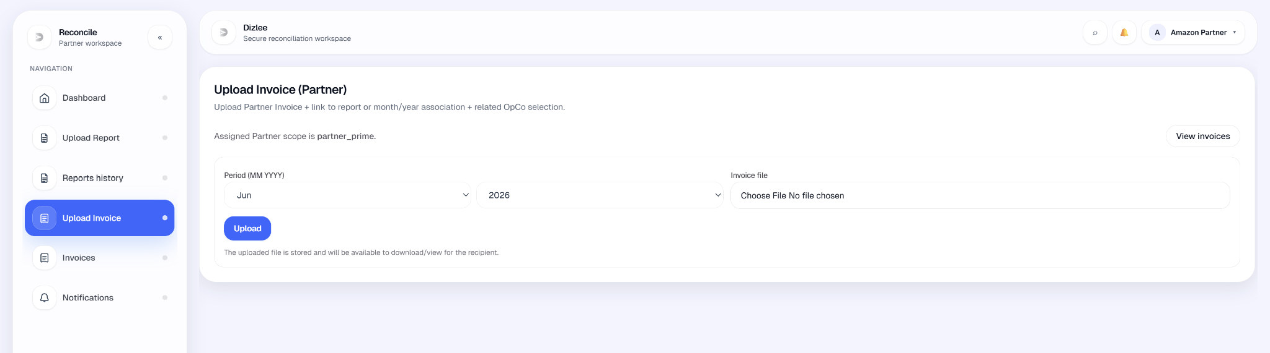

UC-07-PARTNER: View Invoices (Partner)
Element | Detail
Name | View Invoices (Partner)
ID | UC-07-PARTNER
Description | Allows a Partner User to search, filter, and view Partner-uploaded invoices to Dizlee, including payment status, invoice details, and invoice lifecycle progress with activity history.
Actors | Partner User
Organization Benefits | Lets Partner Users track submissions, payment status, and lifecycle stages in one place.
Frequency of Use | On demand.
Triggers | Partner User selects Invoices from the side navigation bar (screen title: View Invoices (Partner)).
Preconditions | Partner User is signed in with a valid partner scope.
Postconditions | Partner User views invoice list and/or lifecycle for invoices matching filters.
Main Course | A — All invoices tab  - Partner User opens Invoices; All invoices tab is shown.  - System displays a paginated grid: period, Dizlee, invoice status, payment status, uploaded date, View action.  - User may set Search (invoice number), Period (MM YYYY), Sort by (Uploaded / Period), and Direction (Newest / Oldest).  - User clicks Apply (search) and/or Refresh.  - System reloads Partner-uploaded invoices.  - User clicks View invoice → Invoice details modal (id, period, statuses, filename, size, uploaded date).  - User reviews and closes the modal.  B — Lifecycle tab  - Partner User selects the Lifecycle tab.  - System shows Invoice lifecycle tracker for invoices in the current filtered result set (same search/period/sort as above; user may Refresh first).  - User selects an invoice from the Invoice dropdown (invoice number • period • Dizlee).  - System displays a lifecycle stepper with four stages:  - Created  - Sent  - Acknowledged  - Payment done  - Completed steps show a checkmark; the next incomplete step is highlighted.  - System loads and displays the Activity log for that invoice (e.g. upload, status changes, payment events).  - User reviews lifecycle progress and activity entries.
Alternate Course | AC1 — No search criteria: User clicks Refresh without search → system shows Partner invoices for the selected period and sort.  AC2 — Lifecycle tab: User switches to Lifecycle to see a lifecycle tracker view for the current result set.  AC3 — Pagination: User uses Prev / Next to browse pages.  AC4 — User changes invoice in Lifecycle dropdown → stepper and activity log update for that invoice.
Exception Courses | EX1 — No matching invoices: Empty state No invoices — Upload an invoice to see it here.  EX2 — List load failure: Error message; grid not updated.  EX3 — Not authenticated / no partner scope: User cannot access the screen.
Business Rules | BR-01: Partner Users only see invoices uploaded by Partner for their own Partner entity.  BR-02: Search matches invoice number (contains), not filename or other fields.  BR-03: Partner → Dizlee invoices have no OpCo on the record; no OpCo filter is shown.  BR-04: Payment status in the grid is summarized as PAID or PENDING for display.

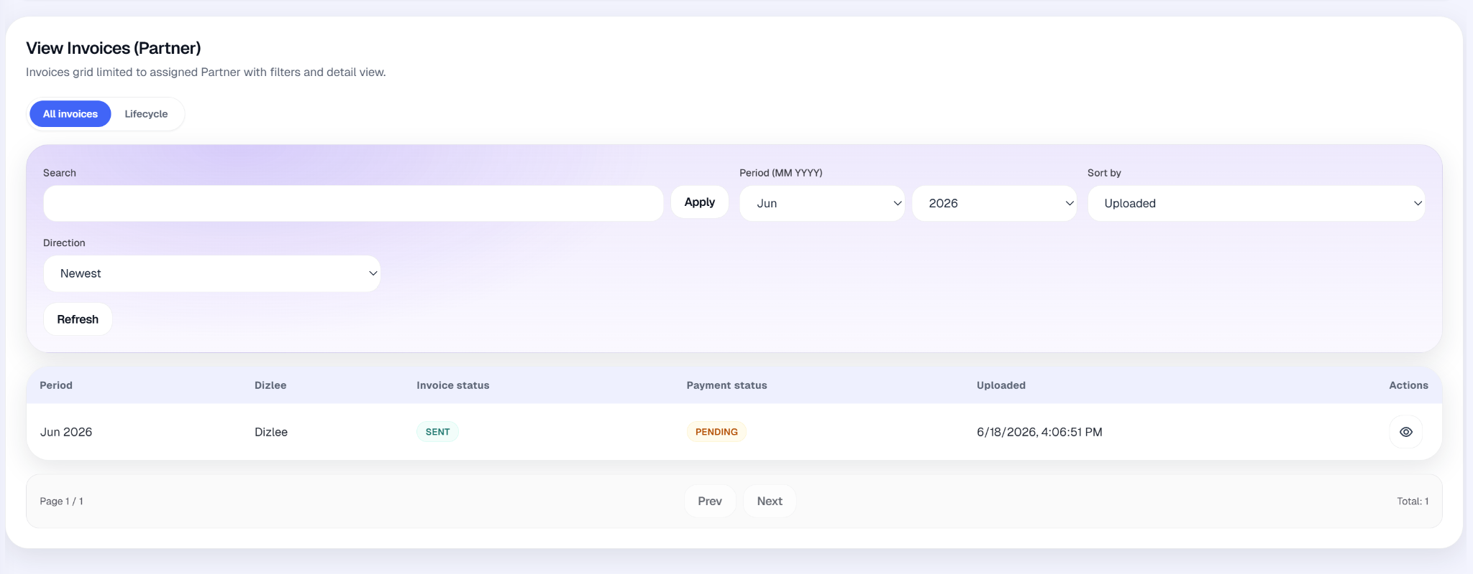
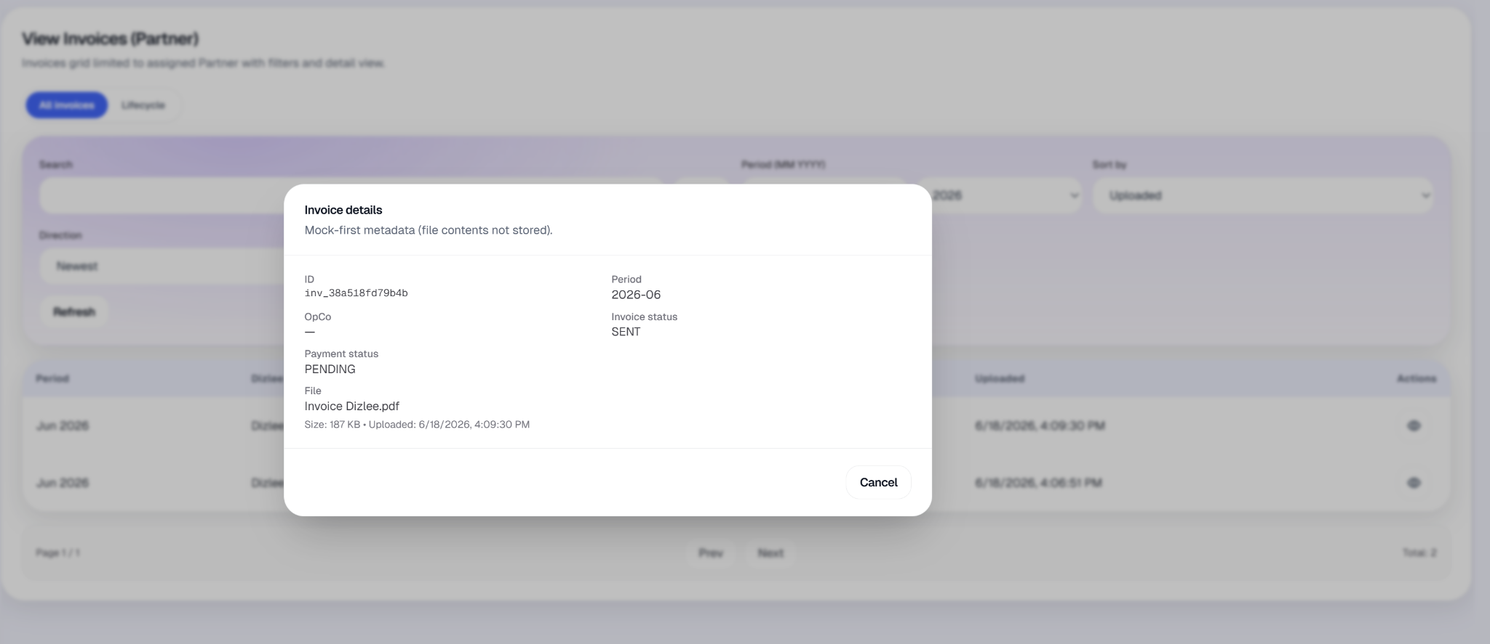
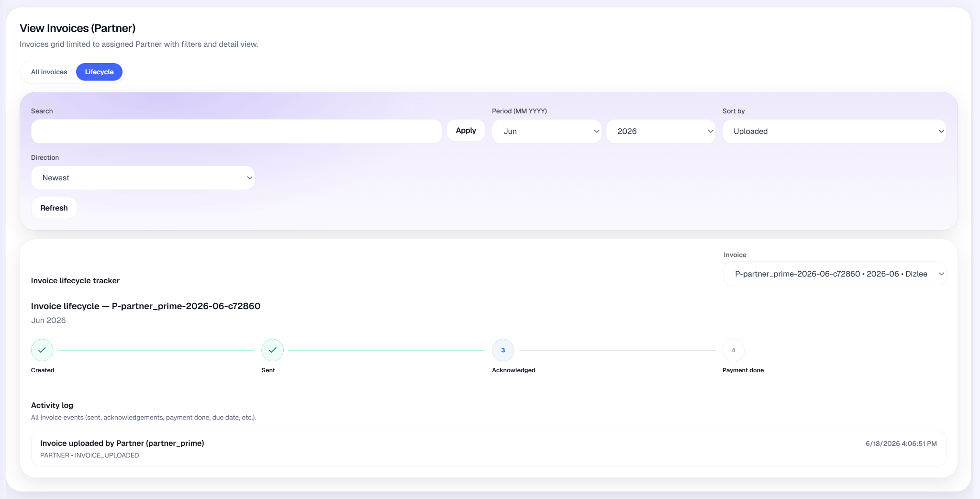

12. Assumptions
(These are contextual understandings, not enforced system rules.)

12.1 Operational
- AS-01: OpCos and Partners provide reports on a monthly period (YYYY-MM).
- AS-02: Report Excel templates are suitable for parsing and reconciliation.
- AS-03: Users manually upload reports; Dizlee creates OpCo invoices; Partners upload their invoices.

12.2 Data
- AS-04: Uploaded data is treated as accurate for operational processing.
- AS-05: Parsed line items include fields needed for lane reconciliation (partner, service, usage).

12.3 System usage
- AS-06: Users have valid credentials (demo or production auth).
- AS-07: In-app notifications are the primary communication channel in the current release; outbound email is planned later.

12.4 Integration
- AS-08: Oracle ERP is out of scope

12.5 Reporting
- AS-09: Dashboard and Reporting views derive from stored reports, invoices, and reconciliations.
- AS-10: Consolidation export uses generated OpCo monthly rows.

13. Field-level validations

13.1 Purpose
Baseline validations for UI, API, and QA for in-scope features only.

13.2 Control principles
- Mandatory fields shall not be saved blank.
- Conditional fields required only when relevant to the selected action.
- File upload requires a selected file before submit.
- Period must be valid YYYY-MM where required.
- List search/filter fields are optional unless a workflow requires them.

13.3 As-built values (reference)
Area | Values / rules
Report upload | Excel only; period, OpCo, Partner required for lane
Invoice lifecycle | e.g. UPLOADED, ACKNOWLEDGED; payment PENDING, PAID
Reconciliation | Admin tolerance %; compare uses usage / usage_usd
Notifications | Subject and body required to send; recipients required

