Construction of a GFP fusion protein by PCR
The purpose of this exercise is to construct a vector that expresses a C-terminal GFP fusion protein between S. cerevisiae cytochrome C and GFP. The final gene will express the cytochrome c open reading frame together with the GFP as one protein. The purpose of doing this could be to follow the localization of GFP inside the cell, since it is possible to see the GFP by fluorescent microscopy (Fig 1).
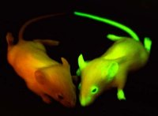Fig 1: GFP mouse

We will construct this fusion gene by sub cloning the CYC1 gene in the GFP fusion vector pUG35 (Fig 2). The pUG35 vector sequence is available from the file “pUG35.txt” that should be available in the same folder as this document. It can also be found under the Genbank accession number AF298787.

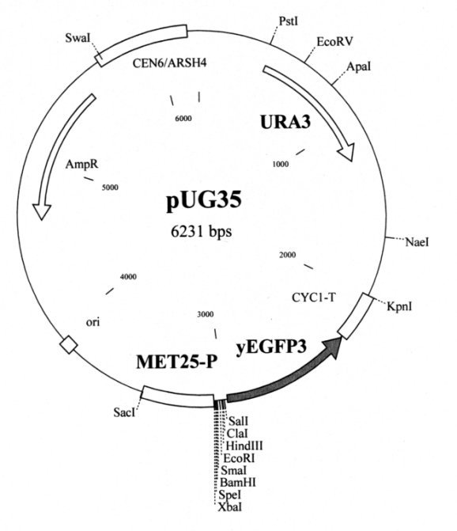Fig 2 The pUG35 vector
The pUG35 has a MET25 (MET25-P in Fig 2) promoter, a multi cloning site and the GFP gene (called yEGFP3 in Fig 2 and EGFP3 in the sequence file of pUG35. The multi cloning site (MCS) is where you can sub clone genes for the expression of c-terminal GFP fusion proteins. A c-terminal fusion means that the GFP is located behind the cytochrome C (in this case) if we count the aminoacids from the N-terminal (Fig 3).

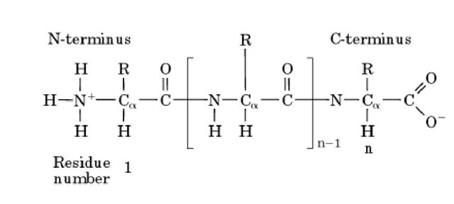Fig 3: N and C teminal of a protein

The MCS has the following available enzymes:

XbaI, SpeI, BamHI, SmaI, EcoRI, HindIII, ClaI and SalI. Look at the Fig 2 and you will find the enzymes just before the EGFP gene.

The sequence of the CYC1 gene is available from the file CYC1.txt in the same folder as this file or from GenBank (accession V01298) or SGD (search for CYC1). The CYC1 gene does not have any of these restriction sites (you should of course check this!), so we can use any of them for sub cloning of CYC1 in gene in pUG35.

Two things are especially important to consider when designing a fusion gene.

1. Stop codon(s).
2. The correct reading frame.

Each gene normally comes with its own stop codon. When we fuse the genes, we only need one stop codon, so that the genes are expressed as one. In the two examples below, the CYC1 is epicted in blue (atg===taa) and the GFP in green (atg---taa).

Fusion gene atg===taaatg---taa 😞
-------->
Only the first gene is expressed since the ribosome stops at the first stop codon (taa). If we remove this, the problem is solved:
-------------->
Fusion gene: atg===atg---taa 😊

We can easily remove the stop codon by relocating the end of the reverse primer three nucleotides upstream (to the left) of the end of the gene. Think of this as simply amplifying a gene that is three base pairs shorter than the normal.
A partial CYC1 gene is depicted below:
>CYC1
atgactgaattcaaggccgg...gaaaaaagcctgtgagtaa
*** ---
Start and stop codons are indicated by *** and ---. Primer design:

>fwd
atgactgaattcaagg
>rev
ctcacaggcttttttc

atgactgaattcaagg>
||||||||||||||||
atgactgaattcaaggccgg...gaaaaaagcctgtgagtaa
tactgacttaagttccggcc...cttttttcggacactcatt
*** ---
||||||||||||||||
<---------------
Note that the reverse primer (blue) stops before the stop codon. Now we need two restriction enzymes in order to clone the PCR product. We choose BamHI and SalI (Simply because we might have these enzymes in the freezer...). We now add nucleotides to the primers for the restriction enzymes. If you are not sure how to do this, review the TP about tailed primers (TP04_Manual_PCR_simulation).
Add the restriction sites to the primer sequences:

>BamHI_fwd
GGATCCatgactgaattcaagg
>SalI_rev
GTCGACctcacaggcttttttc

We need to make sure that the CYC1 and the GFP is in the correct reading frame (Fig 4).
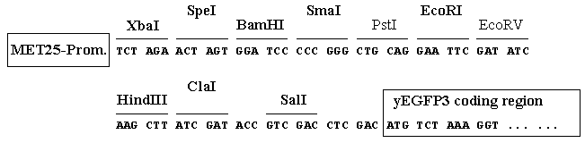Fig 4 pUG35 MCS, reading frame is indicated by the grouping of nucleotides
We know from the translation of the CYC1 gene that the CYC1 encodes a protein of 109 amino acids. This information and the sequence itself can be obtained in several ways:

1. You can look at the GenBank file of CYC1 (V01298), the translation of the gene is available at the end of the “Features” in the sequence file.

2. You can use an online translation tool like http://web.expasy.org/translate For this tool, it is easier only to paste the open reading frame.

3. You can translate the gene with ApE like this:

Open the sequence file or paste the sequence in the main window.

Select from start to the end of the gene (). You can also search for open reading frames using the ORFs>Find next function.
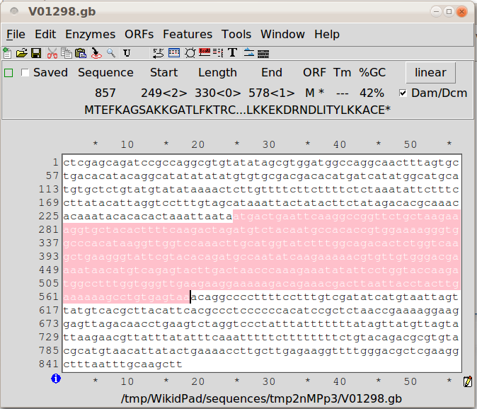Fig 5: CYC1 ORF selected
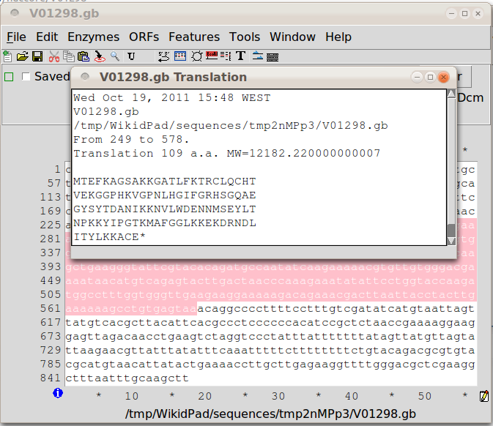Fig 6: CYC1 translation

Select ORFs>Translate... from the Menu, you should be seeing a window like the one in Fig 5.

Copy the translated sequence to a new text file.

We also know from the sequence file of the pUG35 (or by the same method as above) that the EGFP3 gene encodes a protein that is 238 amino acids long. Copy this sequence and place it after the CYC1 protein sequence in your text file.

Note that you may have a * symbol in the sequence file, depending on which software you used. This indicates the stop codon. Remove this symbol (if any) from the end of the CYC1 protein sequence.

We can tell from figure 2 that the amino acids encoded by the linkers would be VDLD between the SalI site and the start codon of the EGFP3 gene. The resulting amino acid sequence should be the one indicated by figure 6.

GTC GAC CTC GAC
(CytC)--YLKKACE V D L D MSKGEEL--(GFP)
Fig 7: Amino acid sequence of the linker

This means that the fusion protein has to contain the sequence YLKKACEVDLDMSKGEEL. We can use this to check our result later. Make sure you really understand this step!

Put the amino acids of the linker in between the the protein sequences in your text file (Fig 7).
MTEFKAGSAKKGATLFKTRCLQCHT
VEKGGPHKVGPNLHGIFGRHSGQAE
GYSYTDANIKKNVLWDENNMSEYLT
NPKKYIPGTKMAFGGLKKEKDRNDL
ITYLKKACE

VDLD

MSKGEELFTGVVPILVELDGDVNGH
KFSVSGEGEGDATYGKLTLKFICTT
GKLPVPWPTLVTTFGYGVQCFARYP
DHMKQHDFFKSAMPEGYVQERTIFF
KDDGNYKTRAEVKFEGDTLVNRIEL
KGIDFKEDGNILGHKLEYNYNSHNV
YIMADKQKNGIKVNFKIRHNIEDGS
VQLADHYQQNTPIGDGPVLLPDNHY
LSTQSALSKDPNEKRDHMVLLEFVT
AAGITHGMDELYK
Fig 8: Fusion protein sequence
Now, simulate the cloning of the PCR product in the pUG35 plasmid. It may be easier to turn the whole plasmid sequence around (view the reverse complement) before starting, since the EGFP gene is on the Crick strand and appears in the opposite direction of what we are used to.

Fig 8 shows the sequence window after the CYC1 sequence has been correctly located. Put the cursor before the A in the start codon of the CYC1 gene. Select ORFs>Find next from the Menu. This tells ApE to search for the next open reading frame that should be our fusion protein.

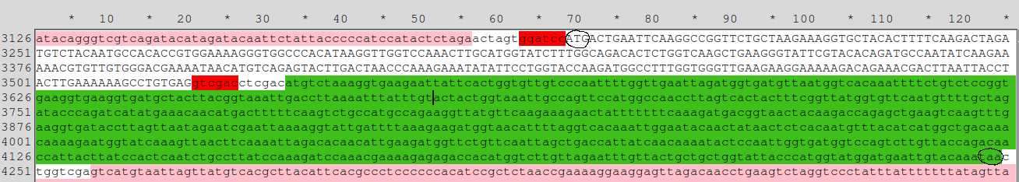Fig 9: The CYC1 gene cloned in front of the EGFP3gene (green). The BamHI and SalI sites are marked in red. The start codon of the CYC1 gene and the stop codon of the EGFP3 are circled. These circles mark the start and stop of the fusion protein translation.
Now the whole fusion protein should be selected. Now select ORFs>translate as before. You should see a window showing a protein sequence of 351 aminoacids. Copy this amino acid sequence and save it in another text file.

Comparison of the sequences

Now you should compare the two aminoacid sequences (they should be the same!).

For this you can go to a web server that implements the Needleman-Wunch algorithm.

http://www.ebi.ac.uk/Tools/psa/emboss_needle/

Paste the translated amino acid sequence and the theoretical sequence in the other window (Fig9).

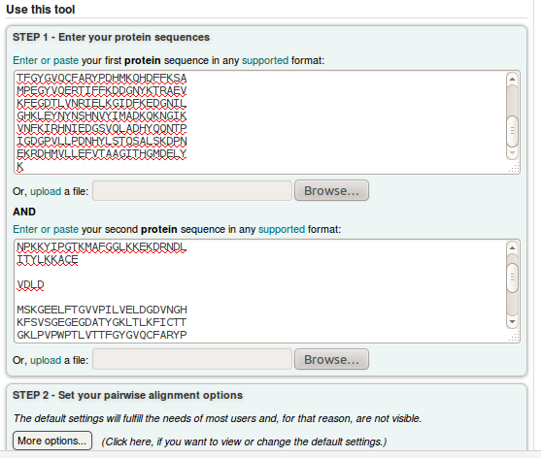Fig 10: The two protein sequences pasted in the two windows.

The two sequence will give the result indicated in Fig 10, 100% identity if they are the same. If not something is wrong! If they are different, you can check the details of the alignment to to find out where the error is.

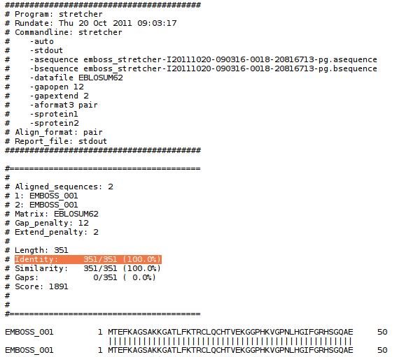Fig 11:

Use what you now know about the design of GFP fusion proteins and design a GFP fusion construct with pUG35, but with the CYC7 gene (available in the file CYC7.txt or from Genbank accession V01299) gene instead and use the restriction enzymes XbaI and ClaI.
Question 1:
The cSEGUID of the plasmid starts with n51k4_og. What are the last four characters in the cSEGUID of the plasmid.
Question 2:
What is the size of the fusion protein (number of amino acids)?

