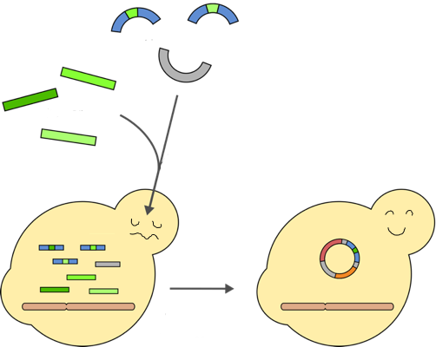
LAB4 Yeast transformation
Each student should make one transformation.

Each student should make one transformation.

1. Transfer 100 µL of the cell suspension to a clen 1.5 mL Eppendorf tube. Mark the tube.
2. Centrifuge the cells for 30s at the highest speed.
3. Remove supernatant with a P200 pipette. Leave the cell pellet at the bottom of the tube, do **not** resuspend.
4. Add 60 µL of "+" **or** "∆" DNA mix to the tube with cells.
5. Add 300 µL PEG-LiAc-ssDNA Be careful and pipette **slowly** as PLS is sticky. Use a P1000 pipette with blue tip.
6. Vortex the tubes until cells are well resuspended and no clumps visible.
7. Put the tubes in a floating tube rack at 42°C.
8. Incubate for **40 min**.
9. Mark a Petri dish with the solid medium with your group number and name. Write on the back side, not on the lid.
10. Add about 1/2 mL glass spheres (~10-15 spheres) to the Petri dish.
11. Go for coffe break!
12. Remove tube from water bath after 40 min and put on ice for at least 2 min.
13. Spin tube for 20s at highest speed.
14. Remove supernatant with a P200 pipette. Leave the cell pellet at the bottom of the tube.
15. Add 300 µL YPD medium and resuspend with the pipette by **slowly** pipetting up and down. Be careful as the cells are sensitive
16. Transfer 100 µL of the cell suspension to your Petri dish.
17. Spread the cells by shaking the glass spheres (the samba method).
18. Give the rest of the cell suspension to the instructor
19. Incubate the plates upside down for 3-4 days at 30°C.

