Interpreting an agarose gel and calculating DNA molecular weights using a standard curve
A common method to study DNA in the laboratory is by agarose gel electrophoresis. A slab of agarose is placed in a buffer between two electrodes and an electrical field is applied (Fig 1). DNA will migrate through the agarose at a rate that depends on the size of the molecule, where shorter molecules migrate faster than longer ones.

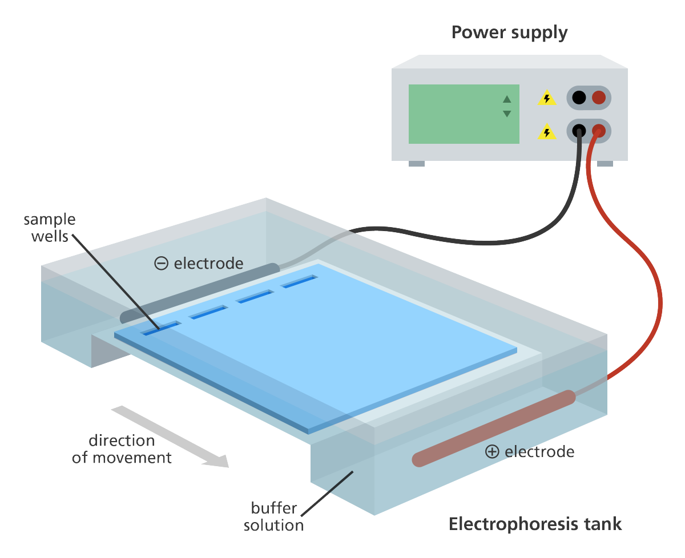Fig 1: Agarose gel electrophoresis

We can determine the length of a DNA fragment using agarose gel electrophoresis by comparison to a set of known molecular weight fragments run on the same gel. The set of known molecular weight fragments is often called a “DNA ladder” or a “Marker” (Fig 2).
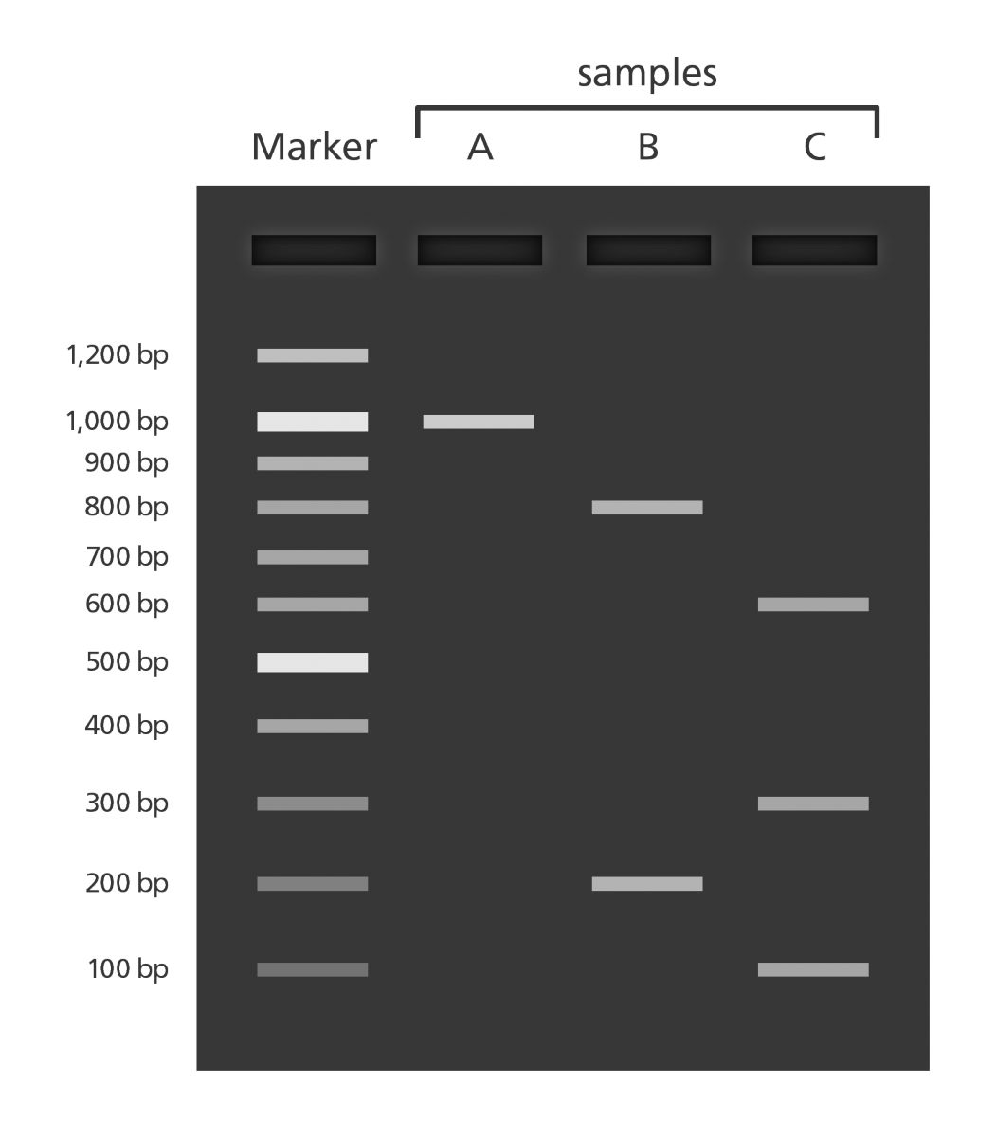Fig 2 Marker and unknown samples

The most accurate way to determine the molecular weight of an unknown DNA fragment is to construct a standard curve from the known fragments and use this to calculate the length.

Constructing a standard curve from a gel image starts with measuring all the distances between the middle of the well where the DNA was loaded (see “sample wells” in Fig 1) and the middle of the gel bands of the standard (for example the “Marker” lane Fig 2).

The migration rate depends on the size of the molecule and can be approximated by plotting the migration distance on the x-axis and the logarithm of the length of the DNA molecules on the y-axis (Fig 3).
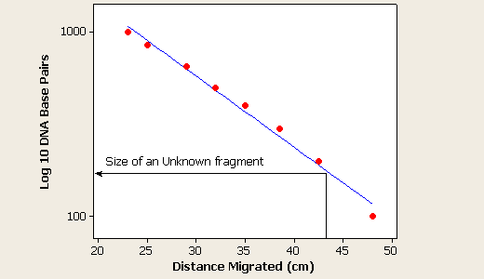Fig 3: distance vs log(length) plot

However, this is not a very good approximation. As can be seen in Fig 3, Some points are located on top of the straight line and some below but there are no points on the curve.

A better approximation can be done using a cubic spline approximation. This method is used in several publications Russell 1984, Gariepy 1986. Fig 4 shows the fit of migration distances and sizes for ten DNA fragments (P0-P9).

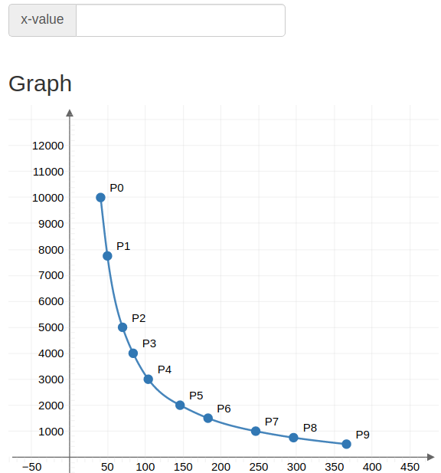Fig 4 A cubic spline fit to migration distance (x) and length in bp (y)

Example using cubic spline
The following section contain a step-by step instruction for constructing a calibration curve and calculating the molecular weight using the method outlined in the previous section.
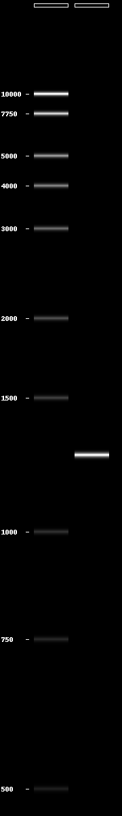Fig 5: gel with Marker and unknown DNA fragment

We will use the Marker (left lane in Fig 5) to calculate the length of the DNA fragment in the right lane in the figure.

The fragment sizes are 500, 750, 1000, 1500, 2000, 3000, 4000, 5000, 7750 and 10000 bp as indicated in Fig 5.

The marker used is called PennState ladder (Henrici 2017). The specific ladder used is the linear pPSU1 & pPSU2 + EcoRV pPSU1 & pPSU2 and the fragment size information comes from the publication above.

The image in Fig 5 was rotated 90 degrees as indicated in Fig 6. This makes it easier to measure. The PINETOOLS/rotate image web tool (Fig 6) can be found here. This makes it easier to measure distances.
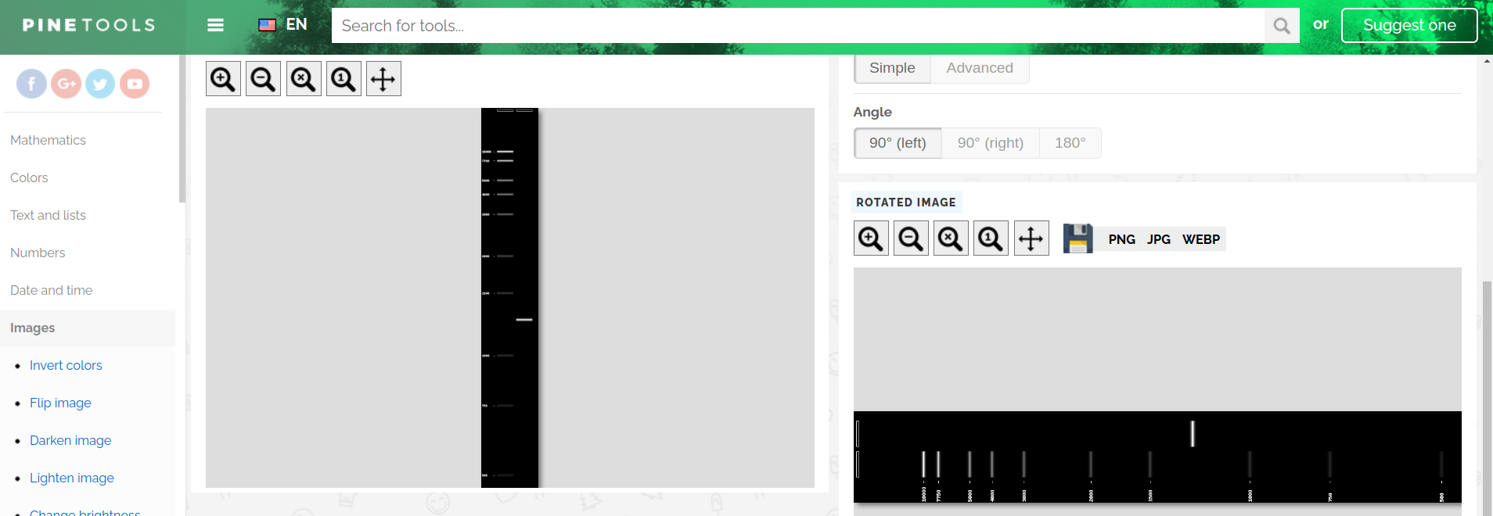Fig 6: rotate picture
The rotated gel image was then copied and pasted into the RapidTables Pixel ruler and the distances between the well and each band was measured in pixels. Fig 7 shows the measurement of the 500 bp band of the PennState Marker. Note that the small window in the middle is a text editor where each measurement was collected. Note that this collection is done manually.

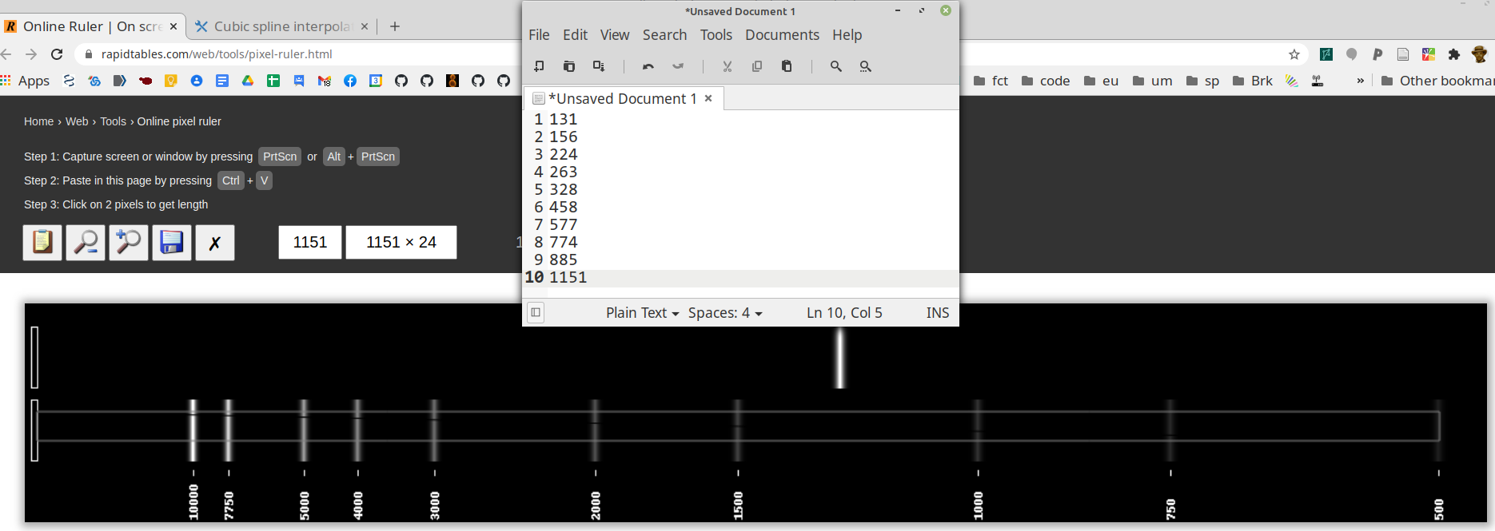Fig 7: Measuring distance in image. The small window in the middle is a text editor where you collect your data manually.
The molecular weights and the measured distances were formatted into two columns in a text editor(Table 1).

Table 1: Pixels in first column and basepairs in second.
131 10000
156 7750
224 5000
263 4000
328 3000
458 2000
577 1500
774 1000
885 750
1151 500

This table was copied and pasted into a Cubic spline interpolation tool (Fig 8) This tool is available here. The blue Interpolate button was clicked and a graph similar to Fig 4 is shown together with a box for x-values.

We had previously measured the distance for the unknown band in Fig 7 to be 660 pixels. We enter this data and get a result of 1265.7 ≈ 1266 bp (Fig 9). The expected size was 1250 bp which makes the error about 1 %.
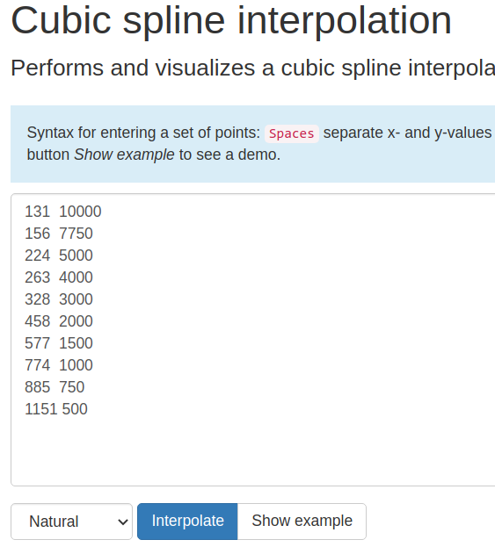Fig 8: Formatted data

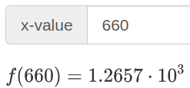Fig 9 660 pixels corresponds to 1265 bp

Question 1:
There is a file called “TP13_gel_image.png” in the same folder as this file. This image shows an agarose gel with two lanes. The right lane is a molecular weight standard containing bands of the following sizes: 10000, 8000, 6000, 5000, 4000, 3000, 2000, 1500, 1000 and 500 bp (base pairs). The left lane has three DNA bands of unknown size. Your task is to calculate the length (in bp) of each of the three unknown bands.
Question 2:
This is an individual question for each student. Go to the Google Spreadsheet for this TP. You should find your name in the leftmost column. Your task is to use the method described to calculate the molecular weight of an unknown sample. In the rightmost cell of the spreadsheet, there is a link to a collection of gel images. These are named “student_name_number.png”. Download your file to perform the analysis. Please answer with the size of the fragment as indicated for the first example student "Max Maximus". If your name is *not* in the list or if there is no gel image with your name, please inform your instructor.

The section below contain alternative tools for performing the analysis

Cubic spline tools
Cubic spline interpolation tool

There are several tools available online to perform cubic spline interpolation. One such tool is the cubic spline interpolation tool available here. See a list of alternative tools below.

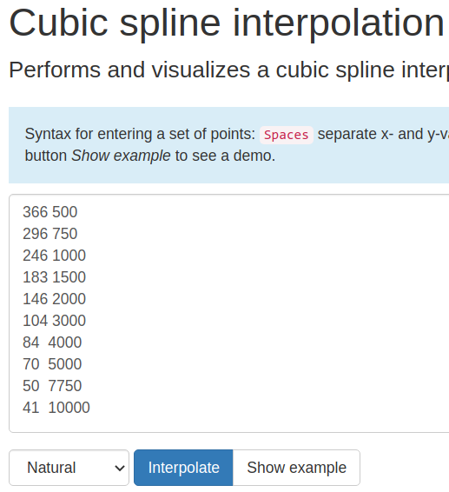Fig 10

The data is added from the image analysis of the standard curve as indicated in Fig 10. Click on the blue Interpolate button (Fig 10).

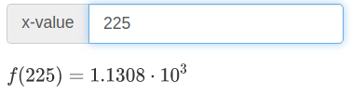Fig 11

Alternative online cubic spline tools:
http://drr.ikcest.org/app/s2852
http://www.akiti.ca/CubicSpline.html
https://solvemymath.com/online_math_calculator/interpolation.php

https://sites.google.com/view/interpolation/download

Google sheets
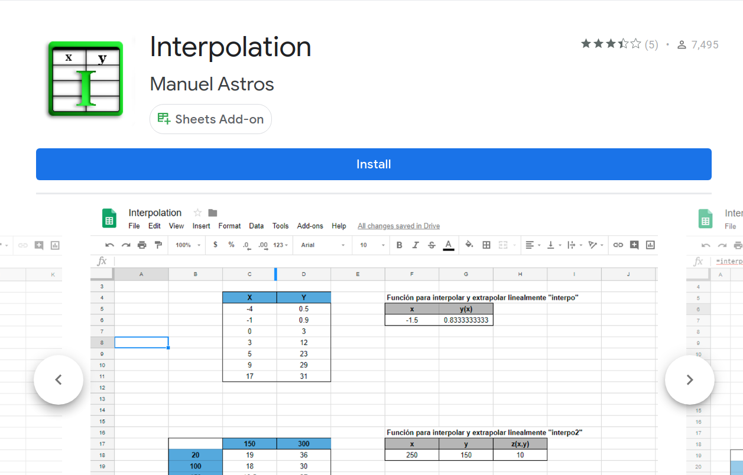Fig 12

There is a Google spreadsheet add-on that is called “Interpolation”. I am not sure if this is maintained. I was not able to install it (2020-11-04).

Excel
There could be a practical reason for performing the analysis locally on your computer instead of using an online tool. The cubic spline functionality can be added to Microsoft Excel by installing the SRS1 Cubic Spline for Excel tool (Fig 13). It can be downloaded for free here.

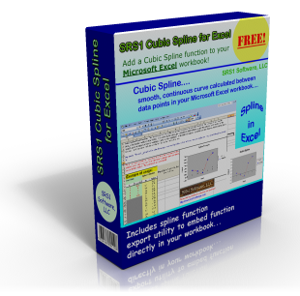Fig 13: The free SRS1 Cubic Spline for Excel tool

There is an informative video on YouTube about how to use the tool. Click on Fig 14 to see the video.
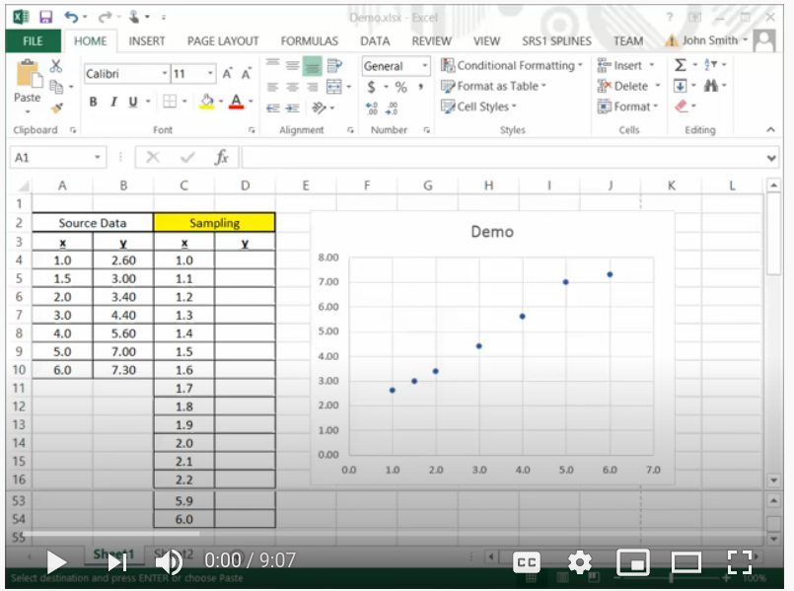Fig 14 How to use the SRS1 Cubic Spline for Excel tool (YouTube)

Gnumeric
The cubic spline function is built in to the free spreadsheet software “Gnumeric” (Fig 15).
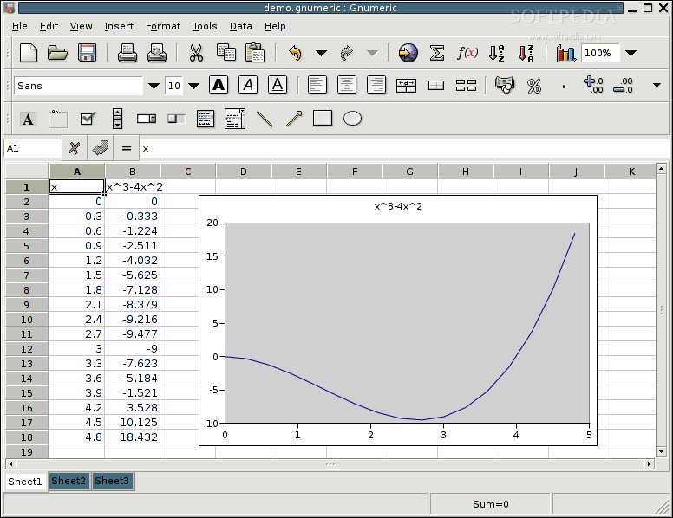Fig 15: Gnumeric

Gnumeric can be installed from here but it is not a native Windows app. If you have Windows Subsystem for Linux (WSL), you can first install for example Ubuntu on your WSL and then install Gnumeric using the command line. Here are some instructions.

Tools for measuring pixel distances in images
Photoshop GIMP or other image software

The graphics programs Photoshop or the similar, but free GNU Image Manipulation Program (GIMP) can do this.

RapidTables On screen pixel ruler

Pixel ruler should work on any computer that has a web browser. This tool is very easy to use. Just copy and paste a gel image on the screen and you can start measuring. This tool allows you to form boxes (see blue arrow in Fig 16) and the size of the box in pixels is shown (see blue box in Fig 16). This tool is available here.

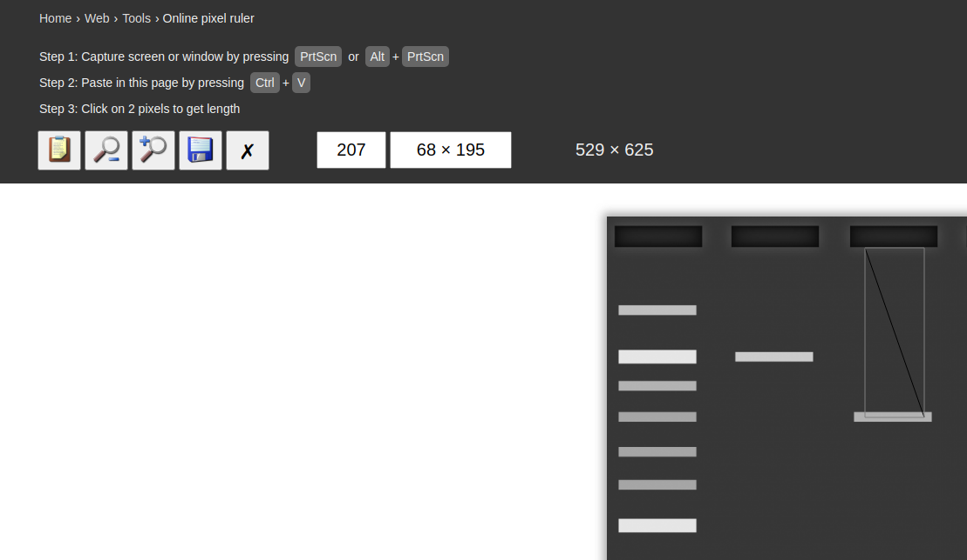Fig 16: Online pixel ruler

Measure-it for Firefox

For Mozilla Firefox there is a tool for measuring distance in images called “Measure-it” (Fig 17). You can install it here.

Fig 17 Measure-it for Firefox

PixelZoomer for Chrome

For Google Chrome there is a tool for measuring distance in images called “PixelZoomer” (Fig 18). You can install it here.
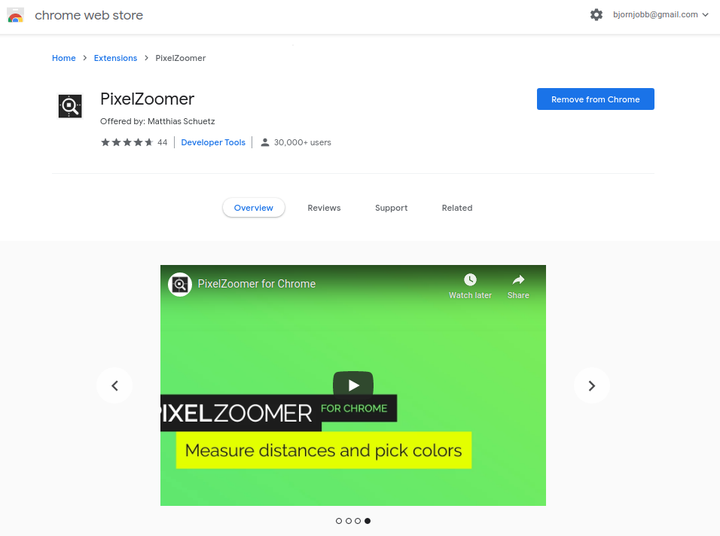Fig 18: PixelZoomer for chrome

