...gcaatgagacaagaacgaaaagcgtttacctcggaactctattgta
∆CRP
...cgttactctgttcttgcttttcgcaaatggagccttgagataacat

gaaaagcgtttacctcggaactctattgtagaacccctat...
AmpR
cttttcgcaaatggagccttgagataacatcttggggata...

...gcaatgagacaagaacgaaaagcgtttacctcggaactctattgta

...cgttactctgttcttg
5´ to 3´ exonuclease
gaacccctat...
cttttcgcaaatggagccttgagataacatcttggggata…

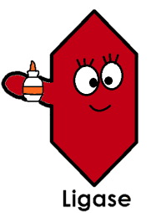

...gcaatgagacaagaacgaaaagcgtttacctcggaactctattgtagaacccctat...
...cgttactctgttcttgcttttcgcaaatggagccttgagataacatcttggggata...
DNA ligase

