GC-MS Metabolomics Analysis for Yeyun Ouyang of the Rutter Lab at the University of Utah

I. Experimental Goal

The goal of this work was to analyze metabolic changes in yeast at various time points with either the oar1 KO or the mct1KO conditions when compared to a time-matched WT using gas chromatography-mass spectrometry (GC-MS).

II. Introduction to Metabolomics

Metabolomics is the unbiased survey of metabolites found within a tissue, biological fluid, organism, culture or other biological source. Metabolomics is a comparative science; we analyze the differences found between biological samples that have been subjected to a treatment. This can be due to a genetic mutation, drug treatment, etc. Because this is a relative analysis, we can only make judgments on individual metabolites, such as comparing the amounts of succinate found in a mutant and a wild type. For example, we cannot compare the levels of succinate and fumarate within the same group or between different groups.

III. Metabolomics Core Requirements

If publishing any data produced by the Metabolomics Core please include the following in the Acknowledgements section of the paper:  
Metabolomics analysis was performed at the Metabolomics Core Facility at the University of Utah. Mass spectrometry equipment was obtained through NCRR Shared Instrumentation Grant 1S10OD016232-01, 1S10OD018210-01A1 and 1S10OD021505-01.

All samples will be discarded by the Core within 6 weeks of you receiving this report. If you wish to keep your samples please come and retieve them before this time

IV. Experimental

Extraction

To each sample was added boiling 75% ethanol (EtOH) solution containing the internal standard d4-succinic acid (Sigma 293075). Boiling samples were vortexed and incubated at 90°C for 5 min. Samples were then incubated at -20 ˚C for 1 hr. After incubation the samples were centrifuged at 5,000 x g for 10 minutes at 4˚C. The supernatant was then transferred from each sample tube into a labeled, fresh 13x100mm glass culture tube. A second standard was then added (d27-myristic acid CDN Isotopes: D-1711). Pooled quality control samples were made by removing a fraction of collected supernatant from each sample and process blanks were made using only extraction solvent and no cell culture. The samples were then dried *en vacuo*. This process was completed in three separate batches.

Mass Spectrometry Analysis of Samples

All GC-MS analysis was performed with an Agilent 5977b GC-MS MSD-HES and an Agilent 7693A automatic liquid sampler. Dried samples were suspended in 40 µL of a 40 mg/mL O-methoxylamine hydrochloride (MOX) (MP Bio #155405) in dry pyridine (EMD Millipore #PX2012-7) and incubated for one hour at 37 °C in a sand bath. 25 µL of this solution was added to auto sampler vials. 60 µL of N-methyl-N-trimethylsilyltrifluoracetamide (MSTFA with 1%TMCS, Thermo #TS48913) was added automatically via the auto sampler and incubated for 30 minutes at 37 °C. After incubation, samples were vortexed and 1 µL of the prepared sample was injected into the gas chromatograph inlet in the split mode with the inlet temperature held at 250°C. A 10:1 split ratio was used for analysis of the majority of metabolites. For those metabolites that saturated the instrument at the 10:1 split concentration, a split of 50:1 was used for analysis. The gas chromatograph had an initial temperature of 60°C for one minute followed by a 10°C/min ramp to 325°C and a hold time of 5 minutes. A 30-meter Phenomenex Zebron AB-5HT with 5m inert Guardian capillary column was employed for chromatographic separation. Helium was used as the carrier gas at a rate of 1 mL/min. Below is a description of the two step derivatization process used to convert non-volatile metabolites to a volatile form amenable to GC-MS. Pyruvic acid is used here as an example.



Analysis of Mass Spectrometry Data

Data was collected using MassHunter software (Agilent). Metabolites were identified and their peak area was recorded using MassHunter Quant. This data was transferred to an Excel spread sheet (Microsoft, Redmond WA). Metabolite identity was established using a combination of an in-house metabolite library developed using pure purchased standards, the NIST library and the Fiehn library. There are a few reasons a specific metabolite may not be observable through GC-MS. The metabolite may not be amenable to GC-MS due to its size, or a quaternary amine such as carnitine, or simply because it does not ionize well. Metabolites that do not ionize well include oxaloacetate, histidine and arginine. Cysteine can be observed depending on cellular conditions. It often forms disulfide bonds with proteins and is generally at a low concentration. Metabolites may not be quantifiable if they are only present in very low concentrations.

V. Data Analysis

Data Pretreatment

Data was exported to an Excel file and the following steps were taken to prepare a data set to be put through the in-house software. I included all the data for transparency purposes but the only tab of interest is the Finalized Data tab. The steps below describe the data pretreatment.

1. Raw Data: No treatment of any kind was performed in this tab. Samples removed from analysis were marked in red.
2. Norm and Composite: All samples were normalized to the internal standard d4-succinate. Samples highlighted in yellow were swapped with normalized data from the unsaturated run.
3. Finalized: The identity of each peak was ensured by visualization in Mass Hunter Qual and Quant. The data has also been roughly reordered by metabolic process. False positives were removed. All but the best representative of duplicate metabolites, which were created through variability in the derivatization process, were also removed.
4. The rest of the tabs were individually saved as .csv files in order to run each comparison through our in-house statistical software.

Data as analyzed using in-house software to prepare for analysis by the "MetaboAnalyst" software tool. A number of steps were performed with a description of each below. The tab of real interest is "MetaboAnalyst Input" which contains the final data in a form that can be provided to MetaboAnalyst. The data file is oar1 0hr vs wt 0hr.xlsx which is attached.

Raw Input: No treatment of any kind was performed in this tab.

Percent CV (%CV) Analysis step 1: A test for individual metabolite reliability.

Percent (%) CV step 1: Results of test for metabolite reliability. Failing compounds were removed.

Other tabs: Output from MetaboAnalyst. Relevant Graphs and values are later in this report.

VI. Statistical Analysis

Statistical analysis was performed using MetaboAnalystR (paper for citation can be found at https://doi.org/10.1093/bioinformatics/bty528). This is functionally the same as using MetaboAnalyst on the internet (https://www.metaboanalyst.ca/). MetaboAnalyst is a freely available web-based program used for significance testing and pathway mapping. For your convenience the steps to replicate the current analysis in MetaboAnalyst are listed below.

Save "MetaboAnalyst Input" tab as a .csv file (filetype option in save as in any spreadsheet program)

Open http://www.metaboanalyst.ca/. Several key papers are listed on the home page; these explain how to use this program.

"Click here to start"

Click on "Statistical Analysis"

In "1) Upload your data" slect the radio button labeled "Peak intensity table"

Press the "Choose File" button and select the .csv file you created and click "Submit"

If no errors on the next screen press "Skip"

On the Data Filtering page press "Proceed"

The remaining steps will need to be repeated for each sample group, though multiple analyses can be done on one sample group without returning to this point

Go to the window on the far left and select "Data editor" in the "Processing" section.

Go to the "Edit Groups" and adjust until only the sample groups desired are in the "Available" box. Then press the "Submit" button

Choose "Normalization by Sum" for Sample Normalization for Sample normalization, "Log transformation" for Data transformation, and "Pareto scaling" for Data scaling and hit the "Normalize" button

Use the "View Result" button to display the normalization graph. The graph in the top right should be gaussian. Close the graph window and click "Proceed"

This will bring you to a page with all statistical tests available. use this page or the "Statistics" menu on the left of the page to navigate to the relevant statistical test.

Select PCA. Default settings are used for our analysis. Different plots can be viewed by selecting various tabs above the current graph.

Select Volcano plot. This will only be possible if only two groups are selected. Variables are set above the graph. For the analysis in this report, settings are detailed in "Description of All Tests Used" below.

VII. Results of Statistical Analysis

Description of All Tests Used

Principal Component Analysis (PCA) is designed to compare 2 or more groups across the most significant "Principal Components" of the data set. PCAs organize their principal components to show the largest difference between data points. The further apart the groups are the more different they are in general, while groups on top of each other are not very different. A wide spread of points within a group indicates the group is noisy or there might be reason to split the group into sub-groups. If points within a group are tightly packed, the group members agree well with little noise (at least within the displayed Principal Components).

Volcano Graphs are a way to visualize significant data points. It compares p-value (statistical significance) on the y-axis with Fold Change (FC) (practical significance) on the x-axis. These are log transformed on the graph due to the large variation in values. Purple dots are above a threshold for both p-value and FC, while black dots fail at least one of them. For this analysis the required settings were as follows: a p-value of less than 0.05 and a FC of at least 1.5. Values are not adjusted for False Discovery Rate.

Comparison of the following groups: wt at 0hr minr+leu, oar1 ko at 0hr minr+leu, qc

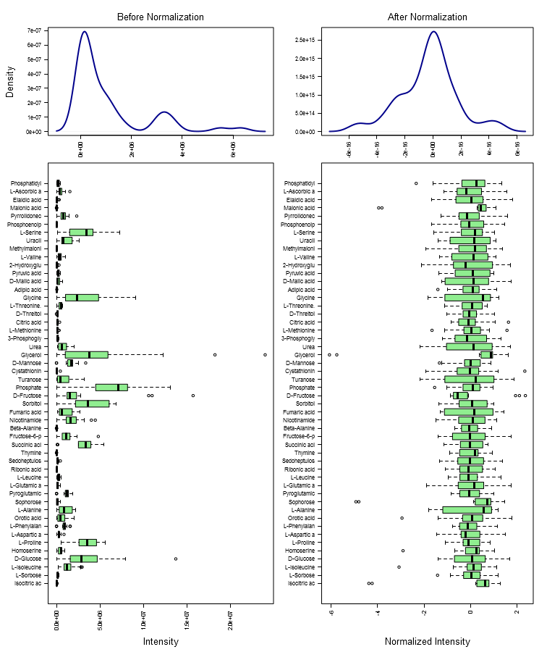

Results of PCA test (groups: wt at 0hr minr+leu, oar1 ko at 0hr minr+leu, qc):

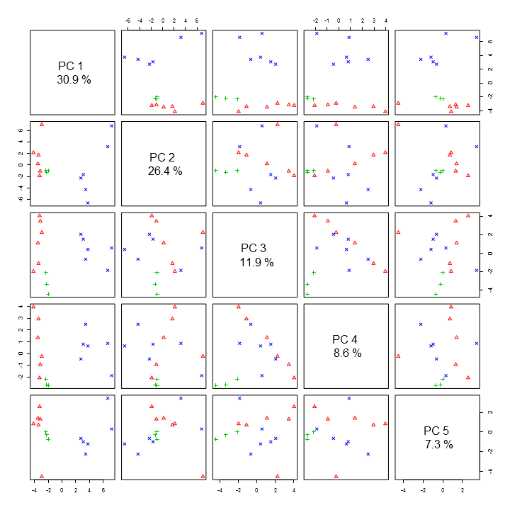

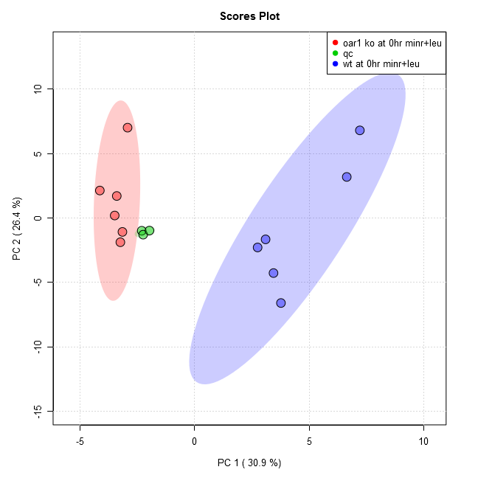

Comparison of the following groups: oar1 ko at 0hr minr+leu, wt at 0hr minr+leu

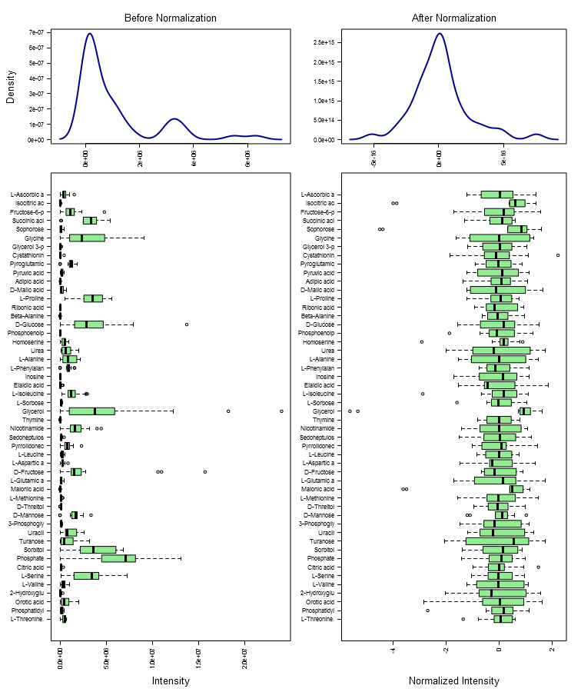

Results of PCA test (groups: oar1 ko at 0hr minr+leu, wt at 0hr minr+leu):

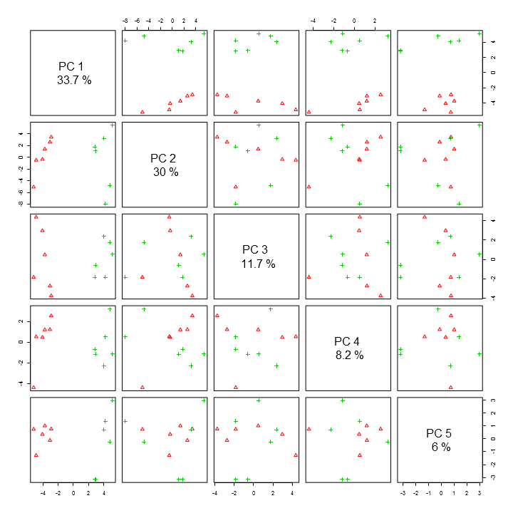

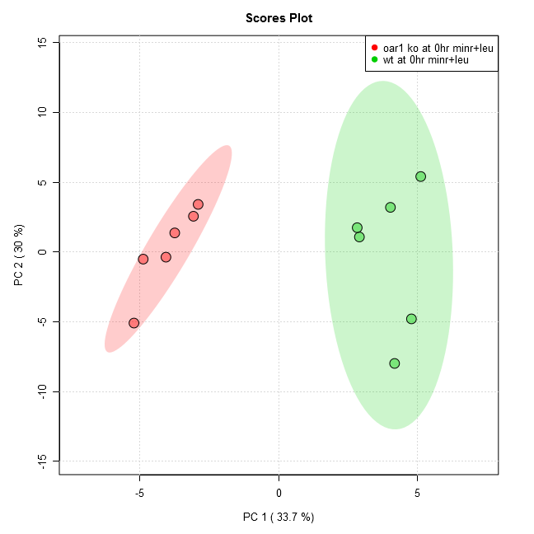

Results of Volcano test (groups: oar1 ko at 0hr minr+leu/wt at 0hr minr+leu):

Analysis shows 18 compounds were significant when using current settings (p-value < 0.05, Fold Change > 1.5, raw adjusted).

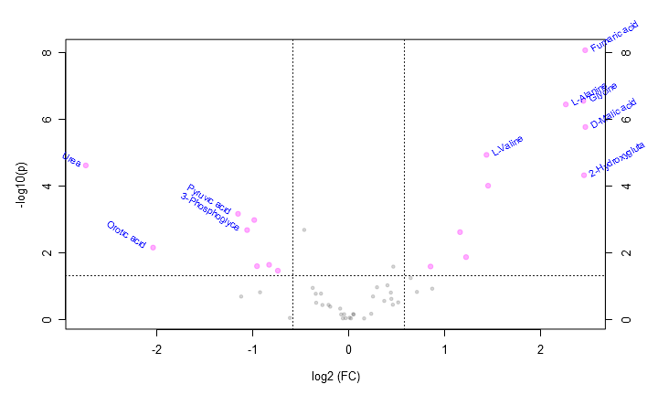

This table contains all the significant points from the Volcano analysis.

|  |  |  |  |  |
| --- | --- | --- | --- | --- |
| **Compound** | **Fold Change** | **log2(FC)** | **raw.pval** | **-log10(p)** |
| D-Malic acid | 5.535400 | 2.468700 | 0.000002 | 5.762300 |
| Fumaric acid | 5.527300 | 2.466600 | 8.63E-9 | 8.063800 |
| 2-Hydroxyglutaric acid | 5.481700 | 2.454600 | 0.000048 | 4.316000 |
| Glycine | 5.455500 | 2.447700 | 2.86E-7 | 6.543200 |
| L-Alanine | 4.805500 | 2.264700 | 3.64E-7 | 6.438900 |
| Uracil | 2.739600 | 1.454000 | 0.000100 | 4.002000 |
| L-Valine | 2.707800 | 1.437100 | 0.000012 | 4.926400 |
| L-Isoleucine | 2.335400 | 1.223700 | 0.013754 | 1.861600 |
| Methylmalonic acid | 2.236100 | 1.161000 | 0.002452 | 2.610600 |
| L-Methionine | 1.806700 | 0.853340 | 0.026283 | 1.580300 |
| L-Ascorbic acid | 0.598810 | -0.739840 | 0.035020 | 1.455700 |
| Phosphoenolpyruvate | 0.562210 | -0.830820 | 0.023407 | 1.630700 |
| D-Glucose | 0.515030 | -0.957270 | 0.025705 | 1.590000 |
| Sorbitol | 0.504920 | -0.985870 | 0.001063 | 2.973600 |
| 3-Phosphoglyceric acid | 0.479460 | -1.060500 | 0.002125 | 2.672500 |
| Pyruvic acid | 0.449040 | -1.155100 | 0.000692 | 3.159700 |
| Orotic acid | 0.242910 | -2.041500 | 0.007123 | 2.147300 |
| Urea | 0.149320 | -2.743600 | 0.000025 | 4.610200 |

Data from oar1 3hr vs wt 3hr.docx

Comparison of the following groups: wt at 3hr minr+leu, oar1 ko at 3hr minr+leu, qc

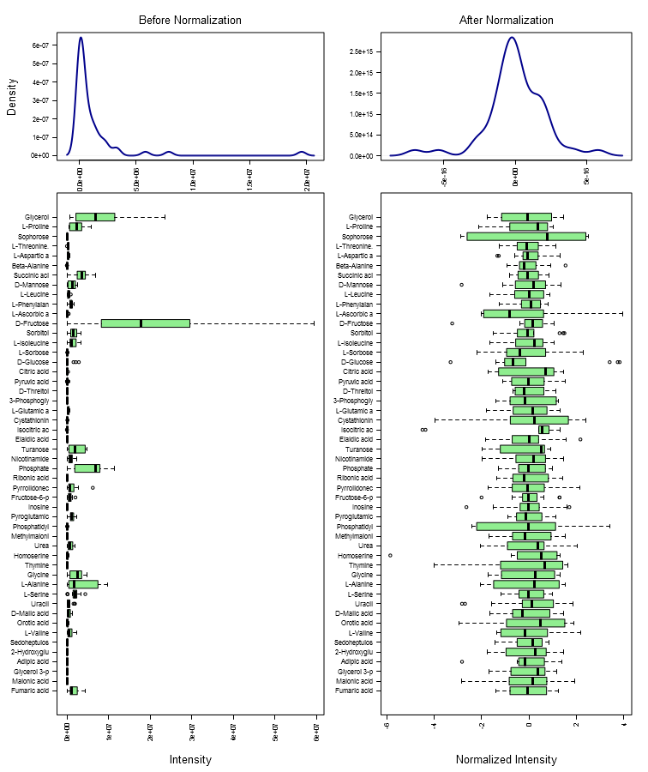

Results of PCA test (groups: wt at 3hr minr+leu, oar1 ko at 3hr minr+leu, qc):

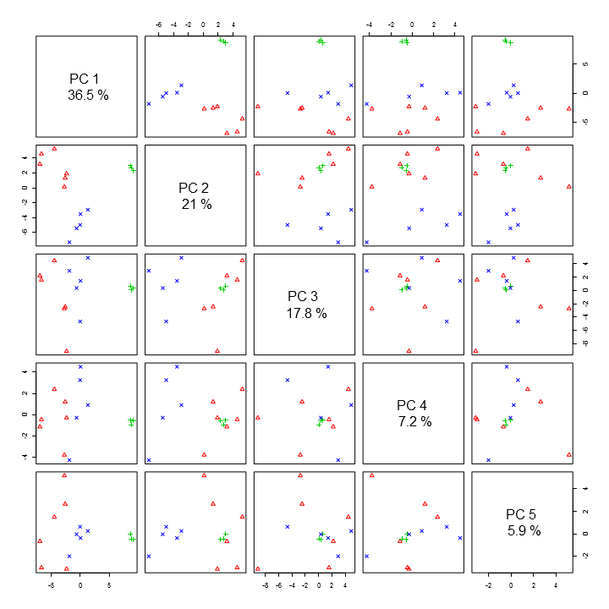

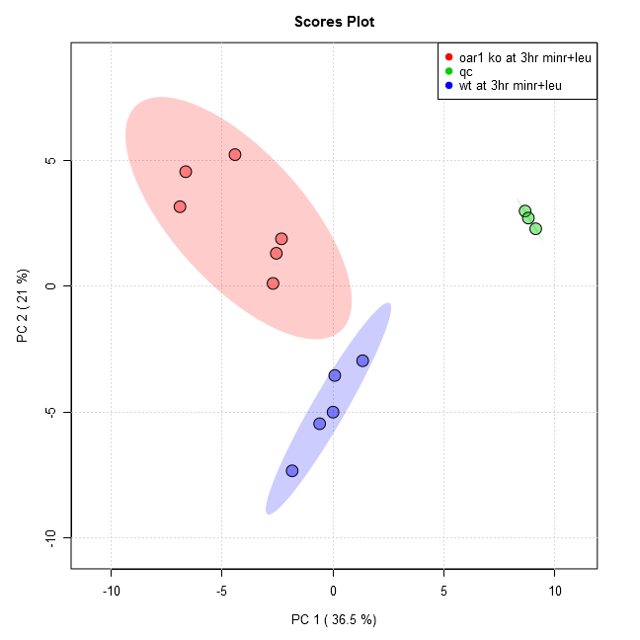

Comparison of the following groups: oar1 ko at 3hr minr+leu, wt at 3hr minr+leu

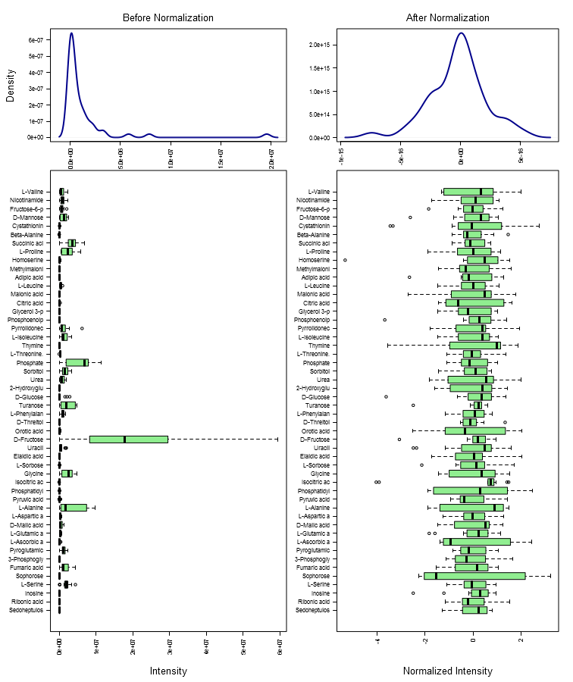

Results of PCA test (groups: oar1 ko at 3hr minr+leu, wt at 3hr minr+leu):

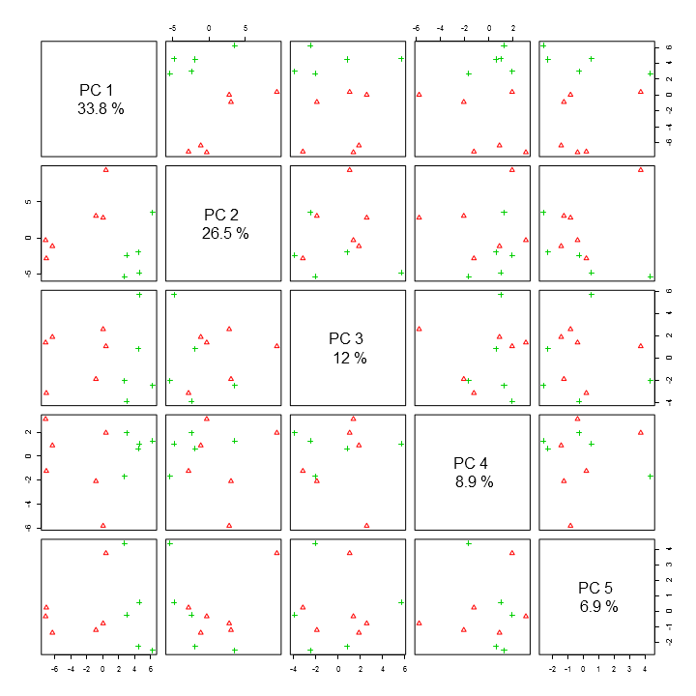

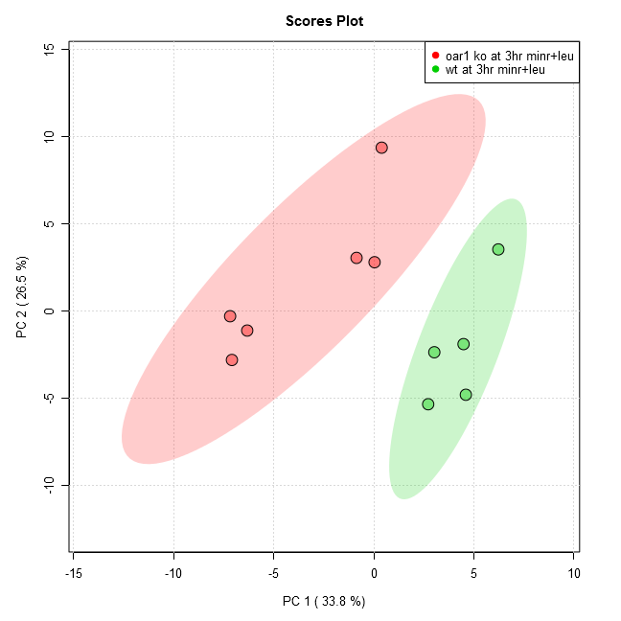

Results of Volcano test (groups: oar1 ko at 3hr minr+leu/wt at 3hr minr+leu):

Analysis shows 16 compounds were significant when using current settings (p-value < 0.05, Fold Change > 1.5, raw adjusted).

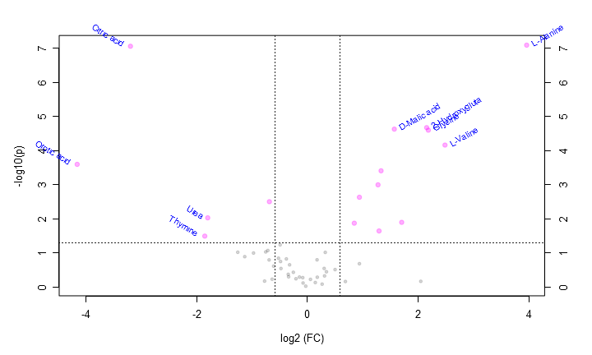

This table contains all the significant points from the Volcano analysis.

|  |  |  |  |  |
| --- | --- | --- | --- | --- |
| **Compound** | **Fold Change** | **log2(FC)** | **raw.pval** | **-log10(p)** |
| L-Alanine | 15.555000 | 3.959300 | 8.23E-8 | 7.084600 |
| L-Valine | 5.597800 | 2.484900 | 0.000069 | 4.158600 |
| Glycine | 4.543200 | 2.183700 | 0.000025 | 4.594300 |
| 2-Hydroxyglutaric acid | 4.449600 | 2.153700 | 0.000021 | 4.669400 |
| Malonic acid | 3.255000 | 1.702700 | 0.012714 | 1.895700 |
| D-Malic acid | 2.968000 | 1.569500 | 0.000024 | 4.625200 |
| L-Isoleucine | 2.514700 | 1.330400 | 0.000394 | 3.404900 |
| Methylmalonic acid | 2.452000 | 1.293900 | 0.022752 | 1.643000 |
| Fumaric acid | 2.420500 | 1.275300 | 0.001013 | 2.994300 |
| L-Leucine | 1.917500 | 0.939240 | 0.002344 | 2.630100 |
| L-Aspartic acid | 1.798000 | 0.846430 | 0.013450 | 1.871300 |
| Sorbitol | 0.621470 | -0.686230 | 0.003159 | 2.500400 |
| Urea | 0.287240 | -1.799700 | 0.009380 | 2.027800 |
| Thymine | 0.276910 | -1.852500 | 0.032196 | 1.492200 |
| Citric acid | 0.109220 | -3.194700 | 8.87E-8 | 7.052100 |
| Orotic acid | 0.056061 | -4.156900 | 0.000255 | 3.594200 |

Data from oar1 1hr vs wt 1hr.docx

Comparison of the following groups: wt at 1hr minr+leu, oar1 ko at 1hr minr+leu, qc

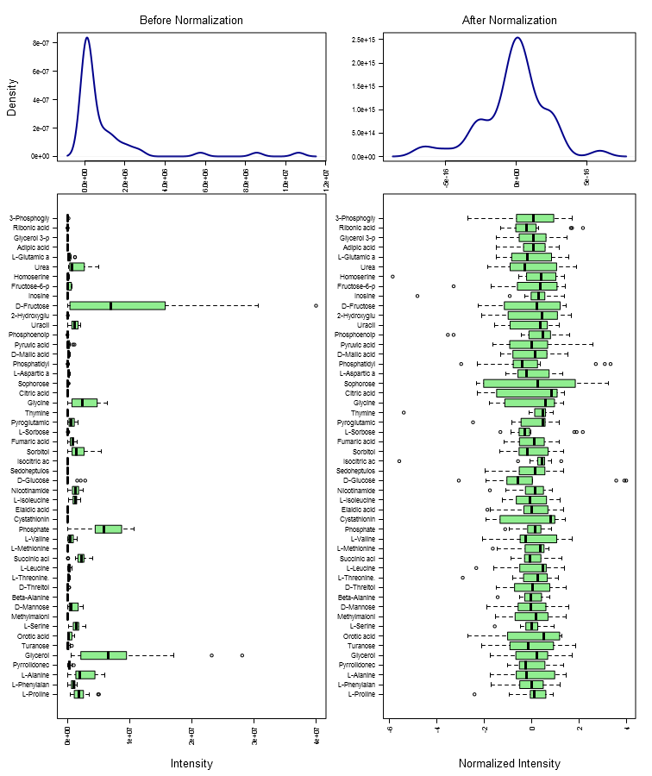

Results of PCA test (groups: wt at 1hr minr+leu, oar1 ko at 1hr minr+leu, qc):

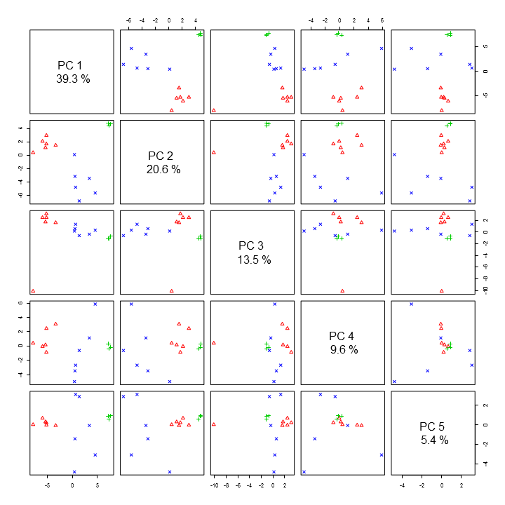

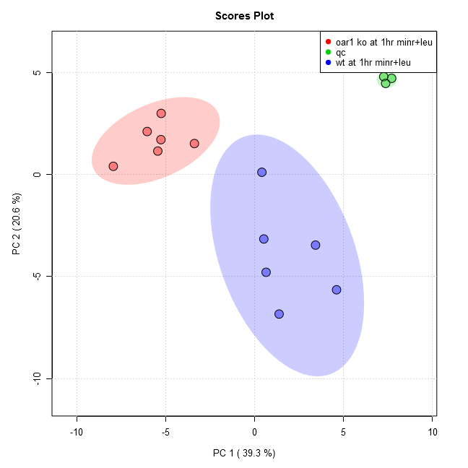

Comparison of the following groups: oar1 ko at 1hr minr+leu, wt at 1hr minr+leu

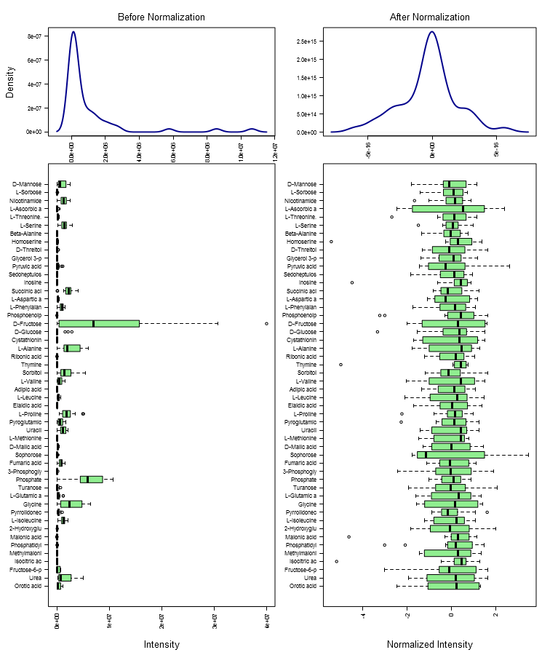

Results of PCA test (groups: oar1 ko at 1hr minr+leu, wt at 1hr minr+leu):

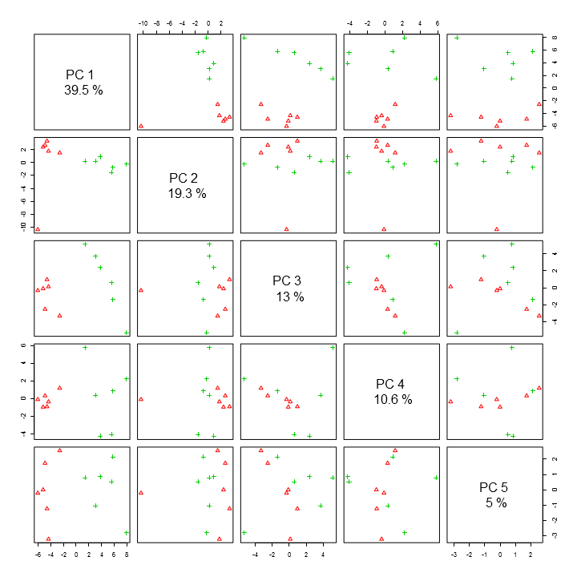

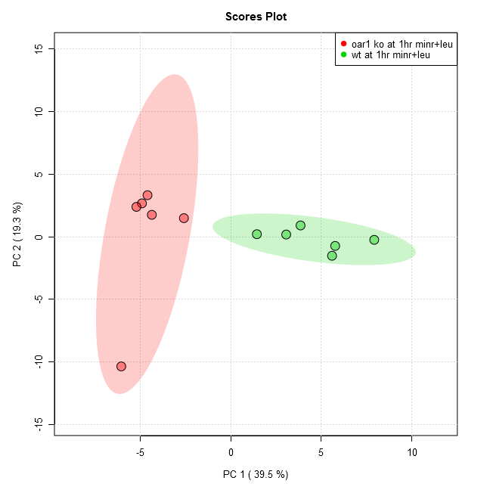

Results of Volcano test (groups: oar1 ko at 1hr minr+leu/wt at 1hr minr+leu):

Analysis shows 28 compounds were significant when using current settings (p-value < 0.05, Fold Change > 1.5, raw adjusted).

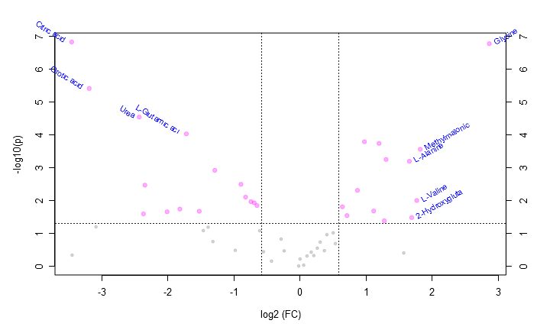

This table contains all the significant points from the Volcano analysis.

|  |  |  |  |  |
| --- | --- | --- | --- | --- |
| **Compound** | **Fold Change** | **log2(FC)** | **raw.pval** | **-log10(p)** |
| Glycine | 7.292900 | 2.866500 | 1.65E-7 | 6.783300 |
| Methylmalonic acid | 3.532100 | 1.820500 | 0.000274 | 3.562400 |
| L-Valine | 3.406600 | 1.768300 | 0.009972 | 2.001200 |
| 2-Hydroxyglutaric acid | 3.231100 | 1.692000 | 0.033050 | 1.480800 |
| L-Alanine | 3.153000 | 1.656700 | 0.000634 | 3.198100 |
| Uracil | 2.468400 | 1.303600 | 0.000559 | 3.252600 |
| L-Leucine | 2.422900 | 1.276800 | 0.041383 | 1.383200 |
| L-Aspartic acid | 2.293000 | 1.197200 | 0.000181 | 3.742300 |
| D-Malic acid | 2.167800 | 1.116300 | 0.020858 | 1.680700 |
| Fumaric acid | 1.966900 | 0.975900 | 0.000161 | 3.793300 |
| L-Methionine | 1.827200 | 0.869620 | 0.004889 | 2.310800 |
| L-Isoleucine | 1.637900 | 0.711850 | 0.028686 | 1.542300 |
| Nicotinamide | 1.560000 | 0.641510 | 0.015499 | 1.809700 |
| Glycerol 3-phosphate | 0.636960 | -0.650730 | 0.014235 | 1.846600 |
| Ribonic acid-gamma-lactone | 0.618690 | -0.692700 | 0.011697 | 1.931900 |
| Sedoheptulose 7-phosphate | 0.597820 | -0.742220 | 0.010804 | 1.966400 |
| Pyrrolidonecarboxylic acid | 0.565030 | -0.823600 | 0.007849 | 2.105200 |
| Sorbitol | 0.538130 | -0.893970 | 0.003197 | 2.495300 |
| Pyroglutamic acid | 0.409180 | -1.289200 | 0.001198 | 2.921600 |
| Turanose | 0.347490 | -1.524900 | 0.021169 | 1.674300 |
| L-Glutamic acid | 0.303420 | -1.720600 | 0.000093 | 4.033300 |
| Cystathionine | 0.283490 | -1.818600 | 0.018146 | 1.741200 |
| Phosphoenolpyruvate | 0.247820 | -2.012600 | 0.022018 | 1.657200 |
| Fructose-6-phosphate | 0.196440 | -2.347800 | 0.003391 | 2.469700 |
| D-Fructose | 0.193440 | -2.370000 | 0.025504 | 1.593400 |
| Urea | 0.184990 | -2.434500 | 0.000029 | 4.544800 |
| Orotic acid | 0.109490 | -3.191200 | 0.000004 | 5.418300 |
| Citric acid | 0.091110 | -3.456200 | 1.46E-7 | 6.836500 |

Data from oar1 15min vs wt 15min.docx

Comparison of the following groups: wt at 15min minr+leu, oar1 ko at 15min minr+leu, qc

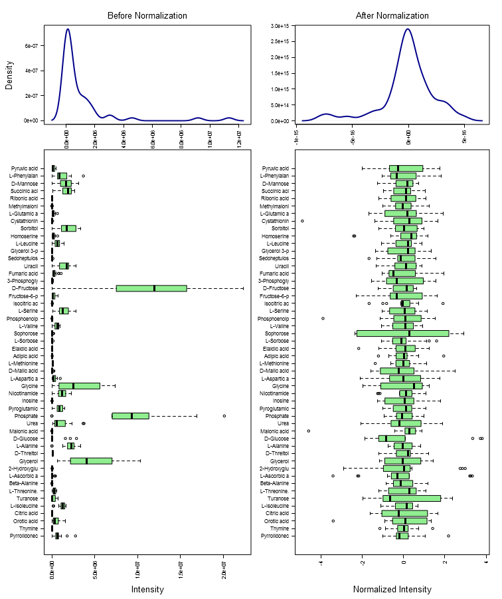

Results of PCA test (groups: wt at 15min minr+leu, oar1 ko at 15min minr+leu, qc):

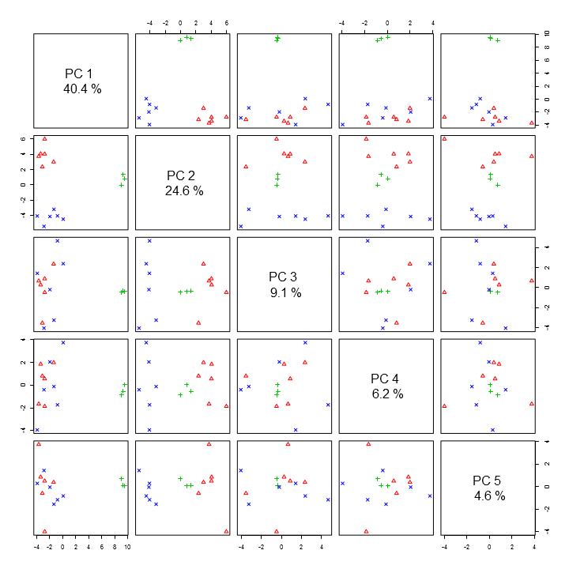

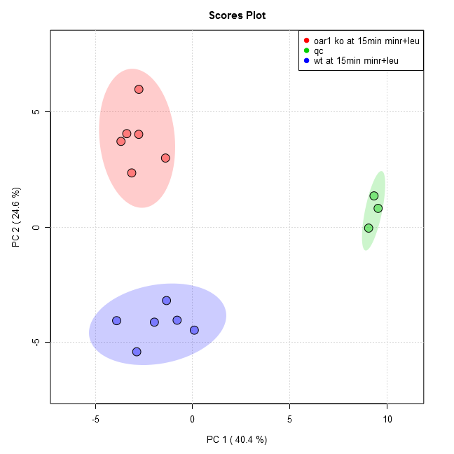

Comparison of the following groups: oar1 ko at 15min minr+leu, wt at 15min minr+leu

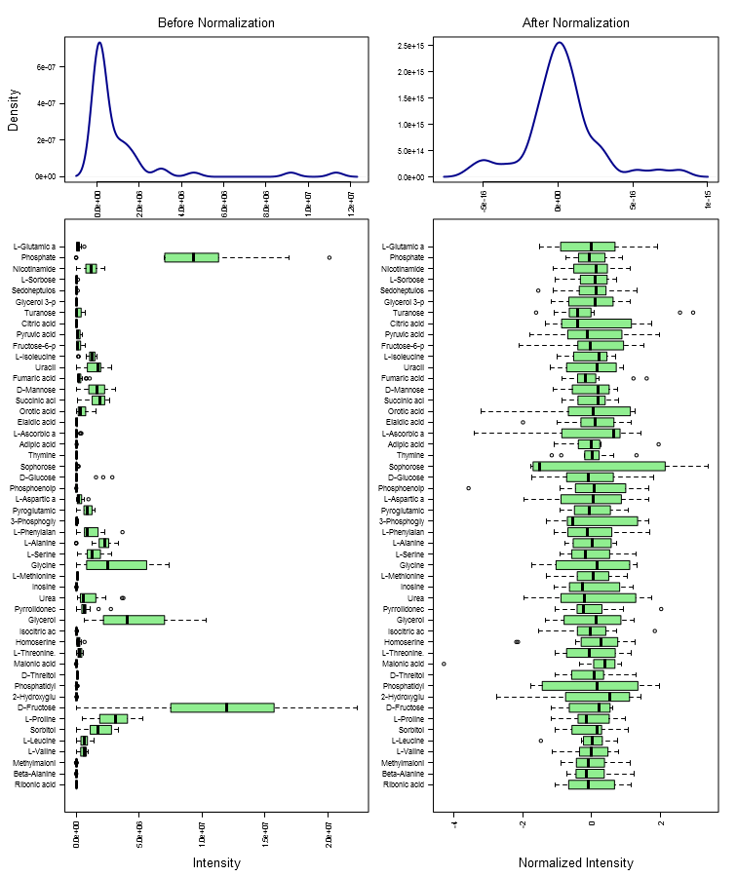

Results of PCA test (groups: oar1 ko at 15min minr+leu, wt at 15min minr+leu):

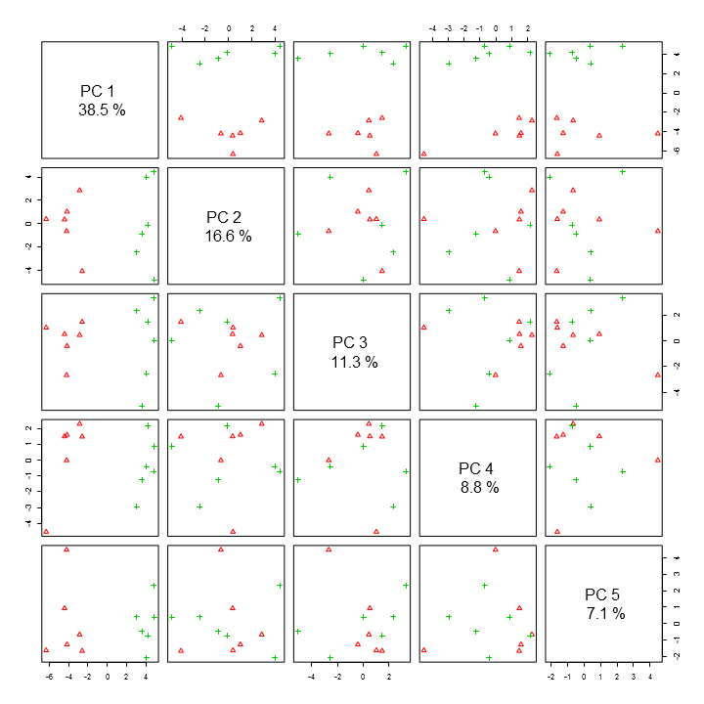

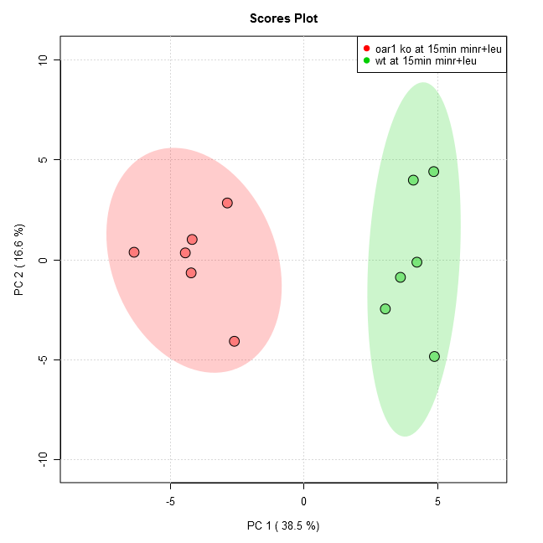

Results of Volcano test (groups: oar1 ko at 15min minr+leu/wt at 15min minr+leu):

Analysis shows 22 compounds were significant when using current settings (p-value < 0.05, Fold Change > 1.5, raw adjusted).

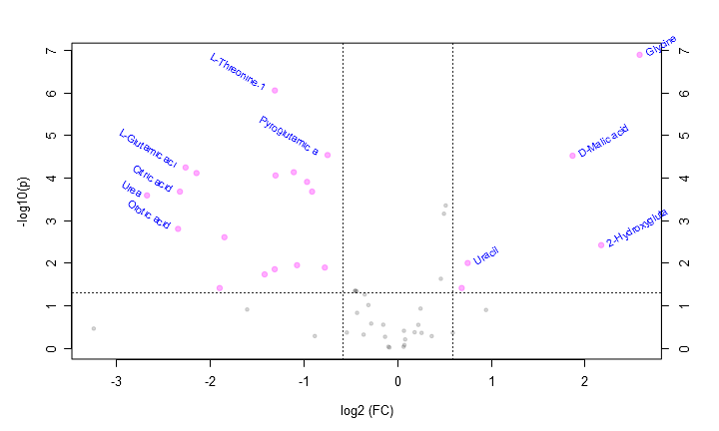

This table contains all the significant points from the Volcano analysis.

|  |  |  |  |  |
| --- | --- | --- | --- | --- |
| **Compound** | **Fold Change** | **log2(FC)** | **raw.pval** | **-log10(p)** |
| Glycine | 5.992400 | 2.583100 | 1.28E-7 | 6.893100 |
| 2-Hydroxyglutaric acid | 4.509700 | 2.173000 | 0.003790 | 2.421300 |
| D-Malic acid | 3.648700 | 1.867400 | 0.000030 | 4.522100 |
| Uracil | 1.679300 | 0.747860 | 0.009987 | 2.000600 |
| Fumaric acid | 1.606300 | 0.683780 | 0.038584 | 1.413600 |
| Pyroglutamic acid | 0.595530 | -0.747760 | 0.000029 | 4.537800 |
| Sedoheptulose 7-phosphate | 0.583520 | -0.777140 | 0.012735 | 1.895000 |
| Glycerol 3-phosphate | 0.531020 | -0.913170 | 0.000210 | 3.678700 |
| L-Serine | 0.511530 | -0.967120 | 0.000124 | 3.907500 |
| Pyrrolidonecarboxylic acid | 0.475030 | -1.073900 | 0.011229 | 1.949700 |
| Ribonic acid-gamma-lactone | 0.463740 | -1.108600 | 0.000073 | 4.135000 |
| L-Phenylalanine | 0.405180 | -1.303400 | 0.000087 | 4.058300 |
| L-Threonine.1 | 0.403160 | -1.310600 | 0.000001 | 6.055400 |
| Homoserine | 0.402710 | -1.312200 | 0.013960 | 1.855100 |
| Fructose-6-phosphate | 0.373760 | -1.419800 | 0.018440 | 1.734200 |
| Pyruvic acid | 0.277620 | -1.848800 | 0.002471 | 2.607200 |
| 3-Phosphoglyceric acid | 0.268020 | -1.899600 | 0.038648 | 1.412900 |
| L-Aspartic acid | 0.225780 | -2.147000 | 0.000077 | 4.114600 |
| L-Glutamic acid | 0.208250 | -2.263600 | 0.000057 | 4.246100 |
| Citric acid | 0.199730 | -2.323900 | 0.000210 | 3.678500 |
| Orotic acid | 0.196970 | -2.343900 | 0.001574 | 2.803100 |
| Urea | 0.156550 | -2.675300 | 0.000257 | 3.589600 |

Data from oar1 30min vs wt 30min.docx

Comparison of the following groups: wt at 30min minr+leu, oar1 ko at 30min minr+leu, qc

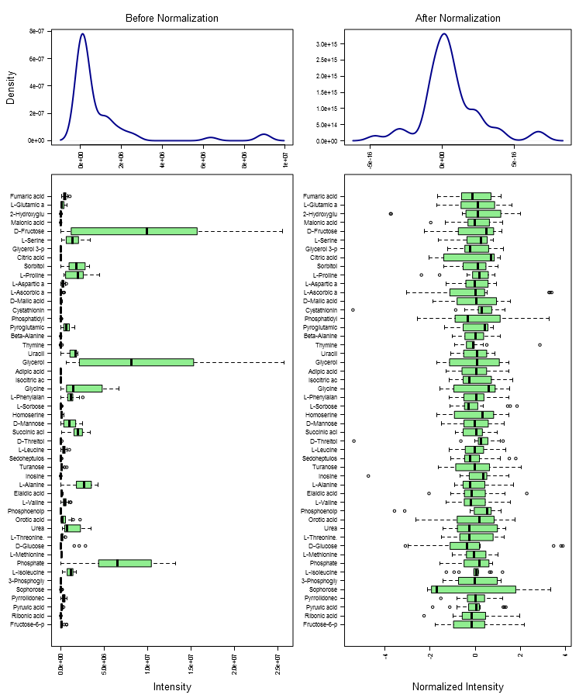

Results of PCA test (groups: wt at 30min minr+leu, oar1 ko at 30min minr+leu, qc):

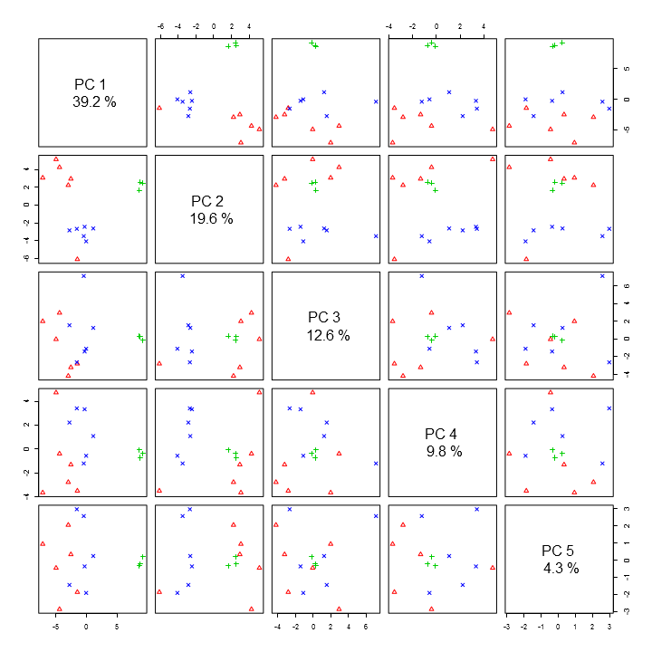

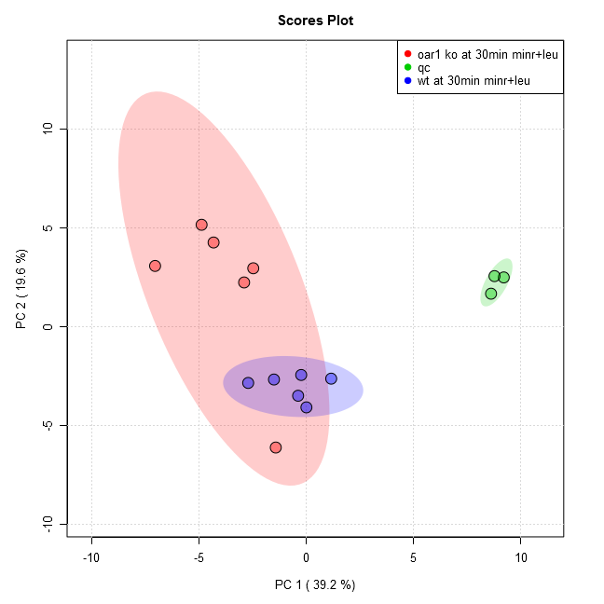

Comparison of the following groups: oar1 ko at 30min minr+leu, wt at 30min minr+leu

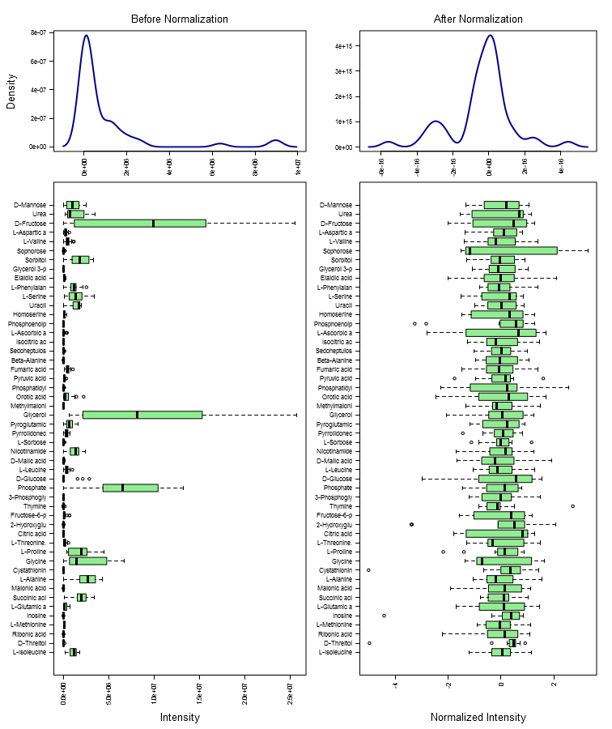

Results of PCA test (groups: oar1 ko at 30min minr+leu, wt at 30min minr+leu):

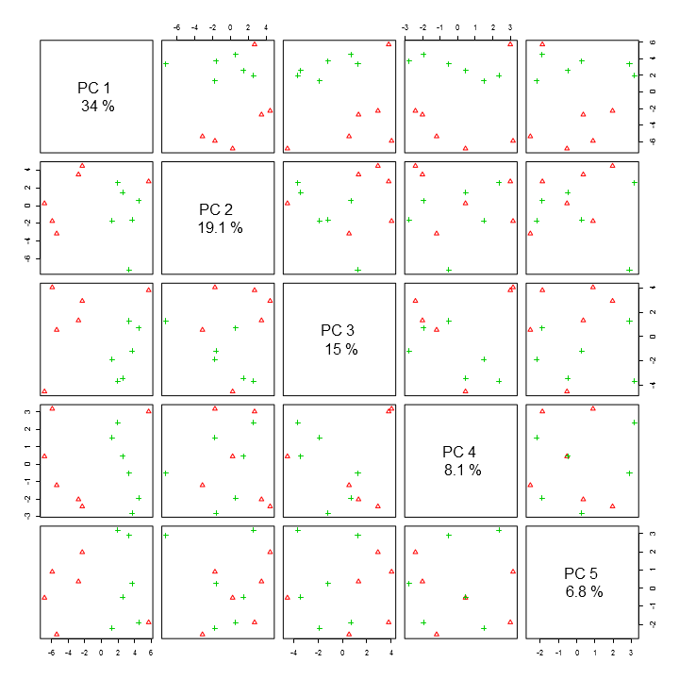

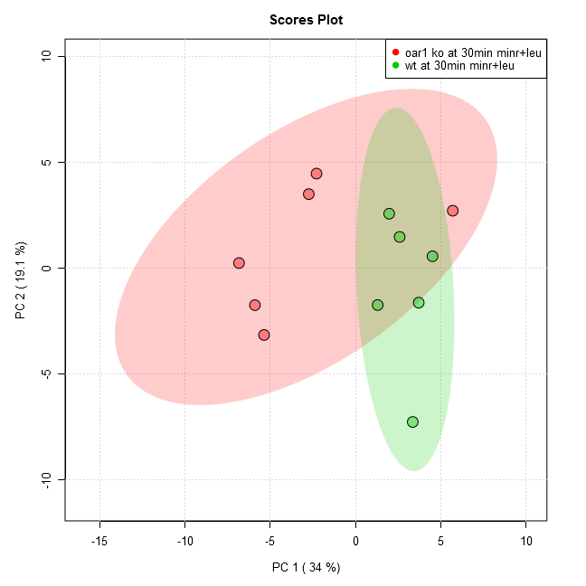

Results of Volcano test (groups: oar1 ko at 30min minr+leu/wt at 30min minr+leu):

Analysis shows 15 compounds were significant when using current settings (p-value < 0.05, Fold Change > 1.5, raw adjusted).

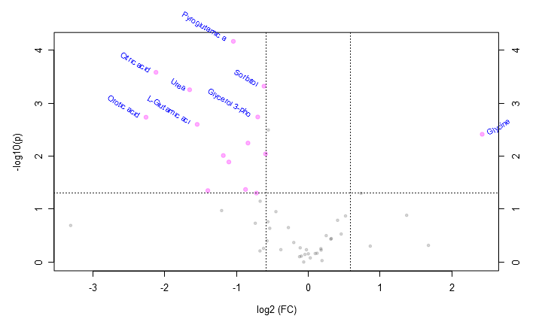

This table contains all the significant points from the Volcano analysis.

|  |  |  |  |  |
| --- | --- | --- | --- | --- |
| **Compound** | **Fold Change** | **log2(FC)** | **raw.pval** | **-log10(p)** |
| Glycine | 5.365900 | 2.423800 | 0.003872 | 2.412000 |
| L-Phenylalanine | 0.661440 | -0.596310 | 0.009090 | 2.041400 |
| Sorbitol | 0.651620 | -0.617900 | 0.000479 | 3.319300 |
| Glycerol 3-phosphate | 0.613560 | -0.704740 | 0.001826 | 2.738600 |
| Pyruvic acid | 0.606060 | -0.722480 | 0.049836 | 1.302500 |
| L-Serine | 0.558290 | -0.840910 | 0.005673 | 2.246200 |
| Isocitric acid | 0.545280 | -0.874920 | 0.042636 | 1.370200 |
| Pyroglutamic acid | 0.484680 | -1.044900 | 0.000068 | 4.165700 |
| Turanose | 0.464110 | -1.107500 | 0.012906 | 1.889200 |
| L-Threonine | 0.439880 | -1.184800 | 0.009741 | 2.011400 |
| Phosphoenolpyruvate | 0.378910 | -1.400100 | 0.044758 | 1.349100 |
| L-Glutamic acid | 0.341730 | -1.549100 | 0.002520 | 2.598600 |
| Urea | 0.317740 | -1.654100 | 0.000560 | 3.252200 |
| Citric acid | 0.229510 | -2.123400 | 0.000262 | 3.580900 |
| Orotic acid | 0.208420 | -2.262400 | 0.001846 | 2.733700 |

Data from mct 0hr vs wt 0hr.docx

Comparison of the following groups: wt at 0hr minr+leu, mct1ko at 0hr minr+leu, qc

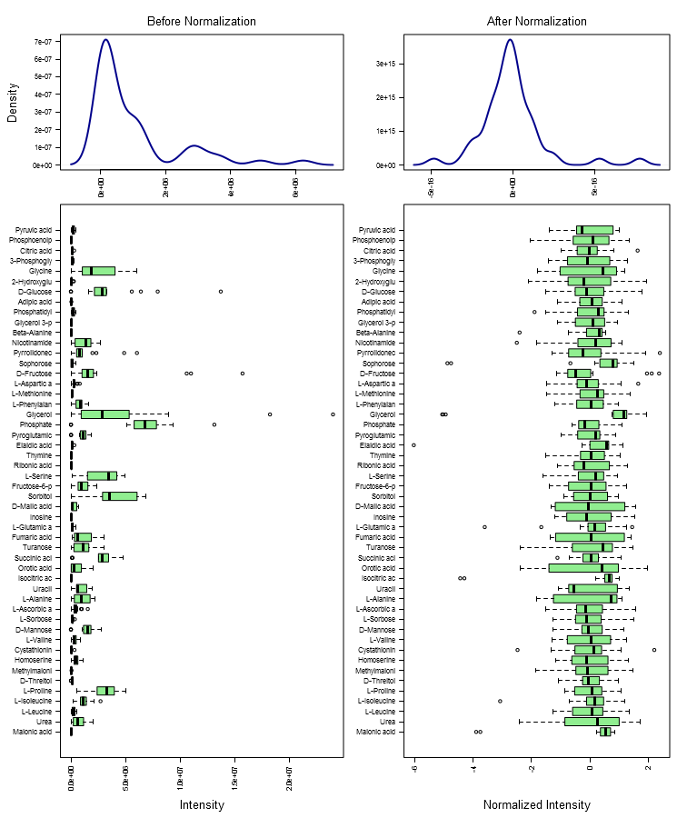

Results of PCA test (groups: wt at 0hr minr+leu, mct1ko at 0hr minr+leu, qc):

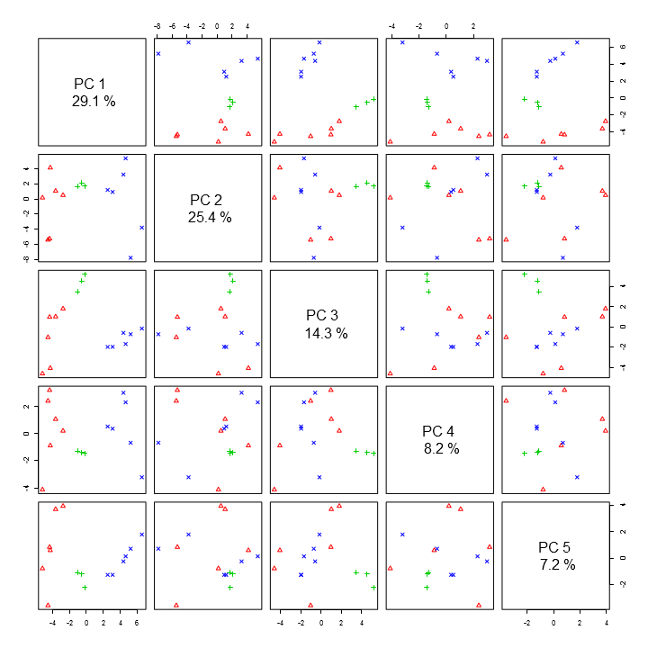

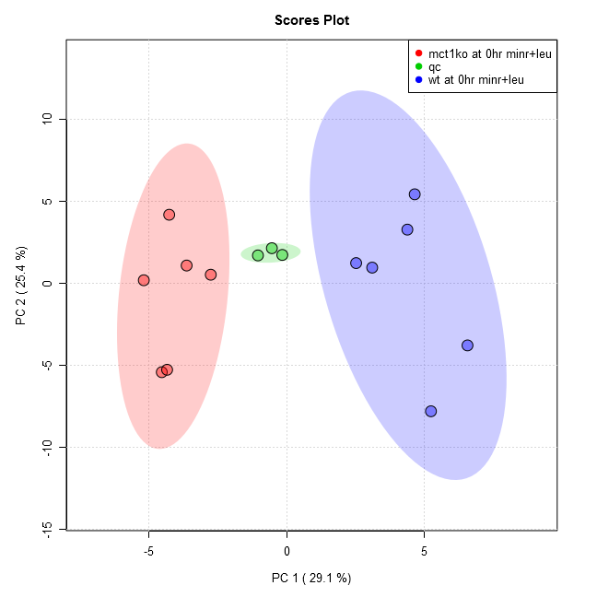

Comparison of the following groups: mct1ko at 0hr minr+leu, wt at 0hr minr+leu

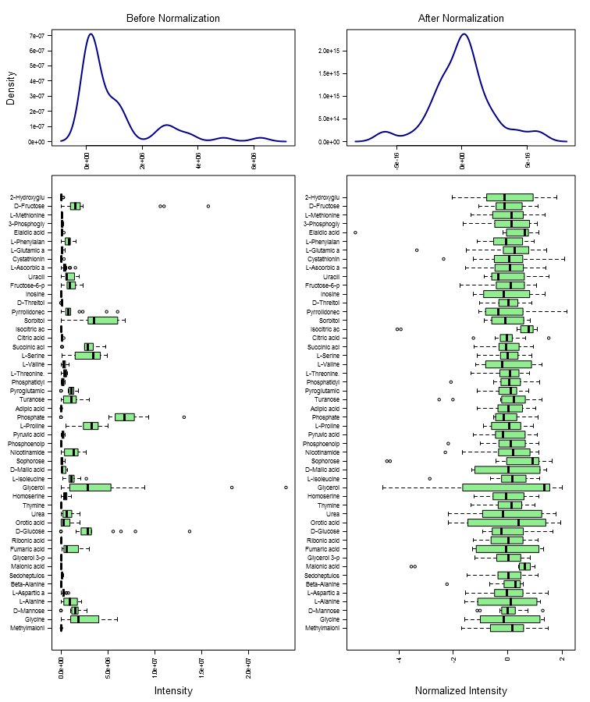

Results of PCA test (groups: mct1ko at 0hr minr+leu, wt at 0hr minr+leu):

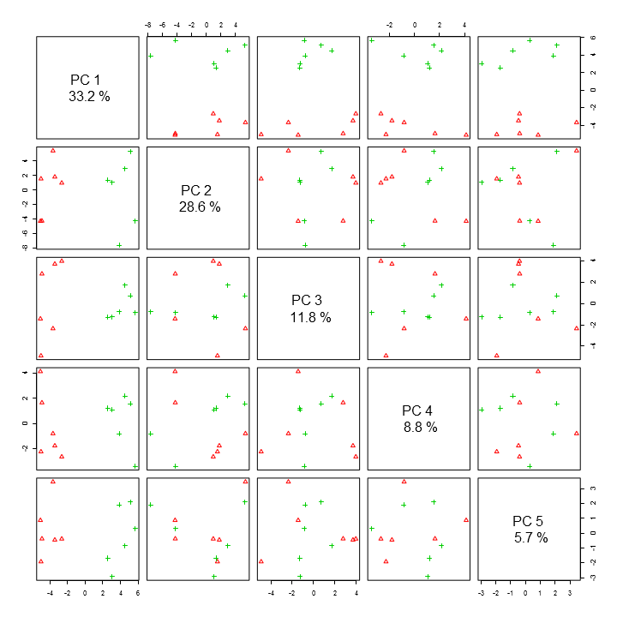

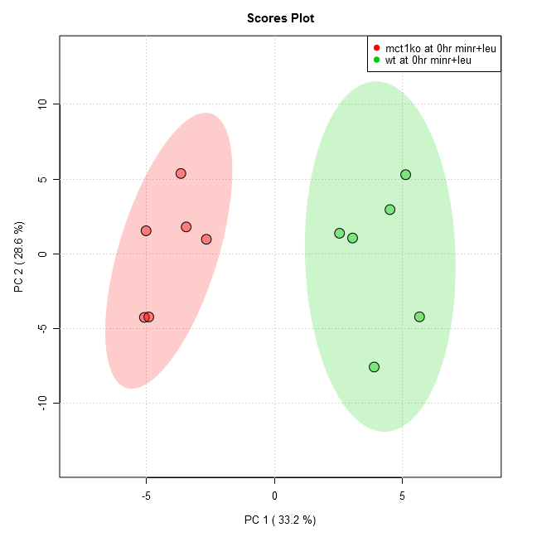

Results of Volcano test (groups: mct1ko at 0hr minr+leu/wt at 0hr minr+leu):

Analysis shows 17 compounds were significant when using current settings (p-value < 0.05, Fold Change > 1.4999999999999996, raw adjusted).

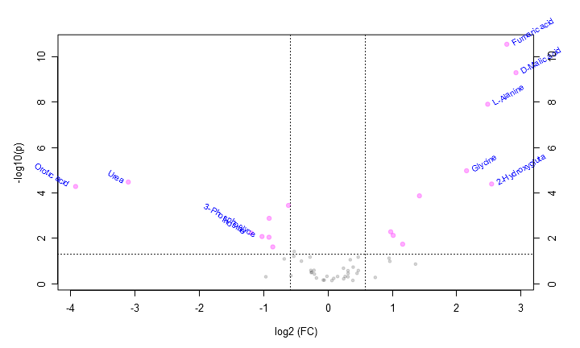

This table contains all the significant points from the Volcano analysis.

|  |  |  |  |  |
| --- | --- | --- | --- | --- |
| **Compound** | **Fold Change** | **log2(FC)** | **raw.pval** | **-log10(p)** |
| D-Malic acid | 7.576600 | 2.921600 | 5.03E-10 | 9.298300 |
| Fumaric acid | 6.863700 | 2.779000 | 2.81E-11 | 10.552000 |
| 2-Hydroxyglutaric acid | 5.827500 | 2.542900 | 0.000041 | 4.391300 |
| L-Alanine | 5.586300 | 2.481900 | 1.24E-8 | 7.907800 |
| Glycine | 4.448700 | 2.153400 | 0.000011 | 4.975300 |
| L-Valine | 2.677200 | 1.420700 | 0.000135 | 3.869200 |
| L-Isoleucine | 2.234900 | 1.160200 | 0.018273 | 1.738200 |
| Methylmalonic acid | 2.018400 | 1.013200 | 0.007493 | 2.125300 |
| L-Aspartic acid | 1.965400 | 0.974820 | 0.005190 | 2.284800 |
| Sorbitol | 0.653180 | -0.614450 | 0.000358 | 3.445700 |
| L-Ascorbic acid | 0.551610 | -0.858270 | 0.024092 | 1.618100 |
| Pyruvic acid | 0.530520 | -0.914520 | 0.001326 | 2.877400 |
| D-Glucose | 0.529570 | -0.917110 | 0.009019 | 2.044800 |
| 3-Phosphoglyceric acid | 0.491150 | -1.025800 | 0.008393 | 2.076100 |
| Inosine | 0.437240 | -1.193500 | 0.005901 | 2.229100 |
| Urea | 0.116290 | -3.104200 | 0.000033 | 4.477100 |
| Orotic acid | 0.065923 | -3.923100 | 0.000052 | 4.281100 |

Data from mct 1hr vs wt 1hr.docx

Comparison of the following groups: wt at 1hr minr+leu, mct1ko at 1hr minr+leu, qc

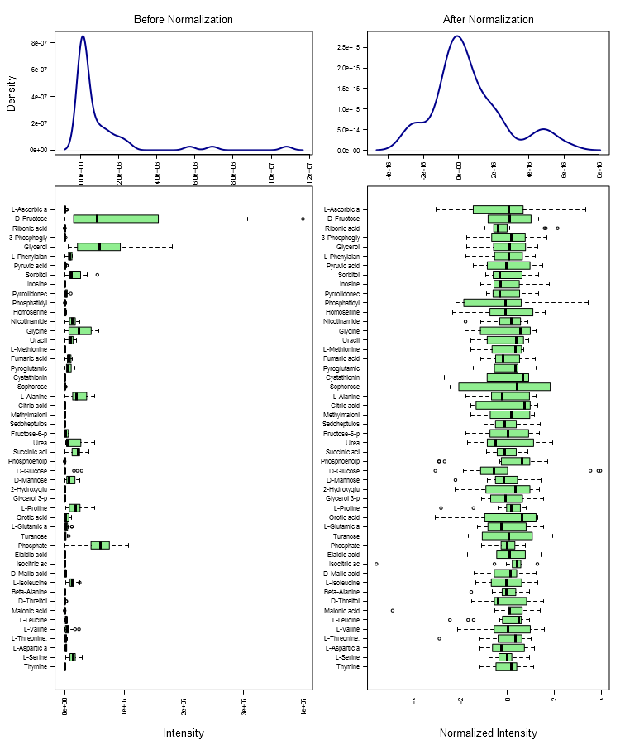

Results of PCA test (groups: wt at 1hr minr+leu, mct1ko at 1hr minr+leu, qc):

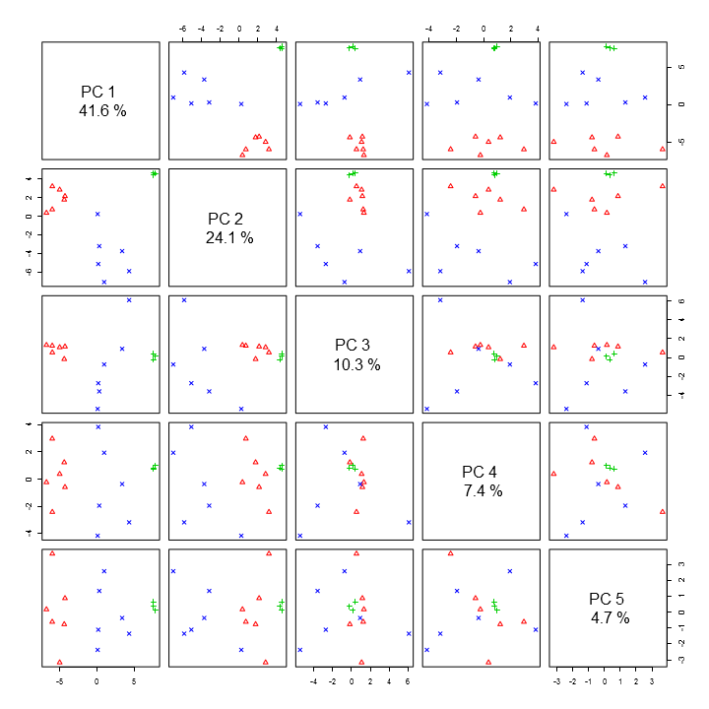

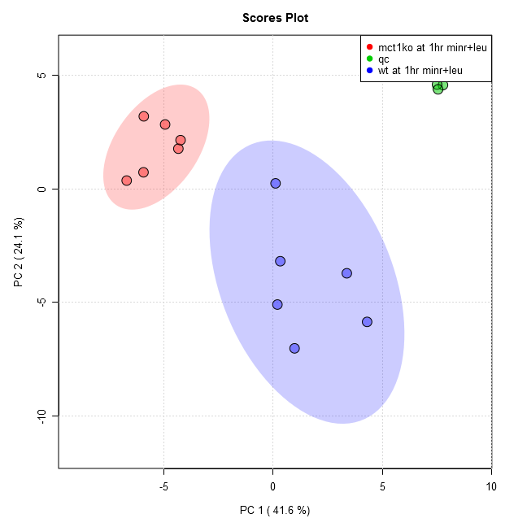

Comparison of the following groups: mct1ko at 1hr minr+leu, wt at 1hr minr+leu

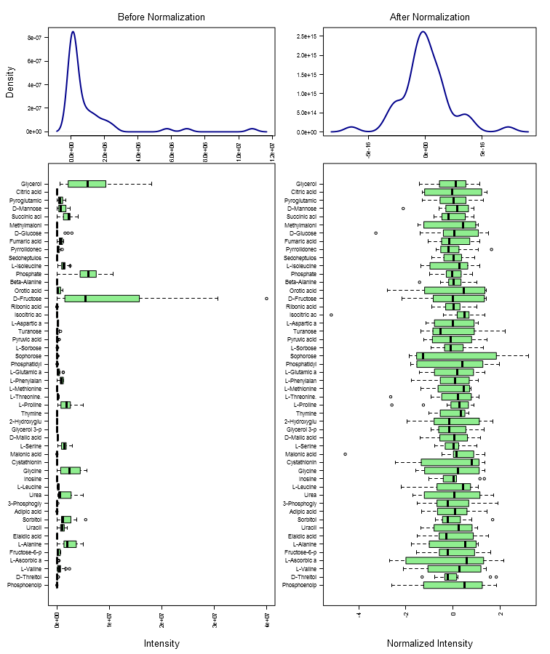

Results of PCA test (groups: mct1ko at 1hr minr+leu, wt at 1hr minr+leu):

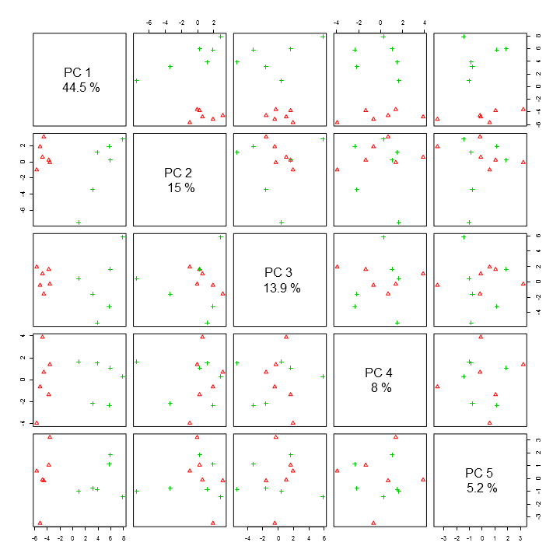

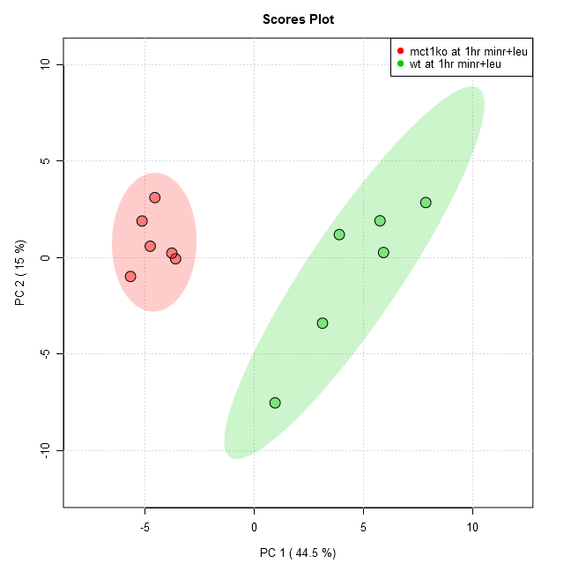

Results of Volcano test (groups: mct1ko at 1hr minr+leu/wt at 1hr minr+leu):

Analysis shows 25 compounds were significant when using current settings (p-value < 0.05, Fold Change > 1.4999999999999996, raw adjusted).

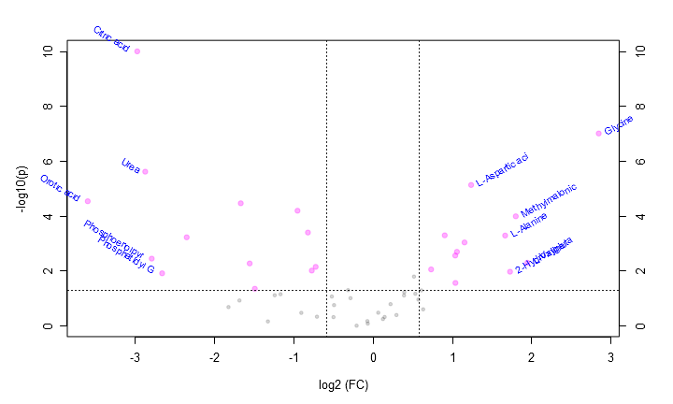

This table contains all the significant points from the Volcano analysis.

|  |  |  |  |  |
| --- | --- | --- | --- | --- |
| **Compound** | **Fold Change** | **log2(FC)** | **raw.pval** | **-log10(p)** |
| Glycine | 7.177500 | 2.843500 | 9.60E-8 | 7.018000 |
| L-Valine | 3.847900 | 1.944100 | 0.004929 | 2.307200 |
| Methylmalonic acid | 3.477500 | 1.798000 | 0.000100 | 3.998800 |
| 2-Hydroxyglutaric acid | 3.307500 | 1.725700 | 0.010500 | 1.978800 |
| L-Alanine | 3.169000 | 1.664000 | 0.000504 | 3.297400 |
| L-Aspartic acid | 2.354200 | 1.235200 | 0.000007 | 5.140600 |
| L-Isoleucine | 2.221900 | 1.151800 | 0.000900 | 3.045600 |
| Uracil | 2.079400 | 1.056200 | 0.001977 | 2.704100 |
| L-Leucine | 2.052200 | 1.037200 | 0.026944 | 1.569500 |
| D-Malic acid | 2.049300 | 1.035100 | 0.002705 | 2.567900 |
| Fumaric acid | 1.869100 | 0.902380 | 0.000495 | 3.305300 |
| Nicotinamide | 1.659800 | 0.731010 | 0.008656 | 2.062700 |
| Sorbitol | 0.605210 | -0.724490 | 0.006981 | 2.156100 |
| Pyrrolidonecarboxylic acid | 0.584910 | -0.773710 | 0.009550 | 2.020000 |
| Glycerol 3-phosphate | 0.565600 | -0.822150 | 0.000392 | 3.406600 |
| Pyroglutamic acid | 0.516430 | -0.953360 | 0.000063 | 4.201800 |
| Homoserine | 0.355590 | -1.491700 | 0.043924 | 1.357300 |
| Fructose-6-phosphate | 0.340000 | -1.556400 | 0.005243 | 2.280400 |
| L-Glutamic acid | 0.314490 | -1.668900 | 0.000034 | 4.473600 |
| Turanose | 0.196090 | -2.350400 | 0.000585 | 3.233000 |
| Phosphatidyl Glycerol | 0.158210 | -2.660100 | 0.011996 | 1.921000 |
| Phosphoenolpyruvate | 0.144450 | -2.791400 | 0.003502 | 2.455700 |
| Urea | 0.136480 | -2.873200 | 0.000002 | 5.625900 |
| Citric acid | 0.127290 | -2.973800 | 9.74E-11 | 10.011000 |
| Orotic acid | 0.082590 | -3.597900 | 0.000028 | 4.547000 |

Data from mct 3hr vs wt 3hr.docx

Comparison of the following groups: wt at 3hr minr+leu, mct1ko at 3hr minr+leu, qc

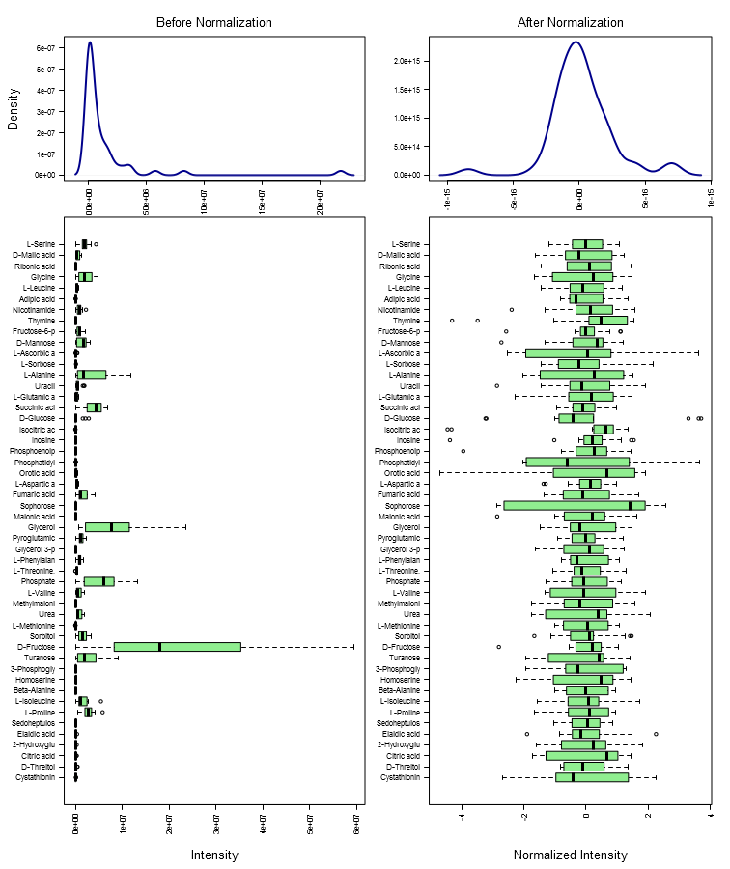

Results of PCA test (groups: wt at 3hr minr+leu, mct1ko at 3hr minr+leu, qc):

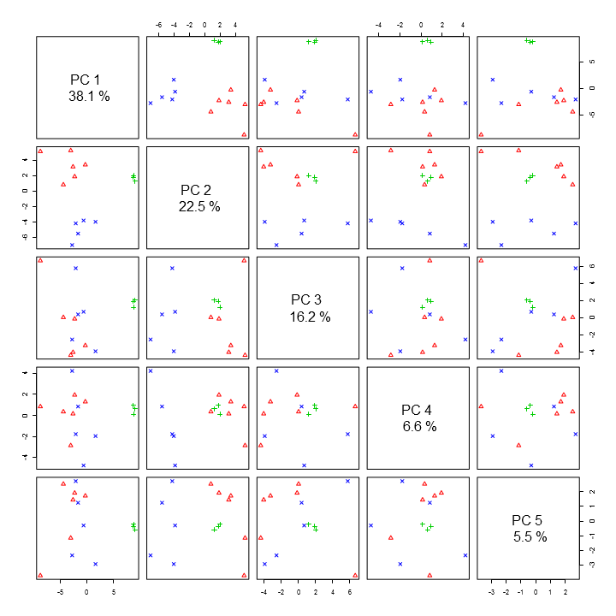

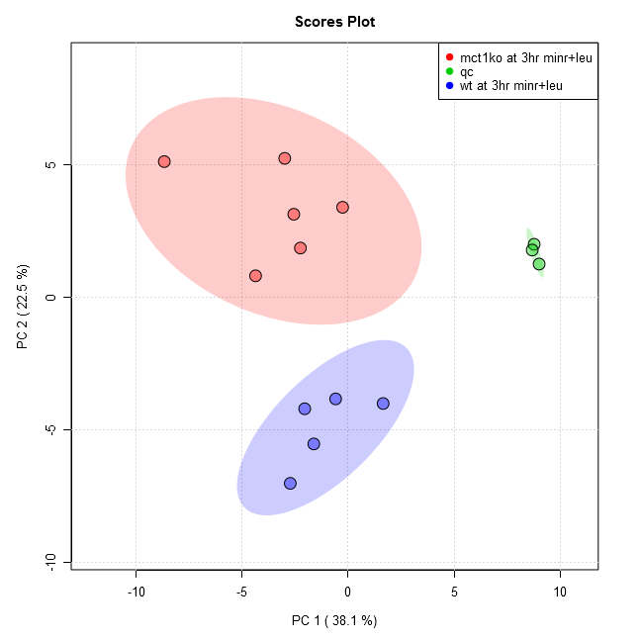

Comparison of the following groups: mct1ko at 3hr minr+leu, wt at 3hr minr+leu

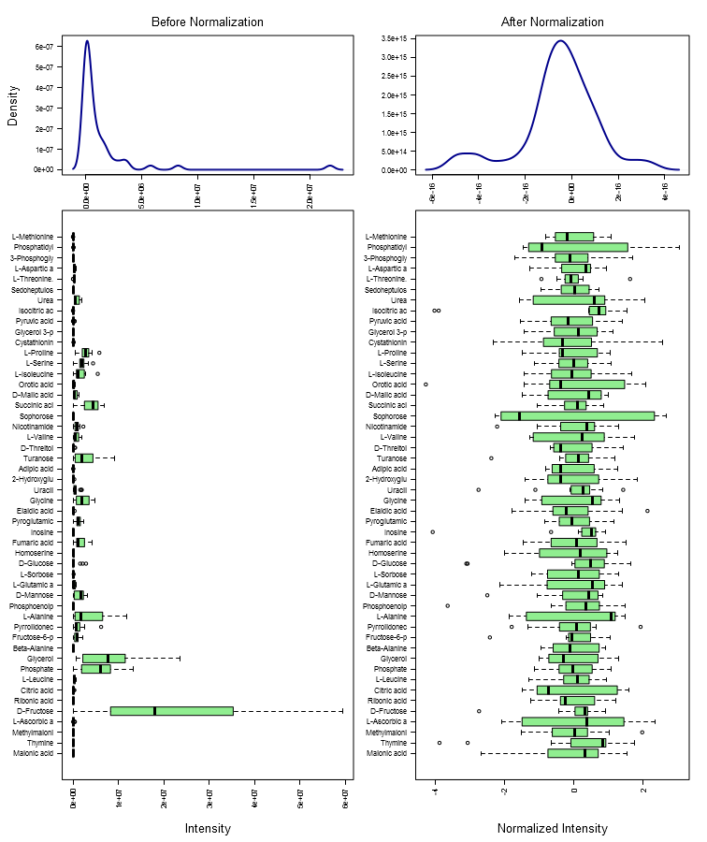

Results of PCA test (groups: mct1ko at 3hr minr+leu, wt at 3hr minr+leu):

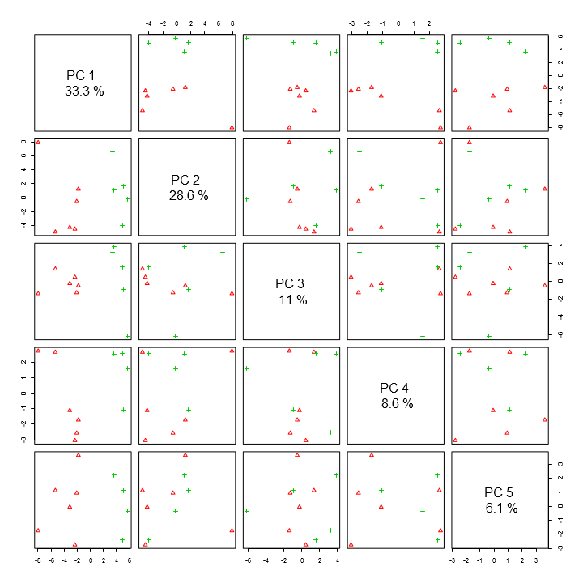

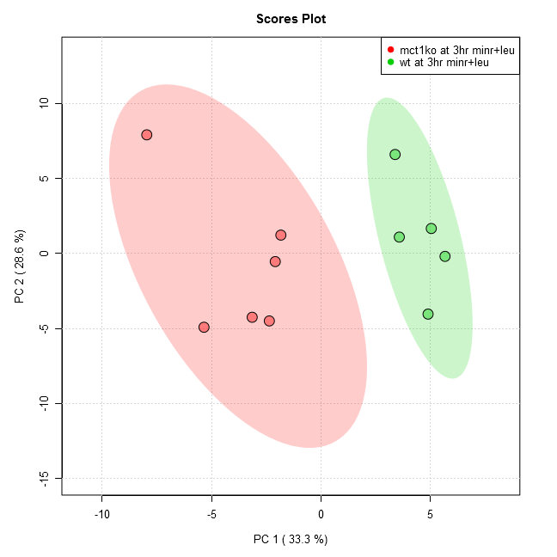

Results of Volcano test (groups: mct1ko at 3hr minr+leu/wt at 3hr minr+leu):

Analysis shows 17 compounds were significant when using current settings (p-value < 0.05, Fold Change > 1.4999999999999996, raw adjusted).

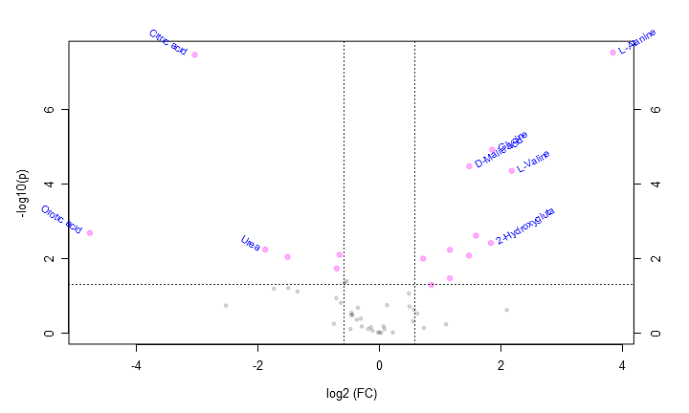

This table contains all the significant points from the Volcano analysis.

|  |  |  |  |  |
| --- | --- | --- | --- | --- |
| **Compound** | **Fold Change** | **log2(FC)** | **raw.pval** | **-log10(p)** |
| L-Alanine | 14.391000 | 3.847100 | 3.08E-8 | 7.511300 |
| L-Valine | 4.534100 | 2.180800 | 0.000045 | 4.349600 |
| Glycine | 3.628500 | 1.859400 | 0.000012 | 4.911400 |
| 2-Hydroxyglutaric acid | 3.570300 | 1.836000 | 0.003812 | 2.418800 |
| L-Isoleucine | 3.011700 | 1.590600 | 0.002421 | 2.616000 |
| D-Malic acid | 2.789200 | 1.479800 | 0.000034 | 4.471400 |
| Methylmalonic acid | 2.780500 | 1.475400 | 0.008277 | 2.082100 |
| Fumaric acid | 2.237800 | 1.162100 | 0.005807 | 2.236100 |
| Malonic acid | 2.234700 | 1.160100 | 0.033313 | 1.477400 |
| D-Threitol | 1.811000 | 0.856770 | 0.049932 | 1.301600 |
| L-Aspartic acid | 1.649200 | 0.721780 | 0.009937 | 2.002700 |
| L-Serine | 0.634590 | -0.656110 | 0.007833 | 2.106100 |
| Sorbitol | 0.614650 | -0.702160 | 0.018312 | 1.737300 |
| L-Glutamic acid | 0.350780 | -1.511400 | 0.008981 | 2.046700 |
| Urea | 0.271800 | -1.879400 | 0.005690 | 2.244900 |
| Citric acid | 0.121540 | -3.040600 | 3.54E-8 | 7.450500 |
| Orotic acid | 0.036692 | -4.768400 | 0.002057 | 2.686900 |

Data from mct 15min vs wt 15min.docx

Comparison of the following groups: wt at 15min minr+leu, mct1ko at 15min minr+leu, qc

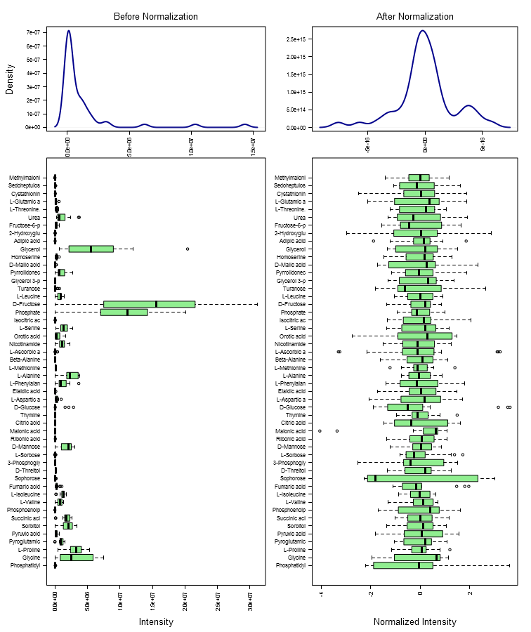

Results of PCA test (groups: wt at 15min minr+leu, mct1ko at 15min minr+leu, qc):

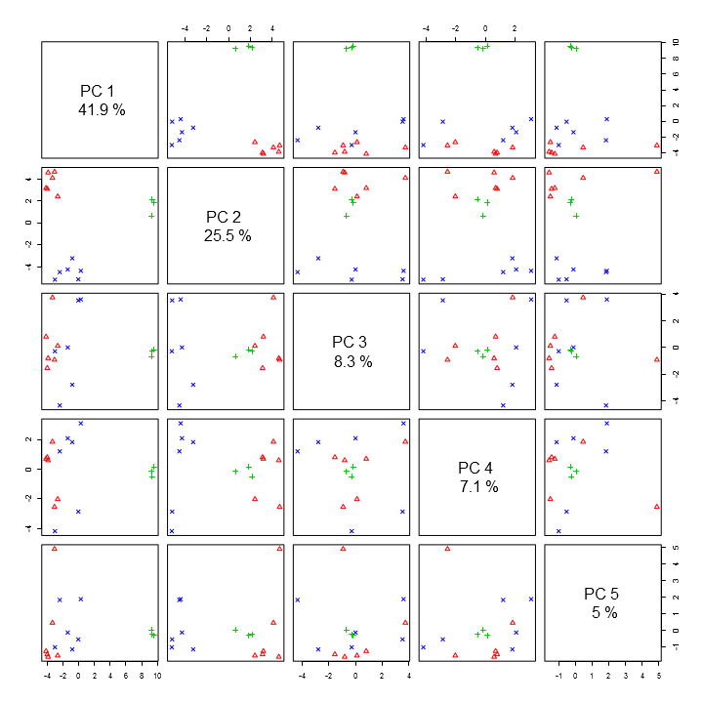

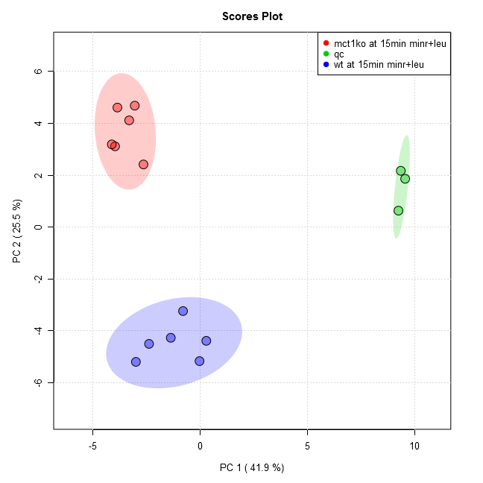

Comparison of the following groups: mct1ko at 15min minr+leu, wt at 15min minr+leu

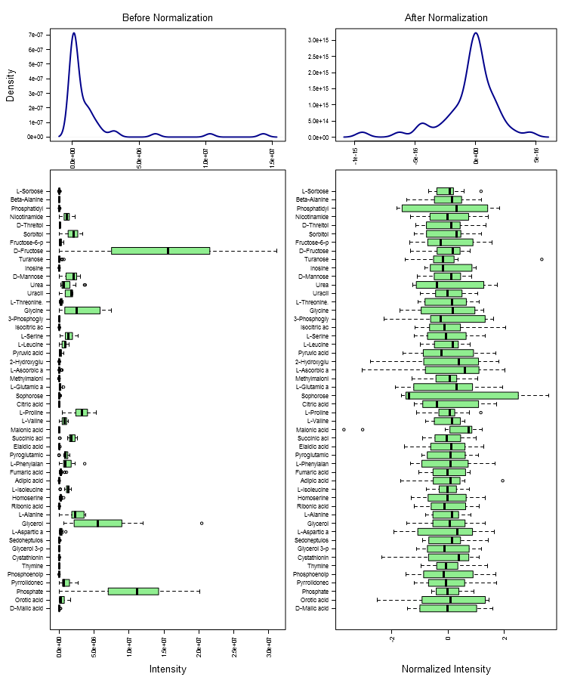

Results of PCA test (groups: mct1ko at 15min minr+leu, wt at 15min minr+leu):

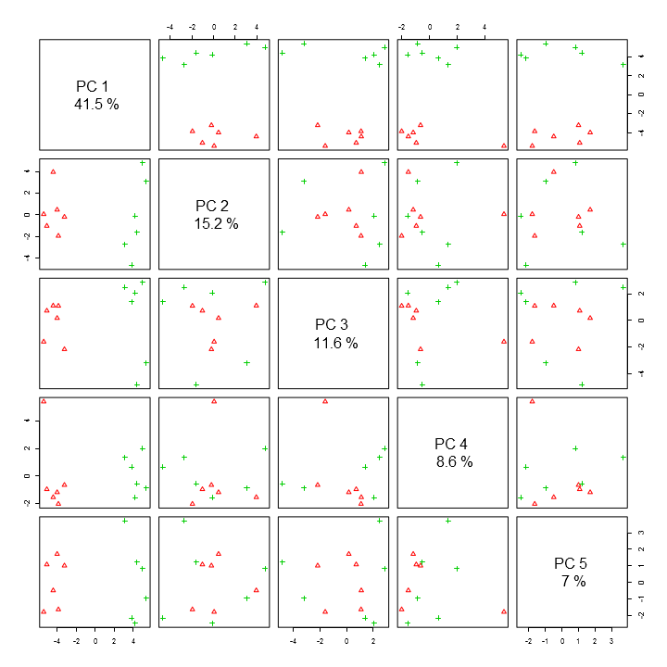

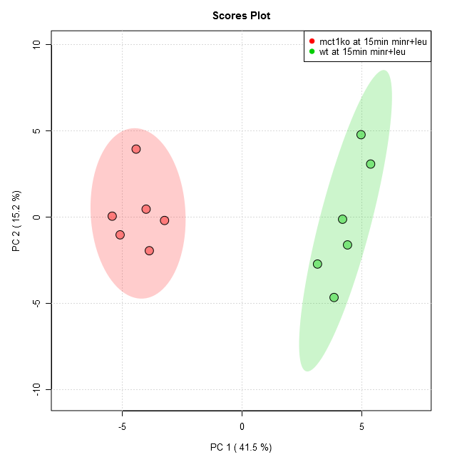

Results of Volcano test (groups: mct1ko at 15min minr+leu/wt at 15min minr+leu):

Analysis shows 26 compounds were significant when using current settings (p-value < 0.05, Fold Change > 1.4999999999999996, raw adjusted).

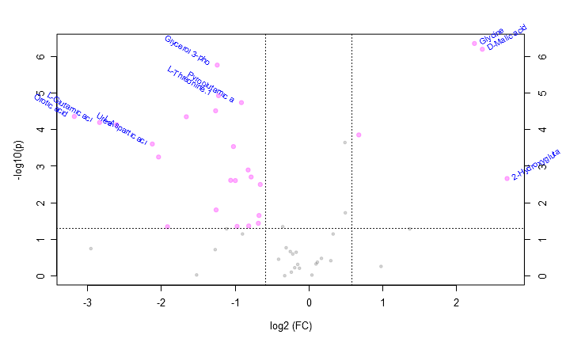

This table contains all the significant points from the Volcano analysis.

|  |  |  |  |  |
| --- | --- | --- | --- | --- |
| **Compound** | **Fold Change** | **log2(FC)** | **raw.pval** | **-log10(p)** |
| 2-Hydroxyglutaric acid | 6.443100 | 2.687800 | 0.002165 | 2.664600 |
| D-Malic acid | 5.105300 | 2.352000 | 0.000001 | 6.193400 |
| Glycine | 4.741000 | 2.245200 | 4.46E-7 | 6.351000 |
| Fumaric acid | 1.598500 | 0.676680 | 0.000140 | 3.855200 |
| Thymine | 0.632890 | -0.659980 | 0.003147 | 2.502100 |
| Beta-Alanine | 0.625480 | -0.676970 | 0.022075 | 1.656100 |
| D-Threitol | 0.621600 | -0.685930 | 0.036063 | 1.442900 |
| Sorbitol | 0.580810 | -0.783860 | 0.001964 | 2.706800 |
| Nicotinamide | 0.567790 | -0.816560 | 0.042587 | 1.370700 |
| Sedoheptulose 7-phosphate | 0.564720 | -0.824400 | 0.001263 | 2.898500 |
| Pyroglutamic acid | 0.530150 | -0.915540 | 0.000018 | 4.737400 |
| Adipic acid | 0.508890 | -0.974590 | 0.043732 | 1.359200 |
| Homoserine | 0.500640 | -0.998160 | 0.002460 | 2.609100 |
| Ribonic acid-gamma-lactone | 0.491870 | -1.023700 | 0.000290 | 3.537300 |
| Elaidic acid | 0.479250 | -1.061100 | 0.002423 | 2.615600 |
| L-Threonine.1 | 0.427580 | -1.225700 | 0.000012 | 4.926500 |
| Glycerol 3-phosphate | 0.422290 | -1.243700 | 0.000002 | 5.761600 |
| Fructose-6-phosphate | 0.417880 | -1.258900 | 0.015573 | 1.807600 |
| L-Serine | 0.415930 | -1.265600 | 0.000031 | 4.513700 |
| L-Phenylalanine | 0.315800 | -1.662900 | 0.000045 | 4.350900 |
| 3-Phosphoglyceric acid | 0.264520 | -1.918500 | 0.044644 | 1.350200 |
| Citric acid | 0.243270 | -2.039400 | 0.000560 | 3.252000 |
| L-Aspartic acid | 0.229430 | -2.123900 | 0.000247 | 3.607100 |
| Urea | 0.163990 | -2.608300 | 0.000073 | 4.136200 |
| L-Glutamic acid | 0.139720 | -2.839400 | 0.000064 | 4.194600 |
| Orotic acid | 0.110170 | -3.182200 | 0.000044 | 4.359000 |

Data from mct 30min vs wt 30min.docx

Comparison of the following groups: wt at 30min minr+leu, mct1ko at 30min minr+leu, qc

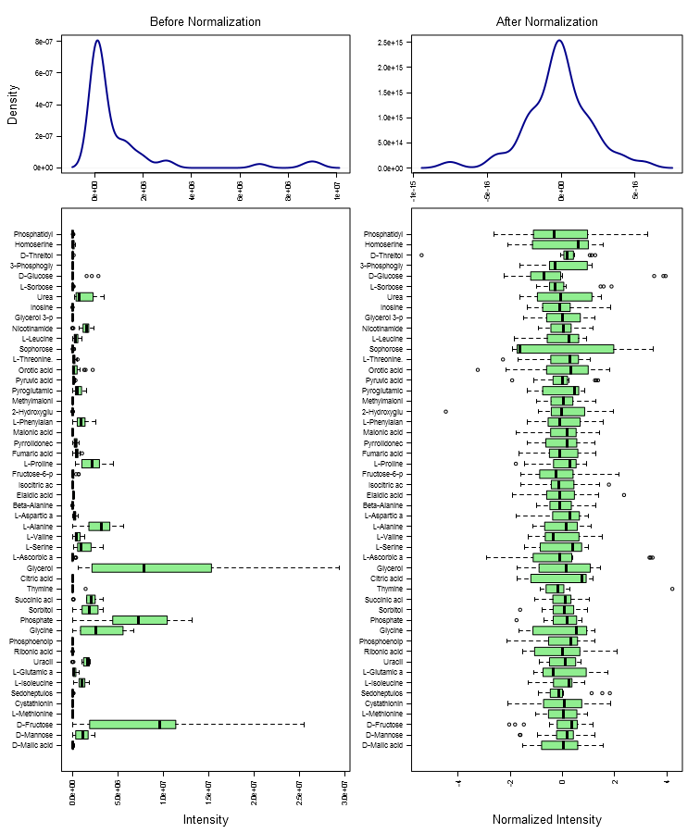

Results of PCA test (groups: wt at 30min minr+leu, mct1ko at 30min minr+leu, qc):

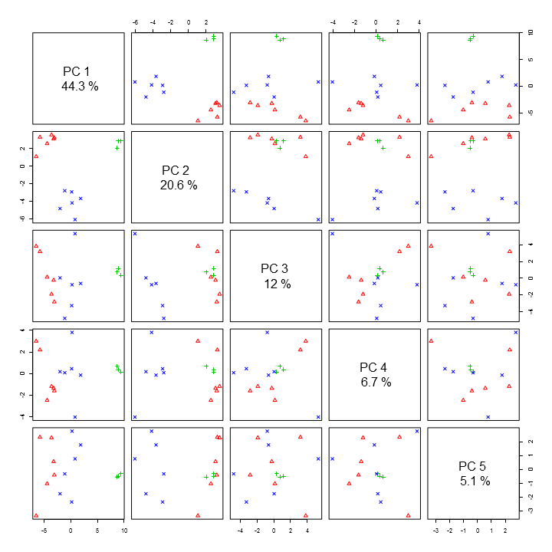

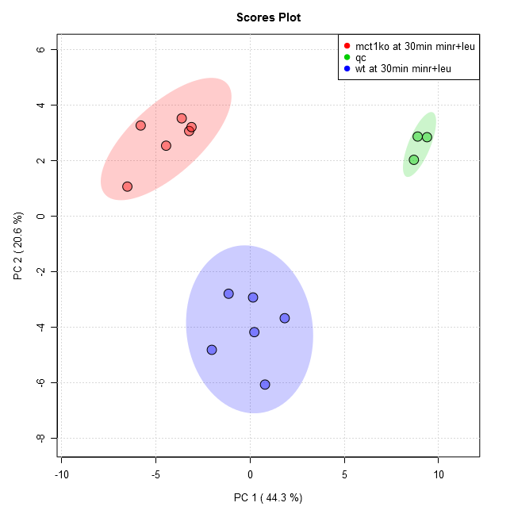

Comparison of the following groups: mct1ko at 30min minr+leu, wt at 30min minr+leu

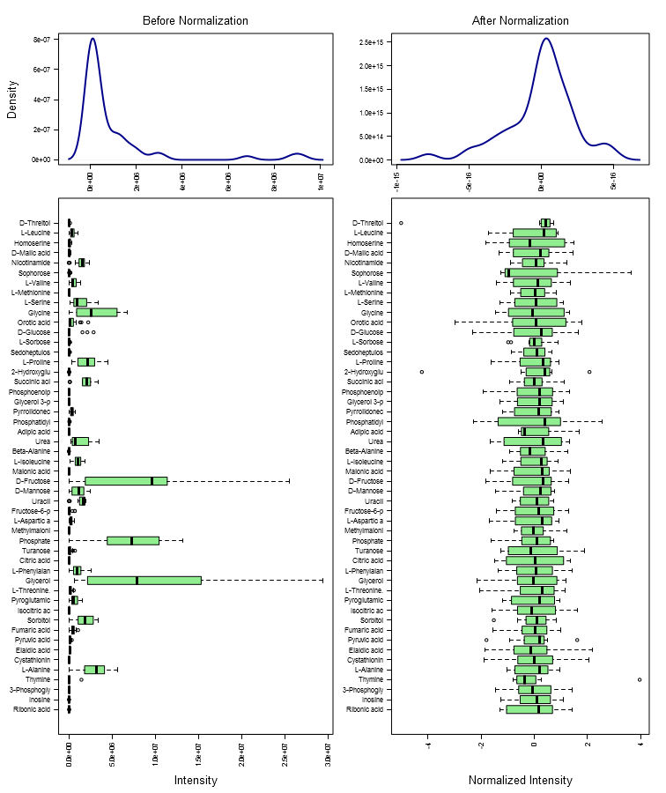

Results of PCA test (groups: mct1ko at 30min minr+leu, wt at 30min minr+leu):

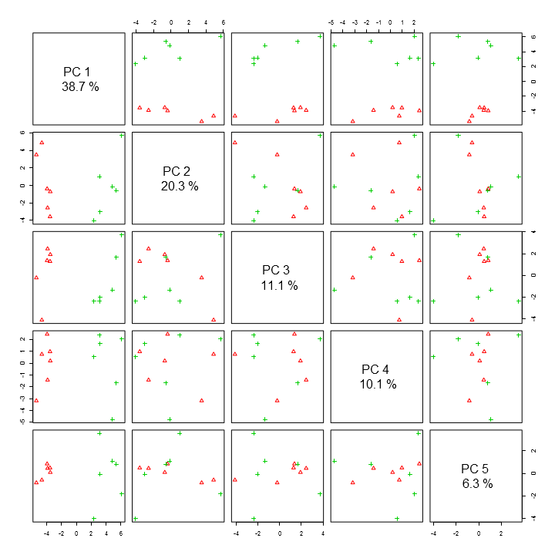

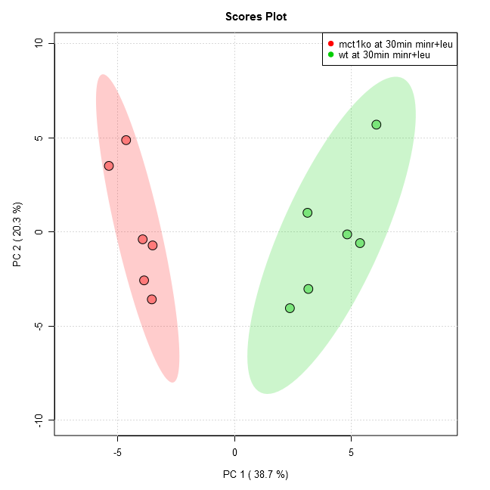

Results of Volcano test (groups: mct1ko at 30min minr+leu/wt at 30min minr+leu):

Analysis shows 23 compounds were significant when using current settings (p-value < 0.05, Fold Change > 1.4999999999999996, raw adjusted).

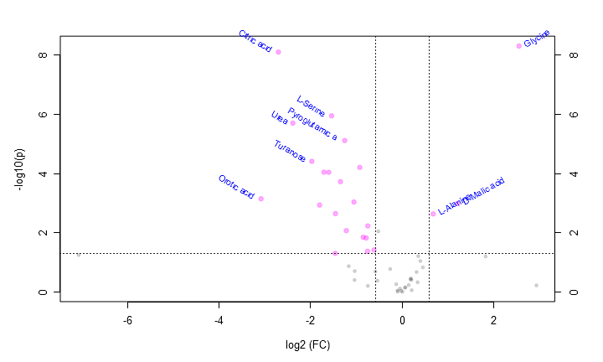

This table contains all the significant points from the Volcano analysis.

|  |  |  |  |  |
| --- | --- | --- | --- | --- |
| **Compound** | **Fold Change** | **log2(FC)** | **raw.pval** | **-log10(p)** |
| Glycine | 5.869600 | 2.553300 | 4.89E-9 | 8.310500 |
| D-Malic acid | 2.311300 | 1.208700 | 0.001011 | 2.995400 |
| L-Alanine | 1.600000 | 0.678110 | 0.002297 | 2.638800 |
| Inosine | 0.652870 | -0.615120 | 0.037835 | 1.422100 |
| Beta-Alanine | 0.594740 | -0.749660 | 0.005842 | 2.233400 |
| Pyruvic acid | 0.592350 | -0.755470 | 0.041923 | 1.377500 |
| Adipic acid | 0.580330 | -0.785050 | 0.014862 | 1.827900 |
| L-Aspartic acid | 0.554220 | -0.851470 | 0.014107 | 1.850600 |
| Pyrrolidonecarboxylic acid | 0.526020 | -0.926820 | 0.000062 | 4.209700 |
| Glycerol 3-phosphate | 0.481910 | -1.053200 | 0.000909 | 3.041400 |
| Phosphoenolpyruvate | 0.429580 | -1.219000 | 0.008411 | 2.075100 |
| Pyroglutamic acid | 0.419060 | -1.254800 | 0.000008 | 5.117900 |
| L-Phenylalanine | 0.392850 | -1.347900 | 0.000187 | 3.728800 |
| Isocitric acid | 0.364360 | -1.456500 | 0.002240 | 2.649800 |
| Elaidic acid | 0.362760 | -1.462900 | 0.049373 | 1.306500 |
| L-Serine | 0.343610 | -1.541100 | 0.000001 | 5.952600 |
| Ribonic acid-gamma-lactone | 0.329030 | -1.603700 | 0.000090 | 4.046000 |
| L-Glutamic acid | 0.305980 | -1.708500 | 0.000089 | 4.049000 |
| Cystathionine | 0.286500 | -1.803400 | 0.001152 | 2.938700 |
| Turanose | 0.254680 | -1.973300 | 0.000038 | 4.415200 |
| Urea | 0.191060 | -2.387900 | 0.000002 | 5.706200 |
| Citric acid | 0.153550 | -2.703200 | 7.85E-9 | 8.105400 |
| Orotic acid | 0.118030 | -3.082800 | 0.000708 | 3.150300 |