**Gazing into the Metaboverse: Automated exploration and contextualization of metabolic data**

*This manuscript was automatically generated on May 28, 2020.*

# Authors

Jordan A. Berg1, Youjia Zhou2,3, T. Cameron Waller4, Yeyun Ouyang1, Sara M. Nowinski1, Tyler Van Ry1,5, Ian George1, James E. Cox1,5,6, Bei Wang2,3, Jared Rutter1,6,7

1. Department of Biochemistry, University of Utah
2. School of Computing, University of Utah
3. Scientific Computing & Imaging Institute, University of Utah
4. Division of Medical Genetics, Department of Medicine, School of Medicine, University of California San Diego
5. Metabolomics Core Facility, University of Utah
6. Diabetes & Metabolism Research Center, University of Utah
7. Howard Hughes Medical Institute, University of Utah

† To whom correspondence should be addressed: rutter@biochem.utah.edu?

* This is a working draft of manuscript and should therefore be treated as such. Conclusions, along with author order and contributions, may change as the manuscript is finalized.

# Abstract

Metabolism and other biological interactions and reactions are complex, each with variable inputs, outputs, and modifiers at the level of genes, proteins/enzymes and/or metabolites. The harmony between these factors consequently determines the health and stability of a cell or organism. Perturbations to any of these components often have rippling downstream effects, and can be difficult to trace across the global reaction network, particularly when the effects occur between canonical representations of pathways. Researchers have primarily utilized reductionist approaches to understanding these systems; however, these methods limit the scope of the analysis. Even the power of systems-centric -omics approaches can be limited when only a handful of high magnitude signals in the data are prioritized. To address these challenges, we developed Metaboverse, an interactive desktop app for the exploration and automated extraction of potential regulatory events, patterns, and trends from multi-omic data within the context of the metabolic network and other global reaction networks. This framework will be foundational in increasing our ability to holistically understand static and temporal metabolic events and shifts and gene-metabolite intra-cooperativity. Metaboverse is freely available under a GPL-3.0 license at [https://](https://github.com/Metaboverse/) [github.com/Metaboverse/](https://github.com/Metaboverse/).

Graphical Abstract (displayed as Figure 1)

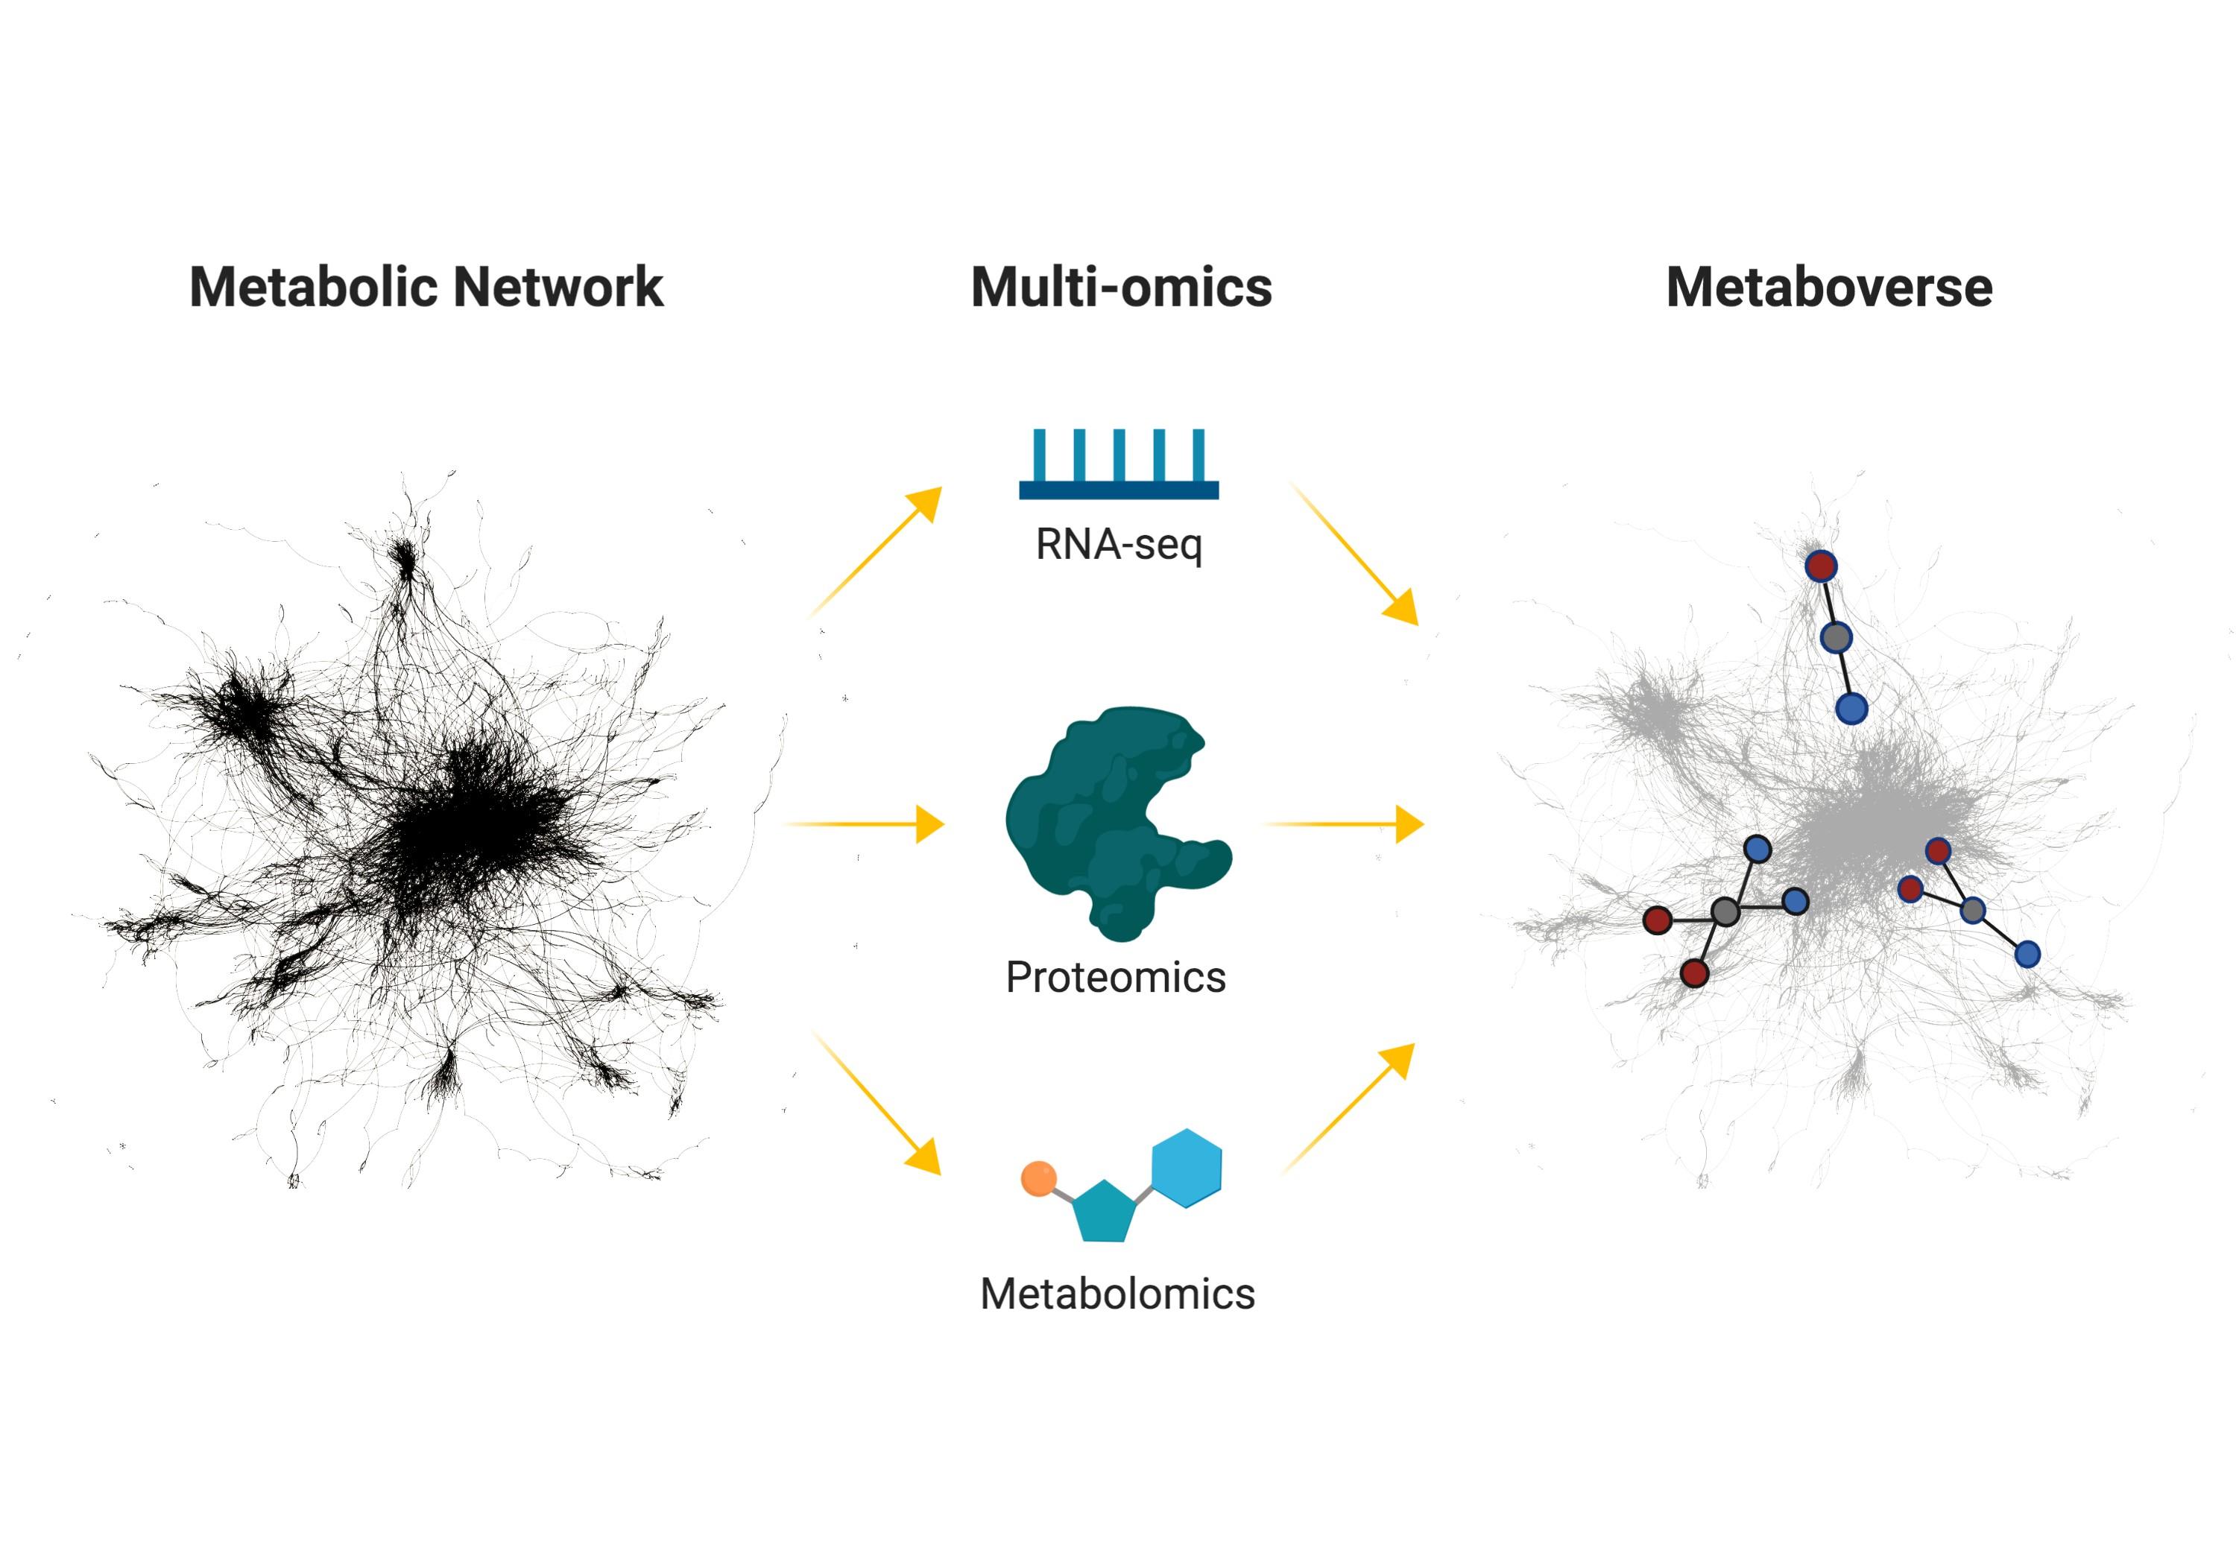

**Figure 1: Metaboverse conceptual overview.** Illustration summarizing the usage of Metaboverse to model biological data on the global reaction network to rapidly identify regulatory hotspots. Traditionally, when a scientist performs an -omics experiment, they tend to focus on a few features that are differentially regulated. Metaboverse contextualizes the data across the metabolic network and identifies interesting regulatory patterns in the data.

# Introduction

Metabolism is a complex network of reactions and interactions between genes, enzymes, complexes, and metabolites [1]. To understand these complex components, researchers frequently adopt a reductionist approach to teasing apart the characteristics and mechanics of these processes and how they fit into the larger picture of biology and disease. While a vital component in the scientific process, by doing so, many interesting properties of metabolism can be missed. For example, in differential gene expression analysis, researchers rely on thresholds of magnitude and statistical significance to prioritize genes for follow-up study. However, this can inadvertently limit the scope of study of metabolism when, in fact, metabolism is a highly interconnected system where distal components and their modulation can have rippling effects across the network. The current approach is analogous to telling the story of Little Red Riding Hood, but only by reading the 20 most frequent words used in the study. Indeed, doing so efficiently highlights keywords like “wolf” and “little red riding hood,” but also prevents a coherent story from being told and would make it difficult for someone who had never heard the story of Little Red Riding Hood to comprehend the actual plot (Figure 2).

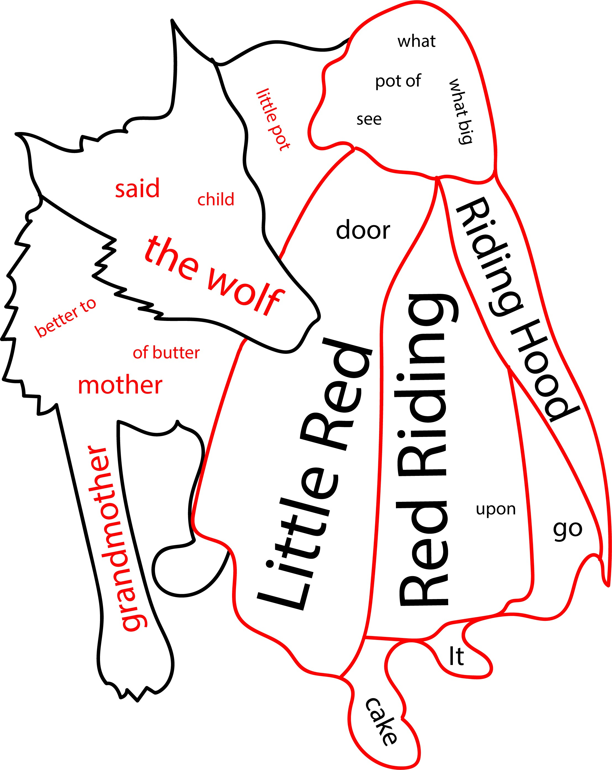

**Figure 2: Word cloud of 20 most frequent words of phrases in the story of Little Red Riding Hood.** Text taken from the original telling of Little Red Riding Hood by Charles Perrault. Words and phrases derived using [ 2]. Outline derived from the piece, “Little Red Riding Hood” by J.W. Smith.

Several computational tools have emerged over the past decade and become popular for their focus on attempting to resolve these issues in data contextualization. We will highlight four, and while others exist, we focus on tools representative and most popular for their respective properties. First is MetaboAnalyst, which relies largely on set enrichment methods for analysis of data, or looking at the belonging-ness of sets of significantly changed analytes (i.e., metabolite, protein, or gene measurements), for extracting interesting information. While network visualization is available, it focuses primarily on interaction networks, and its ability to extract regulatory information is limited, particularly in an automated fashion [3,4]. Second is Cytoscape, which serves as a general go-to platform for representing biological or other networks. One strength of Cytoscape is the ability to design apps or plug-ins to develop customized analyses. However, comprehensive regulatory identification methods are unavailable [5]. MetExplore focuses on the curation of networks and is

particularly useful for collaborative annotation of emerging organisms. It additionally can layer experimental data on the network for visualization [ 6,7]. Reactome, which Metaboverse uses for the curation of biological networks, also offers analytical tools for user data, but again relies on set enrichment or manual methods for identifying patterns. While all have their respective utility, there is still a need for tools that automate pattern and trend detection, especially when data is sparse, across metabolic networks in order to extract regulatory and other features from data [ 8,9,10].

To address these limitations in current conventions of metabolic data analysis, contextualization, and interpretation, we created the operating-system-independent desktop application, Metaboverse, to aid users in filling in and expanding upon the details of their model’s metabolic story. Metaboverse is an interactive tool for exploratory data analysis that searches user data in the context of the metabolic network to identify unusual patterns and trends within the data. Metaboverse will aid scientists in formulating new hypotheses from their data and aid them in designing follow-up experiments for a deeper understanding of their model. Metaboverse operates across the entire metabolic network to quickly and automatically detect patterns and trends from a pre-designed pattern library. Alternatively, the application can also accept interactive input from the user, who can define specific patterns or trends they would like to identify across the global metabolic network.

To provide a platform for the exploration of single or multi-omic metabolic data, we developed several computational features to aid in the aims discussed above. We developed a pattern search engine for the rapid and automated identification of patterns and trends in -omic data on the metabolic network.

Conceptually, this search engine borrows principles of topological motif searching from graph theory [11,12] and builds upon the concept of “activity motifs” [13]. Another feature introduced in Metaboverse allows for the interactive exploration of specific reactions or reaction entities with on- the-fly pattern search analysis. Users can explore specific pathways of interest and look for other interesting patterns and trends in pathways of interest. Perturbations in the abundance or behavior of a particular metabolic network component can lead to downstream genotypic and phenotypic modulations in a biological system. We include an interactive perturbation connectivity module to allow users to explore the effects of perturbations on their system. Finally, we tackle the challenge of sparsity, particularly in metabolomics datasets. We designed a reaction collapsing feature that allows for searching for motifs across multiple reactions, where intermediate steps of the reaction trajectory may not have measured values for their respective input or output components.

Metaboverse is designed to handle standard two-condition experiments, flux metabolomics (in progress), and time-course or multi-condition experiments. Users can provide any combination of datasets from each -omics category (values mapping to gene, protein, and metabolite identifiers). Time-course inputs can consist of matched samples for every time point or can provide a combination of steady-state levels and time points. Users input fold change and appropriate statistical measures with proper multiple-testing adjustments from their respective -omics datasets, which Metaboverse then layers onto the metabolic network. Metaboverse can handle data from a variety of model organisms, including humans, mice, yeast, zebrafish, and more. The foundational curation of Metaboverse is built on Reactome reaction curations, providing 90+ species which the Metaboverse environment can process. To validate these methodologies available in Metaboverse, we analyzed a variety of datasets to provide representative vignettes that highlight Metaboverse’s reliability in extracting canonical features, as well as utility in identifying novel features and patterns. We expect that Metaboverse will become a foundational piece of the analytical toolkit and augment one’s ability to more deeply and holistically explore metabolism and other reaction networks. It will importantly aid in our ability to provide clearer context within these models.

# Results

## Metaboverse is a dynamic, user-friendly tool for the exploration of high-throughput biological data in organism-specific pathways.

### Overview.

We designed Metaboverse as a light-weight, self-contained app for the dynamic exploration of high- throughput biological data. The pathway curations are derived from Reactome [14], coupled with metabolite name cross-referencing from the ChEBI [15] and the Human Metabolome (HMDB) [16] databases. As of the time of writing this manuscript, Metaboverse is capable of analyzing data for over ninety species. A user begins by providing a previously curated Metaboverse file, or the desired output location for a new curation and organism of interest. Next, the user provides the relevant transcriptomic, proteomic, and/or metabolomic datasets to layer onto the global reaction network of their organism of interest. These data categories can be extended to any dataset that uses the relevant mapping IDs; for example, one could provide ribosome profiling translation efficiency values mapped to the appropriate gene IDs for layering onto the network and downstream analysis. During this step, the user will also specify a few experimental parameters for consideration during downstream analysis and visualization. Following these user inputs, the organism’s network, data processing, and motif analysis (discussed further below) are curated, and a curation file is output for future analysis (see Figure 3).

We chose to format network visualizations in a reaction-centric format. This means that a sub- network unit comprises of a reaction node, linked with its reaction input and reaction output nodes, along with any nodes for modifiers. If modifier nodes are a protein complex, the component proteins of that complex are linked to the complex node. Any genes available in the database are linked to their related proteins. Each node and link-type are color-coded to help users quickly distinguish the details of a reaction sub-network structure. Reactions with matching input or output sides are then naturally linked, allowing a multi-reaction pathway to emerge from this graph structure. This formatting differs from other formatting styles users may be familiar with, such as KEGG pathway maps, for several? various? reasons. While this methodology differs from more classical methods, each pathway in the visualization module contains a button linking to a more classically formatted representation of the pathway for reference.

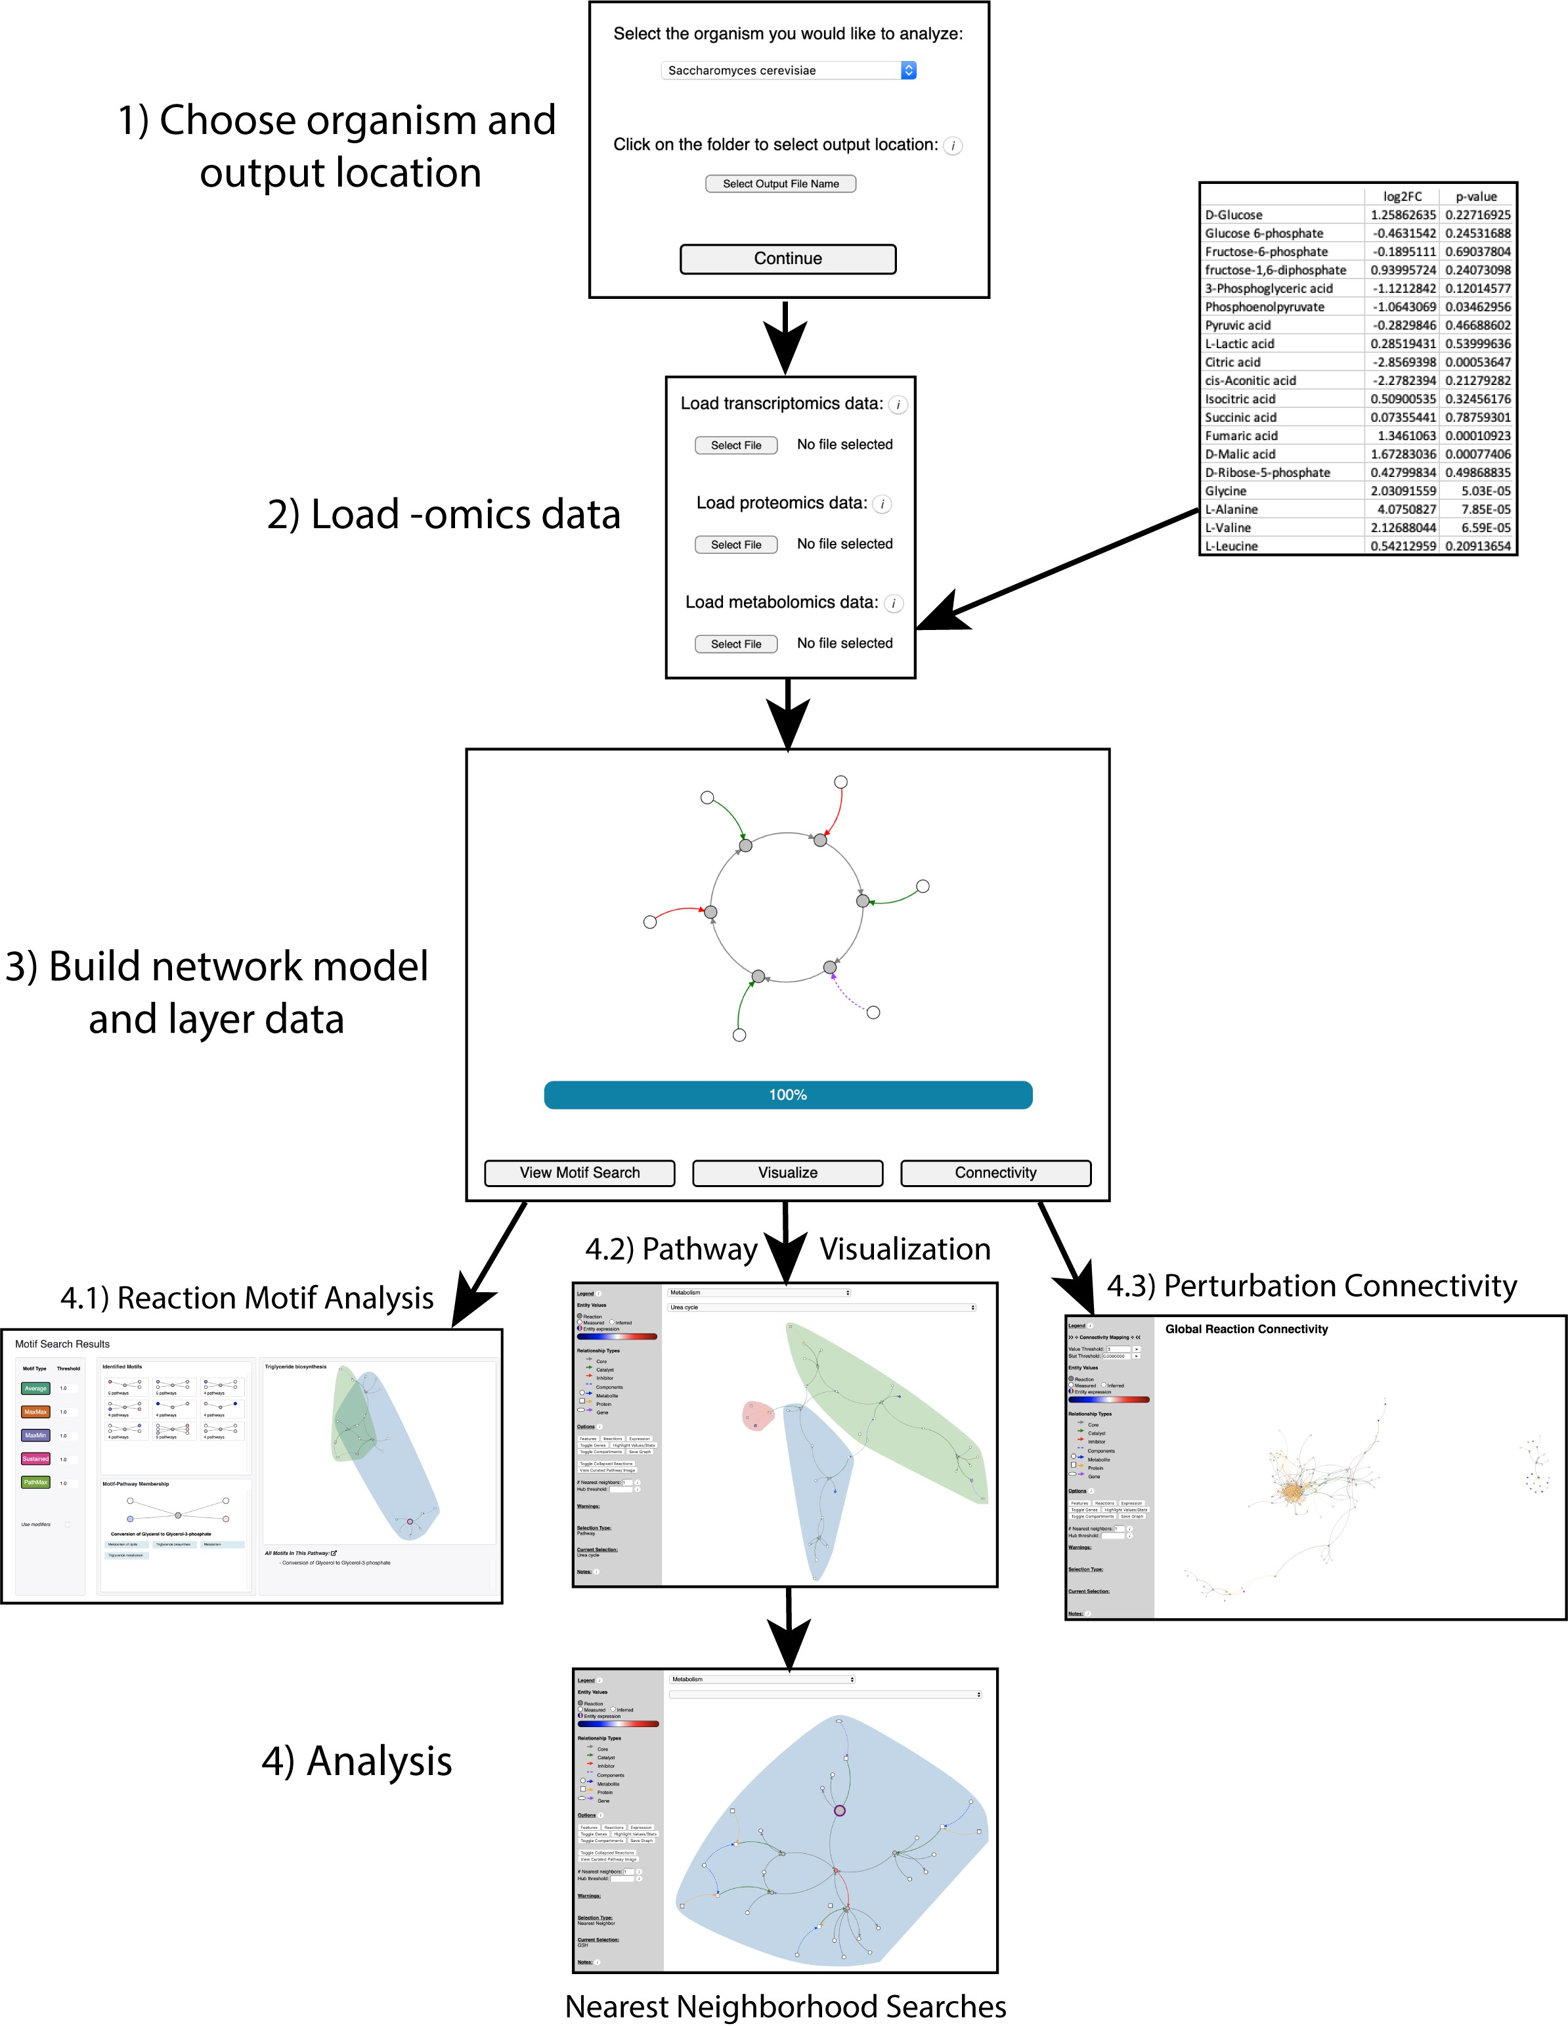

**Figure 3: Metaboverse package overview.** Illustration outlining the data input, processing, and exploration steps of the Metaboverse package.

### Handling data sparsity within the biological global network.

Missing data points, particularly in metabolomics experiments, are frequent and can make the analysis of pathways and identification of regulatory patterns in the network challenging. While thousands of metabolites are known to participate in human metabolism, the current state of the technology for determining which mass spectra belong to which metabolite can be challenging and often results in a limited number of data points being quantified. These can lead to gaps in the metabolic network, which can be challenging to explore and analyze. We, therefore, developed a reaction compression algorithm (detailed more in the Methods section) that collapses up to three reactions with missing data points if they can be bridged with known data on the distal ends of the reaction path. Methods similar to this have been used in metabolomic analysis before to identify amino acid-related metabolites [17], but we introduce the first computational implementation to our knowledge and adopt a slightly more conservative collapsing scheme. These reactions, or pseudo- reactions, are visually distinct to show users where reactions were collapsed and understand what that pseudo-reaction summarizes.

### Rapid identification of interesting regulatory patterns in the reaction network.

Following network curation, the user can visualize available reaction motifs identified across the global reaction network. In a computational science context, a motif is a re-occurring pattern in network structure or the organization of network entities and their relationships to one another. However, with -omic data, we are more interested in identifying patterns in expression or abundance of genes, proteins, and metabolites. Previous work by Checkik, et al. introduced the concept of “activity motifs,” where instead of identifying motifs based on network structure, they were identified using the expression characteristics of nodes in transcription factor binding signaling networks [ 13]. We adapted this methodology to identify and interactively display interesting regulatory hotspots within the global reaction network. For example, a reaction’s inputs may exhibit high levels and its outputs low levels, indicating a regulatory event occurring at the reaction.

In Metaboverse, we define a motif as a regulatory pattern identified across a reaction or pseudo- reaction. Metaboverse contains a library of default motifs to search the network for, and users can define custom motifs they would like to identify across the global network (please refer to the documentation for more details on available motifs [ 18]). Metaboverse will search the global network from a pre-defined library of regulatory patterns (regulatory hotspots, or motifs) and return a graphical stamp view of conserved patterns. These motifs by default are ordered by the statistical values associated with the entity components of the motif, but can be ordered by the strength of the motif based on the magnitude of change. Statistical values associated with each measurement for a measured entity as provided by the user are used to weight these motifs and prioritize returned results. We use a three-tiered sorting strategy when sorting by the associated statistical values. The highest prioritized motifs are those where the relevant components on either side of the reaction (inputs vs. outputs) that determined the reaction motif are statistically significant. Of these motifs from the first tier, motifs are sorted by lowest to highest cumulative p-value or other relevant statistical value. In the second sorting tier, reactions with at least one side of the reaction with a statistically significant motif component are sorted by statistical strength. Finally, all other motifs are sorted by the cumulative statistical value for the motif components.

Reaction motifs are visually distinct during network visualization to quickly draw the user to these interesting patterns. For a given pattern, the user can then explore each pathway this particular motif is found in. Motif analysis of the global regulatory network will allow users to rapidly identify interesting features within the data, particularly patterns between canonical pathways or in other pathways that may seem tangential in their research, but are instead rather striking based on these

contextualized analytical methods. In the data vignettes below, we demonstrate this utility further. Users will also be able to design their own patterns through an interactive pattern drawing tool and even design specific scenarios that are cognizant of feature type (in progress). For example, one might be interested in a pattern where a protein displays higher expression, but the resulting metabolite is decreased. This could then be coded interactively into the Metaboverse framework by the user.

### Dynamic visualization of organism-specific reaction pathways.

Following the curation of the global network as described above, the user can manually search individual canonical pathways or individual entities and their reaction neighborhoods. For a given selection, all relevant reactions that are annotated as a part of that pathway will be graphed, along with their core input (reactant) and output (product) components. In addition to these core elements, known catalysts and inhibitors are included, as well as the component proteins, genes, and metabolites that form functional complexes involved in a particular reaction. For complex nodes, simulated values are calculated by taking the average of all measured component entities in that complex. Assuming a statistical value between 0 and 1, simulated statistics are calculated by taking the maximum statistic value of all measured component entities in that complex. In cases where a gene value is known, but its protein value is unmeasured, the protein value can be inferred using aggregated gene component values. Relevant pathway and analytical metadata are also displayed. All reaction motif types are displayed using default thresholds if present in a selected pathway.

Additional aids for visualization are also available, such as the ability to remove nodes from the visualization that contain a high number of relationships to other network features so that these nodes, which act as hubs in the network, do not lead to cluttered representations of the network.

Often, these hub nodes are ubiquitous features such as water and protons, which may be of limited interest to the user during data visualization [ 19]. Compartment domains are also graphed to include relevant reactions and their components that occur in a given cellular compartment.

### Visualization of downstream effects of network perturbations using reaction neighborhoods.

Users may be interested in a particular metabolite or protein and the downstream effects their perturbation has on related pathways. By double-clicking a node of interest, or by selecting the entity name from the drop-down menu, the user can explore all downstream effects across all pathways in the global network. The user can also define how many neighborhoods to display such that one can visualize two or more reaction steps downstream of the selected entity [**???**, 20]. This functionality moves the analysis away from traditional, pathway-centric approaches, and helps contextualize the far-reaching effects changes in metabolism or other biological systems can have across classical pathways.

### Exploring perturbation connectivity within the global network

Abundance or behavioral changes of a metabolic network component can lead to downstream genotypic and phenotypic modulations in a biological system. One important measure of robustness of a network is “connectivity” [19,21]. In a biological context, an example of connectivity, or the loss of network connectivity, is easily grasped when considering a transport reaction from the cytosol into the mitochondria of a critical metabolite [19,22,23,24]. When the transport hub is abolished, and network connectivity is lost, the critical metabolite cannot participate in the required downstream reactions. For example, our laboratory previously established the consequences of the ablation of the mitochondrial pyruvate carrier on downstream citric acid cycle processes and the corresponding increase in lactate production [ 25] and serious cellular remodeling and dysfunction [26,27].

The importance of connectivity could also be considered in a clinical context. For example, a druggable and critical metabolite may be perturbed in a particular disease context. However, if a metabolite participating in a neighboring, downstream reaction is also perturbed in a way not related to the perturbation of the first metabolite, the efficacy of the drug treatment could be severely impaired [21,28,29,30]. To aid in the exploration of the connectivity of the biological network, we developed a connectivity module where users can display all global reactions or reactions of a specific super pathway that have at least one involved component perturbed based on either an abundance or statistical level. By doing so, when the graph is constructed, proximal reactions that were perturbed will be “sewn” together to reconstruct a perturbation connectivity map. Perturbed, but un-connected reactions would be displayed as single reactions in the network.

## Data vignettes

In order to demonstrate the utility of Metaboverse to the community, we used Metaboverse to analyze public and new datasets. From the vignettes provided below, we show that Metaboverse not only identifies points of interest previously described or expected, but also rapidly identifies unexpected and systematic regulatory patterns in a reaction network context.

### Perturbation of mitochondrial fatty acid synthesis across time.

Mitochondrial fatty acid synthesis (mtFAS) acts as an important metabolic pathway long recognized to produce lipoic acid, a critical cofactor for several metabolic enzymes. Recent work has begun to uncover additional, important roles for this pathway. For example, we now know that mtFAS can perform metabolic nutrient-sensing roles to coordinate lipoic acid synthesis with iron-sulfur (Fe-S) cluster biogenesis and assembly of oxidative phosphorylation complexes, and more [31,32].

Additionally, this pathway has received increased physiological focus with the discovery of patients with mutations in key mtFAS enzymes [33].

*Mct1* in *Saccharomyces cerevisiae* is an evolutionarily conserved acyltransferase responsible for the transfer of a malonyl group from malonyl-CoA to the mitochondrial acyl carrier protein (ACP). By knocking out this gene, one can simulate the effects of a disruption in mtFAS. In order to probe the relationship between mtFAS-related protein concentration and the effects of its perturbation on downstream metabolic processes from a systematic perspective, we used a *mct1*Δ model in *Saccharomyces cerevisiae*. In this model, we previously measured steady-state proteomics [34]. For this study, we additionally measured transcriptomics at 0, 3, and 12 hours after a shift to a non- fermentable carbon source, as well as steady-state metabolomics at 0, 15, 30, 60, and 180 minutes after the shift in carbon source. By layering these data onto the *Saccharomyces cerevisiae* metabolic network using Metaboverse, we observed interesting respiratory signatures as expected based on our previous work [34,35]. For example, we noticed a strong pattern in the electron transfer from ubiquinol to cytochrome C of complex III of the electron transport chain (ETC) (Figure 4 A). At the proteomics level, cytochrome C component proteins, CYC1 and CYC7 are both significantly reduced in

concentration compared to wild-type cells (log2(fold change): -1.57 & -0.88; p-value: < 0.01 & < 0.01; respectively). This reduction in cytochrome C concentration is paired with a marked reduction in the

concentration of the protein components of cytochrome C reductase, which is a catalyst of this electron transfer reaction (average log2(fold change) of all measured protein components = -2.03, where 9/11 component proteins were measured; 7/11 passed statistical significance thresholds of BH- corrected p-value <= 0.05. Range of significant log2(fold change) values: -0.34 to -3.21).

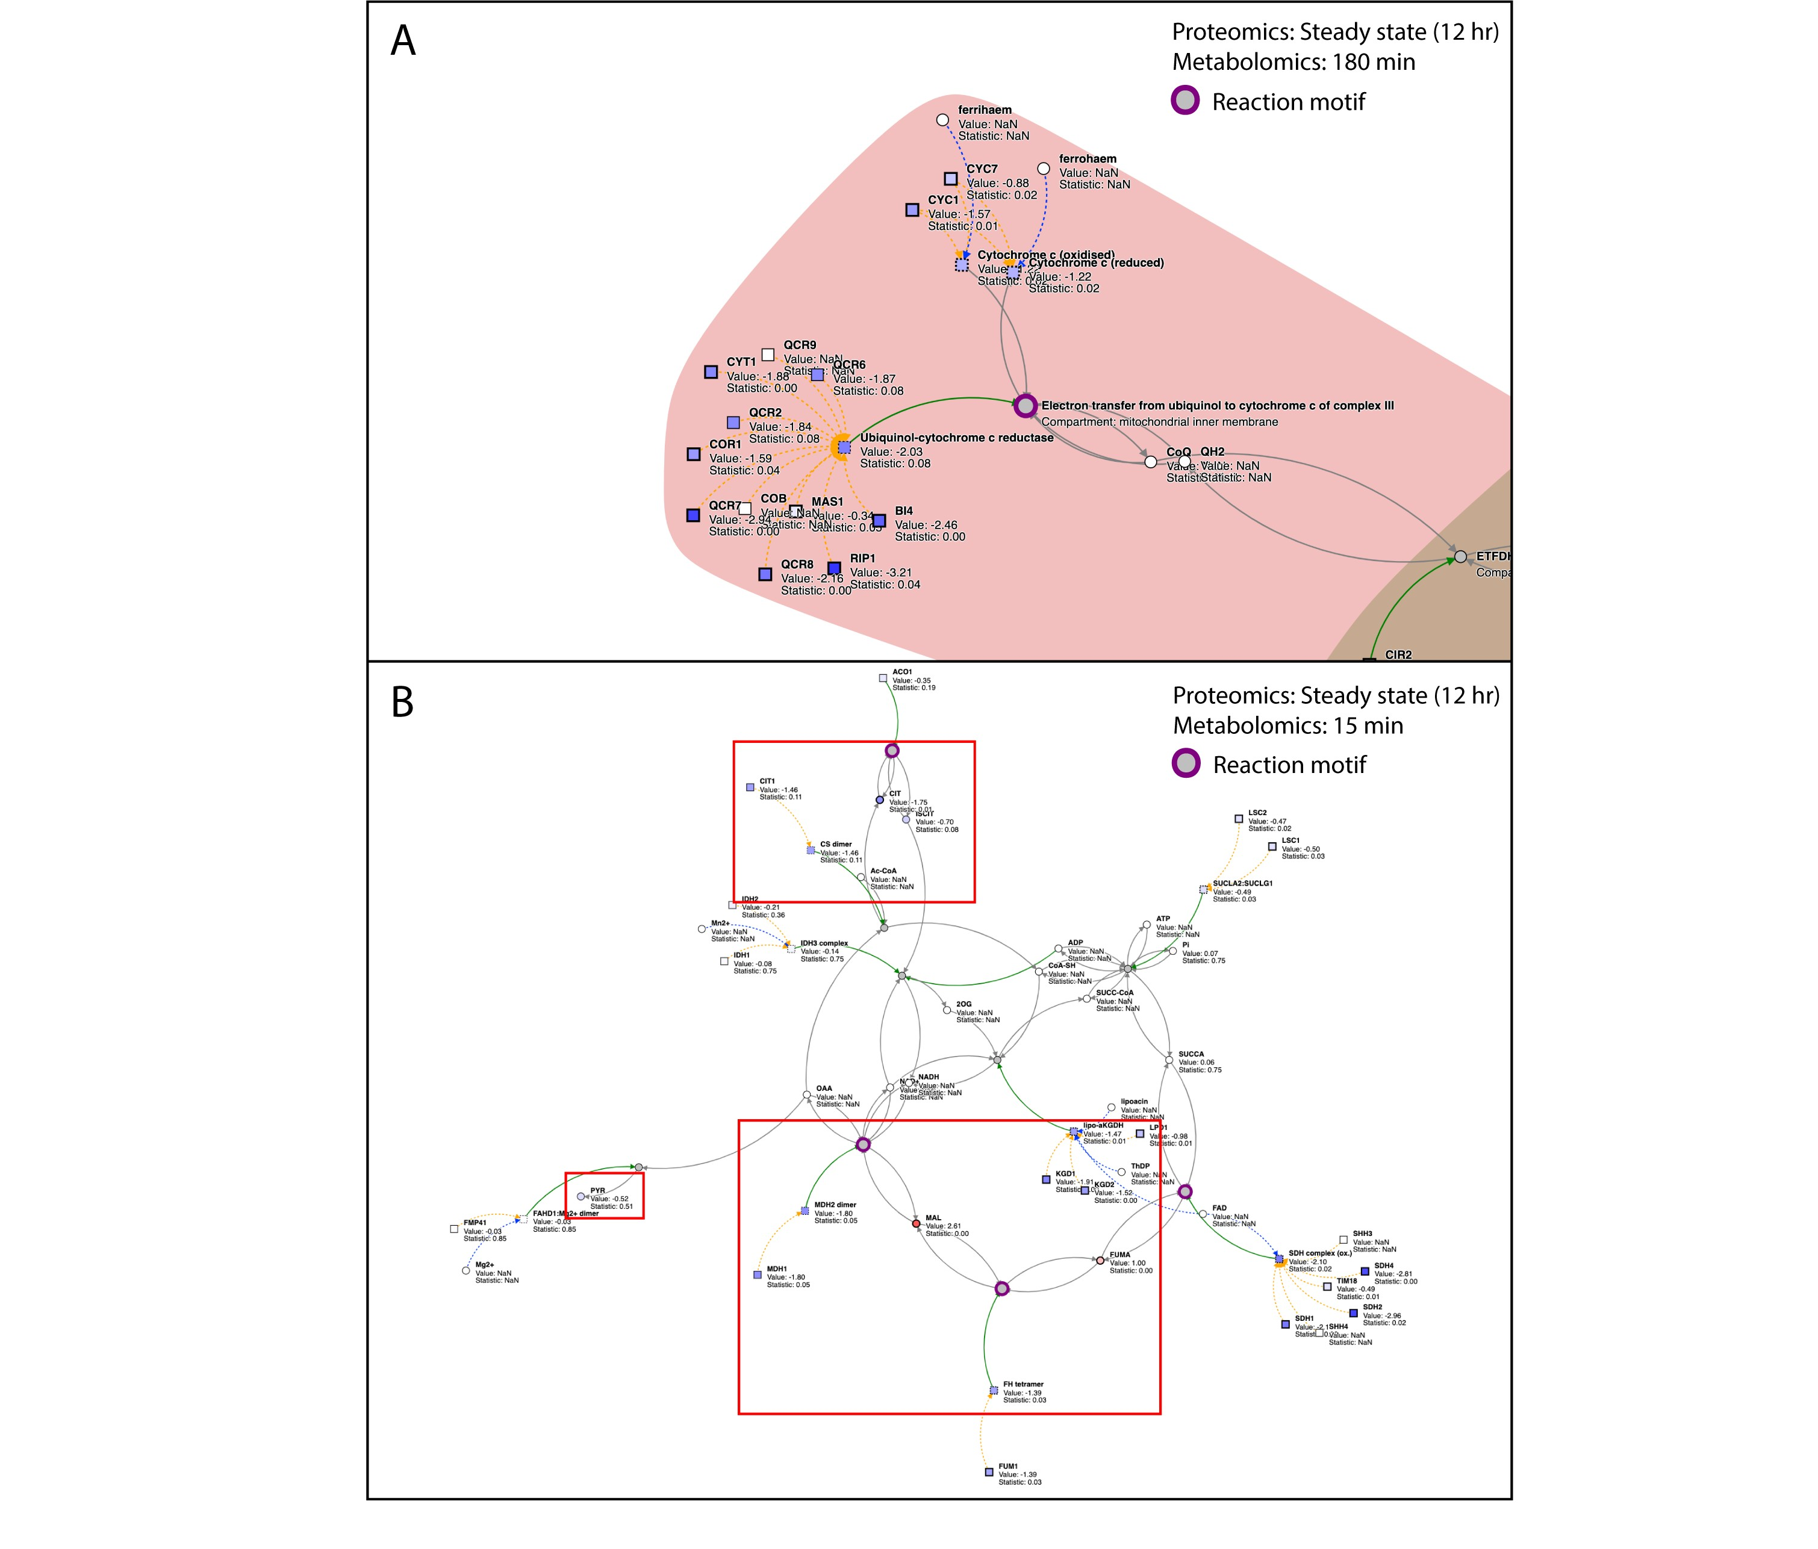

**Figure 4: Metaboverse identifies several reaction motifs of interest in *mct1*Δ cells.** (A) Steady-state proteomics overlaid on the reaction, “Electron transfer from ubiquinol to cytochrome c of complex III”. (B) Steady-state proteomics and metabolomics at 15 minutes overlaid TCA-related reactions. Appropriate time stamps are displayed in the upper- right hand corner of each subplot. Metabolomics and proteomics values are shown as node shading.

The second pattern of interest that was expected was the marked reduction of TCA-related enzymes. Motif analysis within the TCA cycle found several regulatory hotspots between metabolites and metabolite-protein interactions throughout the steps of the TCA cycle (Figure 4 B). However, visualizing these motifs and data across the timecourse reveals interesting patterns. For the following metabolite values, we will provide those for the 15 minute time point as the statistical strength for the discussed metabolites is strongest at this time. First, citrate levels decrease across the metabolomics timecourse (at 15 min; log2FC: -0.-1.75, adjusted-p: 0.01), which is paired by reduced steady-state levels of Ctp1 (log2FC: -0.64, adjusted-p: 0.03), a protein that catalyzes the transfer of citrate from the mitochondrial matrix to the cytosol [36]. Citrate is a key metabolite and the first step in the TCA cycle. We can hypothesize that due to central carbon metabolite reductions, Ctp1 may be down-regulated as a form of regulation to maintain citrate in the mitochondria where it is most physiologically important from a metabolism point of view.

Another point of interest is the up-regulation of Dic1 (log2FC: 2.15, adjusted-p: < 0.01), which catalyzes the exchange of malate (at 15 min; log2FC: 2.61, adjusted-p: < 0.01) between the mitochondrial matrix

and cytosol [37]. Interestingly, Dic1 is essential for growth in non-fermentable carbon source media. When yeast, especially those with deficits in TCA metabolism due to ablation of Mct1, are switched to a non-fermentable carbon, as was done in this experiment, they must adapt by up-regulating Dic1, as we see in this situation.

We also see that while the catalytic enzymes in the TCA cycle are all reduced in concentration, several related metabolites are up-regulated across multiple time points in the dataset. It possible, for example, that the increased fumarate levels (at 15 min; log2FC: 1.00, adjusted-p: < 0.01) are related to the reduction in active fumarate hydratase (FH tetramer; log2FC: -1.39, adjusted-p: 0.03) as has been demonstrated previously and shown to associate with hereditary leiomyomatosis and renal cell cancer in humans [38]. Therefore, this would be an interesting point of further study to understand the adaptations these cells make to disruptions to the TCA cycle and their consequences.

By analyzing this multi-omics dataset using reaction motif analysis and other interactive visualization, interesting questions arise. We see several reaction motifs that are expected based on prior knowledge of this biological model, as well as other interesting behaviors worthy of further follow-up. This demonstrates the potential Metaboverse has to act as a valuable hypothesis-generation tool, particularly with multi-omics and timecourse datasets, as well as a convenient platform for visualization and analysis of a user’s dataset in the context of the metabolic or other reaction networks.

### Metabolic signatures in human lung adenocarcinomas compared to normal lung tissue.

We next turned to published human lung adenocarcinoma steady-state metabolomics data [39] to assess the utility of Metaboverse when analyzing this data. Lung cancer remains a leading cause of death worldwide, and a more complete understanding of the metabolism of these tumors is essential in understanding how to better treat the condition.

Consistent with the original study [39], and in our recent re-study of the data [19], nucleotide metabolism was broadly up-regulated in adenocarcinoma samples in the motif analysis and perturbation connectivity analysis (Figure 5 A). We also notice similar perturbations in xanthine (Figure 5 B), glutamine, and others, which are highlighted to the user quickly in the motif and perturbation connectivity analyses. However, as we previously emphasized [ 19], by approaching these perturbations in a reaction-centric approach, we can identify regulatory behavior that further contextualizes the data. For example, we previously highlighted through a more manual approach the up-regulation of glyceric acid coupled with the proximal down-regulation of 3-Phosphoglyceric acid which could indicate the activity of glycerate kinase. This connection was missed in the original study, but was highlighted by the motif analysis available within Metaboverse. Activity of this sub-pathway is consequential as it has connections to serine metabolism which may be fostering an ideal environment for tumorigenesis (Figure 5 C). Interestingly, within the measured and significant metabolites involved in the TCA cycle, we see a moderate up-regulation of malate (log2 Fold Change: 0.39, adjusted-p: 0.02) and down-regulation of citrate (log2 Fold Change: -0.64, adjusted-p: 0.01). This is consistent with the hypothesis that the TCA cycle is being starved of carbon via pyruvate, which is probably being shunted to lactate production, thus the lower citrate levels, while part of the TCA cycle can be fed through glutamate (log2 Fold Change: 0.47, adjusted-p: < 0.01), thus the increased malate levels (Figure 5 D) [40].

Metaboverse simplifies the analysis process and allows users more flexibility via its interactive platform to identify canonical and interesting regulatory patterns within their data with ease. While we previously identified the regulatory pattern identified in Figure 5 C, Metaboverse offers an automated platform for the discovery of such events, which were missed in the original study. We hope that by

using Metaboverse, users will be able to extract new and exciting hypotheses that can drive their field forward.

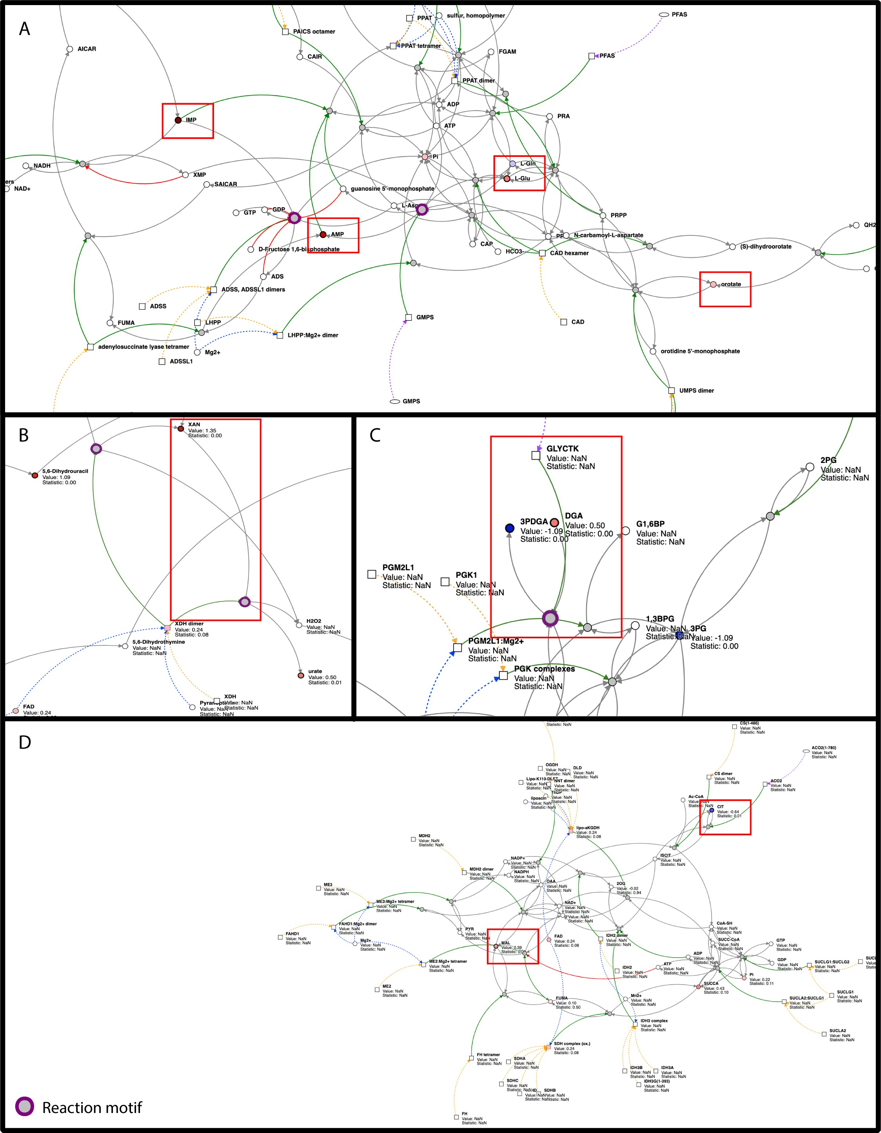

**Figure 5: Metaboverse identifies nucleotide metabolism signatures in lung adenomcarcinoma metabolomics data.** (A) Up-regulation of several nucleotide metabolites. (B) Identification of xanthine regulation by both motif and

perturbation connectivity analysis. (C) Regulatory activity between glyceric acid and 3-Phosphoglyceric acid identified by motif analysis. (D) Disruptions of TCA metabolism support canonical disruptions during adenocarcinoma development.

# Discussion

In this manuscript, we introduce a new software tool for analysis and exploration of user data layered on the metabolic and global reaction networks. To improve on previous tools with similar capabilities, we introduced several new analytical tools and methods to aid users in the automated identification and discovery of regulatory patterns within their data in a reaction network context. These include the automated ability to identify reaction regulatory events across the global reaction network, such as a reaction where an input has a low measured abundance and an output has a high measured abundance. Metaboverse also provides dynamic and interactive visualization capabilities to search for patterns and features within the user data manually within classical pathway representations. If a user is interested in how a reaction motif is propagating across the global reaction network and not just a single pathway, they can explore a reaction component’s nearest reaction neighborhood. The user can also explore the connectedness of perturbations across the global network and begin to explore hypotheses around the role of redundancy within a biological network.

In order to handle the challenge of sparsity, particularly regarding metabolomics data and the metabolic reaction network, we introduce a reaction collapsing feature which summarizes a series of connected reactions where values may be missing between the reactions, but where the terminal ends of the reaction path have measured values. Importantly, this augments the capabilities available within Metaboverse, especially in identifying additional reaction motifs that may be of interest to the user.

We demonstrated the utility of Metaboverse in exploring single- and multi-omic datasets. We analyzed previously published studies and generated a novel dataset that highlights the time-course, multi- omic capabilities of this framework. We demonstrated that Metaboverse was able to identify regulatory motifs that were expected in the models based on the current literature, as well as identify intriguing patterns that lead us to form new hypotheses. We expect these features to be a powerful tool in the researcher’s toolkit as they analyze their data and plan their next steps.

While Metaboverse aims to enhance the computational toolkit for data analysis and hypothesis generation in metabolic and other experiments, a number of challenges remain, which we intend to address in subsequent versions of this software. For example, while the reaction collapsing features of Metaboverse aid in identifying patterns across several reactions where data may be missing, there are various biological and technical edge cases that need to be considered in future implementations of this feature. This is particularly challenging in datasets where few metabolites were measured.

Hopefully, as technical limitations in metabolomics are also overcome, more complete snapshots of metabolism will be visible. Additionally, while we take a more straightforward and somewhat rudimentary approach to statistical significance integration in the reaction motif searches, more holistic platforms for cross-omics integration are needed and remain a significant challenge across multi-omics research.

In summary, we hope that Metaboverse will bring a new perspective to users’ data. We envision Metaboverse as a staple tool in the metabolic research toolkit that will help researchers critically and holistically consider their data in the context of biological network interactions and help draw the connections needed to aid them in extracting new and exciting hypotheses that might be challenging to do without this tool.

# Methods

A tutorial for how to use Metaboverse can be found at metaboverse.readthedocs.io/getting-started.

## Network Curation

Biological networks are curated using the current version of the Reactome database. In particular, the pathway records for each species, complex component and interaction data, Ensembl, and UniProt Reactome mapping tables are integrated into the network database for Metaboverse. Additionally, the ChEBI and The Human Metabolome databases are also referenced for metabolite synonym mapping

[15,16]. These data are used to generate a series of mapping dictionaries for entities to reactions and reactions to pathways for the curation of the global network.

After the relevant information is parsed from each table or record, the global network is propagated using the NetworkX networking framework [ 41] to generate nodes for each reaction and reaction component and edges connecting components to the appropriate reactions. In some cases, a separate ID is used to generate two nodes for the same metabolite within two separate compartments to aid in visualization downstream; however, user data for the given entity would be properly mapped to both nodes.

After the network is curated for the user-specified organism, each node’s degree (or magnitude of edges or connections) is determined to aid in the user’s downstream ability to avoid visualizing high- degree components, such as a proton or water, on the metabolic network, which can lead to graphical entanglement and cluttering and a decrease in computational performance [ 19].

## Data overlay and broadcasting for missing entities

In order to overlay user data on the global network, first, user-provided gene expression, protein abundance, and/or metabolite abundances’ names are mapped to Metaboverse compatible identifiers. For components that Metaboverse is unable to map, a list will be returned to the user so they can provide alternative names to aid in mapping. Second, provided data values are mapped to the appropriate nodes in the network. In cases where gene expression data is available, but protein abundance data is missing, Metaboverse will take the average of the available gene expression values to broadcast to the protein node. For complexes, all available component values (metabolites, proteins, etc.) are averaged. Nodes for which values were inferred will be marked by a dashed border during visualization to clearly show which values are known and which were inferred. Statistical values are derived from the highest value of the components (assuming a scale of 1 denotes no statistical significance and 0 denotes high statistical significance).

## Collapsing reactions with missing expression or abundance user data

After data mapping is complete, Metaboverse will generate a collapsed network representation for optional viewing during later visualization. We did, however, choose to enforce a limit of up to three reactions that can be collapsed as data down a pathway should only be inferred so far. We also enforced certain parameters for reaction collapse as follows:

1. If a reaction has at least one known or inferred value for inputs (reactants) and one known or inferred value for outputs (products), the reaction will be left as is. During the entire reaction collapse step, known catalysts are included when assessing whether a reaction has measured output values (more of a catalyst should lead to more output in most cases) and inhibitors are

included when assessing whether the reaction has measured input values (more inhibitor should lead to accumulation of input in most cases). Catalysts and inhibitors are not included when determining reaction neighbors, as described below.

1. If a reaction has at least one known input, the input is left as is, and each reaction that shares the same input with the assessed reaction inputs are determined whether they have a measured output. If the neighbor reaction does not contain a known output value, the reaction is left as is. If the neighboring reaction does contain a measured output, the original reaction’s inputs and the neighboring reaction’s outputs are collapsed to form a single, pseudo-reaction between the two. If the reaction has at least one known output, the inverse is performed where neighbors with identical components as the reaction’s inputs are assessed for whether a collapsed reaction can be created.
2. If a reaction has no measured values, it is determined if the neighboring reactions on both sides (one sharing the reaction’s inputs and other sharing the reaction’s outputs) have measured values. If both neighbors contain a measured value, a collapsed pseudo-reaction is created, summarizing all three reactions.

For pseudo-reactions, appropriate notes are included to describe the collapse. During visualization, these pseudo-reactions are marked by black dashed edges and dashed node borders. A graphical representation of how this reaction collapse is performed can be found in Figure 6.

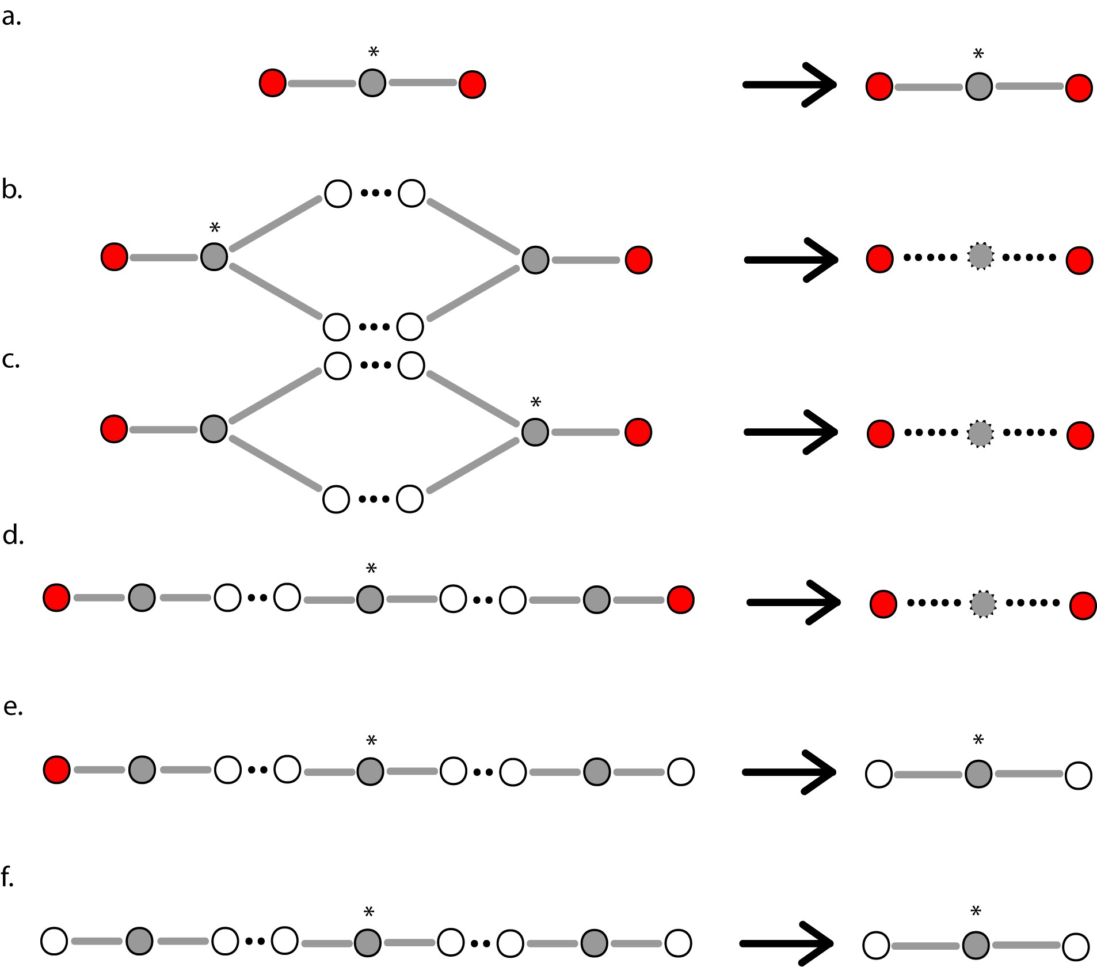

**Figure 6: Reaction node collapse schematic.** (a) For reactions where at least one input and at least one output component contain a measured value from the user data, the reaction will be maintained as is. (b) Where an input of a reaction is known, but no output has a known value, Metaboverse will search for all neighboring reactions that contain identical inputs. If the neighboring reaction has a known output value, the two reactions will be merged into one pseudo-reaction. (c) Where an output of a reaction is known, but no input has a known value, Metaboverse will search for all neighboring reactions that contain identical outputs. If the neighboring reaction has a known input value, the two reactions will be merged into one pseudo-reaction. (d) For reactions with no known values, neighbor pairs that match the inputs and outputs of the considered reaction will be evaluated for whether their respective outputs and inputs both have known values. If values are known for both neighbors, the three reactions will be merged into one pseudo- reaction. (e) As in (d), but if one neighbor does not contain a value and the other does contain a value, no reaction merging will be performed. (f) As in (d), but if neither neighbors contain known values, no reaction merging will be performed. An asterisk (*) indicates the target reaction being considered for a given reaction collapse. A red node indicates a reaction input or output with a measured value. A white node indicates a reaction input or output with no

measured value. A grey node indicates a reaction. A grey node with a dashed border indicates a pseudo-reaction. A solid edge indicates a known relationship. A dashed edge indicates a relationship inferred via reaction merging.

## Regulatory pattern (motif) searches and sorting

Metaboverse provides a variety of different regulatory patterns (motifs) for users to explore. To identify a motif is to compare some value that is computed from a reaction or a pathway with a user- specified threshold.

The identified motifs will be listed in a stamp view. Each stamp represents a motif, with a glyph of the reaction, or the name of the pathway on it. In this stamp view, the identified motifs can be sorted according to three different criteria: the number of pathways containing the motif (not applicable for pathway motifs), the magnitude change of the computed value, and the statistical significance. When sorting by the number of pathways or the magnitude change, the motifs are arranged in order from the largest to the smallest. When sorting by the statistical significance, motifs with statistical significance on both the input side (reactants) and the output side (products) are listed first by the product of their maximum statistics, followed by the motifs with statistical significance on one of the two sides, and finally the motifs with no statistical significance on both sides. Within each tier, the motifs are sorted from lowest to highest p-values. For all values or statistics used in sorting, only those that determined the motif are used.

When the stamp view demonstrates draws reaction motifs, all the pathways containing the corresponding motif will be listed below the stamp view by clicking on the appropriate stamp. For pathway motifs, clicking on a pathway ID will draw the selected pathway as a graph, with all the motifs in this pathway highlighted.

## Nearest neighborhood searches and prioritization

To visualize all global connections, a user can select an entity (a gene, protein, or metabolite) and visualize all reactions in which the component is involved. By doing so, the user can visualize other downstream effects a change of one entity might have across the global network, which consequently aids in bridging and identifying any motifs that may occur between canonically annotated pathways. These neighborhoods can be expanded to view multiple downstream reaction steps and their accompanying genes, proteins, and metabolites by modulating the appropriate user option in the app.

Users can also limit which entities are shown by enforcing a degree threshold. By setting this value at 50, for example, the graph would not show nodes that have 50 or more connections. One caveat, however, is that this will occasionally break synchronous pathways into multiple pieces if one of these high-degree nodes was the bridge between two sides of a pathway.

## Perturbation connectivity

Perturbation connectivity networks are generated by searching each reaction in the global network for any reaction where at least one component is significantly perturbed. Users can modify the necessary criteria to base the search on the expression or abundance value or the statistical value and can choose the thresholding value to be used. For the expression thresholding, the provided value is assumed to be the absolute value, so a thresholding value of 3 would include any reactions where at least one component, showed a greater than 3 measured change or less than -3 measured change, the value of which is dependent on the data provided by the user thus could represent log2 fold changes, z-scores, or any other unit appropriate the biological context.

Once a list of perturbed reactions is collected, the network is constructed included each of these reactions and their components. Perturbed neighboring reactions that share components are thus connected within the graph, and perturbed reactions that are not next to other perturbed reactions are shown as disconnected sub-graphs.

## Network visualization and exploration

### Dynamic network plotting

Users interact with Metaboverse through an interactive app interface. The app uses Electron, a cross- platform app framework that uses JavaScript, HTML, and CSS to design the interface. Metaboverse thus comes packaged as a single executable app with all necessary dependencies included for running on Linux, macOS, and Windows.

Interactive graphing is handled using the D3 and JQuery JavaScript libraries. Force-directed graphs are constructed by taking the user selection for a pathway or entity and determining the reactions that are components of that pathway. All inputs, outputs, modifiers, and other components of these reactions, along with edges where both source and target are found in the sub-graph as nodes, are included and plotted. Relevant metadata, such as user-provided data and reaction descriptions, can be accessed by the user in real-time. Metadata for categorical displays, such as edge or node type, are extracted from the metadata during graphing of the sub-network.

Some performance optimization features are included by default to prevent computational overload. For example, nearest neighbor sub-graphs with more than 1500 nodes, or nodes with more than 500 edges will not be plotted as the plotting of this information in real-time is computationally prohibitive.

### Visualizing pathways and super-pathways

To visualize a pathway, a user selects their pathway of choice, and all component reactions and their reactants, products, modifiers, and metadata are parsed from the global network. Super-pathways help categorize these pathways and are defined as any pathway containing more than 200 nodes.

### Visualizing compartments

Compartments are derived from Reactome annotations. Compartment visualizations are generated using D3’s hull plotting feature. Compartment boundaries are defined at the reaction levels and made to encompass each reaction’s reactants, products, and modifiers for that given compartment.

### Annotations

Annotations for each reaction are derived from the Reactome database. Pseudo-reactions annotations do not include this information; instead, they include notes on which reactions were collapsed to create the selected pseudo-reaction. All inferred pseudo-reactions and protein or complex values are displayed with dashed edges to differentiate them from measured values.

### 7.6 Additional features

While Metaboverse will continue to undergo development and new features will be added, we will briefly highlight some additional features available at the time of publication. We encourage users to check the documentation for more current updates and information regarding the use of Metaboverse [18].

**7.6a Toggle genes**

As gene components can crowd the graph space, users can toggle gene display on and off using the appropriate button. The graph is then refreshed to either include or ignore gene components based on their node meta-tag.

**7.6b Toggling values**

Users can switch between coloring nodes based on the value or statistic provided by toggling the appropriate button. Color bar information for the dataset is saved in the graph metadata during curation and used to generate a color bar.

**7.6c Toggling features/labels**

By default, reaction and feature labels are displayed by hovering the mouse over the node. Reaction or feature nodes can have the labels statically displayed by selecting the appropriate button. An event watch function is used to watch for this user selection and update the display of the node labels.

**7.6d Toggling collapsed reactions**

By selecting the appropriate button, users can toggle between displaying a full or collapsed pathway representation of the sub-network. By selecting this button, the graph is refreshed using the appropriate reaction dictionary, where for graphing of the collapsed representation, a reaction with available pseudo-reactions substituted for the original reactions are included for graph propagation.

**7.6e View curated pathway image**

While Metaboverse graphs networks dynamically, users may be more familiar or comfortable with classical, curated pathway layouts when exploring their data. For a given pathway graph, the user can select the appropriate button, and Metaboverse will open a new window with the Reactome curated pathway layout.

**7.6f Saving graphs**

Users can generate a PNG output file for any network created in Metaboverse by selecting the appropriate button.

**7.6g Nearest neighbor and hub thresholding**

The number of nearest neighbors to graph, or the limit to the number of edges a graphed node can have, can be modulated by the user using the appropriate input spaces. When graphing a nearest neighbors network, Metaboverse will recursively fetch related reactions and their neighbors until a node display threshold is reached. This allows the user to visualize downstream effects of a change that may propagate across several reactions. The hub threshold option prevents the plotting of nodes with more than the specified number of edges. This is handling during graphing by excluding any entity nodes that meet these criteria as the neighborhood is propagated. This is particularly useful in removing hub nodes, such as water or protons, which may be less relevant to the user experience and can quickly clutter the graph. This feature can also help plot more extensive neighborhoods, as often neighborhoods quickly link to high-degree nodes, such as water, and limit graphing ability.

**7.6h Metadata display**

To help inform the user of selection information and relevant metadata, a space in the legend bar during visualization is reserved for spaces where this information can be displayed, which is updated based on the user’s input as it is provided.

## Packaging

The Metaboverse app is packaged using Electron. Back-end network curation and data processing is performed using Python and the NetworkX library. Front-end visualization is performed using Javascript and relies on the D3 and JQuery packages. Saving network representations to a PNG file is performed using the d3-save-svg and string-pixel-width packages (Table 1). Documentation for Metaboverse is found at metaboverse.readthedocs.io. Continuous integration services are performed by Travis CI to routinely run test cases for each change made to the Metaboverse architecture. The Metaboverse source code can be accessed at https://github.com/Metaboverse/metaboverse. The code used to draft and revise this manuscript, as well as all associated scripts used to generate and visualize the data presented in this manuscript can be accessed at https://github.come/Metaboverse/ manuscript.

**Table 1:** Dependencies table.

|  |  |
| --- | --- |
| **Name** | **Reference** |
| HTML | N/A |
| CSS | N/A |
| Javascript | N/A |
| Electron | [42] |
| JQuery | [43] |
| D3 | [44] |
| string-pixel-width | [45] |
| d3-save-svg | [46] |
| Python | [47] |
| pandas | [48,49] |
| numpy | [50] |
| scipy | [51] |
| matplotlib | [52] |
| NetworkX | [41] |

## Validation using biological data

* 1. ***MCT1* perturbation in *Saccharomyces cerevisiae***

**Yeast Strains**

*Saccharomyces cerevisiae* BY4743 (MATa/Α, his3/his3, leu2/leu2, ura3/ura3, met15/MET15, lys2/LYS2) was used to generate the *mct1*Δ strain as described in [34].

**RNA-sequencing sample preparation**

RNA sequencing data were generated by growing *Saccharomyces cerevisiae* biological replicates for strains *mct1*Δ (n=4) and wild-type (n=4). Briefly, cells were grown in glucose and switched to raffinose- supplemented growth medium for 0, 3, and 12 hours such that at time of harvest, cultures were at

OD600=1. Cultures were flash frozen and later total RNA was isolated using the Direct-zol kit (Zymo Research) with on-column DNase digestion and water elution. Sequencing libraries were prepared by

purifying intact poly(A) RNA from total RNA samples (100-500 ng) with oligo(dT) magnetic beads and stranded mRNA sequencing libraries were prepared as described using the Illumina TruSeq Stranded mRNA Library Preparation Kit (RS-122-2101, RS-122-2102). Purified libraries were qualified on an Agilent Technologies 2200 TapeStation using a D1000 ScreenTape assay (cat# 5067-5582 and

5067-5583). The molarity of adapter-modified molecules was defined by quantitative PCR using the Kapa Biosystems Kapa Library Quant Kit (cat#KK4824). Individual libraries were normalized to 5 nM and equal volumes were pooled in preparation for Illumina sequence analysis. Sequencing libraries (25 pM) were chemically denatured and applied to an Illumina HiSeq v4 single read flow cell using an Illumina cBot. Hybridized molecules were clonally amplified and annealed to sequencing primers with reagents from an Illumina HiSeq SR Cluster Kit v4-cBot (GD-401-4001). Following transfer of the flowcell to an Illumina HiSeq 2500 instrument (HCSv2.2.38 and RTA v1.18.61), a 50 cycle single-read sequence run was performed using HiSeq SBS Kit v4 sequencing reagents (FC-401-4002).

**Sequence analysis**

Sequence FASTQ files were processed using XPRESSpipe [ 53]. Batch and log files are available at [ 54]. Notably, reads were trimmed of adapters (Read1: AGATCGGAAGAGCACACGTCTGAACTCCAGTCA, Read2: AGATCGGAAGAGCGTCGTGTAGGGAAAGAGTGT). Based on library complexity quality control, de-duplicated alignments were used for read quantification due to the high number of duplicated sequences in each library. Differential expression analysis was performed using DESeq2 [ 55] by

comparing *mct1*Δ samples with wild-type samples at the 12-hour time-point to match the steady-state

proteomics data. log2(fold change) and false discovery rate (“p-adj”) values were extracted from the DESeq2 output.

**Proteomics analysis**

steady-state quantitative proteomics data were generated as described in [ 34]. Briefly, cells were grown in glucose and switched to raffinose-supplemented growth medium overnight, and harvested at mid-log phase. For this analysis, we compared the *mct1*Δ (n=3) with the wild-type (n=3) cell

populations. log2(fold change) values and Benjamini-Hochberg corrected p-values were generated by comparing *mct1*Δ with the wild-type cells. P-values were generated before correction using a 2-tailed,

homoscedastic Student’s T-test.

**Metabolomics sample preparation**

Metabolomics data were generated by growing the appropriate yeast strains in synthetic minimal media (S-min) supplemented with 2% glucose until they reached OD600 between 0.6-0.8. Cells were then transferred to S-min media containing 2% raffinose and harvested after 0, 15, 30, 60, and 180 minutes (n=6/time-point/strain).

**Metabolite extraction**

A 75% boiling ethanol (EtOH) solution containing the internal standard d4-succinic acid (Sigma 293075) was then added to each sample. Boiling samples were vortexed and incubated at 90°C for 5

min. Samples were then incubated at -20 ˚C for 1 hr. After incubation, samples were centrifuged at 5,000 x g for 10 minutes at 4˚C. The supernatant was then transferred from each sample tube into a labeled, fresh 13x100mm glass culture tube. A second standard was then added (d27-myristic acid CDN Isotopes: D-1711). Pooled quality control samples were made by removing a fraction of collected supernatant from each sample and process blanks were made using only extraction solvent and no cell culture. The samples were then dried en vacuo. This process was completed in three separate batches.

**Mass Spectrometry Analysis of Samples**

All GC-MS analysis was performed with an Agilent 5977b GC-MS MSD-HES and an Agilent 7693A automatic liquid sampler. Dried samples were suspended in 40 µL of a 40 mg/mL O-methoxylamine hydrochloride (MOX) (MP Bio #155405) in dry pyridine (EMD Millipore #PX2012-7) and incubated for one hour at 37 °C in a sand bath. 25 µL of this solution was added to auto sampler vials. 60 µL of N- methyl-N-trimethylsilyltrifluoracetamide (MSTFA with 1%TMCS, Thermo #TS48913) was added automatically via the auto sampler and incubated for 30 minutes at 37 °C. After incubation, samples were vortexed and 1 µL of the prepared sample was injected into the gas chromatograph inlet in the split mode with the inlet temperature held at 250°C. A 10:1 split ratio was used for analysis of the majority of metabolites. For those metabolites that saturated the instrument at the 10:1 split concentration, a split of 50:1 was used for analysis. The gas chromatograph had an initial temperature of 60°C for one minute followed by a 10°C/min ramp to 325°C and a hold time of 5 minutes. A 30- meter Phenomenex Zebron AB-5HT with 5m inert Guardian capillary column was employed for chromatographic separation. Helium was used as the carrier gas at a rate of 1 mL/min. Figure 7 demonstrates an example of the two-step derivatization process used to convert non-volatile metabolites to a volatile form amenable to GC-MS.

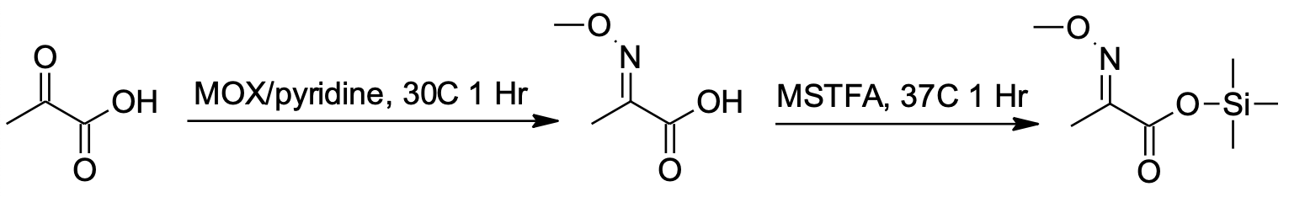

**Figure 7: Mass Spectrometry derivatization process.** This figure demonstrates an example of the two-step derivatization process used to convert non-volatile metabolites to a volatile form amenable to GC-MS. Pyruvic acid is used here as an example.

**Analysis of Mass Spectrometry Data**

Data was collected using MassHunter software (Agilent). Metabolites were identified and their peak area was recorded using MassHunter Quant. This data was transferred to an Excel spread sheet (Microsoft, Redmond WA). Metabolite identity was established using a combination of an in-house metabolite library developed using pure purchased standards, the NIST library and the Fiehn library. There are a few reasons a specific metabolite may not be observable through GC-MS. The metabolite may not be amenable to GC-MS due to its size, or a quaternary amine such as carnitine, or simply because it does not ionize well. Metabolites that do not ionize well include oxaloacetate, histidine and arginine. Cysteine can be observed depending on cellular conditions. It often forms disulfide bonds with proteins and is generally at a low concentration. Metabolites may not be quantifiable if they are only present in very low concentrations.

Resulting data from all samples were normalized to the internal standard d4-succinate. Samples highlighted in yellow were swapped with normalized data from the unsaturated run. The identity of each peak was ensured by visualization in Mass Hunter Qual and Quant. The data has also been

roughly reordered by metabolic process. False positives were removed. All but the best representative of duplicate metabolites, which were created through variability in the derivatization process, were also removed.

### Human lung adenocarcinoma metabolomics.

Data were accessed from Metabolomics Workbench [ 56] and processed as in our previous re-study of this data [19].

## Data availability.

Raw data produced for this study are in the process of being uploaded to the appropriate repositories. In the meantime, the raw data can be accessed at [ 54].

The curated networks for these data are available at [ 54]. Networks were generated by taking the 12- hour transcriptomics and proteomics datasets with their appropriate log2(fold change) and statistical values, along with the 0, 15, 30, 60, and 180 minute metabolomics datasets with their respective log2(fold change) and statistical values and layering these data on the *Saccharomyces cereviseae*

global reaction network as curated by Metaboverse from the Reactome database. Reaction motifs and global connectivity analyses were performed within the Metaboverse platform.

The Metaboverse source code is available at [ 57] and archived versions can be accessed at Zenodo [].

The source code and data for this manuscript and subsequent analyses is available at [ 58] and archived versions can be accessed at Zenodo [].

# Acknowledgements

We thank Alex J. Bott (U. of Utah), Ahmad A. Cluntun (U. of Utah), Kevin G. Hicks (U. of Utah), Jeffrey T. Morgan (U. of Utah), and other members of the Rutter lab for their thoughtful insights and suggestions. We thank Brian Dalley and the University of Utah High-Throughput Genomics Core for help with RNA-sequencing library preparation. The support and resources from the Center for High- Performance Computing at the University of Utah are gratefully acknowledged.

# Funding

J.A.B. received support from the National Institute of Diabetes and Digestive and Kidney Diseases (NIDDK) Inter-disciplinary Training Grant T32 Program in Computational Approaches to Diabetes and Metabolism Research, 1T32DK11096601 to Wendy W. Chapman and Simon J. Fisher (https:// [www.niddk.nih.gov/).](http://www.niddk.nih.gov/)) S.M.N. received support from The United Mitochondrial Disease Foundation PF-15-046 (https://www.umdf.org/) and American Cancer Society PF-18-106-01 (https://www.cancer.org/) postdoctoral fellowships, along with T32HL007576. J.E.C. is funded by S10OD016232, S10OD021505, and U54DK110858. This work was supported by NIDDK fellowship 1T32DK11096601 (to J.A.B.) (https:// [www.niddk.nih.gov/)](http://www.niddk.nih.gov/)) and NIH grant R35GM13185 (to J.R.) [(https://www.nih.gov/).](http://www.nih.gov/)) The computational resources used were partially funded by the NIH Shared Instrumentation Grant 1S10OD021644-01A1 [(https://www.nih.gov/).](http://www.nih.gov/)) Mass spectrometry equipment was obtained through NCRR Shared Instrumentation Grant 1S10OD016232-01, 1S10OD018210-01A1, and 1S10OD021505-01. The funders had no role in study design, data collection and analysis, decision to publish, or preparation of the manuscript.

# Contributions

* + - Conceptualization: J.A.B., T.C.W., B.W., J.R.
    - Supervision: J.A.B., B.W., J.R.
    - Project Administration: J.A.B.
    - Investigation: J.A.B., T.C.W., Y.O., S.M.N., T.V.
    - Formal Analysis: J.A.B.
    - Software: J.A.B., Y.Z.
    - Methodology: J.A.B., Y.Z.
    - Validation: J.A.B., Y.O., I.G.
    - Data Curation: J.A.B., T.C.W.
    - Resources: J.A.B., J.C., B.W., J.R.
    - Funding Acquisition: J.A.B., J.C., B.W., J.R.
    - Writing - Original Draft Preparation: J.A.B.
    - Writing - Review & Editing: J.A.B., Y.Z., T.C.W., Y.O., S.N.M., T.V., I.G., J.C., B.W., J.R.
    - Visualization: J.A.B.

# Supplementary Material

**References**

### Systems Biology and Multi-Omics Integration: Viewpoints from the Metabolomics Research Community

Farhana R. Pinu, David J. Beale, Amy M. Paten, Konstantinos Kouremenos, Sanjay Swarup, Horst J. Schirra, David Wishart

*Metabolites* (2019-04-18) <https://doi.org/ggt2fd>

DOI: [10.3390/metabo9040076](https://doi.org/10.3390/metabo9040076) · PMID: [31003499](https://www.ncbi.nlm.nih.gov/pubmed/31003499) · PMCID: [PMC6523452](https://www.ncbi.nlm.nih.gov/pmc/articles/PMC6523452)

### amueller/word_cloud

Andreas Mueller

(2020-05-28) <https://github.com/amueller/word_cloud>

### MetaboAnalyst: a web server for metabolomic data analysis and interpretation

J. Xia, N. Psychogios, N. Young, D. S. Wishart

*Nucleic Acids Research* (2009-05-08) <https://doi.org/c4hzc2>

DOI: [10.1093/nar/gkp356](https://doi.org/10.1093/nar/gkp356) · PMID: [19429898](https://www.ncbi.nlm.nih.gov/pubmed/19429898) · PMCID: [PMC2703878](https://www.ncbi.nlm.nih.gov/pmc/articles/PMC2703878)

1. **MetaboAnalyst 4.0: towards more transparent and integrative metabolomics analysis** Jasmine Chong, Othman Soufan, Carin Li, Iurie Caraus, Shuzhao Li, Guillaume Bourque, David S Wishart, Jianguo Xia

*Nucleic Acids Research* (2018-05-14) <https://doi.org/gdwvwd>

DOI: [10.1093/nar/gky310](https://doi.org/10.1093/nar/gky310) · PMID: [29762782](https://www.ncbi.nlm.nih.gov/pubmed/29762782) · PMCID: [PMC6030889](https://www.ncbi.nlm.nih.gov/pmc/articles/PMC6030889)

### Cytoscape: A Software Environment for Integrated Models of Biomolecular Interaction Networks

P. Shannon

*Genome Research* (2003-11-01) <https://doi.org/b7kgpg>

DOI: [10.1101/gr.1239303](https://doi.org/10.1101/gr.1239303) · PMID: [14597658](https://www.ncbi.nlm.nih.gov/pubmed/14597658) · PMCID: [PMC403769](https://www.ncbi.nlm.nih.gov/pmc/articles/PMC403769)

### MetExplore: collaborative edition and exploration of metabolic networks

Ludovic Cottret, Clément Frainay, Maxime Chazalviel, Floréal Cabanettes, Yoann Gloaguen, Etienne Camenen, Benjamin Merlet, Stéphanie Heux, Jean-Charles Portais, Nathalie Poupin, … Fabien Jourdan

*Nucleic Acids Research* (2018-04-30) <https://doi.org/gdwx39>

DOI: [10.1093/nar/gky301](https://doi.org/10.1093/nar/gky301) · PMID: [29718355](https://www.ncbi.nlm.nih.gov/pubmed/29718355) · PMCID: [PMC6030842](https://www.ncbi.nlm.nih.gov/pmc/articles/PMC6030842)

### MetExplore: a web server to link metabolomic experiments and genome-scale metabolic networks

L. Cottret, D. Wildridge, F. Vinson, M. P. Barrett, H. Charles, M.-F. Sagot, F. Jourdan

*Nucleic Acids Research* (2010-05-05) <https://doi.org/dkx7z7>

DOI: [10.1093/nar/gkq312](https://doi.org/10.1093/nar/gkq312) · PMID: [20444866](https://www.ncbi.nlm.nih.gov/pubmed/20444866) · PMCID: [PMC2896158](https://www.ncbi.nlm.nih.gov/pmc/articles/PMC2896158)

### Reactome: a knowledgebase of biological pathways

G. Joshi-Tope

*Nucleic Acids Research* (2004-12-17) <https://doi.org/cjhf62>

DOI: [10.1093/nar/gki072](https://doi.org/10.1093/nar/gki072) · PMID: [15608231](https://www.ncbi.nlm.nih.gov/pubmed/15608231) · PMCID: [PMC540026](https://www.ncbi.nlm.nih.gov/pmc/articles/PMC540026)

### The reactome pathway knowledgebase.

Bijay Jassal, Lisa Matthews, Guilherme Viteri, Chuqiao Gong, Pascual Lorente, Antonio Fabregat, Konstantinos Sidiropoulos, Justin Cook, Marc Gillespie, Robin Haw, … Peter D’Eustachio

*Nucleic acids research* (2020-01-08) <https://www.ncbi.nlm.nih.gov/pubmed/31691815> DOI: [10.1093/nar/gkz1031](https://doi.org/10.1093/nar/gkz1031) · PMID: [31691815](https://www.ncbi.nlm.nih.gov/pubmed/31691815) · PMCID: [PMC7145712](https://www.ncbi.nlm.nih.gov/pmc/articles/PMC7145712)

### The Reactome Pathway Knowledgebase.

Antonio Fabregat, Steven Jupe, Lisa Matthews, Konstantinos Sidiropoulos, Marc Gillespie, Phani Garapati, Robin Haw, Bijay Jassal, Florian Korninger, Bruce May, … Peter D’Eustachio

*Nucleic acids research* (2018-01-04) <https://www.ncbi.nlm.nih.gov/pubmed/29145629> DOI: [10.1093/nar/gkx1132](https://doi.org/10.1093/nar/gkx1132) · PMID: [29145629](https://www.ncbi.nlm.nih.gov/pubmed/29145629) · PMCID: [PMC5753187](https://www.ncbi.nlm.nih.gov/pmc/articles/PMC5753187)

### Superfamilies of Evolved and Designed Networks

R. Milo

*Science* (2004-03-05) <https://doi.org/dm5h6p> DOI: [10.1126/science.1089167](https://doi.org/10.1126/science.1089167) · PMID: [15001784](https://www.ncbi.nlm.nih.gov/pubmed/15001784)

### Network motifs in the transcriptional regulation network of Escherichia coli

Shai S. Shen-Orr, Ron Milo, Shmoolik Mangan, Uri Alon *Nature Genetics* (2002-04-22) <https://doi.org/dr6vnt> DOI: [10.1038/ng881](https://doi.org/10.1038/ng881) · PMID: [11967538](https://www.ncbi.nlm.nih.gov/pubmed/11967538)

### Activity motifs reveal principles of timing in transcriptional control of the yeast metabolic network

Gal Chechik, Eugene Oh, Oliver Rando, Jonathan Weissman, Aviv Regev, Daphne Koller

*Nature Biotechnology* (2008-10-26) <https://doi.org/ftng9m>

DOI: [10.1038/nbt.1499](https://doi.org/10.1038/nbt.1499) · PMID: [18953355](https://www.ncbi.nlm.nih.gov/pubmed/18953355) · PMCID: [PMC2651818](https://www.ncbi.nlm.nih.gov/pmc/articles/PMC2651818)

### The reactome pathway knowledgebase

Bijay Jassal, Lisa Matthews, Guilherme Viteri, Chuqiao Gong, Pascual Lorente, Antonio Fabregat, Konstantinos Sidiropoulos, Justin Cook, Marc Gillespie, Robin Haw, … Peter D’Eustachio

*Nucleic Acids Research* (2019-11-06) <https://doi.org/ggpx9m>

DOI: [10.1093/nar/gkz1031](https://doi.org/10.1093/nar/gkz1031) · PMID: [31691815](https://www.ncbi.nlm.nih.gov/pubmed/31691815) · PMCID: [PMC7145712](https://www.ncbi.nlm.nih.gov/pmc/articles/PMC7145712)

1. **ChEBI in 2016: Improved services and an expanding collection of metabolites** Janna Hastings, Gareth Owen, Adriano Dekker, Marcus Ennis, Namrata Kale, Venkatesh Muthukrishnan, Steve Turner, Neil Swainston, Pedro Mendes, Christoph Steinbeck *Nucleic Acids Research* (2015-10-13) <https://doi.org/f8cj93>

DOI: [10.1093/nar/gkv1031](https://doi.org/10.1093/nar/gkv1031) · PMID: [26467479](https://www.ncbi.nlm.nih.gov/pubmed/26467479) · PMCID: [PMC4702775](https://www.ncbi.nlm.nih.gov/pmc/articles/PMC4702775)

### HMDB 4.0: the human metabolome database for 2018

David S Wishart, Yannick Djoumbou Feunang, Ana Marcu, An Chi Guo, Kevin Liang, Rosa Vázquez- Fresno, Tanvir Sajed, Daniel Johnson, Carin Li, Naama Karu, … Augustin Scalbert

*Nucleic Acids Research* (2017-11-11) <https://doi.org/gcwk5k>

DOI: [10.1093/nar/gkx1089](https://doi.org/10.1093/nar/gkx1089) · PMID: [29140435](https://www.ncbi.nlm.nih.gov/pubmed/29140435) · PMCID: [PMC5753273](https://www.ncbi.nlm.nih.gov/pmc/articles/PMC5753273)

### Dietary methionine influences therapy in mouse cancer models and alters human metabolism

Xia Gao, Sydney M. Sanderson, Ziwei Dai, Michael A. Reid, Daniel E. Cooper, Min Lu, John P. Richie Jr, Amy Ciccarella, Ana Calcagnotto, Peter G. Mikhael, … Jason W. Locasale

*Nature* (2019-07-31) <https://doi.org/ggrj3d>

DOI: [10.1038/s41586-019-1437-3](https://doi.org/10.1038/s41586-019-1437-3) · PMID: [31367041](https://www.ncbi.nlm.nih.gov/pubmed/31367041) · PMCID: [PMC6951023](https://www.ncbi.nlm.nih.gov/pmc/articles/PMC6951023)

1. **Metaboverse — Metaboverse 0.0.0-alpha documentation** [https://metaboverse.readthedocs.io/ en/latest/](https://metaboverse.readthedocs.io/en/latest/)

### Compartment and hub definitions tune metabolic networks for metabolomic interpretations

T Cameron Waller, Jordan A Berg, Alexander Lex, Brian E Chapman, Jared Rutter

*GigaScience* (2020-01-01) <https://doi.org/ggt7sk>

DOI: [10.1093/gigascience/giz137](https://doi.org/10.1093/gigascience/giz137) · PMID: [31972021](https://www.ncbi.nlm.nih.gov/pubmed/31972021) · PMCID: [PMC6977586](https://www.ncbi.nlm.nih.gov/pmc/articles/PMC6977586)

### On Nearest-Neighbor Graphs

D. Eppstein, M. S. Paterson, F. F. Yao

*Discrete & Computational Geometry* (1997-04) <https://doi.org/brwn8g> DOI: [10.1007/pl00009293](https://doi.org/10.1007/pl00009293)

### Network biology concepts in complex disease comorbidities

Jessica Xin Hu, Cecilia Engel Thomas, Søren Brunak

*Nature Reviews Genetics* (2016-08-08) <https://doi.org/f84t9c> DOI: [10.1038/nrg.2016.87](https://doi.org/10.1038/nrg.2016.87) · PMID: [27498692](https://www.ncbi.nlm.nih.gov/pubmed/27498692)

### Using graph theory to analyze biological networks

Georgios A Pavlopoulos, Maria Secrier, Charalampos N Moschopoulos, Theodoros G Soldatos, Sophia Kossida, Jan Aerts, Reinhard Schneider, Pantelis G Bagos

*BioData Mining* (2011-04-28) <https://doi.org/bggzw9>

DOI: [10.1186/1756-0381-4-10](https://doi.org/10.1186/1756-0381-4-10) · PMID: [21527005](https://www.ncbi.nlm.nih.gov/pubmed/21527005) · PMCID: [PMC3101653](https://www.ncbi.nlm.nih.gov/pmc/articles/PMC3101653)

### Functional and transcriptional connectivity of communities in breast cancer co-expression networks

Guillermo de Anda-Jáuregui, Sergio Antonio Alcalá-Corona, Jesús Espinal-Enríquez, Enrique Hernández-Lemus

*Applied Network Science* (2019-05-20) <https://doi.org/ggt7sj> DOI: [10.1007/s41109-019-0129-0](https://doi.org/10.1007/s41109-019-0129-0)

### Loss of Connectivity in Cancer Co-Expression Networks

Roberto Anglani, Teresa M. Creanza, Vania C. Liuzzi, Ada Piepoli, Anna Panza, Angelo Andriulli, Nicola Ancona

*PLoS ONE* (2014-01-28) <https://doi.org/f5vhd4>

DOI: [10.1371/journal.pone.0087075](https://doi.org/10.1371/journal.pone.0087075) · PMID: [24489837](https://www.ncbi.nlm.nih.gov/pubmed/24489837) · PMCID: [PMC3904972](https://www.ncbi.nlm.nih.gov/pmc/articles/PMC3904972)

### A Mitochondrial Pyruvate Carrier Required for Pyruvate Uptake in Yeast, Drosophila, and Humans

Daniel K. Bricker, Eric B. Taylor, John C. Schell, Thomas Orsak, Audrey Boutron, Yu-Chan Chen, James E. Cox, Caleb M. Cardon, Jonathan G. Van Vranken, Noah Dephoure, … Jared Rutter *Science* (2012-05-24) <https://doi.org/f33x88>

DOI: [10.1126/science.1218099](https://doi.org/10.1126/science.1218099) · PMID: [22628558](https://www.ncbi.nlm.nih.gov/pubmed/22628558) · PMCID: [PMC3690818](https://www.ncbi.nlm.nih.gov/pmc/articles/PMC3690818)

### Control of intestinal stem cell function and proliferation by mitochondrial pyruvate metabolism

John C. Schell, Dona R. Wisidagama, Claire Bensard, Helong Zhao, Peng Wei, Jason Tanner, Aimee Flores, Jeffrey Mohlman, Lise K. Sorensen, Christian S. Earl, … Jared Rutter

*Nature Cell Biology* (2017-08-14) <https://doi.org/gbrf73>

DOI: [10.1038/ncb3593](https://doi.org/10.1038/ncb3593) · PMID: [28812582](https://www.ncbi.nlm.nih.gov/pubmed/28812582) · PMCID: [PMC6137334](https://www.ncbi.nlm.nih.gov/pmc/articles/PMC6137334)

### Regulation of Tumor Initiation by the Mitochondrial Pyruvate Carrier

Claire L. Bensard, Dona R. Wisidagama, Kristofor A. Olson, Jordan A. Berg, Nathan M. Krah, John C. Schell, Sara M. Nowinski, Sarah Fogarty, Alex J. Bott, Peng Wei, … Jared Rutter

*Cell Metabolism* (2020-02) <https://doi.org/ggt7w8>

DOI: [10.1016/j.cmet.2019.11.002](https://doi.org/10.1016/j.cmet.2019.11.002) · PMID: [31813825](https://www.ncbi.nlm.nih.gov/pubmed/31813825) · PMCID: [PMC7004878](https://www.ncbi.nlm.nih.gov/pmc/articles/PMC7004878)

### Redundancy: A Critical Obstacle to Improving Cancer Therapy

O. Lavi

*Cancer Research* (2015-01-09) <https://doi.org/ggt7xd>

DOI: [10.1158/0008-5472.can-14-3256](https://doi.org/10.1158/0008-5472.can-14-3256) · PMID: [25576083](https://www.ncbi.nlm.nih.gov/pubmed/25576083) · PMCID: [PMC6250436](https://www.ncbi.nlm.nih.gov/pmc/articles/PMC6250436)

### The Connectivity Map: Using Gene-Expression Signatures to Connect Small Molecules, Genes, and Disease

J. Lamb

*Science* (2006-09-29) <https://doi.org/c92ptt>

DOI: [10.1126/science.1132939](https://doi.org/10.1126/science.1132939) · PMID: [17008526](https://www.ncbi.nlm.nih.gov/pubmed/17008526)

### Pathway crosstalk perturbation network modeling for identification of connectivity changes induced by diabetic neuropathy and pioglitazone

Guillermo de Anda-Jáuregui, Kai Guo, Brett A. McGregor, Eva L. Feldman, Junguk Hur

*BMC Systems Biology* (2019-01-07) <https://doi.org/ggt7zx>

DOI: [10.1186/s12918-018-0674-7](https://doi.org/10.1186/s12918-018-0674-7) · PMID: [30616626](https://www.ncbi.nlm.nih.gov/pubmed/30616626) · PMCID: [PMC6322225](https://www.ncbi.nlm.nih.gov/pmc/articles/PMC6322225)

### Impact of Mitochondrial Fatty Acid Synthesis on Mitochondrial Biogenesis

Sara M. Nowinski, Jonathan G. Van Vranken, Katja K. Dove, Jared Rutter

*Current Biology* (2018-10) <https://doi.org/gffn55>

DOI: [10.1016/j.cub.2018.08.022](https://doi.org/10.1016/j.cub.2018.08.022) · PMID: [30352195](https://www.ncbi.nlm.nih.gov/pubmed/30352195) · PMCID: [PMC6258005](https://www.ncbi.nlm.nih.gov/pmc/articles/PMC6258005)

### The mitochondrial acyl carrier protein (ACP) coordinates mitochondrial fatty acid synthesis with iron sulfur cluster biogenesis

Jonathan G Van Vranken, Mi-Young Jeong, Peng Wei, Yu-Chan Chen, Steven P Gygi, Dennis R Winge,

Jared Rutter

*eLife* (2016-08-19) <https://doi.org/ggvrxg>

DOI: [10.7554/elife.17828](https://doi.org/10.7554/elife.17828) · PMID: [27540631](https://www.ncbi.nlm.nih.gov/pubmed/27540631) · PMCID: [PMC4991935](https://www.ncbi.nlm.nih.gov/pmc/articles/PMC4991935)

### MECR Mutations Cause Childhood-Onset Dystonia and Optic Atrophy, a Mitochondrial Fatty Acid Synthesis Disorder

Gali Heimer, Juha M. Kerätär, Lisa G. Riley, Shanti Balasubramaniam, Eran Eyal, Laura P. Pietikäinen, J. Kalervo Hiltunen, Dina Marek-Yagel, Jeffrey Hamada, Allison Gregory, … Qian Yi *The American Journal of Human Genetics* (2016-12) <https://doi.org/f9gbs7>

DOI: [10.1016/j.ajhg.2016.09.021](https://doi.org/10.1016/j.ajhg.2016.09.021) · PMID: [27817865](https://www.ncbi.nlm.nih.gov/pubmed/27817865) · PMCID: [PMC5142118](https://www.ncbi.nlm.nih.gov/pmc/articles/PMC5142118)

### ACP Acylation Is an Acetyl-CoA-Dependent Modification Required for Electron Transport Chain Assembly

Jonathan G. Van Vranken, Sara M. Nowinski, Katie J. Clowers, Mi-Young Jeong, Yeyun Ouyang, Jordan A. Berg, Jeremy P. Gygi, Steven P. Gygi, Dennis R. Winge, Jared Rutter

*Molecular Cell* (2018-08) <https://doi.org/gd5dhm>

DOI: [10.1016/j.molcel.2018.06.039](https://doi.org/10.1016/j.molcel.2018.06.039) · PMID: [30118679](https://www.ncbi.nlm.nih.gov/pubmed/30118679) · PMCID: [PMC6104058](https://www.ncbi.nlm.nih.gov/pmc/articles/PMC6104058)

### Defects in mitochondrial fatty acid synthesis result in failure of multiple aspects of mitochondrial biogenesis in Saccharomyces cerevisiae

* 1. A. Samuli Kursu, Laura P. Pietikäinen, Flavia Fontanesi, Mari J. Aaltonen, Fumi Suomi, Remya Raghavan Nair, Melissa S. Schonauer, Carol L. Dieckmann, Antoni Barrientos, J. Kalervo Hiltunen, Alexander J. Kastaniotis

*Molecular Microbiology* (2013-10-10) <https://doi.org/ggxg4h>

DOI: [10.1111/mmi.12402](https://doi.org/10.1111/mmi.12402) · PMID: [24102902](https://www.ncbi.nlm.nih.gov/pubmed/24102902) · PMCID: [PMC4153884](https://www.ncbi.nlm.nih.gov/pmc/articles/PMC4153884)

### High Level Expression and Characterization of the Mitochondrial Citrate Transport Protein from the YeastSaccharomyces cerevisiae

Ronald S. Kaplan, June A. Mayor, David A. Gremse, David O. Wood *Journal of Biological Chemistry* (1995-02-24) <https://doi.org/c9h8k3> DOI: [10.1074/jbc.270.8.4108](https://doi.org/10.1074/jbc.270.8.4108) · PMID: [7876161](https://www.ncbi.nlm.nih.gov/pubmed/7876161)

### The mitochondrial dicarboxylate carrier is essential for the growth of Saccharomyces cerevisiae on ethanol or acetate as the sole carbon source

Luigi Palmieri, Angelo Vozza, Angelika Honlinger, Klaus Dietmeier, Annamaria Palmisano, Vincenzo Zara, Ferdinando Palmieri

*Molecular Microbiology* (1999-01) <https://doi.org/d6fj3j> DOI: [10.1046/j.1365-2958.1999.01197.x](https://doi.org/10.1046/j.1365-2958.1999.01197.x) · PMID: [10027973](https://www.ncbi.nlm.nih.gov/pubmed/10027973)

### Fumarate is an epigenetic modifier that elicits epithelial-to-mesenchymal transition

Marco Sciacovelli, Emanuel Gonçalves, Timothy Isaac Johnson, Vincent Roberto Zecchini, Ana Sofia Henriques da Costa, Edoardo Gaude, Alizee Vercauteren Drubbel, Sebastian Julian Theobald, Sandra Riekje Abbo, Maxine Gia Binh Tran, … Christian Frezza

*Nature* (2016-08-31) <https://doi.org/f84vs5>

DOI: [10.1038/nature19353](https://doi.org/10.1038/nature19353) · PMID: [27580029](https://www.ncbi.nlm.nih.gov/pubmed/27580029) · PMCID: [PMC5136292](https://www.ncbi.nlm.nih.gov/pmc/articles/PMC5136292)

### Metabolomic Markers of Altered Nucleotide Metabolism in Early Stage Adenocarcinoma

* 1. R. Wikoff, D. Grapov, J. F. Fahrmann, B. DeFelice, W. N. Rom, H. I. Pass, K. Kim, U. Nguyen, S. L. Taylor, D. R. Gandara, … S. Miyamoto

*Cancer Prevention Research* (2015-02-05) <https://doi.org/f69tn7>

DOI: [10.1158/1940-6207.capr-14-0329](https://doi.org/10.1158/1940-6207.capr-14-0329) · PMID: [25657018](https://www.ncbi.nlm.nih.gov/pubmed/25657018) · PMCID: [PMC4618700](https://www.ncbi.nlm.nih.gov/pmc/articles/PMC4618700)

### From Krebs to clinic: glutamine metabolism to cancer therapy

Brian J. Altman, Zachary E. Stine, Chi V. Dang

*Nature Reviews Cancer* (2016-07-29) <https://doi.org/gc95vq>

DOI: [10.1038/nrc.2016.71](https://doi.org/10.1038/nrc.2016.71) · PMID: [27492215](https://www.ncbi.nlm.nih.gov/pubmed/27492215) · PMCID: [PMC5484415](https://www.ncbi.nlm.nih.gov/pmc/articles/PMC5484415)

1. (2014-01-28) <http://conference.scipy.org/proceedings/SciPy2008/paper_2/full_text.pdf>
2. **Electron | Build cross-platform desktop apps with JavaScript, HTML, and CSS.** [https:// www.electronjs.org/](https://www.electronjs.org/)

### jQuery

JS Foundation- js.foundation <https://jquery.com/>

### D3.js - Data-Driven Documents

Mike Bostock <https://d3js.org/>

### adambisek/string-pixel-width

Adam Bisek

(2020-05-13) <https://github.com/adambisek/string-pixel-width>

### edeno/d3-save-svg

GitHub

<https://github.com/edeno/d3-save-svg>

1. **Welcome to Python.org** Python.org <https://www.python.org/>

### pandas-dev/pandas: Pandas 1.0.3

Jeff Reback, Wes McKinney, Jbrockmendel, Joris Van Den Bossche, Tom Augspurger, Phillip Cloud, Gfyoung, Sinhrks, Adam Klein, Matthew Roeschke, … Mortada Mehyar

*Zenodo* (2020-03-18) <https://doi.org/ggt8bh> DOI: [10.5281/zenodo.3509134](https://doi.org/10.5281/zenodo.3509134)

### Data Structures for Statistical Computing in Python

Wes McKinney

*Proceedings of the 9th Python in Science Conference* (2010) <https://doi.org/ggr6q3> DOI: [10.25080/majora-92bf1922-00a](https://doi.org/10.25080/majora-92bf1922-00a)

1. (2007-01-16) <https://web.mit.edu/dvp/Public/numpybook.pdf>

### SciPy 1.0: fundamental algorithms for scientific computing in Python

Pauli VirtanenRalf Gommers, Travis E. Oliphant, Matt Haberland, Tyler Reddy, David Cournapeau, Evgeni Burovski, Pearu Peterson, Warren Weckesser, … Paul van Mulbregt

*Nature Methods* (2020-02-03) <https://doi.org/ggj45f>

DOI: [10.1038/s41592-019-0686-2](https://doi.org/10.1038/s41592-019-0686-2) · PMID: [32015543](https://www.ncbi.nlm.nih.gov/pubmed/32015543) · PMCID: [PMC7056644](https://www.ncbi.nlm.nih.gov/pmc/articles/PMC7056644)

### Matplotlib: A 2D Graphics Environment

John D. Hunter

*Computing in Science & Engineering* (2007) <https://doi.org/drbjhg> DOI: [10.1109/mcse.2007.55](https://doi.org/10.1109/mcse.2007.55)

### XPRESSyourself: Enhancing, standardizing, and automating ribosome profiling computational analyses yields improved insight into data

Jordan A. Berg, Jonathan R. Belyeu, Jeffrey T. Morgan, Yeyun Ouyang, Alex J. Bott, Aaron R. Quinlan, Jason Gertz, Jared Rutter

*PLOS Computational Biology* (2020-01-31) <https://doi.org/ggvg4j>

DOI: [10.1371/journal.pcbi.1007625](https://doi.org/10.1371/journal.pcbi.1007625) · PMID: [32004313](https://www.ncbi.nlm.nih.gov/pubmed/32004313) · PMCID: [PMC7015430](https://www.ncbi.nlm.nih.gov/pmc/articles/PMC7015430)

### Metaboverse/manuscript

GitHub <https://github.com/Metaboverse/manuscript>

### Moderated estimation of fold change and dispersion for RNA-seq data with DESeq2

Michael I Love, Wolfgang Huber, Simon Anders

*Genome Biology* (2014-12) <https://doi.org/gd3zvn>

DOI: [10.1186/s13059-014-0550-8](https://doi.org/10.1186/s13059-014-0550-8) · PMID: [25516281](https://www.ncbi.nlm.nih.gov/pubmed/25516281) · PMCID: [PMC4302049](https://www.ncbi.nlm.nih.gov/pmc/articles/PMC4302049)

56. **PR000305**

Metabolomics Workbench

*Metabolomics Workbench* (2016) <https://doi.org/ggxfdh> DOI: [10.21228/m8pg66](https://doi.org/10.21228/m8pg66)

### Metaboverse/Metaboverse

Metaboverse

(2020-05-28) <https://github.com/Metaboverse/Metaboverse>

### Metaboverse/manuscript

Metaboverse

(2020-05-28) <https://github.com/Metaboverse/manuscript>