What is a GCM? [retired]

IPCC Data Distribution Centre: Retired Pages

When pages on the DDC become obsolete or misleading, the content is moved into archived documents in order to preserve a record of past content while maintaining current information on the DDC pages.

The “What is a GCM?” page describes, in general terms, the principal features of a coupled atmosphere-ocean General Circulation Model as might have been used in the third or fourth IPCC Assessment Report.

The IPCC Glossary for the Fifth Assessment Report provides an updated definition: [http://www.ipcc-data.org/guidelines/pages/glossary/glossary_c.html#climateModel](http://www.ipcc-data.org/guidelines/pages/glossary/glossary_c.html" \l "climateModel)

The terminology decided on for the sixth assessment report is not yet finalised.

The data of initial publication of this page is not known, but the figure used as an illustration is dated 2002.

Date of publication of this document: XX Jan, 2020

Citing this document: What is a GCM? [Retired], 2020: *IPCC Data Distribution Centre: Retired Pages. DOI: [To be completed]*

ACTIONS NEEDED BEFORE RETIRING THIS:

(1) Retire the Scenario Selection page, so that the link to that content can be updated;

(2)Discuss whether alternative information is needed on the DDC.

(3) Reserve DOI;

(4) Add DOI in recommended citation and publication date, remove “Steps needed ….”; convert to PDF and upload to DOI.

(5) Check usage and definitions in AR6, and design replacement page;

What is a GCM?

Numerical models (General Circulation Models or GCMs), representing physical processes in the atmosphere, ocean, cryosphere and land surface, are the most advanced tools currently available for simulating the response of the global climate system to increasing greenhouse gas concentrations (criterion 1 -- see [1]). While simpler models have also been used to provide globally- or regionally-averaged estimates of the climate response, only GCMs, possibly in conjunction with nested regional models, have the potential to provide geographically and physically consistent estimates of regional climate change which are required in impact analysis, thus fulfilling criterion 2.

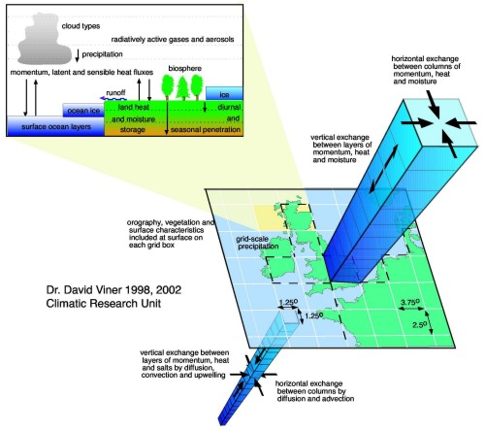

GCMs depict the climate using a three dimensional grid over the globe (see below), typically having a horizontal resolution of between 250 and 600 km, 10 to 20 vertical layers in the atmosphere and sometimes as many as 30 layers in the oceans. Their resolution is thus quite coarse relative to the scale of exposure units in most impact assessments, hence only partially fulfilling criterion 3. Moreover, many physical processes, such as those related to clouds, also occur at smaller scales and cannot be properly modelled. Instead, their known properties must be averaged over the larger scale in a technique known as parameterization. This is one source of uncertainty in GCM-based simulations of future climate. Others relate to the simulation of various feedback mechanisms in models concerning, for example, water vapour and warming, clouds and radiation, ocean circulation and ice and snow albedo. For this reason, GCMs may simulate quite different responses to the same forcing, simply because of the way certain processes and feedbacks are modelled.

However, while these differences in response are usually consistent with the climate sensitivity range described in criterion 1, they are unlikely to satisfy criterion 4 concerning the uncertainty range of regional projections. Even the selection of all the available GCM experiments would not guarantee a representative range, due to other uncertainties that GCMs do not fully address, especially the range in estimates of future atmospheric composition.

# References

[1] Criteria for Selecting Climate Scenarios, IPCC DDC Information Page (<http://www.ipcc-data.org/guidelines/pages/scen_selection.html>; retiring to: XXXXX)