Assignment 4.1 Barycentric Coordinates

1. n dimensional simplex has n number of Barycentric coordinates

2. Split the square diagonally along p1 and p3

P2(0,1,0)

P3(1,0,0)

P1(1,0,0)

P0(0,0,1)

P3(1,0,0)

**(2, 0, 1)**

(3/4, 0, 1/4)

(1, 0, 0)

(1/2, 0, 1/2)

(1/2, 0, 1/2)

(3/4, 0, 1/4)

P1(1,0,0)

(1/2, 0, 1/2)

P0(0,0,1)

Similarly, barycenter is calculated for upper triangle.

P2(0,1,0)

P3(1,0,0)

P1(1,0,0)

**(2, 1, 0)**

3. Anti diagonal

P1(1,0,0)

P2(0,1,0)

P3(1,0,0)

P0(0,0,1)

In this case, barycenter is (1, 1, 1) for each lower and upper triangle.

From the above barycenter values, color of the respective triangle can be found out by mapping the values to (Red, Green, Blue) channels.

4.

5. Barycentric coordinates in a tetrahedron:

[Answer taken from](http://www.cdsimpson.net/2014/10/barycentric-coordinates.html)

If the barycentric coordinates of a triangle are based on the area of sub-triangles, the barycentric coordinates of a tetrahedron are based on the volume of sub-tetrahedra, and the coordinates will have four components.

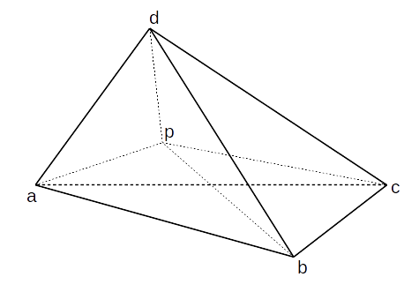

The volume of a tetrahedron can be calculated with a scalar triple product. Let V be the total volume of the tetrahedron, Va be the volume of the sub-tetrahedron opposite vertex a, and similarly for the others.

V’ap to represent a vector from point a to point b. Then,

Va  = 1/6 ( V’bp.(V’bd X V’bc))

Vb  = 1/6 ( V’ap.(V’ac X V’ad))

Vc  = 1/6 ( V’ap.(V’ad X V’ab))

Vd  = 1/6 ( V’ap.(V’ab X V’ac))

V = 1/6 ( V’ab.(V’ac X V’ad))

The barycentric coordinates can then be calculated as,

bc1  = Va / |V|

bc2  = Vb / |V|

bc3  = Vc / |V|

bc4  = Vd / |V|