Polity : Const + Laxmi

Fundamental Rights
- Idea from “US Bill of Rights”, “Magna Carta”, promotes “Political democracy”
- All of them available for arbitrary action of state, some also against private individuals.

Art 12
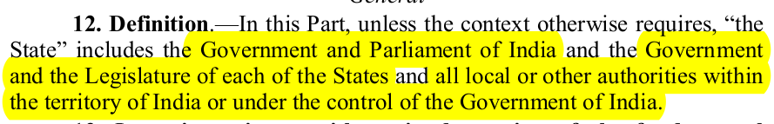- Gov + parliam = Exec + Legis of union
- Gov + SL = Exec + Legis States
- Local : Municipal , panchayat , trusts, dist boards etc
- other authorities : SAIL , LIC , ONGC etc
SC : “even pvt agency working as ‘instrument’ of state falls under this defn”

Art 13
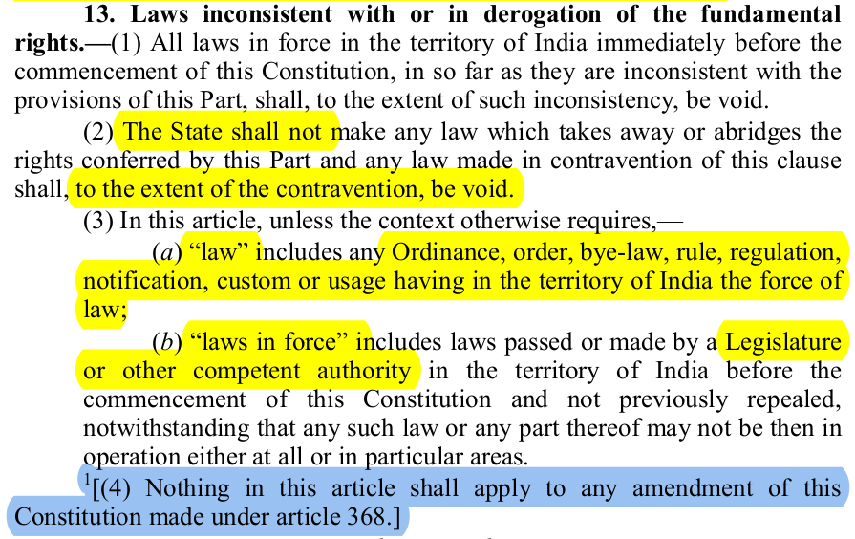
*1: 24th CAA 1971
Law = Permanent (Parliament, SL) + Temp (ordinance) + Statutory institution/delegated legislation (rules, order, byelaws etc) + Custom (usage having force of law)
Art 13 → gives JR power to courts. “extent of contravention to be void”: doctrine of ?
CAA is not law and can not be challenged , however kesavnanda bharti (73’) SC says “can be challenged on ground that it violates FR that forms BS and can be declared void”

Art 14
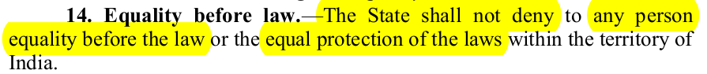
- “Person”: Indiv , corporation , regis societies etc also. Person means “Legal Person”
- Art 14 prohibits class legislation but allows reasonable classification based on intelligible differentia & distinctness
- Exceptions : Prez , governor criminal-civil proceedings , MPs/MLAs , 31C , Foreign ambassadors
- Equalty before Law follows Dicey rule : (1) Absence of arb power (2) Equality of law (3) Primacy of Indiv rights , const just enforcer
*In india only follow (1) & (2) . Primacy of const. Const is giver of indiv rights.

Art 15
Art 15(1) – No discrimination by the State only based on religion, race, caste, sex, place of birth.
Art 15(2) – No discrimination as above in the access to –
- Bathing ghats, public wells, tanks, roads, public resorts maintained wholly or partly by State funds.
- Shops, Public restaurants, Hotels, public entertainment.
Art 15(3) – State can make special provisions for women and children.
Art 15(4) – State can make special provisions for any SEBC, SC, ST
Art 15(5) – State can make special provisions for admission of SEBC, SC, ST in Educational institutions (including Pvt, excluding MEI)
Art 15(6) – State can make special provisions for
- EWS other than the ones mentioned above.
- EWS in Educational institutions (including Pvt, excluding MEI)

Art 16
Art 16(1) – There shall be equality of opportunity in public employment.
Art 16(2) – No discrimination only based on religion, race, caste, sex, place of birth, descent, residence.
Art 16(3) – Parliament can by law provide for residence as a requirement for certain employments within the state/UTs.
Art 16(4) – Reservation for backward classes
Art 16(4A) – Reservation for SC, ST for promotion
Art 16(4B) – Carry forward of vacant reserved seats.
Art 16(5) – Religious or denominational institutions can have religion as a requirement for office.
Art 16(6) – Reservation for EWS

Art 17
Untouchability is abolished.

Art 18
Art 18(1) – No title not being military or academic can be conferred by the state.
Art 18(2) – Citizens shall not accept titles from foreign states.
Art 18(3) – No Person holding an office of profit or trust under the state shall accept titles from a foreign state without Presidential consent.
Art 18(4) – No Person holding an office of profit or trust under the state shall accept emoluments, presents or office of any kind from a foreign state.

Art 19
(1) All citizens shall have the right—
(a) to freedom of speech and expression;
(b) to assemble peaceably and without arms;
(c) to form associations or unions 2011 , 97CA[or co-operative societies];
(d) to move freely throughout the territory of India;
(e) to reside and settle in any part of the territory of India; 1978 ,44CA[and]
[(f)*****] Omitted: 44CA , 1978
(g) to practise any profession, or to carry on any occupation, trade or business.
1951 , 1CA[(2) Nothing in sub-clause (a) of clause (1) shall affect the operation of any existing law, or prevent the State from making any law, in so far as such law imposes reasonable restrictions on the exercise of the right conferred by the said sub-clause in the interests of 1963 , 16CA[the sovereignty and integrity of India], the security of the State, friendly relations with foreign States, public order, decency or morality, or in relation to contempt of court, defamation or incitement to an offence.]
(3) Nothing in sub-clause (b) of the said clause shall affect the operation of any existing law in so
far as it imposes, or prevent the State from making any law imposing, in the interests of 1963 , 16CA[the sovereignty and integrity of India or] public order, reasonable restrictions on the exercise of the right conferred by the said sub-clause.
(4) Nothing in sub-clause (c) of the said clause shall affect the operation of any existing law in so far as it imposes, or prevent the State from making any law imposing, in the interests of 1963 , 16CA[the sovereignty and integrity of India or], public order or morality, reasonable restrictions on the exercise of the right conferred by the said sub-clause.
(5) Nothing in 1978, 44CA[sub-clauses (d) and (e)] of the said clause shall affect the operation of any existing law in so far as it imposes, or prevent the State from making any law imposing, reasonable restrictions on the exercise of any of the rights conferred by the said sub-clauses either in the interests of the general public or for the protection of the interests of any Scheduled Tribe.
(6) Nothing in sub-clause (g) of the said clause shall affect the operation of any existing law in so far as it imposes, or prevent the State from making any law imposing, in the interests of the general public, reasonable restrictions on the exercise of the right conferred by the said sub-clause, and, in particular, 1951 1CA[nothing in the said sub-clause shall affect the operation of any existing law in so far as it relates to, or prevent the State from making any law relating to,—
(i) the professional or technical qualifications necessary for practising any profession or carrying on any occupation, trade or business, or
(ii) the carrying on by the State, or by a corporation owned or controlled by the State, of any trade, business, industry or service, whether to the exclusion, complete or partial, of citizens or otherwise.]

(a) speech & exp | [Sov, integrity], public order, decency or morality, contempt of court, defamation or incitement to offence, security of state, friendly relation with foreign state | 1st amendment added all this
(b) Peaceful assembly | [sov, integrity], public order
(c) form association | [sov, integrity], public order, morality
(d) & (e) | General public, protection of ST
(g) | General public, [profession given by state, carry on itself by state] | 1st Amendment added

- Art 19 protects only against state actions not pvt individuals
- only for citizens and shareholders of company
- all rights under 1(a) speech & exp :
freedom of press , freedom of silence , right to telecast , right to picket (protest) but not strike , right against tapping of telephone etc.
- 1(b) : only on public land , does not include right to strike
Under section 144 CrPC : magistrate can restrain assembly if risk of obstruction , annoyance etc
Under Section 141 of IPC : >=5 assembly unlawful if not following law , commit mischief, occupy property forcibly , threaten gov etc
- 1(c) : rights include forming parties , companies etc. Also covers negative right to not join.
Doesn’t provide trade unions right to bargain or strike.
- 1(d): Only provides internal movement not external (art 21 provides external). Exception like prostitute movement can be restricted on public health, public moral grounds
- 1(e): 2 parts reside + settle. Exception like prostitute, habitual offenders can be banned from certain areas.
Art 20
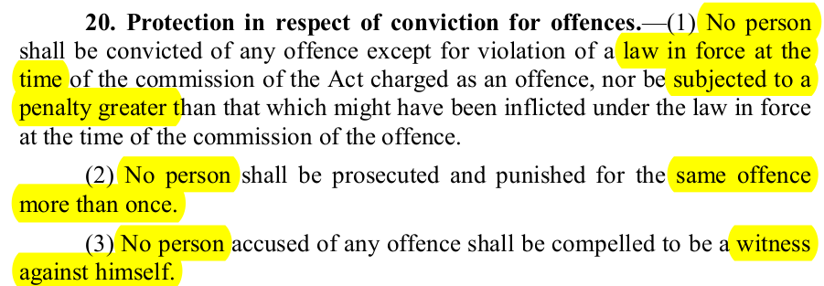
No ex post facto: only criminal, covers only conviction not trial , not applicable during preventive detention
No Double Jeopardy : Court should be judicial in nature. So not applicable for departmental or admin authorities
No Self-incrimination : Both oral + physical evidence however does not extend to compulsion of giving blood, signature , body check etc. Only for criminal proceedings

Art 21
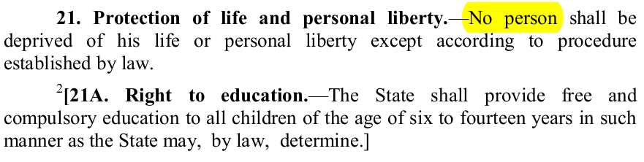*Right to education added in 2002, 86th CA
Art 21 mentions Procedure established by Law.
Gopalan (1950) case:
i. Protection against only executive action. Procedure established by law.
ii. Life means only body / person individual life
Menaka (1978) Case:
i. Life can be deprived by law provided law is just, reasonable , fair
{limitation to both exec + legislature , Due process of law}
ii. Personal liberty has biggest ambit and right to live encompasses right to live with dignity and various other dimensions
rights included : livelihood, privacy , free legal aid , sleep, health , travel abroad , speedy trial etc

Art 22
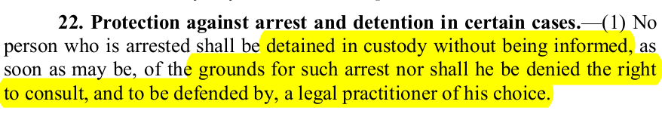
Punitive Detention (cl. 1&2): 24 hr magistrate , leave unless magistrate asks to stay. Ground for arrest. Right to defend
EXCEPT
for enemy alien, preventive detention (cl 3)
Preventive Detention (cl. 4,5,6,7) : detention max 3 months unless advise of advisory board (made of judges of HC) says more OR parliament by law defines circumstances, classes where person can be kept longer than 3 months w/o advisory board approval.
Parliament by law defines maximum period, procedure of advisory board
Person should be told ground (w/o revealing facts disrupting public order) and allow to represent asap
Constitution has divided power of Preventive Detention b/w parliament & state legislature.
Parliament exclusive power for PD law in defence, security, and foreign affair. Others both parliament & SL power.

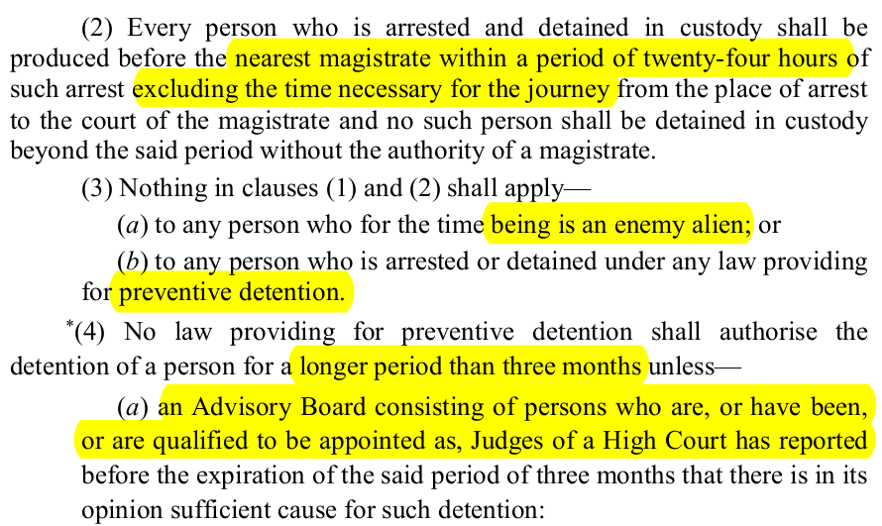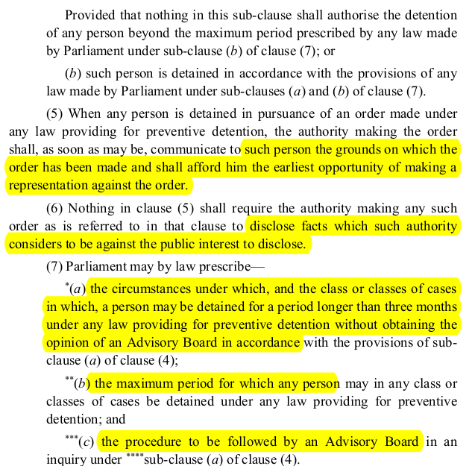
*, **, *** : 44 CA , 1978 notified

Art 23 :
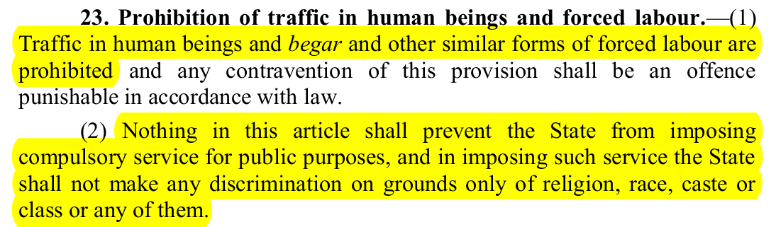
- Both citizen and non-citizen , against both state and private
- cl (1) Traffic in human beings : devadasis , buying & selling , prostitution , slavery --> immoral traffic prevention act , 1956
- Begar : forced labor , force doesn’t just mean physical force but also economic like working below min wages --> minimum wages act , equal remuneration act , labour system abolition act , contract labour act

Art 24 :
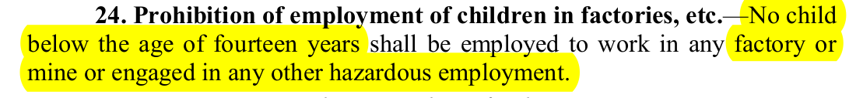
- Child labour act , 1986 (2016 amended) most imp act , other acts : mines act , factory act , bidi cig act , apprentices act all prohibit emp of children
- 1996 : SC ordered child labour rehab fund: 20,000 fine for each child employed by person
- 2005 : Commission for protection of child rights act--> established Ncomission & SC for proetc of child rights and children’s court
- 2006: gov banned employment of children in domestic services or businesses e.g. Dhaba, teashops , restaurants
- child labour act , 2016 (Amendment) [TBD @KUSH]

Art 25: Available to both citizen and non-citizen
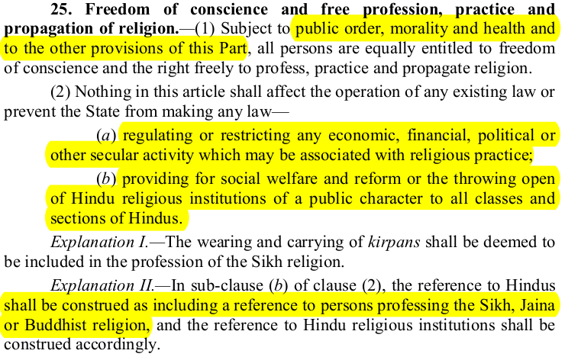
- conscience, profession, practice and propagation (does not mean converting though)
SUBJECT TO public order , morality , health , other provisions of FR
- State can make law regulating activities and for providing social welfare can do reforms

Art 25(2) –
- Regulation of secular activities related to religions.
- Social Welfare and Throwing open of temples.

Art 26:
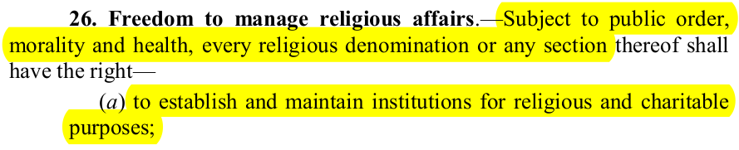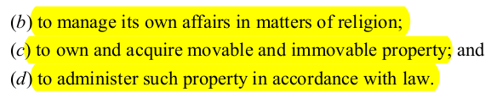
- not subject to other provisions of FR like in article 25
- SC held that religious denomination defn :
i. Distinctive name
ii. Collection of people with same ideology related to spiritual well being
iii. Common Organisation
e.g.: Ramakrishna Mission, Ananda marga [but not aurobindo society]

Art 27:
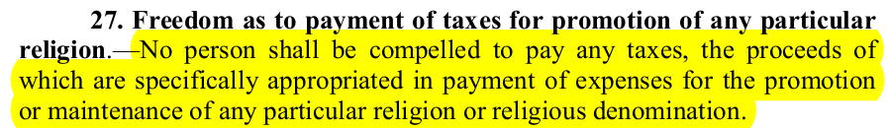
- Can’t tax people to support one religion. However, can charges fees for secular activity like providing safety to pilgrims.

Art 28:
Institution Type | Religious Instruction
Wholly funded by state | Prohibited
Admin by state but established by trust/endowment | Permitted
Recognised by state | Voluntary Basis, Any person can or cannot
Received aid from state | Voluntary Basis, Any person can or cannot
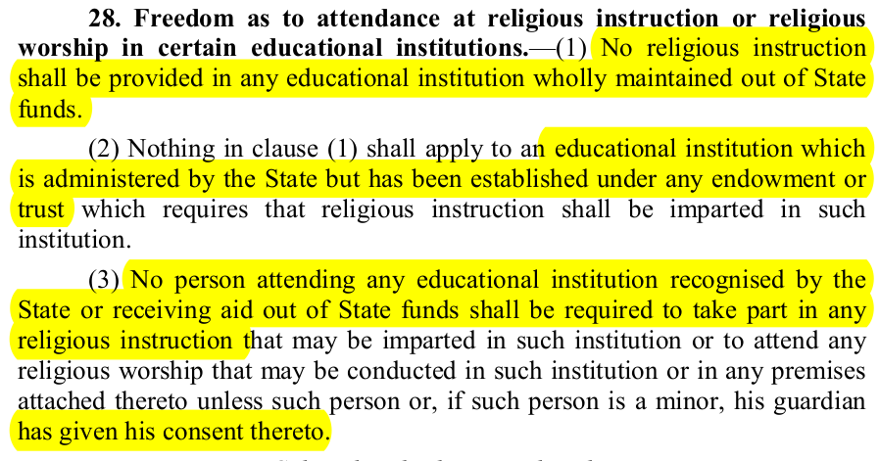
- All persons
- Talks about Religious institutions and religious instruction permitted or not.

Art 29:
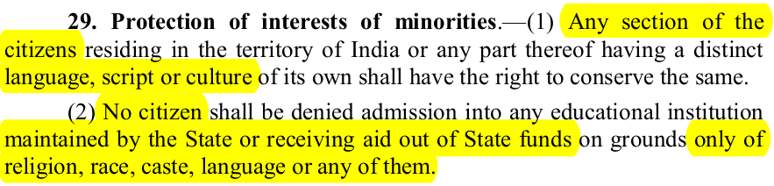
- “Section of Citizen” --> SC says not just limited to minority but majority also
- SC says right to conserve language includes--> right to agitate for protection of language
(So any speeches by PP for conserving language is not against RPA)
- “Group right” cl. 1 + “Individual Right” cl.2
- Protects both religious and linguistic minorities
Read with Art 15 –
- No discrimination only based on Race, Religion, Caste, Sex, Place of Birth by state
- No discrimination only based on Race, Religion, Caste, Language in admission to an educational institute.

Art 30:
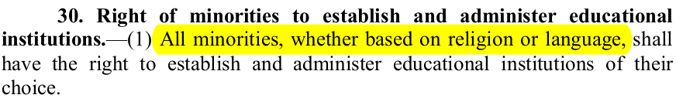
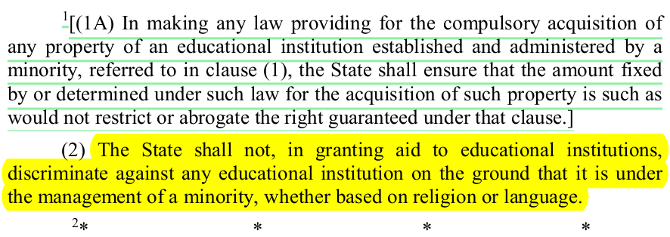
1: 44 CA , 1978 . 2: Right to property omitted by 44CA , 1978
- only “minorities” (unlike art 28) , both religious and linguistic , minority not defined
- 3 type of minority ed institutes
Aided & Recognised by state | Some Regulatory power of state regarding syllabus , teaching staff etc
Not aided but recognised by state
Neither aided nor recognised | Free to manage own affairs provided follow general law of land
- SC : Malankara College case (2007) on general principle relating to establishment and administer:
i. Right to appoint Governing body
ii. Right to appoint Teaching and non-teaching staff and take action against them if defaulting
iii. Right to admit eligible student of their choice and make reasonable fee structure
- Art 30 is not absolute. Right to administer doesn’t guarantee right to maladminister
- General laws of land still applies and further regulation like general teaching criteria, curriculum ,syllabus applies to them too
- Subject to these conditions of state being met , unaided instit are free to make reasonable selection procedure
- Aiding doesn’t alter the nature of institution , it’s just for proper utilisation of aid and not to dilute rights under 30(1)

Art 31 A – 1st CAA – Land reforms
Art 31A (1) – Saves some laws from FRs Art 14, At 19 –
- Acquisition by State of an estate or modification/extinguishment of its rights.
- Taking over property management by state temporarily for public interest/proper management
- Amalgamation of multiple corporations in public interest/proper management
- Extinguishment/modification of shareholder/management rights in a corporation.
- Extinguishment/modification of rights accruing by agreements, leases, licenses etc.
If a law is made by the SL to enact provisions of this article, it requires Presidential assent.
Exceptions –
- Right to Property for acquisition of land under personal cultivation and within ceiling limits.

Art 31 B – 1st CAA
Saves all laws in 9th schedule from contravention of Part III – FR
IR Coelho v/s State of TN - Laws added after Keshavnanda Bharati can be tested for contravention of Art 14,15,19,21, or basic structure.
Art 32B is wider than Art 31A.

Art 31C – Protection of DPSP
Protection of DPSPs 39(b) and 39(c) from contravention of Art 14, 19

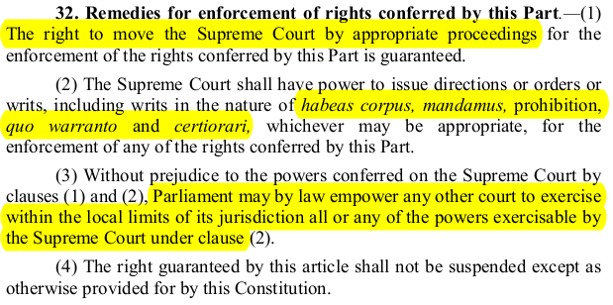

SC has original but not exclusive jurisdiction &
SC can only invoke writs under art 32 for infringement of FR not anything else.

SC Vs HC
- HC discretionary power of writs so can deny it.
- HC jurisdiction limited to only when cause was wholly or partly in its territory
- HC can invoke writs even to enforce ordinary legal rights

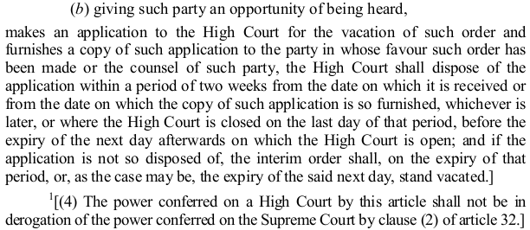
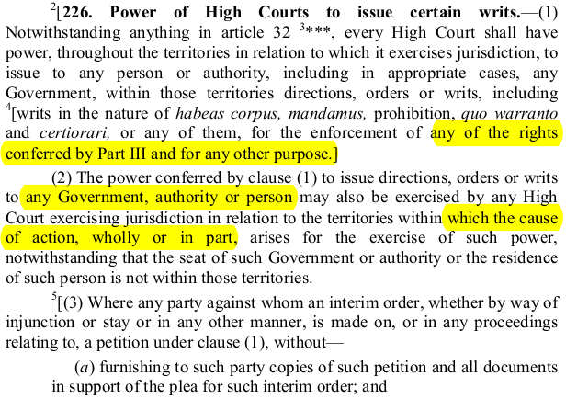
* Process for applying to HC during stay period and HC to dispose witin 2 weeks . [not imp, light read]

Writs:
1. Habeas Corpus: “to have the body of” , “bulwark of individual liberty against arb detention”
- Court issues to person having detained other person to produce body of latter
- Issued for : Public authorities + pvt individuals
- not issued for : lawful detention , contempt of court or legislature , detention by competent court
2. Mandamus: “to command”
- Do your duties properly
- Issued for : public officials , public body , corporation , inferior court , tribunal , governemnt
- not issued for : pvt individual or body , enforce departmental instruction not having statutory force
, discretionary duty, contractual obligation , against president of India or governors or chief
justice of HC
3. Prohibition: “to forbid”
- Higher court to lower court/ tribunal to not cross its jurisdiction. Only preventive
- Issued for: Judicial or quasi-judicial bodies
- not issued for: administrative authorities , legislative bodies , pvt individual or bodies
4. Certiorari: “to be informed”
- Higher court to lower court/tribunal squashing latter’s orders on grounds of “outside jurisdiction”
- Issued for: Judicial or quasi-judicial bodies
- not issued for: administrative auhtorities , legislative bodies , pvt individual or bodies
(1991 SC judgement said: certiorari can be against admin authorities affecting individual rights)
5. Quo Warranto: “By what authority”
- To enquire into legality of claim of a person to a public office, prevents illegal usurpation of public office
- Issued for: Substantive permanent public office with statute or constitutional backing
- not issued for : ministerial or pvt office
(can be issued by public minded person also , not just aggrieved)
Right To Equality | 14-18
Right to Freedom | 19-22
Right against exploitation | 23,24
Right to freedom of religion | 25-28
Cultural and Educational Rights | 29,30

DPSP & FD [Art 37-51A]
[Art 37]: DPSP “Fundamental to governance”, “Not enforceable by any court”
[Art 38]:
(1) Welfare of state = justice S, E, P.
(2) (44th CAA) Inequalities in Income, Status, Facilities, Opportunities b/w groups as well as Individuals ↓
[Art 39]:
L: Secure Livelihood (M+F),
D: Distribution of Material resources,
C: Concn of wealth,
P: Equal pay (M+F),
H: Health & strength of worker (M+F), Children. Economic necessity shouldn’t drive individuals to take up avocations unsuited to their age.
C: Child – healthy growth, conditions of freedom and dignity, free from exploitation and abandonment (42nd CAA)
{LDCPHC: La-Dakh Chal Pade Hai Chu**}
[Art 39A]: Equal Justice - Free Legal Aid (42nd CAA)
[Art 40]: Village Panchayat
[Art 41]: RTE, RTW, RT Public assistance in case of unemployment, sickness, old age, disablement.
[Art 42] : Just & Humane condition for work + Maternity Relief (W&MR)
[Art 43] : (a) For all workers : Decent Standard of life & Living Wage (b) Promote Cottage industries
[Art 43A] : Workers in management of industries (42nd CAA)
[Art 43B] : Democratic control and professional management of Cooperatives ↑ (97th CAA)
[Art 44] : UCC
[Art 45] : Early Childhood Care + Ed for < 6 yrs {4-5 = 1 --> Early Child Care} (86th CAA)
[Art 46] : Special care to educational & economic interest of weaker secs. Especially SC/ST {4-5 = 2 --> SC ST}
[Art 47] : nutrition↑ , std of living , public health , consumption of intoxicating drink & drug↓ {AK47 :health}
[Art 48] : Agri & Animal Husb on scientific lines , prohibition of slaughter {“Adtalis” = Adiyal Saand = AnHusb}
[Art 48A] : Protect & improve env , forests , wildlife (42nd CAA)
[Art 49] : Protection of monuments , place , object from spoilation etc {Forty--> Forts --> Monum}
[Art 50] : Sep of Judic from Exec {50-50 rule}
[Art 51] : Intl peace & security , dispute settle by arbitration , just & honour relation with nations, respect int law {for PEACE , follow LAWS , maintain JUST & HONOR RELN and SETTLE DISPUTE by ARBITRATION}
Socialist: 38, 39, 39A, 41, 42, 43p1, 43A, 47p1
Gandhian: 40, 43p2, 43B, 46, 47p2, 48p1
Intellectual: 44, 45, 48p2, 48A, 49, 50, 51

Directives outside Part IV –
- Art 335 – Claims of SC, ST to services
- Art 350A – Instruction in mother tongue at the primary stage to linguistic minorities within the state
- Art 351 – Development of Hindi language

42nd CAA –
- Art 39 (f) – Healthy growth of children. Growth with Freedom and dignity, Prevention of exploitation and abandonment
- Art 39A – Free Legal aid and Equal justice
- Art 43A – Participation of workers in management
- Art 48A – Protection of environment, safeguarding Forests, and wildlife.

44th CAA -
- Art 38(2) – Inequalities in Status, Income, Facilities, and opportunities between individuals as well as groups

86th CAA – RTE – Art 21A, Art 45, Art 51A (k)
- Art 45 – Early Childhood care and education up to 6 years of age.

97th CAA – Cooperatives added to the constitution (Art 243)
- Art 43B – Democratic control and professional management of cooperatives.
Fundamental Duties [51A]
- Citizens only
- Borrowed from USSR Constitution
- Swaran Singh Committee
- Added by 42nd CAA.
A: Abide | B: Bapu | C: CUI | D: Defence | E: Eksath | F: Forts | G: Green | H: Homi bhabha | I: IA’S’-> Safeguard public prop and abjure violence | J : JBIMS hotel | K : kids < 14
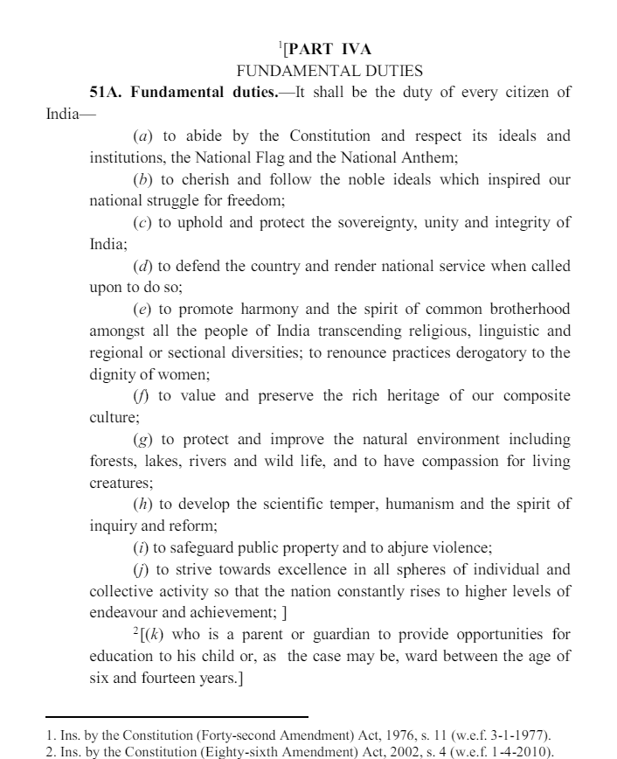
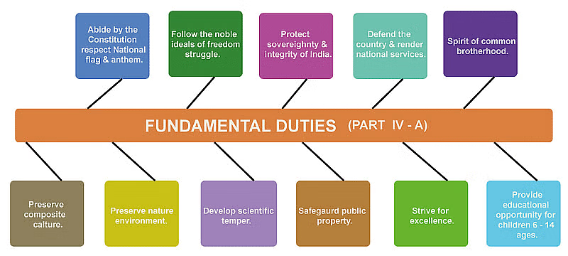

Parliament
- Parliament = President + House of people (LS , 1954) + Council of states (RS , 1954) [Art 79]
taken from British , different from american. Prez not of any house but integral member
- Seats & Manner of Election [Art 80,81]
LS [Art 81] | RS [Art 80]
550 + 2 Total : 530 (s) + 20 (UT) + 2anglo indian  Current : 543 = 524 (S) + 19 (UT) | 250 Total: 238 indirectly elected + 12 Nominated  Current : 245 = 225 (S) + 8 (UT) + 12 (nom)
Seats allocated to states as per (for states popn >6 Mn)  i. Proportion of number of seats / propn of state equal [1971 cens]  ii. Proportion of terr cnts / number of seats equal [2001 cens] | Seats allocated to states as per 4th Schedule
Direct election, (FPTP : not mentioned in const ) | Indirect election : Elected member of state LA  Proportional representation , Single Trans Vote
UTs? : As parliament prescribes : UT (Direct election) Act , 1965  Direct election | UTs? : As parliament prescribes: RPA :  Delhi , Puducherry , J&K : elected member SLA  other UTs no repn as popn low
Art 330 : SC/ST reservation (popn base , [2001] census)  Art 331 : Pres can nominate anglo indian if he feels not adequately rep (not more than 2) [Govrnr can do for states , max 1]  Art 334 : SC/ST reservation till 2030 , Anglo ind reserv till 2020  [104 CA , 2019 -> continued SC/ST reserv till 80 yrs from 1950, however stopped Anglo reservation only at 70 yr i.e ending on 2020] | President nominates 12 members from Art ,Lit , Sc , SS
Tenure [Art 83]
5 year after gen election and automatic dissolution at expiry tenure President can dissolve even before (cant be challenged in court) | 1/3 member to resign every 2 years . Procedure to be made by parliament -->  RPA 1951: Tenure 6 years , first batch asked president to make rules -> rajya sabha order, 1952 : lottery system to determine first batch of retiring  {retiring members eligible for reelection , nomination}
- Readjustment [Art 82] : readjust house of people seats after each census as per parliament makes
fixed till 2026 [84th CA ,01’] . state seats -> 1971 census [42 CA ,76’] , Terr Const seats -> 2001 census [87th CA ,03’]
- Qualification [Art 84] (for qualification to be chosen as MP or basically elections) :
i. Citizen of india
ii. Oath to someone on behalf of EC : Sov & integ + bear true faith to const
iii. RS >= 30 Yrs , LS >=25 yrs
iv. Any other law parliament prescribes ---> RPA
RPA : elector to parliamentary constituency (elector in state dispensed in 2003) , Must be SC/ST to contest for SC/ST seat & SC/ST can also contest for gen seat

- Disqualification & Defection [Art 101,102] :
Art. | Parliament seat vacation clauses in const | Extra Info/ legislations
101 | (1) : cant be member of both house of parliament : parliament to make provison  (2) : cant be member of both SL & parliament : president to denote period to choose  (3) : disqualified under 102(1),(2) or resigns to speaker / chairman  (4) : Absent for 60 days w/o house permission : House MAY declare seat vacant  *{excluding days when house prorog/adj for >=4 consec days} | (1) RPA 1951 :10 days  (2) Prohib of simult. Member rules 1950 : 14 ds  (3) speaker / chairman can reject resignation
102 | (1) : (a) OoP , other than one decided by parliament as not i.e ministerial office  (b) unsound mind , (c) discharged insolvent , (d) not a citizen , (e) if so disqualified under law by parliament --> RPA  (2) : A person disqual for being member of either house if disqual under 10th sch. | 102(1)(e) : RPA ,1951  102(2) : 10th schedule bought by 52nd CA
103 | Disqualification question under 102(1) ? Prez decides after obtaining opinion of EC
104 | If disqualified or not taken oath and still sits & votes then--> 500 rs per day fine
101: Vacation of seats i.e. already MP vacating conditions
102: Disqualification of being chosen to be MP (i.e. can’t contest elections) (1) & for being MP (2)
102(1)(e) → RPA 1951 clauses → Prez decides
102(2) → 10th Schedule (provisions of defection) → Speaker / chairman decides
102(1) disqualification question? → Prez. after obtaining opinion of EC & his decision is final.
102(2) disqualification question? →Chairman / Speaker decides. Subject to JR (Kihoto 1992 case)
101(1): if member of both houses of parliament? Which seat vacated (RPA,1951)
- elected to both? Rajya Sabha will be vacated post 10 days
- elected to 2 seats in a particular house? Vacate one else both will be vacated
- member of house1, elected to house2 later. House1 seat vacated
101(2): If member of both parliament and SL? Parliament vacated post 14 days
102(1)(e) : RPA Provisions:
guilty of electoral offences , convicted for offense w imprisonment ≥ 2 yrs (Preventive detention is allowed) , election expense within time not disclosed , no interest in gov contracts , dismissed from gov service because of corruption or disloyalty , social crimes like untouchability sati , promoting enmity between groups , bribery , OoP or director / managing agent in corporation having gov share ≥ 25%
102(2): 10th schedule defection provisions:
- voluntary giving up membership of PP thru which elected
- votes/abstains contrary to direction given by PP
- nominated member should join PP <=6 months. Independent cant join PP
Other cases: election declared void, for Prez/VP/Governor position, expelled by house.
*Art 104 only gives fine for disqualified person attending sessions but lays no procedure to make election void → RPA 1951 enables High Court to declare election void if disqualified person is elected. (Aggrieved person can approach SC)
- Oath [Art 99]: member of either house --> oath before prez or any person appointed by him
as per 3rd schedule: true faith + sov & integ + discharge duty
- Salaries [75(6) Ministers, 97 : speaker etc , 106: MPs] : [common]
Art 106 - Salaries and allowance decided by an act made by parliament. Pension is not mentioned in constitution but given as per the act.
S & A of MP = speaker = dp speaker = dp chairman = 1 lac/month
sumptry allowance of speaker = cabinet minister & sumptry of dp speaker = Minister of state
chairman salary = 4 lac/ month. Can be seen in 2nd schedule
Speaker & Deputy Speaker [Art 93-97] :
Common :
- The house of people as soon as may be, choose two members to be speaker and dp speaker and if any office becomes vacant, house to choose another as case may be [art 93]
- Early vacancy reasons : [art 94]
i. ceases to member of LS
ii. resigns to dp speaker/speaker
iii. resolution passed against (need 50 members to support. Passing requires majority of all then members: effective majority. Resolution need prior intimation of 14 days)
- salary of both charged on CoFI , no specific oath taken
- if both speaker and dp speaker vacant then president will appoint the speaker [art 95]
- if both speaker and dp speaker absent then rules of procedure of house will determine person [art 95] ---> panel of chairperson (upto 10 , nominated by speaker). Any of which can preside when both speaker and deputy absent. If panel also absent --> house can select any member
- During removal resolution , cant preside but can attend the proceeding and only speaker can vote in first instance during proceedings
Speaker Functions : (Based on constitution , rules of procedure & conduct of LS , parliamentary precedents)
- Election date decided by president , resigns to dy speaker
- Maintains order and decorum , final interpreter within the house , regulates proceedings and his decision final , chooses chairmen of all parliamentary committees , money bill certificate , decides defection cases , heads inter parliamentary group , can allow a secret meeting , joint sitting head , casting vote , adjourns or suspends house on absence of quorum (1/10th of total strength )
- Security of tenure : Life of LS , also whenever house of people dissolved , speaker shall not vacate until immediately before first meeting of house of people after dissolution [art 94]
- power of regulating procedure , conducting business not subject to jurisdiction of court
- chairman of business advisory committee , rules committee , general purpose committee
Dy speaker functions :
- Election date decided by speaker , resigns to speaker
- Performs duties of speaker when vacant and also acts as speaker when latter absent
- Whenever dy speaker part of some parliamentary committee , he is the chairman. Other than this on normal days , he’s just a regular MP
Speaker Pro Tem : President appoints (generally seniormost) during 1st session of new house of people till new speaker is elected

Chairman & Deputy Chairman [Art 89-92] :
Chairman : can only be removed when removed from VP position , not member of house and cant vote during resolution against. Exactly as speaker w/o money bill certificate and joint sitting head provision
Deputy Chairman, Panel of Vice chairperson: Exactly word to word same as dy speaker and chairperson of LS
Secretariat [Art 98]: “Each house to have own secretariat, not preventing to make any post that is common to both. Parliament by law to regulate recruitment etc. Till no such law is made, President post consultation w speaker / chairman can make rules. “
Each secretariat headed by secretary general (permanent post, appointed by speaker / chairman)
Leader of the house and opposition [not in const]
- mentioned in rules of house and parliament statute
- rules of lok sabha : leader of house = PM or any minister in LS
rajya sabha leader of house = minister in RS nominated by PM
- Leader of oppositon : Leader of single largest party as per numerical strength or if two parties having same numerical strength , then chairman/speaker can recognise any one as leader and their recognition is conclusive and final
(min strength for leader of opp criteria is 1/10th of total membership of house)
- LoO same salary as cabinet , as per salaries and allowance act
Whip [not in const]
- not in rules of house or anything but a parliamentary convention
- LS Chief whip of gov party : minister of parliamentary affairs
- RS chief whip of gov party : minister of state of parliamentary affairs
- whips of recognised party or group gets telephone and secretarial facilities

Sessions of Parliament
Summoning [85(1)] : “Prez from time to time summon each house to meet at time and place as he thinks fit. 6 months shouldn’t intervene between two sessions”
i.e min 2 sessions in a year . Generally 3 → budget, winter and monsoon
session : first sitting of house ---to-- prorogation/dissolution (LS) . Time bw 2 sessions : “recess”
During session , house meets everyday to transact business
Adjournment : House adjourning w reassembly in hours, days etc
Adjournment sine dine : House adjourning w/o reassembly time mentioned (indefinite)
(*head of house can call sitting even before the reqd time of adj or call after anytime dj sine dine)
Prorogue [Art 85(2)(a)] : Prez prorogues when he sees fit. Ends life of session. Generally pres passes notification after few days of adj sine dine but can prorogue even when in session
Dissolution (LS)[Art 85(2)(b)] : Ends the very life of house. When pres sees fit time & place
Adjournment | Prorogue | Dissolution (LS)
Presiding officer does | President does | I. automatically on term expiry  II. Whenever prez sees fit
Death of sitting | Death of Session | Death of House (LS)
Does not affect any business | Only notice lapses , not BARM . Notice of intention to move for leave to intro a bill doesnt lapse  BARM : bills , ammendment , resolution , motion | Everything lapses except some pending bill and assurances + 1 motion: removal of SC/HC judge
- Pending bills that dont lapse during dissolution : [Art 107]
Pending in RS and not yet passed by LS, joint sitting , pres sends back , waiting for pres assent
- All pending assurances need to be examined by committee on gov assurance and dont lapse on dissolution (not in const)
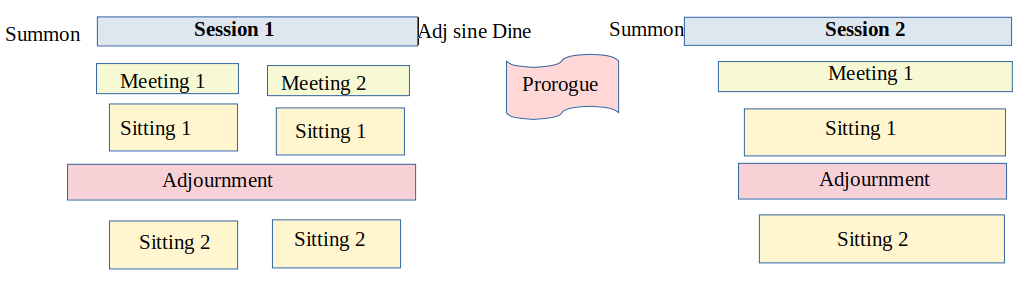 * Prez summons -> speaker calls for meetings -> speaker adj sine dine -> prez prorogues
Quorum [Art 100(3),(4) ] : “(1/10th of total no of members) Duty of speaker to adj or suspend house until quorum met” i.e LS : 55 , RS : 25
Voting in house [Art 100]:
“The proceedings of a house are to be valid irrespective of any unauthorised voting or participation or any vacancy in its membership” [Art 100(2)]
“Save as otherwise provided in constitution -> all questions in any sitting of any house or joint sitting will be decided by majority of votes of members present & voting excluding speaker/chairman” [Art 100(1)]
Voting procedure in LS :
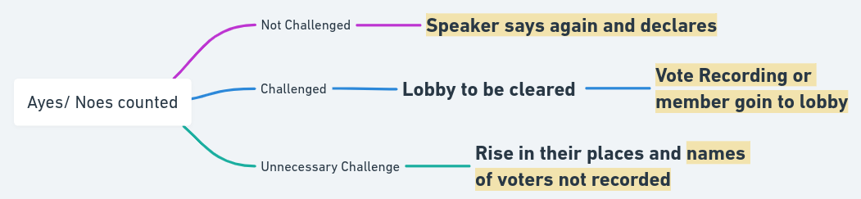
*All this ayes/noes counted , lobby cleared , rise in places etc are done by speaker/chairman
Methods of voting [Rules of House] : Voice vote , Division (vote recording machine , aye/no slips , members into lobbies) , secret ballot (LED on vote recording machine only shows white) , physical count of members in their place only when unnecessary claim (names not to be recorded)
Language in parliament [Art 120] : business in parliament shall be transacted in hindi or english.
However speaker / chairman can allow person to address in mother tongue , its his duty to provide translation copies if already facility not available. In const “omit english after 15 yrs” is given but post Language act 1963. english is also allowed
Minsters and AGI [Art 88] : Every minister and AG have right to speak and take part in proceeding of any house , JS or committee they’re part of. Shall not by virtue of this article be entitled to vote
Majorities :
SM2 | 2/3 of Total Membership: [>366] | Impeachment of President
SM1 | Absolute & 2/3 members Present & voting: [>240] | Removal of SC judge, HC Judge , CAG , CEC , SEC . Approval of Emergency. Const Amendment
Absolute | Total Membership [>225] | - (but essential to form government)
Effective | Majority of all the then members.  Total – vacant [>221] | Removal of VP , dep chairman, speaker , dp speaker
Simple | Majority of members present & voting: [>180] | All bills , motions pasing . Removal of VP in LS . Election of speaker , dp speaker , dp chairman , Financial emergency , Prez rule , Discontinue National Emergency
SM3 (RS) | 2/3 Members present & voting in RS: [>100] | New AIS, legislation on state list
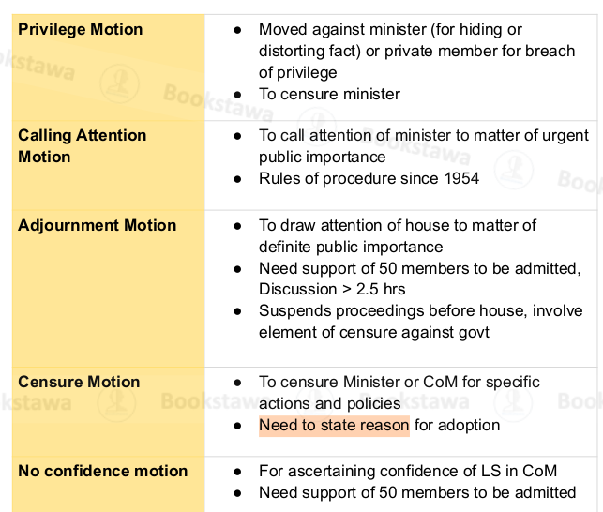
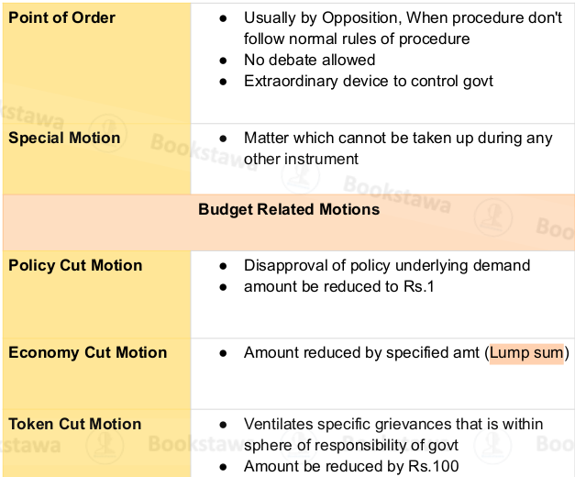
Eg LS: total membership : 550 , total elected : 543 , vacant : 7 , suppose at a session present 360
RS : suppose at present : 150

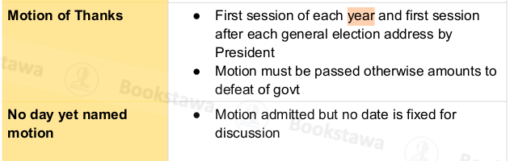

Bills:
Ordinary bill passage: (not in const)
1st Reading: Intro bill after taking leave of house. Intro title and principles. Gazette notification
2nd Reading:
a) General Discussion. House can do one of 4 things now i.e
(i). Pass it to select committee, or (ii) joint committee. Publish for public opinion (iii), reserve another day and time for consideration (iv)
(Generally sends to select committee only)
b) Committee scrutinises and even amend provisions but not altering the principle underlying it
c) Sends bill back to house. Each clause is discussed and voted. Amendments can be moved and if accepted they become part of bill
3rd Reading : Final debate whether to accept or reject . No amendments in this stage
- On passing , bill is authenticated by speaker/chairman is sent to next house
- IF House2 rejects , doesnt respond within 6 months , suggests amendments that house 1 rejects -----> DEADLOCK ---> Joint sitting [Art 108]
- After everything , passed bill goes to president. Pres can assent, withhold assent and the bill dies or return for reconsideration but if house sends bill again w or w/o amendments Prez has no choice but to assent [Art 111]
Joint sitting [Art 108]:
Grounds: H1 accepts H2 rejects, HI-H2 don’t agree on amendments, H1 – H2 6 month elapsed (not counting those days where adj / prorogues >4 consec days)
Type of amendments allowed during JS : amendments due to delay or amendments on disagreement matter. Validity of amendment is done by presiding officer (speaker)
Majority: Simple
Money Bills [109, 110]:
Art 110 Defn :
- “only if deals with any or all of :
imposition, abolition, remission, regulation of tax , regulation of borrowing of money of union
custody of CoFI , contingency & payments into & withdrawal from them
appropriation from CoFI , Receipt of money on CoFI or Public fund ,
Declaration of charged expenditure and if increasing , or any matter incidental to it.
- And not money bill if deals with
imposition of fines & pecuniary penalties , charging fees for service rendered , imposition , abolition , remission or regulation of tax by local authorities for local purpose
- Speaker certifies MB or nah
Other features
- Pres prior approval needed. (not in const) & only minister can introduce
- Pres cant return it , JS cant happen, introduced in LS only (Art 108 , 109, 111)
- LS can pass w or w/o considering RS recommendation , also if RS doesn’t return bill in 14 days ,its automatically passed anyways (Art 109)
Budget [“Annual Financial Statement”] [Art 112]

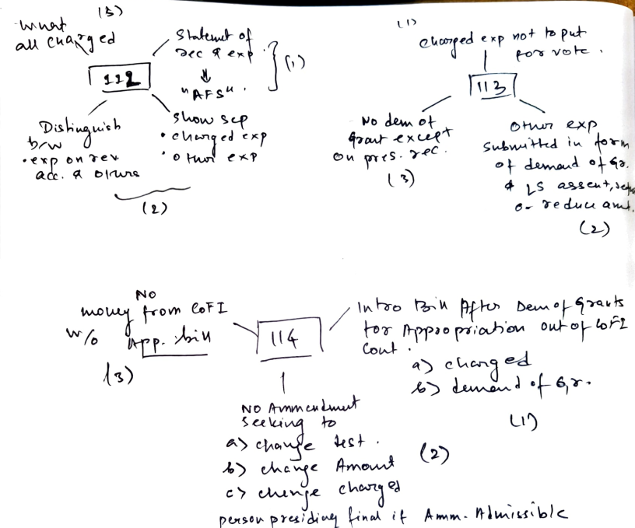
Charged exp :
- Emol & allowance of pres and other expense related to office
- SA of speaker , dp speaker , chairman , dp chairman
- SAP of judges of SC , UPSC chairman & members , CAG
- Admin expense & SAP of people in above offices
- P of High court judges
- Debt charges for which gov is liable , Decree award to satisfy judgement
- Any other that parliament wants
Parliamentary privileges :
- Doesnt extend to president. Extend to other parliament members and AGI
- Collective :
i. right to publish its reports & right to prohibit others for same (True reports can be published wo house approval) [not applicable to secret sittings]
ii. Call secret sittings.
Iii. No arrest (civil or criminal) or orders for same can be given to anyone (member or outsider) wo presiding officer approval

State Legislature [Art 168 – 212 , part VI]
Art 168: Legislature = Governor + 1/2 Houses
2 houses : AP , MH , Ktka , Telangana , UP , Bihar
** MP , TN also given in const. Idea is resolution was passed by respective states but either parliament didnt make legislation or they did but president finally didnt notify to enforce.
SLC (Vidhan parishad) | SLA (Vidhan sabha)
Max : 1/3rd total members of SLA  Min : 40  Max ,min -> const. But exact strength : parliament ; [Art 171] | Max : 500  Min : 60  [AP , Skm , Goa (min) : 30 , mizoram : 40 , nagaland (min) : 46 ]  Direct election [Art 170]
Until parliament otherwise prescribes , the electoral college is  1/3 elected by local bodies , municipalties  1/12 elected by graduates  1/12 elected by teachers  1/3 elected by SLA amongst people not in assembly  1/6 Nominated by Governor on  Art , Lit , Sc, SS , Cooperative soc. Election via PRS -STV ; [Art 171] | Direct Election :  popn/ state seats equivalent [1971 census]  & terr constns/popn equivalent [2001 cen]
1/3rd member bye bye every 2 years [Art 172] | 5 years , if not dissolution [Art 172]  During emergency , parliam can extend
Qualification : CoI , Oath , 30 yrs [Art 173]  RPA : elector in assembly const , for nomination need to be resident | Qualification : CoI , Oath , 25 yrs [Art 173]  RPA : elector in assembly const
 | SC/ST reservation on popn ratios

Oath , Minister & AGS attend meeting , disqualification , defection , voting in house , secretariat , quorum , adjournment Everything exactly same as parliament just replace prez with govrnr
Speaker , dp speaker , chairman , dp chairman exact same also. Just assume chairman to have exact same thing as speaker (like vote in 1st instace during resolution against , elected )
*Language : Hindi or English or Official language (s) of state. Floor of house can remove english after 15 yrs . For HP , Manipur , Meghalaya : 25 yrs , For ArP , Goa , Mizo : 45 yrs [from 1965]
Creation on Legislative councils? Complete @ KUSH
Ordinary Bills & Money Bill Passage
SLC has 4 options : accept , reject , return w amendments , keep it pending for 3 months
is SLC does anything other accept --> & SLA passes bill again w or w/o amendment --> SLC again 4 options but this time can only keep it for 1 month. No matter what option , post expiry of 1 month it will be considered passed in the form that SLA sent the 2nd time
Governor Assesnt , withold , return , reserve [ Art 200] : if return and house sends back then governor needs to assent only
Presz reserve if governor feels endangeer power of HC. Pres can assent , withold or return. If return , house can consider for max 6 months . Constitution doesnt mention what will happen if house again sends the bill [Ar 201]
*Money Bill exactly same as parliament . Only thing money bill can also be reserved by govrnr for pres and pres can only accept or withold , cant return

Judiciary

Supreme court [Art 124-147 , part V]
- Replaced British privy council as highest court of appeal and also federal court of India
- Integrated Judiciary system unlike USA where federal courts different from state courts
- Currently 34 = 33 + CJI
- Appointment: Prez on consultation with CJI, CJI opinion binding. But CJI to decide based on discussion of collegium 4 senior most judges and even if 2 have adverse opinion then dont send
(If CJI don’t follow procedure, his advice not binding on prez.) [art 124]
- Tenure: not given in constitution. Just should be <=65 yrs (parliament can make authority to check that), resign to prez or removed by prez [art 124]
- Qualification: [art 124]
i. 5 year HC judge
ii. 10 year advocate in HC
iii. Exceptional jurist as per prez
- Oath: Schedule 3 - to prez. True faith & alleg + sov-integ + duty properly w/o fear or favour + uphold constitution.
- Removal: [art 124]
A judge of SC can be removed by order of prez provided address by parliament presented to him in same session by parliament. The address must be passed by SM1 & grounds are misbehaviour or incapacity Judge of enquiry act 1968 denotes procedure :
Removal motion (>100 in LS , > 50 in RS) ---> speaker / chairman (can accept or reject) ---> if accept , presiding officer to form 3 member committee to investigate ---> if proven then each house to pass by SM1 --> if passed , an address presented to prez and prez gives order to remove
[3 member committee : CJI or SC judge , Chief justice HC , distinguished jurist]
- Other Appointments : No person who has held office as judge of SC shall plead or act in any court or before any authority within territory of India [art 124]
- Salary, Allowance, Pension: salary, allow , provided in II Sch. Parliament determines [art 125]
- Acting Chief Justice: Prez may appoint any other judge when CJI seat vacant, temp absent , unable to perform duties [art 126]
- Ad Hoc Judge: When quorum not there for sessions. CJI on prior consent of Prez + consent of CJ of concerned HC, can make any judge of HC who is qualified enough to be SC judge, as ad hoc judge to SC to fill quorum for temp period. Will enjoy all perks of being judge of SC [art 127]
- Retired Judge: At any time, CJI with prior consent of Prez and consent of person , appoint retired SC judge or retired HC judge qualified to be SC judge , as retired judge in sitting.
Allowance to be determined by Prez by order. Will enjoy perks but not “judge of SC” [art 128]
- Seat of SC: SC sit in Delhi or any other place chosen by CJI with prez approval [art 130]
- Review own judgement: SC have power to review any judgement or order made by it [Art 137]
- Binding on all courts: Law made by SC to be binding on all courts [Art 141]
- Judicial Review: not mentioned in const. Derives power from Art 13,32,136,142 ,226
- Aid of SC: All authorities, civil and judicial, shall act in aid of the Supreme Court [Art 144]
- Procedure of Court [Art 145]: SC on approval of prez makes rules for regulating and making procedure of court i.e. rules for person practising before court, grant of bail, hearing appeals, court proceedings for enforcing FR.
Also (2), (3): min no of judge for any purpose& for substantial question of law, powers of single and division benches.
(4): All judgements & opinions under art 143 to be in Open Court.
(5): Judgement with concurrence of majority though each judge can deliver dissenting opinion
- Independence Provisions: Security of tenure, SA&P of judges + staff & admin expense charged on CoFI [art 146] , Conduct of judges not to be discussed except during impeachment [Art 121] , CJI appoints office and staff of SC & prescribe their condition of service [art 146] , Power to punish anyone for its contempt
CJI prescribe condition of service but -
(a) if it deals with SA&P --> require approval of Prez
(b) President to provide rules for if any person not already attached to court is appointed to office of court post consultation with UPSC [Art 146]
- Jurisdictions:
Original | Art 131 | 1. Federal Issues : C v/s S(s) , C + S(s) v/s S(s) , S(s) v/s S(s) ; [Og & Ex]  (See below table for exclusive original points and excluded matters)
Writ | Art 32, 139 | 1. Habeas Corpus, Mandamus, Prohibition, Certiorari, Quo Warranto [Og but not ex]  (can only be used to enforce FR. However, Parliament can extend the scope of it)
Appellate | Art 132,  133, 134 | 1. Constitutional matters: can appeal against HC judgement. Need HC certificate saying case involves substantial question of law that requires constitution interpretation  2. Civil matters: Can appeal against HC judgement. Need HC certificate saying case.  (a) Involves subs question of law of general importance (ii) Questions need to be decided by SC  3. Criminal Matters: Can appeal against HC judgement if HC :  a. Has on appeal reversed order of acquittal to death / life imprisonment / 10 yr in prison  b. Taken case of subordinate court and convicted accused to death /life inprison /10 yr  c. Certifies case is fit one to appeal for SC  Death is a constitutional ground under Art 134, Life Imprisonment and Imprisonment for 10 years are grounds made by the Parliament.  (a,b are right to appeal and don’t need HC cert. If on appeal, reversed conviction & accused is acquited then no right to appeal)
Special Leave | Art 136 | 1. SC authorised to grant in its discretion special leave to appeal from any judgement (final or interlocutory) of any court , tribunal (except military)  (Petitioner --> special leave petition to SC --> if SC accepts -> takes case under 136)
Advisory | Art 143 | President can ask for advise on two matters:  1. Question of law or fact of public importance  2. Dispute arising from preconst treaty, sanad or other excluded from OG juris of SC  SC advise not binding on pres. SC can refuse (1) but have to give advice on (2)
*Exclusive : Only SC has authority ; Original : Can approach SC directly, covenant, not reqd
Exclusive original points: “Federal dispute part of exclusive original jurisdiction of SC if [Art 131]
a. Dispute involves any question (law or fact) on which existence or extent of legal right depends
b. [Provided said jurisdiction not extended to dispute arising from treaty, covenant , engagement , sanad agreement or similar instrument taken place before commencement of constitution and still functioning or which provides explicitly that said juris will not extend to such dispute] [7 CA 1956]
i.e under b some matters where SC don’t have ex og: Interstate water disputes , matters referred to finance commission , adjustment of expenses & pension b/w centre & states
- Court of Record [Art 129]: SC to be court of record & can punish for contempt of itself:
(i) proceedings, acts etc are recorded & are of evidentiary value, can’t be questioned when produced before any court. Legal precedents & Legal reference
(ii) can punish anyone of contempt of itself & 1991 judgement : any HC , sub court , tribunal etc
HN sanyal committee --> contempt of court act 1971 :
- contempt can be civil if wilful disobedience of judgement , order , writ etc
- or criminal if scandalises/lowers authority of court ,interferes in judicial proceedings or administration of justice in any manner
Contempt is punishable w simple imprisonment of 6 months or fine 2000 or both and court need to start proceeding within 1 year . This act not applicable to nyay panchayat or other village courts
- Review Jurisdiction: [Art 137]
Review petition need to be filed within 30 days. To same bench / judge. On grounds:
(i) Mistake/error (ii) Discovery of new facts (iii) Any other sufficient reason.
(not just parties to case but any person aggrieved can file review petition)
Court can deny. However, even after denying, court can reconsider via curative petition on grounds:
(i) Biased Judge (ii) Violation of PNJ (iii) Cure gross miscarriage of justice (iv) prevent abuse of process of court
(CJI + 3 senior most judge + judges giving against judgement decides)
- Other powers:
(i). Original exclusive and final authority for disputes regarding election of Prez, VP
(ii). Enquires conduct of UPSC, SPSC, JPSC members if Re from prez. If guilty of misbehaviour can recommend to prez and its advise is binding is this regard
(iii) Can transfer HC pending cases dealing with subs question on public importance directly to itself or transfer case of one HC to another HC also [Art 139A][added by 42 CA , 76’]
(iv) SC power w.r.t Union list can be enlarged by parliament , further its jurisdiction & powers with respect to other matters can be enlarged by special agreement b/w centre & states [Art 138] . Also ancillary, supplementary power can be given to SC w/o violating provisions by parliament [Art 140]
(v) Judicial superintendence and control over all courts, tribunals etc

High Court
- Articles 214 - 231
- currently 25 HC. 3 share it with UT
- Parliament can extend/remove jurisdiction of HC to UT. 7th CA 56’ authorised parliament to establish common HC for states or state-UT or UTs. The territory of HC is co-terminus with state(s)
- Composition: Every HC should contain CJ & other judges as Prez may time to time deem necessary to appoint [Art 216] {Thus const doesnt mention strenght of HC but pres does}
- Appointment: Appointed by Prez by warrant under hand & seal with governor, CJI & for other judges except CJ-HC, CJ-HC. [Art 217(1)]
2nd Judge Case: No appointment to HC w/o conformity of CJI
3rd Judge Case: Not just CJI but CJI + 2 senior most members
- Qualifications: [Art 217(2)]
i. CoI
ii. Judicial office in india for 10 yrs OR
iii. Advocate of HC(s) for 10 yrs
- Oath: to Govrnr. True faith & alleg + sov-integ + duty properly w/o fear or favour + uphold cons
[Art 219]. (Same oath as SC )
- Tenure: no fixed tenure just <= 62 years (Any questions on age , prez consultation with CJI decide and Prez decision final, For SC – Parliament decides) , resign to president , removed by president on parliament recommendation , vacates when judge of another HC or moved to SC [Art 217]
- Transfer : President may from one HC to another , parliament to determine compensatory allowance [Art 222]
2nd Judge Case : public imp & not punishment. JR allowed but transferred judge needs to challenge
3rd Judge Case : consultation with CJI + 4 senior most judge + CJ(s) of HC (going & recving both)
- Acting CJ, Retied Judge: same as SC [Art 223 , 224A]
- Additional Judge [Art 224]: President can appoint duly qualified person. When business of house increases or arrears in work. Tenure not exceeding 2 years
Acting Judge [Art 224] : President can appoint duly qualified person when a particular judge is unable to perfom due to absent or appointed as CJ-HC . Holds office until judge resumes office
*Age <=62 years for both
- Removal [Art 218]: Same as SC
- Independence: Same as SC. Its jurisdiction can be enlarged by both Parliament, SL

- Powers:
The constitution does not empower HCs with far reaching powers. It only says that it enjoys the same powers as right before commencement of the constn. However, it adds one more power in the original jurisdiction – Revenue matters.
Thus, Powers of the HCs are derived from multiple acts of Parliament/SL + Constitution.
Original | Admiralty, Contempt of Court, Revenue matters, FRs, Original Civil jurisdiction in high value cases (Bombay, Madras, Delhi, Calcutta), Cases ordered to be transferred form subordinate courts for constitutional interpretation, Elections of MPs, MLAs, MLCs.
Writ | (Art 226) – discretionary, wider than SC
Appellate | 1.Civil –  a. First appeals (if the amount exceeds a stipulated limit on both questions of Law and Fact)  b. Second appeal on questions of Law only  c. Appeal to division bench from a judgement made by a single bench of the same HC (Only in Madras, Bombay, Calcutta)  d. Appeals from Tribunals  2.Criminal –  a. Death penalty must always be verified by the HC.  b. Appeal lies for punishment of imprisonment > 7 years.
Supervisory | (Art 227) – judicial + administrative superintendence over all courts + tribunals in the territory of the HC.  (Art 228) – It can withdraw cases pending in subordinate courts that require a substantial question of law (Similar to Art 139A of SC)  Its law is binding on all courts on the territory.  It is consulted on appointments, posting, promotion of dist judges etc.
Court of Record | (Art 215) – Similar to Art (129 of SC)  Note – HC does not have a constitutional review power (like SC – Art 137), but the review power flows from being a court of record (Art 215)

Note – Art 13 read with Art 226 confer power of judicial review to HCs.

President, VP, Governor etc
President,VP – Art 52 - 78
President | Vice President | Governor
Elected MPs, Elected MLAs, Elected MLA of Delhi, Puducherry (Art 54) | MPs (Art 66) | Appointed by Prez, warrant under hand and seal
PRS, STV, Secret Ballot, (Art 55)  Election Question? SC (Art 71)  Value of MLA vote = Population / # of MLA * 0.01  Value of MP vote = Total Value of MLA/ # MP | PRS, STV, Secret ballot (Art 66)  Election Questions? SC (Art 71) | _
CoI , 35 yr , No OoP , LS Elector  Conditions: leave MP/MLA seat when prez , No other OoP, rent free Rashtrapati Bhawan, emolument | CoI , 35 yr , No OoP , RS elector  Conditions: Leave MP/MLA seat when VP, no other OoP | CoI , 35 yrs  Conditions : Same as Prez  Convention: outsider + not political.
Oath to CJI: faithfully execute + preserve protect const + serve people (Art 60) | Oath to Prez : true faith allegiance + discharge functions (Art 69) | Oath to CJ HC: Same as Prez [in const]
Tenure: 5 years, vacancy filled by VP till new president (within 6 months)  Prez continue post term expiry if new prez not elected | Tenure: 5 years  Vacancy to be filled ASAP  VP can continue post term expiry if new VP not elected | Tenure : 5 Yrs . Pleasure of Prez  Governor continue post term expiry if new governor not appointed
Impeachment: 1/4th member to start resolution prior 14 days’ notice.  SM2 majority both houses. Prez right to appear & represent . Grounds : “violation of const” | Removal: Resolution in RS  by effective majority and agreed by LS in simple majority  No Grounds | Removal : when prez wants.  Dec of Prez not justiciable , cant be JR
Pardon , commutation , remission , respite , reprieve (all things even court martials) . Petition rejected can petition again . This power not under JR unless dec based of malafide , arbit , discrim. | _
Absolute, Suspensive , Pocket(even for state legislation reserved for him) .  MB cant be returned irrespective centre or state | _ | Same as Prez . Also reserve bill
*Any candidate for Prez election need 50 members as proposers & 50 as secondary. For VP its just 20 each
President powers :
Executive : Appoint PM , MP , CAG , AGI (determines his remuneration) , CEC , UPSC , SC/ST commission , inter-state council , denote area as schedule area , make rules for convenient trxn and allocation of business to ministers , can take information on any matter/legislation from PM , bring to CoM something a minister has done , make rules for specifying manner in which orders on his name to be authenticated
Legislative : Ordinance , Vote in grant prior permission , money bill prior permission , boundary reorganisation , summon/prorogue houses , disqualification of MPs check , assent to bills , appoints speaker when both speker dp speaker vacant
Judiciary : Appoints CJI , CJ HC , pardoning powers , reference under 143
Diplomatic : Every intl thing under his name
Military : Supreme commander
Emergency Powers
Governor Powers:
- President can move one governor to different state and he completes remainder of time.
- President can make provision for discharge of functions of governor in any contingency not provided in const eg: Death of sitting governor --> CJ HC to be governor till new comes.
- When same person is appointed governor in 2 or more states. Emoluments and allowance shared by states and determined by president
- Executive, legislative, judiciary same as Prez. Few Differences:
Executive: Appoints tribal welfare ministers in Chhattisgarh, JHK , OD , MP ; Chancellor of universities and appoints vice chancellors
Legislative :
Reserving bill for president conditions : Obligatory when endangers position of HC
other reason when governor can : Opposed to constitution , DPSP. National importance. Deals with right to property acquisition under 31A
Discretionary Powers & Pardoning powers: TBD @ KUSH
Prime Minister :
- Constitution : president appoints PM . However in parliamentary conventions it is written to appoint leader of majority part
- SC judgement : as per const , PM not to prove majority before becoming PM. Pres can appoint anyone and give them suff time to prove
- Generally when PM resigns , dies . Pres appoints a caretaker PM (usually the seniormost) till new PM is decided by the majority party
- PM oath : true fait + sov integ + do rigt to manner of people + faithfully execute office and one more office of secrecy
Central CoM : Parliamentary democracy enshrined in Art 74,75
- Advice tendered by ministers to president shall not be inquired into any court
- Total number of ministers including PM <= 15% of strength of LS [91 CA 03’]
- Right to take part in any house , JS , parliam committee of which member but not entitled to vote

TBD :
AGI , CAG , remaining FR , DPSP , FD , Elections , Centre State Relations , Inter State councils , Charged of COFI list , Subordinate courts , HC left , Bills left , parliamentary committees , NCST etc UPSC FC , PIL , JR , Const Ammendment , Emergency , PRI writing , Municipalities , Schedules , SL SLC formation , UT , ordinance

Centre – State Relations

Legislative Relations
Art 246 – Legislative distribution between Centre, States.
Art 246A – Centre makes laws on IGST, state makes laws on GST.
Territorial Extent – Parliament (Entire Territory of India + Int’l), State (State territory)
Exceptions – President makes regulations for good governance of A&N, Lakshadweep, Dadra Nagar Haveli, Daman, and Diu, Ladakh; Gov modifies parliamentary law for SA and Assam.
Schedule 7 lists follow the Canadian model.
Parliament may make laws on any subject (even state list subjects) for UTs and Acquired territories.
If there is a conflict between Union/Concurrent list and State list – The former prevails, except when the State law has received Presidential assent.
Parliamentary legislation on state fields –
- RS passes a resolution – SM2 – Resolution remains in force for 1 year – Parliamentary law ceases 6 months after resolution lapses.
- Proclamation of Emergency – Parliamentary law ceases 6 months after resolution lapses.
- 2+ states request – Complete surrender of those powers to the Parliament – Repeal or amendment can also only be done by the Parliament then.
- International agreements.
- President’s rule – Parliamentary law operative even after the rule.
Centre’s control over state legislation –
- Governor can reserve bills for President.
- Certain bills require Presidential sanction before introduction (Restriction in Trade and commerce)
- MB, FB can be reserved during financial emergency.

Administrative Relations –
Art 256 – Obligation of states to exercise the executive power in compliance with Parliamentary and state legislation.
Art 257 – The executive power of the state should not impede on the executive power of the Union.
Note – Both these articles allow the Union to give instructions to the state (coercive)
Art 355 – Duty of the Union to protect states from External aggression, Internal disturbance.
Art 356 – Provisions in case of failure of constitutional machinery (Prez rule)
Art 365 – If the state fails to comply with Executive directions of the Union under any constitutional provision, President may hold that the State governance is not carried out in accordance with conditional provisions.

Other directions to state by Union – Construction & maintenance of means of communication of national importance, protection of railways, ST welfare, Mother tongue language at primary level.
Distribution –
Union List - Central government (Entire territory),
State List - State (State territory)
Concurrent List – State (Even if it is a parliamentary legislation)
Mutual delegation –
- With consent – President with state govt. consent/ Governor with Union govt. consent
- Without consent – Parliament through a legislation.
Art 263 – Interstate council – Established by the President.
Art 312 – New AIS based on RS resolution.

Financial Relations -
- Taxation subjects
Union list: 13 (Centre), State List: 18 (states), Concurrent: 1 (GST) , before this none.
- Residuary power of tax (tax not in any list) vested in parliament eg: gift tax, wealth tax
- Restriction on state taxing power:
Can’t tax goods & service where supply is out of state, or supply takes place in the course of import/export, can tax on professions employment etc but can’t be more than 2500 annually. No tax on Elec provided to centre or railways.
Can tax for stored/generated/consumed/distributed/sold water or energy by an authority made by the parliament for developing inter-state river/river valley but such a law needs Prez assent.
Dist. of Tax revenues:
From 88th CA (basically recco of 10th FC telling 29% to states) & 101 CA (GST)
GST subsumes: countervailing duty , service tax , purchase tax , luxury tax , Entertainment etc
Levied by Centre. Collected & App by state  [268] | Stamp duties, transfer of shares, cheques, insurance policies
Levied & Collected by Centre. App to State  (in manner decided by parliament) [269] | Sale, purchase & consignment of goods in inter-state trade or commerce (except newspapers)
Levied & collected of GST in interstate trade or commerce [269A] | GST on supplies of inter-state trade or commerce. Distributed b/w state and centre based by parliament on GST council recommendation.
Levied & collected by centre & dist b/w C & S  [270] | All taxes & duties of union list except:  (i) Duties & tax in 268, 269, 269A (ii) Surcharge and Cess
Parliament can levy surcharge on taxes & duties mentioned in 269, 270. *Surcharge can’t be imposed on GST
Levied & collected & retained by state | Those 18 in state list
*Surcharge exclusively goes to centre
Dist of non-tax revenue:
Major source of NTR
Centre : Railways , broadcasting , coinage , post and telegraph , CPSE , Escheat and lapse
State : Fisheries , Irrigation , forests , SPSE , Escheat and lapse (prop ownership)
Grants in Aid:
Statutory grants: General to any needy state or for specific ST welfare scheme. Charged on CoFI. On recommendation of FC [275]
Discretionary Grants: Centre & state can give grants for public purpose. Under this provision centre gives grants to state [282]
GST Council: [279A] empowers president to create by order.
Finance Commission [280] Duties : Net proceeds of tax dist b/w C & S , principles governing grant in aids , measures needed to augment CoFS to supplement resources of panchayat municipalities based on SFC recomm, Any other matter referred to it by prez

State interest protection: [art 274]
Bills needing prior approval of prez for intro to parliament:
(i) imposing / varying tax related is which states are interested
(ii) Changing meaning of expression “Agri Income” as defined in income tax act
(iii) Affecting principle of money distribution given in foregoing chapters to states
(iv) Bill imposing surcharge.

Inter-governmental tax immunities –
- Central Property exempt from state tax. (Not corporations) – Parliament can remove this ban.
- State Property & Income exempt from central tax. (Not local authorities/corporations) – Parliament can change this.

Inter-State relations
- Inter-State water disputes
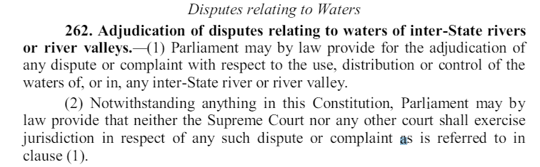
Parliament legislations – River Boards Act (1956), Inter-state water disputes Act (1956)

- Inter-State councils – (Art 263) – President constitutes.
  - Permanent ISC – PM (Chair), CMs, Administrators, Governors, Cabinet Ministers
  - HM is the head of the standing committee.
- Full Faith and credit clause
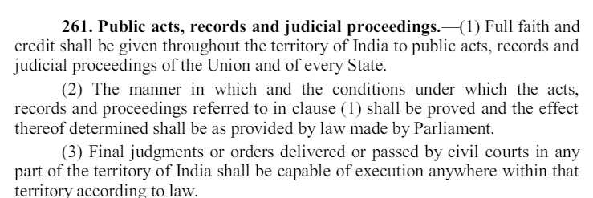
- Freedom of inter-state trade and commerce

Zonal Councils – Statutory – HM (Chair), One of the CMs (Vice Chair)

Emergency [Part XVIII, Art 352-360]
Rationale – To protect the sovereignty, unity, integrity of the country, democratic political system, Constitution.
 | National Emergency | President Rule | Financial Emerg
Grounds | War or External Aggression (External emergency),  Armed Rebellion or Imminent Danger (Internal emergency)  Prez can call only after written order by cabinet [352] | Constitutional breakdown [356] or State not listening to centre under constitutional provisions [365] | Fin stab threatened
Proclamation | SM1 (Total membership + 2/3 Members P+V), within 1 month | Simple majority, within 2 months | Simple, 2 months
Periodic | Periodic approval every 6 month.  Continue indefinitely. | Periodic approval every 6 month  Extended till max 3 yrs  Approval after 1 year also need grounds (a) Nat. Emergency part or whole of country or (b) ECI certificate – No SLA elections possible | -
LS-RS | If LS dissolved: RS approval and approval of reconstituted LS within 30 days | Same | Same
Remove | i. President, not requiring parliamentary approval  or  ii. if LS passes resolution with >1/10th member to speaker (or Prez if Parliament not in session).  Special session to be held within 14 days & LS to approve simple majority | President not req parliametary approval | Prez not req parliam approval
Exec | - Centre give direction to state on any matter (Normally, under Art 257, 356-The State shall not impede Union Exec functioning + Union Exec can direct state based on some constitutional provisions like protection of Railways, ST welfare, Mother Tongue Primary education (Art 350), Maintenance of Means of Communication of National importance).  - State CoM not suspended | - Prez (governor) is vested with all exec powers & can suspend constitutional provisions relating to any authority in the state.  - State CoM suspended  - Can ask parliament to take over SL | Centre direction to state to observe canons of financial property
Legis | - Parliament can make laws on state list & can also confer power or impose duties upon centre on matters outside union list  - Prez can ordinate on state list matters.  - Parliamentary laws cease to operate post 6 month after emergency expiry  - SL not suspended | - Parliament can delegate powers to president or any other authority – President’s Act.  - President can authorise when LS not in session, expenditure from state CoF  - Parliam laws stays.  (can be removed by reconst SL resolution)  - SL suspended & resolution to dissolve held before parliament. If parliam doesnt pass, SL is reactivated | Money bill, Financial bills to be reserved for prez & redxn of salaries even of HC, SC judges
Finan | - Prez can modify constitutional distribution of revenues between centre and state (order need to be put in the parliament  - till end of FY | - | Same as above
Specials | - FR suspended (Art 358,359)  - Exec, Legis provisions apply not only to part of state but any other for Nat security.  - LS, SLA extension 1 year at a time (by the Parliament)  - Minerva Mills (1980) – JR possible to check for malafide declaration.  - Issuance of multiple proclamations possible. | - Right grounds to impose (Bommai)

Art 358 | Art 359
Art 19 automatically suspended & automatically revoked once emergency stops | All FR there but prez can give order to suspend enforcement of certain FR  Enforcement of Art 20,21 cannot be stopped
Acts done cannot be challenged provided  (a) Legis relating to emergency laws only  (b) Exec on such laws only | Acts done cannot be challenged provided  (a) Legis relating to emergency laws only  (b) Exec on such laws only
Only External Emergency | Both types of Emergencies
Entire country for entire duration | Can be part or for only some duration as prez by order gives (approved by parliament later)
No remedy lies even after expiry of order for ex & legislative acts done during emergency

National Emergency Special Provisions :
- LS extension can be done 1 year at a time through parliament by law. Continuation can’t continue post 6 months after emergency over. Same thing parliament can do for SL also
- Laws made by parliament on state subjects inoperable post 6 months
- President can issue diff proclamations irrespective if earlier proclamation still goin on . i.e armed rebellion over external aggression [38th CA 75’]
- Emergency provision can be for a part or whole of country and exec & legis fns can be applied to different part than the one in which emergency going on also. [42nd CA 76’]
- Art 352 defines cabinet as council including PM and other ministers of cabinet rank.
Prez Rule Special provisions:
- HC constitution status or anything can’t be changed
SC judgment Bommai Case
- Pres satisfaction on relevant material only. The adequacy or credibility of material can’t be challenged but material relevance can be
- when new PP form power at centre, it will not have authority to dismiss ministeries formed by other parties in states
Grounds :
- Hung assembly , majority party refuses to form gov , Gov resigns but not alternate party , internal subversion where gov intentionally not followin const principles or physical breakdown and not discharging their constitutional duties, Constitutional direction of centre is disregarded by state
Not Grounds : internal disturbance not amounting to internal subvention or physical breakdown , maladminstration of corruption allegation , power used for irrelvant things to what is conferred by const , if govrnr impose prez rule w/o allowing alternating partys to prove majority
*Emergency under JR on grounds like malafide etc (Minerva mills) , P. rule also under JR (44th CA)
44th CAA additions :
- ‘internal disturbance’ --> ‘armed rebellion’
- 2 months’ notice approval --> 1 month
- Periodic approval every 6 months
- SM1 instead of simple
- LS can start resolution to remove emergency
- art 20,21 out of art 359
- exec , legislation restriction on powers that can’t be challenged
- Prez Rule post 1 year conditions & under JR

Amendments [Part XX, Art 368]
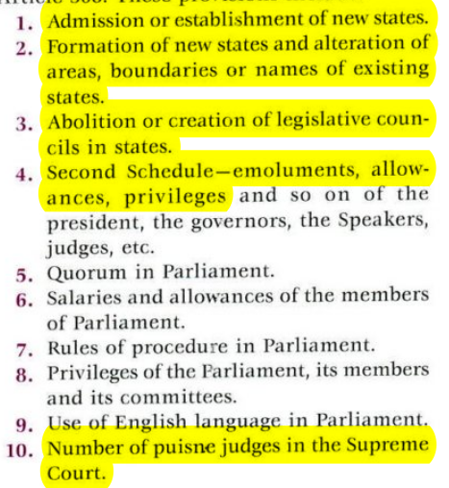
Simple majority and out of scope of 368, not amendments:
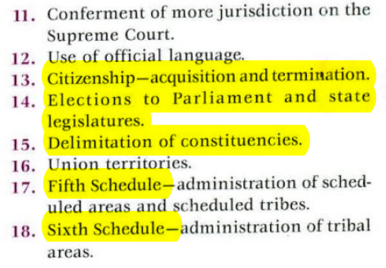

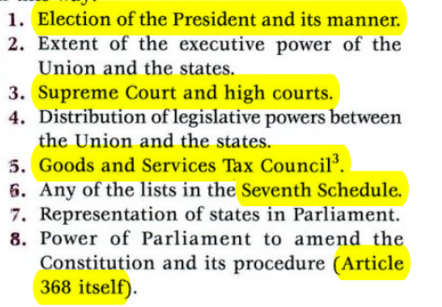
- SM1: FR , DPSP , All other not covered by 1st and 3rd
- Special majority : SM1 + 1/2 state legislatures simple majority passing

- Issues : No time frame till when state legislature approval reqd , no joint sitting , silent on what if parliam wants to take the bill back , hardly state participation
- CA bill : Prez can only assent. No prior approval of prez needed. No joint sitting. Can be introduced in any house either by minister or pvt member
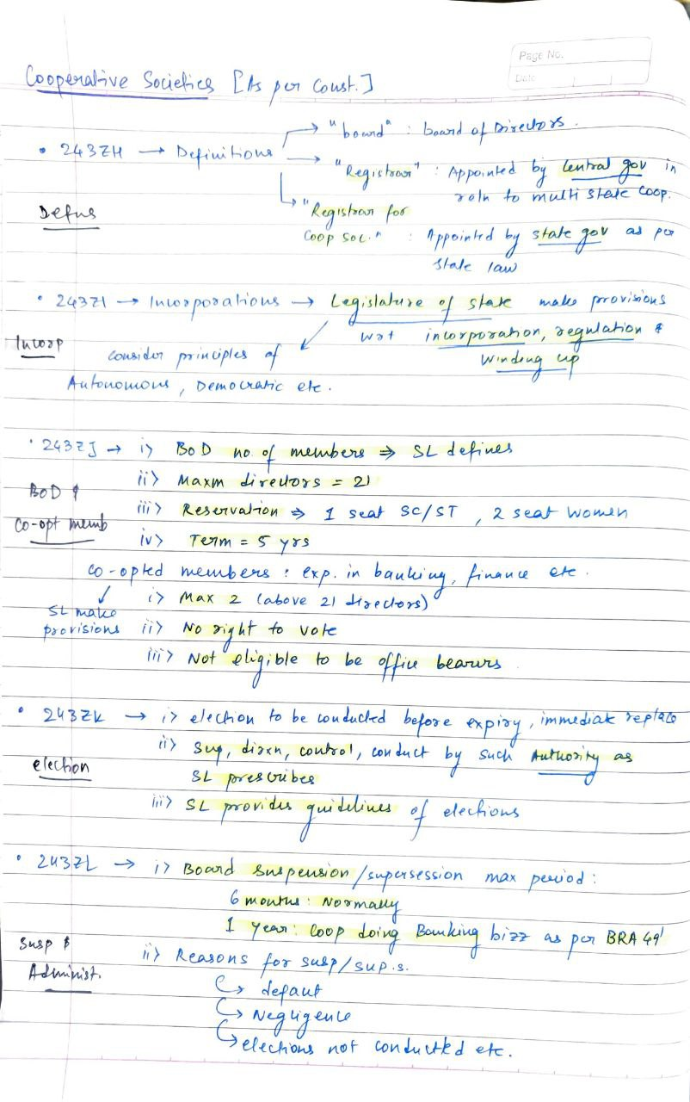
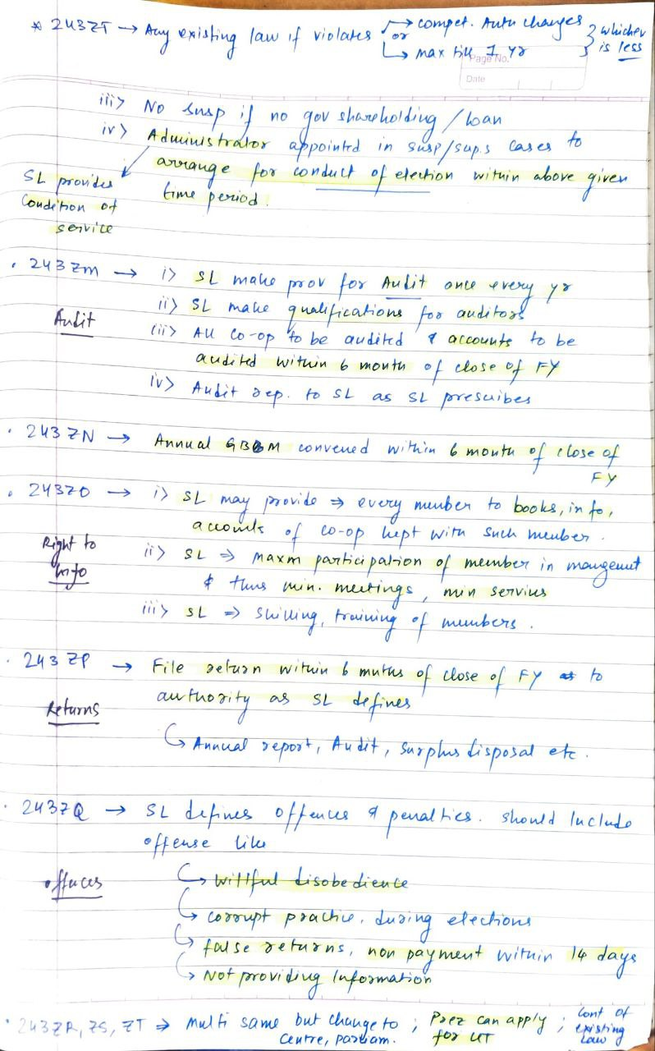

CA –
- UoI v/s All India Judges Association – Dist. Judiciary’s independence is a part of basic structure.
- Art 370 (Repealed) – Except for Defence, Foreign affairs, Finance, Communication; The SL concurrence is required by the GoI to make laws.
- Art 35A – Residents of J&K (Repealed)
- Right to protection of personality (Flows from Right to Privacy (Art 21), Right to publicity – TM Act, Copyrights Act)
- Kui language – Odisha
- Ranganath Mishra commission – Scheduled Caste status must be de-linked to Religion. Dalits who converted to Islam, Christianity must benefit from affirmative action.
- No confidence motion – Rules of Procedure of LS – Only 1 can be moved per session.
- Constitution differentiates between disqualification (Can not contest election) and Expulsion (Can contest election)
- Ordinance making – ICA 1861 – Now Art 123, 213
- Speaker/Chairman can create new posts in respective secretariats; however, Class I and II posts require prior consultation with Ministry of Finance
- Swamitva scheme – Provides ‘record’ of rights to village household owners and issuance of property cards.
- Capacity Building Commission – Non – statutory – Key component of Mission Karma yogi
- PESA Act – Bhuria committee
- Adjournment motion – LS; Rule 267 – RS
- High court collegium – CJ + 2 senior-most judges – Initiate the proposal for appointment to the HC, and send it onwards to the SC Collegium
- Patron-in-chief of NALSA – CJI
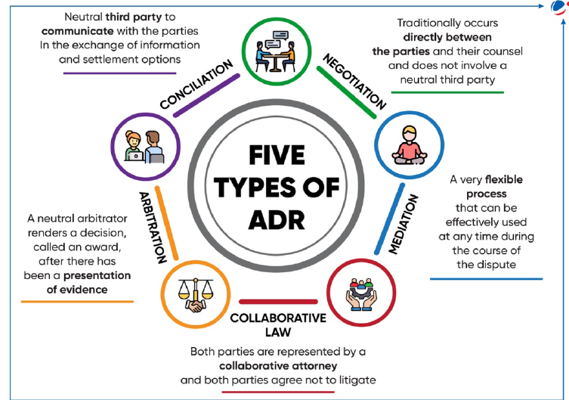
- Mediation Act 2023 – Defines mediation, provides for voluntary pre-litigation mediation.
- Model Prisons Act 2003 –
  - Furlough – Treated as reduction of sentence.
  - Parole – Treated as temporary suspension of sentence.
  - Vocational training
  - Separate accommodation for women and transgenders
- Doctrine of Promissory Estoppel – Prevents a person from backing out of a promise even if there is no legal contract.
- Fast Track special courts – Centrally Sponsored Scheme – Dept. of Justice – Dedicated courts for Rape and POCSO
- CEC Act –
  - Search committee (Headed by Mo Law) – Prepares a list of 5 candidates.
  - Selection committee (PM + LoO + Cabinet Minister) – [Note -Same for CIC]
  - Term of 6 years
  - No Reappointment
  - Removed like the judge of SC.
- Simultaneous elections – 1st recommended by Dinesh Goswami Committee
- Poll expenditure – RPA, 1951 – Monitoring from the day of nomination, not the date of announcement of polls.
- SVEEP Program (Systematic Voter Education and Electoral Participation) – Flagship ECI Program
- ENCORE app – Election management app for Returning Officers to digitize votes, tabulate data etc.
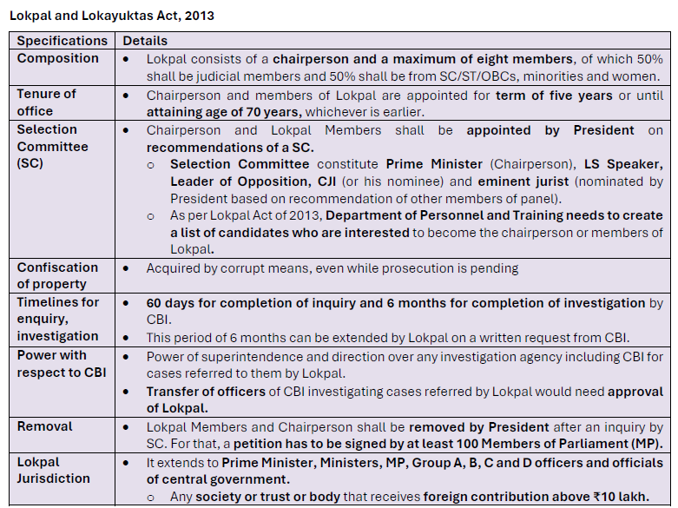
- Selection committee of Lokpal – PM + LoO (LS) + CJI + Eminent Jurist + LS Speaker
- Delimitation Commission – SC Judge (Chairman) + CEC (or EC nominated by him) + State’s EC
- ED – 2-year Tenure (3 annual extensions possible) – Dept. of Revenue – Can investigate and make arrests under PMLA and FEMA without a formal FIR – Statements recorded by ED have evidentiary value.
- CBI – superintendence by CVC for PCA cases – Can initiate cases suo moto in UTs but require state consent otherwise.
- NCC – MoD – NCC Act, 1948
- Competition Commission of India – Statutory – Mo Corporate affairs
- National Centre for good governance – Mo Personnel, Public Grievance, Pensions
  - Headed by Cabinet Secy
- Mission Karmayogi – To build future ready civil servants.
- Online gaming – Covered under IT Rules Act
  - Defines Online Game, Online Game intermediary.
  - Specifies OGI responsibilities and obligations.
  - SRB – Self Regulating Body (designated by MeITY) shall verify an online game as permissible.
- ConfoNet Project – To improve operational efficiency in Consumer Redressal
- Kerala – India’s 1st e-governance state
- Panchayat Development Index – Mo PR
- Aaina Dashboard – MOHUA
  - City level data from ULBS
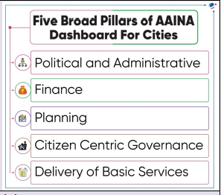
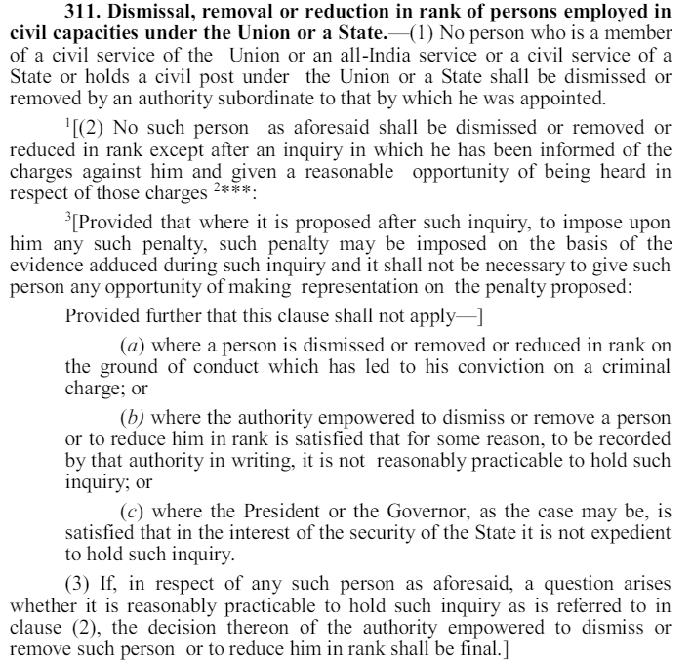
- Removal from civil service –
  - Only authority > appointing authority can do this.
  - Inquiry + reasonable opportunity of representation is mandatory except –
    - Conviction on a criminal charge
    - Authority is convinced that the inquiry is not practicable (The authority must record this in written)
    - Prez/Gov is convinced that in the interest of security of state, inquiry is not practicable.
- 106th CAA, 2003 – Nari Shakti Vandan –
  - 1/3 reservation in LS + SLA + LA of Delhi NCT
  - Art 239AA – Legislature of Delhi NCT
  - Art 330A – Reservation in Parliament
  - Art 332A – Reservation in SLA
  - To have this reservation in J&K and Puducherry LAs, the relevant acts were amended. (This is not a part of the constitution).
- MSCSA, 2003 –
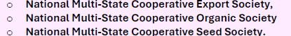
  - Cooperative election authority has been constituted.
  - Restriction on redemption of gov. shares
- CBFC – Ministry of Information and Broadcasting

